FIRST AMENDMENT TO
SHIRLEY BERNSTEIN TRUST AGREEMENT

This First Amendment is dated this / f day of /l}e. v , 2008, and is between SHIRLEY BERNSTEIN of Palm Beach County, Florida referred to in the first person, as settlor, and SHIRLEY BERNSTEIN of Palm Beach County, Florida as trustee (referred to as the "Trustee," which term more particularly refers to all individuals and entities serving as trustee of a trust created hereunder during the time of such service, whether alone or as co-trustees, and whether originally serving or as a successor trustee).

WHEREAS, on May 20, 2008, Icreated and funded the SHIRLEY BERNSTEIN TRUST AGREEMENT (the "TrustAgreement, "which reference includes any subsequent amendments of said trust agreement);

WHEREAS, Paragraph A. of Article I.of said Trust Agreement provides, inter alia, that during my lifetime I shall have the right at any time and from time to time by an instrument, in writing, delivered to the Trustee to amend or revoke the said Trust Agreement, in whole or in part.

NOW THEREFORE, by executing this instrument, I hereby amend the Trust Agreement as follows:

- I hereby delete Paragraph B. of Article II. in its entirety.

- I hereby amend the last sentence of Paragraph E. of Article III. to read as follows:

"Notwithstanding the foregoing, as my spouse and I have adequately provided for them during our lifetimes, for purposes of the dispositions made under this Trust, my children, TED S. BERNSTEIN ("TED") and PAMELA B. SIMON ("PAM '), shall be deemed to have predeceased the survivor of my spouse and me, provided, however, if my children, ELIOT BERNSTEIN, JILL!ANTONI and LISA S. FRIEDSTEIN, and their respective lineal descendants all predecease the survivor of my spouse and me, then TED and PAM shall not be deemed to have predeceased the survivor of my spouse and me and shall become eligible beneficiaries for purposes of the dispositions made hereunder."

- I hereby ratify and reaffirm the Trust Agreement as amended by this First Amendment.

[remainder of page intentionally left blank]

FIRST AMENDMENT TO
SHIRLEY BERNSTEIN TRUST AGREEMENT

TESCHER 0 SPALLINA, P.A.

IN WITNESS WHEREOF, the parties hereto have executed this First Amendment on the date first above written.

SETTLOR and TRUSTEE:

SHEIN

This instrument was signed by SHIRLEY BERNSTEIN in our presence, and at the request of
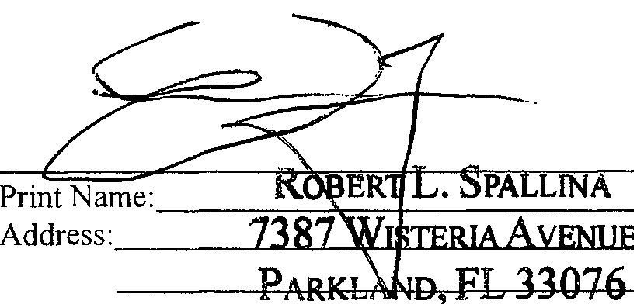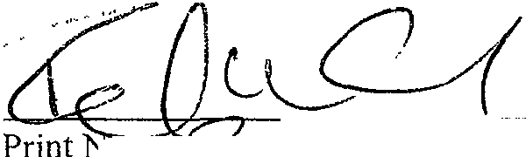and in th;,_presence of SHI Y BERNSTEIN and each other, we subscribe our names as witnesses on this Lj'.:::_ day of / V' '-" ,2008:

Prmtarr;jS.q;<.hcQ COal
Address: /00 f?tc&Z:O\. 'K.et1.1 Yx.,Jin

ap+_ ;70-g;,

STATE OF FLORIDA

COUNTY OF PALM BEACH

SS.

The foregoing instrument was acknowledged before me this IS day of 1UuVP.Itlber ' 2008, by SHIRLEY BERNSTEIN.
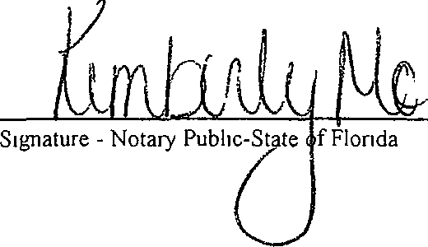 ,.T,., c."'ATY> oY 'FT·oaron.DA
\ [

NOTA....,.n,
. ..,,. • .\ Mor
- ...
-" "\)ALY
,70

<flt, If'.1-:,,. ,·· ''
OD766'1. /l

.,,,u,,,
1 ·,i - •'• Jl.

i :t....- -·.-·l·1,.:.0. ···",:. .:.r:·-R·. 2"o, ?-f.Jl1·2..
., l Ex, -,!,· · ;'..,µmG co., '.\'-'·
'''""''" 'filRU A,tl.J.ut ·l.b'n
.>:<DED
[Seal with Commission Expiration Date]

Prmt, type or stamp name of Notary Public

Personally Known-----or Produced Identification-----
Type of Identification Produced --------------------------

N \WPDATA\drt\Bernstem, Shirley & Simon\2008 Estate Planmng\First Amendment to Shirley Bernstein Trust Agreement wpd [1 1 09 26 18 08]

FIRST AMENDMENT TO
SHIRLEY BERNSTEIN TRUST AGREEMENT -2-

TESCHER s SPALLINA, p.A.

