Filing # 49291071 E-Filed 11/25/2016 02:13:13 PM

IN THE CIRCUIT COURT OF THE FIFTEENTH JUDICIAL CIRCUIT IN AND FOR PALM BEACH COUNTY, FLORIDA
CIVIL DIVISION

CASE NO.: 2015-CA-011261XXXXMB

BANK OF AMERICA, N.A.,

Plaintiff,

v.

SKENDER HOTI, et al

Defendant(s),

/

DEFENDANT’S AMENDED MOTION TO STAY ALL PROCEEDINGS, AND CANCEL SALE, PENDING DEFENDANT’S APPEAL TO THE FOURTH DISTRICT COURT OF APPEAL IN THIS ACTION

COMES NOW, the Defendant, Skender Hoti, by and through the undersigned attorney, and hereby files this Motion to Stay All Proceedings, and CANCEL SALE Pending Defendant’s Appeal to the Fourth District Court of Appeal in this Action, and to Cancel and/or Postpone Any Writs of Possession in this action, Pending Such Appeal by Defendant, and states as grounds, the following:
- On August 1, 2016, the Court issued Final Judgment of Foreclosure in favor of Plaintiff, Bank of America, N.A. and against Defendant, regarding this action.
- On October 11, 2016, Defendant filed a Notice of Appeal against Plaintiff in this action. (See Exhibit A)
- The sale of the foreclosed property of the Defendant therefore would be premature until such time as the Fourth District Court of Appeal issues a final ruling concerning the Defendant’s appeal of this Court’s Final Judgment entered on August 1, 2016.
- The Defendant would also like to include his signed and notarized Affidavit evidencing the ineffectiveness of his previous counsel handling this matter.

- Defendant now brings this Motion to Stay All Proceedings, Pending Defendant’s Appeal to the Fourth District Court of Appeal in this Action, and to Cancel and/or Postpone Sale and Stay Proceedings in this action, Pending Such Appeal by Defendant.

ARGUMENT

- Per Fla. R. App. P. § 9.310(a), Defendant asks for this Stay of Proceedings and/or Evictions to allow sufficient time for the Fourth District Court of Appeal to consider his appeal of the September 9, 2016 decision of this Court, which denied the Defendant (Interested Person's) Motion for Extension of Time to File for a new Trial, Fraud on the Court filed by Skender Hoti on August 16, 2016. This Court has the ability to stay proceedings pending appeal of a decision of the Court to the Fourth District Court of Appeal.
- It is established under Florida law that a supersedeas bond is not required to be imposed on a moving party seeking a stay, but that posting of such a bond makes a stay automatic in nature as to all proceedings. See Palm Beach Heights Development v. Decillis, 385 So. 2d 1170 (Fla. 3d DCA 1980); see also Proprietors Ins. Co. v. Valsecchi, 385 So. 2d 749, 750 (Fla. 3d DCA 1980); Fla. R. App. P. § 9.310(b)(1).
- That said, if the appeals court reverses the ruling made at a lower Court level, then the Appellant is entitled to have his property restored by the Appellee. See Ronette Comm’ns Corp. v. Lopez, 475 So. 2d 1360, 1361 (Fla. 5th DCA 1985).
- Furthermore, under Florida law, a party does not have to post a bond to appeal a money judgment. See Campbell v. Jones, 648 So. 2d 208, 209 (Fla. 4th DCA 1994).
- Also, a trial court cannot require a party to post a bond. See Palm Beach Heights Development v. Decillis, 385 So. 2d 1170 (Fla. 3d DCA 1980).
- Per Fla. R. Civ. P. § 9.310(a), “except as provided by general law and in subdivision (b) of this rule, a party seeking to stay a final or non-final order pending review shall file a motion in

the lower tribunal, which shall have continuing jurisdiction, in its discretion, to grant, modify, or deny such relief. A stay pending review may be conditioned on the posting of a good and sufficient bond, other conditions, or both.” See Id.
- In the instant action, Defendant is facing foreclosure sale of his property, even though he filed a valid appeal before the Fourth District Court of Appeal as of this Motion’s filing.
- Defendant does not have the ability to place a surety bond himself in regards to any Grant of Stay, and requiring him to do so would cause irreparable and injurious harm to his current situation, as Defendant will certainly lose his property by requiring a bond that he cannot possibly pay or place at this time.
- In addition, requiring the placement of such a bond requirement on Defendant will pose a dramatic and potentially catastrophic hardship on Defendant’s already fragile financial situation, and may act to completely subvert and undermine his ability to bring his timely appeal at the Fourth District Court of Appeal, permanently endangering his procedural rights to Due Process under Fla. Const. § Art. I, Sec. 9, where “no person shall be deprived of life, liberty or property without due process of law.” See Id.
- By placing any bond requirement for a Grant of Stay, Defendant will be immediately evicted and deprived of his property, because he will be unable to proceed with a timely appeal with the Fourth District Court of Appeal, and risk losing his property outright, even though he is pursuing the proper avenues of appeal of his case. Such a requirement is highly unreasonable to ask of anyone, especially that of Defendant, and would create a manifest injustice to Defendant in this action.
- The subject matter of the appellate court’s jurisdiction could be mooted if the parties’ legal positions were inexorably altered by the execution of the judgment before the appeal was concluded. See Fitzgerald v. Addison, 287 So. 2d 151 (Fla. 2d DCA 1973).

- Furthermore, by not granting a Stay of All Proceedings, it would cause the Defendant and Plaintiff additional fees due to the litigation that would take place to reverse any Eviction of Defendant’s property, especially if Defendant is successful with his appeal case.
- Defendant’s case is a foreclosure defense action being brought against him by Plaintiff, and is not necessarily a money judgment, but actually involves the very ownership of his property, which cannot be readily quantified. As Defendant is in imminent danger of losing his property, this becomes even more paramount.
- Defendant is confident of the arguments being brought forward for appeal and consideration by the Fourth District Court of Appeal, and believes that such arguments will be successful at the appellate level.
- Defendant also now asks and moves this Court to cancel and/or postpone any currently scheduled and/or pending Evictions regarding his property, pending the outcome of his appeal case with the Fourth District Court of Appeal, along with Staying All Proceedings in this case, until Defendant’s appeal case is decided, including the staying of any Writs of Possession, in this action.
WHEREFORE, Defendant, Skender Hoti, by and through the undersigned attorney, now asks and moves this Honorable Court to immediately Grant his Motion to Stay All Proceedings, Pending Defendant’s Appeal to the Fourth District Court of Appeal in this Action, and to Cancel and/or Postpone Any Writs of Possession in this action, Pending Such Appeal by Defendant, so that there is no bond requirement on a Grant of Stay, as well as immediately canceling and/or postponing any currently scheduled and/or pending Evictions for Defendant’s property, until Defendant’s appeal case is decided.

Respectfully Submitted,

ROBERT B. COOK, P.A.
Attorney for Defendant(s)
4362 Northlake Blvd. Ste. 213 Palm Beach Gardens, FL 33410 Tel: 561-310-1177
Rbc1960@yahoo.com Service@cooklawfl.com By: /s/ Robert B. Cook
FBN 131356

CERTIFICATE OF SERVICE

I HEREBY CERTIFY that on November 25, 2016, a copy of the foregoing was furnished via electronic mail to servicefl@mlg-defaultlaw.com for service upon Marinosci Law Group., P.C., Attorney for Plaintiff.

ROBERT B. COOK, P.A.
Attorney for Defendant(s)
4362 Northlake Blvd. Ste. 213 Palm Beach Gardens, FL 33410 Tel: 561-310-1177
Rbc1960@yahoo.com Service@cooklawfl.com By: /s/ Robert B. Cook
FBN 131356

IN THE CIRCUIT COURT OF THE FIFTEENTH JUDICIAL CIRCUIT IN AND FOR PALM BEACH COUNTY, FLORIDA
CIVIL DIVISION

CASE NO.: 2015-CA-011261XXXXMB

BANK OF AMERICA, N.A.,

Plaintiff,

v.

SKENDER HOTI, et al

Defendant(s),

/

PRO POS ED ORDER OF DE FENDANT’S MOTION TO STAY ALL PROCEEDINGS,
INCLUDING DEFEN D ANT’S PENDIN G SALE OF HIS PROPERTY, PENDING
DEFENDA NT’S A PPEAL TO THE FOURTH DISTRICT COURT OF APPEAL IN THIS ACTION

THIS CAUSE, having come before the Court on Defendant’s Motion to Stay All Proceedings, Pending Defendant’s Appeal to the Fourth District Court of Appeal in this Action, and to Cancel and/or Postpone Sale of Defendant’s Property in this action, Pending Such Appeal by Defendant; the Court having reviewed the file and the arguments of both parties, hereby states that:
IT IS ORDERED that Defendant’s Motion is hereby GRANTED, and that a Stay of All Proceedings, without a bond requirement of Defendant, is hereby put into place, and that all Pending Evictions of Defendant are Stayed, until Defendant’s appeal case is heard by the Fourth District Court of Appeal.
DONE AND ORDERED at West Palm Beach County, Florida, on this day of November, 2016.

CIRCUIT JUDGE

Copies To:

Robert B. Cook, P.A. Attorney for Defendant
4362 Northlake Blvd., Ste. 213 Palm Beach Gardens, FL 33410 Rbc1960@yahoo.com

Marinosci Law Group Attorney for the Plaintiff
100 W Cypress Creek RD Ste 1045 Ft. Lauderdale, FL 33309 servicefl@mlg-defaultlaw.com

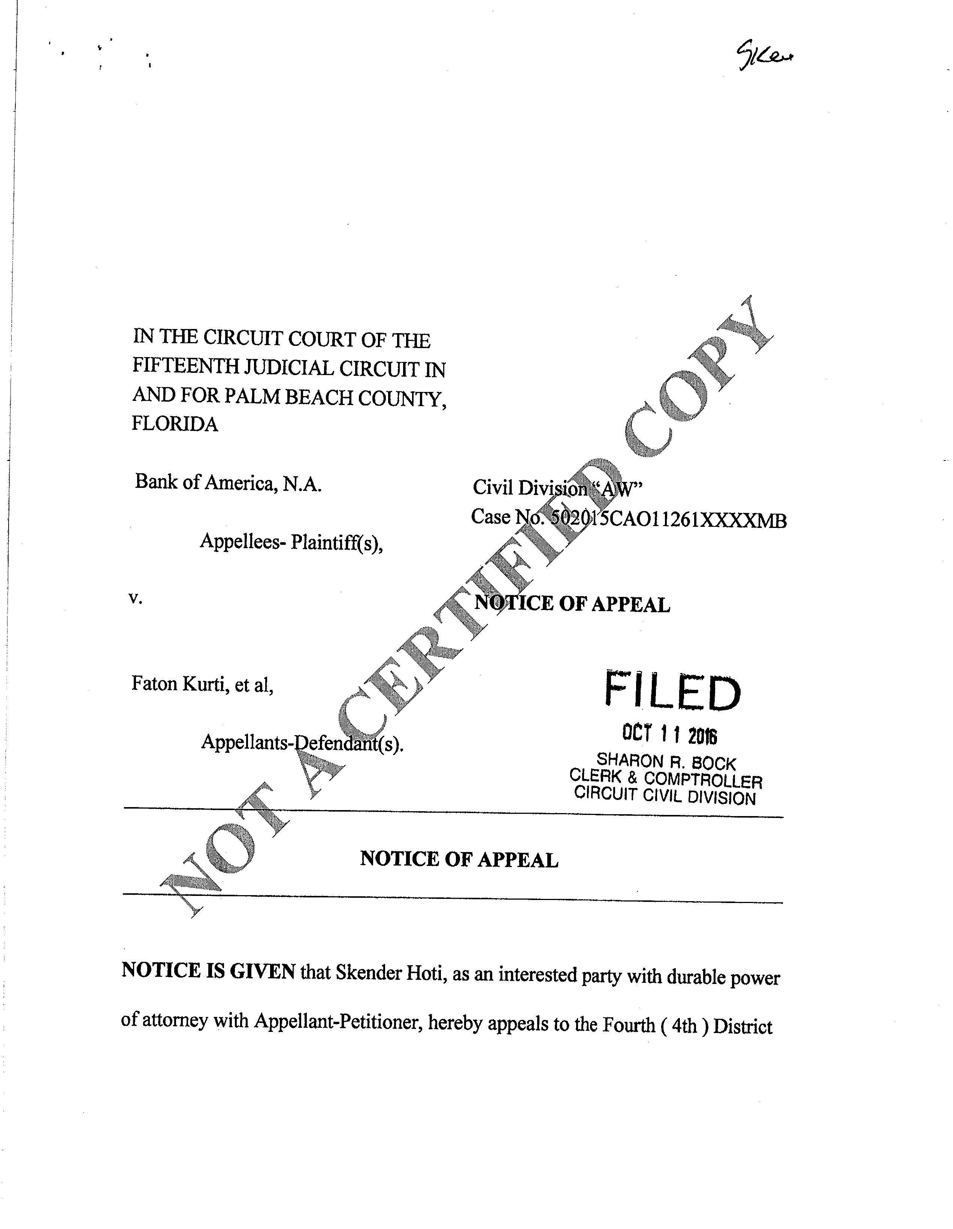

EXHIBIT A

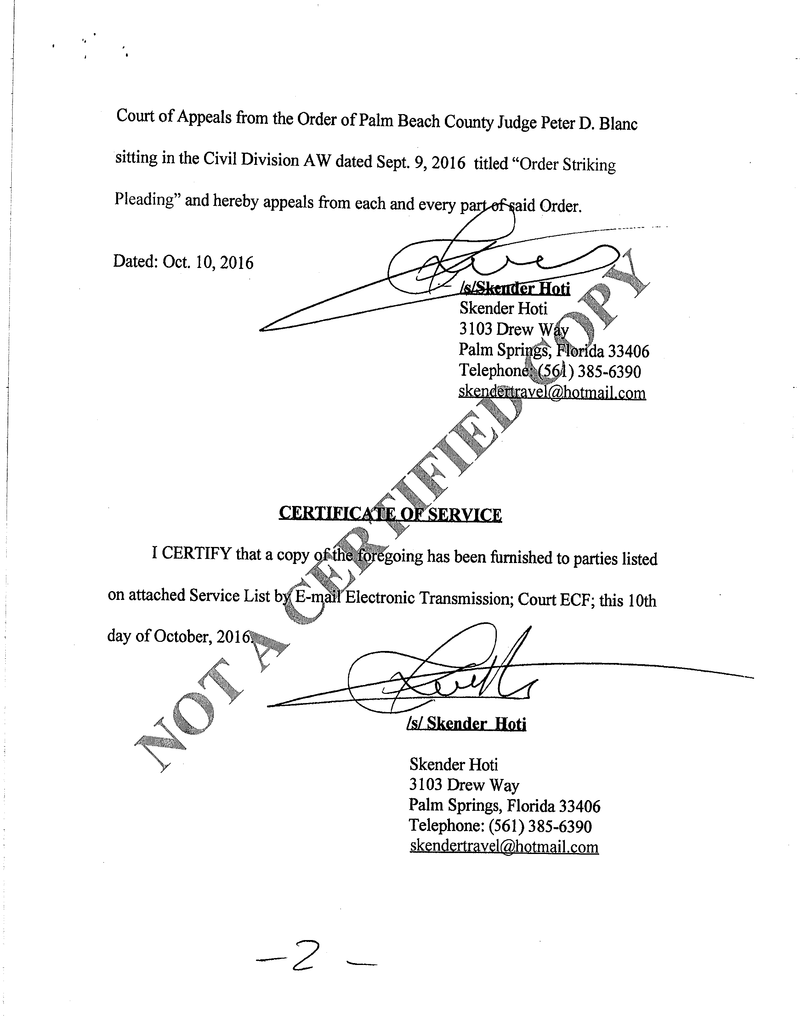

EXHIBIT A

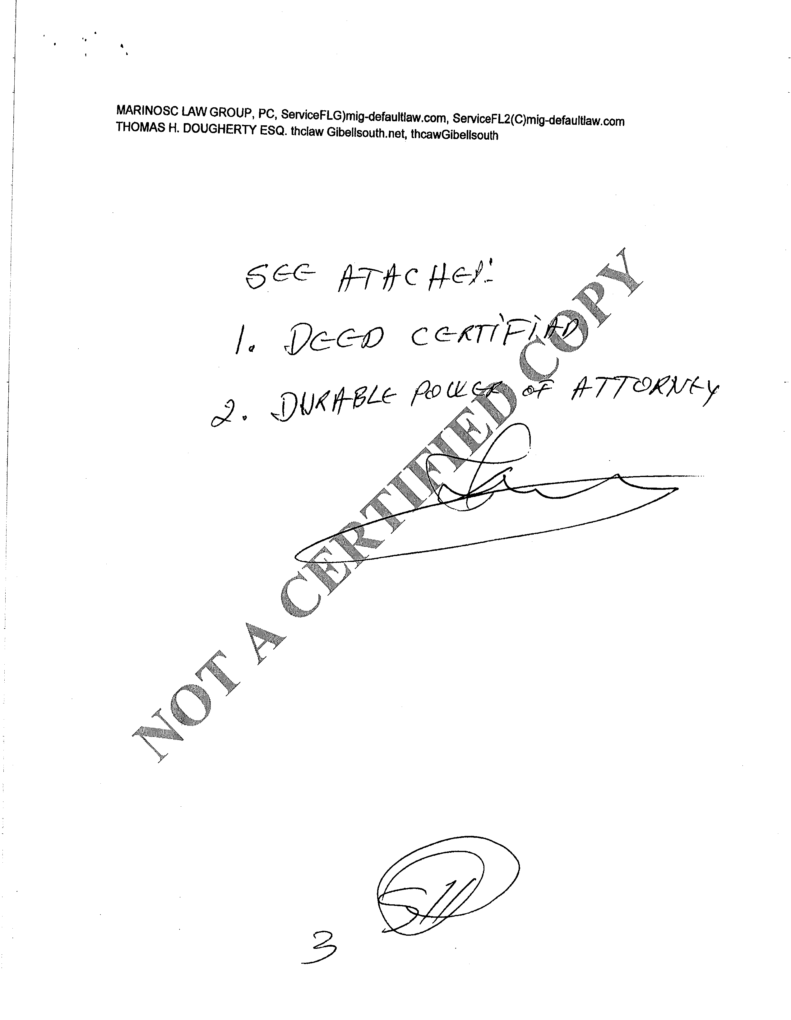

EXHIBIT A

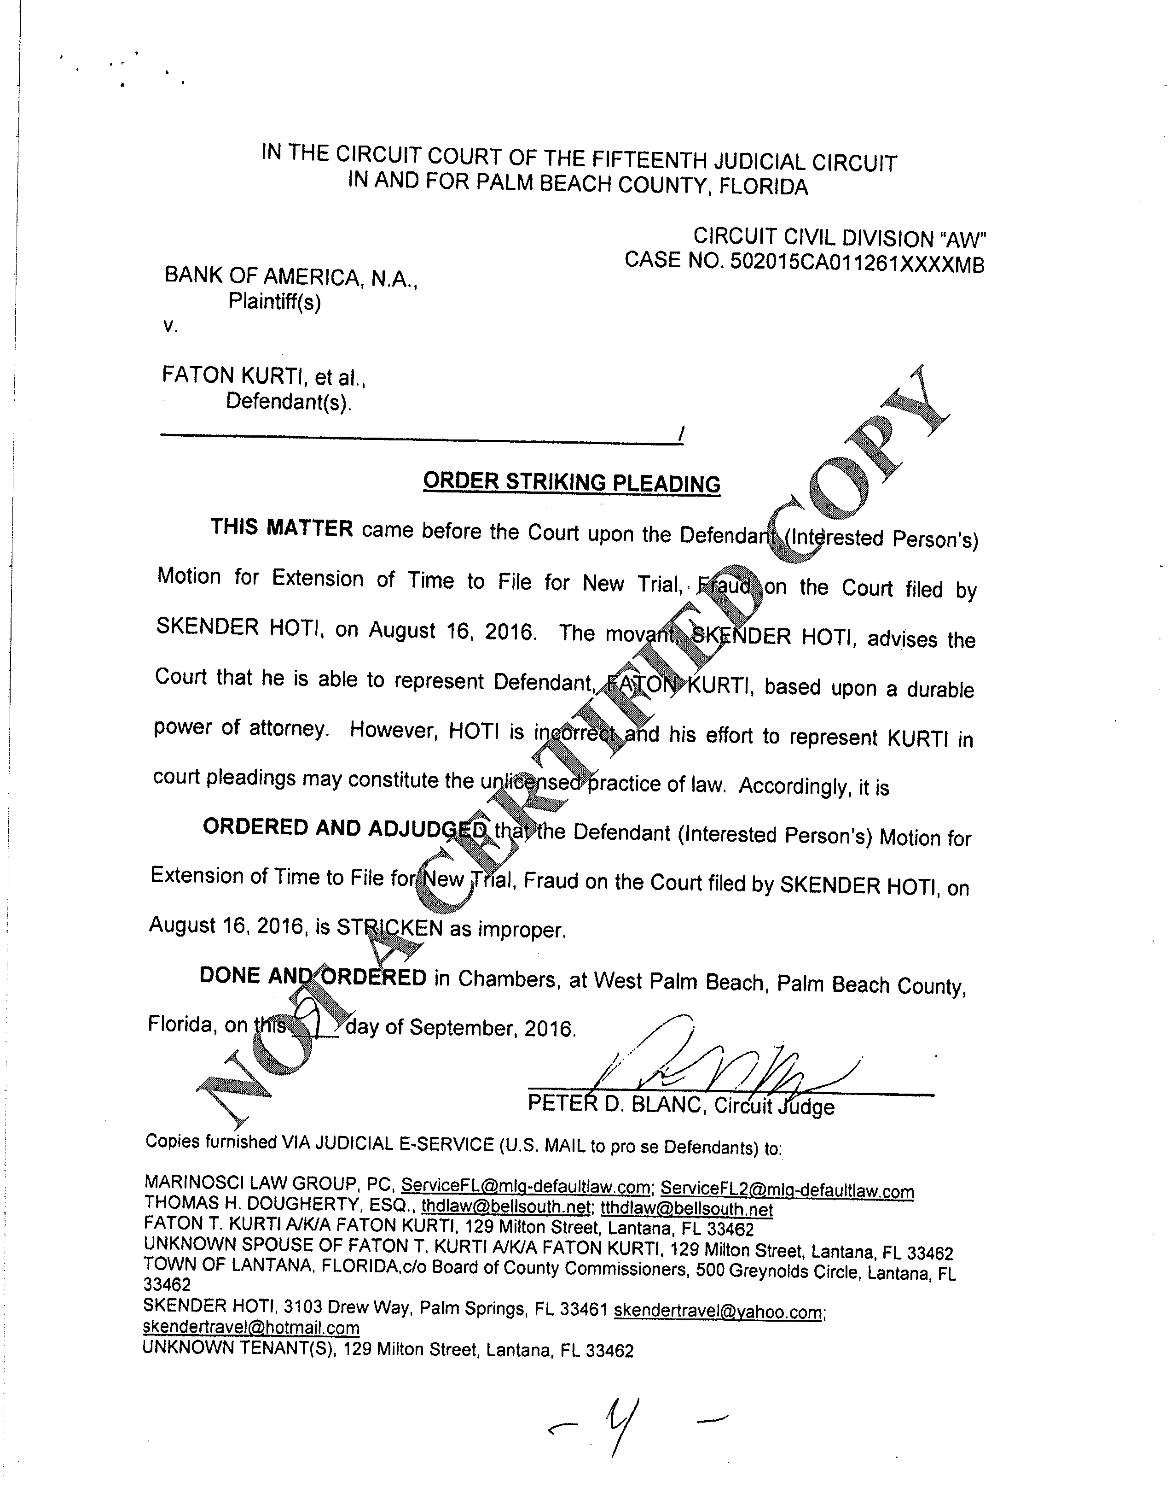

EXHIBIT A

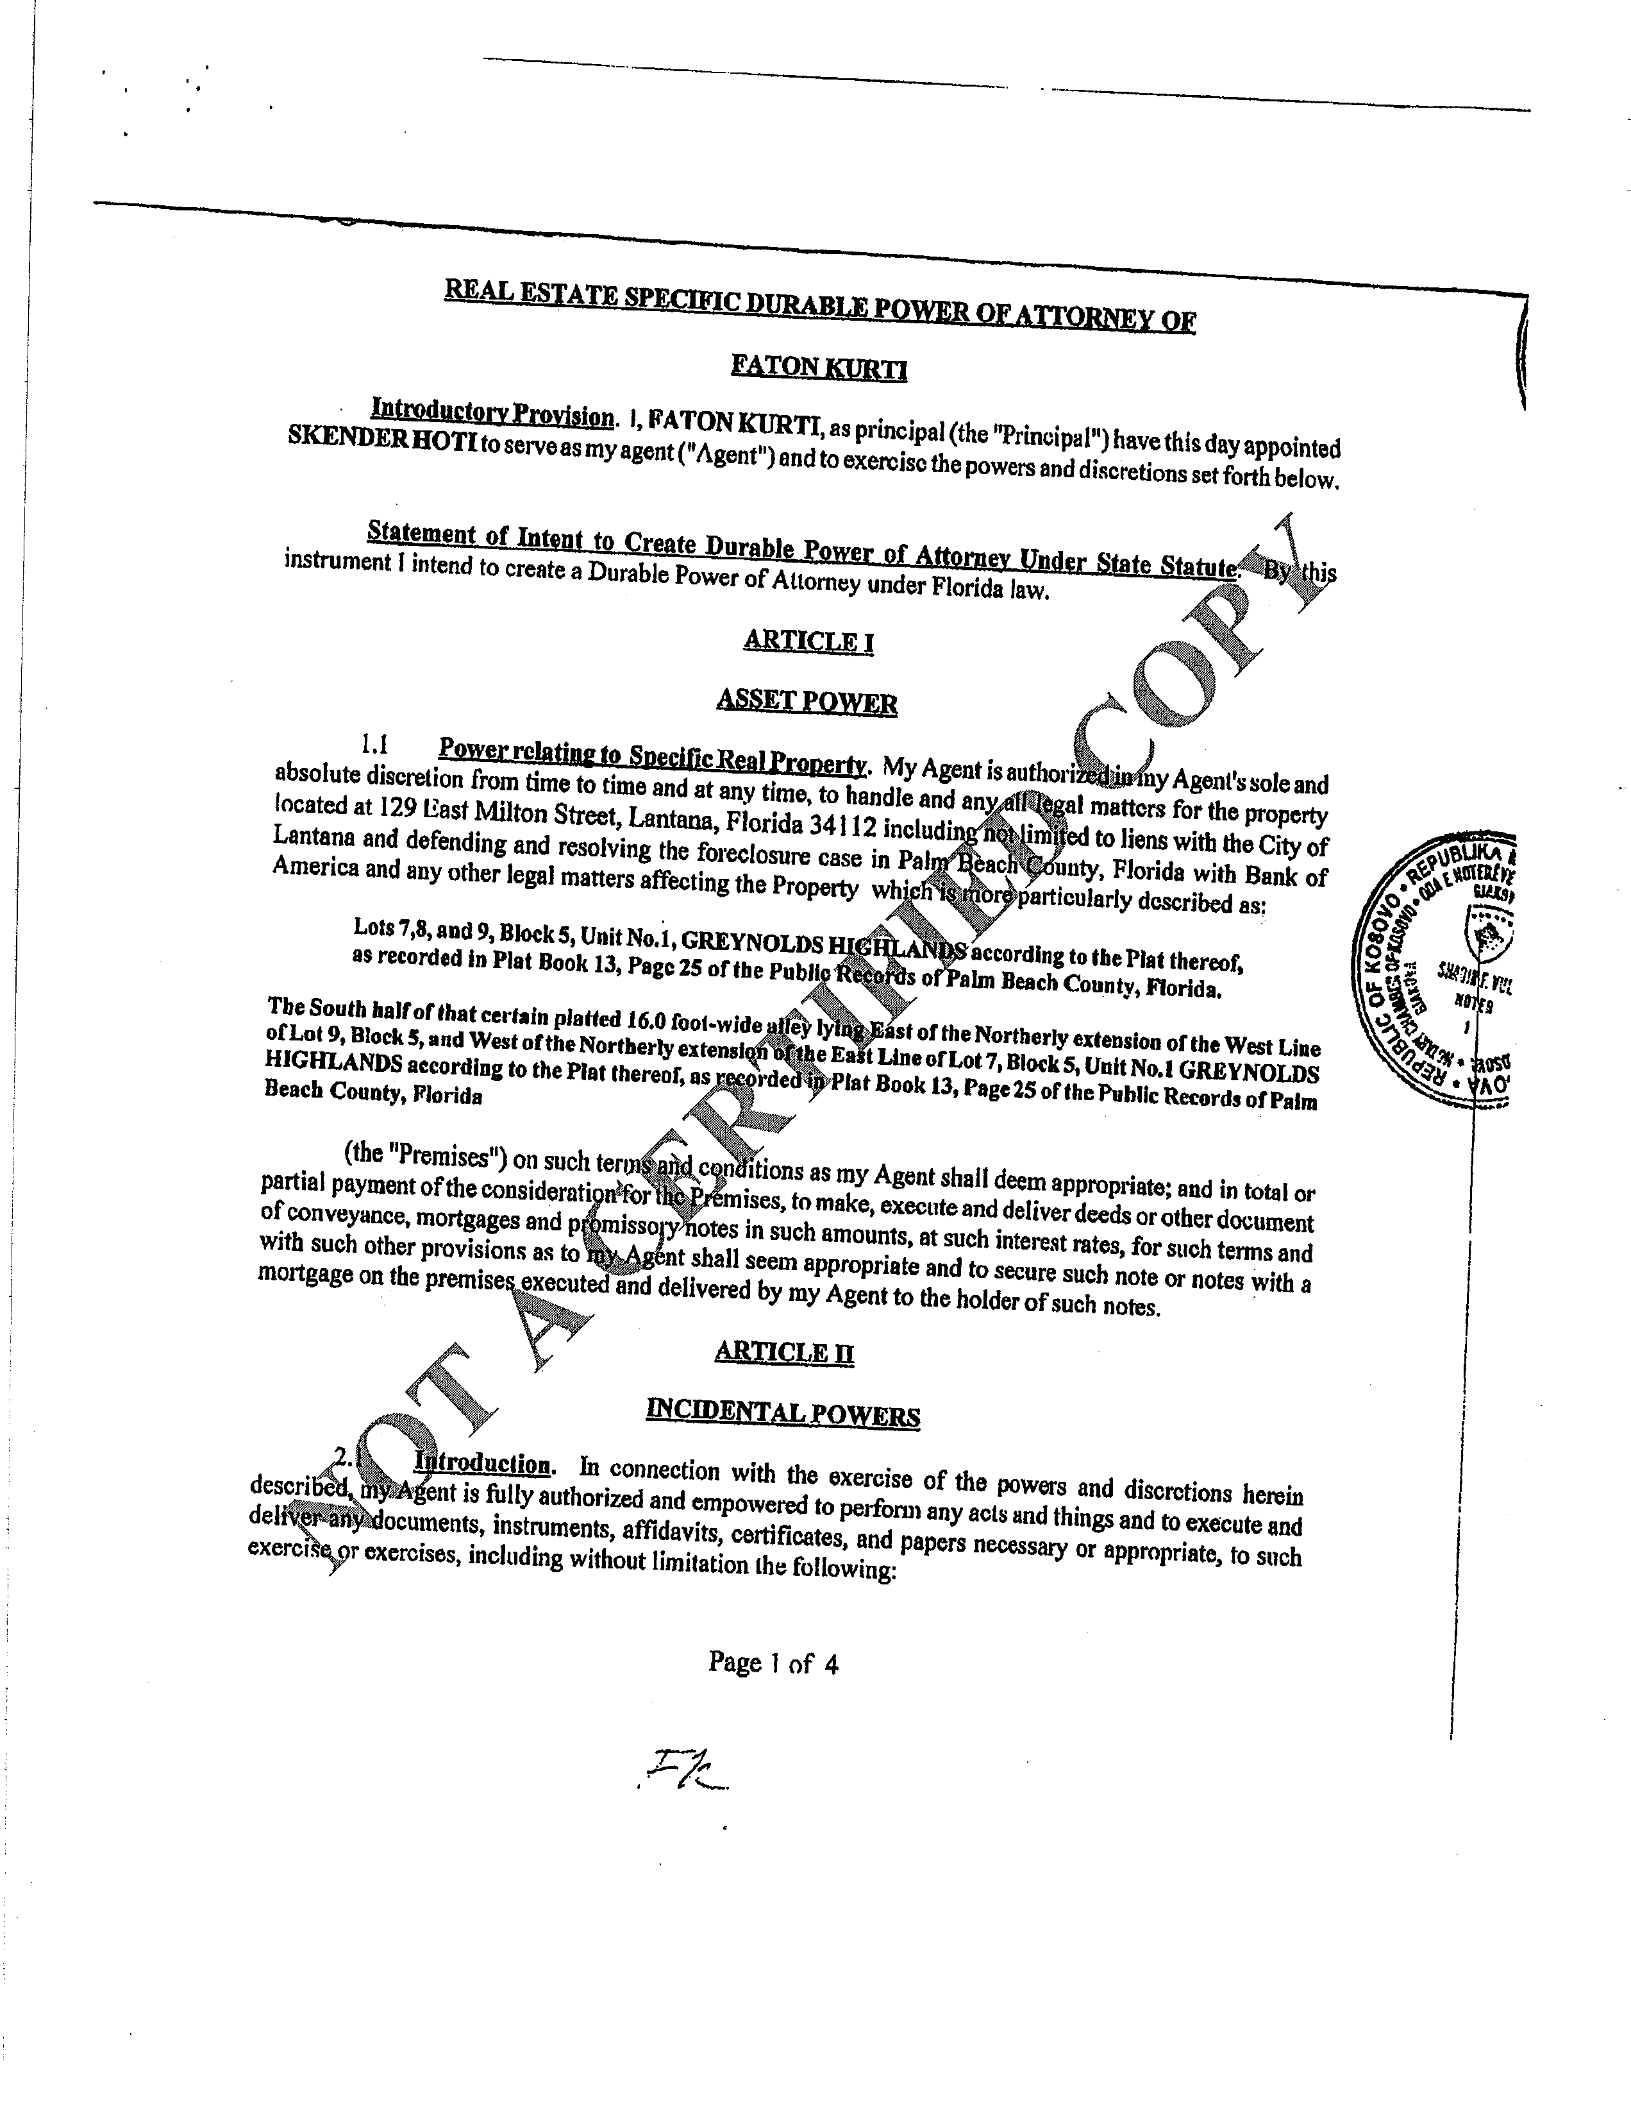

EXHIBIT A

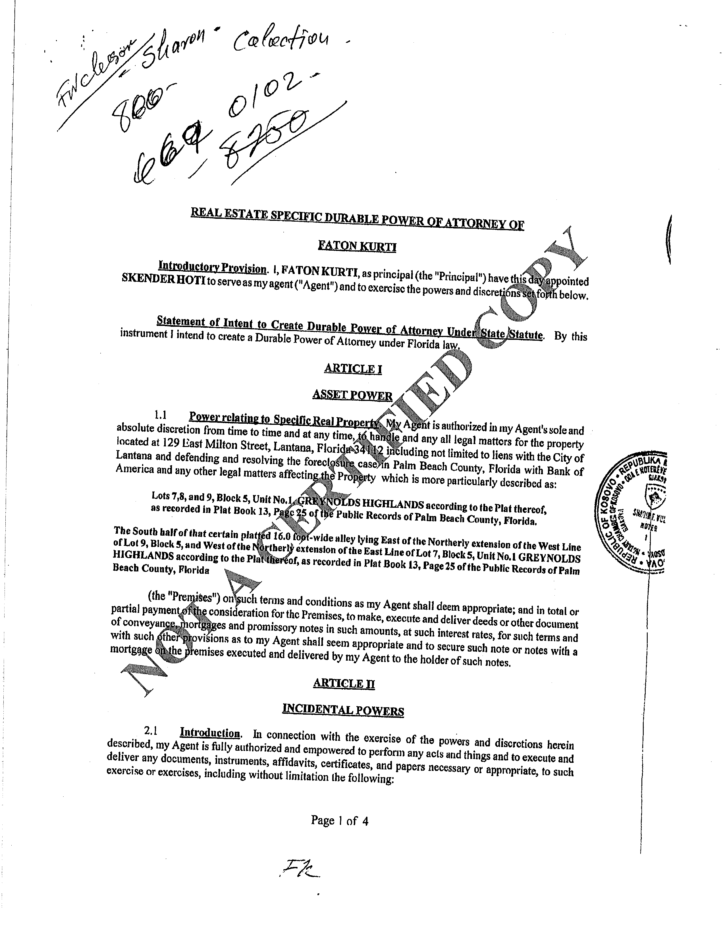

EXHIBIT A

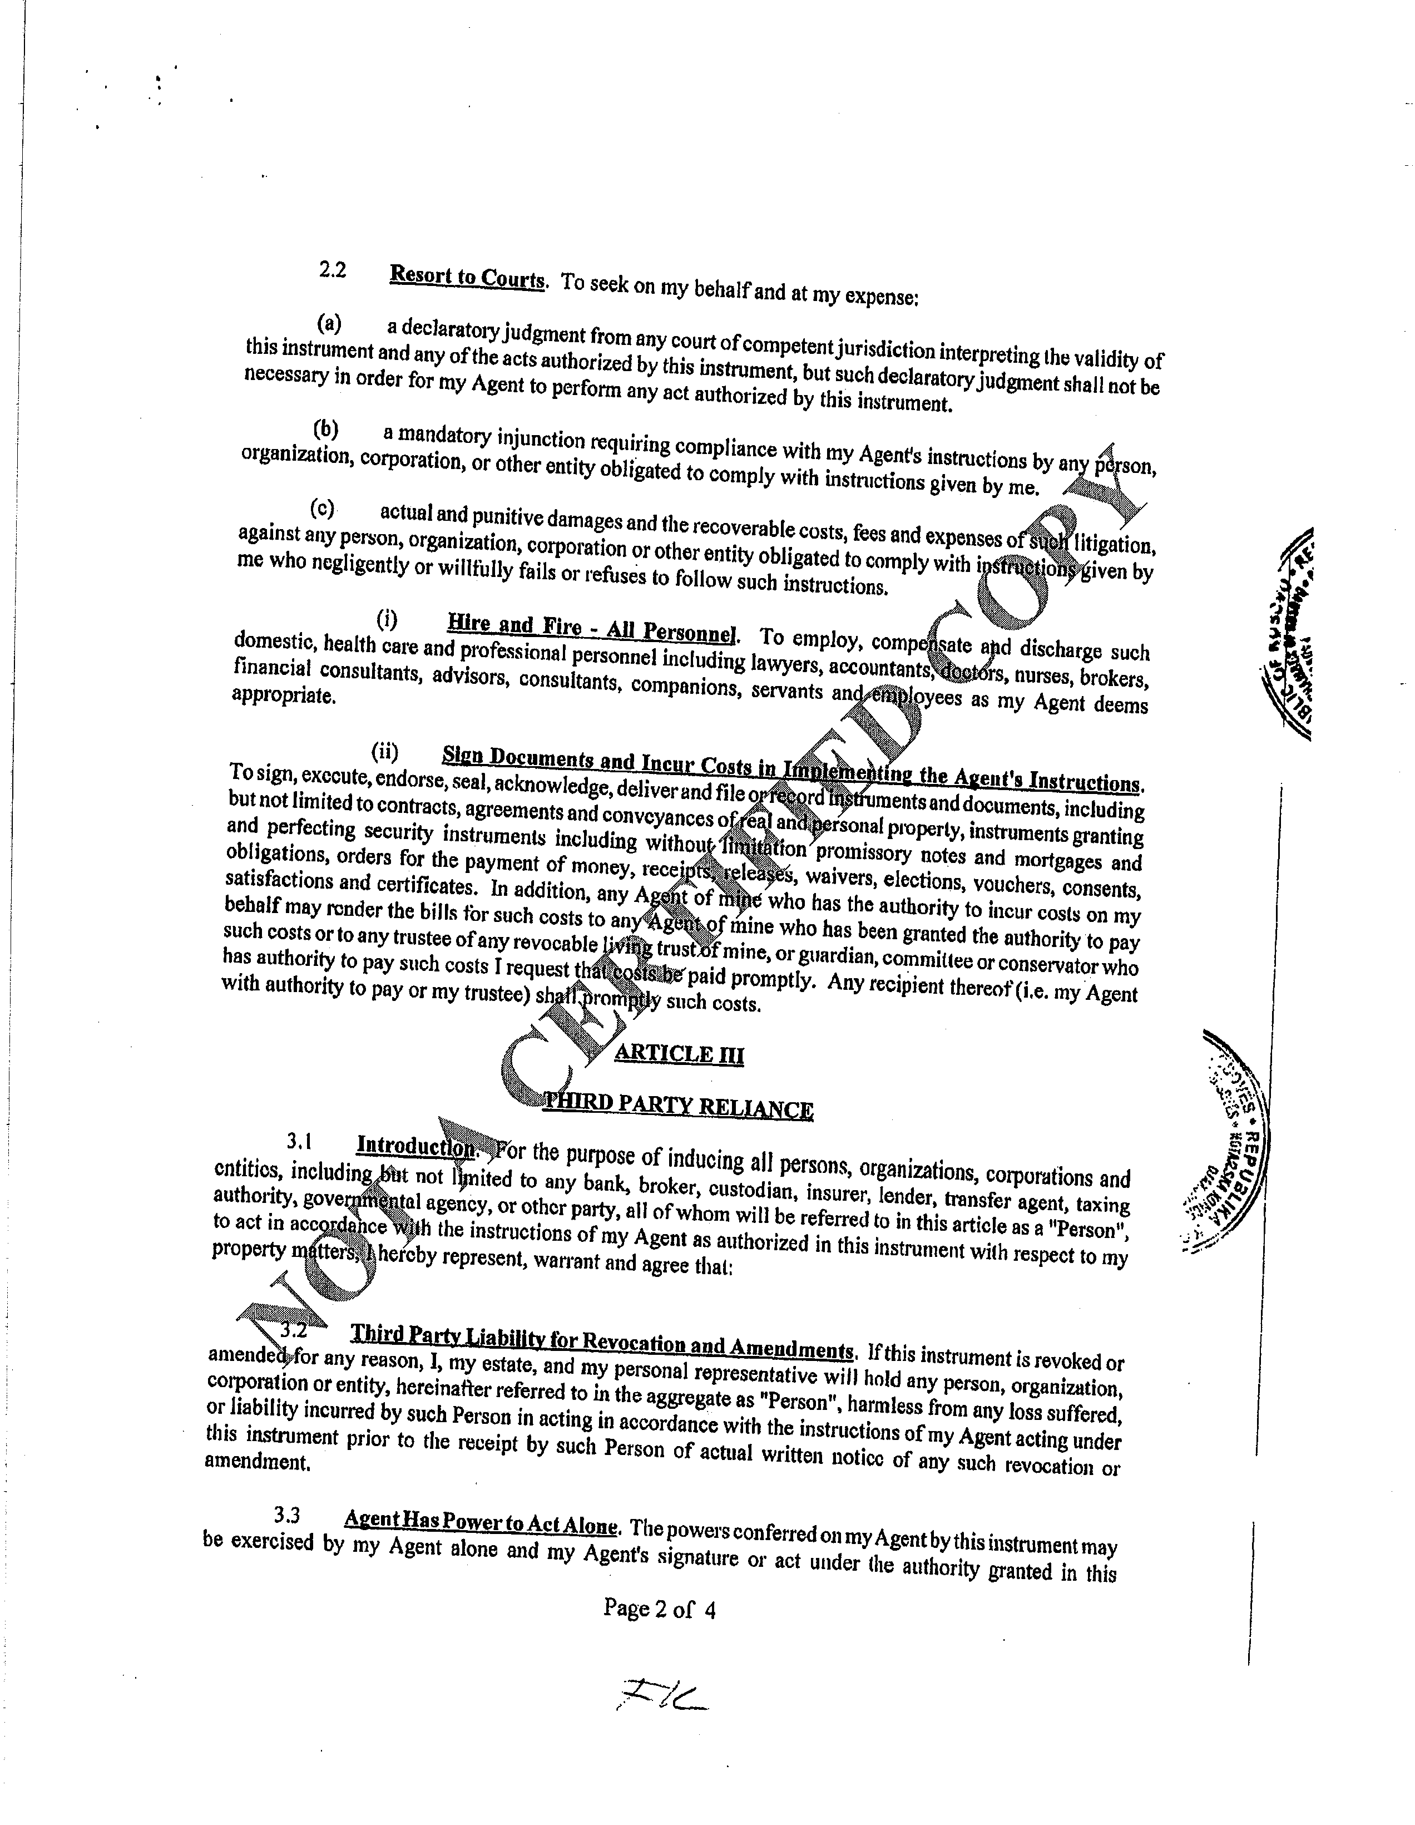

EXHIBIT A

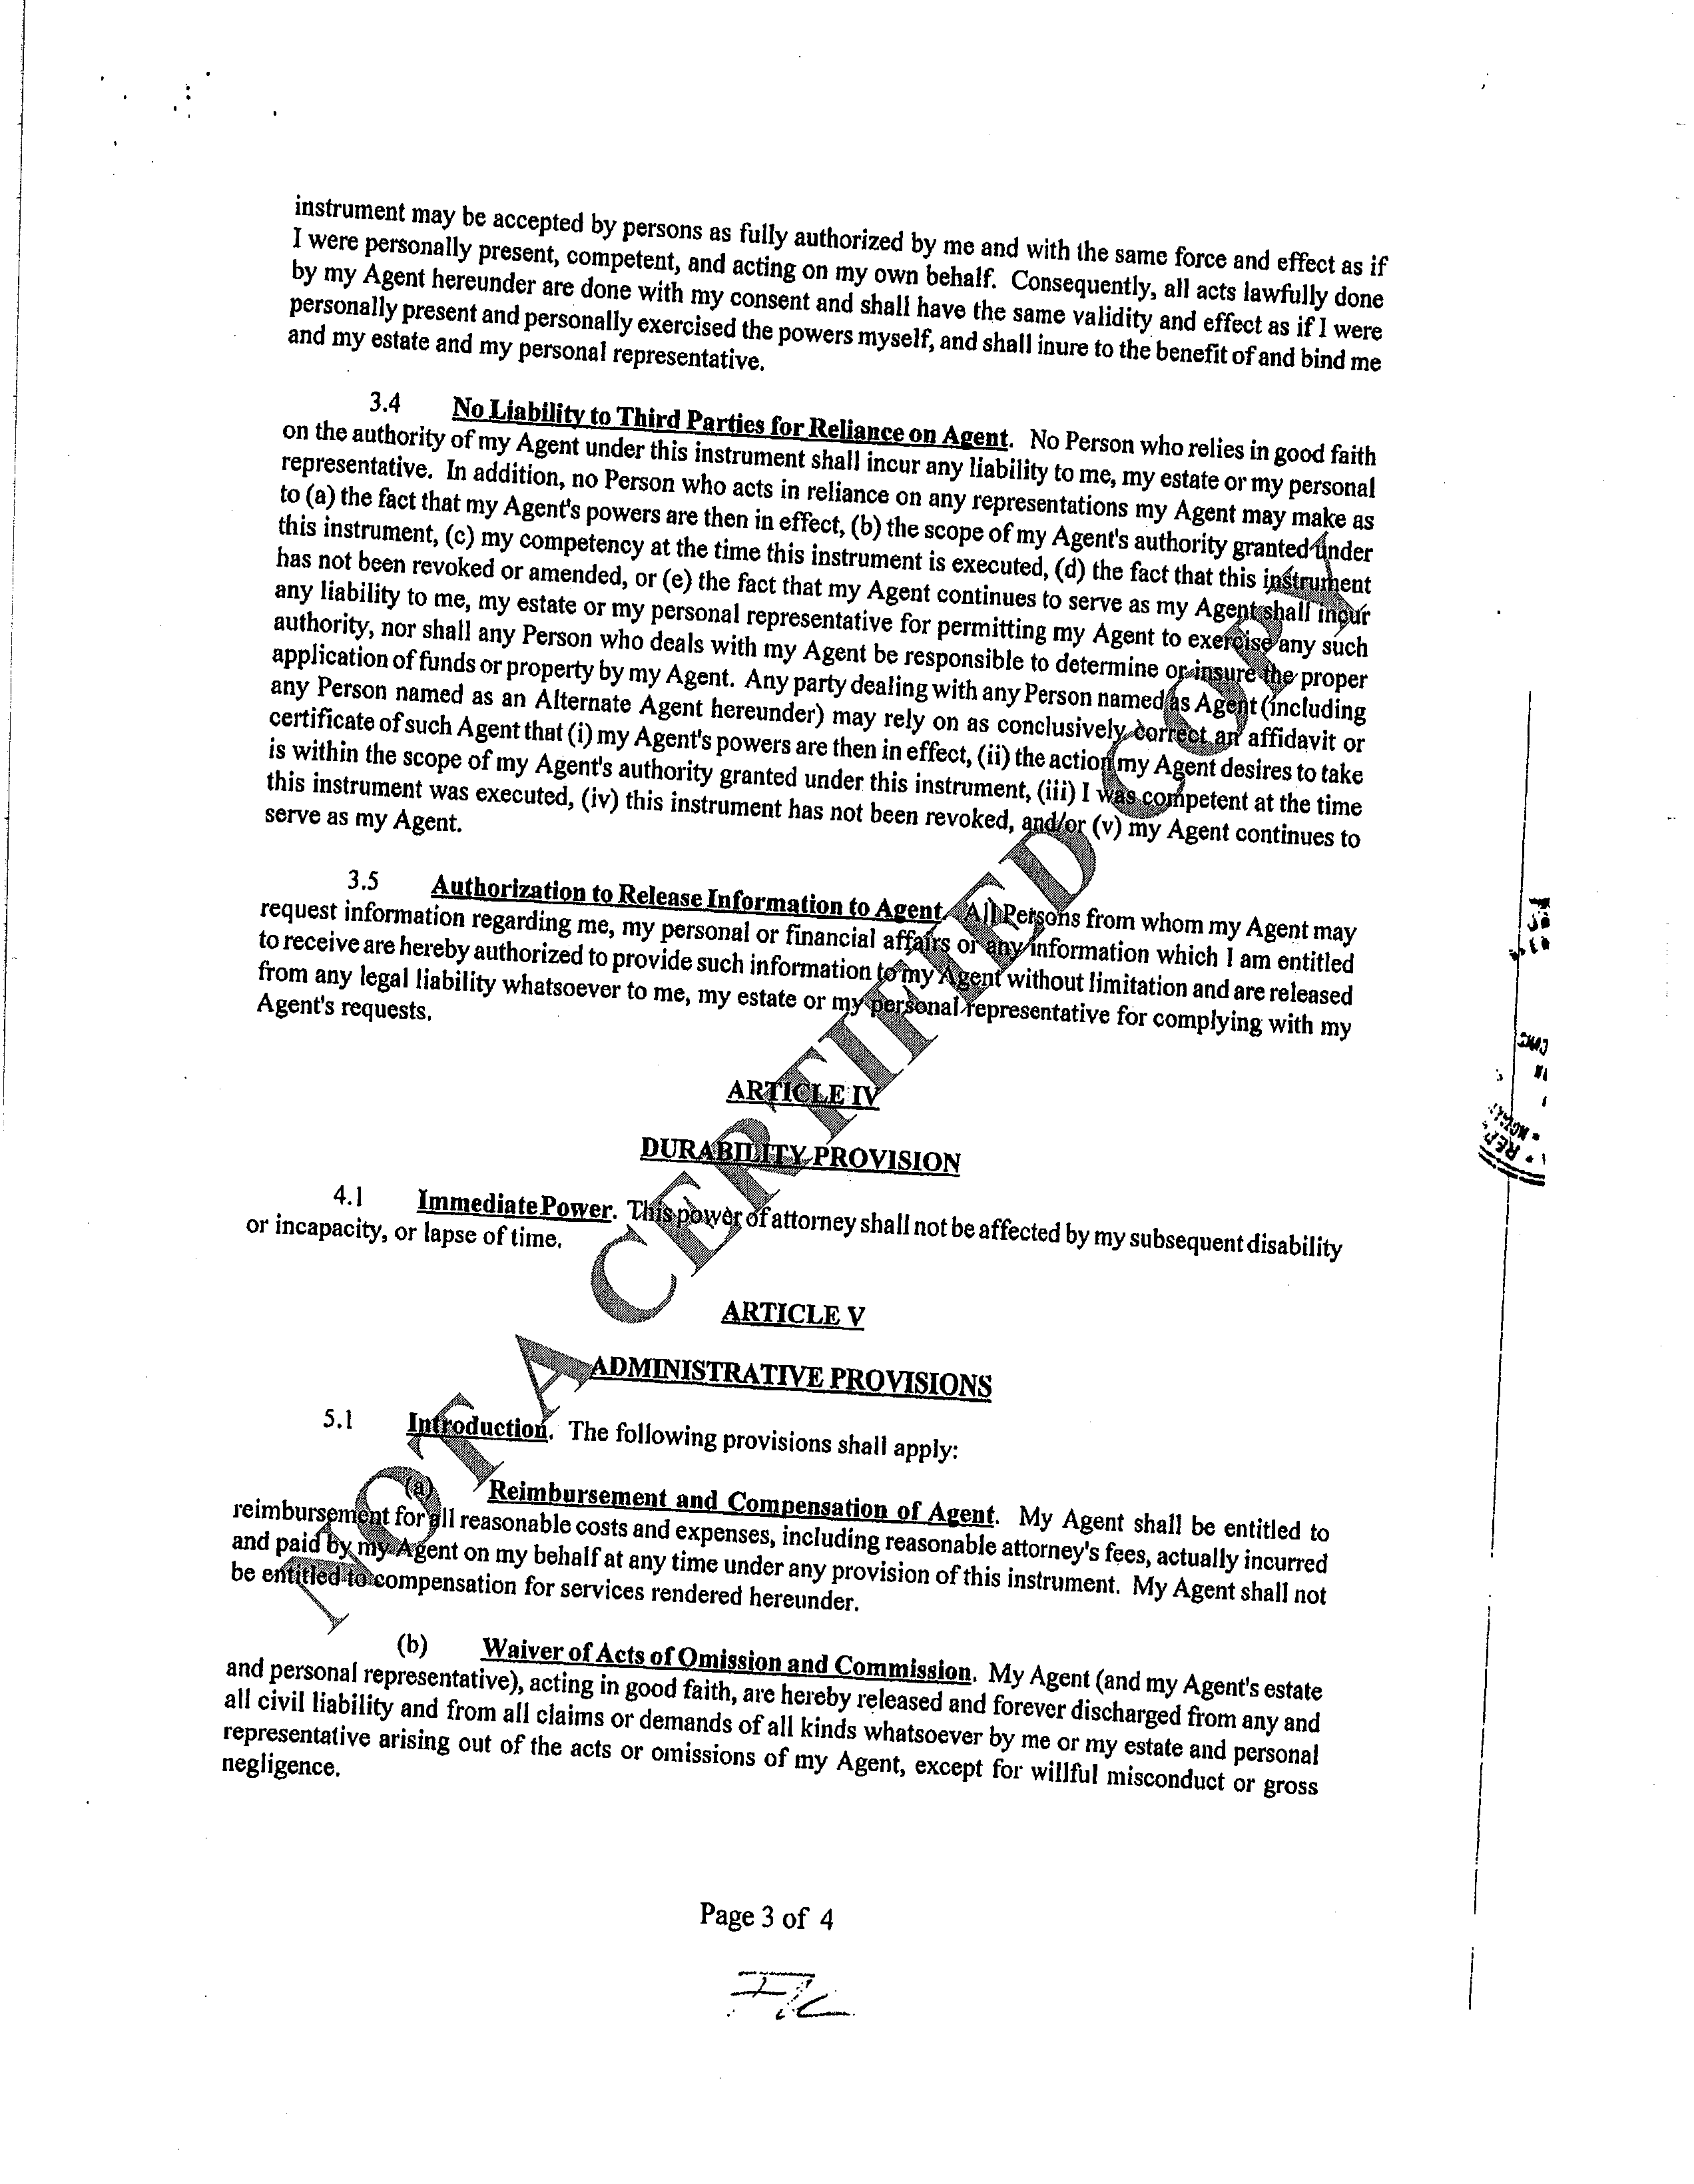

EXHIBIT A

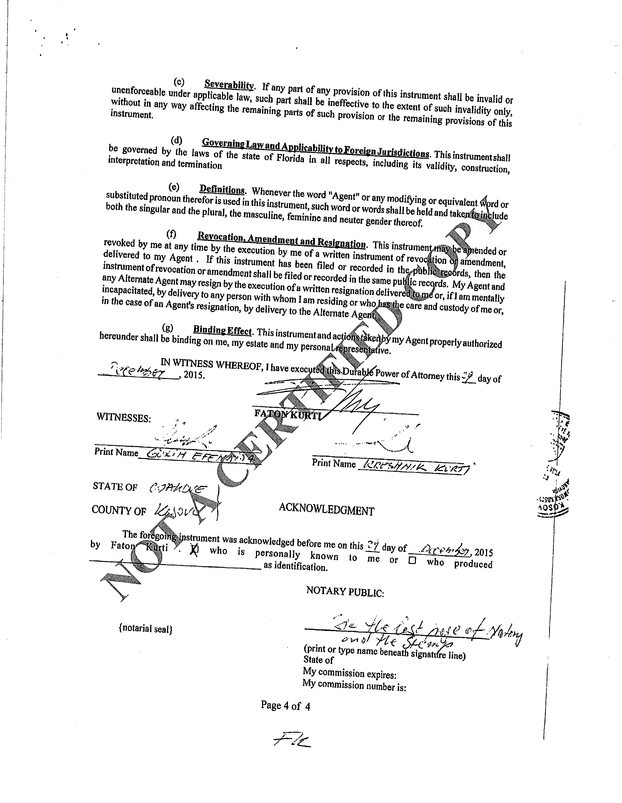

EXHIBIT A

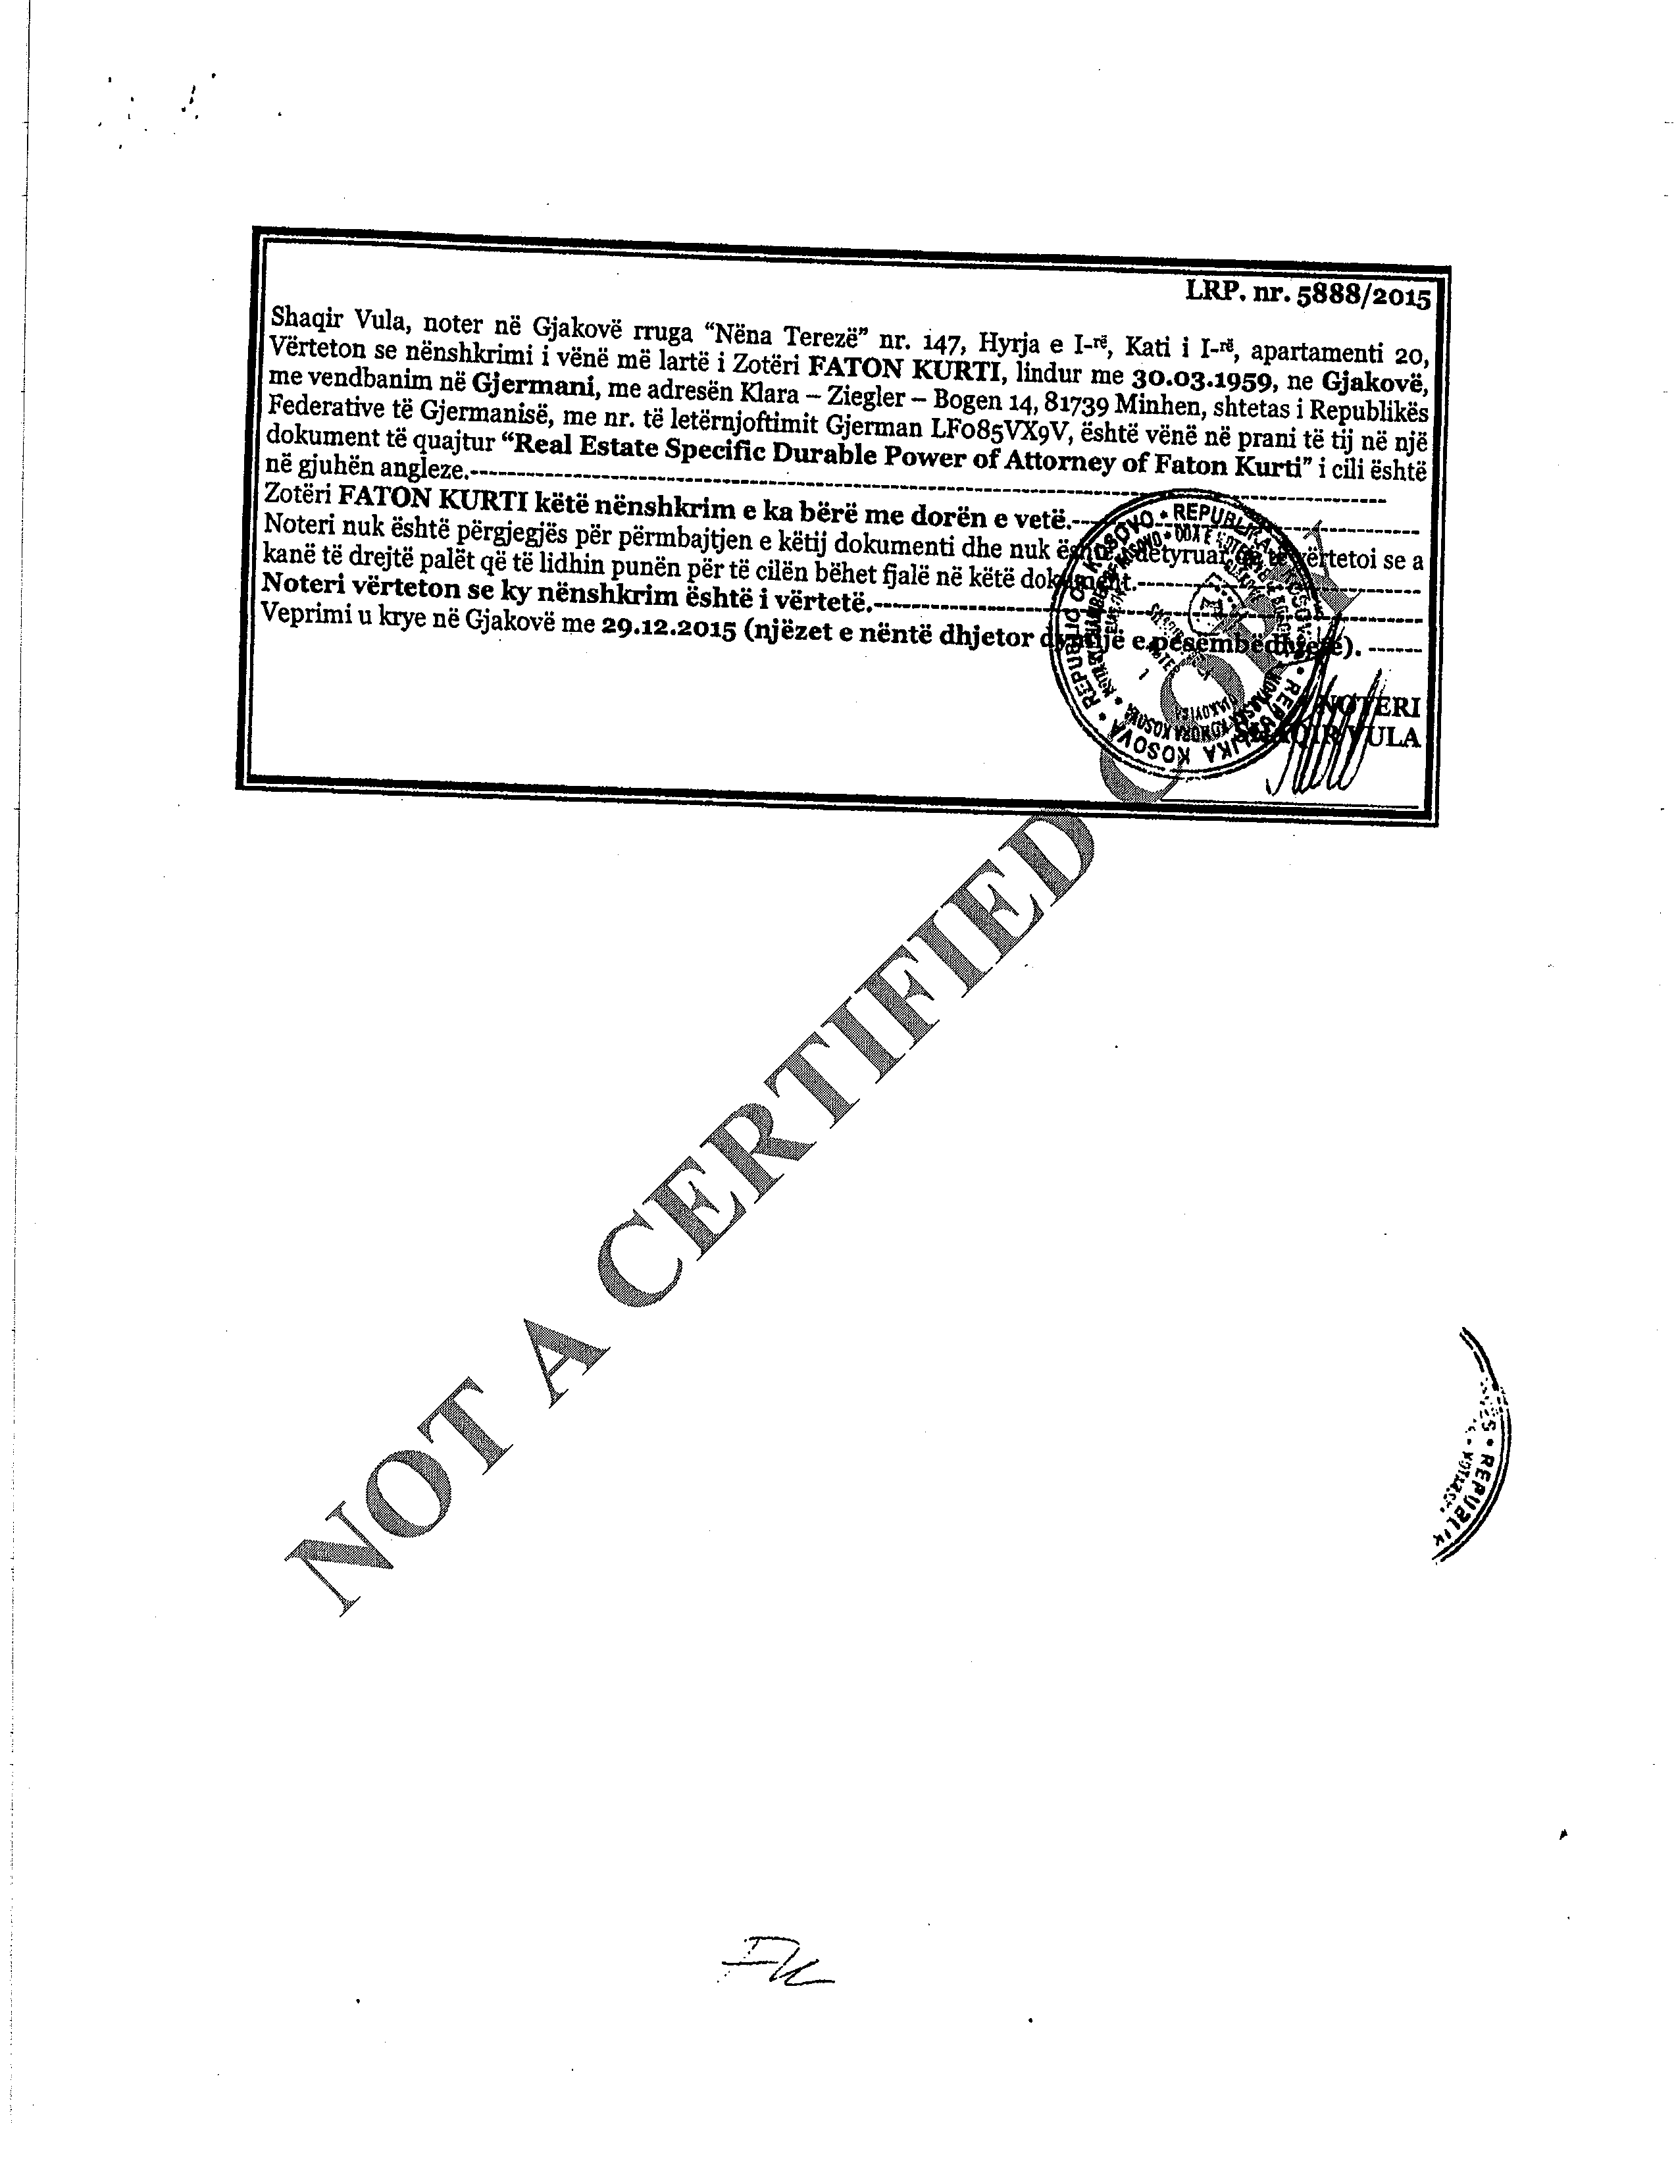

EXHIBIT A



EXHIBIT A

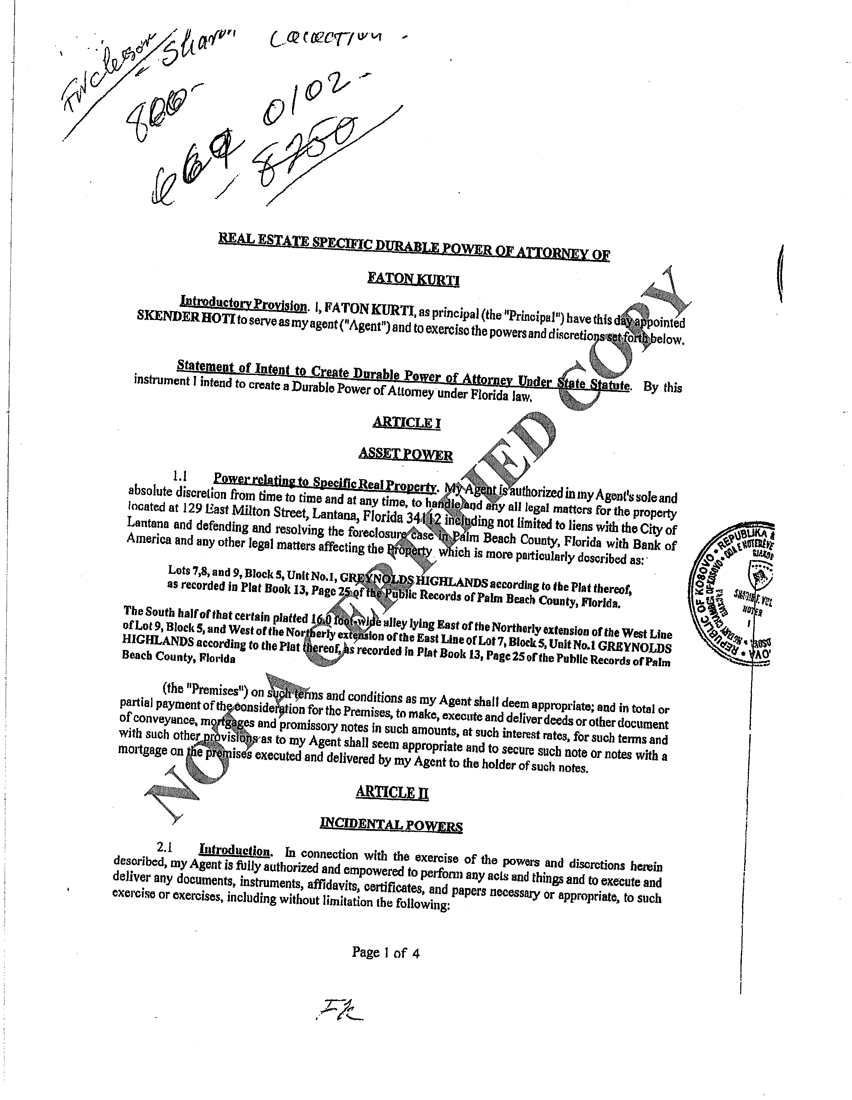

EXHIBIT A

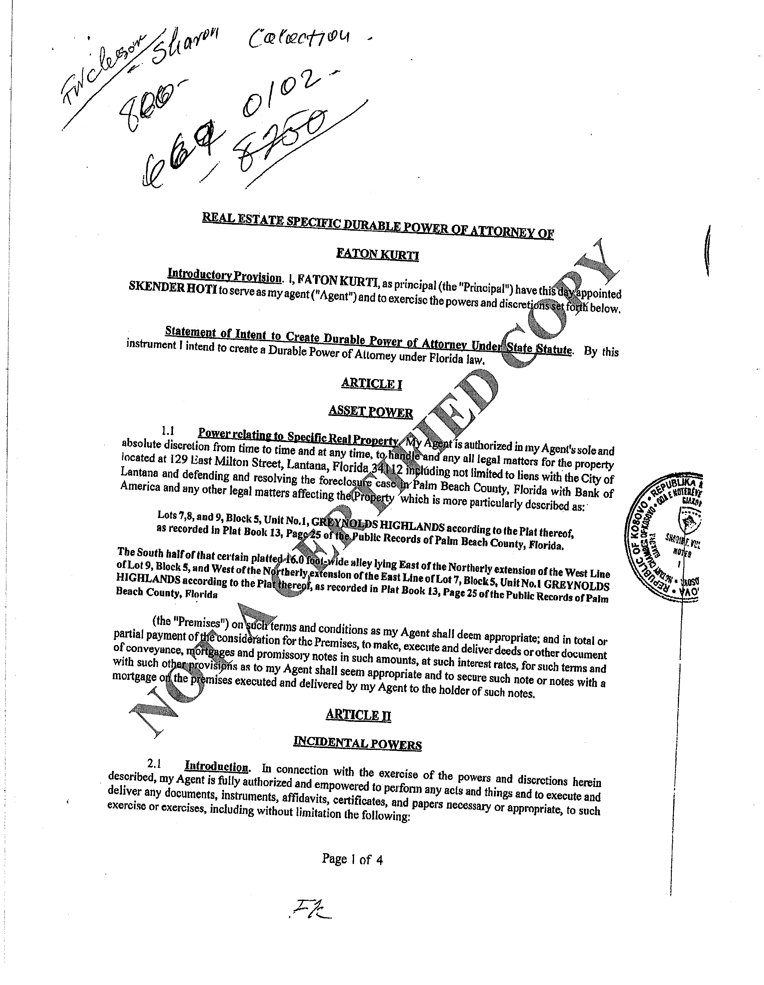

EXHIBIT A

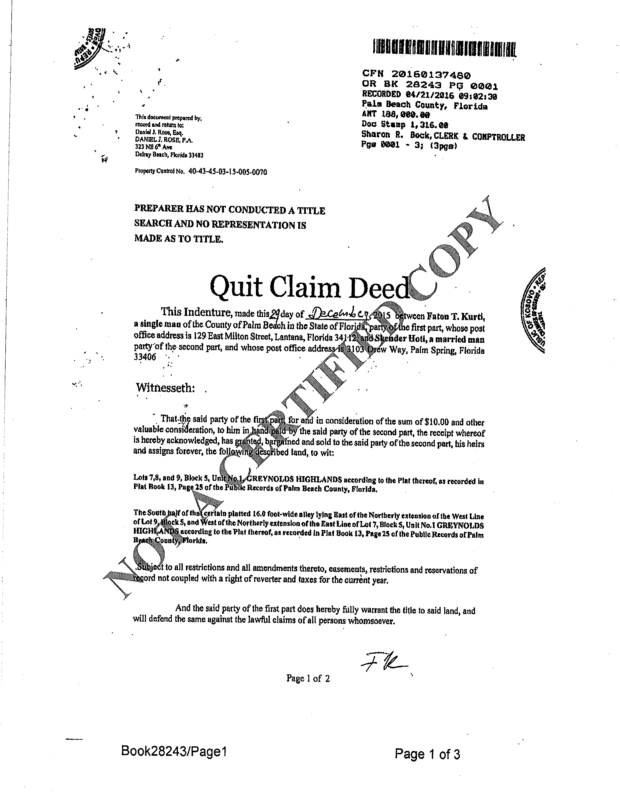

EXHIBIT A

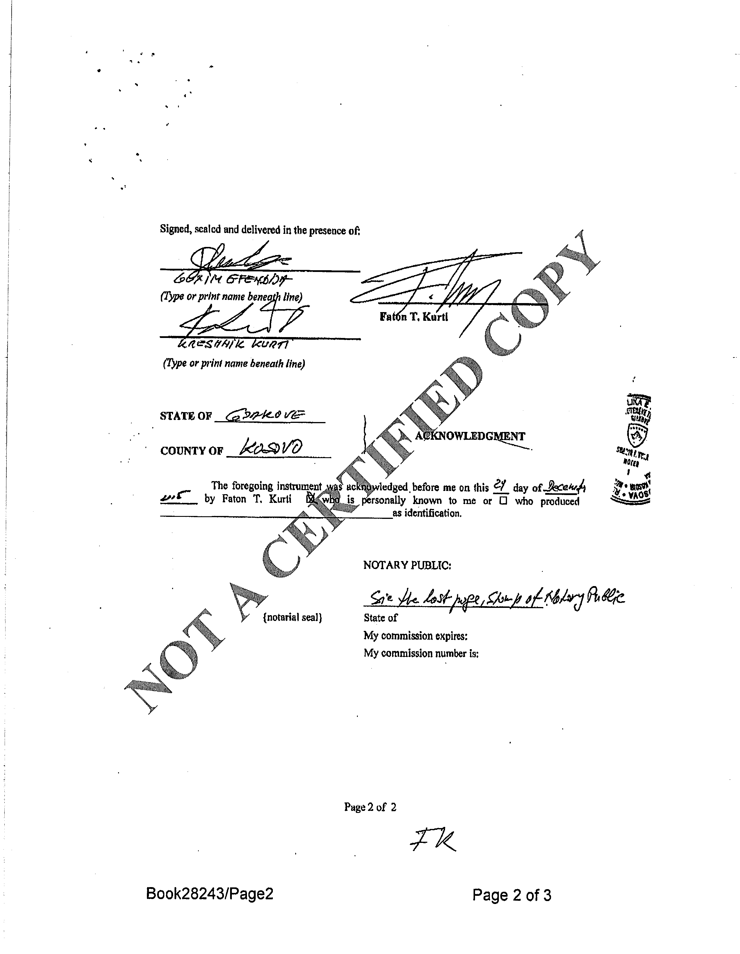

EXHIBIT A



EXHIBIT A

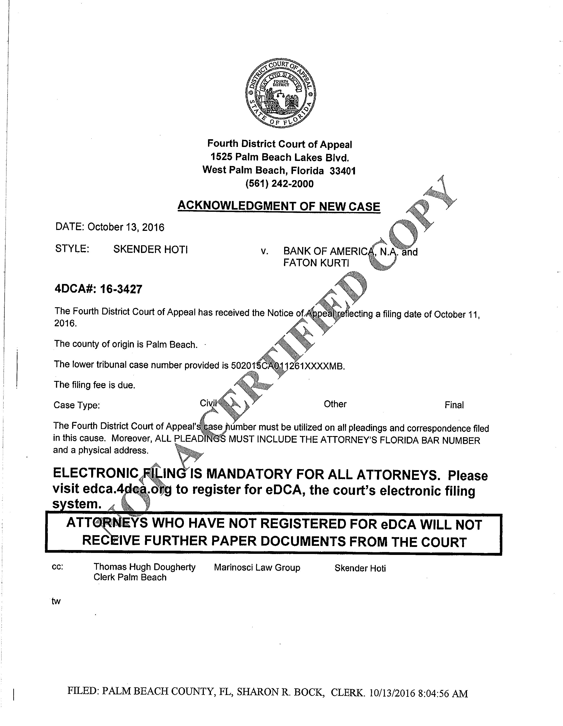

EXHIBIT A

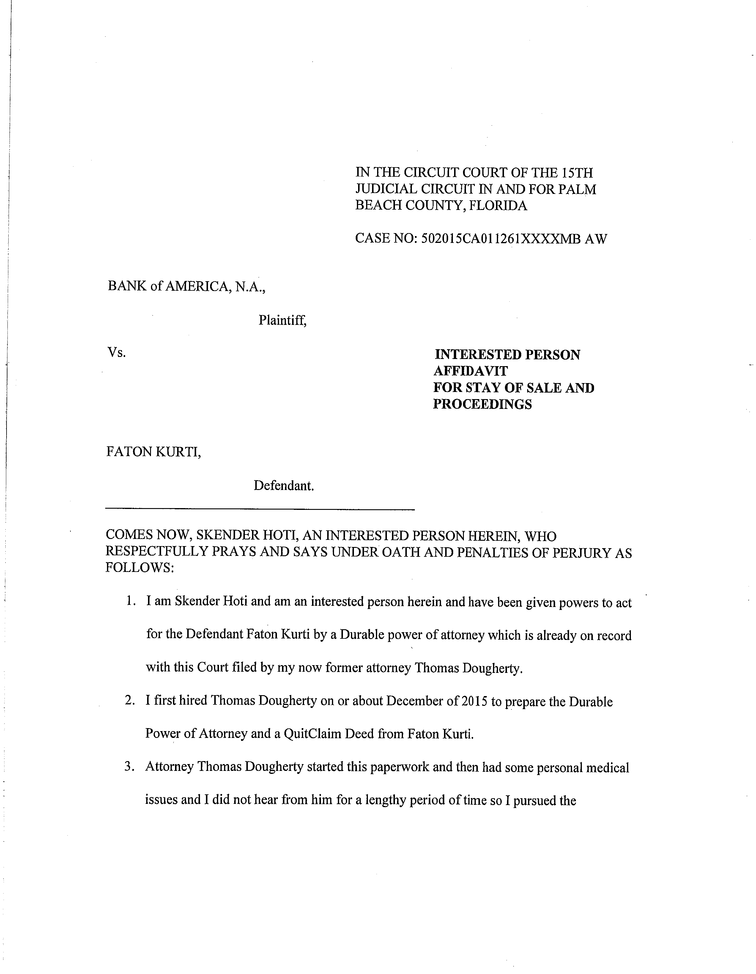

EXHIBIT B

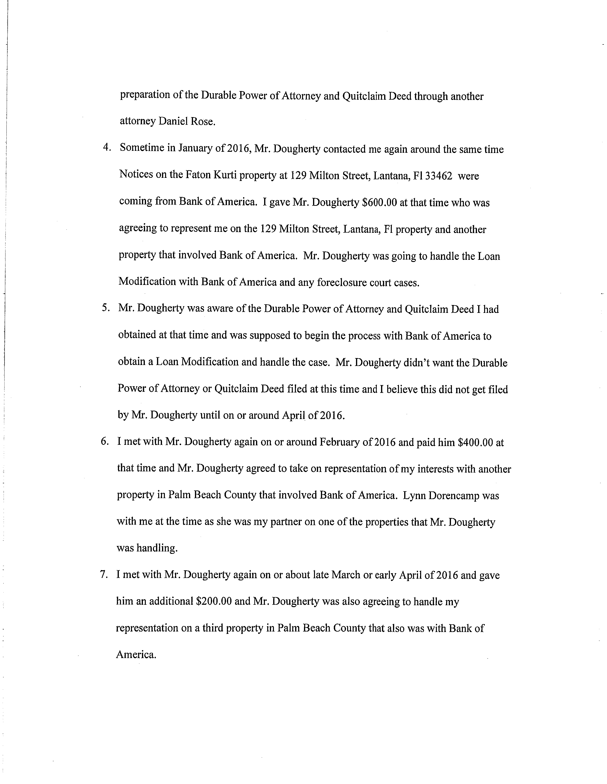

EXHIBIT B

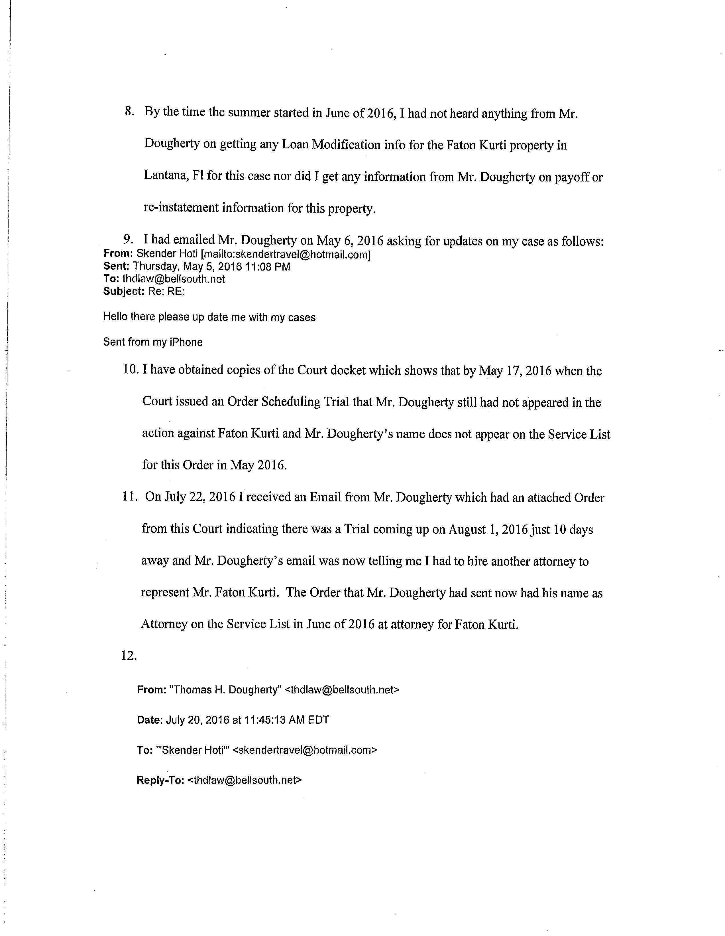

EXHIBIT B

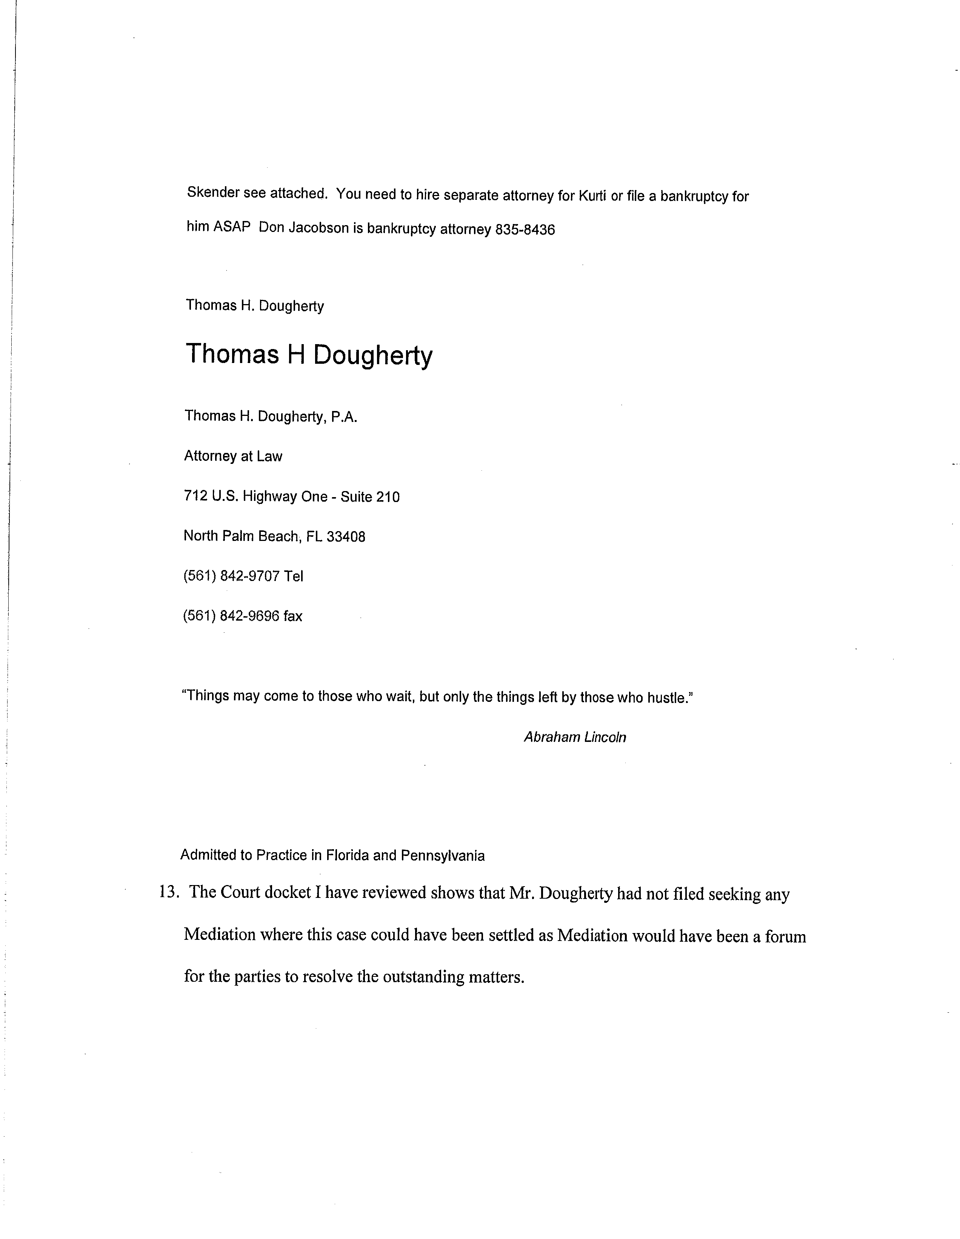

EXHIBIT B

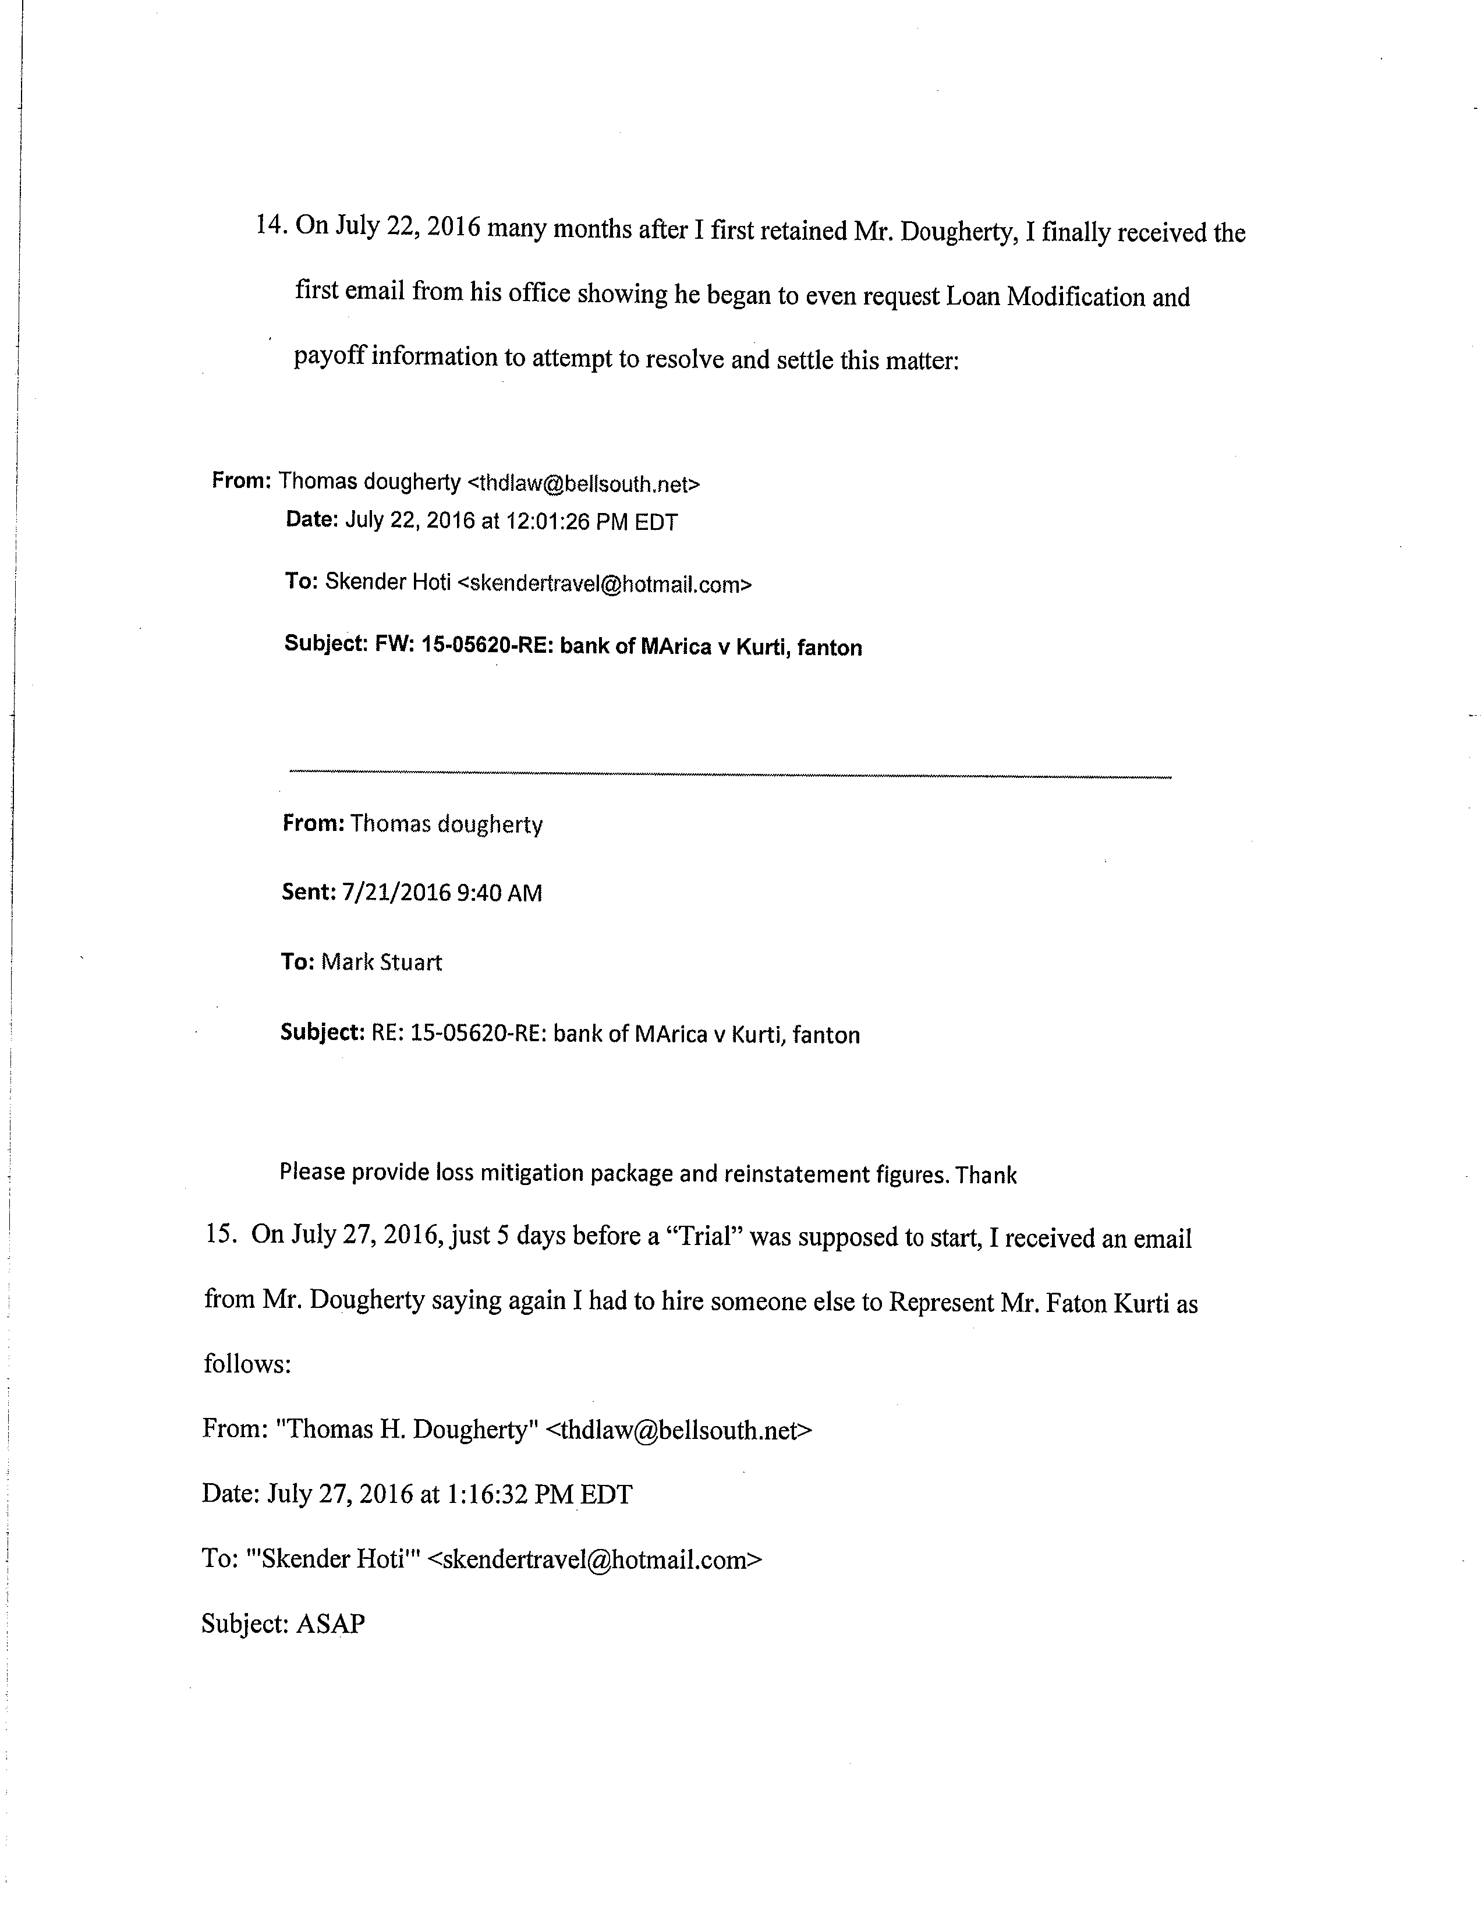

EXHIBIT B

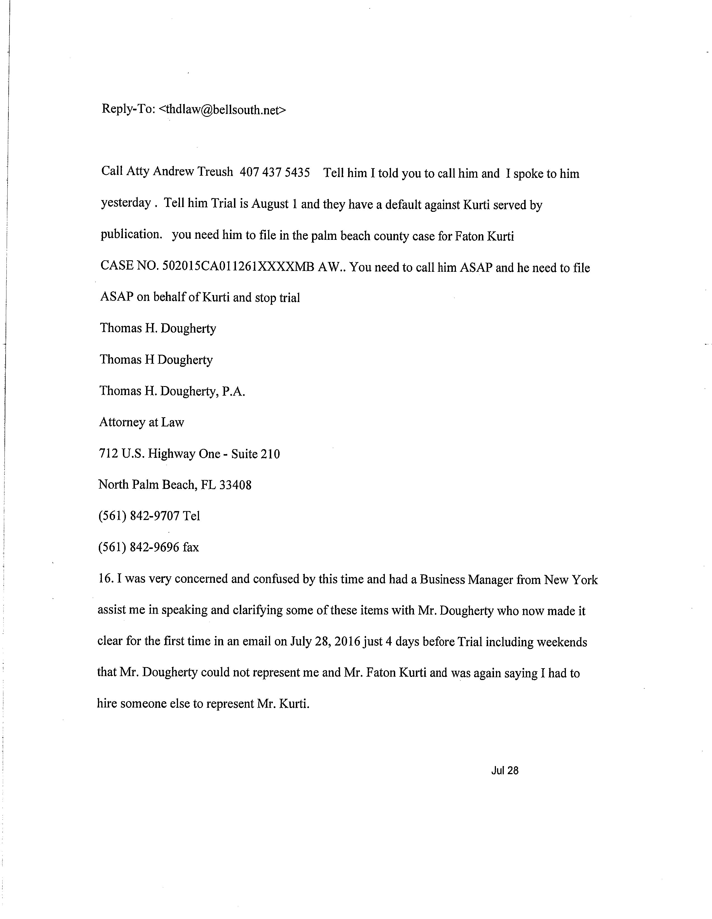

EXHIBIT B

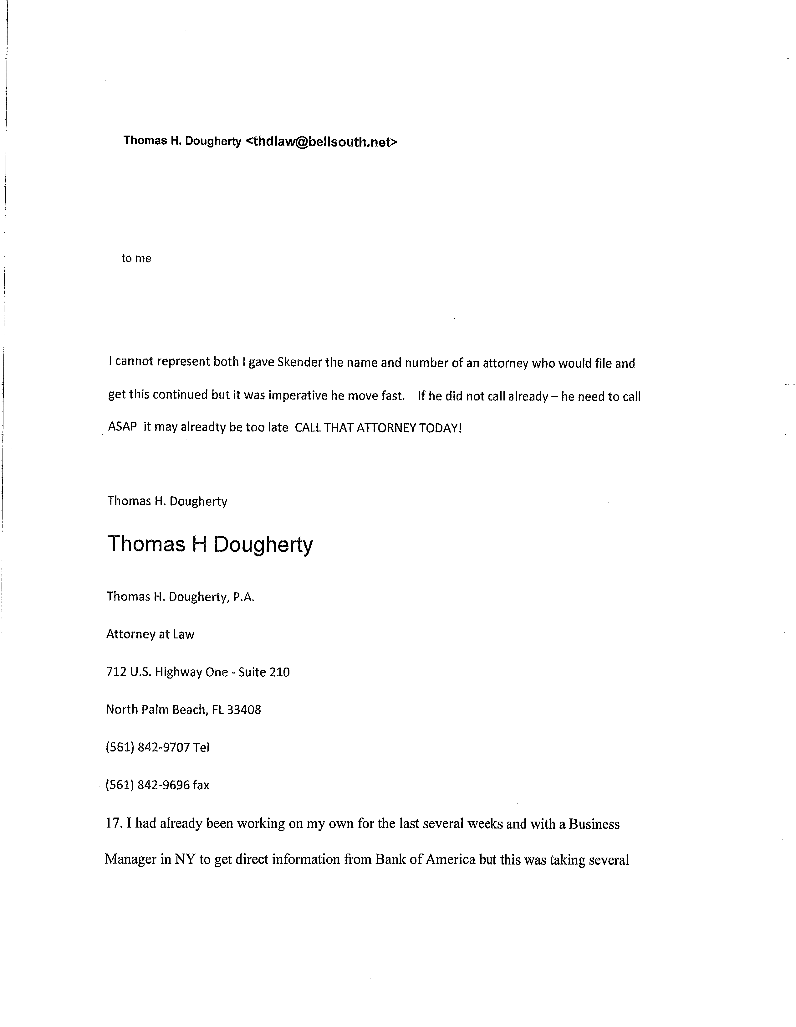

EXHIBIT B

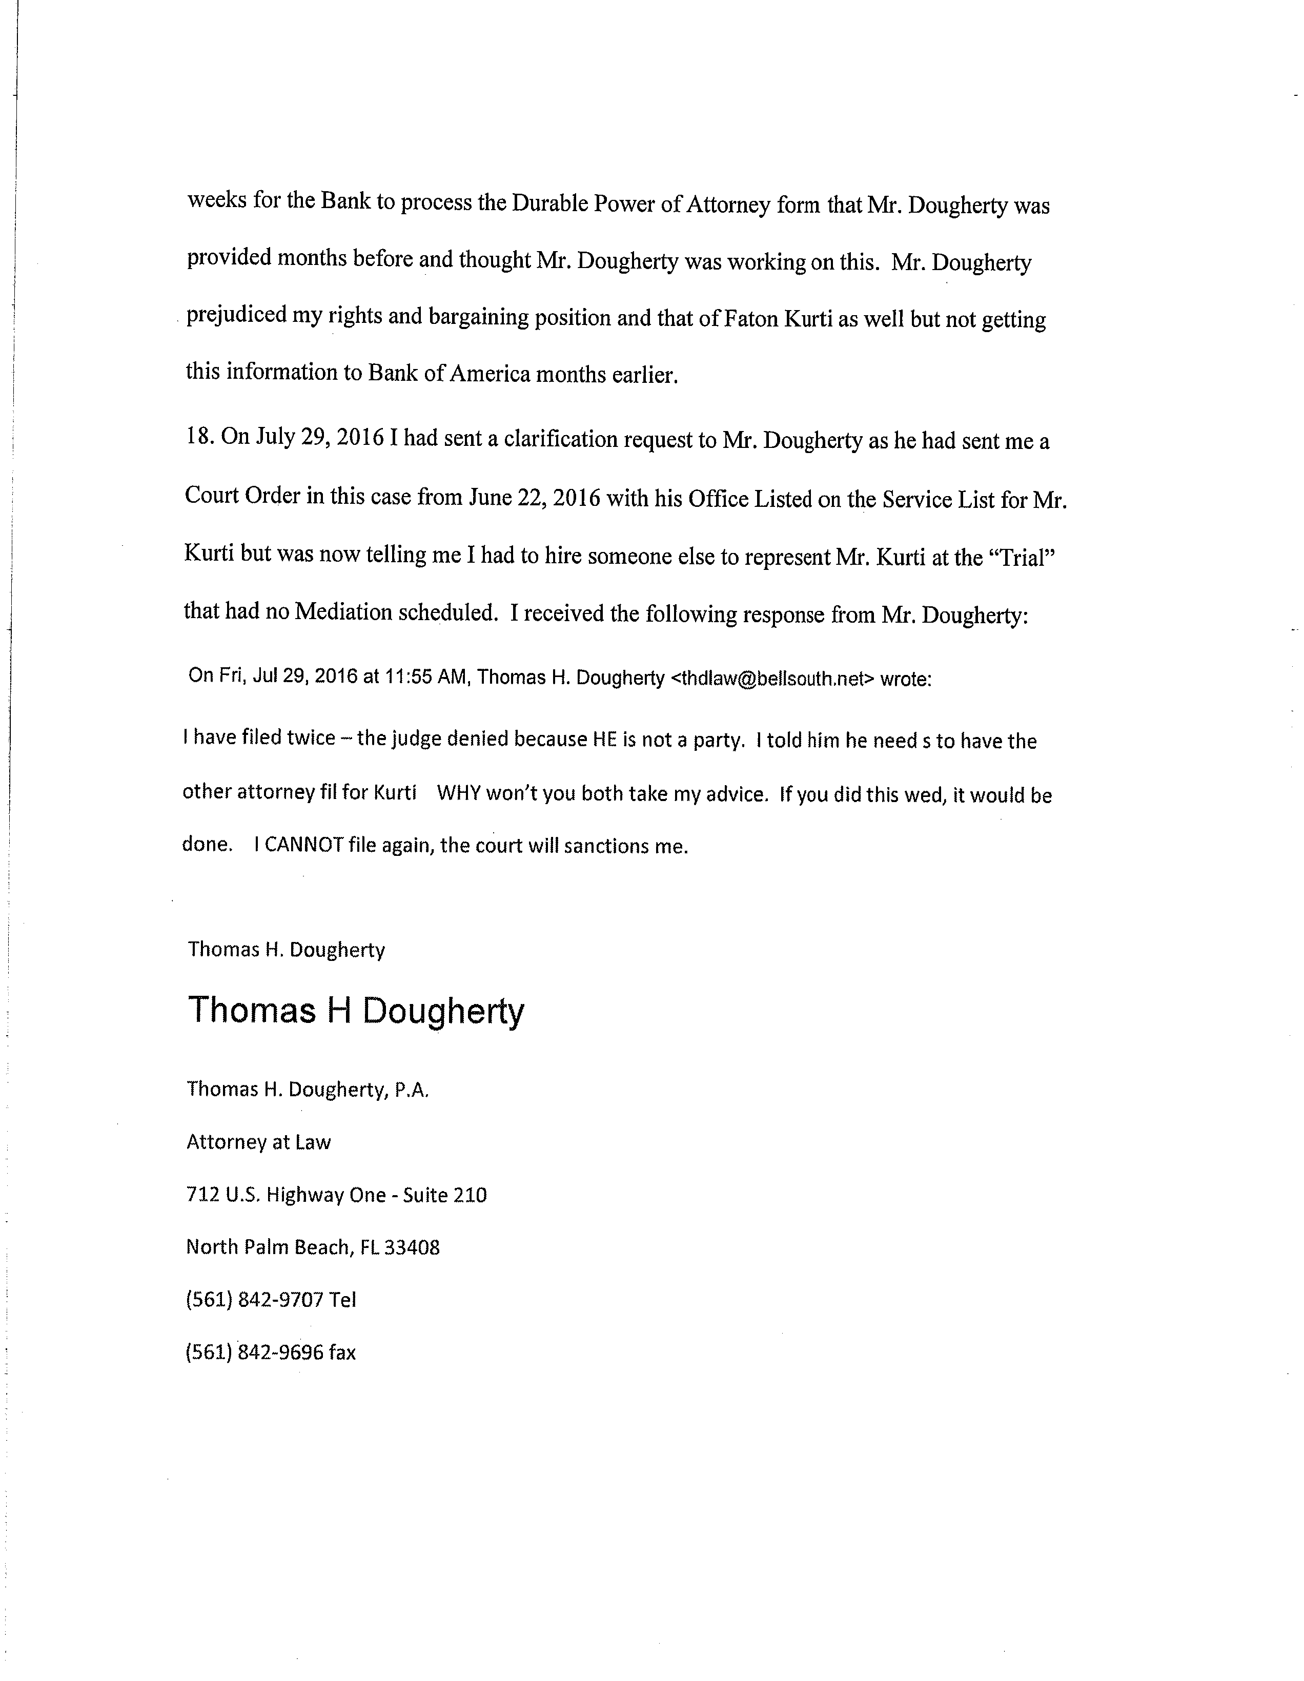

EXHIBIT B

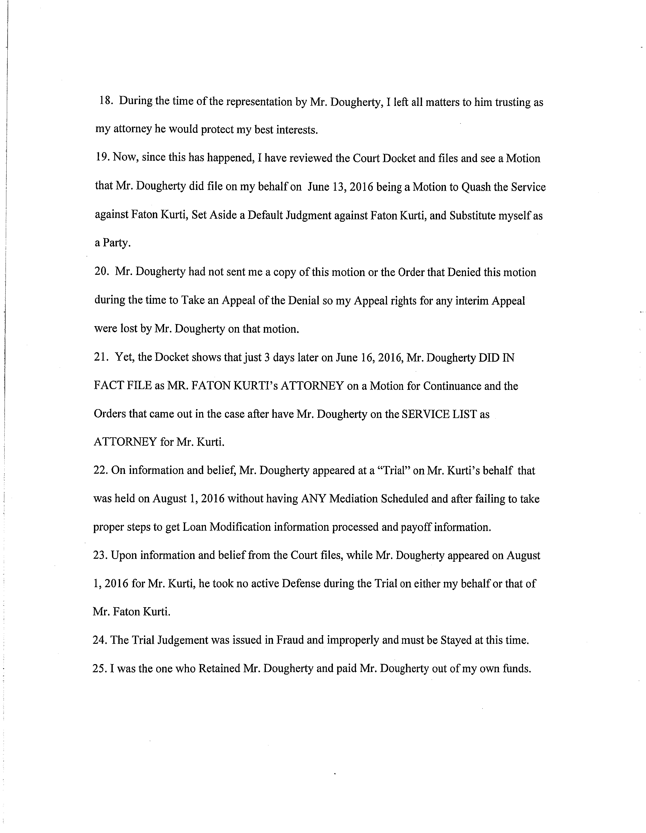

EXHIBIT B

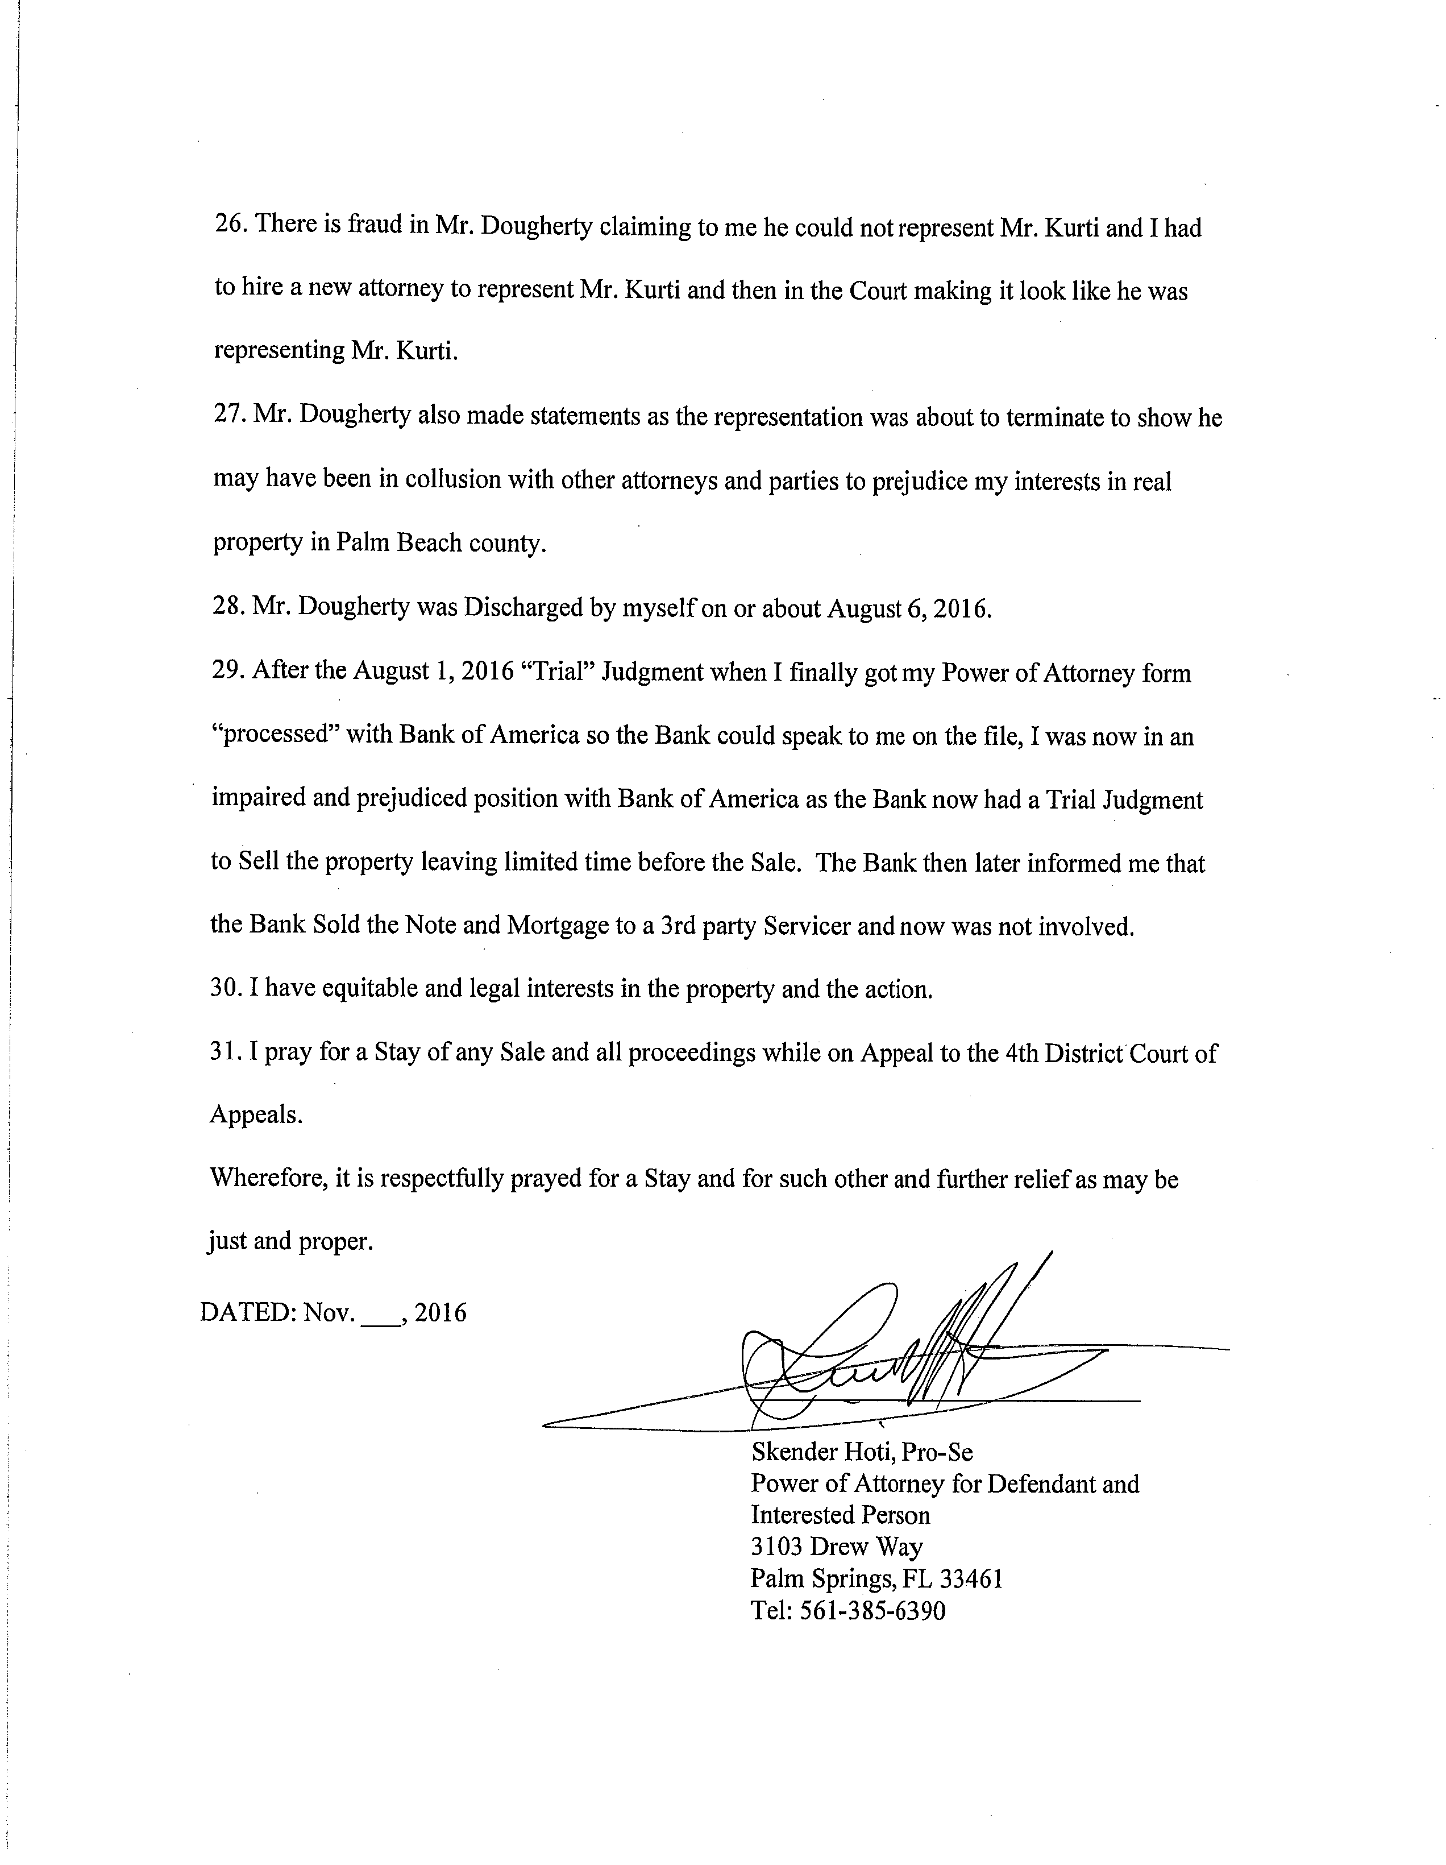

EXHIBIT B

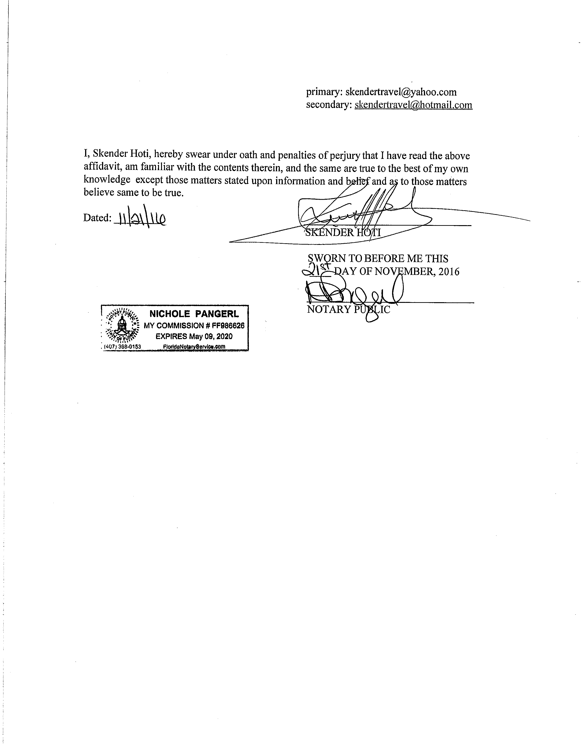

EXHIBIT B

