Filing # 44336938 E-Filed 07/22/2016 05:13: 16 PM

IN THE CIRCUIT COURT IN AND FOR THE 15rn JUDICIAL CIRCUIT IN AND FOR PALM BEACH COUNTY, FLORIDA

IN RE: ESTATE OF: PROBATE DIVISION

SIMON L. BERNSTEIN, FILE NO: 502012CP4391XXXXNB/IH

Deceased.

PETITION FOR AUTHORIZATION TO SELL ESTATE JEWELRY

BRIAN M. 0'CONNELL, as Successor Personal Representative of the Estate of SIMON

- BERNSTEIN ("Mr. O'Connell" or "Successor Personal Representative"), hereby files this Petition for Authorization to Sell Estate Jewelry ("Petition"), and as grounds, states:
  - On June 24, 2014, Mr. O'Connell was appointed as the Successor Personal Representative of the Estate of Simon L. Bernstein ("Estate" and "Decedent", respectively).
- On or about March 3, 2016, the Court entered an Order authorizing payment for an appraisal of the Estate's jewelry, attached hereto as Exhibit "A" (hereinafter "Appraisal" and "Jewelry," respectively).
- The fair market value of the Jewelry as stated on the Appraisal is $80,175.00.

- The Successor Personal Representative believes it is expedient, necessary and in the best interest of the Estate to sell the Jewelry.
- Accordingly, the Successor Personal Representative requests authorization to sell the Jewelry by a method to be established by the Successor Personal Representative.
- Prior to the sale of any Jewelry pursuant to the paragraph 5 above, the Successor Personal Representative agrees to provide the children of the Decedent, namely: Ted S. Bersnstein, Pamela B. Simon, Eliot Bernstein, Jill Iantoni and Lisa S. Friedstein, fourteen (14) days from entry of an order, on this Petition to state, in writing, which pieces they would like to purchase (purchase

In Re: Estate of Simon L. Bernstein File No: 502012CP004391XXXXSB/

price to be that listed on the Appraisal), by a method to be established by the Successor Personal Representative.
- The Personal Representative requests that any remaining items of jewelry not disposed of under paragraph 6, above, are to be sold by the Successor Personal Representative by a method to be established by Brian M. O'Connell, as Successor Personal Representative of the Estate.
WHEREFORE, the Successor Personal Representative respectfully requests the Court enter an Order granting the relief set forth above, and for his attorneys' fees and costs, and such other relief as the Court deems just and proper.
CERTIFICATE OF SERVICE

I HEREBY CERTIFY that a true and correct copy of the foregoing was furnished to counsel ofrecord via the Court's e-portal system or U.S. Postal Service on this ;rfl day of July, 2016 to the parties on the attached Service List.

By: /S/ Joielle A. Foglietta BRIAN M. O'CONNELL
Florida Bar No: 308471 ASHLEY CRISPIN ACK.AL
Florida Bar No: 037495 JOIELLE A. FOGLIETTA
Florida Bar No: 094238 ZACHARY M. ROTHMAN
Florida Bar No: 117924 Ciklin Lubitz & O'Connell 515 N. Flagler Dr., 20th Floor West Palm Beach, FL 33401
Tel: 561-832-5900; Fax: 561-833-4209
service@ciklinlubitz.com probateservice@ciklinlubitz.com

In Re: Estate of Simon L. Bernstein
File No: 502012CP004391XXXXSB/

SERVICE LIST

Alan B. Rose, Esq.  Page, Mrachek, Fitzgerald &  Rose, PA.  505 S. Flagler Dr., Suite 600 West Palm Beach, FL 33401 (561) 355-6991  arose@mrachek-law.com | John P. Morrissey, Esq. 330 Clematis St., Suite 213  West Palm Beach, FL 33401 john@jmorrissexlaw.com | Donald R. Tescher, Esq. Robert L. Spallina, Esq.  925 S. Federal Highway, Suite 500  Boca Raton, FL 33432 Dtescher@tescherlaw.com
 | Attorney for Molly Simon et al
 | Attorney for Molly Simon et al | ddustin@tescherlaw.com
mchandler@mrachek-law.com | Attorney for Molly Simon et al | rsgallina@teschersgallina.com
Attorney for Ted S. Bernstein | Attorney for Molly Simon et al | kmoran@teschersgallina.com
Peter Feaman, Esq. | Shendell & Pollock, P.L. | Max Friedstein
Peter M. Feaman, P.A. | 2700 N. Military Trail, suite | 2142 Churchill Lane
3695 Boynton Beach | 150 | Highland Park, IL 60035
Blvd.,Suite 9 | Boca Raton, FL 33431 | Beneficiary
Boynton Beach, FL 33436 | 241-2323 Fax: 241-2330 | Beneficiary
gfeaman@feamanlaw.com | Gary R. Shendell, Esq. | Beneficiary
 | gai:x@shendellwllock.com | Beneficiary
 | estella@shendellgollock.com | Beneficiary
 | grs@shendellgollock.com | Beneficiary
 | Kenneth S. Pollock, Esq.  ken@shendellgollock.com | Beneficiary
 | britt@shendellgollock.com | Beneficiary
 | grs@shendellpollock.com | Beneficiary
 | Matthew A. Tornincasa, Esq.  matt@shendellgollock.com | Beneficiary
 | robxne@shendellpollock.com | Beneficiary
 | grs@shendellpollock.com  Attorney for Tescher and Spallina | Beneficiary
Eliot Bernstein and Joshua, Jacob and Daniel Bernstein, Minors  c/o Eliot and Candice Bernstein, Parents and Natural Guardians  2753 N.W. 34111 St.  Boca Raton, FL 33434 iviewit@iviewit.tv | Pamela Beth Simon  950 N. Michigan Ave., Apt. 2603  Chicago, IL 60611 gsimon@stgcorp.com | Lisa Friedstein and Carley Friedstein, Minor  c/o Jeffrey and Lisa Friedstein Parent and Natural Guardian 2142 Churchill Lane  Highland Park, IL 60035 Lisa@friedsteins.com
 |  | Lisa.friedstein@gmail.com
 |  | Beneficiary
Jill Iantoni and
Julia Iantoni, a Minor
c/o Guy and Jill Iantoni, her Parents & Natural Guardians 2101 Magnolia Lane
Highland Park, IL 60035
iilliantoni@ Pmail.com

-PR@.
VIDEN­T

J E VJ
EXHIBIT
I A
j
E L R v

FAIR MARKET VALUE APPRAISAL
\

January 15,2016

Fair Market Value Appraisal of Mr. Simon Bmstein's Jewelry as requested by the Estate. ATIORNEY:
Clo Zachary Rothman, Ciklin Lubitz & O'Connell SIS N. Flagler Dr.
20111 Floor
West Palm Beach, FL 33401 Office: 561.820.0324
Fax: 561.833.4209

Dear Mr. Rothman,

At your request I examined the jewelry you submitted for valuation and have provided an opinion of the Fair Market Value. i

This report is valid only in its entirety and the fipal figure excludes any applicable taxes. You may wish to talce this into consideration when using the report. The value conclusions are subject to limiting conditions that are set forth in the body of the report. To the best of my knoledge arid experience, I estimate the FIFTEEN (IS) pieces presented on appraisals numbered 1-13 have a ttal Fair Market Value of$ 80,175.00

Photographs are included with the original repor,t for your reference. This report was prepared in accordance with the Uniform Standards of Professional Appraisal Practice (USPAP).
-tr°

Ifl can be of any further assistance, please call. \
Sincerely, 4. .
'
Stephanie L. Hardy G.J.G., (GIA)
Graduate Jeweler Gemologist, Jewelry Designer; and Appraiser
)

{
/:\....._ .. ··
1· .
' --W-H-t-P-•-lm--IH--c-h----------N-a-p-l --I i -----------------------------------------------------

Na;plH ll
Fort Myera Jupiter
Boca Allton

331 Clematis Street | S41 5th Avenue South | 768 5th Avenue South 15245 South Tamlami Tr |  | 828 W Indiantown Rd | 8221 Glad• Rd. #1-F
West Palm Beach, FL 33401 | Naples, FL 34102 | Naplesi FL 34102 | For! Myers, FL 33908 | Jupiter, FL 33458 | Boca Raton, FL 33434
581.833.7755 | 239.649. 7737 | 239.649.7200  ; | 239.274.7777 | 561.747.4449 | 561.488.7737

Table of Contents
- Letter of Transmittal
- Table of Contents
- Purpose
- Intended Use
- Definition of Fair Market Value
- Approach to Value
- Market
- Limiting Conditions
- Subscriptions Retained for Value Consulting
- Metal Markets
- Certification
- List of Laboratory Instruments
- Resume
- Item Descriptions .
- Gemsoft Appraisals as recorded in the Provident Point of Sale System

This report is valid only in its entirety and for its stated purpose and intended use and was prepared in accordance with the Uniform Standards of Professional Appraisal Practice (USPAP).
/
\.

Statementsi and Limiting Conditions
!
Purpose .
The purpose of this report is to describe and document the quality of the jewelry listed and to estimate the
Fair Market Value.

Intended Use .
The intended use of this repon is for providing an estate appraisal listing the Fair Market Value for use in the
resolution of The Estate of Simon Bernstein. .

Valuation Date: January 15, 2016

Definition of Fair Market Value
The fair market value is the price at which the property would change hands between a willing buyer and a willing seller, neither being under any compulsion to buy or sell and both having reasonable knowledge of relevant facts. The fair market value of a particular item of prorty is not to be determined by a forced sale price. Nor is the fair market value of an item of property to be detennned by the sale price of the item in a market other than that in which such item is most commonly sold to the p'\iblic, taking into account location of the item wherever appropriate. Taken from Treasury Regulation 20.2031-1 (b) '

(

2

Approach to Value .
There are three traditional approaches to value t:hat are as follows:

Income approach: Applies to income producing properties and is used only if an income situation or rental property can be identified. ·

Market Data approach: Compares the qualities f the subject item to an article with similar or identical qualities, and researches and records current verifiable sales Qf such merchandise.

Cost approach: Establishes the total value of an )item by considering the value of its component parts (precious metal content, gemstone weights and qualities, labor, and any other fees) together with the appropriate retail markup according to the nonns of the jewelers in the lo¢ale, supply and demand, and the current state of the marketplace.

Fair Market Valueis estimated usi,;,g the market data approach. Neither the income approach nor the cost approach applies in establishing Fair Market Value. However, tire cost approach to value was used to check o the market valuesfound.

Market
To value an item a market (and market level) mpst be recognized. The most appropriate market for jewelry can vary depending upon the article's age, condition, quality, intrinsic content, aesthetic appeal, provenance, current fashion trends, artistic interpretation, and period of manpfacture among others.

The type ofretail outlet that most commonly caP"ies the items being appraised is considered to be the most appropriate market. However, the auction maret was also considered as another appropriate market in establishing Fair Market Value for this type ofjewelry.

Limiting Conditions
The jewelry described within has been analyzed and graded in accordance with prescribed grading standards using "state of the art" methods and precision Jaboratqry equipment.

Jewelry constructed solely of, or in combination with, precious metals (i.e. platinum, palladium, yellow or white gold and/or silver) is tested, analyzed and described for its type and content of such metal. Unless otherwise stated, all gemstone weights, grades and measurement are approximate and stones have not been removed from their mountings. !

Diamonds are graded with the prescribed grading nomenclature of the Gemological Institute of America (GIA).

Colored stones are color graded with the use of e GIA Gem Set color grading system. Unless otherwise stated, all colored stones listed on this appraisal report have probably been subjected to various treatments to improve their appearance. Treatments are considered usual and customary practices when properly disclosed and when done without intent to defraud the consumer. The tretments are mostly stable and do not require special care. When a treatment is detected and considered unusual it be so noted by this appraiser. Some treatments are reversible and re-treatable. lt may be beyond the scope ot1an appraisal to determine exact treatment methods or the amount of treatment present. Some treatments require sopisticated equipment not found in a standard gemological laboratory. Prevailing market values are based on these uniyersolly practiced and accepted processes by the gems and jewelry
will
trade. !

3

Stones which are not described in detail have no significant value.

Sources are assumed to be reliable and the appqtiser does not assume responsibility for their information.
j
The appraiser assumes the ownership of the suject propeny is true as stated by the client.

The fees paid for this appraisal do not include te services of the appraiser for any other matter. In particular, fees paid to date do not include any of the appraiser· time or services in connection with any statement, testimony or other matters before an insurance company, its agents, employees or any court or other body in connection with the property herein described. ·

If the appraiser is required to testify or to make!any statements to a third party concerning the described property and/or appraisal, the applicant shall pay the appraiser for all of such time and services so rendered.

This document is limited to its stated intended yse and is invalid if all items listed in the Table of Contents are not present.

Unless expressly stated, the items appraised ar in good condition. Any serious deficiencies and repairs are noted. Ordinary wear and tear is not noted. ·

The information in this report is confidential.
(

This appraisal process does not discover liens, encumbrances, or fractional interests but, if known, they are noted. The limited owner of this appraisal is the partyjfor whom the work was performed.
Possession of this report does not provide title to the items appraised.

Possession of this report, any portion of this reort, or any copy thereof, does not include the right of publication without the appraiser's written consent. ·

Each item described in this report has been phqtographed and file copies of the photograph(s) as well as a copy of the report are maintained in the appraiser's file for at least five years after the report date.

Third parties may rely on the infonnation in this report for the defined purpose and intended use only. Third parties requiring further information than what is in th,1e report must obtain the written permission of the owner of the appraisal before the appraiser will discuss the epon.

No changes may be made to this report by anypne other than the appraiser. The appraiser cannot be responsible for unauthorized alterations. '

The professional relationship between the appraiser and the client ends with the delivery of this report or at the
conclusion of the settlement. '

4

Subscriptions and Sources Retained for Yalu Consulting Rapaport, Martin - Rapaport Diamond Report, New York, NY KitCo.com ·
Ebay.com JomaShop.com Tradesy.com
DirectAuction.HiBid.com
The Diamond and Gemstone Book, Stuller v. 6

Metal Market
Gold Silver Platinum

01/1512016
s 1,089.80
s 14.01
s 833.00

List of Laboratory Instruments
Binocular microscope
Loupe Electronic scale
Touchstone and acids Fiber optic light Spectrascope Polariscope
GIA Gem Set color grading system

Leveridge gauge
Thennal conductivity diamond tester
Ultraviolet light unit Electronic metals tester Dichroscope Refractometer Meleemeter

5

STEPHANIE!L. HARDY G.J.G., GIA
PROVIDENT JEWELRY
!331 CLEMATIS ST. WEST PALM BEACH, FL 3340 I
: W: 561-833-7755
. C: 561-215-7321
\ FAX: 561-833-8763
EMAIL: STEPHANIE PROVlDENT@HOTMAI L.COM

PROFESSIONAL: RESPONSIB(LITIES INCLUDE, BUT HAVE NOT BEEN LIMITED TO:
PROVIDENT J EWELRY WEST PALM BEACH, FL
GEMOLOGIST, APPRAISER AND DESIGNER
Retail and Wholesale Sales, Appraisal . Purchasing, Inventory Control, Stone Identification and Grading, Custom Jewelry Design,iJewelry Display and Merchandising, Photography of Fine Jewelry, Exhibit and Sell at Trad Shows.

LlTTLE SWITZERLAND BOCA RATON, FL,
SUNRISE, FL
. & KETCHIKAN, AK
SALES TRAINER, SPECIAL f ROJECTS AND SENIOR MANAGER
Train Sales Staff on Location, Compoe Sales Training Manual, and Establish Sales Training Program, Compile a Manual of Product Overvies, Customer Service
Open and Close a Seasonal Store in A\aska, Bring a Retail Store to Maximum Efficiency in Florida,
I' Maintain Budget and Reach Sales Goa;ls. Train and Educate Sales Staff, Close Sales of Luxury Goods and
I Fine Jewelry, Appraisals, Customer Srvice, Scheduling, Inventory Control, Merchandising. Establish Online Store and Marketing Strategy. i

DIAMONDS INTERNATIONAL &i TANZAN I T E NTERNATIONAL ; SENIOR MANAGER . .
JUNEAU, AK
& ST. THOMAS USVI

Oversee Operations of High Volume J4uxury Jewelry Stores in Vacation Destinations, Fine Jewelry Sales, Appraisals, Conduct Training Semin, Maintain Control of Inventory, Hire Sales Staff

EXCALIBUR BY KURT ROTH NER LOS ANGELES, CA
GEMOLOGIST \
Identify and Grade Stones, Appraise, Buy and Sell Estate and Period Jewelry and Vintage Watches, Customer Service to Celebrity Clientele, Exhibit, Buy and Sell at Trade Shows, Inventory Control, Establish Website and List Items ;

EDUCATION:
GEMOLOGICAL INSTITUTE OF AMERICA 1995 GRADUATE JEWELER, GRADYATE GEMOLOGlST, JEWELRY DESIGN

INDIANA UNIVERSITY OF PENNSYLVANIA 1994
B.S. GEOLOGY, BUSINESS MANAGEMENT MINOR
ASSOCIATIONS: ;
Gemological Institute of America Alupmi Association, Cambridge Who's Who, MJSA, Women's Jewelry Association, Association for the Study of Jewelry and the Related Arts,

American Society of Jewelry Historia s, Appraisers International Society, USPAP 15 Hour Course

6

Certification
I hereby certify that, to the best of my knowl1ge and belief
- The statements of fact contained in this report \are true and correct.
+ The reported analyses, opinions, and conclusions are limited only by the reported assumptions and limiting conditions,
and are my unbiased professional analysis, opinions, and conclusions.
- I have no present or prospective interest in th property that is the subject of this report and I have no personal interest or bias with respect to the parties involved. ·
- My compensation is not contingent upon the evelopment or reporting of a predetermined value or direction in value that favors the cause of my client, the amoUnt of the value estimate, the attainment of a stipulated result or the occurrence of a subsequent event. ·
- I have made a personal inspection of the proP<irty that is the subject of this report.
- No one provided significant professional assistance to the person signing this report.
- My analyses, opinions, and conclusions were developed. and this report has been prepared, in confonnity with the Uniform Standards of Professional Appraisal fractice.

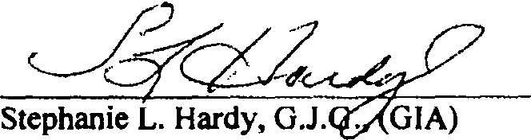

Graduate Jeweler Gemologist, Jewelry Designer; and Appraiser Provident Jewelry
01/15/2016

7

/
Prepared For: The Estate of Simon Bernstein Date: 01/15/2016

I . One Semi-Mount Diamond Ripg set in platinum. The ring is engraved "David S...."* The ring features two (2) prong-set round brilliant cut diamonds which average 1-J color, VS2-Si I clarity and are approximately Oi.97 carats total weight. The ring weighs 6.1 DWT (9.5 grams.) ·
FMV = $ 1.800.00
•The hand engraved signature of the jeweler who made the ring is not legible.
i

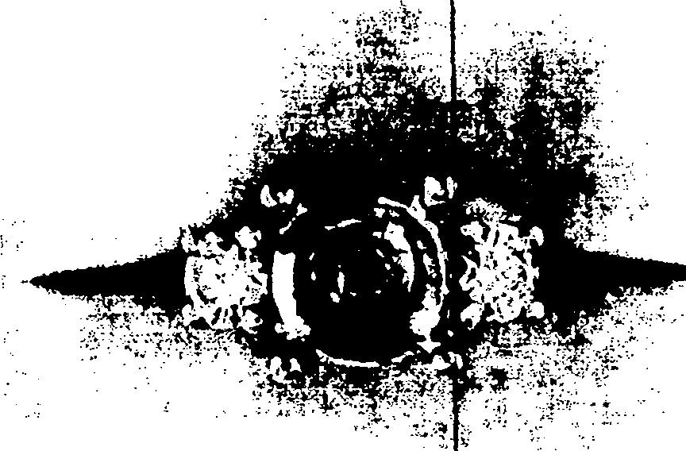
... ;;--: ;
....:·.,
.: ·: ··-- --··...........c.. •.•• • - - ·--· • ' •

  - One Loose Rou nd Brilliant Cut Diamond which weighs 4.77 carats. The diamond measures approximately I 0.58-10.72 x 6i60mm and is approximately K-L color, Sl1-Sf2 clarity. FMV = $ 30,750.00* )
    - 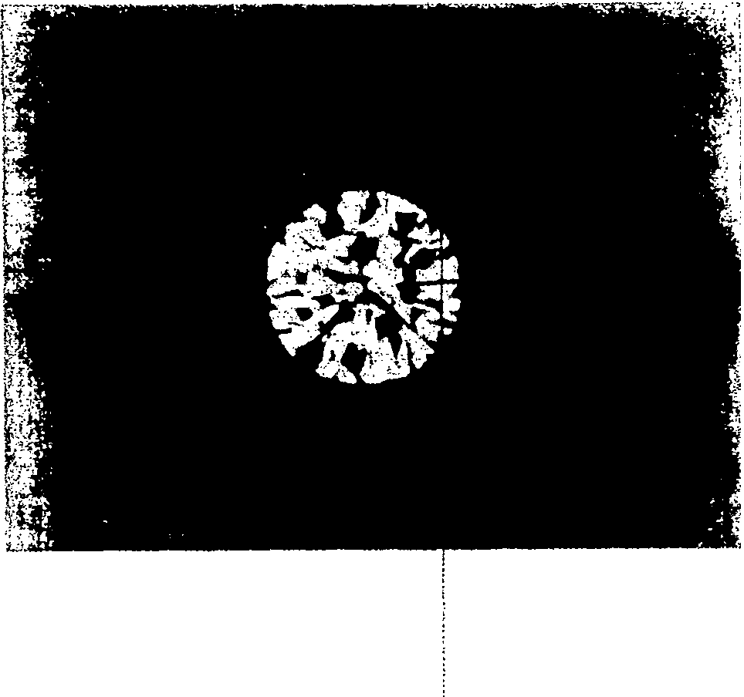The diamond is significantly abraded on the pavilion and will have to be re-cut. The process of re-cutting will decrease the weight of the diamond. 'Ilhc Fair Markel Val ue reflects the loss of weight and the cost of re-cutting.

8

  - One Semi-Mount Diamond Ritjg set in platinum. The ring features two (2) prong-set triangular brilliant cut diamoncls which average 1-J color, VS I -SI I clarity and are approximately 1.59 carats totaf weight. The ring weighs 5.0 DWT (7.8 grams.)
FMV = $ 3,700.00 .

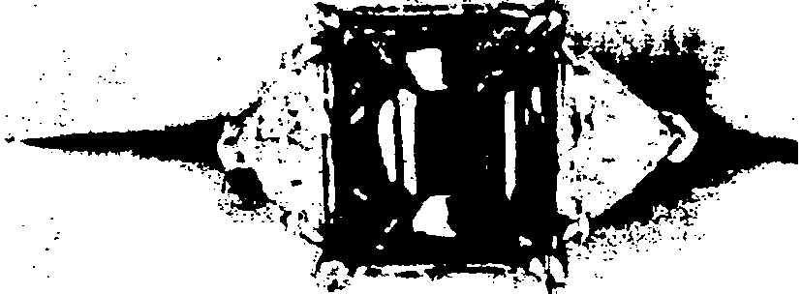
. ·.··,,··;_···

  - 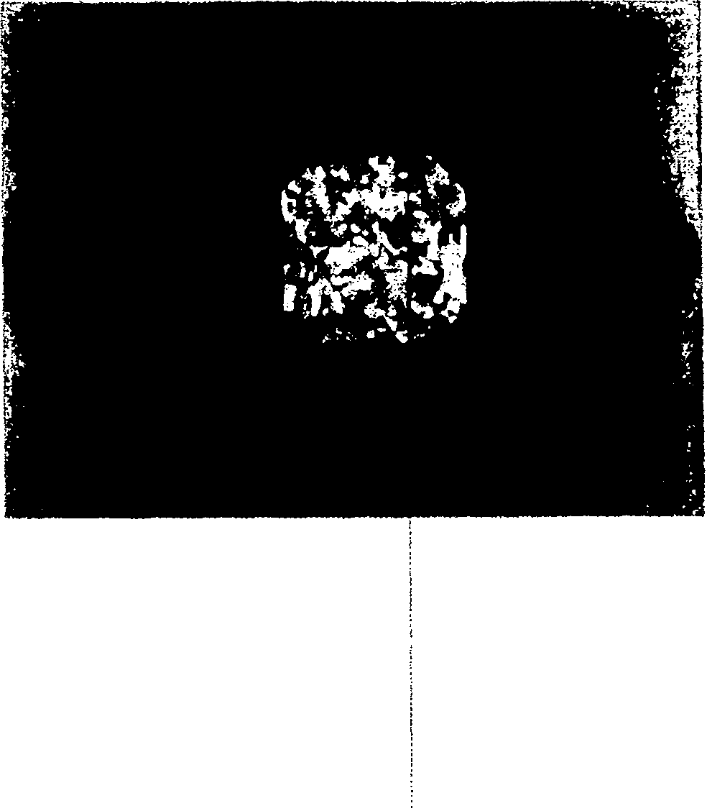One Loose Radiant Cut Diamond which weighs 7. l7 carats. The diamond measures approximately 11.19 x 10.49 x!6.86mm and is approximately K-L color, SI2-ll clarity. FMY = $ 33,350.00 '

9

/.-·· 5 . One "Shared Prong" Diamond!Etemity Ring set in platinum. The ring features eighteen (18) prong-set round brilliant cut di*monds which average 1-J color, SI 1-812• clarity and calculate to approximately 3.96 carats total weight. The ring weighs 4.9 DWT (7.6 grams.)
FMV = $ 1,500.00 :
*Fifteen (15) of the diamonds are chiJ)ped. The Fair Market Value reflects the loss of weight and the cost ofre· cutting and I or replacing the damage diamonds.

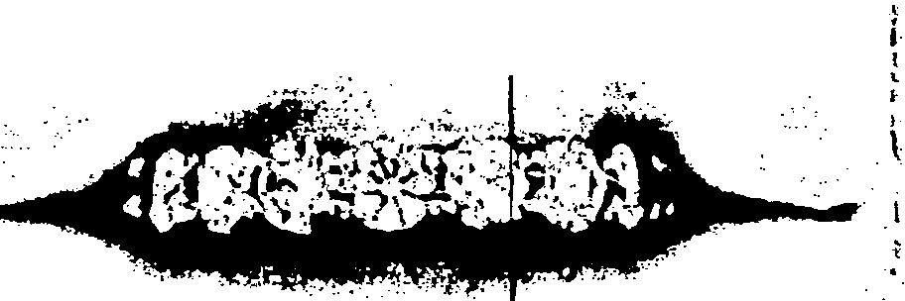
.,

,-
6. One Open Cuban Link Bracele.t. The bracelet links are 18 karat yellow gold with a 14 karat yellow gold lobster-claw clasp.\The bracelet is approximately 7.5 inches (l l .7cm) long. The bracelet weighs 8.0 DWT (12.4: grams.)
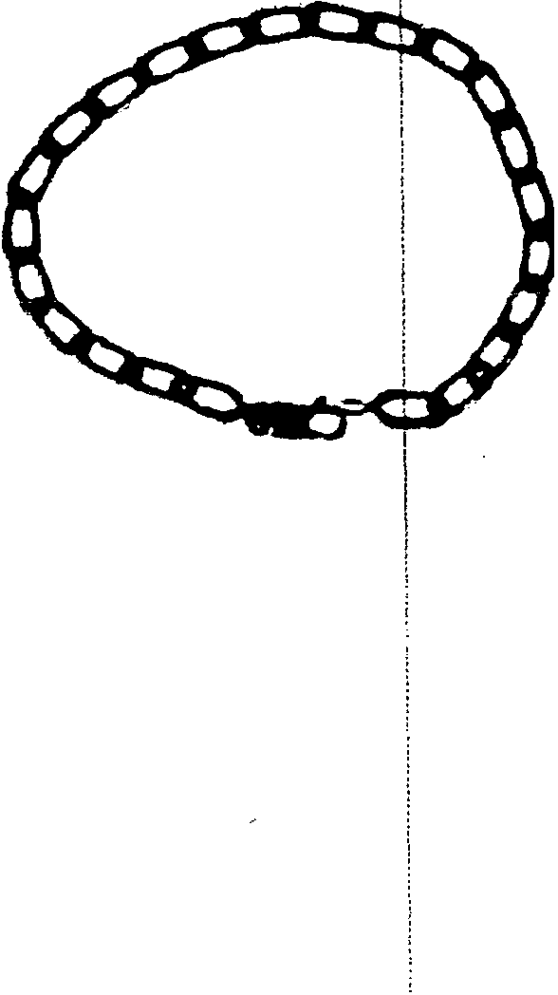FMV = $ 300.00 '

10

,..--·-· · 7. One Moss Agate Talon Necklce set in 14 karat yellow gold. The necklace features a polished piece of moss agate ich is approximately 2 inches (5 cm) long. The agate is supported* by a textured open {ink chain which is approximately 24 inches (60 cm). The necklace weighs 14.0 DWT (2 ).8 grams.)
FMV = $ 225.00 '
*The tip of the "talon" needs to be re-iittached.

r ·r'·
·..... '
f...1 ·r:·.
·.' . ,..

';jC,
...... i\
;. '.·'
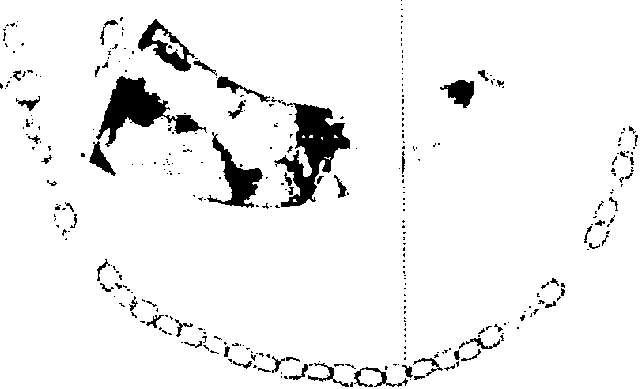...... . ""'\
·::\:,.-' :.-"1'
i"')
:·,,-(
,
..

·..........

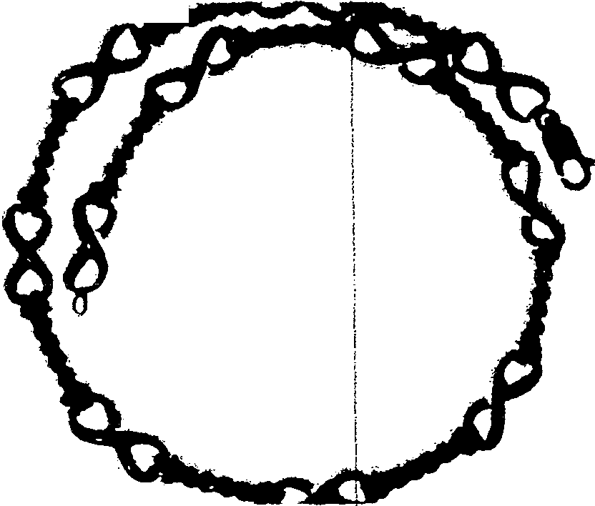8. One "Infinity and Twisted Rope" Link Necklace. The links of the necklace are 18 karat yellow gold and the clasp is a 1!4 karat yellow gold lobster claw. The necklace is approximately 15.5 inches (38.j5cm) long. The necklace weighs 30.85 DWT (47.9 grams.) FMV = $ 1,125.00 !

11

( 9. One "Flower" Ring set in 14 karat yellow gold. The ring features six (6) prong-set pear­ shaped cabochons ofjade. The jade stones average 8mm x 6mm and are white, black, orange, gold and green. The ring weighs 4.1 DWT (6.4 grams.)
FMV = $ 120.00

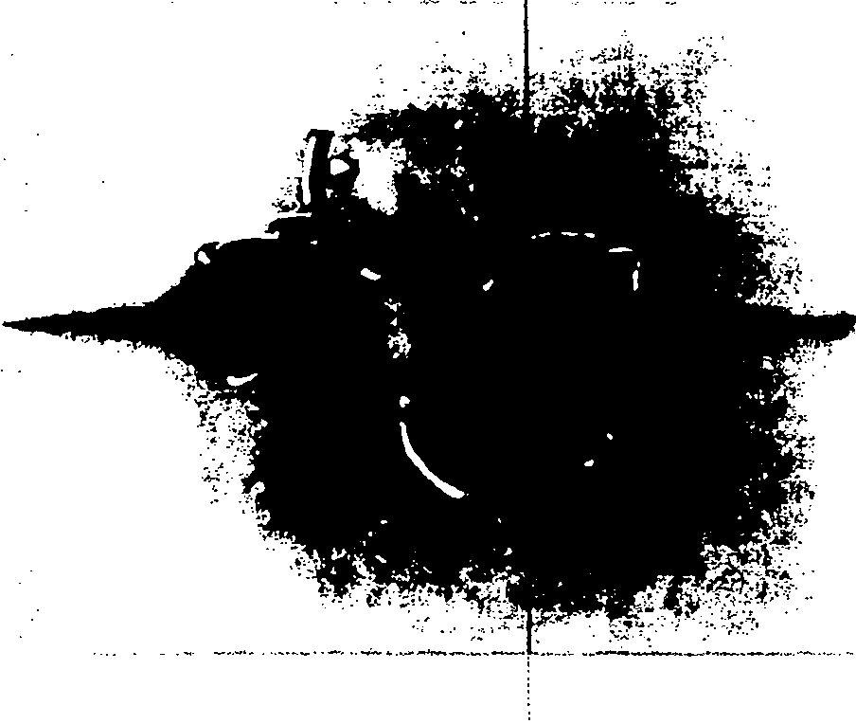

10. One Hunter Case Pocket WatGb. The case of the watch tests as 14 karat* and the bow of the watch is not gold. The watch is engraved "Withall MiLove, Shirley 7-25-74" inside the front cover. It is also engrav "No 410 STEMWINDER Breguet Hairspring Compons,
and cut Balance Paul Rochat! LOCLE" on the cuvee. The watch features a manual wind movement and a white face with roman numerals. The face and crystal are damaged. The watch weighs 37.4 DWT (58.2i grams.)
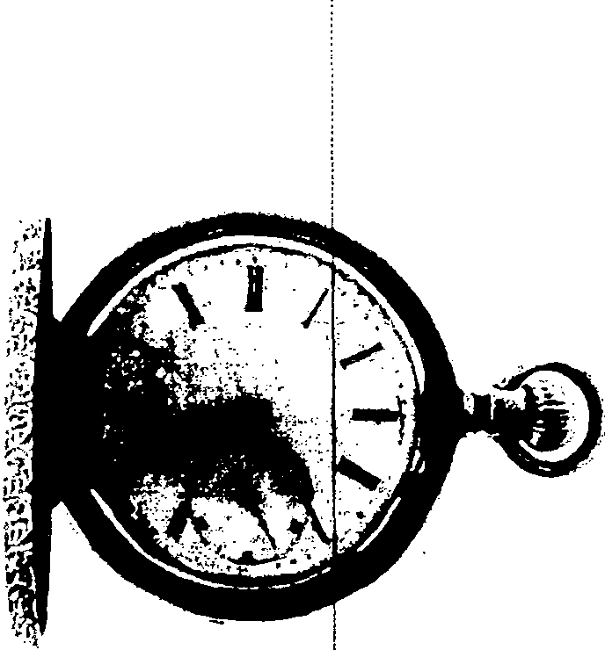FMV = $ 300.00 ;
•Gold filled case.

12

I 1. One pair of Crystal Earrings s¢t in a silver colored base metal. The earrings feature twelve
(12) round crystals and two {2)imarquise cut crystals. The earrings weigh 3.1 DWT (4.8 grams.) ·
FMV = $ I O.OO

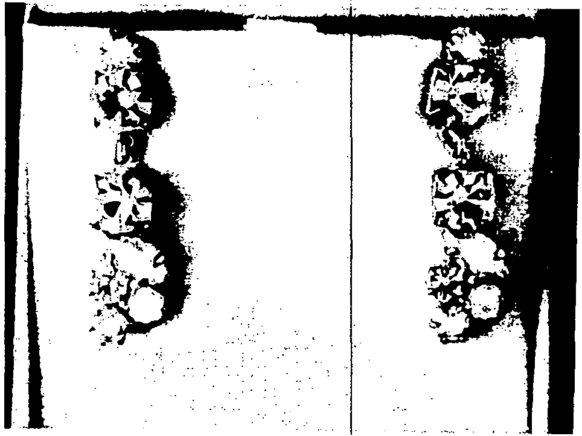

- One Signet Ring set in 154 ka$t yellow gold. The ring is engraved with a stylized "B." The
ring weighs 9.3 DWT ( 14.5 grams.)
FMV = $ 270.00 ,

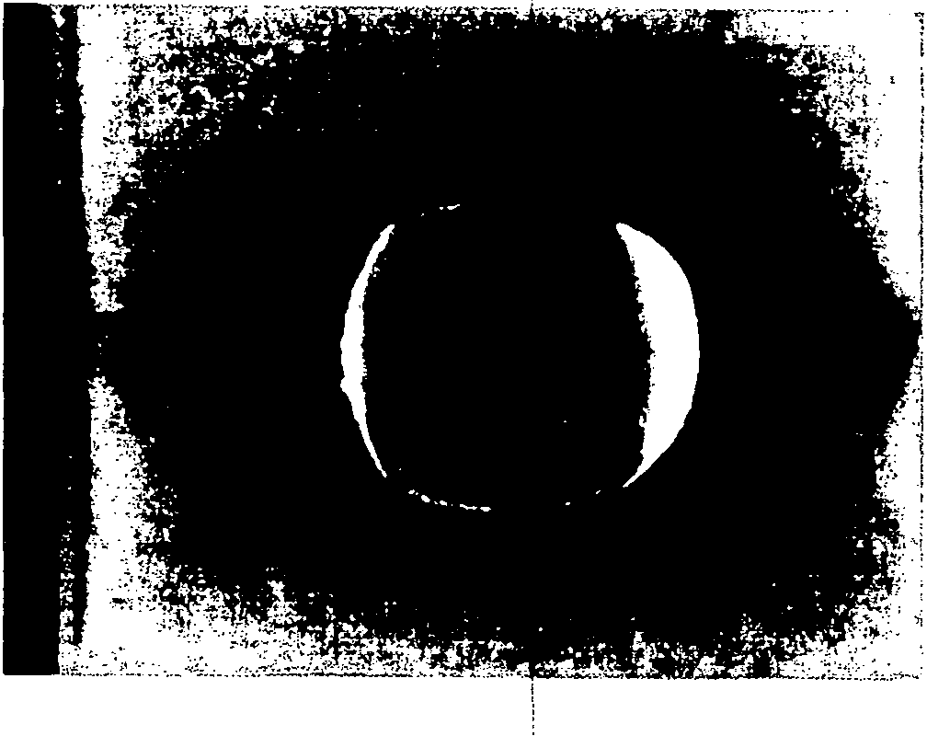

13

- One pair of Oval Cuftlinks set!in 14 karat yellow gold by Avedon. The cutllinks have a Florentine finish and feature fW:o (2) prong-set round brilliant cut sapphires which are approximately 0.14 carats total !weight. The sapphires average sl.g-Blue ( T 7-8 I S 3-4 ) color, Type II: VS clarity. Thei cuffiinks weigh 6.5 DWT (10.l grams.)
FMV = $ 225.00 .

( )11_ ..
l
l J
: ·: - -- J II,,,

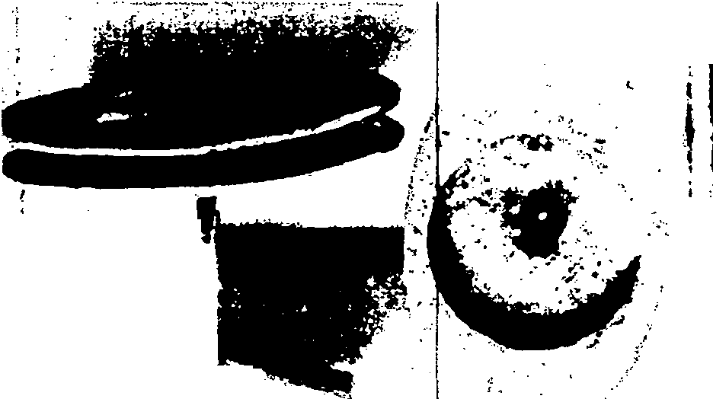.•-. .... > --··
·
.. -.
·-· !

! .

- One Corum Coin Pocket Watqh on a Chain. The Corum watch is housed in an Israeli State commemorative gold coin and \bas a manual wind movement. The watch is supported by a large oval frame which is 18 krat yellow gold. The watch is hinged at the 3:00 and 6:00 positions so that it may rotate i the frame. The chain is a Cuban link of 14 karat yellow gold, approximately 13.5 inchs (21 cm) with a spring ring clasp and a swivel clasp. The chain weighs 11.6 DWT (18.0 'grams.) The watch, frame and chain together weigh 42.0 DWT (65.3 grams.) ·
FMV = $ 6,350.00

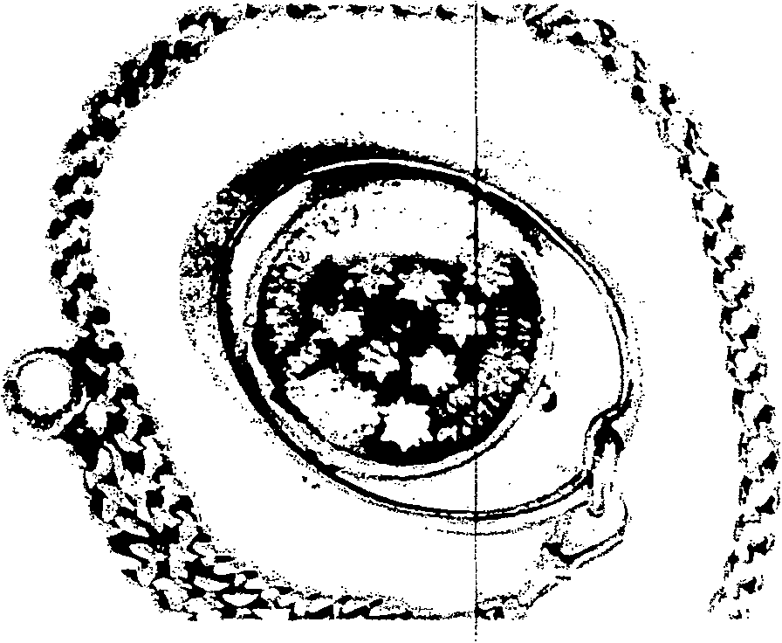

14

! 15. One Diamond and Enamel Tie Pin set in 10 karat* yellow gold. The pin features ten (10)
/
flush-set single cut diamonds which average H-I color, VS2-SI1 clarity and are approximately 0.22 carats total weight. The black enamel is damaged. The pin weighs 2.3 DWT (3.6 grams.)
FMV = $ 150.00
*As tested with assaying acids.

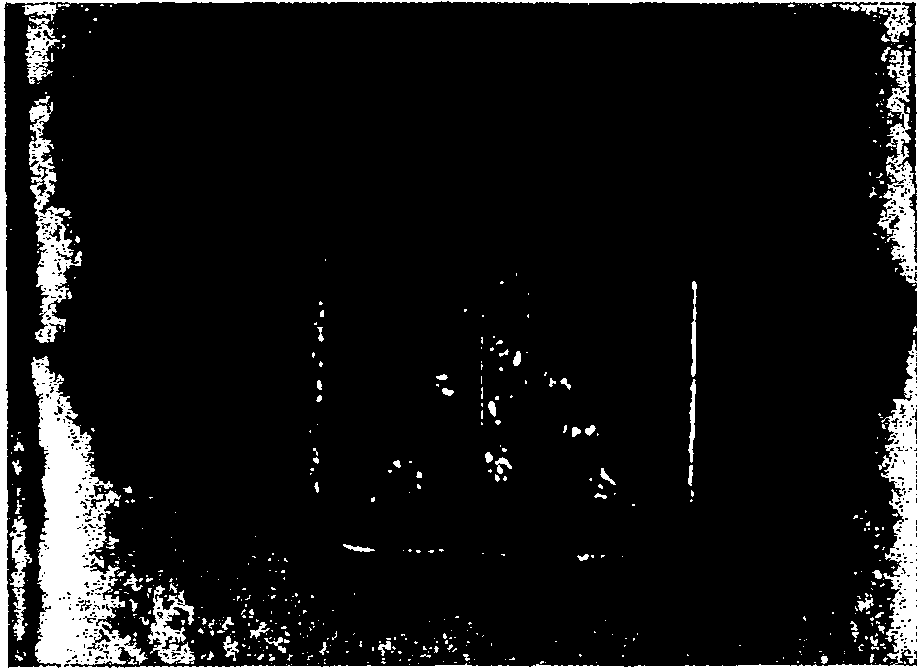

I'
<

15

Appraisal
Following is the name and address of the Presentor of the items: Appraisal No: 1102745763 Name: THE ESTATE OF SIMON BERNSTEIN
Address: 515 N. FLAGLER DR WEST PALM BEACH, FL 33401

This is to certify that we are, and/or ma11yyears have been, engaged in thejewelry business, purchasi11g. selling and appraising Diamonds, Watches, Jewelery and Precious Stones of every name and nature. We herewith certify that we have carefi1lly examined thefollowing listed and described articles. Appraisals
are based on limitations of settings. All gemstones have been analyzed in the settings. The appraised value given is NOT an offer lopurchase.

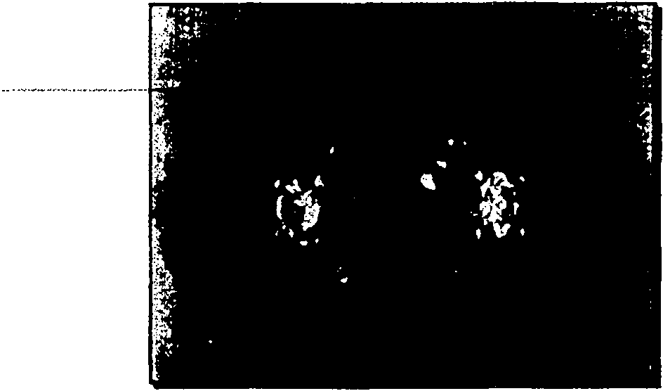ITEM NO.: FMV 1

·-s·:::·
DESC
RIPTION: One Semi-Mount Diamond Ring set in platinum. The ring is engraved "David
two-(2f firon9sefiouni:f.t>niiiiiifcuf a1amonas·Whld1..averageT.:J-cX>1or;-··
··ifie-nn9'fealures
0.97 carats total weight. The ring weighs 6.1 DWT (9.5

THISAPPRAISAL IS FOR
F.4/R MARKET VALUE
VS2-Si 1darity and are approximately
grams.)
FMV = $ 1,800.00
*The hand engraved signature of the jeweler who made the ring is not legible.

APPRAISED VALUE: $1,800.00

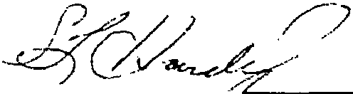PROVIDENT JEWELRY
Fine Estate Jewelry 331 Clematis Street
West Palm Beach, FL 33401
Phone: (888) 888-4367 Fax: (561) 833-8(63 Stepha1rle L HaJ.G. (GIA) Jan. 18, 2016
Graduate Jeweler- Gemologist, Jewelry Designer and Appraiser

Appraisal
Following is the name and address of the Presentor of the items: Appraisal No: 1102745764 Name: THE ESTATE OF SIMON BERNSTEIN

Address: 515 N. FLAGLER DR WEST PALM BEACH, FL 33401

This is tocertifY that we are, andfor many years have been, engaged in thejewelry business. purchasing. selli11g and appraising Diamonds, IVatches, Jewelery and Precious Stones of every name and natl/re. We herewith certify that we have carefully examined thefollowing listed and described articles. Appraisals
are based on /imitations of settings. Alf gemstones have been analyzed in the settings. The appraised \•alue given is NOT an offer topurchase.

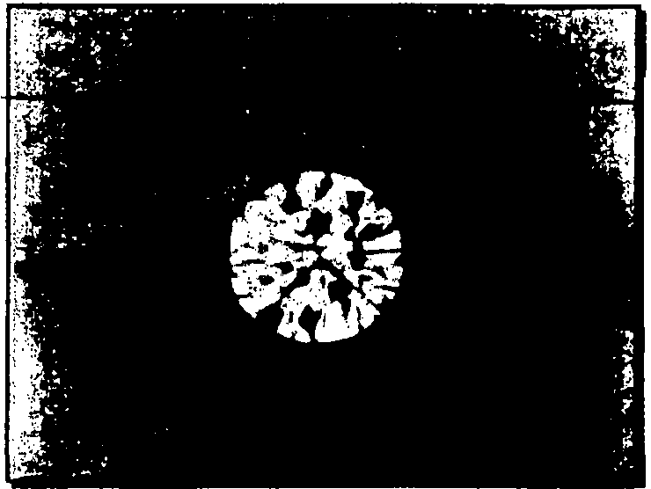ITEM NO.: FMV 2

': ...DESCRIPTION:..One..Loose.Rounct Brilliant.Cut.Diamond.Which..weighsA.71_carats•..T.1:1........ .. -··-·- ... diamond measures approximately 10.58-10.72 x 6.60mm and is approximately K-L color, Sl1-Sl2 clarity.
FMV = $ 30,750.00*
• The diamond is significantly abraded on the pavilion and will have to be re-cut. The process of
re-cutting will decrease the weight of the diamond. The Fair Market Value reflects the loss of weight and the cost of re-cutting.

APPRAISED VALUE: $30,750.00

THIS APPRAISAL IS FOR FAIR MARKET VALUE

PROVIDENT JEWELRY
Fine Estate Jewelry
331 Clematis Street
West Pafm .Beach, FL 33401
Phone: (888) 888-4367 Fax: (561) 833-8763 Step Jan.18,2016
Graduate Jeweler- Gemologist, Jewelry Designer and Appraiser

Appraisal
Following is the name and address of the Presentor of the items: Appraisal No: 1102745765 Name: THE ESTATE OF SIMON BERNSTEIN

Address: 515 N. FLAGLER DR WEST PALM BEACH, FL 33401

This is to certify that we are, andfor many years have bee11, engaged in thejewelry business, purchasing, selling and appraising Diamonds, Watches, Jewelery and Precious Stones of every name and 11ature. JJ herewith certify that we have carefully examined thefollowing listed a11d described articles. Appraisals
are based on limitations of settings. All gemstones have been analyzed in the settings. The appraised \•al11e given isNOT an offer topurchase.

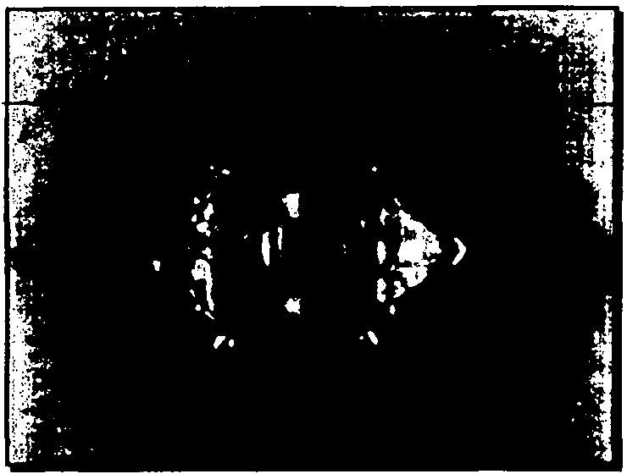ITEM NO.: FMV 3

_ DESCRIPTIQN;_Qoe Semi M_ount Pimon<LRing.t .in.p!tjl'!f.!m....Tt1 _rir::ig 'tLJr!!.!w<> (2) prong-set triangular brilliant cut diamonds which average 1-J color, VS1-Sl1 clarity and are approximately 1.59 carats total weight. The ring weighs 5.0 DWT (7.8 grams.)
FMV = $ 3,700.00

APPRAISED VALUE: $3,700.00

THIS APPRAISAL JS FOR
FAIR MARKET VA.LUE

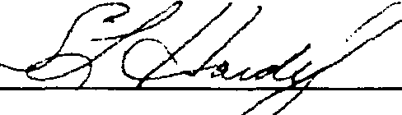PROVIDENT JEWELRY
Fine Estate Jewelry
331 Clematis Street
West Palm Beach, FL 33401
Phone: (888) 888-4367 Fax: (561) 833-8763 Stqlranie L Hardy .G. (GIA) Jan. 18, 2016
Graduate Jeweler- Gemologist, Jewelry Designer and Appraiser ,

Appraisal
Following is the name and address of the Presentor of the items: Appraisal No: 1102745766 Name: THE ESTATE OF SIMON BERNSTEIN

Address: 515 N. FLAGLER DR WEST PALM BEACH, FL 33401

This is to certify that we are, andfor manyyears h(/\>e been, engaged in thejewelry business, purchasing, selling and appraising Diamonds, Watches. Jewelery and Precious St011es of every name and nature. We hell!Witlr certify that we have carefully examined thefollowing listed and described articles. Appraisals
are based on /imitations of setlings. All gemstones have been analyzed in the settings. The appraised value given is NOT an offer topurchase.

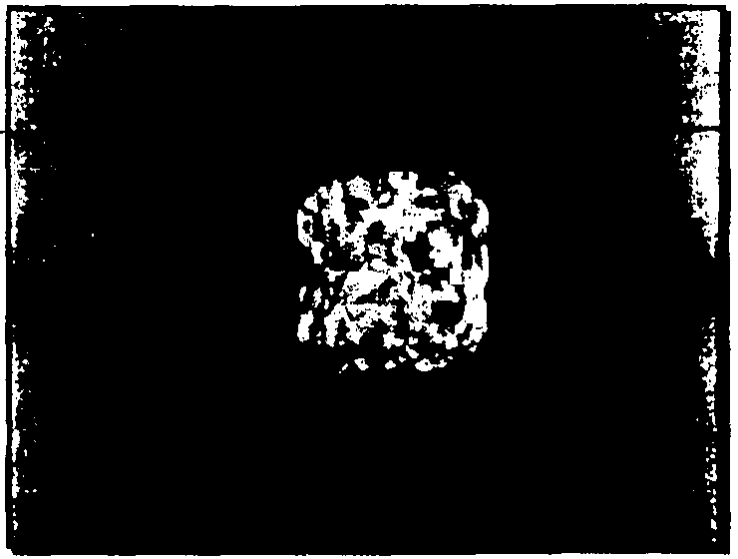ITEM NO.: FMV 4

_p_f;;_§_GB!.f'.>.T!Ql1LQn..l,,QQ .R. ljnt..CYtOJam9.o.l:f.wtlichw.e.ighs-7.fl.carats•..The diamond ......... measures approximately 11.19 x 10.49 x 6.86mm and is approximately K-L color, Sl2-l1clarity. FMV == $ 33,350.00

APPRAISED VALUE: $33,350.00

THIS APPRAISAL IS FOR FAIR MARKET VALUE

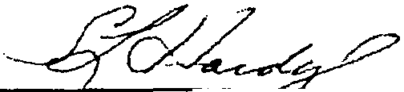PROVIDENT JEWELRY
Fine &tale Jewelry
331 Clematis Street
Phone: (888) 888-4367 Fax: (561) 833-8763 Stephanie L Hardy G.J.eGJ; Jan. 18, 2016
West Palm Beach, FL 33401
Graduate Jeweler- Gemologist, Jewelry Designer and Appraiser

Appraisal
Following is the name and address of the Presentor of the items: Appraisal No: 1102745767 Name: THE ESTATE OF SIMON BERNSTEIN

Address: 515 N. FLAGLER DR WEST PALM BEACH, FL 33401

This is to certify that we are, andfor many years Jifl\le been, engaged ill thejewelry business, purchasing, selling and appraising Diamonds, Watches, Jewelery and Precious Stones of every name and nature. We herewith certify that we have carefully examined thefollowing listed and described articles. Appraisals
are based on limitations of settings. All gemstones /rave been ana{vzed in the settings. The appraised val11e given is NOT an offer topurchase.

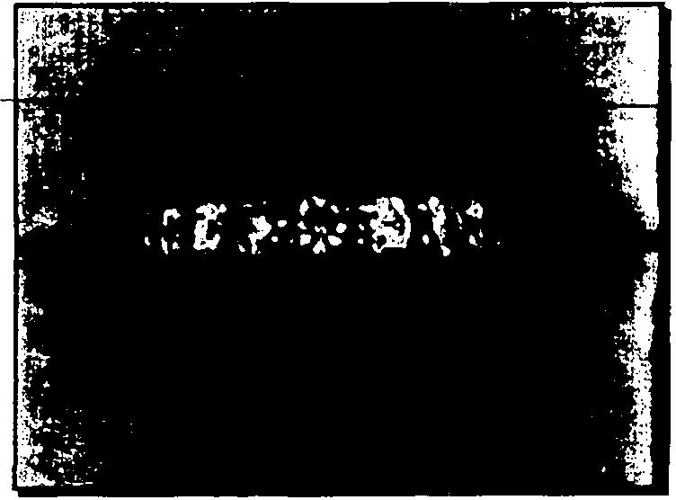ITEM NO.:FMV 5

DESCRleIION:_Q11e ''.St:@r P C>r:K.l,.()ial'll()llcj E:; -rr!ty i11g_ "'t_if1 platinum. The ring features eighteen (18) prong-set round brilliant cut diamonds which average iJci:ilor;sr1.::s12•C1arit)'and
calculate to approximately 3.96 carats total weight. The ring weighs 4.9 DWT (7.6 grams.) FMV = $ 1,500.00
*Fifteen (15) of the diamonds are chipped. The Fair Market Value reflects the loss of weight and the cost of re-cutting and I or replacing the damaged diamonds.

APPRAISED VALUE: $1,500.00

THISAPPRAISAL IS FOR FAIR MARKET VALUE

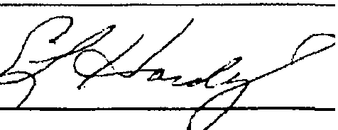PROVIDENT JEWELRY
Fine Estate Jewelry 331 Clematis Street
West Palm Beach, FL 33401
Phone_·(888) 888-4367 Fax: (561) 833-8763 Stephanie L Hardy G.J.G. 'GIA) Jan. 18. 2016
Graduate Jeweler- Gemologist, Jewelry Designer and Appraiser

Appraisal
Following is the name and address of the Presentor of the items: Appraisal No: 1102745768 Name: THE ESTATE OF SIMON BERNSTEIN

Address: 515 N. FLAGLER DR WEST PALM BEACH, FL 33401

This is to certifj• that we are, and/or manyyears have been, engaged in thejewelry business, purchasing, selling and appraising Diamonds, Watches, Jewelery and Precious Stones of every name and nature. We herewith certify that we have carefully examined thefollowing listed and described articles. Appraisals
are based on limitations of settings. All gemstones ha\'ebeen analyzed in the settings. The appraised value given is NOT a" offer topurchase.

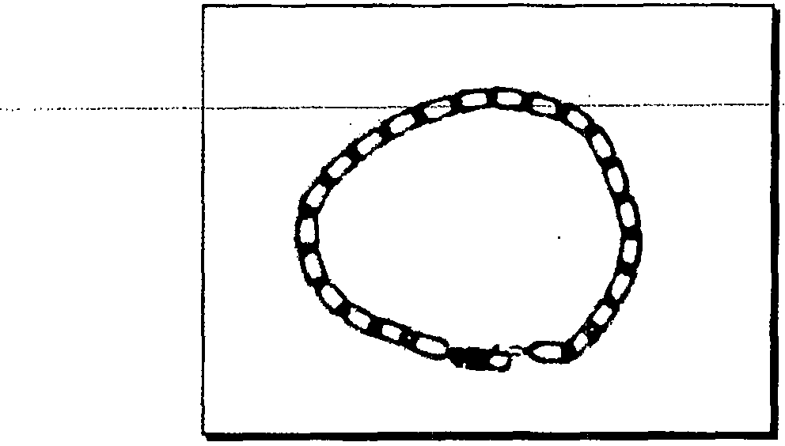ITEM NO.: FMV 6

DESCRIPTION: One..QP.t:lll._91.J.li.11.i.11.-'!'llL.Tb !:>[ lJinlc.$.r..18 k.aratyllow.gold.with ...
-a-·1;narat yellow-gold lobster-claw clasp. The bracelet is approximately 7.5 inches (11. 7cm) long. The bracelet weighs 8.0 DWT (12.4 grams.)
FMV = $ 300.00

APPRAISED VALUE: $300.00

THISAPPRAISAL IS FOR
FAIR MARKET VA.LUE

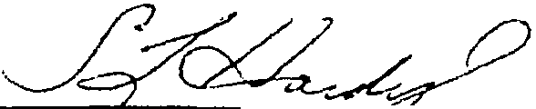PROVIDENT JEWELRY
Fine Estate Jewelry
331 Clematis Street
West Palm Beach, FL 33401
Phone: (888) 888-4367 Fax: (561) 833-8763 Stqllank L Hard)' G.J.G.( Jan. 18, 2016
Graduate Jeweler- Gemologist, Jewelry Deslg11er and Appraiser

\

Appraisal
Following is the name and address of the Presentor of the items: Appraisal No: 1102745769 Name: THE ESTATE OF SIMON BERNSTEIN
Address: 515 N. FLAGLER DR WEST PALM BEACH, FL 33401

This is to certify that we are, andfor many years have been, engaged in thejewelry business, p11rchasing. selling and appraising Diamonds, Watches, Jewelery and Precious Stones of every na111e and nature. JVe herewith certify that we have carefully examined thefollowing listed a11d described articles. Appraisals
are based on limitations of settings. All gemstones have been analyzed in the settings. The appraised value given is NOT an offer topurchase.

t1'-·' ITEM NO.: FMV 7
.·!.. i"""';

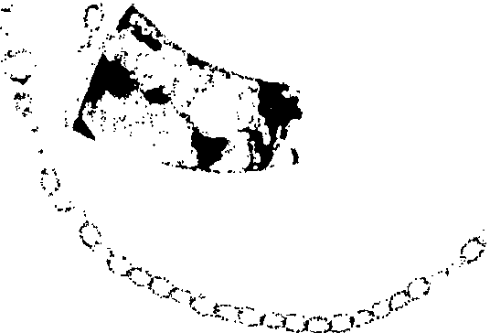.. . -··---····--------·--··--·•·-·--.-;'-,- --------·-----

--- -- ---- ---.-+c';

\-::.
_,,_ _ _ _ _
---DESCRIP-TlON:--One- Moss-Agate--TalonNecklace set in-14karat yellow.gold.-The-neckl ace-

:,' ;j features a polished piece of moss agate which is approximately 2 inches (5 cm) long. The agate
11''· , · is supported* by a textured open link chain which is approximately 24 inches (60 cm). The
necklace weighs 14.0 DWT (21.8 grams.)
FMV = $ 225.00
*The tip of the "talon" needs to be re-attached.

APPRAISED VALUE: $225.00

THIS APPRAISAL JS FOR FAIR MARKET VALUE

PROVIDENT JEWELRY
Fine Estate Jewelry
331 Clematis Street
West Palm Beach, FL 33401
Phone: (888) 888-4367 Fax: (561) 833-8763

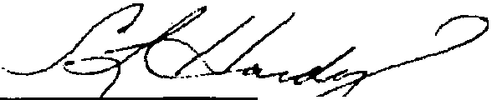Steplranfe L Hanl)• G.J.G. (GIA) Jan. 18, 2016 Graduate Jeweler- Gemologist, Jewelry Dnigner andAppraiser
l/

. '.

Appraisal
Following is the name and address of the Presentor of the items: Appraisal No: 1102745770

Name: THE ESTATE OF SIMON BERNSTEIN
Address: 515 N. FLAGLER DR WEST PALM BEACH, FL 33401

This is to cerlifY thai we are, andfor manyyears htn•e been, engaged in thejewelry b"siness, p1UY:hasing, selling and appraising Diamonds, Watches, Jewelery and Precious Stones of e\•ery name and nature. 11'.i herewith certify that we ha\•e carefully examined thefollowi11g listed and described articles. Appraisals
are based on limitations of settings. All gemstones ha\•e been analyzed in the settings. The appraised \•alue given is NOT an offer topurchase.

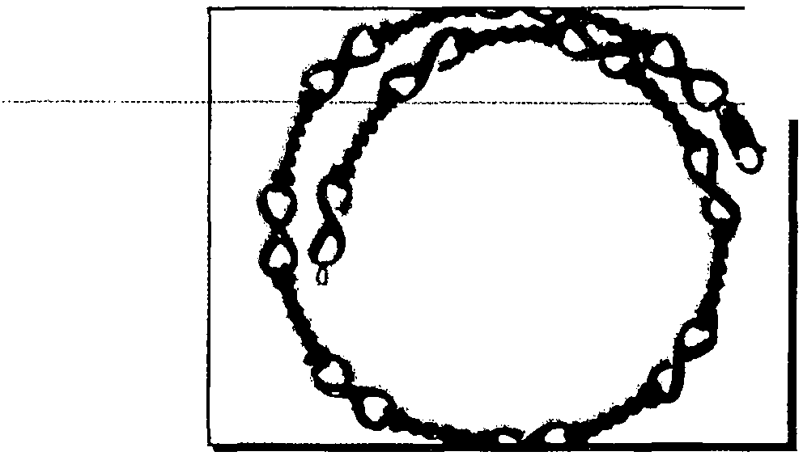ITEM NO.: FMV 8

.-.P.$.QRJEDQN:.Qr:i"'_'_'!r:!!iri.i_tY. .. r:ic,t _Ilfo'i.t - Rc:>''...P'-1.- -<=k.l!_lc.e_,._J!l.1!.li -t;_pfJ -!1 !!1. - -1- karat yellow gold and the clasp is a 14 karat yellow gold lobster claw. The necklace is approximately 15.5 inches (38.75cm) long. The necklace weighs 30.85 DWT (47.9 grams.)
FMV = $ 1,125::00 .

APPRAISED VALUE: $1,125.00

THIS APPRAISAL JS FOR FAJR MARKET VALUE

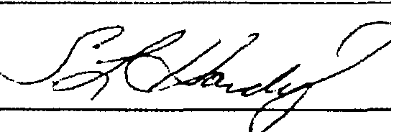PROVIDENT JEWELRY
Fine Estate Jewelry
331 Clematis Street
West Palm Beach, FL 33401
Phone: (888) 888-4367 Fax: (561) 833-8763 Steplta11ie L Hardy G.J.G. "GIA) Ja11. 18, 2016
Graduate Jeweler- Gemologist, Jewelry Designer and Appraiser

Appraisal
Following is the name and address of tJie Presentor of the items: Appraisal No: 1102745771 Name: THE ESTATE OF SIMON BERNSTEIN

Address: SIS N. FLAGLER DR WEST PALM BEACH, FL 33401

This is to certify that we are, andfor marry years have been, engaged in tirejewelry business, p1m:hasing, selling and appraising Diamonds, Watches, Jewelery and Precious Stones of every name and nature. Jf't herewith certify that we have carefully examined thefollowing listed and described articles. Appraisals
are based on /imitations of settings. All gemstones have been analyzed in the settings. The appraised value given is NOT an o.ffer topurchase.

ITEM NO.: FMV 9
-- , i /;:<>t1 e1r i!a J " 1 vI ii in n re- White; - -
black, orange, gold and green. The ring weighs 4.1 DWT (6.4 grams.) FMV = $ 120.00

APPRAISED VALUE: $120.00

THIS APPRAISAL JS FOR FAIR MARKET VALUE

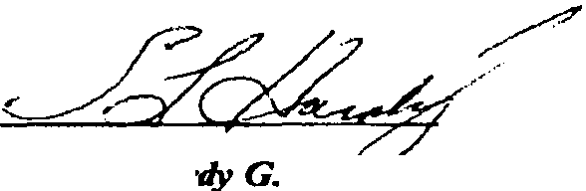PROVIDENT JEWELRY
Fine Estate Jewelry 331 Clematis Street
West Palm Beach, FL 33401
Phone: (888) 888-4367 Fax: (561) 833-8763 Steplranie L. rdy G lA Jan. Ill, 2016
Gradllate Jeweler- Gemologist, Jewelry Designer and Appraiser

/
\

Appraisal
Following is the name and address of the Presentor of the items: Appraisal No: 1102745772 Name: THE ESTATE OF SIMON BERNSTEIN

Address: 51S N. FLAGLER DR WEST PALM BEACH, FL 33401

This is to certify that we are, andfor many years have been, engaged in thejewelry business, purchasing, selling and appraising Diamonds, Watches, Jewelery and Precious Stones of every name and nature. lfe herewith certify that we have carefully examined thefollowing listed and described articles. Appraisals
are based on limitations of sellings. All gemstones ha\•e been analyzed in the settings. The appraised value given is NOT an offer topurchase.

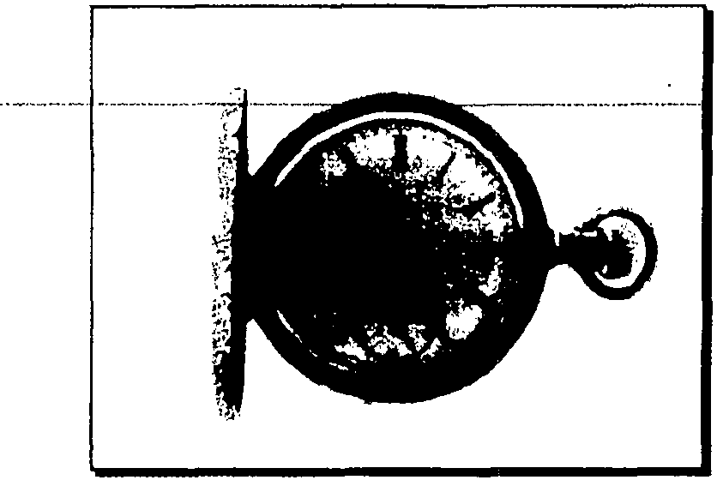

THJS APPRAISAL IS FOR FAIR MARKET VALUE

ITEM NO.: FMV 10

.OE.SC.BlP. O.N.:._QneJ:!!.!ole.t.Cas.e. P.9C.ket..Wci.t..Th.e..qi.s_Eu>JJb _wcitc.tJ.Je$ts..asJ..kcir.al*...a.od..... .
the bow of the wcitch is not gold. The wcitch is engraved 'With all My Love, Shirley 7-25-74" inside the front cover. It is also engraved "No 410 STEMWINDER Breguet Hairspring
Componsd and cut Balance Paul Rochat LOCLE" on the cuvee. The watch features a manual wind movement and a white face with roman numerals. The face and crystal are damaged. The watch weighs 37.4 DWT (58.2 grams.)
FMV = $ 300.00
*Gold filled case.

APPRAISED VALUE: $300.00

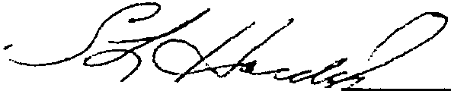PROVIDENT JEWELRY
Fine Estate Jewelry 331 Clematis Street
West Palm Beach. FL 33401
Phone: (888) 888-4367 Fax: (561) 833-8763 Stepllanie L Hardy G.J.PrGIA) Jan. I ll, 2016 Graduate Jewele,.... Gemologist, Jewelry Designer and Appraiser

Appraisal
Following is the name and address of the Presentor of the items: Appraisal No: 1102745773 Name: THE ESTATE OF SIMON BERNSTEIN

Address: 515 N. FLAGLER DR WEST PALM BEACH, FL 33401

This is to certify that we are, andfor many years have been, engaged in thejewelry business, purchasing, selling and appraising Diamonds, Watches, Jewelery and Precious Stones of every name and nature. We herewillr certify that we have careful(\• examined thefollowing listed and described articles. Appraisals
are based on limitations of settings. All gemstones have been analyzed in tire settings. The appraised value given is NOT an offer topurchase.

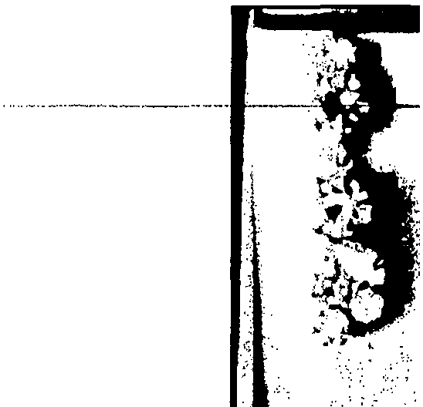ITEM NO.: FMV 11

OESCRIPTION: One pair of Crystal Earrings set in a silver colored base metal. The earrings

···reamre·tWeTve {12n'oLrna·crvslats·arl"i:f _tw0_(2)·marq ise·cu1·c;ystais:111e·eaffings wer9n·3:1··
DWT (4.8 grams.)
FMV = $ 10.00

APPRAISED VALUE: $10.00

THIS APPRAISAL JS FOR FAIR MARKET VALUE

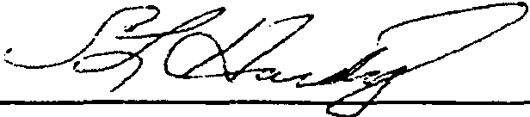PROVIDENT JEWELRY
Fine Estate Jewelry 331 Clematis Street
West Palm Beach, FL 33401
Phone: (888) 888-4367 Fax: (561) 833-8763 Stephanie L Hardy G.J.G. (GIA) Jan.18, 2016
Graduate Jeweler- Gemologist, Jewelry Designer and Appraiser

·,...._
(

Appraisal
Following is the name and address of the Presentor of the items: Appraisal No: 1102745774 Name: THE ESTATE OF SIMON BERNSTEIN

Address: 515 N. FLAGLER DR WEST PALM BEACH, FL 33401

This is to certify that we are, and/or manyyears have been, engaged in thejewelry business, purchasi,,g, selling and appraising Diamonds, Watches, Jewelery and Precious Stones of every name and na111re. n-e liemvith certify that we have carefi1lly examined thefollowing listed and described articles. Appraisals
are based on limitations of sellings. All gemstones have been analyzed in the settings. The appraised value given is NOT a11 o.ffer lopurchase.

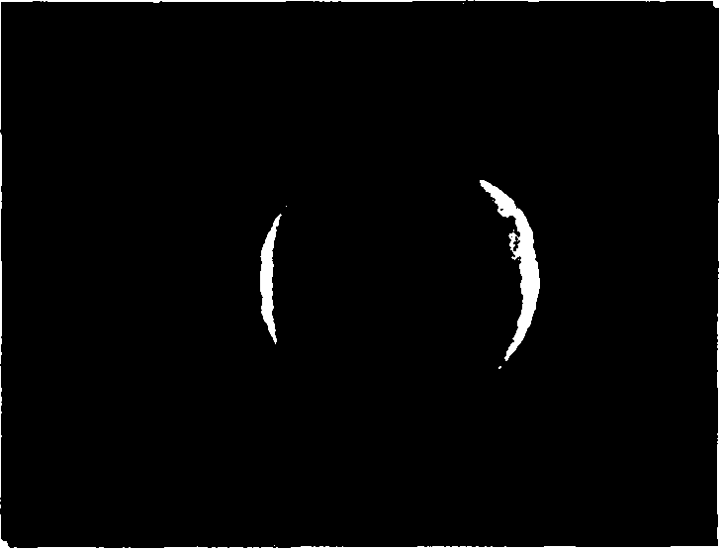ITEM NO.: FMV 12

DESCRIPTION: One Signet Ring set in 154 karat yellow gold. The ring is engraved with a
sfylfzed"B:"·Ttifnng we191rs·9:3owrr14t5 grifms:r· - ·- ··· - -·- · · -- ··· - ············-
FMV = $ 270.00

APPRAISED VALUE: $270.00

THISAPPRAISAL JS FOR
FAIR MARKET l'llL VE

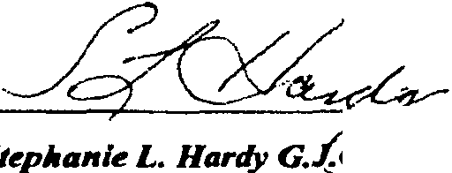PROVIDENT JEWELRY
Fine Estate Jewelry
JJ I Clematis Street
(GM)
West Palm Beach, FL 33401
Phone: (888) 888-4367 Fax: (561) 833-8763 Steplranie L. Hardy Jan. J I, 2016
Graduate Jeweler- Gemologist, Jewelry Designer and Appraiser

/ ----.. -·.,.

Appraisal
Following is the name and address of the Presentor of the items: Appraisal No: 1102745775 Name: THE ESTATE OF SIMON BERNSTEIN

Address: 515 N. FLAGLER DR WEST PALM BEACH, FL 33401

This is to certify that we are, andfor manyyears have been, engaged in thejewelry business, purchasing, selling and appraising Diamonds, Watches, Jewelery and Precious Stones of every name and nat11re. ff herewith certify that we have carefully examined thefollowing listed and described articles. Appraisals
are based on /imitations of sellings. A fl gemstones lun•e been a11alyzed in the settings. The appraised value gi1•e11 is NOT an offer topurchase .

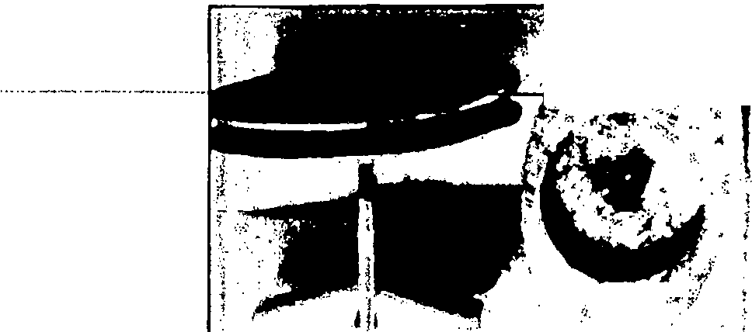......,_..·<___-...·_·_·· ·· ·.°."':.:.:.......... . :c: : _ :.P-JLQtQ.v t.9.ff!.in._k.!t..IS. tin...1 -k."'_r<1t _y_f!ll_() g?ld byAvedon. The cufflinks have a Florentine finish and feature two (2) prong-set round briillarif cut sappti-lres WlilCfi-are--···· approximately 0.14 carats total weight. The sapphires average sl.g-Blue ( T 7-8 IS 3-4 ) color, Type II: VS clarity. The cufflinks weigh 6.5 DWT (10.1grams.)
FMV = $ 225.00

APPRAISED VALUE: $225.00

THIS APPRAISAL JS FOR
FAIR MARKET J j4LUE

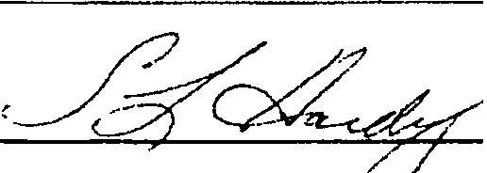PROVIDENT JEWELRY
Fine Estate Jewelry 331 Clematis Street
We.st Palm Beach, FL 33401
Phone: (888) 888-4367 Fax: (56/) 833-8763 Stephanie L Hardy G.J.G (GIA) Jan. 18, 2016
Gradllate Jeweler- Gemologi.st, Jewelry Designer and A.pprai.ser

Appraisal
Following is the name and address of the Presentor of the items: Appraisal No: 1102745776 Name: THE ESTATE OF SIMON BERNSTEIN

Address: 515 N. FLAGLER DR WEST PALM BEACH, FL 33401

This is to certify that we are, andfor many years lla1•e been, engaged in thejewelry business, purcllasing ..sel/ing and appraising Diamonds, Watches, Jewelery and Precious Stones of e\'ery name and nature. 11 herewith certify that we h(ll'e carefully examined thefollowing listed and described articles. Appraisals
are based on limitations of sellings. All gemstones have been analyzed i11 the settings. The appraised vallle given is NOT an offer topurr:hase.

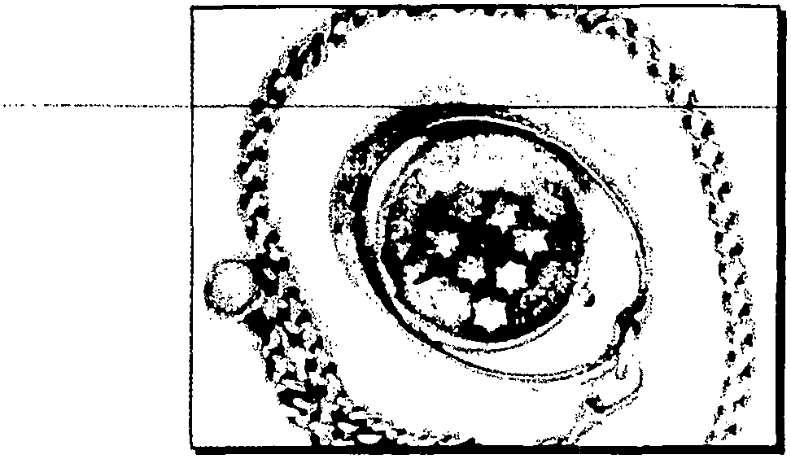

THIS APPRAISAL JS FOR FAIR MARKET VA.LUE

ITEM NO.: FMV 14

DESCRIPTION: One Corum Coin Pocket Watch on a Chain. The Corum watch is housed in an
·1sraeifsfa1e··- commemorafiva·9ald·ooin-anCil as·a-mari"ualWind-movemer CThe-waTcflis· --·­
supported by a large oval frame which is 18 karat yellow gold. The watch is hinged at the 3:00 and 6:00 positions so that it may rotate in the frame. The chain is a Cuban link of 14 karat yellow gold, approximately 13.5 inches (21 cm) with a spring ring dasp and a swivel dasp. The chain weighs 11.6 DWT (18.0 grams.} The watch, frame and chain together weigh 42.0 DWT (65.3 grams.)
FMV = $ 6,350.00

APPRAISED VALUE: $6,350.00

PROVIDENT JEWELRY
Fine &tate Jewelry 331 Clematis Street
West Palm Beach, FL 33401
Plwne: (888) 888-4367 Fax: (S6J) 833-8763 JaL Jl,20]6
Graduate Jeweler- Gemologist, Jewelry Designer and Appraiser

Appraisal
Following is the name and address of the Presentor of the items: Appraisal No: 1102745777 Name:THE ESTATE OF SIMON BERNSTEIN

Address: 515 N. FLAGLER DR WEST PALM BEACH, FL 33401

This is to certify that we are, and/or many years have been, engaged in thejewelry business. purchasing, se/li11g and appraisi11g Diamonds, Watches, Jewelery and Precious Stones of every name and nat11re. lf-e herewith certify that we have carefully examined thefollowing listed and described articles. Appraisals
are based on limitations of settings. All gemstones have been anal)'zed in the settings. The appraised value given is NOT an offer top11rchase.

ITEM NO.: FMV 15
J;>J;_§QRlfI!QN; Q11 Pia.!!IQl1<:l .11.nc:f _l::1111m.IJlf i_11_11e.tJn.!Q.1:1r11t*._Y l_ g_<:>I_:..!f:l_P!".1J tu.c;,--..
ten (10) flush-set single cut diamonds which average H-1 color, VS2-Sl1clarity and are
approximately 0.22 carats total weight. The black. enamel is damaged. The pin weighs 2.3 DWT
(3.6 grams.) FMV = $ 150.00
•As tested with assaying acids.

APPRAISED VALUE: $150.00

THISAPPRAISAL JS FOR
FAIR lvf.4.RKET VALUE

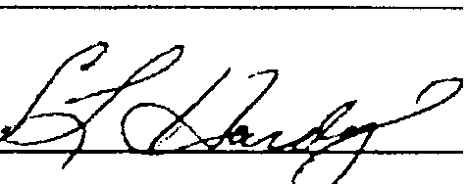Graduate Jeweler- Gemolog8t, Jewelr)' Dalgner 11nd Appraiser
PROVIDENT JEWELRY
Fine Estate Jewelry 33 J Clematis Street
West Palm Beach, FL 33401
Phone: (888) 888-4367 Fax: (56/) 833-8763
Stepllanie L Hardy G.J. _ 'GIA)
Jan. 18, 2016

