WILL OF

SIMON L. BERNSTEIN

I, SIMON L. BERNSTEIN, of Pa lm Beach County, Florida, here by revoke all my prior Wi lls and Codicils and make this Will. I am a widower, but in the event that I marry subseq uent to the execution of th is Will, I specifically make no provision for my spouse. My children are TED S. BERNSTEIN, PAM ELA B. SIMON, ELIOT BERNSTEIN, J I LL !ANTON I and LISA S. FRI EDSTEIN.

ARTICLE I. TANGIBLE PERSONAL PROPERTY

I give such items of my tangible personal property to such persons as I may designate in a separate written memorandum prepared for this purpose. I give to my chi ldren who survive me, divided among them as they agree, or if they fail to agree, divided among them by my Personal Representatives in asnearly equa l shares as practical my personal effects,jewel ry, col lections, household furnishings and equi pment, automobiles and all other non-business tangi ble personal property other than cash, not. effecti vely disposed of by such memorandum, and ifno child of mine survives me, this property shall pass with the resid ue of my estate.

ARTICLE II. EXERCISE OF POWER OF APPOINTMENT

U nder Subparagraph E. l . of Article ll. of the SHIRLEY BERNSTEIN TRUST AGREEMENT dated May 20, 2008, (the "Shirley Trust"), I was granted a special power of appointment upon my death to d irect the disposition of the remai ning assets of the Marital Trust and the Family Trust establ ished under the Shirley Trust. Pursuant to the power granted to me under the Shirley Trust, upon my death, I hereby direct the then serving Trustees of the Marital Trust and the Family Trust to divide the remaini ng trust assets into equal shares for my then l iving grandchildren and distribute said shares to the then serving Trustees of thei r respective trusts established under Subparagraph 11.B. of my Existing Trust, as referenced below, and administered pursuant to Subparagraph 11.C. thereu nder.

ARTICLE III. RESIDUE OF MY ESTATE

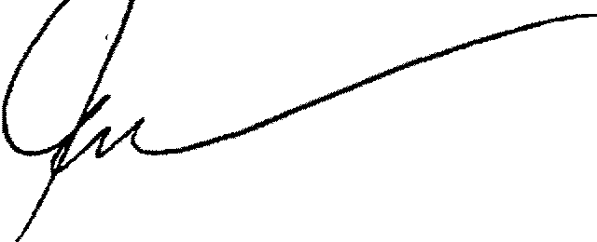I give all the residue of my estate, includi ng my homestead, to the Trustee then serving under my revocable Trust Agreement dated May 20, 2008, as amended and restated from time to time and on even date herewith (the "Existing Trust"), as Trustee without bond, but I do not exercise any powers of appointment held by me except as provided in Article II., above, and in the later paragraph titled "Death Costs." The residue shall be added to and become a part of the Existing Trust n shall be held under

LAST WILL
OF SIMON L. BERNSTEIN
L A W O F F I C E S
TESCHER & SPALLINA , P.A.

