UNITED STATES COURT OF APPEALS
FOR THE SEVENTH CIRCUIT

SIMON BERNSTEIN IRREVOCABLE )
INSURANCE TRUST DTD. 6/21/95, )
et al., ) Appellate Case No: 17-3595
Plaintiffs-Appellees, )
V. ) LC No. 1:13-CV-O3643
) John Robert Blakey, Judge
HERITAGE UNION LIFE )
INSURANCE CO., et al., )
Defendants-Appellees. )
)
APPEAL OF: )
ELIOT BERNSTEIN, )
Cross and Counter-Claimant- )
Appellant. )
__________________________________________________________________
Motion for Extension of Time to File Brief
_________________________________________________________________
ELIOT IVAN BERNSTEIN (“Eliot”), Pro Se, hereby submits this Motion for Extension of Time to File Brief.
- That Eliot’s blood pressure has been averaging 238/152 and his pulse is at 87. Together these vitals are “life threatening.”
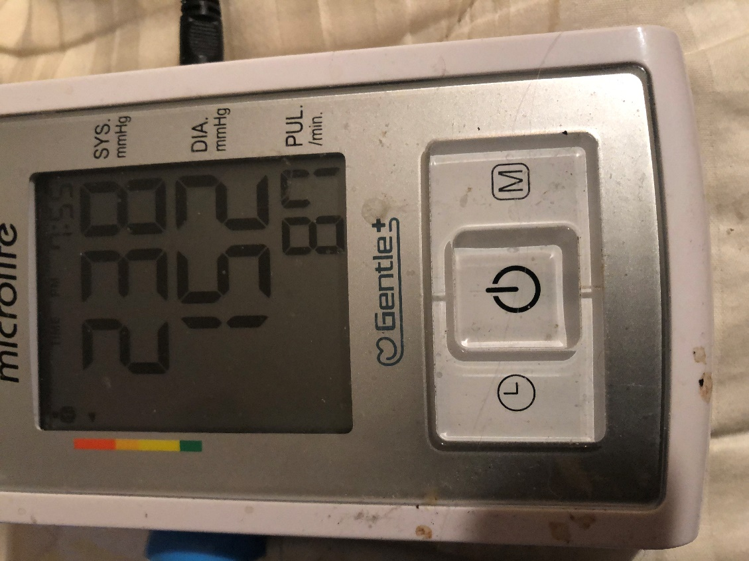
- Also see link @
http://www.heart.org/en/health-topics/high-blood-pressure/understanding-blood-pressure-readings/hypertensive-crisis-when-you-should-call-911-for-high-blood-pressure

- Therefore, Eliot requests a 30-day extension of time required by all other still ongoing medical issues.
WHEREFORE, Eliot respectfully prays that this Honorable Court grant the relief requested.
DATED: November 13, 2018
Respectfully submitted,
/s/ Eliot Ivan Bernstein
Cross and Counter-Plaintiff, Appellant
PRO SE
Eliot Ivan Bernstein
2753 NW 34th St.
Boca Raton, FL 33434
Phone (561) 245-8588
iviewit@iviewit.tv

CERTIFICATE OF SERVICE
Eliot Ivan Bernstein, Pro Se certifies that he filed a “Motion for Extension of Time to File Brief & For Reconsideration of Pro Bono Counsel and Informa Pauperis Status” via ECF filing and served copies of same upon those listed below via ECF or email on this 13th day of November, 2018.

/s/ Eliot Ivan Bernstein
Cross and Counter-Plaintiff, Appellant
PRO SE
Eliot Ivan Bernstein
2753 NW 34th St.
Boca Raton, FL 33434
Phone (561) 245-8588
iviewit@iviewit.tv

SERVICE LIST
Service List Case USDC NDIL 13-cv-03643 - IL Insurance
# | Law Firm / Attorneys | Address/Emails | Party Represented
1 | The Simon Law Firm /  David B. Simon, Esq.,  Adam M. Simon, Esq. | 303 East Wacker Drive  Suite 210  Chicago IL 60601-5210  dsimon@stpcorp.com,  asimon@chicago-law.com | Ted Bernstein (Individually & Alleged Trustee),  Pamela Simon,  Jill Iantoni,  Lisa Friedstein,  1995 Simon L. Bernstein Insurance Trust,  Adam Simon (Personally & Professionally),  David Simon (Personally & Professionally,  The Simon Law Firm,  S.T.P. Enterprises, Inc.
2 | Mrachek, Fitzgerald, Rose, Konopka, Thomas & Weiss, P.A. /  Alan B. Rose, Esq. | 505 South Flagler Drive  Suite 600  West Palm Beach, Florida 33401  +1 (561) 355-6991  arose@mrachek-law.com, arose@pm-law.com, mchandler@mrachek-law.com | Ted Bernstein
3 | Burke, Warren, MacKay & Serritella, P.C. /  Frederic A. Mendelsohn, Esq.,  Alexander "Alex" David Marks, Esq. | 330 N. Wabash Ave., 22nd Floor  Chicago, Illinois 60611  312-840-7000  312-840-7900 (facsimile)  amarks@burkelaw.com,  fmendelsohn@burkelaw.com | Jackson National, Heritage Union
4 | Law Offices of Glenn E. Heilizer / Glenn E. Heilizer, Esq. | Five North Wabash Avenue  Suite 1304  Chicago, IL 60602  +1 (312) 759-9000  glenn@heilizer.com | JPMorgan Chase Bank, N.A.
5 | Stamos & Trucco LLP /  James J. Stamos, Esq.,  Kevin P. Horan, Esq. | 1 E. Wacker Drive  3rd Floor  Chicago, IL 60601  312-630-1208  khoran@stamostrucco.com,  jstamos@stamostrucco.com | Intervenor Simon Estate, PR Brian O'Connell
6 | McVey & Parsky, LLC /  John M. O'Halloran, Esq. | 30 N. LaSalle St.,  Suite 2100  Chicago, Illinois 60602  (312) 551-2457  joh@mcveyparsky-law.com | William Stansbury Intervenor
7 | Purcell & Wardrope, Chtd. / Michael Duane Sanders, Esq.,  Thomas B. Underwood, Esq. | 10 South LaSalle Street  Suite 1200  Chicago, IL 60603  (312) 427-3900  mds@pw-law.com,  tbu@pw-law.com | Donald Tescher, Robert Spallina, Tescher & Spallina, P.A.
8 | Myron M. Cherry & Associates, LLC /  Theodore Herbert Kuyper | 30 N. LaSalle St.  Suite 2300  Chicago, IL 60602  (312) 372-2100 | Brian O'Connell
9 | Matrix Mediation /  Ronald Alvarez,  Rodney G Romano | 1655 Palm Beach Lakes Boulevard  Suite 700 and Suite 710  West Palm Beach, Florida 33401  (800) 379.2580  ron@matrixmediation.com,  tamara@matrixmediation.com,  eservicematrixmediation@gmail.com ,
10 | ADR & MEDIATIONS SERVICES, LLC / Diana Lewis Fla. Bar No. 351350 - GAL | 2765 Tecumseh Drive  West Palm Beach, FL 33409  (561) 758-3017  dzlewis@aol.com | Joshua, Jacob & Daniel Bernstein
11 | Pro Se |  | Eliot Bernstein  2753 NW 34th St  Boca Raton, FL 33434  561-245-8588  iviewit@iviewit.tv,  iviewit@gmail.com,  tourcandy@gmail.com
12 | Unrepresented |  | Pamela Beth Simon  950 North Michigan Avenue  Suite 2603  Chicago, IL 60611  +1 (312) 819-7474 x Ext. 414  psimon@stpcorp.com,
13 | Unrepresented |  | Jill Iantoni  2101 Magnolia Lane  Highland Park, IL 60035  +1 (312) 804-2318  jilliantoni@gmail.com
14 | Unrepresented |  | Lisa Friedstein,  Carly Friedstein,  Max Friedstein  2142 Churchill Lane  Highland Park, IL 60035  +1 (847) 877-4633  lisa@friedsteins.com,  lisa.friedstein@gmail.com

Service List Case 50-2012-CP-004391-XXXX-NB - Simon Estate
# | Law Firm / Attorney | Address/Emails | Party Represented
1 | Tescher & Spallina, PA /  Donald R. Tescher, Robert L. Spallina | Boca Village Corporate Center I  4855 Technology Way  Suite 720  Boca Raton, FL 33431  (561) 997-7008  dtescher@tescherlaw.com,  dtescher@tescherspallina.com,  ddustin@tescherlaw.com,  rspallina@comcast.net,  rspallina@tescherspallina.com | Estate Simon Bernstein,  CO-PR Robert Spallina,  CO-PR Donald Tescher,  Tescher & Spallina, PA,  Robert Spallina (Personally & Professionally),  Donald Tescher (Personally & Professionally),  Ted Bernstein
2 | Shendell & Pollock, P.L. /  Gary R. Shendell, Esq.,  Kenneth S. Pollock, Esq.,  Matthew A. Tornincasa, Esq.,  Mimi K. McAndrews, Esq. | 2700 N. Military Trail  Suite 150  Boca Raton, FL 33431  +1 (561) 241-2323  ken@shendellpollock.com,  gary@shendellpollock.com,  estella@shendellpollock.com,  grs@shehndellpollock.com,  mimi@shendellpollock.com,  britt@shendellpollock.com,  matt@shendellpollock.com,  robyne@shendellpollock.com | Tescher & Spallina, PA
3 | The Law Office of Irwin J. Block PL /  Irwin J. Block, Esq. | 700 South Federal Highway  Suite 200  Boca Raton, Florida 33432  +1 (561) 910-3071  ijb@ijblegal.com | Donald Tescher, Limited Appearance
4 | Mark R. Manceri, P.A. /  Mark R. Manceri, Esq. - Bar Number: 444560 | 1600 S Federal Hwy  Ste 900  Pompano Beach, FL 33062-7520  954-491-7099  mrmlaw@comcast.net,  mrmlaw1@gmail.com | Co-PR Robert Spallina,  CO-PR Donald Tescher,  Bernstein Family Realty (BFR),  Ted Bernstein,  Mark R. Manceri, Esq. (Professionally & Personally)
5 | Mrachek, Fitzgerald, Rose, Konopka, Thomas & Weiss, P.A. /  Page, Mrachek, Fitzgerald & Rose, P.A. /  Alan B. Rose, Esq. | 505 South Flagler Drive  Suite 600  West Palm Beach, Florida 33401  +1 (561) 355-6991  arose@mrachek-law.com,  arose@pm-law.com,  mchandler@mrachek-law.com | Ted Bernstein (Individually & as Successor Trustee to Simon Trust),  Attorney Alan B. Rose, Esq. (Personally & Professionally),  Page, Mrachek, Fitzgerald & Rose, P.A.
6 | Pankauski Law Firm PLLC /  John J. Pankauski, Esq. | 120 South Olive Avenue  7th Floor  West Palm Beach, FL 33401  +1 (561) 514-0900  john@pankauskilawfirm.com,  courtfilings@pankauskilawfirm.com,  Michelle@Pankauskilawfirm.com | Ted Bernstein,  Attorney John Pankauski, Esq. (Personally & Professionally),  Pankauski Law Firm PLLC
7 | Matwiczyk & Brown, LLP /  Benjamin Brown, Esq. (Deceased) | 625 No. Flagler Drive  Suite 401  West Palm Beach, FL 33401  +1 (561) 651-4004  bbrown@matbrolaw.com,  pmatwiczyk@matbrolaw.com,  attorneys@matbrolaw.com,  bhenry@matbrolaw.com | Estate Simon Bernstein as Curator
8 | Ciklin Lubitz Martens & O'Connell /  Brian M. O'Connell, Esq. PA,  Joielle "Joy" A. Foglietta Esq.,  Ashley Crispin Ackal, Esq. | 515 N Flagler Dr  20th Floor  West Palm Beach, FL 33401  +1 (561) 832-5900  boconnell@ciklinlubitz.com, jfoglietta@ciklinlubitz.com, CAnderson@ciklinlubitz.com, | Estate Simon Bernstein,  Brian O'Connell PR
9 | O'Connell & Crispin Ackal, PLLC /  Brian M. O'Connell, Esq. PA,  Joielle "Joy" A. Foglietta Esq.,  Ashley Crispin Ackal, Esq. | 420 Royal Palm Way  Suite 300  Palm Beach, FL 33480  +1 (561) 355-0403  boconnell@ocalawyers.com,  service@OCAlawyers.com,  acrispinackal@ocalawyers.com,  secondaryservice@OCAlawyers.com,  jfoglietta@ocalawyers.com,  dreed@OCAlawyers.com | Estate Simon Bernstein,  Brian O'Connell PR
10 | Barner & Barner, P.A. /  Thornton "Brad" Henry, Esq.,  Brett C. Barner, Esq. | Mirasol Town Square  11360 Jog Road, Suite 104  Palm Beach Gardens, FL 33418  +1 (561) 296-7771  bhenry@barnerlaw.com,  bbarner@barnerlaw.com,  service@barnerlaw.com | Ciklin Lubitz fka Ciklin Lubitz Martens & O'Connell
11 | Peter M. Feaman, P.A. /  Peter M. Feaman, Esq.,  Nancy Guffey, Esq. | 3695 W. Boynton Beach Blvd.  Suite 9  Boynton Beach, FL 33436  +1 (561) 734-5552  pfeaman@feamanlaw.com,  mkoskey@feamanlaw.com,  service@feamanlaw.com,  nguffey@feamanlaw.com | William E. Stansbury
12 | Golden Cowan, P.A. /  William Henry Glasko, Esq. | 17345 S. Dixie Highway  Miami, FL 33157  +1 (305) 809-7913  EService@PalmettoBayLaw.com,  Tmealy@gcprobatelaw.com,  bill@PalmettoBayLaw.com | Lisa Friedstein,  Jill Iantoni,  Julia Iantoni,  Max Friedstein,  Carly Friedstein
13 | Perlman, Bajandas, Yevoli & Albright, P.L. /  Paul D. Turner, Esq. (FL Bar No. 113743)  Miguel Armenteros, Jr., Esq. (FL Bar No. 14929) | 200 S Andrews Avenue  Suite 600  Fort Lauderdale, FL 33301  +1 (954) 566-7117  pturner@pbyalaw.com,  miguel@pbyalaw.com,  rking@pbyalaw.com,  eservicemia@pbyalaw.com,  mzucker@pbyalaw.com,  eserviceftl@pbyalaw.com | Joshua Ennio Zander Bernstein
14 | Marc J. Soss, Esq. | 2070 Ringling Blvd  Sarasota, FL 34237  P.O. Box 110127  Lakewood Ranch, FL 34211  +1 (941) 928-0310  mjs@fl-estateplanning.com | Joshua Ennio Zander Bernstein
15 | ADR & MEDIATIONS SERVICES, LLC / Diana Lewis Fla. Bar No. 351350 - GAL | 2765 Tecumseh Drive  West Palm Beach, FL 33409  (561) 758-3017  dzlewis@aol.com | Joshua, Jacob & Daniel Bernstein
16 | John P. Morrissey, P.A. /  John Patrick Morrissey, Esq. (FL Bar No. 993727) | 330 Clematis Street  Suite 213  West Palm Beach, FL 33401  +1 (561) 833-0866  john@jmorrisseylaw.com | Alexandra Bernstein,  Eric Bernstein,  Michael Bernstein,  Molly Simon
17 | Huth, Pratt & Milhauser f.k.a.  Huth & Pratt /  Brandan J. Pratt, Esq. (FL Bar No. 0745) | 2500 N Military Trl Ste 312  Boca Raton, FL 33431-6324  Office: 561-392-1800  Cell: 561-392-1800  Fax: 561-392-3535  bpratt@hpmlawyers.com | Eliot Bernstein
18 | Roth & Duncan, P.A. /  David Roth, Esq. (FL Bar No. 116023) | 515 N Flagler Dr  Ste 325  West Palm Beach, FL 33401-4349  +1 (561) 655-5529  droth@rothduncan.com | Kimberly Francis Moran (Personally & Professionally)
19 | Matrix Mediation /  Ronald Alvarez,  Rodney G Romano | 1655 Palm Beach Lakes Boulevard  Suite 700 and Suite 710  West Palm Beach, Florida 33401  (800) 379.2580  ron@matrixmediation.com,  tamara@matrixmediation.com,  eservicematrixmediation@gmail.com ,
20 | Pro Se |  | Eliot Bernstein  2753 NW 34th St  Boca Raton, FL 33434  561-245-8588  iviewit@iviewit.tv,  iviewit@gmail.com,  tourcandy@gmail.com
21 | Unrepresented |  | Jacob Noah Archie Bernstein  2753 NW 34th St  Boca Raton, FL 33434  561-245-8588  telenetjake@gmail.com
22 | Unrepresented |  | Daniel Elijsha Abe Ottomo Bernstein  c/o Eliot & Candice Bernstein  2753 NW 34th St  Boca Raton, FL 33434  561-245-8588  iviewit@iviewit.tv,  tourcandy@gmail.com
23 | Unrepresented |  | Joshua Ennio Zander Bernstein  2753 NW 34th St  Boca Raton, FL 33434  561-245-8588  telenetjosh@gmail.com
24 | Unrepresented |  | Matthew Logan
25 | Unrepresented |  | Pamela Beth Simon,  Molly Simon  950 North Michigan Avenue  Suite 2603  Chicago, IL 60611  +1 (312) 819-7474 x Ext. 414  psimon@stpcorp.com,  molly.simon1203@gmail.com
26 | Unrepresented |  | Jill Iantoni  2101 Magnolia Lane  Highland Park, IL 60035  +1 (312) 804-2318  jilliantoni@gmail.com
27 | Unrepresented |  | Lisa Friedstein,  Carly Friedstein,  Max Friedstein  2142 Churchill Lane  Highland Park, IL 60035  +1 (847) 877-4633  lisa@friedsteins.com,  lisa.friedstein@gmail.com,  mscarly@gmail.com,  khoolmax@gmail.com
28 | Unrepresented |  | Michael Bernstein,  Eric Bernstein,  Alexandra Bernstein  880 Berkley Street  Boca Raton, FL 33487  alb07c@gmail.com,  mchl_bernstein@yahoo.com,  edb07fsu@gmail.com
29 | Unrepresented |  | Lindsay Baxley aka Lindsay Giles (Personally & Professionally)
30 | Unrepresented |  | Kimberly Francis Moran (Personally & Professionally)

