! \'

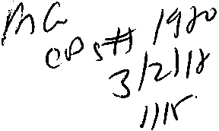Filing # 68506733 E-Filed 02/27/2018 11:07:44 AM

CASE NO.: 50-2018-CA-002317

WALTER E. SAHM and PATRlCIA SAHM

Plaintiffs,

v.

BERNSTEIN FAMILY REALTY, LLC and ALL UNKNOWN TENANTS.

Defendant
IN THE CIRCUIT COURT OF THE 15TH JUDICIAL CIRCUIT, IN AND FOR PALM BEACH COUNTY, FLORIDA

SUMMONS

TO DEFENDANT: BERNSTEIN FAMILY REALTY LLC
Clo DONALD R. TESCHER
925 S.FEDERAL IDGHWAY
SUITE 500
BOCA RATON, FL 33432

IMPORTANTE/IMPORTANT
En Espaftol AI Dorso/Fran9ais Au Verso IMPORTANT

A lawsuit has been filed against you. You have twenty (20) calendar days after this Summons is served on you to file a written response to the attached Complaint in this Court. A phone call will not protect you; your written response, including the above case number and named parties must be filed if you want the Court to hear your case. Ifyou do not file your response on time, you may lose the case, and your wages, money and property may thereafter be taken without further warning from the Court. There are other legal requirements. You may want to call an attorney right away. If you do not know an attorney, you may call an attorney referral service or legal aid office (listed in the phone book).

If you choose to file a written response yourself, at the same time you file your written response to the Court, located at: Palm Beach County Courthouse, Clerk of Courts, 205 North Dixie Highway, West Palm Beach, FL 33401, you must also mail or ,fake a carbon copy or photocopy of your written response to the Plaintiff's Attorney named below:

FILED: PALM BEACH COUNTY, FL, SHARON R. BOCK, CLERK, 02/27/2018 11:07:44 AM

WALTER E. SAHM AND PATRICIA SAHM v BERNSTEIN FAMILY REALTY LLC AND ALL UNKNOWN TENANTS CASE NO. 50-2018-CA-002317 ; PALM BEACH COUNTY

Plaintiff's Attorney: Robert Sweetapple, Esquire
SWEETAPPLE, BROEKER & VARK.AS, PL
150 East Boca Raton Road Boca Raton, Florida 33432 Telephone: (561) 392-1230

THE STATE OF FLORIDA

TO EACH SHERIFF OF THE STATE: You are commanded to serve this Summons and a copy of the Complaint in this lawsuit on the above named Defendant.

DATED o"'Eeb=u;c2'&
Mar 01 2018

SHARON R. BOCK,
As Clerk of the Court

(COURT SEAL) By:_ -
As Deputy Clerk
SHANNON FATU
IMPORTANTE

Usted ha sido demandado legalmente. Tiene 20 Dias, contados a partir del recibo de esta notificacion, para contestar la demanda adjunta, por escrito, y presentarla ante este tribunal. Una Hamada telefonica no lo protegera. Si usted desea que el tribunal considere su defensa, debe presentar su respuesta por escrito, incluyendo el numero del caso y los nobres de las partes interesadas. Si usted no contesta la demanda a tiempo, pudiese perder el caso y prodria ser despojado de sus ingresos y propiedades, o privado de sus derCchos, sin previo aviso del tribunal. Existen otros reguisitors legales. Si lo desea, puede usted consultar a un abogado immediatarnente. Si no conoce a un abogado, puede Hamar a una de las oficinas de asistencia legal que aparecen en la guia telefonica.

Si desea responder a la demanda por su cuenta, al mismo tiempo en que presenta su respuesta ante el tribunal, debera usted enviar por correo o entregar una copia de su respuesta a la persona denominada abajo como "Plaintiff/Plaintitl's Attorney'' (Demandante o Abogado de!Demandante).

IMPORTANT

Des poursuites judiciares ont ete entreprises contre Yous. Vous aYez 20 jours consecutifa a partir de la date de
!'assignation de cette citation pour deposer une reponse ecrite a la plainte ci-jointe auprps de ce tribunal. Un simple coup de telephone aYec mention du numero de dossier ci-dessus et du nom des parties nommees ici, si Yous souhaitez que le tribunal entende Yotre cause. Si Yous ne deposez pas Yotre reponse excite dans le relai requis, Yous risquez de perdre la cause ainsi que Yotre salaire, votre argent, et vos biens peuvent etre saisis par la suite, sans aucun preavis ulterieu du tribunal. Il ya d'autres obligations juridiques et vous pouvez requerir les service un service de reference d'ayocats ou a un bureau d'assistance juridique (figurant a l'annuaire de telephones).

Si Yous choisissez de deposer vous-meme une repones ecrita, i1Yous faudra egalment en meme temps que cette fonnalits, faire parvenir ou expedier une copie de votre reponse ecrite au 11PJaintiff/Plaintiffs Attoniey 0 (Plaignant ou a son aYoicat) nomme ci-dessous.

2

Filing # 68395751 E-Filed 02/23/2018 02:46:11 PM

FORM 1.997. CIVIL COVER SHEET

The civil cover sheet and the Information contained In It neither replace nor supplement the flllng and service of pleadings or other documents as required by law. This form must be flied by the plaintiff or petitioner for the use of the Clerk of
Court for the purpose of reportingjudicial workload data pursuant to section 25.075, Florida Statutes. (See Instructions for completion.)

I. CASE STYLE

IN THE CIRCUIT COURT OF THE FIFTEENTH JUDICIAL CIRCUIT, IN AND FOR PALM BEACH COUNTY, FLORIDA

Walter E Sahm. Patricia Sahm
Plaintiff
Case No.:. _
Judge: _

vs.

Berstein Family Realty LLC
Defendant

- TYPE OF CASE

0 Condominium
0 Contracts and indebtedness D Eminent domain
Q Auto negligence
D Negligence - other
g Business governance
D Business torts
0 EnvlronmentaVToxlc tort D Third party Indemnification D Construction defect
D Mass tort
D Negligent security
D Nursing home negligence

Q Premises llablllty - commercial D Premises liability - residential
Q Products llablllty
Real Property/Mortgage foreclosure
D Commercial foreclosure $0 - $50,000
D Commercial foreclosure $50,001 - $249,999
Q Commercial foreclosure $250,000 or more
Q Homestead residential foreclosure $0 - 50,000
Jill Homestead residential foreclosure $50,001 -
$249,999
0 Homestead residential foreclosure $250,000 or more
Q Non-homestead residential foreclosure $0 -
$50,000
Q Non-homestead residential foreclosure
$50,001 -$249,999
Q Non-homestead resldentlal foreclosure
$250,00 or more
Q Other real property actions $0 - $50,000
Q Other real property actions $50,001 - $249,999
Q Other real property actions $250,000 or more

Q Professional malpractice
 | Q  Q | Malpractice - business  Malpractice - medical
 | Q | Malpractice - other professional
Q | Other
 | D | Antitrust/Trade Regulation
 | Q | Business Transaction
 | Q | Circuit Clv\1 - Nol Applicable
 | Q | Constltutlonal challenge-slalule or
 |  | ordinance
 | Q | Constitutlonal challenge-proposed  amendment
 | Q | Corporate Trusts
 | Q | Discrimination-employment or other
 | Q | Insurance claims
 | Q | Intellectual property
 | Q | Libel/Slander
 | Q | Shareholder derivative action
 | D | Securities litlgatlon
 | D | Trade secrets
 | Q | Trust llligatlon

COMPLEX BUSINESS COURT

This action Is appropriate for assignment to Complex Business Court as delineated and mandated by the Administrative Order. Yes 0 No .@

Ill. REMEDIES SOUGHT (check all that apply):
.@ Monetary;
181 Non-monetary declaratory or Injunctive relief;
0 Punitive

  - NUMBER OF CAUSES OF ACTION: ( (Specify)

!

  - IS THIS CASE A CLASS ACTION LAWSUIT?
0 Yes
181 No

VI. HAS NOTICE OF ANY KNOWN RELATED CASE BEEN FILED?
181 No
0 Yes - If ''yes" list all related cases by name, case number and court:

VII. IS JURY TRIAL DEMANDED IN COMPLAINT?
0 Yes
J1i1. No

I CERTIFY that the Information I have provided In this cover sheet Is accurate to the best of my knowledge and belief, and that Ihave read and will comply with the requirements of Florida Rule of Judicial Administration 2.425.

Signature s/ Robert A Sweetapple Attorney or party
FL Bar No.: 296988

(Bar number. If attorney)

Robert A Sweetapple 02/23/2018
(Type or print name) Date

Filing # 68395751 E-Filed 02/23/2018 02:46:11 PM

IN TIIE CIRCUIT COURT OF TIIE 15rn JUDICIAL CIRCUIT IN AND FOR PALM BEACH COUNTY, FLORIDA

CASE NO.:

WALTER E. SAHM and PATRICIA SAHM

Plaintiffs,

v.

BERNSTEIN FAMILY REALTY, LLC and ALL UNKNOWN TENANTS.

Defendant

COMPLAINT FOR FORECLOSURE

Plaintiffs, WALTER E. SAHM, an individual, and PATRICIA SAHM, an individual, by and through their undersigned counsel, hereby sue BERNSTEIN FAMILY REALTY, LLC, a Florida Limited Liability Company, and allege:
JURISDICTION AND VENUE.

The Court has subject matter jurisdiction over this action be<:ause it is both an action in equity seeking to foreclose a mortgage on real property, and because it is an action seeking to enforce a promissory note for damages in excess of fifteen thousand dollars ($15,000.00).
- Venue is proper in Palm Beach County, pursuant to § 47.011, Florida Statutes,

because Palm Beach County is the county inwhich the subject property is located.
'
- All conditions precedent and necessary to bring this cause of action either have been performed, have occurred, have been waived, or otherwise excused.

Walter E. Sahm and Patricia Sahm v..Bernstein Family Realty, LLC: Case No.:
Complaint for Foreclosure.

PARTIES1

- Plaintiff, WALTER E. SAHM ("Mr. Sahm"), is an individual residing in Palm Beach County, Florida, and at all times material was suijuris.
- Plaintiff, PATRICIA SAHM ("Mrs. Sahm"), is an individual residing in Plilm Beach County, Florida, and all times material was suijuris.
6. Defendant, BERNSTEIN FAMILY REALTY, LLC ("BFR") is an administratively

dissolved Florida Limited Liability, with its principal place of business in Boca Raton, Florida, and its registered agent, T&S Registered Agents, LLC, also located in Boca Raton, Florida.
COUNT I -FORECLOSURE OF MORTGAGE

This action seeks to foreclose a mortgage on real property which secures an outstanding debt owed under a promissory note between the parties.
- On June 20, 2008, BFR entered into a Promissory Note ("Note") with the Sahms, agreeing to pay the Sahms the sum of $110,000.00 plus interest under terms set forth in the Note. Exhibit "1".
- On June 20, 2008, BFR executed a Mortgage on real property in favor of the Sahms as collateral to the debt owed under the Note. Composite Exhibit "2".
- The Mortgage was recorded on June 26, 2008 in the Public Records of Palm Beach County, Florida: O.R. Book 22723, Page 0691.
- On February 15,2012, BFR and the Sahms executed an Amendment to Mortgage and Promissory Note ("Amendment" to the Note and Mortgage). Composite Exhibit "3".

1Mr. Sahm and Mrs. Sahm may collectively be referred to as the "Sahms".
2

Walter E. Sahm and Patricia Sahm v. Bernstein Family Realty, LLC. Case No.:
Complaint for Foreclosure.

The Amendment was recorded on April 12, 2012 in the Public Records of Palm Beach County, Florida: O.R. Book 25132, Page 1051.
- The Sahms both own and hold both the Note and Mortgage.

- BFR owns the subject property and is in possession of it.

- BFR defaulted under, and subsequently breached its obligations under both the Note and Mortgage by failing to make all necessary payments under the Note, Mortgage, and Amendment.
- As of the date of the filing of this lawsuit, BFR owes the Sahms at least

$187,163.80, exclusive of both attorney's fees and costs.

WHEREFORE, Plaintiffs, WALTER E. SAHM and PA1RICIA SAHM, pray for a final judgment of foreclosure against Defendant, BERNSTEIN FAMILY REALTY, LLC:
  - concluding that Plaintiffs' Mortgage is a valid Lien on the subject property

and is superior to any lien of record;

- foreclosing Plaintiffs' Mortgage;

- foreclosing of all Defendants named in this action;:

- delivering full possession of the subject property to Plaintiffs;

- retaining jurisdiction for the Court to determine any deficiency to which Plaintiffs may be entitled; and
f. retaining jurisdiction to determine the reasonable amount of both attorney's fees and costs which Plaintiffs are entitled to recover against Defendant; and
g. any other relief which the Court deems just and proper.

3

Waltor E. Sahm and Patricia Sahm y. Bornstein Family Realty, LLC.
Caso No.:
Complaint for Foreclosure.

ATTQRNEY FEE DEMAND

Plaintiffs, WALTER E. SAHM and PATRICIA SAHM, have retained the undersigned law firm to represent them inthis action. The Note, which the Sahms are suing to enforce, contains an attorney's fees provision. Florida Statute §57.105(7) state that "if a contract contains a provision allowing attorney's fees to a party when he or she is required to take any action to enforce the contract, the court may also allowreasonable attorney's fees when that party prevails in any action, whether as plaintiff or defendant, wHh respect to the contract." Thus, if the Sahms are the prevailing party inthis action, then the Sahms are entitled to recover their attorney'sfees and costs from Defendant, BERNSTEIN FAMILY REALTY, LLC. Plaintiffs hereby exercise that right.

Respectfully submitted,

SWEETAPPLE, BROEKER & VARKAS, P.L.

Attorneys for Plaintiffs 20 SE 3rd Street
Boca Raton, Florida 33432 Telephone: (561) 392-1230
Email: Pleadings@sweetapplelaw.com

By: Isl Alexander D. Varkas III ALEXANDER D. VARKAS Jiil
Florida Bar No.: 95773

4

PROMISSORY NOTE

suo,000.00 June 20, 2008
Boca Raton, Palm Beach County, Florida

FOR VALUE RECEIVED, the uodersigned promise to pay to the order of Walter'E. Sahm and Patricia Sahm, his wife at 8230 SE l77th Wlntertbru Loop, The VUlages, FL 32162 or at such other address as may be indicated in writing, in tho manner hereinafter specified, the principal sum of One Hundred Ten Thousand and 00/100 Dollars ($110,000.00) with interest from the date hereof, at the rate of Six and One Half percent (6.5%) per annum on the balance from time to time remaining unpaid. Tho said principal and interest shall be payable in lawful money of the United States of Am6rica, on the date and in the following manner:

The sum of $7,150.00 representing a payment of interest only shall be due and payable on June 19, 2009, and on June 19, 2010, and on June 19,2011 at which time all unpaid principal and accrued but unpaid interest shall be due and payable in full.

All paymenta shall be first applied to late charges, if any, Oten to the payment of accrued interes and the balance remaining, ifany, shall be applied to Ote payment of the principal sum.

This note may be prepaid, inwhole or inpart, without penalty, at any time prior to maturity.

This note with interest is secured by a purchase money mortgage, of even date herewith, the temlB of which a.re incol}lorated herein by reference, made by the makers hereof in lilvor of the said payee, is given as part of Oto purchase price of the real property described in the mortgage, and shall be C.nstrued and enforced according to the laws of Oto State of Florida.

Ifdefault be made in the payment of any installment under this note, and ifsuch default is not mad• good within 15days, Ote ontire principal sum and accrued interest shall at once become due and payable. without notico at Ote option of the holder of this Note. Failure to exercise this option shall not constitute a waiver of the right to exercise the same at a later time for the samo default or for any subsequent default Any payment not received within 10 days of the due dato shall Include a late charge of 5% of the payment due. In the event of default in the payment of this note, interest shall accrue at the highest rate pennitted by law, and ifthe same is placed in the hands of any attorney for collection, the undersigned heroby agree to pay all costs of collection, including a reasonable attorneys' fee.

Makers waive demand, presenbnent for payment, protest, and notice of nonpayment and dishonor.

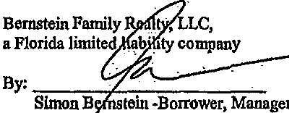

(Corporate Seal)

The state documentary tax due on this Note has been paid on the Mortgage securing this indebtedness.

t
EXHIBIT
j_
DoubteTimet

,.

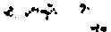

Preriared by and return to: John M: Cappeller, Jr. Florida Tiiie & Closing Co.
350 Camino Gardens Blvd. Suite 303 Boca Raton, FL 33432
561-392-3636

l:!!XHIBIT
l . . .
. m ?..
11011IllllllllDIRllYIHlllll 11 11iIDH

CFN 20080241511
OR BK 22723 PG 0691
RECORDED 06/26/2008 09106117
Pala Beach County, Florida
AHT 110,000.00
Deed Doc 385.00
Intang 220.00
Sharon R.Book,CLERK & COMPTROLLER
Pga 0691 - 6941 14pga>

File Number: FTil8-087Will Call No.: 159

[Space Above This UncFor Recording Data. -----------

_TI_D_S_l_S_A BA_L_L_OON-=M-0-R"""TGAGE AND THE FINAL PRINCIPAL PAYMENT
OR THE PRINCIPAL BALANCE DUE UPON MATURITY IS $110,000.00, TOGETHER WITH ACCRUED INTEREST, IF ANY, AND ALL ADVANCEMENTS MADE BY THE MORTGAGEE UNDER THE TERMS OF TIDS MORTGAGE.
MORTGAGE
This Indenture, Made this June 20, 2008 by and between Bernstein Family Realty, LLC, a Florida limited liability company whose address is 950 Peninsula Corporate Circle, Suite 3010, Boes Raton, FL 33431, hereinafter called the Mortgagor, and Walter E. Sahm and Patricia Sahm, his wife whose address is 8230 SE 177tb Wlntertbru Loop, The Villages,FL 32162, hereinafter called the Mortgagee:

The terms "Mortgagor" and "Mortgagee11 shall Include heirs, personal representatives, successors, lesal representatives and assigns, and shall denote the singular and/or the plural, and the masculine and/or the femfntnc and natural and/or artificial persons, whenever and wherever the context so admits or requires.

Witnesseth, that the said Mortgagor, for and in consideration of the aggregate sum named in the promissory note, a copy of which is attached hereto and made a part hereof, tho receipt of which Is hereby aclmowlodged, does grant, bargain and sell to the said Mortgagee, his successors and assigns, infee simple, the following described land, situate, lying and being in Palm Beach County, Florida, to.wit:

Lot 68, Block G, BOCA MADERA UNIT 2, according to the Plat thereof, recorded In Plat Book 32, Pages 59 AND 60, of the Public Records of Palm Beach County, Florida.

And the ssid Mortgagor does hereby fully warrant the title to said land, and will defend the same against the lawful claims of
all persons whomsoever.

Provided always, that if said Mortgagor, his successors or assigns, shall pay unto the said Mortgagee, his successors or assigns, .that certain promissory note, of which a true and correct copy is attached, and Mortgagor shall perfonn, comply with and abide by each and every stipulation, agreement, condition and covenant of said promissory note and of this mortgage, and shall duly pay all taxes, all insurance premiwm reasonably required, all costs and expenses including reasonable attorneys fees that Mortgagee may incur in collecting money secured by this mortgage, aod also in enforcing this mortgage by suit or otherwise, then this mortgage and the estate hereby created shall cease and be null and void.

Mortgagor hereby covenants and agrees:

I. To pay the principal and interest and other sums of money payable by virtue of said promissory note and this mortgage, or either. promptly on the days respectively the same severally cnme due.

2. To keep the buildings now or hereafter on the land insured for fire and extended coverage in a sum at least equal to the amount owed on the above described promissory note, and name the Mortgagee as loss payees, and to furnish Mortgagee with a copy of all current policies. If Mortgagor does not provide Mortgagee with copies of the pol.i es showing Mortgagee as loss payees after 14 days written demand by Mortgagee, then Mortgagee may purchase such: ura and

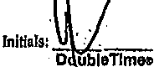

.

\

shall add any pa)'lllellts made fbr such policy to the principal balance owed on the mortgage, and such payments shall accrue interest at the maximwn rate of interest allowed by law. In the event any sum of money becomes payable under such policy, Mortgagee, his legal representatives or assigns, shall have the option to receive and apply the same on account of the indebtedness hereby secured or to permit Mortgagor to receive end use it or any part thereof for repair or replacemen without hereby waiving or impairing any equity, lien or right under or by virtue of thlB mortgage. In the event ofloss Mortgagor shall give immediate notice to Mortgagee.

3. To pemtlt commit or suffer no waste, bnpainnent or deterioration of the property, or any part thereof.
- To pennit no other lien or mortgage to be placed ahead of this mortgage.

- Mortgagor shall provide proof of payment of aenual real estate taxes by March IS, for the preceding years taxes. Inthe event that Mortgagor does not pay the taxes by such date, the Mortgagee may pay the taxes end the full amount of such payment by Mortgagee shall be added to the principal balance owed on the mortgage, and shall accrue interest at the maximum rate allowed by law.

- The Mortgagee may, at any time pending a suit npon this mortgage, apply to tho conrt having jurisdiction thereof for tho appointment of a receiver, and such court shall forthwith appoint a receiver, and such receiver shall have all the broad and effective functions and powers in anywise entrusted by a court to a receiver, end such appointmet shall ho made by such conrt as en admitted equity and a matter of absolute right to said Mortgagee. The rents, profits, income, issues, and reveuues shall be applied by such receiver according to tho lien of this mortgage.

- If any of the sums of money due and owing to Mortgagee under the terms of the promissory note and this mortgage, including but not limited to any advance made by Mortgagee fbr the payment of insurance or taxes, are not paid within 15 days after the same become due and payable. or ifeach of the stipulations, agreements, conditions and covenants of the promissory note and this mortgage, or either, are not fully performed or complied with the aggregate sum owed on the promissory note sbaU become due and payable forthwith or thereafter at the option of Mortgagee, his successors, legal representatives, or assigns.

This mortgage and the note hereby secured shall be couslrued and enforced according to the laws of the State of Florida.

Tho principal sum secured hereby, along with any interest to be paid in accordance with tho tenns of the noto secured hereby,. shall immediately become duo and payable without notice, If a transfer of title to the prerllises .bY._sale .or ot4erwtse" js..1JJ•de without the Mortgage•'• "Wiitte1f coiisen'While this mortgage remliliis alfmnnercoD;'iit ihe·option of'Mortgage;.hi!
successorS, legal-representatives, or assigns. .

Executed at Palm Beach County, Florida on the date written above. Signed, sealed and delivered in the presence of:
THIS IS A BALLOON MORTGAGE AND THE FINAL PRINCIPAL PAYMENT OR THE PRINCIPAL BALANCE DUE UPON MATURITY IS $110,000.00, TOGETHER WITH ACCRUED INTEREST, IF.ANY, AND ALL ADVANCEMENTS MADE BY THE MORTGAGEE UNDER THE TERMS OF THIS MORTGAGE.

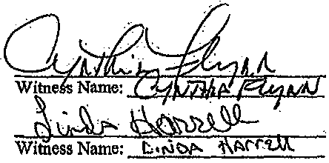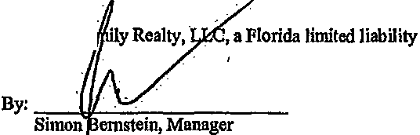
Bernstein Fa company

Floridn Mortgage {Seller) - Page 2 OoubleTlmet

.• ..... '

State of Florida County of Palm Beach

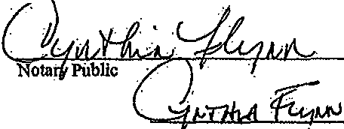The foregoing instnunent was acknowledged before mo thi§.20th day of June, 2008 by Simon Bernstein ofBemstein Family Realty, LLC, on behalf of the coi:poration. He/she personall . known to me or [X] has produced a driver's license as identification. · ·

[Nohlry Seal]

Printed Name:

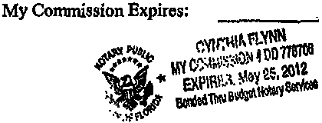

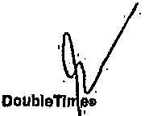Florida Mortgage (Seller)" Page 3

f r;O\ .
Y

.

'

'·
Prepared by and return to:

John M. Cappeller; Jr. Cappeller ·Law
John M. Cappeller, Jr.
350 Camino Gardens Blvd., Suite 303 Boua Raton, FL 33432
lll!111u1111111111 11mIim 111m 1111111mi110··
CFN 2Q120143493
OR ·BK 251_32 PG 1051
RECORDED .04/12/2012 09<21:00

Palm Beach County, lorida
Sharon R.Bock,CLERK. & COMPTROLLER
Pgs 1051 - 1054; C4pgs>

AMENPMENT TO MORTGAGE AND PROMISSORY NOTE

This AMENDMENT TO MORTGAGE AND PROMISSORY NOTE (this
"Amendment") is entered into effective the _./s_ day of February, 2012, among BERNSTEIN FAMILY REALTY, LLC, a Florida limited liability company, having an address at 950
Peninsula Corporate Circle, Suite 3010, Boca Raton, FL 33487 (the "Mort!ia. gor"), and WALTER E. SAHM.and PATRICIA SAHM, having an address at 8230·SE 177 Wlnterthru Loop, The Villages, FL 32162 (''Mortgagee").

WITNESS ETH
WHEREAS, Mortgagee granted Mortgage( a purchase money mortgage in th•amount 9f
$110,000.00, evidenced by that certain Promissozy Note dated June 20, 2008, (t!ie "Promissozy Note"); and

WHEREAS, the Promissozy Note is secured, inter alia. by that certain Mortgage dated June 20, 2008 from'Mortgagor .In favor of Mortgagee, recorded on June 26, :?008 in Official Records Book 22723, Page 691, of the Public Records of Palm Beach County, Florida (the ''Mortgage"); and ·

WHEREAS, Mortgagor has asked Mortgagee to extend the tenn of the Mortgage 8lld the Promissozy Note. (the "Amendment"); and

·· WHEREAS, to document the Amendment, 'Mortgagor is executing and delivering to Mortgagee this Amendment to Mortgage and Promissozy Note; ·

..•
DOCUMENTARY STAMP TAXES AND INTANGIBLE TAXES ON THE ORIGINAL INDEBTEDNES!t OF $110,000.00 WERE PAID ·IN FULL UPON THE RECORDING OF THE MORTGAGE AND SECURITY AGREEMENT. DATED JllNE 20, W08 AND
RECORDED ON JUNE 26, 2008 IN OFFICIAL imc;oRl>s BOOK.22723 PAGE 691, IN

THE Ptl'BLI(:RECORDS OFPALM BEACH, FLOIUD;\.
.
EXHIBl.T
1. s

1

.. t: ,.

NOW REFORE, in consideration of the foregoing premises and other valuable considerath>n, the .receipt and suffiiency of which is hereby acknowl"lfged, the parties hereio hereby e as follows:

- Amendment to Mortgage and Promissory Note. Effectlve·June 19, 2011, the parties hereto ame\id the Mortgage and Promissory l;fote to provide that by agreement the date on whlch·all principalis due and payable is hereby extended to June 19, 2014. Annual payments of interest only at the rate of 3.5% per annum sha\l continue to be due on the anniversary date cif the Promissory Note until June 19, 2014 when all unpaid principal and aocrued interest shall be due and payable infull. · · ·

  - · Configpation and Ratification. Morigagor hereby ratifies and confirms All its obligations set·forth in the Mortgage' and Promissory Note. Mortgagor hereby certifies to Mortgagee that no event of default has o.ecurred ·under such documents, nor any event which, · with the giving of notice or the passage of time or both, would constitute such an event of default Mortgagor hereby represents and warrants to Mortgagee that Mortgagor has no defense or offsets against the payment of any amounts due, or the performance of any obligations required by,.the Loan Documents.

  - Miscellaneous.

    - Except as expressly amended herein, the Mortgage and Promissory Note remain infull force and effect.

- This.Amendment l!l•Y be executed inmultiple counterparts each of which, whn Ween together, shall constitute·one and the same instrument.

- . Jn the event of any inconsistency between the terms contained herein, and the provisions of Mortgage and Promissory Note; the terms of this Amendment shall govern.

(d) The individual executing this document hereby certifies ·that he has authority to eng,age in and execute this Amendment to Mortgage and Promissory Note. ·

SEE EXECUTION BLOCK ON NEXT PAGE

2

I(
"

IN.WITNESS WHEREOF, the parties hereto have executed this Amendment as. of the day and year first above written.

Signed, ·sealed and·delivered
itlthe presence of: ..
WITNESSES: MORTGAGOR:

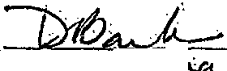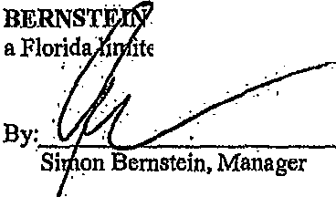
. FAMILY REALTY, 'LLC,
1 itea liability compati

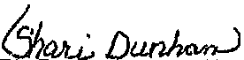Print Name: Sha.-; {Jwi ha'r'o

STATE OF FLORIDA COUNTY OF PALM BEACH
The foregoing instrument was acknowledged before "me this l'5day of February,
2012, by Shnon Bernstein, as Manager of Bernstein .Family Realty, LLC, a Florida limited liabil\ty company.He ..JL_ is personally known to me or has jltoduced a driver's license . as identification. '
(Seal) 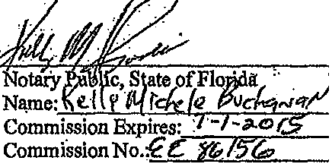



3

f'.•• '
. .
... . .

(," (
'·· ..

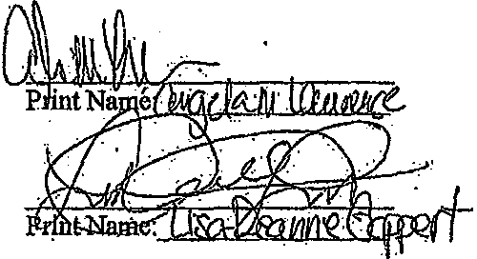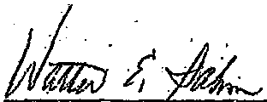WITNESSES; M:O'J:GAGEE:

Walter E. Sahm'
i!a1\ J cJa

u' a., /9 . .

Patricia Sahm ··

STAIB OFFLORIDA COUNTY OF SUMPIBR

lfYI . The .foregoing· instrument was acknowledged before me this: Q \ day of
22
w!).rrh . , ·by Walter E. Sahm and Patricia Sahm. They_. .are
personally known to me or . have produced dri'l'.e 's licenses asid/j'tifiatio.
1

(Seal)

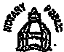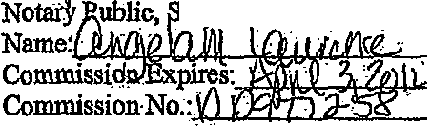
ANGELA M.LAWR!NCS
NotaryPufu.Staieo!Flmlda '
Commlsslon11Dll977258 ·
My Qlmm. •"lllres April S, 2014
tate of \orida

4. .

•,'

