Filing # 45062985 E-Filed 08/10/2016 03:22:14 PM

IN THE CIRCUIT COURT OF THE FIFTEENTH JUDICIAL CIRCUIT, IN AND FOR PALM BEACH COUNTY, FLORIDA.

IN RE:

ESTATE OF SIMON L. BERNSTEIN,
CASE NO. 502012CP004391XXXXNB-IH
Probate – Judge John L. Phillips

/

MOTION TO RATIFY AND CONFIRM APPOINTMENT
OF TED S. BERNSTEIN AS SUCCESSOR TRUSTEE OF TRUST WHICH IS SOLE BENFICIARY OF THIS ESTATE

Ted S. Bernstein, Successor Trustee of the Simon Bernstein Amended and Restated Trust Agreement dated July 25, 2012 ("Simon's Trust"), which is the sole residuary beneficiary of the Estate, files this Motion to Ratify and Confirm Appointment of Ted S. Bernstein as Successor Trustee, and states:
- A vacancy was created in the trusteeship of Simon's Trust after the named successor trustees resigned. Robert Spallina resigned initially, leaving Donald Tescher as the sole remaining trustee. There was no vacancy because one cotrustee remained in office. § 736.0704(2) ("If one or more cotrustees remain in office, a vacancy in a trusteeship need not be filled. A vacancy in a trusteeship must be filled if the trust has no remaining trustee.").
- Mr. Tescher then resigned, which created a vacancy which had to be filled. Section 736.0704(3) provides:
  - A vacancy in a trusteeship of a noncharitable trust that is required to be filled must be filled in the following order of priority:

    - By a person named or designated pursuant to the terms of the trust to act as successor trustee.

    - By a person appointed by unanimous agreement of the qualified beneficiaries.

    - By a person appointed by the court.

- Looking at these three methods in order, first, under section (3)(a), Simon's Trust designated a method and manner of designating a successor trustee. There was no one named, but under the terms of the Trust, Simon designated that Simon's "last serving trustee" may appoint his or her successor trustee or a majority in interest of the beneficiaries may designate as successor. In this case, Mr. Tescher, as last serving trustee, appointed Ted S. Bernstein as his successor.
- That was a logical and sound choice, given the fact that: (i) there was pending litigation against Simon L. Bernstein’s Estate and Trust, as well as the Shirley Bernstein Trust, involving a business formerly operated by Simon and his son Ted; (b) the fact that Shirley Bernstein had named Ted as the sole successor PR and sole successor Trustee in case of Simon's death; and
(c) in light of his knowledge, professional friendship and fiduciary relationship with both Simon and Shirley during their lives. Mr. Tescher determined and believed it was in the best interest of the family and the beneficiaries to have Ted S. Bernstein serve as Successor Trustee of the Simon L. Bernstein Trust.
- Mr. Tescher based his decision on his 40-plus year's experience as a lawyer with an impeccable reputation and as one of the most well-respected trusts and estate lawyers in Palm Beach County. He earned that reputation over many years, and notwithstanding the misguided beliefs of Eliot Bernstein and William Stansbury (the onlytwo people trying to win money from Simon's estate through litigation of disputed claims), there is no reason to doubt Mr. Tescher's choice. Mr. Tescher confirmed and explained his view in an Affidavit (Ex. A) dated March 4, 2014.

- Mr. Tescher designated Ted as his successor trustee and resigned effective upon Ted's acceptance of that role on February 3 2014. (Ex. B) Since February 3, 2014, Ted S. Bernstein has been serving as successor Trustee, with the acknowledgment of the Court, and in the best interests of the beneficiaries of the Trust. There have been numerous attempts by Eliot Bernstein and William Stansbury to remove Ted as Trustee, and to object to him serving. The last of these was a Petition for Removal filed by Eliot, Case No. 502015CP001162XXXXNB IJ, dismissed with prejudice by a final unappealed order dated April 8, 2016.
- Part of the basis for these challenges was a claim that Ted Bernstein was ineligible for appointment under section IV.C.3 of the Trust, a clause designed to protect against adverse tax consequences which do not exist here. Ted Bernstein is eligible to serve and, indeed, was appointed and is serving as the sole successor trustee of his mother's trust, which benefits the same ten people. Ted Bernstein and an expert witness retained by him believe there was no question as to his service as trustee.
- Regardless, to avoid any issue, reduce expenses and put to rest for all time any concerns raised as to Ted S. Bernstein's service as Successor Trustee, the beneficiaries of the Trust unanimously have agreed to ratify and confirm the appointment of Ted S. Bernstein.
- Alternatively, section 736.0704(3) allows a successor trustee to be appointed by unanimous agreement of the qualified beneficiaries. The Court having determined who are the qualified beneficiaries and having appointed a Guardian ad Litem to represent the interests of Eliot's children, the qualified beneficiaries of the Trust unanimously have agreed to appoint Ted S. Bernstein as successor trustee, nunc pro tunc February 3, 2014.

- Finally, to remove any possible doubt, the Successor Trustee and all qualified beneficiaries ask the Court to confirm the appointment and/or formally appoint Ted S. Bernstein under section 736.0704(3) on the basis that his observed actions and the actions of his counsel have clearly and undeniably demonstrated that he has acted in the best interests of the Trust and its qualified beneficiaries.
WHEREFORE, Ted requests that this Court: (a) accept and approve the qualified beneficiaries' ratification and confirm the appointment of Ted S. Bernstein; (b) accept and approve the qualified unanimous agreement that Ted S. Bernstein be appointed as successor trustee, nunc pro tunc February 3, 2014; and/or (c) enter an order appointing Ted S. Bernstein as Successor Trustee.
CERTIFICATE OF SERVICE
I CERTIFY that a copy of the foregoing has been furnished to parties listed on attached Service List by: Γ Facsimile and U.S. Mail; Γ U.S. Mail; E-mail Electronic Transmission; Γ FedEx; Γ Hand Delivery this 10th day of August, 2016.

MRACHEK, FITZGERALD, ROSE, KONOPKA, THOMAS & WEISS, P.A.
505 South Flagler Drive, Suite 600 West Palm Beach, FL 33401
(561) 655-2250 Telephone /(561) 655-5537 Facsimile email: arose@mrachek-law.com
Attorneys for Ted S. Bernstein

By: /s/ Alan B. Rose Alan B. Rose (Fla. Bar No. 961825)

Ted S. Bernstein 880 Berkeley Street
Boca Raton, FL 33487

Pamela Beth Simon
950 N. Michigan Avenue Apartment 2603
Chicago, IL 60611

Eliot Bernstein
2753 NW 34th Street Boca Raton, FL 33434

Jill Iantoni
2101 Magnolia Lane Highland Park, IL 60035

Lisa Friedstein
2142 Churchill Lane Highland Park, IL 60035

Alexandra Bernstein
3000 Washington Blvd, Apt 424
Arlington, VA, 22201

Eric Bernstein
2231 Bloods Grove Circle Delray Beach, Fl 33445

Michael Bernstein
2231 Bloods Grove Circle Delray Beach, Fl 33445

Matt Logan
2231 Bloods Grove Circle Delray Beach, Fl 33445

Molly Simon
1731 N. Old Pueblo Drive Tucson, AZ 85745

SERVICE LIST
Daniel Bernstein, a Minor
c/o Eliot and Candice Bernstein,
His Parents and Natural Guardians 2753 NW 34th Street
Boca Raton, FL 33434

Jacob Bernstein, a Minor
c/o Eliot and Candice Bernstein,
His Parents and Natural Guardians 2753 NW 34th Street
Boca Raton, FL 33434

Joshua Bernstein, a Minor
c/o Eliot and Candice Bernstein,
His Parents and Natural Guardians 2753 NW 34th Street
Boca Raton, FL 33434

Julia Iantoni, a Minor c/o Guy and Jill Iantoni,
Her Parents and Natural Guardians 2101 Magnolia Lane
Highland Park, IL 60035

Max Friedstein, a Minor
c/o Jeffrey and Lisa Friedstein,
His Parents and Natural Guardians 2142 Churchill Lane
Highland Park, IL 60035

Carley Friedstein, a Minor
c/o Jeffrey and Lisa Friedstein,
Her Parents and Natural Guardians 2142 Churchill Lane
Highland Park, IL 60035

Eliot I. Bernstein 2753 N.W. 34th Street Boca Raton, FL 33434
(561) 245-8588 - Telephone (561) 886-7628 - Cell
(561) 245-8644 - Facsimile
Email: Eliot I. Bernstein (iviewit@iviewit.tv)

Peter M. Feaman, Esq. Peter M. Feaman, P.A.
3695 West Boynton Beach Blvd., Suite 9 Boynton Beach, FL 33436
(561) 734-5552 - Telephone
(561) 734-5554 - Facsimile
Email: pfeaman@feamanlaw.com; service@feamanlaw.com; mkoskey@feamanlaw.com Counsel for William Stansbury

William H. Glasko, Esq. Golden & Cowan, P.A. 17345 S. Dixie Highway Palmetto Bay, FL 33157
(305) 856-5440 - Telephone
(305) 856-9388 - Facsimile
Email: eservice@palmettobaylaw.com; bill@palmettobaylaw.com; tmealy@gcprobatelaw.com
Counsel for Lisa Sue Friedstein, individually and as trustee for her children, and as natural guardian for M.F. and C.F., Minors; Jill Marla Iantoni, individually and as trustee for her children, and as natural guardian for J.I. a minor

Irwin J. Block, Esq.
700 South Federal Highway, Suite 200 Boca Raton, FL 33432
(561) 910-3071 - Telephone
(561) 910-3080 - Facsimile Email: ijb@ijblegal.com Counsel for Tescher & Spallina

Robert Spallina, Esq. Tescher & Spallina
Boca Village Corporate Center I 4855 Technology Way, Suite 720 Boca Raton, FL 33431

Donald Tescher, Esq. Tescher & Spallina
Boca Village Corporate Center I 4855 Technology Way, Suite 720 Boca Raton, FL 33431
Benjamin P. Brown, Esq. Matwiczyk & Brown, LLP
625 North Flagler Drive, Suite 401 West Palm Beach, FL 33401
(561) 651-4004 - Telephone
(561) 651-4003 - Facsimile Email: attorneys@matbrolaw.com
Curator for the Estate of Simon Bernstein

John P. Morrissey, Esq.
330 Clematis Street, Suite 213 West Palm Beach, FL 33401
(561) 833-0766 - Telephone
(561) 833-0867 - Facsimile Email: John P. Morrissey (john@jmorrisseylaw.com)
Counsel for Molly Simon, Alexandra Bernstein, Eric Bernstein, Michael Bernstein

IN THE CIRCUIT COURT OF THE FIFTEENTH JUDICIAL CIRCUIT, IN AND FOR PALM BEACH COUNTY, FLORIDA.

IN RE:

ESTATE OF SIMON L. BERNSTEIN,
CASE NO. 502012CP004391XXXXSB
CP - Probate

AFFIDAVIT OF DONALD R. TESCHER

STATE OF FLORIDA )
)
COUNTY OF PALM BEACH )

BEFORE ME, the undersigned authority, personally appeared Donald R. Tescher, upon being duly sworn, deposes and says:
- I am over the age of eighteen years, sui juris, and have personal knowledge of the facts set forth herein.
- Tescher & Spallina, P.A. ("Firm") were counsel to Shirley Bernstein and Simon L. Bernstein while they were alive. They had five children borne of their long-time marriage, Ted Bernstein, Pamela Simon, Eliot Bernstein, Lisa Friedstein and Jill Iantoni. Simon was the natural father and Shirley was the natural mother of each of these children. Sin1on and Shirley also had ten living grandchildren, each of whom was a direct and natural descendant of one of the children. Thus, Simon and Shirley had fifteen lineal descendants.
- After consultations with Robert L. Spallina and myself or soley with Robert L. Spallina, a Will and Trust was created for each of Simon and Shirley, as amended. I am aware of the final estate plan of each, as expressed in their final testamentary documents, specifically:

EXHIBIT
I k

  - Will of Shirley Bernstein dated May 20, 2008 (Exhibit A);

  - Shirley Bernstein Trust Agreement dated May 20, 2008 (Exhibit B), as Amended on November 18, 2008 (Exhibit C);

  - Will of Simon L. Bernstein dated July 25, 2012 (Exhibit D); and

  - Simon L. Bernstein Amended and Restated Trust Agreement dated July 25, 2013 (Exhibit E).

- The attached five documents are the final documents signed by each of Shirley and Simon, respectively, during their lives. The originals of the Wills were retained in our Firm's safe deposit box (or "vault") until the times of their deaths.
- It is my understanding and belief that, during their lifetimes, neither Shirley nor Simon shared copies of their testamentary documents with their children. None of the five children were involved in the estate planning process, nor did any of them attend any meetings with myself as counsel.
- When Shirley died on December 8, 2010, her testamentary documents provided that Simon be given any tangible personal property in her name, other then anything disposed of in a separate written memorm1dum. The residue of her estate was devised to the Shirley Trust. After her death, the beneficiary of the Shirley Trust was Simon during his life, with the assets disposed
of after his death through a limited power of appointment, empowering Simon to transfer the assets to or for the benefit of one of more of their lineal descendants and their spouses.1
- Our Firm prepared the July 2012 Amended and Restated Trust Agreement and the Will for Simon Bernstein. Those are the final documents that our Firm prepared and the final documents I am aware of Simon having signed prior to his death in September, 2013. Our Finn
There is an alternate disposition of the assets upon the death of Simon if he did not exercise his power of appointment, but in my view that is irrelevant.

retained the originals of those documents in our safe deposit box until Simon's death. There are no later executed testamentary documents for Simon L. Bernstein.
- Simon exercised his limited power of appointment in Article II of the July 2012 Will, which specifically references Shirley's Trust and the power given to him under subparagraph
E. I of Article II of Shirley's Trust. Pursuant to that power of appointment, Simon directed Shirley's Trustee to divide the remaining trust assets into equal shares for his then living grandchildren to be added to trusts established for the ten grandchildren under Simon's Trust. Because Simon exercised his power of appointment, the assets in the Shirley Trust were distributed according to Simon's direction, and did not pass under the Shirley Trust to Shirley's default beneficiaries.
- Under these testamentary documents, neither Ted, Pam, Eliot, Lisa or Jill is a beneficiary of any of their Trusts and Estates. With the sole exception of possibly some specific items of tangible personal property not relevant to the estate and trust administration, Shirley and Simon effectively disinherited all five of their children, and none of them take anything from either of their Trusts or Wills.
- While he was alive, Simon was the Personal Representative of the Estate of Shirley Bernstein and was the Trustee of the Shirley Bernstein Trust. After Simon's death, under the terms of the Will and Trust, Ted S. Bernstein became the Successor Personal Representative and Successor Trustee. Prior to that time, Ted had not been involved in the administration of Shirley's Estate or Trust. As far as I am aware, Ted was not aware that he would be the successor to Simon until after Simon's death.

- Upon Ted assuming his fiduciary role as Successor Personal Representative and Successor Trustee, Ted retained our Firm to represent him as a fiduciary. From that point in time until our withdrawal from representing Ted, which was approved by the Court in February 2014, Ted was a responsive client who listened to and followed my advice. At no time did Ted take any action which I advised him would be improper or a breach of his fiduciary duty. In my view, at all times Ted acted as a fiduciary based upon the facts and circumstances and information available to him at that time. ·
- At some point after Simon died, a significant asset of Shirley's Trust (a condominium) was sold, and the decision was made to make a partial interim distribution to all of the beneficiaries of the Shirley Trust. In connection with the decision to make an interim distribution, I participated inconsulting with Ted and his siblings (other than Eliot) as his counsel. I engaged in a call with various members of the family (other than Eliot). Among those children who participated in the phone call, there was a general consensus that it was appropriate to make an interim partial distribution. I assisted in the mechanics of making these distributions, including providing tax identification numbers and instructions to open a bank account for each of the grandchildren's trusts.
- At no time did I advise Ted that it would be a violation of his fiduciary duty to make the interim distribution to the trusts for the ten living grandchildren of Simon. I did not advise Ted at any time that there was any question concerning the proper beneficiaries of the Trust, nor was Ted aware of any issue concerning the effectiveness of the exercise of the power of appointment until I advised him and others of that fact in mid-January, 2014.
- In my view, during the time I was counsel for Ted as fiduciary, it is my opinion that he fulfilled his fiduciary duties and acted in a reasonable and appropriate manner. I am aware of

no facts that would give a court cause to be concerned about whether Ted could continue to fulfill his fiduciary duty in those capacities, or serve as Personal Representative of Simon's Estate.
- Upon my resignation as Trustee of the Simon Trust, I concluded that the appointment of Ted as Successor Trustee would be consistent with Simon's wishes and would be in the best interest of the family. Under the terms of Simon's Trust, he gave the power to appoint a successor trustee to the last resigning trustee. In this case, for a variety of reasons I concluded that Ted was the logical choice for Successor Trustee, including the following: Ted's knowledge of the facts and of these estate matters; his current service in similar capacities in Shirley's Trust and Estate; his knowledge of the pending litigation with a creditor, William Stansbury; the fact that he is not a beneficiary of or seeking monies from any of the Trusts or Estates; and the fact that I believe him to be a reasonable and competent business person capable of fulfilling his fiduciary duties. Accordingly, after Robert Spallina resigned, I exercised the power given to me by Simon to appoint Ted S. Bernstein as Successor Trustee of the Simon Bernstein Trust.
- The last person Simon would want to serve in any fiduciary capacity is Eliot. Simon did not want Eliot to have any role in any of these matters.

FURTIJER AFFIANT SAYETI! NAUGIIT. // _/ /j/)
2
 tf!ir
DONALD R. TESCHER

Sworn to and subscribed before me this 1 \ day of f'f\:)cc'h , 2014,by Donald R. Tescher, who is personally knmvn to me and who did take an oath.
-

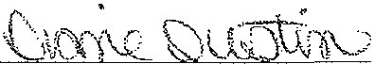
Notary Public
My commission expires:

RESIGNATION OF CO-TRUSTEE

I, ROBERT L SPALLINA, pursuant to Subparagraph B. of Article IV of the SIMON L. BER.N. STEIN TRUST dated September 13, 2012 ("Trust Agreement "), do hereby resign as co- Trustee Trust Agreement, effective immediately.
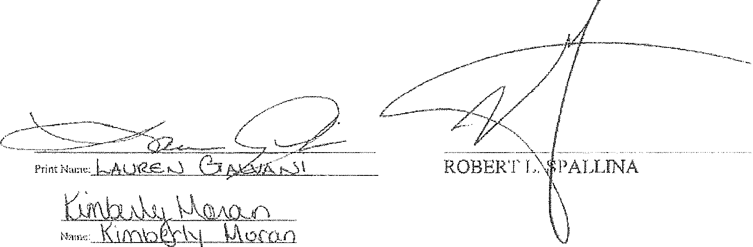lN WITNESS WHEREOF, l have hereunto executed this Resignation of Co-Trnstee on this
CL0: ; day of Jammry, 2014.

Signed, Sealed & Delivered in thepresence of
Print

STATE OF FLORIDA
SS
COUNTY OF PALM BEACH

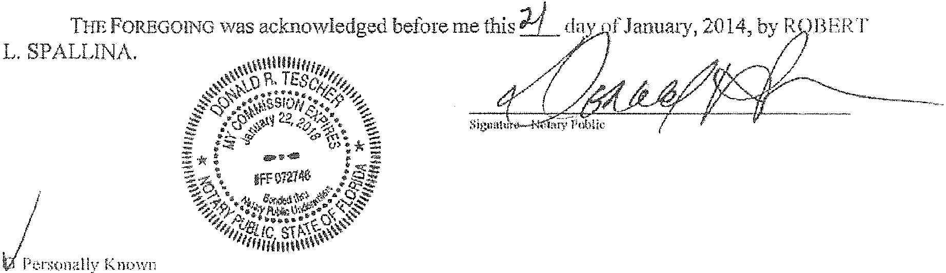
Print, typc or stomp nomc of Notacy Public
D Produced Identification/Typo ofldcntification Produced _ _

EXHIBIT
)!
1 \../
Q

RESIGNATION OF' TRUSTEE

I, DONALD R. TESCHER, pursuant to Subparagraph B. of Article IV of the SIMON L. BERNSTEIN TRUST dated September 13, 2012 ("TrustAgreemenf' ), do hereby resign as Trustee of the Trust Agreement, effective immediately upon TED S. BERNSTEINaccepting his appointment
as successor Trustee.

IN WIT!"<'ESS WHEREOF, I have hereunto executed this Resignation of Trn.stee on this.l-.::Z-. day of January, 2014.

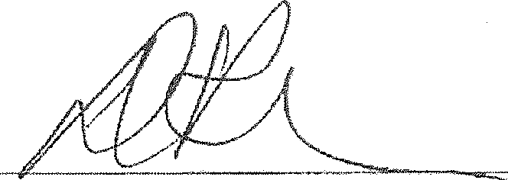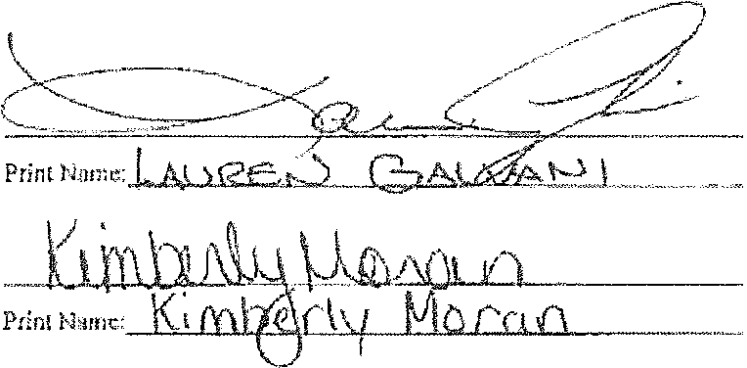Signed, Sealed & Delivered in the presence of:

DONALD R. TESCHER

STATE OF FLORIDA
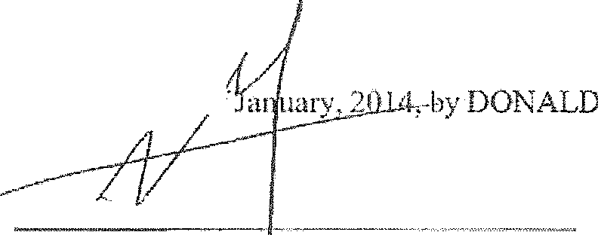SS
COUNTY OF PALM BEACH
THE FOREGOJNG was acknowledged before me th id9--day c .·
R. TESCHER.

Sign.lure- No!my Public

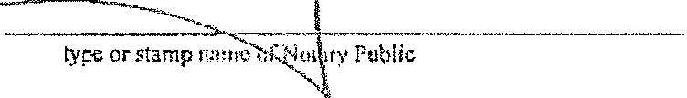/ /
Print,
_,/
/

Jtmlly Known
D Produced ldentificationiType of identific&tion Produced ---------

---- -

ACCEPTANCE BY SUCCESSOR TRUSTEE

THE UNDER.SIGNED successor Trustee hereby accepts his designation as successor Trustee of the SIMON L. BERNSTEIN TRUST dated September 13, 2012, and hereby agrees to administer said Trust in accordance with the te1ms contained therein, effective immediately.
INWITNESS WHEREOF, iheundersigned has hereunto executed this Acceptance by Successor
Trustee on this _j day of!;,i(.Ui'tl(7 - -· 2014.

Signed, Sealed & Delivered
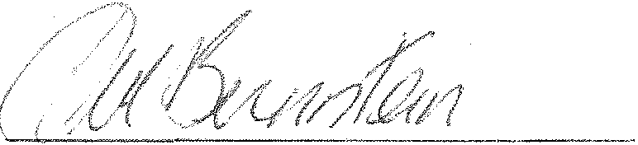in the presenr:: of:

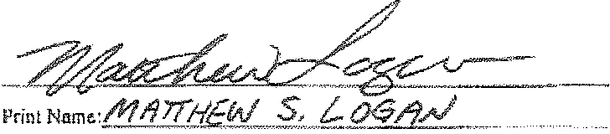 TED S. BERNSTEIN

Print Name:. ------

STATE OF FLORIDA
SS
COUNTY OF PALM BEACH

E:B£Wltt1..'(

THE FOREGOTI'l"G was acknowledged before me this day of, 2014, by TED S.
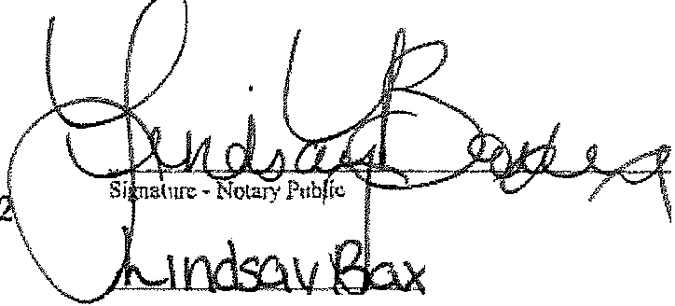BERNSTEIN.

;1Personally Known
NOTA. Y PUBLIC·STATE OF FLORIDA
.,-- ·""",·.. Lindsay Baxley
Commission # EE09228
••,,,,""'/ Expires: 'J:..ifl1.Y 10, 2015
BO:-<lJF.DitlRL' ATUlh"ITC B01'1J!NG CO., !NC.

f
Prir.t, lype or •lamp n••n• of Nola¥, ",..,"Y-·---····-"

D Produced Identification/Type of Identification Produced _

