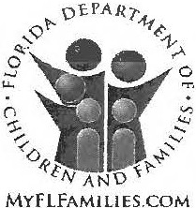
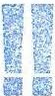


Case Name  Candice BERNSTEIN | Intake Number 2015-121408-01 | Intake Sub-Type  In-Home | County  Palm Beach
Date!Time Intake Received  05/04/2015 2:07 PM | Date!Time Screening Decision  05/04/2015 3:17 PM | Protective Investigator  Bourgoine, Leigh
Date!Time Investigation Closed  07/03/2015 9:14 PM |  | Approving Protective Investigative Supervisor  Gray, Meredith E

I. Allegation Narrative(s)

Sequence Type  Initial | Date!Time Received  05/04/2015 2:07 PM | Response Priority  24 Hours
Narrative
The mother and father are using drugs and alcohol. The parents are using marijuana and prescription narcotics. There are concerns that the father is not in a good mental state when he is under the influence of drugs and alcohol. The father is delusional and makes all types of erratic statements towards the children. The father believes that he will be murdered or poisoned. He also believes that his car will be bombed. The father makes excuses on why the children can't attend a certain school. The father threatens the children and tells them things about their grandparents being murdered. The mother and father were being supported by the paternal grandparents who since has passed away. The grandmother passed in 2010 and the grandfather in 2012. The mother and father do not work and it is unknown how they are supporting their family or drug habits. The father tends to blame a lot of things on money. In the past, the father was admitted to a psychiatric hospital.

Our Response

This “Allegation Narrative” is wholly false statements made to this department. There is no illegal prescription drug use of any kind by Eliot or Candice Bernstein and any alcohol use is at extremely rare social occasions and very responsibly in moderation as the report indicates, Eliot Ivan Bernstein (“Father”), has never been admitted to a psychiatric hospital in his life for any reason. Father never has been diagnosed with delusions or any other mental illness. The statements made by the anonymous caller however match with a current slander and defamation that is being made in an Illinois insurance fraud case and recently made in Palm Beach Court by attorney Alan B. Rose, Esq. on behalf of Father’s brother Theodore Stuart Bernstein.

Father has recently come into possession of court documents filed by a one Alan B. Rose, Esq. on behalf of Father’s brother Ted S. Bernstein that are strikingly similar to the false statements made to this agency. Both Ted and Alan Rose are under investigation in several matters both state and federally. Ted Bernstein’s former counsel, Robert Spallina, Esq. has also admitted to Palm Beach Sheriff investigators that he personally, with his partner Donald Tescher’s consent, Fraudulently Altered with scienter a Shirley Bernstein Trust document Post Mortem to benefit Ted Bernstein at the expense of Father’s family. One of the employees of the firm Tescher & Spallina PA has been arrested for fraudulently notarizing 6 estate documents, including Post Mortem Forgeries of Simon Bernstein and admitted to forging the signatures of 6 separate parties. Spallina has also admitted to committing a fraud on the West Palm Beach Court in closing Shirley Bernstein’s Estate, which led to the reopening of the Shirley Bernstein Estate due to the fraud. These crimes have intentionally delayed inheritances to Father’s family and caused economic harms upon them. There are a multiplicity of ancillary felony acts alleged to have been committed by Ted Bernstein and several of his attorneys at law and under investigation.

Father’s brother, Ted Bernstein, made statements in a complaint he instigated to Palm Beach County Sheriffs on the day his father died, September 13, 2012, that his father Simon Bernstein was murdered by Poisoning, see PB Sheriff Case #12121312 and PB Medical Examiner Coroner #12-0913. Father did not believe his father Simon may have been murdered until he obtained results over a year after his death from the Palm Beach County Medical Examiner of a Heavy Metal Poison Screen that indicated over reportable levels of Arsenic, Cadmium and more found.

The Mother and Father and children were being supported by Simon and Shirley Bernstein due to several ongoing lawsuits and state and federal investigations regarding the bombing of Father’s family minivan as it relates to a patent theft case for technologies valued in hundreds of billions of dollars, which provides ample motive for the attacks upon Eliot and Candice Bernstein, see images of car bombing further attached herein and www.iviewit.tv for more information. It should be noted as reported to the FBI that Ted Bernstein was the last person in possession of Father’s minivan prior to the bomb going off.

The anonymous caller indicates that there was no car bombing or that Father was worrying that their car would be bombed when as seen below it was blown up several years prior.

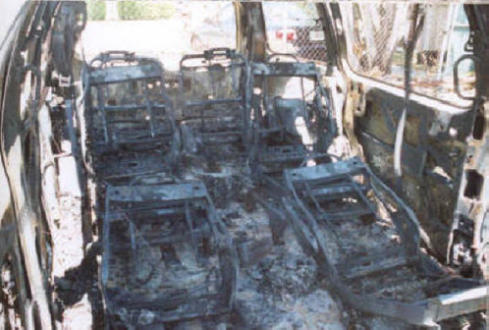

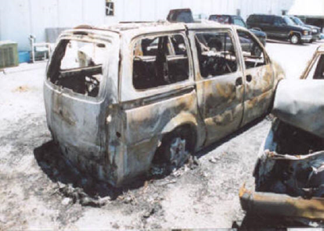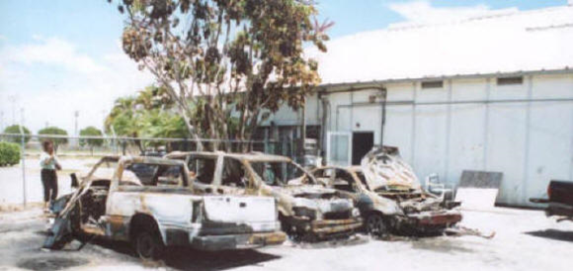
When the Father’s parents passed away, they left inheritances worth millions of dollars for Father’s family, including millions of dollars that were owed to the Father for losses incurred in a family business transfer to his sister Pamela who stole millions of dollars from both Simon Bernstein and the Eliot Bernstein, which resulted in Eliot’s sister Pam Simon and her children being wholly cut out of all estate plans of both her mother and father.

Several years later Ted Bernstein along with his sister Pamela and their lineal descendants were cut out of their parents’ estates and trusts for a variety of reasons and this caused Ted and Pam to have very hostile feelings towards their parents and perhaps the other children (including Eliot) who are inheritors. Monies had been set aside for Father’s family for the children to go college, for all monthly expenses to be paid for many years to come and a fully paid for house but when Father’s father Simon passed away, attorneys at law Donald Tescher, Esq., Robert Spallina, Esq., Alan Rose, Esq. and Ted Bernstein committed a series of fraudulent acts, including forgery Post Mortem of documents for both Simon Bernstein and his deceased wife Shirley Bernstein and are alleged to have stolen assets and more and Father’s family has been cut off of the inheritances with intent for almost three years, greatly economically harming Father and his children.

Tescher and Spallina were subsequently removed from the Estate and Trust cases where they were acting as alleged fiduciaries and attorneys due to the fraud they committed.

Both Eliot and Candice work while also working in courts and other agencies to reclaim their patent rights and reclaim their inheritances, which again appear to be further false claims made to this agency by the anonymous caller. There are ongoing state and federal lawsuits and investigations involving all of these matters and it appears that this complaint to child services was an act of retaliation for reporting the misconduct and crimes of several lawyers, judges and fiduciaries involved.

Field Narrative
Maltreatment

Substance Misuse - Alcohol Name
BERNSTEIN, JACOB
Maltreatment
Substance Misuse - Prescription Dru!'.ls
Name
BERNSTEIN,JOSHUA
Findings
No Indicator DOB
01/01/ 1999
Findings
Incident Date
Caregiver Responsible
Fatality

No
Age
16
Gender
Male
Race
White
Disabilities
Incident Date
IZl Yes
Caregiver Responsible
0 No
Fatality
No Indicator
No
DOB
08/27/1997
Age
17
Gender
Male
Race
White
Disabilities
IZl Yes Caregiver Responsible
0 No
Fatality
No

11. | Victim(s)
 | Name | DOB | Age | Gender | Race | Disabilities
 | BERNSTEIN, JACOB | 01/01/1999 | 16 | Male | White | IZl Yes | 0 No

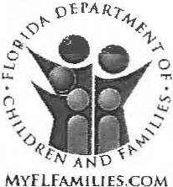

Name  BERNSTEIN, JOSHUA | DOB 08/27/1997 | Age 17 | Gender Male |  | Race White |  | Disabilities  [8] Yes 0 No
Maltreatment  Substance Misuse - Prescription Druqs | Findings  No Indicator |  |  | Incident Date |  | Caregiver Responsible |  | Fatality  No
Name  Bernstein, Daniel | DOB  11/26/2002 | Age  12 | Gender  Male |  | Race  Unknown |  | Disabilities  0 Yes [8] No
Maltreatment  Substance Misuse - Alcohol | Findings Incident Date |  |  |  |  | Caregiver Responsible |  | Fatality  No
Maltreatment  Substance Misuse - Alcohol | No Indicator |  |  |  |  |  |  | Fatality  No
Name  Bernstein, Daniel | DOB  11/26/2002 | Age  12 | Gender  Male |  | Race  Unknown |  | Disabilities  0 Yes [8] No
Maltreatment  Substance Misuse - Prescription Druqs | Findings  No Indicator |  |  | Incident Date |  | Caregiver Responsible |  | Fatality  No

Ill. Other Participant(s)

Name  Bernstein, Eliot | DOB  09/30/ 1963 | Age  51 | Gender  Male | Race  While | Role  ParenUCaregiver
Bernstein, Candice | 10/09/ 1972 | 42 | Female | White | ParenUCaregiver

Date Last Updated: 07/03/2015 Last Updated By: Bourgoine, Leigh

What is the extent of the maltreatment?
What surrounding circumstances accompany the alleged maltreatment, precipitating events, history?

Investigation is being closed no indicators for substance misuse- prescription drugs, and substance misuse- alcohol. The children all denied the allegations. The parents refused to go on a drug screen however this CPI was at the home on numerous occasions and never witnessed the parents appearing to be under the influence, or any indication in the home that their any any issues with alcohol or drugs. The parents also denied any drug or alcohol abuse in the home. The father is currently involved in several court actions involving family members and believes this to be retaliation because of the court ongoing court cases. Collateral had no concerns for the children's safety and also stated that she believes that the report was received was of retaliatory nature as she is with the family often and has never seen any indication herself that there is anything going on with the family in the home.A neighbor collateral did express concerns however they were more so rumors that she had heard from the prior owners of the home. LE closed out their investigation unfounded for abuse or
neglect. Grids pose no concerns for child safety. Risk is low; no further intervention warranted by the Department at this time.

Our Response
The neighbor cited in the report appears from research to be a one Rosemary Chenery 2769 NW 34th St. Boca Raton, FL 33434, who has in the last several months had the Boca Raton PD at her home for domestic violence from her former live in boyfriend Dan Stout, whereby PD responded several times with guns drawn and made arrests of Stout who also resisted arrest and was charged for same (see attached information regarding the arrest of Dan Stout, Rosemary’s boyfriend.) This is an older couple with a history of heavy drinking and possible drug use starting early in the mornings and throughout the day and causing very violent behaviors that have led to Boca PD to their home repeatedly and where they scare the neighborhood children as they live adjunct to Saint Andrews school and do not like children. They have been to the home of Father once for a Bar Mitzvah for his son several years ago where they were asked to leave due to heavy drinking an Dan Stout’s inappropriate comments to the children. Finally, Rosemary worked at IBM directly for Brian Utley one of the key parties alleged to have stolen Intellectual Properties from Father and his father Simon’s technology companies.

On 5/4/15 the hotline received a report alleging the following:
The mother and father are using drugs and alcohol. The parents are using marijuana and prescription narcotics. There are concerns that the father is not in a good mental state when he is under the influence of drugs and alcohol. The father is delusional and makes all types of erratic statements towards the children. The father believes that he will be murdered or poisoned. He also believes that his car will be bombed. The father makes excuses on why the children can't attend a certain school. The father threatens the children and tells them things about their grandparents being murdered. The mother and father were being supported by the paternal grandparents who since has passed away. The grandmother passed in 2010 and the grandfather in 2012. The mother and father do not work and it is unknown how they are supporting their family or drug



habits. The father tends to blame a lot of things on money. In the past, the father was admitted to a psychiatric hospital.

The father had 2 "attorneys" on the phone while we spoke with him.The father called 911 while we were at Omni Middle School on 5/5. He then called back and said he didn't want an officer to come to the home, he just wanted to speak with an officer. At first he would not allow this CPI into the home or the speak with the children. When this CPI went back to the home alone, later on 5/5 he was much more cooperative and stated he just didn't want police in the home.

Our Response

911 was contacted because Federal Judge Hon. John Robert Blakey had directed Father to contact 911 and report information concerning his family’s safety as an attorney at law, Candice Schwager, Esq. had contacted the Bernstein’s to advise them that she had information that their lives and their children were in imminent danger and to contact state and federal authorities and seek protection. Father notified federal judge Honorable John Robert Blakey of this and on his instruction contacted 911 to report the matter but stated it was not necessary to have 911 come to the home and that he and his wife would come by the station to fill out the report as the threat did not appear imminent danger.

Several minutes later, Boca PD and Child Services appeared at the home together with no notice to Father or his family that Child Services was even conducting an investigation and had already been to the minor children’s school that day to interview the children without parental consent. This also was reported to Judge Blakey in a subsequent filing in his court (see Federal Court case files, case number provided at the end of this response.) Father and Candice Bernstein “Mother” were not notified by Child Services of any complaint or that they were interviewing the children at school on that day or that they were coming to visit their home. Confused at first by what was going on with Child Services and the Boca PD showing up simultaneously Father and Mother did not let officers into the home until they could understand what was being claimed and who had claimed anything about Child Services and why child services was there. Father was on phone with business consultants and a former attorney who advised Father not to let anyone in the home until they could figure out what was going on and not to do any tests or let the children be interviewed without determining if the family needed legal counsel first.

That Father and Mother answered all questions of the PD and they left after taking the information relating to the information from attorney Candice Schwager, Esq. about their lives being in danger. Later that day the CPS officer came to the home alone and was immediately allowed entry into the home to inspect and it appeared based on the claims made by the anonymous caller that the complaint issues appeared to be retaliatory. Several follow up calls and visits further confirmed that the claims in the complaint were baseless. CPS was allowed full reign of the home and allowed to have private talks with the children without counsel.

The father Eliot reported that he called 911, as he was advised by his attorney to do so and had a court order stating to do so from a federal judge. He provided a copy of the order that stated if he felt he was in immediate danger to contact 911.
The Boca PD officers explained to him what 911is for andif he wanted to just make a report to contact the non-emergency line. Eliot stated that he filed a "whistle blower" petition while in court, and thinks heis being sought after for whistle blowing on attorneys and judges in local community and other locations in the US. He thinks false allegations were made because of this. He stated that he does think he and his family are in immediate danger because "I do not know when they will murder me, poison me, or try to blow up my car". He denied having any mental health history or diagnosis. He denied ever being in a psychiatric facility. He stated to call Andrew Panzer with PBSO about his father's "murder investigation". He denied he or his wife being on any medications. He denied he or Candice smoking marijuana. He stated that his parents died and their estate and trust money are tied up in litigation and there were "documents forged". He stated that there are a number of court cases for this, the murder investigation and patents of his which were "stolen". He reported that his father had an autopsy and the
Coroner's report done showed he may have been poisoned. He stated that the car bombing happened in Boynton in 2006. He is not currently employed but works on "preserving his patents". He stated that he and Candice were working for a company that was "shut down by the estate". He refused to go on a drug screen.

Our response

Mostly true statements, except Father and Mother both initially declined a drug screen when CPS and PD came as advised by parties on the phone but later stated to CPS that we were both willing to take a screening by a private party and CPS did not find it necessary as there was no evidence of drugs or alcohol use whatsoever in the home.

The mother Candice denied using marijuana and denied either she or her husband being on medications. She denied any history of alcohol or drug abuse, or treatment history. She denied having any personal mental health history and denied the father having any mental health history. She stated that the paternal grandfather died unexpectedly and an autopsy was
done. The paternal uncle made allegations that the grandfather's girlfriend murdered him. The coroner's report showed elevated levels of arsenic in the grandfather's tissue samples. She stated that there is an ongoing murder investigation. She reported that everyone is fighting over the money that was left by the grandparents. There were 5 children; 2 disinherited, as they received the family businesses. There are a lot of legal issues involved. The mother reported she and the father are representing themselves in these matters.

They think Ted (the paternal uncle} called in the report because of the ongoing legal issues. She stated that the car bombing happened in 2004-2005; sheriffs notified the family that the car exploded while at the shop. They are also involved with the Supreme Court about patent cases for the father's inventions. She denied any history of Baker Acts for her or her husband. She reported that neither she nor the children have any medical issues. She refused to go on a drug screen.

who resides to the family reported that the parents don't work, and she believes the family had money, like trust funds and they live off that. She believes she has smelled marijuana coming from the home. She heard from the previous owner of the home the family resides in that the father is a druggie. She stated that the children do whatever they want and the parents "have no idea about responsibility". She then sited an issue about the children going through a fence to St. Andrews as to why the children do whatever they want. The children used to attend St. Andrews and don't anymore. She stated that the family doesn't take care of the house or property.

Our Response

We believe that the prior owner of the home mentioned in the report by the anonymous neighbor is a one Walter Sahm, (see Walter Sahm statement regarding CPS claims attached herein) who has never met the children of the family and only met the Father and Mother once in person for less than five minutes several years ago was perhaps when speaking with the neighbor referring to Ted Bernstein having a drug problem, as Mr. Sahm knows Ted Bernstein personally and professionally while Ted was having drug problems, going through a divorce that ended with his wife later overdosing, bankruptcy and other issues. Mr. Sahm, a highly respected Boca Raton business person responded to our call by writing a letter that virtually damns the neighbor for her false statements as slanderous and defamatory of both himself and our family as stated in the letter.

Josh denied marijuana use or use of medications by his parents.He reported his parents drink socially like at a party or dinner. He has a good relationship with his parents. He reported that his parents have a good relationship with each other and he denied any domestic violence occurring in the home. He stated that he is not sure exactly what happened with the car bombing. He stated that his grandmother died of natural causes and his grandfather died of heart problems. He denied hearing his father say that anyone is trying to kill him and doesn't believe anyone will. He denied witnessing either of his parents under the influence. He stated that his father hasn't threatened the family, he feels safe at home and then he said, "this is my safe place".

Our Response

This is horrible that the children were asked these questions and exposed to these wild claims against their parents, where Eliot and Candice then had to talk to the children about these matters that had previously been keep out their sight and minds, like the alleged by Ted murder of his father, as these issues are very real about the potential murder of Simon Bernstein now and the crimes being committed against their family. Due to this CPS report being filed Eliot and Candice had to explain to the children these matters in detail and why they were being harassed and false claims made against them by certain parties. However, this CPS issue promoted full disclosure to the children of what their uncle had claimed and done and this was very sad but all children now understand these very complex issues and how the family may be in very real danger, including retaliatory acts trying to separate parents and children on wholly falsified charges as was the case with the claims submitted in to this agency.

Jacob reported that his parents drink on occasion and he denied witnessing either of them intoxicated. He is unaware of whether his parents are on any medications. He described his father as "unique", and a very smart man. He stated that his father does worry about the family.He has said things about his car being bombed or being poisoned in the past. His paternal

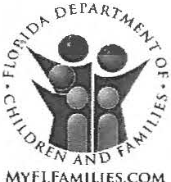

grandparents passed away from natural causes a few years ago and his father was heart broken. He denied the father threatening the family in any way and stated that he has a good relationship with his parents. His parents have a good relationship with each other and he denied any domestic violence in the home. He denied seeing either of his parents appearing under the influence. He stated that his father was a victim of a car bombing over 10 years ago. He knows that this happened because he has seen pictures of the car. He is unaware of whether his father has ever been Baker Acted. He reported that there are no problems at home, and he feels safe at home.
Our Response
This is very sad the children had to be asked these crazy questions regarding the allegations made by the anonymous caller. To further see that the perpetrators of the complaint are distorting information, including the car bombing information to make Father appear crazy, again see the graphic images of the very real car bombing and the three cars next to it that were incinerated see below and see www.iviewit.tv

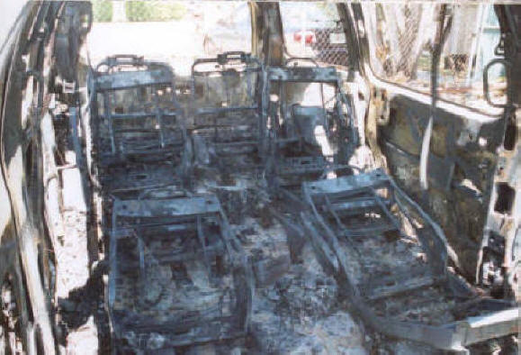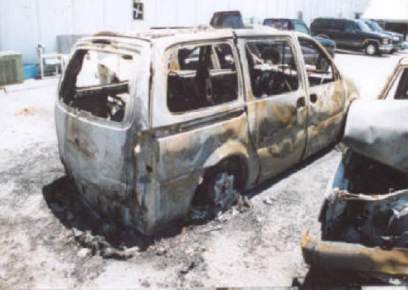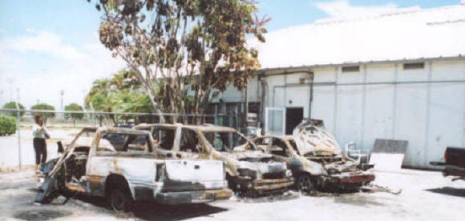

a family friend reported that she has known the family for the past 7 years. They met at St. Andrews School in Boca Raton and her children are the same ages as the children in the current investigation and are friends. Her children spend a lot of time with the Bernstein's in their home. She reported that she sees the family often. The children are always clean, dressed appropriately and free of marks or bruises. They have no behavioral issues. She reported that the parents drink socially like at a dinner party and never to excess. She reported that she is unaware of any drug use in the home and would not allow her children to be around that if she ever thought that was the case with this family. She reported that the father Eliot has uncovered fraud in the courts and this is retaliation from that. She is shocked about the allegations received. She reported that she has no concerns for the children in the home with the parents. If anything what the paternal uncle has done to the children has been damaging as he is keeping the litigation going and money from the family which is theirs. The kids are no longer attending St. Andrews because of this.

Danny denied all of the allegations in the report and stated that he feels safe in the home with his family. Family has no prior history with the Department.
Grids pose no negative impact upon child safety. LE unfounded their report for abuse or neglect.

Safety Analysis Summary
The children are safe in the home and no impending danger threats have been identified which meet the safety threshold. The children are all verbal and visible in the community; they are able to tell someone if something happens in the home.
Investigation is being closed no indicators for substance misuse- prescription drugs, and substance misuse- alcohol. The children all denied the allegations. The parents refused to go on a drug screen however this CPI was at the home on numerous occasions and never witnessed the parents appearing to be under the influence, or any indication in the home that there any issues with alcohol or drugs. The parents also denied any drug or alcohol abuse in the home. The father is currently involved in several court actions involving family members and believes this to be retaliation because of the court ongoing court cases. Collateral had no concerns for the children's safety and also stated that she believes that the report was received was of retaliatory nature as she is with the family often and has never seen any indication herself that there is anything going on with the family in the home.. _ collateral did express concerns however they were more so rumors that she had heard from the prior owners of the home. LE closed out their investigation unfounded for abuse or neglect. Grids pose no concerns for child safety. Risk is low; no further intervention warranted by the Department at this time.

Our Response

The entire complaint filed by the anonymous party appears to be part of a coordinated effort to defame, slander and harm our family. The economic problems faced by our family are directly due to delays in inheritance that have all been caused by the frauds of the fiduciaries in the estates and trusts of Simon and Shirley Bernstein and these economic troubles would likely be known only by those directly involved in these cases. Of course, since the car bombing, the allegations by Ted Bernstein that his father was poisoned and the direct attack on the inheritances to financially harm our family, it does appear true that our family is in potential imminent danger from those participating in those activities and perhaps those involved in filing this report with your agency.

The Civil l Cases Involved are as follows:

- Case ID: 502015CP002717XXXXNB
1 Case # 502012CP004391XXXXSB – Simon Bernstein Estate
2. Case # 502011CP000653XXXXSB – Shirley Bernstein Estate
3. Case # 502014CP002815XXXXSB – Oppenheimer v. Bernstein Minor Children
4. Case # 502014CP003698XXXXSB – Shirley Trust
5. Case # 502015CP001162XXXXSB – Eliot Bernstein v. Trustee Simon Trust Case OLD CASE # 502014CA014637XXXXMB
6. Case # TBD – Creditor Claim – Eliot v. Estate of Simon
7. Case # 13-cv-03643 - Federal Lawsuit in the US District Court of Eastern Illinois, before the Hon. Judge Amy St. Eve.
Judge David E. French Cases
- Case # 20I2CP004391 IX – Simon Bernstein Estate

Cases @ New York Second Circuit
- File USCA Case Number 10-5303 = P. Stephen Lamont Appeal Docket No.
Case 08-4873-cv United States Court of Appeals for the Second Circuit Docket - Bernstein, et al. v Appellate Division First Department Disciplinary Committee, et al. - TRILLION DOLLAR LAWSUIT
2.Capogrosso v New York State Commission on Judicial Conduct, et al.
3.Esposito v The State of New York, et al.
4.McKeown v The State of New York, et al.
Related Cases @ US District Court - Southern District NY
5.07cv09599 Anderson v The State of New York, et al. - WHISTLEBLOWER LAWSUIT which other cases have been marked legally “related” to by Fed. Judge Shira A. Scheindlin
6.07cv11196 Bernstein, et al. v Appellate Division First Department Disciplinary Committee, et al.
7.07cv11612 Esposito v The State of New York, et al.,
8.08cv00526 Capogrosso v New York State Commission on Judicial Conduct, et al.,
9.08cv02391 McKeown v The State of New York, et al.,
10 08cv03305 Carvel v The State of New York, et al., and,
11.08cv4438 Suzanne McCormick v The State of New York, et al.
12.08 cv 6368 John L. Petrec-Tolino v. The State of New York
Sought Relation but not
13. 08cv02852 Galison v The State of New York, et al.,
14.08cv4053 Gizella Weisshaus v The State of New York, et al.
15.06cv05169 McNamara v The State of New York, et al

The Criminal Case Involved are as Follows:

- Case No. 12121312 - Palm Beach Sheriff - Alleged Murder of Simon Bernstein filed by Ted Stuart Bernstein
- Case No. 12-0913 2 - Palm Beach County Medical Examiner - Palm Beach County Coroner Reports - - Alleged by Ted Stuart Bernstein murder of his father Simon Bernstein
- Case No. 13097087 - Palm Beach County Sheriff Multiple Financial Crimes, Fraud, Forgery, Theft of Assets and more 07/15/13 Palm Beach County Sheriff
- Case No. TBD - Palm Beach County Sheriff Internal Affairs & Captain Carol Gregg
- Case No. 14029489 - Palm Beach County Sheriff - Supplemental Financial Crimes
- Case No. 13159967 - Palm Beach County Sheriff - 12/23/13 Palm Beach County Sheriff Theft Report
- Case #2014-015-141 - Boca Raton, Police Dept Boca PD
- Case No. - 2013008568 - Boca Raton, Police Dept Boca Raton PD - Fraudulent Documents
- Case #2014000865 - Jacksonville IL PD - Jacksonville IL - Insurance Fraud and more
- Case No. 13CF010745 - Palm Beach County Sheriff Arrest of Kimberly Moran Kimberly Moran Criminal Complaint - Palm Beach County
- IA Case IR15263 - Palm Beach County Sheriff Internal Affairs Palm Beach County FL –
- Governor Rick Scott Notary Public Division Governor Rick Scott Notary Public - Kimberly Moran - Fraudulent and Forged Notary Documents submitted to Courts
- Governor Rick Scott Notary Public Division Governor Rick Scott Notary Public - Lindsay Baxley aka Lindsay Giles Fraudulent and Forged Notary Documents submitted to Courts
- New York Senate Judiciary Committee
- Case # 201009030002 FL Governor / Florida AG / Florida Grand Jury #19 "Florida Grand Jury Chief Inspector General Case # 201009030002"
Thank you for your time, effort and consideration of these matters and making this response part of the formal complaint. We will be reviewing our legal remedies and await your answer if your offices will be conducting investigation into the possibility that this complaint was filed with bad intent by the anonymous filing party(ies).

Eliot I. Bernstein
Inventor
Iviewit Holdings, Inc. – DL
2753 N.W. 34th St.
Boca Raton, Florida 33434-3459
(561) 245.8588 (o)
(561) 886.7628 (c)
(561) 245-8644 (f)
iviewit@iviewit.tv
http://www.iviewit.tv

