IN THE CIRCUIT COURT OF lHE FIFTEENlH JUDICIAL CIRCUIT OF FLORIDA, IN AND FOR PALM BEACH COUNTY, FLORIDA

In Re:
SHIRLEY BERNSTEIN TRUST AGREEMENT, dated, May 20, 2008,

Deceased.

ELIOT IVAN BERNSTEIN, Individually ; ELIOT IVAN BERNSTEIN in his capacity as Natural Guardian of his minor children, JOSHUA, JACOB and DANIEL;
and as beneficiary of the SHIRLEY BERNSTEIN TRUST dated May 20, 2008, as
amended and ELIOT IVAN BERNSTEIN
as Trustee of the ELIOT BERNSTEIN FAMILY TRUST dated May 20, 2008,

Counter Plaintiffs,

v.

Case No. 502014CP003698XXXXSB
Hon. Martin Colin

Tescher & Spallina, P.A., and all Partners Associates and of Counsel ; Robert L. Spallina, Esq., Personally ;
Robert L. Spallina, Esq., Professionally ;
Donald R. Tescher, Esq., Personally ; Donald R. Tescher, Esq., Professionally;
Gutter Chaves Josepher Rubin Forman Fleisher Miller, P.A.; Theodore Stuart Bernstein, Individually ;
Theodore Stuart Bernstein, as alleged Trustee of the Shirley Trust; Theodore Bernstein as Personal Representative of the Shirley Estate; Lisa Sue Friedstein, Individually ;
Jill Marla Iantoni, Individually; Pamela Beth Simon, Individually ; Mark Manceri, Esq., Personally ; Mark Manceri, Esq., Professionally;
Mark R. Manceri, P.A., and all Partners, Associates and of Counsel;
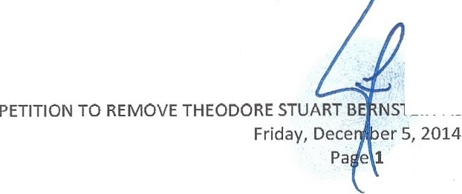Page, Mrachek , Fitzgerald & Rose, P.A., and all P rtners Associates and of Counsel; Alan B. Rose, Esq. -Personally ;
Alan B. Rose, Esq. - Professionally ;

NSTEIN AS ALLEGED SUCCESSOR TRUSTEE

Pankauski Law Firm PLLC, and all Partners, Associates and of Counsel; John J. Pankauski, Esq. - Personally;
John J. Pankauski, Esq. - Professionally; Kimberly Francis Moran -Personally; Kimberly Francis Moran -Professionally;
Lindsay Baxley aka Lindsay Giles -Personally; Lindsay Baxley aka Lindsay Giles - Professionally ;
"Simon L. Bernstein Amended and Restated Trust Agreement" Dated July 25, 2012; Simon Bernstein Trust Agreement Dated May 20th 2008;
Shirley Bernstein Trust Agreement Dated May 20th 2008; The Estate of Simon Bernstein;
The Estate of Shirley Bernstein;
SIMON L. BERNSTEIN IRREVOCABLE TRUST AGREEMENT (2008); SIMON BERNSTEIN IRREVOCABLE TRUST U/A 917106;
SIIlRLEY BERNSTEIN IRREVOCABLE TRUST U/A 917106;
SIIlRLEY BERNSTEIN IRREVOCABLE TRUST AGREEMENT (2008);
SIMON BERNSTEIN IRREVOCABLE INSURANCE TRUST DATED 6/21/1995; SIMON BERNSTEIN 2000 INSURANCE TRUST (dated August 15, 2000);
SIIlRLEY BERNSTEIN 2000 INSURANCE TRUST (DATED AUGUST 15, 2000);
Trust f/b/o Joshua Bernstein under the Simon L. Bernstein Trust <ltd 9/13/2012; Trust f/b/o Daniel Bernstein under the Simon L. Bernstein Trust dtd 9/ 13/2012; Trust f/b/o Jake Bernstein under the Simon L. Bernstein Trust <ltd 9/13/2012; ELIOT BERNSTEIN FAMILY TRUST DATED MAY 20, 2008;
DANIEL BERNSTEIN IRREVOCABLE TRUST DATED SEPTEMBER 7, 2006; JAKE BERNSTEIN IRREVOCABLE TRUST DATED SEPTEMBER 7, 2006; JOSHUA Z. BERNSTEIN IRREVOCABLE TRUST DATED SEPTEMBER 7, 2006; DANIEL BERNSTEIN IRREVOCABLE TRUST 07-JUL-10 049738;
JAKE BERNSTEIN IRREVOCABLE TRUST 07-JUL-10 0497381 ; JOSHUA Z BERNSTEIN IRREVOCABLE TRUST 07-JUL-10 0497381;
John and Jane Doe's (1-5000), Counter Defendants.

PETITION TO REMOVE THEODORE STUART BERNSTEIN AS ALLEGED SUCCESSOR TRUSTEE

COMES NOW, Eliot Ivan Bernstein ("Eliot" or "Counter Plaintiff '), beneficiary of the Shirley Bernstein Trust Agreement, dated May 20, 2008 ("Exhibit A") and then as FRAUDULENTLY AMENDED on an unknown date1 ("Exhibit B") and then again

1"Exhibit B" attached hereto is an alleged First Amendm ent to the Shirley Trust. The Court should note the lack of a dated on the first page. That the alleged Witness A torney at Law Robert L. Spallina,Esq. (while representing Ted

PETITION TO REMOVE THEODORE ST ART ERNSTEIN AS ALLEGED SUCCESSOR TRUSTEE
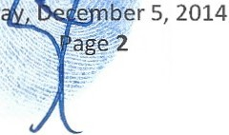Frid

FRAUDULENTLY AMENDED on November 08, 20082 ("Exhibit C") (Exhibits A, B and C together herein the "Shirley Trust" or ''Trust") and Eliot Ivan Bernstein as Legal Guardian of his three minor children and pursuant to §736.0706, Fla. Stat. (2013) and any other applicable statutes, files this Petition To Remove Theodore Stuart Bernstein as Successor Trustee, and in support, on information and belief, states as follows:
- Counter Plaintiff Eliot Ivan Bernstein is over the age of 18, a resident of Palm Beach County, Florida and is a beneficiary of the 2008 Shirley Trust.
- Counter Plaintiff Eliot Ivan Bernstein is legal guardian of his three minor children, Joshua Bernstein, Jacob Bernstein and Daniel Bernstein, alleged beneficiaries of the Shirley Trust.
- Counter Defendant, Theodore Stuart Bernstein ("Ted" or "TED") is currently serving as the alleged Successor Trustee of the Shirley Trust and is a resident of Palm Beach County.
Legal Standa1·d for Removal of Trustee

- When removal of a trustee is at issue, §736.0706, Fla. Stat. (2014) governs:

736.0706. Removal of trustee

  - The court may remove a trustee if:
    - The trustee has committed a serious breach of trust;
    - The lack of cooperation among cotrustees substantially impairs the administration of the trust;
    - Due to unfitness, unwillingness, or persistent failure of the trustee to administer the trust effectively, the court determines that removal of the trustee best serves the interests of the beneficiaries; or
    - There has been a substantial change of circumstances or removal is requested by all of the qualified beneficiarie s, the court finds that removal of the trustee best serves the interests of all of the beneficiaries and is not inconsistent with a material purpose of the trust, and a suitable cotrustee or successor trustee is available.

as alleged Successor Trustee) has admitted to Fraudulently Altering Shirley Trust documents to Palm Beach County Sheriff Investigators. The alleged Notary, Kimberly Moran, has been arrested and admitted to forgery and fraudulent notarizations of estate documents in these matters.

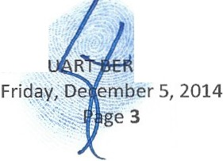" Exhibit C" attached hereto is an alleged SECOND First Amendment to the Shirley Trust. The Court should note that the alleged Witness Attorney at Law Robert L. Spallina, Esq. (while representing Ted as alleged Successor Trustee ) has admitted to Fraudulently Altering this SECOND First Amendment. The fraudulent alteration inserted language to attempt to insert Ted's family into the Shirley Trust for a one third interest, where w ithout this fraudulent language Ted's family receives no interest under the Shirley Trust, as Ted and his lineal descendants were considered predeceased in the alleged dispositive ocuments for all purposes of dispositions made thereunder.
2

PETITION TO REMOVE THEODORE ST NSTEIN AS ALLEGED SUCCESSOR TRUSTEE

- TED's removal is warranted by Subsections (2) (a), (c) and/or (d) of §736.0706, Fla Stat. (2014).

- The previous Trustee of the 2008 Shirley Trust was Simon L. Bernstein .

- By a letter dated January 14, 2014 addressed to the five children of Shirley Bernstein, as opposed to the beneficiaries of the Shirley Trust, only three of the five children of Shirley (Eliot, Lisa Friedstein and Jill Iantoni), the attorneys at law who were representing TED as counsel at the law firm Tescher & Spallina, P.A., both Donald R. Tescher, Esq. ("TESCHER") and Robert
- Spallina ("SPALLINA"), resigned in the Estates and Trusts of Shirley Bernstein ("Shirley") and Simon L. Bernstein ("Simon").
- Their resignations and removal came due to their direct involvement in proven fraud on the court and fraud on the beneficiaries that directly benefited their legal client, business associate and friend TED, to the detriment of other beneficiaries.
- The law firm of Tescher & Spallina, P.A. was representing Ted as alleged Successor Trustee of the Shirley Trust and Personal Representative of Shirley's Estate, while simultaneously the partners SPALLINA and TESCHER were acting as fiduciaries of the Estate and Trust of Simon as alleged Personal Representatives and Successor Trustees and then representing themselves as counsel for their role as fiduciaries .
- That TESCHER and SPALLINA, after their law firm was implicated and admissions made of fraud, fraud on the Court, illegal alteration of Shirley Trust documents and more resigned and then were removed from the proceedin gs by Your Honor, in all of the following capacities, including but not limited to,
I. Co-Trustees of Simon's 2012 trust,
11. Co-Personal Representatives /Executors to the Simon Estate,
ni. Counsel to themselves as Co-Trustees and Co-Personal Representatives of Simon's Estate and trusts,
- Counsel to TED as alleged Trustee of the Shirley Trust,
- Counsel to TED as Personal Representative of the Shirley Estate,
- 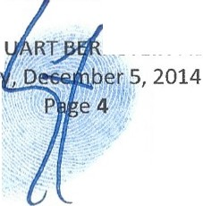Counel to TED as Alleged Trustee of the legally nonexistent Simon Bernstein Irrevocable Insurance Trust ated 1995,

PETITION TO REMOVE THEODORE ST
NSTEIN AS ALLEGED SUCCESSOR TRUSTEE

FridaLL..::""--......-

vu. Alle2ed Tmstee of the legally nonexistent Simon Bernstein Irrevocable Insurance Trust dated 1995, and,
vm. Counsel in all other fiducial and legal capacities they were acting in for any Bernstein family related matters.

A copy of the resignation letter is attached hereto as Exhibit "D."3

11. That the frauds and other felony misconduct that has taken place in both the Estates and Trusts of both Simon and Shirley Bernstein committed by the Fiduciaries and their Attorneys at Law, all acting as Officers of this Court, are comingled between various bad faith acts committed across the Estates and Trusts of both Simon and Shirley. Therefore, the acts done by TED et al. in one instance should be sufficient for Ted's removal in any of the ongoing litigations where he is an alleged fiduciary.
12. TED's egregious acts of bad faith with unclean hands while acting as an alleged fiduciary in any of the ongoing litigations involving the Estates and Trusts of Simon that TED and his former and present counsel are implicated in are hereby included in these Shirley Trust matters as parole evidence and act as further cause for his removal in this particular Trust Construction lawsuit involving the Shirley Trust.
- That TED should not have filed this pleading for a Trust Construction lawsuit involving the Shirley Trust as he is conflicted with the matters, has adverse interests to beneficiaries and is implicated in ongoing civil and criminal, state and federal, legal actions involving both the estates and trusts of Simon and Shirley Bernstein. Therefore, TED cannot argue the matters impartially as a fiduciary and must be removed.
TED BERNSTEIN IS NOT ELIGIBLE TO SERVE AS SUCCESSOR TRUSTEE AS THE LANGUAGE OF THE TRUST DISQUALIFIES HIM TO SERVE AS SUCH

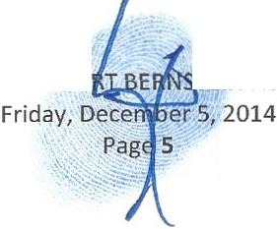3 The Court should note that Tescher and Spallina on their way out the door am idst admitted frauds committed by their firm, partners and employee and ongoing investigations of further fraudulent acts, attempted to secretly pass the Trusteeship of Simon's Trust to TED, their client who they committed the frauds to benefit. This highly unethical and possibly criminal successorship has left TE as an alleged Successor Trustee as discussed further herein.

PETnlON TO REMOVE THEODORE STUA JEIN AS ALLEGED SUCCESSOR TRUSTEE

- That SPALLINA admitted to Palm Beach County Sheriff Investigators to altering a Shirley Trust document to defraud beneficiaries, which benefited TED'S family. This fraud gave TED an alleged 3/IOlh interest inthe Shirley Trust, whereas without the fraud TED'S family would receive zero, as TED and his lineal descendants were considered PREDECEASED in the language of the Shirley Trust.
  - Definitions. In this Agreement,
    - Children, Lineal Descendants. The terms "child," "children" and "lineal descendant" mean only persons whose relationship to the ancestor designated is created entirely by or through (a) legitimate births occurring during the marriage of thejoint biological parents to each other, (b) children and their lineal descendants arising from surrogate births and/or third party donors when (i) the child is raised from or near the time of birth by a married couple (other than a same sex married couple) through the pendency of such marriage, (ii) one of such couple is the designated ancestor, and (iii) to the best knowledge of the Trustee both members of such couple participated in the decision to have such child, and (c) lawful adoptions of minors under the age of twelve years. No such child or lineal descendant loses his or her status as such through adoption by another person. Notwithstanding the foregoing, as I have adequately provided for them during my lifetime, for purposes of the dispositions made under this Trust, my children, TED S. BERNSTEIN ("TED") and PAMELA B. SIMON ("PAM'), and their respective lineal descendants shall be deemed to have p1· edeceased the survivor of my spouse and me.. . (emphasis added)

- That it is alleged that since TED was considered "for purposes of the dispositions ...predeceased" that he was fraudulently inserted as a fiduciary into the Shirley Trust by TESCHER and SPALLINA, in order to illegally gain Dominion and Control of the Shirley Estate and Shirley Trust, constituting a further breach of trust through fraud to gain the fiducial role as Trustee for TED.
- The alleged Shirley Trust was the basis used for TED to be appointed by the Court as Successor Personal Representative when the Court ReOpened the Estate of Shirley . The Court will recall that the estate was illegally closed due to a, fraud on the beneficiaries, document forgeries, fraudulent notarizations and submitted to this Court as part of an elaborate Fraud on the Court, due to the fact that Simon Bernstein closed the state while acting as Personal Representative,
PETITION TO REMOVE THEODORE STUA STEIN AS ALLEGED SUCCESSOR TRUSTEE
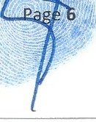Friday, _..,.,,,·.rr1..-.1er 5, 2014

WIDLE LEGALLY DECEASED for months, leaving the estate technically abandoned after the fraudulent closure.
- The Court reopened the Shirley Estate due to these proven criminal acts.

- There was no proper successor chosen for Shirley's Estate after Simon passed away and for over a year there was none, until this Court appointed TED when reoperung the Estate due to the illegal closing of the Estate of Shirley by the Fiduciaries and their counsel.
- Beneficiaries have been denied repeated requests to inspect the original signed and executed Shirley and Simon Trusts and all Amendments, Codicil's, Addendums and Memorandums that were attached.
- That TESCHER and SPALLINA did not turn over an original Shirley Trust or Simon Trust to Benjarllin Brown, Esq. when Ordered to turn over their files upon their removal by this Court.
- In light of the already proven fraud and forgeries committed with alleged dispositive documents by TED's former counsel, TESCHER and SPALLINA, in the Estate and Trusts of Shirley, the insertion of TED as a Successor Trustee and all other elements of the documents must be verified with forensic inspection of the originals for inspection for fraud, alteration and forgery.
- That TESCHER has stated in deposition that Simon and Shirley 's Estates and Trusts were done on May 20, 2008 together and were mirrored to each other.
- 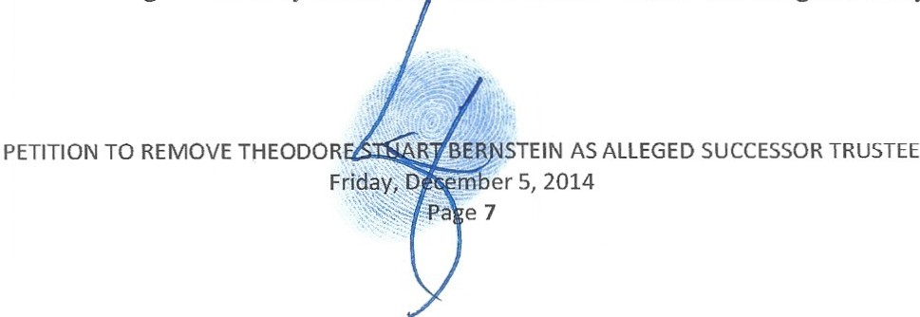That a recently turned over copy of the 2008 Simon Trust that had been suppressed for almost two years was turned over to beneficiaries by this Court's Order upon TESCHER and SPALLINA' s removal and Order for production of all of their records to the Curator, Benjarllin Brown, Esq. upon his succession, revealed that Simon's Successor Trustee in the trust he did with Shirley while both were alive was William Stansbury (the Creditor to the Simon Estate), NOT TED as is alleged in Shirley 's trust an this does not "mirror" the alleged Shirley Trust.

- TED is considered predeceased for purposes of dispositions in both Simon and Shirley 's Trusts making this insertion of TED as Successor Tmstee either an egregious construction error that contradicts other language and intent of the Trust or further parole evidence of fraud.
- TED has failed to administer the trust prudently by considering the purposes, terms and distribution requirements of the trust and has violated Florida Statute 736.0804.
- That whether this Court decides that TED was a suitable successor trustee at any time and was not maliciously and illegally inserted into the Shirley Trust, TED remains at this time not now
qualified to be a successor trustee for all of the following additional reasons despite whether he is named or not, all making his removal mandatory at this time.
TED BERNSTEIN, AS SUCCESSOR TRUSTEE, HAS FAILED TO FOLLOW FLORIDA STATUTE 736.0813AND 736.08135 BY BREACHING ms DUTY TO INFORM AND
ACCOUNT

- The duty of a trustee to account has been codified in Florida Statute 736.0813:

736.0813 Duty to info1m and account.---The trustee shall keep the qualified beneficiaries of the trust reasonably informed of the trust and its administration.
  - The trustee's duty to inform and account includes, but is not limited to, the following:
    - Within 60 days after acceptance of the trust, the trustee shall give notice to the qualified beneficiaries of the acceptance of the trust and the full name and address of the trustee.
    - Within 60 days after the date the trustee acquires knowledge of the
creation of an irrevocable trust, or the date the trustee acquires knowledge that a formerly revocable trust has become irrevocable, whether by the death of the settlor or otherwise, the trustee shall give notice to the qualified beneficiaries of the trust's existence, the identity of the settlor or settlors, the right to request a copy of the trust instrument, and the right to accountings under this section.
    - Upon reasonable request, the trustee shall provide a qualified beneficiary with a complete copy of the trust instrument.
    - A trustee of an irrevocable trust shall provide a trust accounting, as set forth in s. 736.08135, to each qualified beneficiary annually and on termination of the trust or on change of the trustee. (emohasis supplied)
    - 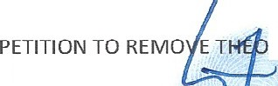Upon reasonable request, the trustee shall provide a qualified beneficiary with relevant information about the assets and liabilities of the trust and the particulars relating to a ministration.

DORE STUART BERNSTEIN AS ALLEGED SUCCESSOR TRUSTEE
Friday, December 5,2014
Page 8

- TED has provided NO accountings for the estate of Shirley and the Simon and Shirley Trusts since he has become the alleged Successor Trustee.
- The duty to account is so fundamental to the law of trusts that this duty cannot be diminished by the trust itself The trust instrument may provide that a trustee need not account or only account informally to a beneficiary, but according to the Florida Trust Code, any such limiting provisions are ineffectual and cannot relieve the trustee of his or her duty to account fully to a qualified beneficiary. See: Florida Statute. 736.0105(2) (s).
- FAILURE TO ACCOUNT IN THE SIMON ESTATE AND TRUST

- Ted, currently acting as successor trustee in the Simon Trust has provided NO accountings

despite repeated requests by beneficiaries and despite a change in Successor Trustee, when TED's former counsel and fiduciaries for the 2012 Simon Trust, TESCHER and SPALLINA resigned after admitting their law firm committed Fraud, Fraudulent Notarizations, Forged documents and more that all were in efforts to benefit their friend and client TED and his family.
- Between TED and his former counsel there has been NO accounting for over two years in the Simon trust in violation of probate and trust, rules and statutes.
- That TESCHER and SPALLINA were ordered by the Court to produce a final accounting upon their removal and that accounting has been challenged by multiple parties, including the former Curator Benjamin Brown, Esq., the current Successor Personal Representative Brian O'Connell, the Creditor William Stansbury, Eliot and others on virtually every single line. The objections have been stayed with the case and remain unheard.
- FAILURE TO ACCOUNT IN THE SHIRLEY ESTATE AND SIURLEY BERNSTEIN TRUST

- Since TED was appointed Personal Representative in the Shirley Bernstein Estate after the Estate of Shirley was reopened by this Court due to Fraud d Fraud on the Court committed by TED's
..,
PETITION TO REMOVE THEODORE STUART.B IN AS ALLEGED SUCCESSOR TRUSTEE

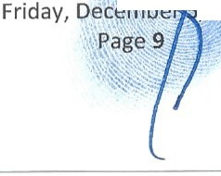
' .14

counsel as PR, TESCHER and SPALLINA, NO statutorily required or required under the Shirley Trust accountings have been filed with the Court and/or provided beneficiaries.
- Despite repeated requests and despite changes in fiduciaries when the Estate was reopened requiring accounting, none has been provided by Ted, in violation of probate and trust rules and statutes.
- Since becoming the alleged Successor Trustee of Shirley's 2008 Shirley Bernstein Trust Agreement on September 13, 2012 Ted has failed to provide a full copy of Shirley's Trusts with all Schedules, Memorandums, Codicils, and Addendurns as required by statute.
- TED's failure to account leaves beneficiaries with no way to determine the Shirley Trust value.

- A trustee cannot fulfill his duty to account by merely turning over to the beneficiaries the check register of the trust bank account, a list of checks, bank statements, copies of bills and receipts. It is the duty of the trustee to provide a proper and sufficient accounting. TED has failed to turn over to beneficiaries a register, list of checks, banks statements, copies of bills and receipts or any other verified accounting and :financial information in the Estate and Trusts of Shirley.
- TED's failure to account in the Shirley Estate, the Shirley trust and the Simon trust is cause alone for this Court to remove TED as a fiduciary of the Shirley Trust.
TED BERNSTEIN, AS ALLEGED SUCCESSOR TRUSTEE, HAS FAILED TO KEEP ACCURATE RECORDS AND COMMITTED WASTE, FRAUD AND ABUSES OF TRUST AND ESTATE ASSETS

- TED as alleged successor trustee has a duty to maintain clear, complete, and accurate books and records regarding the trust.
- The Florida Trust Code explicitly states that a trustee shall keep clear, distinct and accurate records of the administration of the trust.
736.0810 Record keeping and identification of tmst property.
  - A trustee shall keep clear, distinct, and accurate records of the administration of the trust.
- A trustee shall keep trust property separate from the trustee's own property.
- Except as otherwise provided in su section

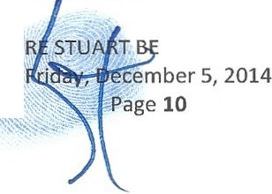PETITION TO REMOVE THEODO
RNSTEIN AS ALLEGED SUCCESSOR TRUSTEE

\,.

(4), a trustee shall cause the trust property to be designated so that the interest of the trust, to the extent feasible, appears in records maintained by a party other than a trustee or beneficiary.
(5) If the trustee maintains records clearly indicating the respective interests, a trustee may invest as a whole the property of two or more separate trusts.

- TESCHER and SPALLINA were ordered to tum over all their records and properties in their possession to the Curator, Bertjamin Brown, Esq. No original signed and executed Trust for Simon and Shirley were turned over to him. TED does not possess the original signed and executed 2012 Simon Trust under which he alleges to operate as Successor Trustee.
- At this time no original signed and legally executed originals exist of the 2012 Simon Trust.

- The former fiduciaries of the Trust, TESCHER and SPALLINA , upon termination as Co- Trustees, have produced no original dispositive documents to the former Curator, Benjamin Brown, Esq., despite the Court's Order to tum over all records and properties in their possession to the former Curator.
- The 2012 Simon trust was also used to seize dominion and control of the Shirley Trust assets through an alleged power of appointment exercised, where the Simon trust is challenged in entirety and already has been found to be improperly notarized.
- Once control was gained by TED and his attorneys, TESCHER and SPALLINA, they began to loot Simon and Shirley's Trusts and Estates through a series of fraudulent acts and they began recklessly billing outrageous and unaccounted for legal and fiduciary fees, while simultaneously concealing, altering and destroying records and precluding beneficiaries from any financial information or access to the dispositive documents. To date, several trusts are suppressed, claimed missing, life insurance policies and life insurance trusts are missing and claimed lost, IRA beneficiaries are claimed missing and more involving the estate plans of Simon and Shirley.
- The Court should note that Simon Bernstein was one of the nation's leading innovative insurance salesman with over a billion dollars of sold premiums and was integral of estate planning for some of the nation 's wealthiest families an would not have left his estate or his beloved wife's
PETITION TO REMOVE THEODORE ST .;..E-R."N"' STEIN AS ALLEGED SUCCESSOR TRUSTEE
Friq . , embf s,2014
...:: ;, ; ' ge tiW


estates and trusts in this disorder. It is alleged that these acts to suppress and deny documents are all attempts to convert assets to improper parties by TED and his counsel.
- Legal and fiduciary fees have run rampant, with often 6-7 attorneys attending hearings and all of this is cost is a result of TED and his former counsel SPALLINA and TESCHER'S and others involvement in fraud and other civil and criminal misconduct.
48. Real estate was sold at fire sale prices and distributions were made to knowingly improper parties by TED, against the advice of SPALLINA and againstthe express wishes of beneficiaries and their counsel.
- Bank and other accounts were discovered being used post mortem at Legacy Bank and others. Bank accounts and investment accounts are alleged unaccounted for. IRA accounts are missing information regarding beneficiaries.
- A trustee like TED who, after being requested to do so, refuses to provide a beneficiary with relevant information about the assets, documents and information of the trust, refuses to account for how the trust is being administered , and who refuses to provide an accounting when required, has breached his fiduciary duty owing to the beneficiaries and should be removed.
- TED has failed to administer the Shirley Trust in good faith, in accordance with its terms and purposes and the interests of the beneficiaries in violation of Florida Statute 736.0801.
TED BERNSTEIN SHOULD BE REMOVED AS SUCCESSOR TRUSTEE BASED ON CONFLICT OF INTEREST

  - ILLINOIS INSURANCE LITIGATION CONFLICT OF INTEREST

- At the time of SIMON'S death, it was determined that there existed a life insurance policy issued by Heritage Union Insurance Company ("Heritage") allegedly payable to the Simon Bernstein Irrevocable Insurance Trust dated June 1, 1995 (the "Insurance Trust) as beneficiary.
- Heritage claims however that the Primary Beneficiary was LaSalle National Trust, NA and the

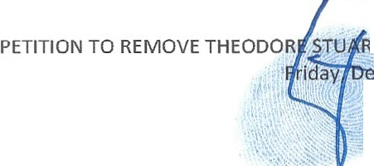Contingent Beneficia1y was the Simon emstein Trust NA.

T BERNSTEIN AS ALLEGED SUCCESSOR TRUSTEE
cember 5, 2014
Page 12

- SPALLINA also represented to Heritage that he was the Trustee of LaSalle National Trust NA, which he is not.
- Shortly after SIMON'S death in 2012, SPALLINA submitted a claim form to Heritage on behalf of a legally nonexistent Simon Bernstein Irrevocable Insurance Trust dated June 1, 1995.
- SPALLINA signed the claim form as the "acting Trustee" of the nonexistent trust in an effort to make the insurance proceeds payable to his law firm trust account to then distribute the proceeds outside the Simon Bernstein Estate and Simon Bernstein Trust to the detriment of the Estate and Trust beneficiaries.
- SPALLINA did this for the benefit of four of five of the grown children of Simon Bernstein including TED, who as set forth above, was considered predeceased under Simon and Shirley's Estate and Trusts.
- Under Florida law, if it is determined that no Simon Bernstein Irrevocable Insurance Trust dated June 1, 1995 exists, the insurance proceeds are payable to the Estate of Simon and then per the terms of Simon's Last Will and Testament they would pour over into Trust. In this instance both TED and his sister PAMELA would receive $0.00.
- After SPALLINA'S claim was denied by Heritage for failure to provide either a court order to pay the nonexistent trust or provide a legal trust instrument before a claim could be paid, TED then somehow replaced SPALLINA as the alleged "Trustee" of the lost trust and he filed an Illinois circuit court breach of contract lawsuit against Heritage for failure to pay the fraudulent claim submitted by SPALLINA The suit was transferred to federal court in the United States District Court for the Northern District of Illinois in Chicago under the tutelage of Hon. Judge Arny St. Eve.
- After TESCHER and SPALLINA resigned and were removed as Personal Representatives for their firm's fraudulent acts, the Estate of Simon ernstein filed a Motion to Intervene in the

Illinois life insurance litigation to assert the Estate's interest in the life insurance proceeds. The Curator, Ben Brown, retained counsel with the approval of this Court to intercede on behalf of the Estate and SPALLINA and TESCHER refused to assert the Estates interest as they were acting as TED's counsel as Trustee of the legally nonexistent Simon Bernstein Irrevocable Insurance Trust dated June 1, 1995 simultaneously and in conflict and violation of attorney conduct codes and statutes.
- The Plaintiffs in the Life Insurance Litigation include TED acting as "Trustee" of the nonexistent 1995 trust and TED, individually. TED and the other Plaintiffs filed a Memorandum of Law in Opposition to the Estate's Motion to Intervene (the "Opposition Memorandum").
- The opening paragraph of the Opposition Memorandum states as follows:

NOW COMES Plaintiffs, SIMON BERNSTEIN IRREVOCABLE INSURANCE TRUST dated 6/21/95, by TED BERNSTEIN, as
Trustee, (collectively referred to as "BERNSTEIN TRUST"), TED BERNSTEIN, individually, PAMELA B. SIMON, TILL
!ANTONI AND LISA FRIEDSTEIN ... (emphasis added)

- As Plaintiff, TED stands to benefit personally if the claim by the Simon Bernstein Estate to the life insurance proceeds is defeated because TED and his siblings (other than Eliot) have taken the position that they are the beneficiaries of the legally nonexistent Simon Bernstein Irrevocable Insurance Trust dated June 1, 1995 and not their children.
- Despite the opposition of TED BERNSTEIN and the other Plaintiffs to the Intervention, the federal court granted the Estate's Motion to Intervene.
- TED is now an opposing party of record to the Estate's claim in the Illinois life insurance litigation.
- 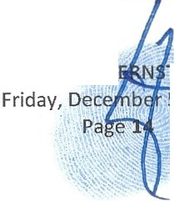TED, individually and as the alleged trustee of the legally nonexistent 1995 Simon Bernstein Irrevocable Insurance Trust, has placed his personal interests above the interests of the Simon Trust beneficiaries , allegedly the grandchildren of IMON, including TED's own children.

PETITION TO REMOVE THEODORE STUART B TEIN AS ALLEGED SUCCESSOR TRUSTEE
5,2014

- Through TED's opposition to the Estate's intervention in the Illinois life insurance litigation, an inherent conflict of interest is displayed where TED is blocking the interests of beneficiaries of the Simon Trust, including his own children, while simultaneously acting as Trustee of the Simon Bernstein Irrevocable Insurance Trust dated June 1, 1995 whereby he personally claims to have an interest in the policy .
- TED, as alleged Successor Trustee of the Simon trust, owes a duty ofloyalty under

§736.0706(1), Fla Stat. (2014) to the Simon trust beneficiaries to administer the trust solely in their interests. His actions in the Illinois Insurance Litigation have violated that duty.
- TED, acting as a fiduciary to the Trust, must support, or at the least not obstruct, the efforts of the Estate and the Simon Trust to recover the additional $1.7 million in life insurance benefits. However, TED benefits directly from his obstruction and therefore has an obvious conflict of interest.
- Ifthe insurance proceeds are recovered for the Estate, this would dramatically increase the Estate assets that Estate and Trust beneficiaries receive and leave TED with nothing.
- This attempt to redirect the insurance proceeds by TED and his former Counsel SPALLINA and TESCHER, through the lost insurance trust scheme to benefit TED have caused intentional interferences and delays with expectancies to the Simon Trust and Estate beneficiaries .
- TED blocked the grandchildren, including minor children, from their interests being represented by counsel in the lllinois insurance litigation, leaving the grandchildren's interests wholly unprotected while trying to secure the benefits for himself personally.
- 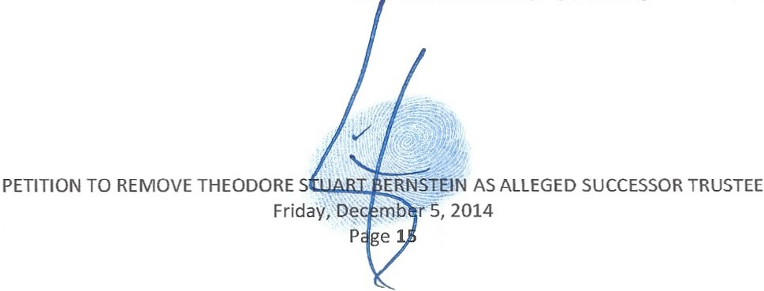The Federal court has now allowed intervention by the Estate of Simon Bernstein despite the best efforts to block the Estate's intervention by TE and his former Counsel SPALLINA and TESCHER.

- The Court should note that SPALLINA and TESCHER had also blocked through Conflicts of Interest the Simon Estate and Simon Trust beneficiaries from asserting their interests in the
policy while they were acting as PR and Trustees of Simon's Estate before their removal, acting instead to benefit their other client TED instead.
- More importantly, TED and his former counsel's efforts in the Life Insurance Litigation are designed to keep the I .7 million out of the estate and trust and to redirect the money to TED and his siblings (excluding Eliot).
- As a consequence of the foregoing conflict of interest and adverse interests, TED is in breach of his fiduciary duty to the beneficiaries of the Simon Trust by opposing efforts to make the Estate and Simon Trusts more solvent, which in tum exposes the Estate and Simon Trusts to increased liability . This warrants his removal under §736.0706(2)(a).
- TED's continued interference is an attempt to redirect estate assets to himself personally and further damages the trust beneficiaries, as Ted's interference has caused unnecessary and costly legal fees to the Estate and Trust beneficiaries already with his counsel TESCHER, SPALLINA et al. who have committed acts of fraud to benefit TED as an alleged Fiduciary in Simon and Shirley 's estates and trusts.
- TED'S CONFLICT OF INTEREST WITH BENEFICIARIES

  - TED'S ADVERSE INTEREST WITH ELIOT

- TED and his former and current counsel have adverse interests to Eliot and in fact are hostile towards Eliot and his minor children, due to the fact that Eliot is the one who has uncovered their wrongdoings and exposed them to potential criminal prosecution.
- 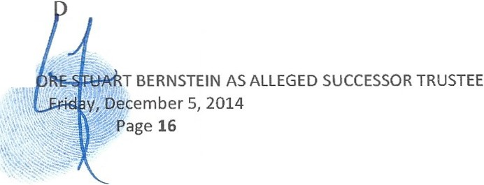TED and his attorneys have conspired to use a strategy of force and aggression on Eliot, which was discovered in an email TED sent to Eliot describing their tactics and admitted on the record in a hearing before this Court by TE .

PETITION TO REMOVE THEOD

i. TED'S CONFLICT OF INTEREST HAS CAUSED HARM TO MINOR CIDLDREN BENEFICIARIES

- This Court ordered on August 20, 2014 and again on August 22, 2014, that tuition for Saint Andrews school, including past due balances, be paid for Eliot's three minor children for the 2014-2015 school year.
- TED intentionally failed to make the Court-ordered payment, resulting in all three children being removed from school on the second day of school and forced them to attend new schools, causing major damages to the minor children both emotionally and scholastically. That these damages
are now both short term and long term, affecting their futures dramatically.

- Because of the conflicts of interests and adverse interests with the beneficiaries, TED has failed to maintain a duty of impartiality owed to the beneficiaries and should therefore be removed.
- Attorney SPALLINA, representing TED as Personal Representati ve of the Estate of Shirley Bernstein, has admitted to fraudulently altering provisions of the Shirley Bernstein Trust to Palm Beach County Sheriff investigators, which had the effect of benefitting TED'S family over others.
- No successor was appointed until this Court reopened the Estate of Shirley due to the fact that Simon closed the Estate as Personal Representative/Executor while dead, yet TED acted as Personal Representative in multiple transactions during that time in order to begin selling assets of the estate and trusts of Shirley while the Estate was closed and no successor to Simon was ever appointed.
- 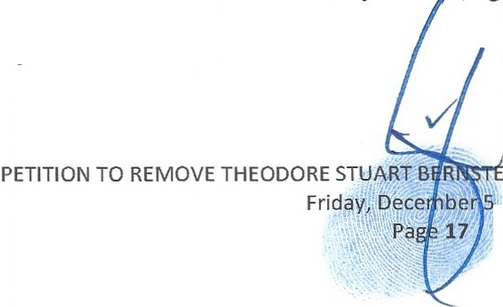Statements made by SPALLINA to Palm Beach Sheriff Investigators reveal that TED made distributions while acting as Trustee against the advice of his counsel that benefited his family to the determinant of beneficiaries in Shirley 's Tr t, again making him wholly unfit to continue as a fiduciary in these matters.

IN AS ALLEGED SUCCESSOR TRUSTEE
, 2014

- TED claimed to Palm Beach Sheriff Investigators that he had not read all of the trust documents that he was acting as a fiduciary under and only followed orders from his counsel TESCHER and SPALLINA.
- TED's involvement with his former counsel TESCHER and SPALLINA in illegal and highly unethical activity all to benefit TED directly in the Estate and Trust of Shirley Bernstein should disqualify him from serving as Successor Trustee of the Shirley and Simon Trusts or any other fiducial capacities involving the estates and trusts of Simon and Shirley.
- TED has failed to act impartially as a fiduciary in both Simon and Shirley 's estates and trusts as among beneficiaries, in violation of Florida Statute 736.0803 and therefore TED cannot be expected to act impartially in the future due to his multiple conflicts of interest, adverse interests with beneficiaries and implication in ongoing criminal investigations and civil litigations, in both state and federal, civil and criminal, actions.
TIDS COURT PREVIOUSLY REJECTED TED AS A FIDUCIARY IN THE ESTATE OF SIMON BERNSTEIN

- TED's Petition to be appointed Curator or Personal Representative in Simon's Estate was rejected on February 19th, 2014 by this Court. See, Order attached hereto as Exhibit "E." The same reasons the Court did not appoint TED in this fiducial capacity, including that it would shut down the proper and efficient administration of the Estate of Simon, are applicable in removing TED now in the Shirley Trust.
WHEREFORE, COUNTER Plaintiff requests that this Court;

  - Request an URGENT HEARING DATE be picked by the Court and prior to any other hearing request for any other reason filed by TED acting as alleged Trustee, to settle if TED should be allowed to participate as a qualified Trustee forward.
  - Removal of TED as the alle ed successor trustee of the Shirley Trust,

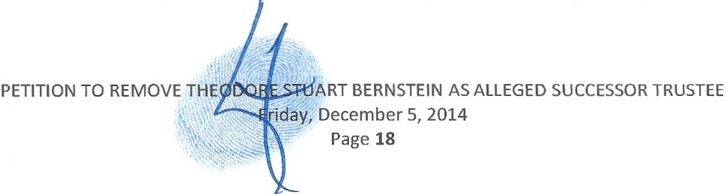

  - Appoint a successor trustee with no conflicts of interests or affiliation with any of the former fiduciaries or attorneys at law involved in the prior frauds in any way,
  - Require the filing of a Shirley Estate and Shirley Trust Accounting as none has been provided to beneficiaries for over FOUR years.
  - Award damages for failure to account or for improper accounting, including the removal of the trustee, reducing or denying compensation to the trustee, requiring the trustee to repay money to the trust or by restoring property to the trust by other means, or any other relief the court deems appropriate.
  - Compel the trustee to redress a breach of trust by paying money or restoring property or by other means;
  - Appoint a special fiduciary to take possession of the trust property and administer the trust;
  - Deny compensation to the trustee;

  - Subject to §736.1016, void an act of the trustee, impose a lien or a constrnctive trust on trust property, or trace trust property wrongfully disposed of and recover the property or its proceeds;
  - 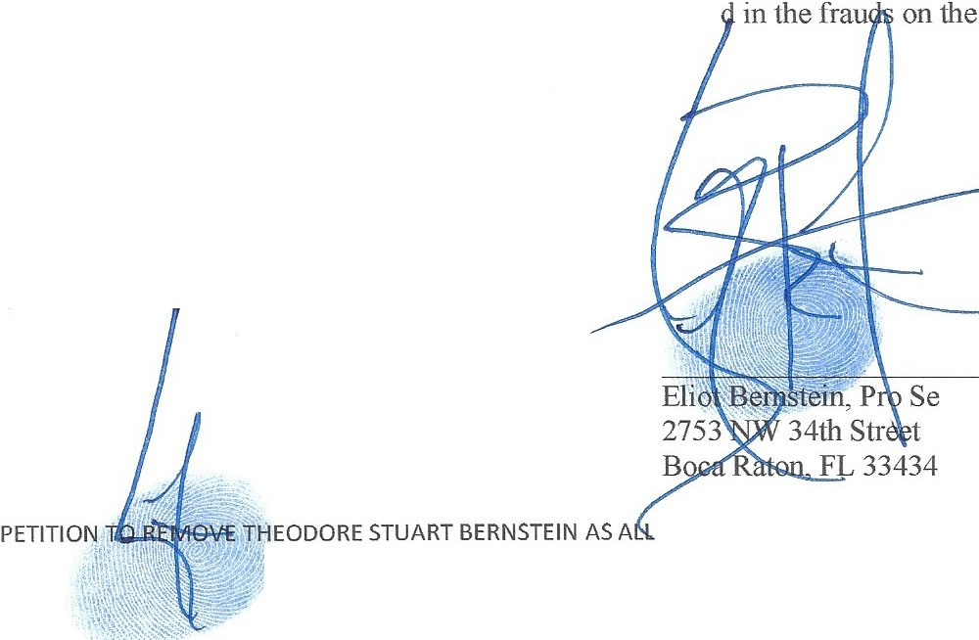Force appropriate bonds be posted by all fiduciaries and attorneys at law who have already been proven and those alleged to have been involve
beneficiaries and the frauds on the Court, and

  - Order any other appropriate relief.

Dated: Friday, December , 2014

Friday, December 5, 2014
Page 19
EGED SUCCESSOR TRUSTEE

iviewit rd,iviewit.tv

CERTIFICATE OF SERVICE

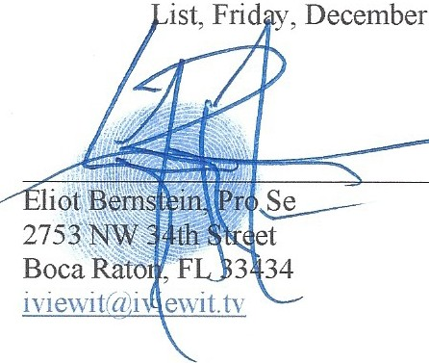I, ELIOT IVAN BERNSTEIN, HEREBY CERTIFY that a true and correct copy of the foregoing has been furnished by email to all parties on the following Service
5, 2014.

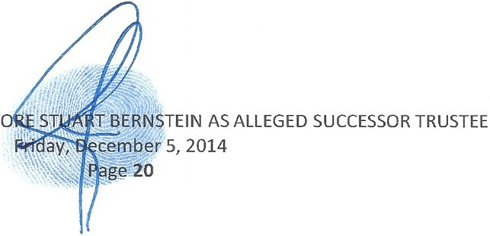PETITION TO REMOVE THEOD

SERVICE LIST

Donald Tescher, Esq., Tcscher & Alan B. Rose, Esq. Jolm J. Pankauski, Esq. Robert L. Spallina, Esq., Spallina, P.A. Page, Mrachek, Fitzgerald & Rose, Pankauski Law Firm PLLC Tescher & Spallina, P.A. Boca Village Corporate Center I PA. 120 South Olive Avenue Boca Village Corporate 48SS Technology Way SOS South Flagler Drive, Suite 600 7th Floor Center I
Suite 720 West Palm Beach, Florida 33401 West Palm Beach, FL 33401 48SS Technology Way Boca Raton, FL 33431 (S61) 3SS-6991 (S6 l) s14-0900 Suite 720
dteschcrr(1 tcschcrspal Iin a.com arose' G'pm-lm' .com courtfili ngs@1;1ankauskilawfirm. com Boca Raton, FL 33431

dtcschcni"1tcschcrs12allina.com and joh n@1;1an kauskilawfirm .com
rs12al linalii tcschcrspal I ma .com

ddust inr"ii'teschers12alI in a .com aros c'a mrachck -law.com kmoranr(1tcschcrspallina .com
kmoran·a tescherspallina.com mchandlcr dmrnchek-la\\ .com ddustinrc1tcschcrspallina .com lmrachekii mrachck -la\\ . com

Pamela Beth Simon Theodore Stuart Bernstein Mark R. Manceri, Esq., and Irwin J. Block, Esq.
9SO N. Michigan Avenue Life Insurance Concepts Mark R. Manceri, P.A., The Law Office of Irwin J. Apartment 2603 9SO Peninsula Corporate Circle, Suite 2929 East Commercial Bou levard Block PL
Chicago, IL 60611 3010 Suite 702 700 South Federal Highway psinHm ri"1stgcoq .com Boca Raton, J71orida 33487 Fort Lauderdale, FL 33308 Suite 200
tbem stein(d' Ii fcin su ranceconccgts.com mrm la\\"' G com cast.net Boca Raton, Florida 33432
mrm la\\ I rdgmail .com i jb ra ijhlegal .com
martin a ·kola\\.Vers.com

Jill lantoni Lisa Friedstein Kimberly Moran John P Morrissey. Esq. 2101 Magnolia Lane 2142 Churchill Lane Tescher & Spallina, P.A. John P. Morrissey, P.A. Highland Park. IL 6003S Highland Park, IL 6003S Boca Village Corporate Center I 330 Clematis Street jilliantoni rc1'gmail . com Lisa@friedstei ns.com 48S5 Technology Way Suite 213
Julia Iantoni. a Minor lisa. fricdstcill'a gmail .com Suite 720 West Palm Beach, FL 3340 I c/o Guy and Jill lantoni, lisa' <Vfricdstcins.com Boca Raton,FL 33431 john r(i<jmorrisscj'.law .com Iler Parents and Natural Guardians Carley & Max Friedstein, Minors kmoran 'a'teschersgallina .com
ji ll1antoni ' agmail . com c/o Jeffrey and Lisa Friedstein Parents and Natural Guardians Lisa@friedsteins.com lisa.fricdstcin (1 gmail.com

Charles D. Rubin Joshua, Jacob and Daniel Bernstein , L. Louis Mrachek, Esq.
Managing Partner Minors PAGE, MRACHEK,
Gutter Chaves Josepher Rubin c/o Eliot and Candice Bernstein, FITZGERALD, ROSE,
Forman Fleisher Miller PA Parents and Natural Guardians KONOPKA, THOMAS & WEISS, Boca Corporate Center 2753 NW 34th Street P.A.
2101 NW Corporate Blvd., Suite Boca Raton, FL 33434 SOS South Flagler Drive, Suite 600
107 iYie''it · a i\iC\\it.h West Palm Beach, Florida 33401
Boca Raton , FL 33431-7343 lmrachck 'a mrachck-la\\ . com cm bin ii Ooridatax.com I
I
Lindsay Baxley aka Lindsay Giles Life Insurance Concepts
9SO Peninsula Corporate Circle, Suite 3010
Boca Raton, Florida 33487

l indsa"tt lifeinsuranccconccnts com
I
11
(
_, -
-...;

PETITION TO REMOVE THEODORE STUART Bl RNSTEIN AS SUCCESSOR TRUSTEE
Friday, December. r 2014
.· '.:"-

\.

EXHIBIT A

Shirley Bernstein Trust Agreement, dated May 20, 2008



SHIRLEY BERNSTEIN TRUST AGREEMENT

Prepared by:

Tescher & Spallina, P.A.
2101 Corporate Blvd., Suite 107, Boca Raton, Florida 33431
(561) 998-7847

TESCHER 8 SPALLINA, P.A.
... ... _

.. . ·-
- "' ....

SHIRLEY BERNSTEIN

TRUST AGREEMENT

This Trust Agreement is dated this .2..J:L day of /Y? > 2008, .and is between SHIRLEY BERNSTEIN, of Palm Beach County, Florida referred the first person, as settlor, and SHIRLEY BERNSTEIN, of Palm Beach County, and SHIRLEY BERNSTEIN's successors, as trustee (referred to as the "Trustee," which term more particularly refers to all individuals and entities serving as .trustee of a trust created hereunder during the time of such service, whether alone or as co-trustees,
and whether originally serving or as a successor trustee). Said Trustee acknowledges receipt of the property described in the Attachment to this Agreement, and agrees to hold said property ad all additions, in trust, as provided in this Agreement.

ARTICLE I. DURING MY LIFE AND UPON MY DEATH

- Rii:hts Reserved. I reserve the right (a) to add property to this trust during my life or on my death, by my Will or otherwise; (b) to withdraw property held hereunder; and (c) by separate written instrument delivered to the Trustee, to revoke this Agreement in whole or in part and·otherwise modify or amend this Agreement. However, after my spouse'sdeath I may not exercise any of said rights with respect to property added by my spouse upon my spouse's death by my spouse's Will or otherwise.

- Payments Durini: My Life. If income producing property is held in the trust during my life, the Trustee shall pay the net income of the trust to me or as I may direct. However, during any periods while I am Disabled, the Trustee shall pay to me oron my behalf such amountsof the net income and principal of the trust as is proper for my Welfare. and also may in its discretion pay to my spouse such amounts of said net income and principal as isproper for his Welfare.Any income not so paid shall be added to principal.

C. Gifts. IfI am Disabled, I authorize the Trustee to make gifts from trust property during my lifetime for estate planning purposes, or to distribute amounts to my legally appointed guardian or to my attorney-in-fact for those purposes, subject to the following limitations:

l . Recipients. Thegifts may be made only to my spouse and my lineal descendants or to trusts primarily for their benefit, and in aggregate annual amounts to any one such recipient that do not exceed the exclusion amount provided for under Code Section 2503(b).

- Trustee Limited. When a person eligible to receive gifts is serving as Trustee, the aggregate of all gifts to that person during the calendar year allowable under the preceding subparagraph I .shall thereafter not exceed the greater ofFive Thousand Dollars ($5,000),orfivepercent

SHIRi.EV BERNSTEIN
TRUST AGREEMBWT

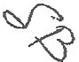TESCHER s SPALLINA, P.A.

·
4L
. 1!
'... | ;t';f
.

.

·-· . --·-----·-· --

(5%) of the aggregate value of the trust estate. However, gifts completed prior to a recipient's commencing to serve as Trustee shall not be affected by this limitation.

3, Charitable Pledges. The Trustee may pay any charitable pledges 1 made while I was not Disabled (even if not yet due).

D. Upon My Death. Upon my death the Trustee shall collect and add to the trust all amounts due to the trust under any insurance policy on my life or under any death benefit plan and aJI property added to the trust by my Will or otherwise. After paying or providing for the payment from the augmented trust of all current charges and any amounts payable under the later paragraph captioned "Death Costs," the Trustee shall hold the trust according to the following provisions.

ARTICLE II.AFTER MY DEATH

- Disposition of Tana:ible Personal Property. If any non-business tangible personal property other than cash (including, but not limited to, my personal effects, jewelry, collections, household furnishings,and equipment, and automobiles) isheld in the trust at the time of my death, such items shall be promptly distributed by the Trustee of the trust to such person or persons, including my estate, as to the item or items or proportion specified, as I may appoint, and to the extent that any such items are not disposed of by such appointment, such items shall be disposed of by the Trustee of the trust in exactly the same manner as such items would have been disposed of under the terms and provisions of my Will (including any Codicil thereto, or what the Trustee in good faith believes to be such Will and Codicil) had such items been included in my probate estate. Any such items which are not effectively disposed of pursuant to the preceding sentence shall pass with the other trust assets.

- Specific Cash Devise.The Trustee shall set aside in a separate trust the sum of Two Hundred Thousand ($200,000.00) Dollars for MAITHEW LOGAN, and said separate trust shall be administered as provided in Subparagraph IJ.Fbelow. If MAITHEW LOGAN does not survive me this devise shall lapse.

- Marital Deduction Gift. Ifmy spouse survives me:

I . Family Trust. The Trustee shall hold asa separate "Family Trust" (i) all property of the trust estate as to which a federal estate tax marital deduction would not be allowed 'if it were distributed outright to my spouse, and (ii) after giving effect to (i), the largest pecuniary amount which will not result in or increase any federal or state death tax otherwise payable by reason of my death. In detennining the pecunfary·amount the Trustee shall assume that none of this Family Trust qualifies for a federal estate tax deduction, and shall assume that all of the Marital Trust hereinafter established (including any part thereof disclaimed by my spouse) qualifies for the federal estate tax marital deduction. I recognize that the pecuniary amount may be reduced by certain state death taxes and administration expenses which are not deducted for federal estate tax purposes.

SH RLEY DF.RNSlEIN
TRUST AOR.l!EM.ENT - -2-

TESCHER g SPALLINA, P.A.

- ....,.....

·.-·: •

  - Marital Trust. The balance of the trust remaining after the establishment of the Family Trust shall be held as a separate "Marital Trust."

  - Disclaimer. Any part of the Marital Trust my spouse disclaims shall be added to the Family Trust. My spouse shall not be deemed to have predeceased me for purposes of such addition. I suggest that my spouse or my spouse's fiduciaries consider an appropriate partial disclaimer to minimize the death taxes due upon both of our deaths.

If my spouse does not survive me, the entire trust shall be held as the Family Trust without regard to the provisions of Subparagraph Il.B.1 describing or limiting which assets shall be held thereunder.

- During Spouse's Life. Commencing with the date of my death the Trustee shalJ,

J . Marital Trust. Pay to my spouse from the Marital Trust, the net income,and such amounts of principal as is proper for my spouse's Welfare; and

2. Family Trust. Pay to my spouse from the Family Trust, the net income, and such amounts of principal as is proper for my spouse's Welfare. 1request (but do not require) that no principal be paid to my spouse from the Family Trust for my spouse's Welfare unless the Marital Trust has been exhausted by use, consumption, distribution, or otherwise or is not reasonably available.

- Disposition of Trusts Upon Death of Survivor of My Spouse and Me. Upon the death of the survivor of my spouse and me,

  - Limited Power. My spouse (if my spouse survives me) may appoint the Marital Trust and Family Trust (except any part added by disclaimer from the Marital Trust and proceeds of insurance policies on my spouse's life) to or for the benefit of one or more of my l ineal descendants and their spouses;

  - Disposition of Balance. Any parts of the Marital Trust and the Family Trust my spouse does not or cannot effectively appoint (including any additions upon my spouse's death),or all of the Family Trust if my spouse did not survive me, shall be divided among and held in separate Trusts for my lineal descendants then Jiving,per stirpes. Any assets allocated under this Subparagraph Il.D. to my children (as that term is defined under this Trust), shall be distributed to the then serving Trustees ofeach of their respective Family Trusts, established by my spouse asgrantor on even date herewith (the "Family Trusts" which term includes any successor trust thereto), to be held and administered as provided under said Trusts. The provisions of the Family Trusts are incorporated herein by reference, and if any of the Family Trusts are not then in existence and it is necessary to accomplish the foregoing dispositions, the current Trustee of this Trust is directed to take such action to establish or reconstitute such applicable trust(s), or if the Trustee is unable to do so, said assets shall be held in separate trusts for such lineal descendants and administered asprovided in Subparagraph 11.E.below. Each of my lineal descendants for whom a separate Trust is held hereunder shall hereinafter be referred to as a "beneficiary," with their separate trusts to be administered as provided in Subparagraph 11.E. below.

SHIRLEY BERNS'JEIN
TRUST AGREEMENT ·3-

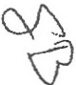TESCHER 8 SPALLINA, P.A.

.,,.,,...,... .

........-_.., -.........-.,,.....--................................,.,...

....,.....------ -·...-----·-·-- ·--- ···-· - -·· ··•-.......---._.._.,.,.

- Trusts for Beneficiaries. The Trustee shall pay to a beneficiary the net income of such beneficiary's trust. The Trustee shall pay to the beneficiary and the beneficiary' s children, such amounts of the principal of such beneficiary' s trust as is proper for the Welfare of such individuals. After a beneficiary has reached any one or more of the following birthdays,the beneficiary may withdraw the principal of his or her separate trust at anytime ortimes, not to exceed in the aggregate 1/3 in value after the beneficiary's 25th birthday, 112 in value (after deducting any amount previously subject to withdrawal but not actually withdrawn) after the beneficiary's 30th birthday, and the balance after the beneficiary's 35th birthday, provided that the withdrawal powers described in this sentence shall not apply to any child of mine as beneficiary of a separate trust. The value of each trust shall be its value as of the first exercise of each withdrawal right, plus the value of any subsequent addition as of the date of addition. The right of withdrawal shall be a privilege which may be exercised only voluntarily and shall not include an involuntary exercise. If a beneficiary dies with assets remaining in his or her separate trust, upon the beneficiary's death the beneficiary may appoint his or her trust to or for the benefit of one or more of my lineal descendants and their spouses (excluding from said class, however, such beneficiary and such beneficiary's creditors, estate, and creditors of such beneficiary's estate). Any part of his or her trust such beneficiary does not effectively appoint shall upon his or her death be divided among and held in separate Trusts for the following persons:

l . for his or her lineal descendants then Jiving,per stirpes; or

2. if he or she leaves no lineal descendant then living, per stirpes for the lineal descendants then living of his or her nearest ancestor (among me and my lineal descendants) with a lineal descendant then living who is also a lineal descendant of my spouse.

A trust for a lineal descendant of mine shall be held under this paragraph, or if a trust is then so held, shall be added to such trust.

- Termination of Small Trust. If at any time after the death of the survivor of my spouse and me in the opinion of the Trustee a separate trust holds assets of a value of less than $50,000.00 and is too small to justify the expense of its retention, and tennination of such trust is in the best interests of its current income beneficiary, the Trustee in its discretion may terminate such trust and pay it to said beneficiary .

- Contine,ent Gift. If at any time property of a trust held under this Agreement is not disposed of under the other provisions of this Agreement, it shall be paid, as a gift made hereunder, to such persons and in such shares as such property would be d istributed if my spouse and I had each then owned one-half of such property and had each then died solvent, unmarried and intestate domiciled in the State of Florida, according to the laws of inheritance of the State of Florida then in effect.

I. Protective Provision. No beneficiary of any trust herein created shall have any right or power to anticipate, transfer, pledge, sell, alienate, assign or encumber in any way his or her interest in the income or principal of such trust. Furthermore, no creditor shall have the right to attach, lien, seize or levy upon the interest of a beneficiary in this trust (other than myself) .and such interest shall not be

SHIRLEY BERHSTEIN
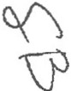TRUST AOREEMENT -4-
TuscHER s SPALL NA, P.A.

!!<11:A,,1:ra,1.!'?1t.1.m::s:1':. wn111.•t}'""!'-'*.':''4 41117 "+fl:''"'". .• • ,.." * , . , •· --·--·-· -..- --·--·--
'.;?_:•:\ ';:·.ll l• fornr sub ct to thedebts, liabilities orobligations of any such beneflciary or any claims against such beneficiary (whether voluntarily or involuntarily created), and the Trustee shall pay directly to or for the use or benefit of such beneficiary all income and principal to which such beneficiary is entitled, notwithstanding that such beneficiary has executed a pledge, assignment, encumbrance or in any other manner aliehated or transferred his or her beneficial interest in the trust to another.This paragraph shall not preclude the effective. exercise of any power of appointment granted herein or the exercise of any disclaimer. ·

J_ Maximum Duration. Regardless of anything in t_his Agreement to the contrary, no trust interest herein created shall continue beyond three hundred sixty (360) years as provided in F.S. § 689.225(2)(a)(2), nor shall any power ofappointment be exercised in such manner soasto delay vesting of any trust beyond such period. Immediately prior to the expiration of such period, all such trusts then in existence shall terminate, and the assets thereof shall be distributed outright and in fee to then beneficiaries of the current income and in the proportions in which such persons are the beneficiaries, and if such proportions cannot be ascertained, then equally among such beneficiaries.

K. Florida Homestead Possessory Riehts. Notwithstanding anything herein to the contrary, ifany portion ofany Florida improved residential real estate (excluding commercial multi-unit rental property) is an asset of the Marital Trust, my spouse shall have the exclusive and continuous present right to full use, occupancy and possession of such real estate for life. It is my intention that my spouse's interest in such property shaJI constitute a "beneficial interest for life" and "equitable title to real estate" as contemplated by Section J 96.041(2) of Florida Statutes, asamended from time to time or any corresponding provision of law.

ARTICLE III. GENERAL

A. Disability. Subjectto the following Subparagraph captioned "Subchapter SStock," while any beneficiary (other than my spouse as beneficiary of the Marital Trust) is Disabled, the Trustee shall pay to him or her only such portion of the income to which he or she is otherwise entitled as is proper for his or her Welfare, and any income not so paid shall be added to the principal from which derived. While any beneficiary is Disabled, income or principal payable to him or her may, in the discretion of the Trustee, be paid directly to him or her, without the intervention of a guardian, directly to his or her creditors or others for his orher sole benefit orto an adult person oran eligible institution (including the Trustee) selected by the Trustee as custodian for a minor beneficiary under the Uniform Transfers to Minors Act or similar law. The receipt of such payee is a complete release to the Trustee.

B. Timine ofincom e D!:!!tributhm!.The Trustee shaJ! make required payments ofincome at least quarterly.

- Su bstance Abuse.

SH!!U.!!Y BERNSTS!N
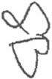TRUST AGIU:llMf.NT -5-

TESCHE,R,
8 SPALLINA, p .A.

lf!''-J1".!P"fi''...».!.!l'J!."M"l,"I110 11o:.,1..".!''"""'li'.'*.!.:"ti"»"'"".""'".+'04\!'"*"-"'U'l'"<l?'.,J>,3.1,1&1l'!"F"i&IJCl!Sllllll!l!! it "'%"'". -P'.!f!JOA.,.,,,..,'"'"..,,._,"·"'... ,.,_,-

• "!"+'"' "'.','.,
---...- .------- -· - ,.,.......,._,.....",."·"''"-"''"''1"

I . Ii1 General. If the Trustee reasonably believes that a beneficiary (other than myself) of any trust:

- routinely or frequently uses or consumes any illegal substance so as to be physically or psychologically dependent upon that substance, or

- is clinically dependent'upon the use or consumption of alcohol or any other legal drug or chemical substance tha.t is not prescribed by a board certified medical doctor or psychiatrist in a current program of treatment supervised by such doctor or psychiatrist,

and if the Trustee reasonably believes that as a result the beneficiary is unable to care for himself or herself, or is unable to manage his or her financial affairs, all mandatory distributions (including distributions upon termination of the trust) to the beneficiary, all of the beneficiary 1s withdrawal rights, and all of the beneficiary's rights to participate in decisions concerning the removal and appointment of Trustees will be suspended (excluding, however, mandatory income rights under the Marital Trust). Jn that event, the following provisions of this Subparagraph 111. C wiJI apply.

- Testing. The Trustee may request the beneficiary to submit to one or more examinations (including laboratory tests of bodily fluids) determined to be appropriate by a board certified medical doctor and to consent to full disclosure to the Trustee of the results of all such examinations. The Trustee shall maintain strict confidentiality of those results and shall not disclose those results to any person other than the beneficiary without the prior written pennission of the beneficiary .The Trustee maytotally or partially suspend all distributions otherwise required orpermitted to be made to that beneficiary until the beneficiary consents to the examination and disclosure to the Trustee.

- Treatment. If, in the opinion of the examining doctor, the examination indicates current or recent use of a drug or substance as described above, the examining doctor will determine an appropriate method of treatment for the beneficiary (for example. counseling or treatment on an in-patient basis in a rehabilitation facility) that is acceptable to the Trustee. Ifthe beneficiary consents to the treatment, the Trustee·shal I pay the costs of treatment directly to the provider of those services from the distributions suspended under this Subparagraph III.C.

- Resumption of Distributions. The Trustee may resume other distributions to the beneficiary (and the beneficiary's other suspended rights will be restored) when, in the case of use or consumption of an illegal substance, examinations indicate no such use for 12 months and, in all cases, when the Trustee· in its discretion determines that the beneficiary is able to care for himself or herself and is able to manage his or her financial affairs.

- Disposition of Suspended Amounts. When other distributions to the beneficiary are resumed, the remaining balance, if any, of d istributions that were suspended may be distributed to the beneficiary at that time. Ifthe beneficiary dies before distribution of those suspended amounts, the Trustee shall distribute the balance of the suspended amounts to the persons who would be the alternate

SHIRLEY BERNSTEIN
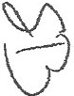TRUST AGREEMENT -6-

TESCHER 8 SPALLINA, P.A.

"•"'·,'.
J \·t " :'

takers of that beneficiary'sshare (or takers through the exercise of a power of appointment) asotherwise provided in this Trust Agreement.

- Exoneration. No Trustee (or any doctor retained by the Trustee) will be responsible or liable to anyone for a beneficiary's actions or welfare. The Trustee has no duty t9 inquire whether a beneficiary uses drugs orothersubstances as described in this Subparagraph III.C. The Trustee (and any doctor retained by the Trustee) is to be indemnified from the trust estate and held harmless from any liability of any nature in exercising itsjudgment and authority under this Subparagraph III.C, including any failureto request a beneficiary to submit to medical examination, and including a decision to distribute suspended amounts to a beneficiary.

- Tax Savings Provision. Despite the provisions of this Subparagraph IIJ.C, the Trustee cannot suspend any mandatory distributions or withdrawal rights that are required for that trust to become or remain a Qualified Subchapter S Trust (unless the Trustee elects for the trust to be an Electing Small Business Trust), or to qualify for any federal transfer tax exemption, deduction, or exclusion allowable with respect to that trust.

- Income on Death of Beneficiary. Subject to the later paragraph captioned "Subchapter S Stock," and except as otherwise explicitly provided herein, upon the death of any beneficiary, all accrued or undistributed income of such deceased beneficiary'strust shall pass with the principal of his or her trust but shall remain income for trust accounting purposes.

- Definitions. Inthis Agreement,

  - Children. Lineal Descendants. The terms "child," "children" and "lineal descendant" mean only persons whose relationship to the ancestor designated is created entirely by or through (a) legitimate births occurring during the marriage of thejoint biological parents to each other,
(b) children and their 1ineaI descendants arising from surrogate births and/or third party donors when (i) the child is raised from or near the time of birth by a married couple (other than a same sex married couple) through the pendency of such marriage, (ii) one of such couple is the designated ancestor, and
(iii) to the best knowledge of the Trustee both members of such couple participated in the decision to have such chiId, and (c) lawful adoptions ofminors under theage of twelve years. No such child or lineal descendant loses his or her status as such through adoption by another person. Notwithstanding the foregoing, as I have adequately provided for them during my lifetime, for purposes of the dispositions made under this Trust, my children, TED S.BERNSTEIN ("TED'')and PAMELA B. SIMON ("PAM"), and their respective lineal descendants shall be deemed to have predeceased the survivor of my spouse and me, provided, however, if my children, ELIOT BERNSTEIN, JILL lANTONI and L1SA S.
FRIEDSTEIN, and their lineal descendants allpredecease the survivor of my spouse and me, then TED
and PAM, and their respective lineal descendants shall not be deemed to have predeceased me and shall be eligible beneficiaries for purposes of the dispositions made hereunder.

SHllUJ:Y BERNSTEIN
TllUST ACREEMl!"1T -7-

TESCHER 8 SPALLINA, P.A.

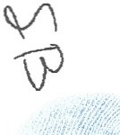
\ . .
' •\1

·; .·. .. ·. . . . . . . .
re : Ji 't4 . tlJ•. ; ; WI S I I 4Cli I 4 .J ti!-. il..1. 'f,
I

- Code. '.'Code11 means the Internal Revenue Code of 1986, as amended, and in referring to any particular provision of the Code, includes a reference to any equivalent or successor provision of a successor federal tax law.

- Disabled. "Disabled" or.being under "Disability" means, as to any applicable individual: (1) being under the age of 21 years, (2) having been adjudicated by a court of competent jurisdiction as mentaJiy or physically incompetent or unable to·manage his. or her own property or personal affairs (or a substantialJy similar finding under applicable state or national law), or (3) being unable to properly manage his or her personal or financial affairs, or a trust estate hereunder as to a Trustee hereunder, because of a mental or physical impairment (whether temporary or permanent in nature). A written certificate executed by an individual's attending physician or attending psychiatrist confirming that person's impairment will be sufficient evidence of Disability under item (3) above,and all persons may rely conclusively on such a certificate.

- Education. The term "education" herein means vocational, primary, secondary, preparatory, theological, college and professional education, including post-graduate courses of study, at educational institutions or elsewhere, and expenses relating directly thereto, including tuition, books and supplies, room and board, and travel from and to home during school vacations. It is intended that the Trustee liberally construe and interpret references to "education," so that the beneficiaries entitled to distributions hereunder for education obtain the best possible education commensurate with their abilities and desires.

- My Spouse. "Myspouse" is SIMON L. BERNSTEIN ("SIMON').

- Needs and Welfare Distributions . Payments to be made for a person's "Needs" means payments for such person's support,health (including lifetime residential or nursing home care), maintenance and education. Payments to be made for a person's "Welfare" means payments for such person's Needs, and as the Trustee determ ines in its sole discretion also for such person'sadvancement in life (including assistance in the purchase of a home or establishment or development of any business or professional enterprise which the Trustee believes to be reasonably sound), happiness and general wellbeing. However, the Trustee, based upon information reasonably available to it, shall make such payments for a person'sNeeds or Welfare only to the extent such person's income, and funds available from others obligated to supply funds for such purposes (including, without limitation, pursuant to child support orders and agreements), are insufficient in its opinion for such purposes, and shall take into account such person's accustomed manner of living, age, health, marital status and any other factor it considers important. Income or principal to be paid for a person'sNeeds or Welfare may be paid to such individual or applied by the Trustee directly for the benefit of such person. The Trustee may make a distribution or application authorized for a person's Needs or Welfare even if such distribution or application substantiaJly depletes or exhausts such person's trust, without any duty upon the Trustee to retain it for future use or for other persons who might otherwise benefit from such trust.

- Per Stir:pes. ln a division "perstirpes" each generation shall be represented and counted whether or not it has a living member.

SHllU.E'.Y BEIVl!>IEIN
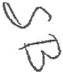TRUST AOREEMl!NT -8-

TESCHER & SPALLINA, P.A.

.... .·;:;/'.f fJ;<::;n{:/·:·,:;'..,:·'.".:..··: ··· ··
  - - ·r ;'·;,· 1i*:. JiliJir!if!r :S.iihrillnate. Party!! ·to a trust
tl ... .,...·! -rltW&Hub"or4inate·party to ·a beneficiary of the trust
. . .... ,,._ ..·...,. .- .." .r Mr£1(aie"defiried'·uder C.?de.Se¢tion 672(c).
p: ·.'
fot'.. F: :·; ':..,!'"'':'.·:'.(.J:i('.'.:..;i!:·:<·:!.:·;-,,;'. ·":'::'\· , :.: : "spose"·includes only a spouse then married to and living
as husband 'and wife with him or her, or a spouse who was married to and living as husband and wife with him or her at his or her death. The following rules apply to each person who is a beneficiary or a permissible appointee under this Trust Agreement and who is married to a descendant of mine. Such a person will cease to be a beneficiary and will be excluded from the class of permissible appointees upon:

or after my death), or
- the legal termination of the marriage to my descendant (whether before

- ·the death of my descendant if a dissolution of marriage proceeding was pending when he or she died.

I 0. Gender. Number. Where appropriate, words of any gender include all genders and the singular and plural are interchangeable.

F. Powers of Appointment. Properly subject to a power of appointment shall be paid to, or retained by the Trustee or paid to any trustee under any will or trust agreement for the benefit of, such one or more permissible appointees, in such amounts and proportions, granting such interests, powers and powers of appointment, and upon such conditions including spendthrift provisions as the holder of such power (i) in the case of a power exercisable upon the death of such holder, appoints in his or her
will or in a trust agreement revocable by him or her until his or her death, or (ii) in the case of a power exercisable during the life of such holder, appoints in a written instrument signed by such holder,two witnesses and a notary public, but in- either case only if such will, trust agreement, or instrument specifically refers to such power.

- Limitations on Powers of Trustee. Regardless of anything herein to the contrary. no Trustee shall make or participate in making any distribution of income or principal of a trust to or for the benefit of a beneficiary which would directly or indirectly discharge any legal obligation of such Trustee or a donor of such trust (as an individual, and other than myself as donor) to support such beneficiary; and no Trustee (other than myself and other than my spouse as Trustee of the Marital Trust) shall make or participate in making any discretionary distribution of income or principal to or for the benefit of himself or herself other than for his or her Needs, including by reason of a determination to terminate atrust described herein. For example, if a Trustee (other than myself and other than my spouse as Trustee of the Marital Trust) has the power to distribute income or principal to himself or herself for his or her own Welfare, such Trustee (the "restricted Trustee") shall only have the power to make or participate in making a distribution of income or principal to the restricted Trustee for the restricted Trustee's Needs, although any co-Trustee who is not also a restricted Trustee may make or participate in making a distribution of income or principal to the restricted Trustee for such restricted Trustee's Welfare without the participation or consent of said restricted Trustee.

SHIRLEY BERNSTE.IN
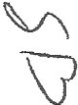TRUST AORl!liMENI' -9-
TESCHER s SPALLINA, P.A.

• . • - 1r·.• ·-·-. •. ··. -. -

·. .'

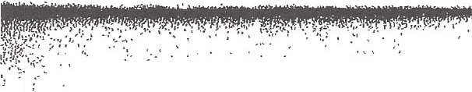• . • .... ' • ..!,. • i.. . • :· .• , . ' . • .• ••

- :,; ;_.;··:1 - __,.··· P..-s pfign ofSurviv-orsbip. Ifmy spouse·and Idie under circumstanpes which make
it difficult odmpracticabfo to determine which oneof us survived the other, I direct that my spouse shall be deemed to have survived me for purposes of this Agreement (except in regard to any property passing hereunder that became part of this trust solely by reason of passage to my probate estate orthis trust from the probate estate of or a revocable trust established by y spouse in which case the opposite presumption shall apply), notwithstand ing any provisions of. law which provide for ·a contrary presumption. Ifany person other than my spouse shall be required to survive another person in order to take any interest under this Agreement, the former person shall be deemed to have predeceased the latter person, if such persons die under circumstances which make it difficult or impracticable to determine which one died first.

  - Governini: Law. This Agreement is governed by the law of the State of Florida.

J. Other Beneficiary Desienations. Except asotherwise explicitly and with particularity provided herein, (a) noprovision of this trust shall revoke or modify any beneficiary designation of mine made by me and not revoked by me prior to my death under any individual retirement account, other retirement plan or account, or annuity or insurance contract, (b) Ihereby reaffirm any such beneficiary designation such that any assets held in such account, plan, or contract shall pass in accordance with such designation, and (c) regardless ofanything herein to the contrary, any of such assets which would otherwise pass pursuant to this trust due to the beneficiary designation not having met the requirements for a valid testamentary disposition under applicable law or otherwise shatl be paid as a gift made hereunder to the persons and in the manner provided in such designation which is incorporated herein by this reference.

K. Mandatory Notice Required by Florida Law.The trustee of a trust may have duties and responsibilities in addition to those described in the instrument creating the trust. If you have questions, you should obtain legal advice.

- Release of Medical Information.

  - Disability of Beneficiary. Upon the written request ofa Trustee (with or without the concurrence of co-Trustees) issued to any current income or principal beneficiary (including discretionary beneficiaries) for whom a determination of Disability is relevant to the administration of a trust hereunder and for whom a Trustee (with or without the concurrence of co-Trustees) desires to make such a determination, such beneficiary shall. issue to all Trustees (who shall be identified thereon both by name to .the extent known and by class description) a valid authorization under the Health Insurance Portability and Accountability Act of 1996 and any other applicable or successor law authGiizing all health ca;e providers and all medicil souices of such requested beneficiary to release protected health information of the requested beneficiary to all Trustees that is relevant to the determination of the Disability of the requested beneficiary as Disability is defined hereunder. The period of each such valid authorization shall be for six months (or the earlier death of the requested beneficiary) . If such beneficiary (or his or her legal representative if such beneficiary is a minor or legally disabled) refuses within thirty days ofreceipt of the request to provide a valid authorization, or

SHIRLEY BllRNS"fEIN
TRUST AGREEM6NT -10-

TESCHER S SPALLINA, P.A. 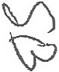

I ' I I • • "1'"' "',' : '" •, :\ • '· ' , •,' t :-: ; •,• ,::•• • •• '• •, '
·'J.· \-;.:i(··;
!, !:. .'·;(":;.·:;_.:..:r (:': ·:::·:·::·.. :.: ... .!; ..· :
fij ?f :.::.;,·.:,:···' ·;at ay lme;eokes .an authoriution within its term; the Trustee shall treat such beneficiary as Disabled
·hereunder until such valid authorization is delivered. ·

- Disability of Trustee.Upon the request to ·a Trustee that is an individual by (a) a co-Trustee, or if none, (b) the person orentity next designated to serve as a successor Trustee not under legal incapacity, or if none, (c) any adult current income or principal beneficiary not under legal incapacity, or in any event and at any time (d) a court of competent jurisdiction, such Trustee shaJI issue to such person and all persons, courts of competent jurisdiction, and entities (who shall be identified thereon both by name to the extent known and by class description), with authority hereunder to determine such requested Trustee's Disability, a valid authorization under the Health Insurance Portability and Accountability Act of J 996 and any other applicable or successor law authorizing all health care providers and all medical sources of such requested Trustee to release protected health information of the requested Trustee to such persons, courts and entities, ·that is relevant to the determination of the Disability of the requested Trustee as Disability is defined hereunder. The period of each such valid authorization shall be for six months (or the earlier death or resignation of the requested Trustee). Ifsuch requested Trustee refuses within thirty days ofreceipt of the request to deliver a valid authorization, or at any time revokes an authorization within its term, such requested Trustee shall thereupon be treated as having resigned as Trustee hereunder.

- Authorization to Issue Certificate. All required authorizations under this paragraph shall include the power of a physician or psychiatrist to issue a written certificate to the appropriate persons or entities as provided in Subparagraph 111.E.3 hereof.

ARTICLE IV. FIDUCIARIES

- Powers of the Trustee. During my life except while I am Disabled, the Trustee shall exercise all powers provided by law and the following powers,other than the power to retain assets, only with my written approval. While I am Disabled and after my death, the Trustee shall exercise said powers without approval, provided that the Trustee shaJJ exercise all powers in a fiduciary capacity.

  - Investments. To sell or exchange at public or private sale and on credit or otherwise, with or without security, and to lease for any term or perpetually, any property, real and personal, at any time forming a part of the trust estate (the "estate"); to grant and exercise options to:buy or sell; to invest or reinvest in real or personal property of every kind, description and location; and to receive and retain any such property whether origina lly a part of any trust herein created or subsequently acquired, even if the Trustee is personally interested in such property, and without liability for any decline in the value thereof; all without Jim itation byany statutes orj!:!dicial decisions whenever enacted or announced , regulating investments or requiring diversification ofinvestments, it being my intention to give the broadest investment powers and discretion to the Trustee. Any bank, trust company, orother corporate trustee serving hereunder as Trustee is authorized to invest in its own common trust funds.

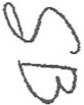SHIRLBY BERNSTEIN
TllUST AGREEMENT -11-

TESCHER 8 SPALLINA:) P.A.

. ..

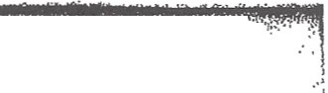;\ :,:.(:-..:. :/ t!.t..:. ·/t: (:t:i.:?;:·::1;:P;.:\<:;:.:·:·..:·',-· .·· : ·. ..,.:....·.-·:· ·:·:·."·:·:::=<· '_-;.; '. .:'>·«..:·:.r·;·:· ·-.. "........ ?·:...··:·.:··:--::--'·:/... ..
!'-*'. ;t;\ \ ::'°.:..··. : ·.;·:·/?<> : .;:«.:.'.,,: >>::<$pec;a1 Iiiyetments. Th.-T_rustee.Js · xprsly: ut9tized (bµt.oo.r dit¢co) to . ·
- ·· reta.in.m e, old, and'dispo'se of fov.stmens not .regarded ;:\S traditional for trusts, incluqing interests
or investments in privately held b4siness and investme11t entities and enterprises, incluqing withqut limitation stock in closely held corporations, limited partnership interests,jointventure interests, mutual funds, business trust intrests, and limited liability company membership interests, notwithstanding (a) any applicable prudent investor rule or variation thereof, (b) common Jaw or tatutory diversification requirements (it being my intent that no such duty to diversify shall exist) (c) a lack ofcurrent cash flow therefrom, (d) the presence of any risk or speculative elements as compared to other available investments (it being my intent that the Trustee have sole and absolute discretion in determining what constitutes acceptable risk and what constitutes proper investment strategy),.(e) lack of a reasonable rate of return, (f) risks to the preservation of principal, (g). violation of a Trustee's duty of impartiality as to different beneficiaries (it being my intent that no such duty exists for this purpose), and (h) similar limitations on investment under this Agreement or.under law pertaining to investments that may or should be made by a Trustee (including without limitation the provisions of Fla.Stats. §518.1 J and successor provisions thereto that would characterize such investmentsas forbidden, imprudent, improper or unlawful). The Trustee shall not be responsible to any trust created hereunder or the beneficiaries thereof for any loss resulting from any such authorized investment, including without limitation loss engendered by the higher risk element of that particular entity, investment, or enterprise, the failure to invest in more conservative investments, the failure to diversify trust assets, the prudent investor rule or variant thereof. Notwithstanding any provisions for distributions to beneficiaries hereunder, if the Trustee determines that the future potential investment return from any illiquid or closely held investment asset warrants the retention of that investment asset or that sufficient value could not be obtained from the sale or other disposition of an illiquid or closely held investment asset,the Trustee is authorized to retain that asset and if necessary reduce the distributions to beneficiaries due to lack of sufficient liquid or marketable assets. However, the preceding provisions of this Subparagraph shall not be exercised in a manner as tojeopardize the availability of the estate tax marital deduction for assets
passing to or held in the a trust for my surviving spouse or that would otherwise qualify for the estate tax marital deduction but for such provisions, shall not override any express powers hereunder of my surviving spouse to demand conversion of unproductive property to productive property, or reduce any income distributions otherwise required hereunder for a trust held forthe benefit of my surviving spouse or a "qualified subchapter S trust" as that term is defined in Code Section J 36l(d)(3).

- Distributions .To make any division or distribution pro rata or non-pro rata, in cash or in kind, and to alJocate undivided interests in property and dissimilar property (without regard to its tax basis) to different shares.

- Management. To manage, develop, improve, partition or change the character of an asset or interest in property at any time; and to make ordinary and extraordinary repairs, replacements, alterations and improvements, structural or otherwise.

5. Borrowing. To borrow money from anyone on commercially reasonable tenns, including entities owned in whole or in part by the trust, a Trustee, beneficiaries and other persons who may have a direct or indirect interest in a Trust; and to mortgage, margin, encumber and pledge real and

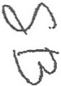SHIRLEY BERNSTEIN
TAUSTAGREEMENT -12-
TESCHER s SPALLINA, p.A.

,,,.... :...,--; -:::1;.:i;·:.::: sf1.,-,_;.:- ::: ::;/f·"'.'i: :·r?:}::;''.·::'f··;_.·r: <·: .... .-_-"- ·-.:("·'...:..-?:·: <"'.>....;-,..." ..·.' ......· .....,··:.... ....... .. .. -,,.., . .. ...... ....
_;·1..".-::.:·.:,:·--:=;".· .;"pefotiiil pr.ot(rtf of ifth.isi s·s·curity.for-the paymentthereor, without incurring any personaMiability
  - thereori 'and'to-do'so for a term within or extending beyond the terms of the trust and to renew,.modify
or extend existing borrowing or'l similar ordifferent terms and with the sameor different security without incurring an'y personal liability; and such borrowing from a Trustee may be with or without interest, and may be secured with a lien on trust assets.

6. Lending. To extend, modify or waive the terms of any obligation, bond or mortgage at any time fonning a part of a trust and to foreclose any such mortgage; accept a conveyance of encumbered property, and take title to the property securing it by deed in lieu of foreclosure or otherwise and to satisfy or not satisfy the indebtedness securing said property; to protect or redeem any such property from forfeiture for nonpayment of taxes or other lien; generally, to exercise as to such bond, obligation or mortgage all powers that an absolute owner might exercise; and to loan funds to beneficiaries at commercially reasonable rates, terms and conditions.

7. Abandonment of Property. To abandon any property orassetwhen it is valueless or so encumbered or in such condition that it is of no benefit to a trust. To abstain from the payment of taxes, liens, rents, assessments, or repairs on such property and/or permit such property fo be lost by tax sale, foreclosure or other proceeding or by conveyance for nominal or no consideration to anyone including a charity or by escheat to a state; all without personal liability incurred therefor.

- Real Property Matters. Tosubdivide, develop orpartition real estate; to purchase or sell real property and to enter into contracts to do the same; to dedicate the same to public use; to make or obtain the location of any plats; to adjust boundaries; to adjust differences in valuations on exchange or partition by giving or receiving consideration; and, to grant easements with or without consideration as the fiduciaries may determine; and to demolish any building, structures, walls and improvements, or to erect new buildings, structures, walls and improvements and to insure against fire and other risks; and to protect and conserve, or to lease, or to encumber, or otherwise to manage and dispose of real property to the extent such power is not otherwise granted herein or otherwise restricted herein .

- Claims. To enforce, compromise, adjust, arbitrate, release or otherwise settle or
pay any claims or demands by or against a trust.

l 0. Business Entities. To deal with any business entity or enterprise even if a Trustee is or may be a fiduciary of or own interests in said business entity or enterprise, whether operated in the fonn of a corporation, partnership, business trust, limited liability company, joint venture, sole proprietorship, or other form (all of which business entities and enterprises are referred to herein as "Business Entities"). I vest the Trustee with the following powers and authority in regard to Business Entities:

  - To retain and continue to operate a Business Entity for such period as the Trustee deems advisable;

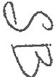SHIRLEY BERNSTEIN
TRUST AGREEMENT -13-

TESCHER & SPALLINA, P.A.

· ...

    - ·.-, .· - ;. ·b.:,.To control; direct and·manage the -Business Entities.In this·connection, the
- Trustee,' in its sole discretion, shall determine the manner and extent of its active participation in the operati.on and may delegate all or any part of its power to supervise and operate to such person or persons as the Trustee may select, including any associate, partner, officer or employee of the Business Entity;

- To hire and discharge officers and employees, fix their compensation and define their duties; and similarly to employ, compensate and discharge agents, attorneys, consultants, accountants, and such other representatives as the Trustee may deem appropriate; including the right to employ any beneficiary or fiduciary in any of the foregoing capacities;

- To invest funds in the Business Entities, to pledge other assets of a trust as security for loans made to the Business Entities, and to lend funds from a trust to the Business Entities;

- To organize one or more Business Entities under the laws of this or any other state or country and to transfer thereto al I or anypart of the Business Entities or other property of a trust, and to receive in exchange such stocks, bonds, partnership and member interests, and such other securities or interests as the Trustee may deem advisable;

f. To treat Business Entities as separate from a trust. In a Trustee's accounting toany beneficiary, the Trustee shall only be required to report the earnings and condition of the Business Entities in accordance with standard busi ness accounting practice;

- To retain in Business Entities such net earnings for working capital and other purposes of the Business Entities as the Trustee may deem advisable in conformity with sound business practice ;

- To sell or liquidate all or any part of the Business Entities at such time and price and upon such terms and conditions (including credit) as the Trustee may detennine.My Trustee is specifically authorised and empowered to make such sale to any person, including any partner,officer, or employee of the Business Entities, a fiduciary, or to any beneficiary; and

- Toguaranty the obligations of the Business Entities, or pledge assets of a trust to secure such a guaranty.

- Principal and Income.To allocate items of income or expense between income and principal as pennitted or provided by the laws of the State of Florida but without limiting the availability of the estatetax marital deduction, provided that the Trustee shall not be required to provide a rate of return on unproductive property unless otherwise provided in this instrument.

- Life Insurance. With respect to any life insurance policies constituting an asse of a trust, to pay premiums; to apply dividends in reduction of such premiums; to borrow against the cas values thereof; to convert such policies into other forms of insurance, including paid"up insurance; t

StllRLl!Y BERNSTI!IN
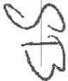TRUST AOR.EEMENT -14-

TESCHER s SPALLINA, P.A.

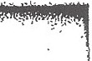.,.:: ·r.i: : ;:'.';=.f-:;1/f 1>;.i_:7;- ;!f.'..{'r ;;:'';:"::"::-,z< :?",::-!":··:·;__._:··.'_:·'::·'\·/''·;-:: :'.-'.:.?t'·;··,.:.·:·\'. ·J• ..,,·,·:':·- ,. .. ': ..._ . . ..• :·. .·
·:·....-;..;-_ _..... ,, . ....e)c.erdse'lin setdein'ent.Qptions prov.ided in any such policies; to receive theproceed of any J)olicy upon "' its.inaturlty and to administer such proceeds as a part of the principal of the Trust; and in general, to
exercise all other options, benefits, rights and priviJeges under such policies.

- Continuing Power. To continue to have or exercise, after the termination of a trust,in whole or in part and unti I final distribution thereof, all title, power, discretions, rights and duties conferred or imposed upon the Trustee by Jaw or by this Agreement or during the existence of the trust.

- Exoneration. To provide for the exoneration of the Trustee from any personal liability on account of any arrangement or contract entered into in a fiduciary capacity.

- Agreements. To comply with, amend,. modify or rescind any agreement made during my lifetime, including those regarding the disposition, management or continuation of any closely held unincorporated business, corporation, partnership or joint venture, and including the power to complete contracts to purchase and sell real estate.

- Voting. To vote and give proxies, with power of substitution to vote, stocks, bonds and other securities, or not to vote a security.

- Combination of Shares. To hold the several shares of a trust or several Trusts as a common fund, dividing the income proportionately among them, to assign undivided interests to the
several shares or Trusts, and to make joint investments of the funds belonging to them. For such purposes and insofar as may be practicable, the Trustee, to the extent that division of the trust estate is directed hereby, may administer the trust estate physically undivided until actual division thereof
becomes necessary to make distributions. The Trustee may hold, manage, invest and account for whole or fractional trust shares as a single estate, making the division thereof by appropriate entries in the books of account only, and may allocate to each whole or fractional trust share its proportionate part of all receipt:; and expenses; provided, however, this carrying of several Trusts as a single estate shall not defer the vesting in possession of any whole or fractional share of a trust for the beneficiaries thereof at the times specified herein.

t 8. Reimbursement. To reimburse itself from atrust for reasonable expenses incurred in the administration thereof.

- Reliance Upon Communication. To rely, in aotingunder a-trust, upon any letter, notice, certificate, report, statement, document or other paper, or upon any telephone, telegraph, cable, wireless or radio message, if believed by the Trustee to be genuine, and to' be signed, sealed, acknowl­ edged, presented , sent, delivered or given by or on behalf of the proper person, firm or corporation, without incurring liability for any action or inaction based thereon.

- Assumptions.To assume. in the absence of written notice to the contrary from the person or persons concerned, that a fact or an event, by reason of which an interest or estate under

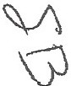SHIRLEY BERNSTEIN
TRUSTAGMa.IBNT -15-

TESCHER g SPALLINA, p .A .

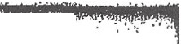...,., . A·:p::::;:.'s/ :}::X* 1.- f .:!.f ,; :J'!fi 'f :·./ i.:i·.: ·.\:··.::·'<·-:...···:·,.:·..··:':·'?:.:'. ·:,:v;:.'.f:;:?.·Y·;:,·:.'<'i'·:::"{: :.<.: , :.'.::·,. ,:" • . • . ,., ...· , ·:. .:--·. . ...'. .,.
:-.:·:>.:'"··· : ," ". "i-:ttu i'h.all c'()tfuVt6iioo'of'teifu'inate; does nofexist br:has hot occurred, without incurring liability·for
- · · any tj_on oi' inadi(;n'bas·ed upon such assumption.

- Service as Custodian. To serve as successor custodian for any beneficiary of any gifts that Imay have made under any Transfer to Minors Act, if at the time of my death no custodian is named in the instrument creating the gift.

- Removal of Assets. The Trustee may remove from the domiciliary state during the entire duration of a trust or for such lesser period as it may deem advisable, any cash, securities or other property at any time in its hands whether principal or not, and to take and keep the same outside the domiciliary state and at such place or places within or outside the borders of the United States as it may determine, wjthout in any event being chargeable for any lossor depreciation tothetrust which may result therefrom.

- Change of Sitys. The situs and/or applicable law of any trust created hereunder may be transferred to such other place as the Trustee may deem to be for the best interests of the trust estate. In so doing, the Trustee may resign and appoint a successor Trustee, but may remove such successor Trustee so appointed and appoint others. Each successor Trustee may 'delegate any and all fiduciary powers, discretionary and ministerial, to the appointing Trustee as its agent.

- Fiduciary Outside Domiciliary State. In the event the Trustee shall not be able and willing to act as Trustee with respect to any property located outside the domiciliary state, the Trustee, without order ofcourt, may appoint another individual or corporation (including any employee or agent of any appointing Trustee) to act as Trustee with respect to such property. Such appointed Trustee shall have all of the powers and discretions with respect to such property as are herein given to the appointing Trustee with respect to the remaining trust assets. The appointing Trustee may remove such appointed Trustee and appoint another upon ten (10)days notice in writing. All income from such property, and if such property is sold, exchanged or otherwise disposed of, the proceeds thereof, shall be remitted to the appointing Trustee, to be held and administered by it as Trustee hereunder. Such appointed Trustee may employ the appointing Trustee as agent in the administration of such property . No surety shall be required on the bond of the Trustee or agent acting under the provisions of this paragraph. No periodic court accounting shall be required of such appointed Trustee, it being my intention to excuse any statutory accounting which may ordinarily be required.

- Selection of Assets for Marital Trust. The Trustee shall have sole discretion to determine which assets shall be allocated to the Marital Trust; provided, if possible no assets or the proceeds of any assets which do not qualify for the federal estate tax marital deduction shall be allocated to the Marital Trust. To the extent that other assets qualifying for the marital deduction are available, the Trustee shall not allocate to the Marital Trust any assets with respect to which a credit for foreign taxes paid is allowable under the Code, nor any policy of insurance on the life of my spouse. Any allocation of assets among the Family Trust and the Marital Trust shall, with respect to each such trust, be comprised of assets having an aggregate market value at the time of such allocation fairly representative of the net appreciation or depreciation in the value of the property available for such

Slmu.l!Y Bl!Rl'ISTEIN
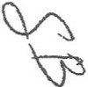TRUST AGIU!&4EITT -16-

TESCHER & SPALLINA, P.A.
,.

f!t"'""P",;1Vl'"'f-"T"7J?;', -,....·,' • •:,1,-.....,.,.. ···r-' (Y'"" 1:· ·:-·--...f:T17'f:•" 1''".0,i'r f ,';-; :, ..., ';
;,

• • • • •• .. :t •• •• • •• -. ·-,
.... .(..·:t. 8/:.h;·!?(fi.t:..,.r:.- -,,;.4.. ;.,:": i:··x</ .... :·-..·.····. -:.. ·:·:. ··· · ·
·:· ahJ·a.9oh' fOJ:.fe<iehil_stafotjl;purposes and the date ·or dates of said
' ·!..·, ·

- Additions. To receive and accept additions to the Trusts in cash or in kind from donors, executors, administrators,Trustee or attorneys in fact, including additions ofmy property bythe Trustee or others as my attorneys in fact.

- Title and Possession. To have title to and possession of all real or personal property held in the Trusts, and to register or hold title to such property in its own name or in the name of its nominee, without disclosing its fiduciary capacity, or in bearer form.

- Dealing with Estates. To use principal of the Truststo make loans to my estate, with or without interest, and to make purchases from my estate or my spouse's estate.

- Agents. To employ persons, including attorneys, auditors, investment advisers, and agents, even if they are the Trustee or associated with the Trustee, to advise or assist the Trustee in the performance of its administrative duties and to pay compensation and costs incurred in connection with such employment from the assets of the Trust; to act without independent investigation upon their recommendations; and, instead of acting personally, to employ one or more agents to perform any act of administration, whether or not discretionary.

- Tax Elections. To file tax returns, and to exercise all tax-related elections and options at itsdiscretion, without compensating adjustments orreimbursements between any of the Trusts or any of the trust accounts or any beneficiaries.

- Resienation.A Trustee may resign with or without cause, by giving no lessthan 30 days advance written notice, specifying the effective date of such resignation, to its successor Trustee and to the persons required and in the manner provided under Fla.Stats. §§736.0705(1)(a) and 736.0109. As toany required recipient, deficiencies in fulfillingthe foregoing resignation requirements may be waived in a writing signed by such recipient. Upon the resignation of a Trustee, such Trustee shall be entitled to reimbursement from the trust for all reasonable expenses incurred in the settlement of accounts and in the transfer of assets to his or her successor.

- Appointment of Successor Trustee.

- Appointment. Upon a Trustee's resignation, or ifa Trustee becomes Disabled or forany reason ceases to serve as Trustee, I may appoint anyperson or persons as successor Trustee, and in default of such appointn1ent by me, SIMON and TED, one at a time and successively in that order, shall serve as successor Trustee. Notwithstanding the foregoing, if a named Trustee is not a U.S. citizen or resident at the time of commencement of his term as Trustee, such Trustee should give due consideration to declining to serve to avoid potential adverse U.S.income tax consequences by reason of the characterization of a trust hereunder as a foreign trust under the Code, but shall not be construed to have any duty to so decline if such Trustee desires to serve.

Sl!IRLEY BBRNSTl!IN
TRUSTA<JREEMEITT -17- 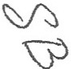
TESCHER 8 SPALLINA, P.A.

I;•



  - Trustee of the Marital Trust. SIMON and TED, one at a time and successively in that order, shall serve as Trustee of the Marital Trust. While serving as Trustee, my spouse may designate a co Trustee to serve with my spouse and my spouse may remove and/or replace such co-Trustee from time to time.

  - Trustee of the Family Trust. SIMON and TED, one at a time and successively in that order, shall serve as Trustee of the Family Trust. While serving as Trustee, my spouse may designate a co-Trustee that is not a Related or Subordinate Party to serve with my spouse and my spouse may remove arid/or replace such co-Trustee with another that is not a Related or Subordinate Party from time to time.

  - Trustee of Separate Trusts for My Children . Each child of mine shall serve as sole Trustee of his or her separate trust. While serving alone as Trustee, a child of mine may designate a co-Trustee that is not a Related or Subordinate Party to serve with such child and such child may remove and/or replace such co-Trustee with another that isnot a Related or Subordinate Party from time to time.

  - Trustee of Separate Trusts for My Lineal Descendants Other Than My Children. In regard to a separate trust held for a lineal descendant of mine other than a child of mine which lineal descendant is the sole current mandatory or discretionary income beneficiary, each such lineal descendant shall serve as coTrustee, or sole Trustee ifthe preceding described Trustees cease or are unable to serve or to continue to serve, of his or her separate trust upon reaching age twenty-five (25) years.

e. Trustee of Separate Trust for MAITHEW LOGAN. In rgard to a
separate trust held MATIHEW LOGAN, his mother, DEBORAH BERNSTEIN ("DEBORAH'); shall serve as Trustee until MATTHEW attains age 25 years, at which time he shall serve as a co-Trustee with
DEBORAH of such separate trust.

- Successor Trustees Not Provided For. Whenever a successor Trustee or co- Trustee is required and no successor or other functioning mechanism for succession is provided for under the terms of this Trust Agreement , the last serving Trustee or the last person or entity designated to serve as Trustee of the applicable trust may appoint his or her successor, and ifnone is so appointed, the following persons sha!! appoint a successor Trustee (..vhc may be one of t.11e persons making the appointment):

  - The remaining Trustees, if any; otherwise,

SHIRLl!V BERNSTEIN
TRUST AOll.EEMEITT -18·

TESCHER 8 SPALLINA, P.A. 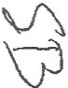



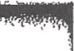
-;.,;.:· .l'J o;.-(;,,;,,-:":=)J;_h·*t?i>!i:.t1-i'-!.?;:·.:<:.j.<0, :>_"·:_-' ·:.':_. -·:=- -5- :'.:_":!·:;/=•·:_;:- ':>."··" .... .... ..,.. .:...... .. .·. . . '.:"·".'.... ';" .'? ... ) "".; .
1
..;.. -. ..:;': : ·::"::-.
1
·/·:·:->._: :·\:-. -. -:·:7;:>,:,:'!·: • &; ;:_..i:..;:.·/)\·mjori.ty of.the prmisible'.current mandatory or-:discretionary income
beneficiries;icluding the ntural or legal guardians of any beneficiaries who are Disahled.

A successor Trustee appointed under this subparagraph shall not be a Related or Subordinate Party of the trust. The appointment will be by a written document executed by such person inthe presence oftwo witnesses and acknowledged before a notary public delivered to the appointed Trustee and to me ifl am living and not Disabled or in a valid last Will. Notwithstanding tne foregoing, a designation under this Subparagraph of a successor trustee to a corporate or entity trustee shall be limited to a corporate or entity trustee authorized to serve as such under Florida law with assets under trust management of no less than one billion dollars.

- Power to Remove Trustee. Subsequent to my death,. the age 25 or older pennissible current mandatory or discretionary income beneficiaries from time to time of any trust established hereunder shall have the power to unanimously remove a Trustee of such trust at any time with or without cause, with the successor Trustee to be determined in accordance with the foregoing provisions.

- Method of Appointment of Trustee.Any such appointment of a successor Trustee by a person shall be made in a written instrument executed by such person in the presence oftwo witnesses and acknowledged before a notary public which is delivered to such appointed Trustee during the lifetime of the person making such appointment, or any such appointment of a successor Trustee by a person may be ma9e under the last Will of such person.

- Limitations on Removal and Replacement Power. Any power to remove and/or replace a trustee hereunder that is granted to an individual (including such power when reserved to me) ispersonal to that individual and may not be exercised by a guardian,power of attorney holder, or other legal representative or agent.

- Successor Fiduciaries. No Trustee is responsible for, nor has any duty to inquire into, the administration, acts or omissions of any executor,administrator, Personal Representative, ortrustee or attorney-in-fact addingproperty to these Trusts, orof anypredecessor Trustee. Each successor Trustee has all the powers, privileges, immunities, rights and title (without the execution of any instrument of transfer or any other act by any retiring Trustee) and all the duties of all predecessors.

- Liability and Indemnification of Trustee.

I . Liability in General. No individual Trustee (that is, a Trustee that is not a corporation or other entity) shall be liable for any of his or her actions or failures to act as Trustee, even if the individual Trustee is found by a court to have been negligent or in breach of fiduciary duty, except for liability caused by his or her actions or failures to act done in bad faith or with reckless indifference to the purposes ofthe trust orthe interests ofthe beneficiaries. Each Trllfttee that is a corporation orother entity will be liable for its actions or failures to act that are negligent or that breach its fiduciary duty, without contribution by any individual Trustee.

SHIRLEY BERNSTEIN
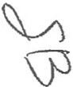TRUST AOREEMEl'IT -19-

TESCHER 8 SPALLINA, p.A.

'·- .

,,..:,:ff,·...1• •• • ,.. - ••., • •
"·Jri<t6r:Sbpaagrlt.pt{iv.Q;
• ,_, .1!. •l·lj:6 '4;,.(/,:·7• •·:t»,: J::::' :. !.:,·•·'1:-:::1. :.t :·:·_:' <·;:'' • :• '• '..;· ,.,.' : I" ;'. • .,. ,,., I ,., • " h• ' ' .' ··
1.''-i'.:l .: f'i- J -;. '-i - dlo liabilities·imposed on a Trustee
ri eacli.Trustee shali"be held harmless and indemnified from the assets of the

trust for any liability, damages, attorney's fees, expenses, and costs incurred as a result of its service as
Trustee. A Trustee who ceases to serve for any reason will be entitled to receivereasonable security from the assets of the trust to protect it from liability, and may enforce these provisions for indemnification against the current Trustee or against any assets held in the trust, o if the former Trustee isan individual and not a corporation or other entity, against any beneficiary to the extent of distributions received by that beneficiary. This indemnification right extends to the estate, personal representatives, legal successors and assigns of a Trustee.

3. lndemnification of Trustee - Add itional Provisions. I recognize that ifa beneficiary accuses a Trustee ofwrongdoing or breach of fiduciary duty, the Trustee may have a conflict ofinterest that ordinarily would prevent it from paying legal fees and costs from the trust estate to defend itself. I do not want to put a financial burden on any individual named to serve as a Trustee. Just as important, I do not want an individual who has been selected to serve as a Trustee to be reluctant to accept the position, or while serving to be intimidated in the perfonnanceof the Trustee'sduties because of the threats oflawsuits that might force the Trustee to pay fees and costs from the Trustee's personal resources. For this reason, I deliberately and intentionally waive any such contlictofinterest with respect to any individual servingasTrustee so that he or shecan hire counsel to defend himself orherself against allegations of wrongdoing orif sued for any reason (whether by a beneficiary or by someone else) and pay all fees and costs for his or her defense from the trust estate until the dispute is resolved.I understand and agree that a court may award, disallow or allocate feesand costs in whole or in part after the dispute is resolved, as provided by law. The Trustee will account for all such fees and costs paid by it as provided by law. This provision shall not apply to any Trustee that is a corporation or other entity.

- Compensation, Bond. Each Trustee is entitled to be paid reasonable compensation for services rendered in the administration of the trust. Reasonable compensation for a non-individual Trustee will be its published fee schedule in effect when its services are rendered unless otherwise agreed in writing, and except as follows. Any fees paid to a non-ihdividual Trustee for making principal distributions, for termination of the trust, and upon termination of its services must be based solely on the value ofitsservices rendered, not on the value ofthe trust principal. During my lifetime the Trustee's fees are to be charged wholly against income (to the extent sufficient), unless directed otherwise by me in writing. Each Trustee shall serve without bond.

I. Maintenance of Records.The Trustee shall maintain accurate accounts and records. It shall render annual statements of the receipts and disbursements of income and principal of a trust upon the written request of any adult vested beneficiary of such trust or the guardian ofthe person of any vested beneficiary and the approval of such beneficiary gha!! be binding upon all persons then or thereafter interested in such trust as to the matters and transactions shown on such statement. The Trustee may at any time apply for ajudicial settlement of any account. No Trustee shall be required to file any statutory or other periodic accountings of the administration of a trust.

SHUU-EY BERNSTEIN
TRUST AGRl!t:MENT -20-

TESCHER s SPALLINA, P.A.

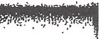!'-1i!J;·'t'. :'i"-? ·;:;.:;\,: :i,.;- /; ''S'\·-.._. ,;:..b·.':·'/; ;·;·.'.:':··:..··.. '·:·.'f·!.·1.=:'<·:,·;: ._.....,;."".: ... :·,:·::. " ......
.. .._ ..'"" ,.,.. ..,:-.,. . ....... .. . ,_·.:· 'e·"·The·>rruse"may iici':'untfor this.Agreeinenr e:ven if interested in
  - these Trusts..in an individual capaCitY, as a.fiduciary of another trust or estate (including my estate) or in any other capacity. The Trustee may in good faith enter into a sale, encumbrance, or other transaction involving the investment or management of trust property for the Trustee1s own personal account or which is otherwise affected by a conflict between the Trustee's fiduciary and personal interests, without liability and without being voidable by a beneficiary. The Trustee is specifically authorized to make loans to, to receive loans from, or to sell, purchase or exchange assets in a transaction with (i) the Trustee's spouse, (ii) th Trustee's children or grandchildren, siblings, parents, or spouses of such persons, (iii) an officer, director, employee, agent, or attorney of the. Trustee, or (iv) a corporation, partnership, limited liability company, or other business entity in which the Trustee has a financial interest, provided that in any transaction the trusts hereunder receive fair and adequate consideration in money or money's worth. The Trustee may renounce any interest or expectancy of a trust in.-or an opportunity to participate in, specified business opportunities or specified classes or categories of businessopportunities that are presented to the Trustee. Such renunciation shall not prohibit the Trustee from participating in the Trustee's individual capaity in such opportunity or expectancy.

- Third Parties. No one dealing with the Trustee need inquire into its authority or its application of property.

- Meri:er of Trusts. Ifthe Trustee is also trustee of a trust established by myself or another person by will or trust agreement, the beneficiaries to whom income and principal may then be paid and then operative terms of which are substantially the same as those of a trust held under this Agreement, the Trustee in its discretion may merge either such trust into the other trust. .The Trustee, in exercising itsdiscretion, shall consider economy of administration, convenience to the beneficiaries, tax consequences and any other factor it considers important. Ifit is later necessary to reestablish the merged trust as separate trusts, it shall be divided proportionately to the value of each trust at the time of merger.

- Multiple Trustees. Iftwo Trustees are serving at any time, any power or discretion of the Trustees may be exercised only by their joint agreement. .Either Trustee may delegate to the other Trustee the authority to act on behalf of both Trustees and to exercise any power held by the Trustees. If more than two Trustees are serving at any time, and unless unanimous agreement is specifically required by the terms of this Trust Agreement, any power or discretil;m of the Trustees may be exercised only by a majority. The Trustees may delegate to any one or more of themselves the authprity to act on behalf of all the Trustees and to exercise any power held by the Trustees. Trustees who consent to the delegation of authority to other Trustees will be liable for the consequences of the actions of those other Trustees as if the consenting Trustees had joined the other Trustees in performing those actions. A dissenting Trustee who did not consent to the delegation of authority to another Trµstee and who has not joined in the exercise of apower or discretion cannot be held liable for the consequences ofthe exercise. A dissenting Trustee who joins only at the direction of the majority will not be liable for the consequences of the exercise if the dissent is expressed in writing delivered to any of the other Trustees before the exercise of that power or discretion.

SlfJIU.EY BERNSTIOl!i
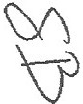TRUST AGREEMENT -21-

TESCHER sSPALLINA, P.A.



.. ··';-, ···· !.· • ··,
' . . .,.


,,'·
··'·. ; ;;,- ,_.!i'.:![ :;c_,; ,:·,.,_.:-.\'-i':' ' .:
.,GST..Trusts.'· ·· -
·"
  - Family Trust. I direct (a) that the Trustee shall divide any trust other than the Marital Trust to which there is allocated any GST exemption into two separate Trusts (each subject to the provisions of this Trust Agreement relating to the trust that is being divided) so that the generation­ skipping tax inclusion ratio of one such trust is zero.

  - Marital Trust. I direct that, if possible, (a) the Trustee shall divide the Marital Trust into two separate Marital Trusts (each subject to the provisions hereof concerning the Marital Trust) so that through allocation of my GST exemption remaining unallocated at my death and not otherwise allocated to transfers occurring at or by reason of my death (including allocations to the Family Trust), if any, the generation-skipping tax inclusion ratio of one such Marital Trust is zero (the GST Marital Trust), (b) my Personal Representative to exercise the election provided by Code Section 2652(a)(3) as to the GST Marital Trust, and (c) that upon the death of my spouse the total amount recoverable by my spouse's estate from the property of the Marital Trusts under Code Section 2207A shall first be recoverable in full from the non-GST Marital Trust to the extent thereof.

  - Misc. I direct that (a) upon the death of the survivor of e and my spouse, any property then directed to be paid or distributed which constitutes a direct skip shall be paid first from property then exempt from generation-skipping taxation (by reason of the allocation of any GST exemption) to the extent thereof, (b) property exempt from generation-skipping taxation (by rea_son of the allocation of any GST exemption) and not directed to be paid or distributed in a manner which constitutes a direct skip shall be divided and distributed as otherwise provided herein and held for the same persons designated in Trusts separate from any property then also so divided which is not exempt from generation-skipping taxation, and (c) ifupon the death of a beneficiary a taxable termination would otherwise occur with respect to any property held in trust for him or her with an inclusion ratio greater than zero, such beneficiary shall have with respect only to such property a power to appoint such fractional share thereof which ifincluded in such beneficiary's gross estate for federal estate tax purposes (without a11owing any deduction with respect to such share) would not be taxed at the highest federal estate tax rate and such fractional share of such property shall be distributed to such persons including only such beneficiary's estate, spouse, and lineal descendants, in such estates, interests, and proportions
as such beneficiary may, by a will specifically referring to this general power appoint, and any part of
atrust such beneficiary does not effectively appoint shaH be treated as otherwise provided fordisposition upon his or her death, provided, if upon his or her death two or more Trusts for his or her benefit are directed to be divided among and held or distributed for the same persons and the generation-skipping tax inclusion retie ofany such trust is zero, the amount of any othersuch trust to '.xlhich there :sallocated any of such beneficiary' s GST exemption shall be added to the Trusts with generation-skipping tax inclusion ratios ofzero in equal shares. I request (but do not require) that if two or more Trusts are held hereunder for any person, no principal be paid to such person from the Trusts with the lower inclusion ratios for generationskipping tax purposes unless the trust with the highest inclusion ratio has been exhausted by use, consumption, distribution, or otheiwise or is not reasonably available.

SHIRLEY BERNSlEIN
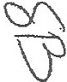TRuS'T AaltBEMJ!NT -22-
TESCHER 8 SPALLINA, P.A.

:J:j;., ::. .+, • 1.; ·i"' r\,."t::. ,'{!! }-'-l... ;',,
. .N·-·· ''j'i<i;i;•5· tt ::c> -\ ·1 '-" ..-·. _. .,..,. ' ,..
· ·", 0 ' IS V••''0A" . , vl• ·• "'''1"''1 · '· · ·"
or or
. paymet 'trtist ditiion t whih there·is alioated 'ruiy:ost.exeptlon suc.h payent trust division .
allocation shall be satisfied with cash or property which fairly represents appreciation and depreciation (occurring between the valuation date and the date of distribution) in all of the assets from which such distribution or allocation could be made, and any pecuniary payment made before a residual transfer of property to which any GST exemption is allocated shall be satisfied with cash orproperty which fairly represents appreciation and depreciation (occurring between the valuation date and the date of distribution) in all of the assets from which such pecuniary payment could be satisfied and shall be allocated a pro rata share of income earned by all such assets between the valuation date and the date of payment. In regard to the division orseverance of a trust hereunder, including the Marital Trust, such division or severance shall be made in a manner that all resulting trusts are recognized for purposes of Chapter 13 of the Code, including without limitation complying with the requirements of Treas.Regs.
§26.2654-l (b).Except as otherwise expressly provided herein, the valuation date with respect to any property shall be the date asof which its value is determined for federal estate tax purposes with respect to the transferor thereof, and subject to the foregoing, property distributed in kind in satisfaction of any pecuniary payment shall be selected on the basis of the value of such property on the valuation date.All terms used in this Article which are defined or explained in Chapter 13 of the Code or the regulations thereunder shall have the same meaning when used herein. The Trustee is authorized and directed to comply with the provisions of the Treasury Regulations interpreting the generation skipping tax provisions of the Code in severing or combining any trust, creating or combining separate trust shares, allocating GST exemption, or otherwise, as necessary to best accomplish the foregoing alJocations, inclusion ratios, combinations, and divisions, including, without limitation, the payment of "appropriate interest" as determined by the Trustee as that term is appJied and used in said Regulations.

- Individual Retirement Accounts. In the event that this trust or any trust created under this Agreement is the beneficiary of an Individual retirement account established and maintained under Code Section 408 or a qualified pension, profit sharing or stock bonus plan established and maintained under Code Section 401 (referred to in this paragraph as "IRA"), the following provisions shall apply to such trust:

  - Iintend that the beneficiaries of such trust shall be beneficiaries within the meaning of Code Section 40t(a)(9) and the Treasury Regulations thereunder. All provisionsofsuch trust shall be construed consistent with such intent.Accordingly ,the following provisions shall apply to such trust:

    - No benefits from any JRA may be used or applied for the payment of any debts, taxes orother claims against my estate asset forth in the later paragraph captioned "Taxes", unless other assets of this trust are not available for such payment.

    - In the event that a beneficiary of any trust created under this Agreement has a testamentary general power of appointment or a limited power of appointment over all or any portion of any trust established under this Agreement, and if such trust is the beneficiary of any benefits from any IRA, the beneficiary shall not appoint any part of such trust to a charitable organization or to

SHIRLEY BBRNSTl!IN
TRUST AORliliMEHT -23-

TESCHER (!) SPALLINA, p.A. 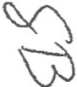
... l l

a Iineal descendant of mine (or a spouse of a lineal descendant of mine) who isolder than the beneficiary whose life expectancy is being used to calculate distributions from such IRA.

2. The Trustee shall deliver a copy of this Agreement to the custodian of any IRA of which this trust or any trust created under this Agreement is the named beneficiary within the time period prscribed Code Section 40l(a)(9) and the Treasury Regulations thereunder, along with such additional items required thereunder. Ifthe custodian of the IRA changesafteracopy of this Agreement has been provided pursuant to the preceding sentence, the Trustee shall immediately provide a copy of
this Agreement to the new custodian. The Trustee shall request each custodian to complete a receipt of the Agreement and shall attach such receipt to this Agreement. Th Trustee shall provide acopy of each amendment of this Agreement to the custodian and shall obtain a receipt of such amendment.

- Gift Transfers Made From Trust Dorine My Lifetime. I direct that all gift transfers made from the trust during my lifetime be treated for all purposes as if the gift property had been first withdrawn by (or distributed to) me and then transferred by me to the donees involved. Thus; in each instance, even where title to the gift property is transferred directly from the name of the trust (or its nominee) into the name of the donee, such transfer shall be treated for all purposes as first a withdrawal by (or distribution of the property to) me followed by a gift transfer of the property to the donee by me as donor, the Trustee making the actual transfer in my behalf acting asmy attorney in fact, thisparagraph being, to that extent, a power of attorney from me to the Trustee to make such transfer, which power of attorney shall not be affected by my Disability, incompetence, or incapacity.

D. Death Cost. Ifupon my death the Trustee hold any United States bonds which may be redeemed at par in payment offederal estate tax, the Trustee shall pay the federal estate tax due because of my death up to the amount of the par value of such bonds and interest accrued thereon at the time of payment. The Trustee shall also pay from the trust all of my following death costs, but if there is an acting executor, administrator or Personal Representative of my estate my Trustee shall pay only such amounts of such costs as such executor, administrator or Personal Representative directs:

I . my debts which are allowed as claims against my estate,

- my funeral expenses without regard to legal limitations,

- the e"penses of administering my estate,

- the balance of the estate, inheritance and other death taxes (excluding generation-skipping transfer taxes unless arising from direct skips), and interest and penalties thereon, due because of my death with respect to all property whether or not passing under my Will or this Agreement (other than property over which I have a power of appointment granted to me by another person, and qualified terminable interest property which is not held in a trust that was subject to an election under Code Section 2652(a)(3) at or about the time of its funding) and life insurance proceeds on policies insuring my life which p;occeds are ;;ot held under this trust or my probate estate at or by reason of my death), and

SHIRLEY BERNSTS!N
TRUST AGREEMENT
-24-
TESCHER s SPALLINA, P.A.

,:,,: . . . -.
lll i\iutiJiu!/1'R>'c\jo ·It>j. ii !··--...... ...

5. any gifts made in my Will or any Codicil thereto.

The Trustee may make any such payment either to my executor. administrator or Personal Representative or directly tothe proper party. The Trustee shall not be reimbursed for any such payment, and is not responsible for the com:ctness or application of the amounts so paid at the direction of my executor, administrator, or Personal Representative. The Trustee shall not pay any of such death costs with any asset which would not otherwise be included in my gross estate for federal or state estate or inheritance tax purposes, orwith any asset which otherwise cannot be so used, such as property received under a limited power of appointment which prohibits such use: Further, no payment of any such death costs shall be charged against or paid from the property disposed of pursuant to the prior paragraphs captioned "Disposition of Tangible Personal Property", "Specific Cash Devise" nor from the Marital Trust.

- Marital Trust. I intend the maximum obtainable reduction offederal estate tax due by reason of my death by use of the federal estate tax marital deduction, and qualification of all property of the Marital Trust for the marital deduction. This Agreement shall be construed and all powers shall be exercised consistent with such intent. For example, the Trustee shall not allocate any receipt to principal or any disbursement to income if such allocation understates the net income of the Marital Trust under Florida law; and upon the written demand of my spouse, the Trustee shall convert unproductive orunderproductive property of said trust into productive property within a reasonabletime notwithstanding any other provision hereunder. The foregoing not withstanding, if my spouse survives me but dies within six months after my death, the Marital Trust provided in Subparagraph ll,B will be reduced to that amount, if any, required to obtain for my estate an estate tax marital deduction resulting in the lowest combined estate taxes in my estate and my spouse's estate, on the assumption that my spouse died after me on the date of my death, that my spouse's estate is valued on the same date and in the same manner as my estate isvalued for federal estate tax purposes, and that elections in my spouse's estate were made that would be consistent with minimizing taxes. The purpose of this provision is to equalize, insofar as possible, our estates for federal estate tax purposes, based on the above assumptions.

- Subchapter SStock. Regardless of anything herein to the contrary. in the event that after my death the principal of a trust includes stock in a corporation for which there is a valid election to be treated under the provisions of Subchapter Sof the Code, the income beneficiary of such a trust isa U.S. citizen or U.S. resident for federal income tax purposes,and such trust is not an "electing small business trust" under Code Section 1361(e)(l) in regard to that corporation, the Trustee shall (a) hold such stock as a substantially separate and independent share of such trust within the meaning of Code Section 663(c), which share shall otherwise be subject to aU of the terms of this Agreement, (b) distribute all of the income of such share to the one income beneficiary thereofin annual or more frequent installments,
(c) upon such beneficiary's death, pay all accrued or undistributed income of such share to the beneficiary'sestate, (d) distribute principal from such shareduringthe lifetime ofthe income beneficiary only to such beneficiary, notwithstanding any powers of appo'intment granted to any person including the income beneficiary. and (e) otherwise administer such share in a manner that qualifies it as a "qualified Subchapter S trust" as that term is defined in Code Section J 361(d)(3), and shall otherwise

•"
. ·:
.. ·

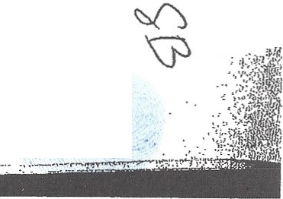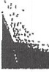SHIRL!iY BeRl'ISTEIN
TRUST AGRf!l!MENT
-25-
TESCHER s SPALLINA, P.A.
J

'·
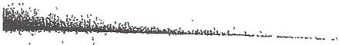

manage and administer such share asprovided under this Agreement to the extent not inconsistent with the foregoing provisions of this paragraph.

- Residence as Homestead. Regardless of anything herein to the contrary, while any residential real property located in Florida is owned by a trust, I, or my spouse ifl am not then living and such trust is the Marital Trust, shall have the right to use, possess and occupy such residence as a personal residence so that such right shall constitute a possessory right in such real property within the meaning of Florida Statute Section 196.041.

[remainder ofpage intentionally left blank]

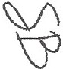SHIRLEY BERNSTEIN
TRUSTAGREEMENT -26-

TESCHER 8 SPALLINA, P.A.

================
JN WITNESS WHEREOF, the parties hereto have executed this Trust Agreement on the date first above written.

SETTLOR and TRUSTEE:

E™
This instrument was signed by SHIRLEY BERNSTEIN in our presence, and at the request of
and in the presence of SHIRLEY BERNSTEfN and each other, we subscribe our names as witnesses on

this cP;;:. "! , 2008:
£=·......._ _ _

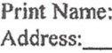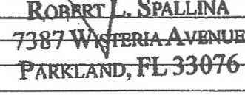Print Name: @ fl kf1r7?>JI
Address: I M6t ,f\.eA!vt::
!EACH . Fz. '5191.j(

STATE OF FLORIDA

COUNTY OF PALM BEACH

SS.

The foregoing instrument was acknowledged before me this2flday of MCMJ
by SHIRLEY BERNSTEIN.

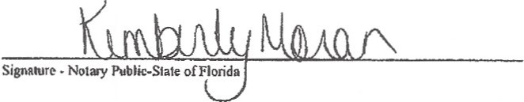o1FJ.OlUDA
oTARY pUBLlC..SThTf w.oran
N ,.......,. J<itnber y#DD766470
{WiColl\tnl6 \oAr1'·?.S,'!Ol2
\ I E1P .:....c"'ONDWOCO·,DIC.
#fU\ L\ 11!.lUJ ftl_l.J\l.H• U
[Seal witlP m1ssion Expiration Date]

,2008,

Print, typeor scamp nmm of N<>tary Public

Personally Known
/ or Produced Identification ----

Type of Identification Produced ------------------------

f.IWPDATAldrt\BcrAStein, Slull•yk Simoo\2008 Bstll• Planoins\Shirky Bt1n>tein Truu Agi<•mcnl wpd [-05 U 11 19 08)

SHllU.EY BERNSTEIN
TRUST AGREEMENT -27-

TESCHER Ci5 SPALLINA, P.A.

--...._ ··., ...: ,.

ATTACHMENT

The following property has been delivered in trust under this Agreement:

One Dollar ($1.00) Cash

During my life, the Trustee has no duty to maintain, invest, review, insure, account for, or any other responsibility with respect to trust property other than income producing property, or any duty to pay premiums on life insurance payable to the trust, and shall receive no fee for its services as Trustee based on any trust property other than income producing properly .

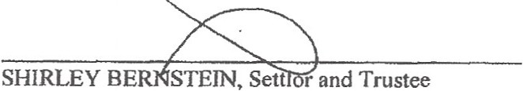

SHIRLEY BERNSTEIN
1'11.USTAGREEMENT -28-
TESCHER 8 SPALLINA, p.A.

EXHIBIT B

First Amendment to Shirley Trust

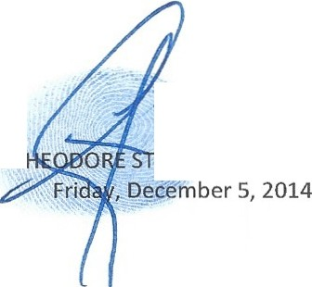PETITION TO REMOVE T UART BERNSTEIN AS SUCCESSOR TRUSTEE

t • A

._r._·.

FIRST AMENDMENT TO
SHIRLEY BERNSTEIN TRUST AGREEMENT

This First Amendment is dated this day of , 2008, and is between SHIRLEY BERNSTEIN of Pal m Beach County, f lo1ida referred to in ti1e ficst person, as settlor, and SHfRLEY BERNSTEIN of Pahn Beach County, Flol'ida ast1ustee (referred to asthe "Trustee," which tenn more pa1ticularly refors to all individuals and entities serving as tl'Ustee of a t11Jst created hereunder during the time of such servfoe,whether alone or as co-trustees.. and 11vhether originally serving or as a successor trustee).

\>/HEREAS,on May 20,2008, l created and funded the SHIRLEY BERNSTEIN TRUST AGREEMENT (the "'TrustAgreement,"which reference includes any subsequenl amendments of said trust agreement);

. WHEREAS, Paragraph A. of Article I.of said Trust Agreement provides, inter alia, that du1ing my lifotiroe I shall have the L'ight at any lime and from time to time by an i.nstrument. in w1iting, delivered to the Trustee to amend or revoke the said Trust Agreement, in \VhoJe or in pa1't.

NOW TH BREFORE, by executing this instrument, I hereby amend the Trust Agreement as follows:

- I hereby delete Paragrapl B. of Article IL tn its entirety.

- l he1-eby ratify a11d reaffifm the Trust Agreement as amended by this·First Amendment.

ftemirinder ofpage intenffonally lejf blank]

flRS1" Mtl!ND:.l&IT •ro
Sllll\U!Y'lll.INTllUS"r AT

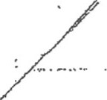.; ./ .

IN WITNESS WHEREOF, the parties hereto·have executed this First A mendment on the date
fo'sl above written. ·

SETTLOR and 'l'RUSTEEi

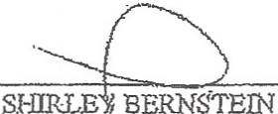

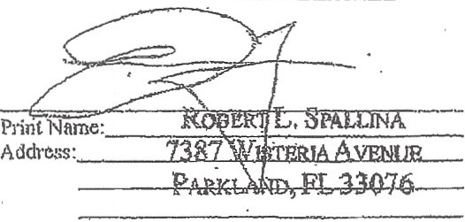This iostrument was signed by SfURLEY BERNSTEIN in our presence, and at the request of and in the pre:ence of ·sm:FiEY BERNSTEIN and eacb other, we subsc1ibe ou names as witnesses · on this /P. day of f V<l v 2008 : · ·
--v--
.

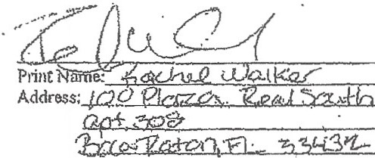

STATEOFFLORIDA

SS.

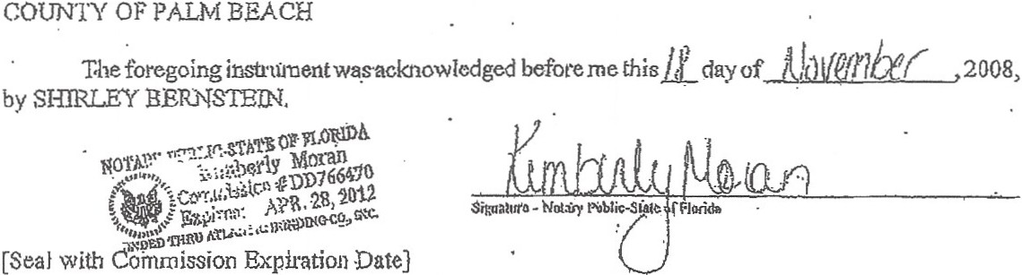

Prim, ll'Jl" smp nai11b OfNotorj l'ubfio

Personally Known /. ... Ol' Produced ldencitication _
Typ of Identification Produced - ----- ---------------

Flll.STAMlrnJJl>reHJ'TO
Sll!IU.l?Y DuE()-!Tl\u:rrAGl\lnlMD!"tT
"

-2-
TESCI-IBR s SPALLINA, p.A•

···-------···- ··- ··--···---·- · ..-----,---·-.•····-----

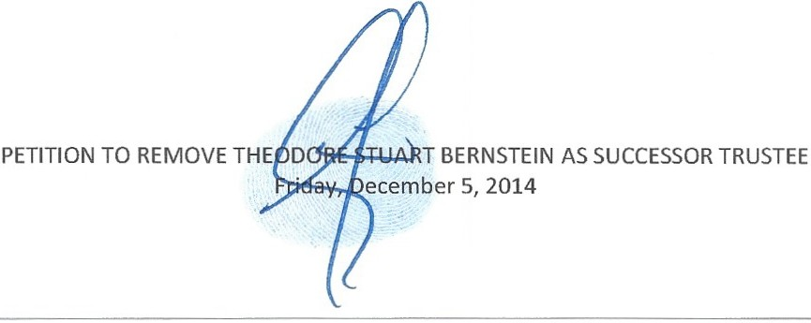
EXHIBIT C

Second First Amendment to Shirley Trust

:_ '. . · 1"· .. .· ·, '' - . ·.- _:_. -- - · " _ .' ,· . , . _.·.:-: ::."";•': , · :c··,<:,_ ..:.- . . . .

•?:.· , <' " • •• • , • ' • - - ; ... •

':i.•. . , ,
. . . -
. -

FIRST AMENDMENT TO
SHIRLEY BERNSTEIN TRUST AGREEMENT

This First Amendment is dated this / f day of ;t}o v , 2008, and is between SHIRLEY BERNSTEIN of Palm Beach County, Florida referred to in the first person, as settler, and SHIRLEY BERNSTEIN of Palm Beach County, Florida as trustee (referred to as the "Trustee," which term more particularly refers to all individuals and entities serving as trustee of a trust created hereunder during the time of such service, whether alone or as co-trustees, and whether originally serving or as a successor trustee).

WHEREAS, on May 20,2008, Icreated and funded the SHIRLEYBERNSTEIN TRUST AGREEMENT (the "TrustAgreement, "which reference includes any subsequent amendments of said trust agreement);

WHEREAS, Paragraph A. of Article I.of said Trust Agreement provides, inter alia,that during my lifetime I shall have the right at any time and from time to time by an instrument, in writing, delivered to the Trustee to amend or revoke the said Trust Agreement, in whole or in part.

NOW THEREFORE, by executing this instrument, I hereby amend the Trust Agreement as follows:

I . I hereby delete Paragraph B. of Article II. in its entirety.

  - I hereby amend the last sentence of Paragraph E. of Article III. to read as follows:

"Notwithstanding the foregoing, as my spouse and I have adequately provided for them during our lifetimes, for purposes of the dispositions made under this Trust, my children, TED S.BERNSTEIN ("TED")and PAMELA B. SIMON ("PAM'), shall be deemed to have predeceased the survivor of my spouse and me, provided, however, if my children, ELIOT BERNSTEIN, JILL !ANTONI and LISA S. FRIEDSTEIN, and their respective lineal descendants all predecease the survivor of my spouse and me, then TED and PAM shall not be deemed to have predeceased the survivor of my spouse and me and shall become eligible beneficiaries for purposes of the dispositions made hereunder."

  - I hereby ratify and reaffirm the Trust Agreement as amended by this First Amendment.

============

[remainder ofpage intentionally left blank]

i:-iRST AMENDMENT TO
SHIRLEY BERNSTEIN TRUST AGREEMENT

TESCHER 0 SPALLINA, P.A.

IN WITNESS WHEREOF, the parties hereto have executed this First Amendment on the date first above written.

SETTLOR and TRUSTEE:

SHI:uQIBIN
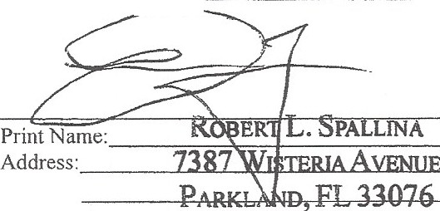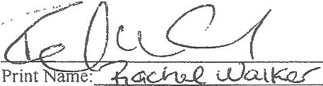This instrument was signed by SHIRLEY BERNSTEIN in our presence, and at the request of and in thf resence of SHI1liEY BERNSTEIN and each other, we subscribe our names as witnesses on this /. day of / V <) v , 2008:

Address: [QO f?fc&Z0- 12.ecd X.X.,

apt :zoc?

STATE OF FLORIDA

COUNTY OF PALM BEACH

SS.

Theforegoing instrument was acknowledged before me this ii_day of iUu\Jefl'}/:xf , 2008, by SHIRLEY BERNSTEIN.
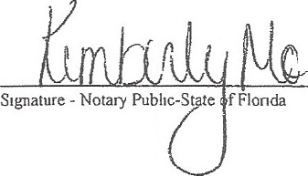A>. :',.,,-_--.-,,,_.s1A'r'\EOYM"FoT .coalUnDA
!

!..-._,.,••.'\:•,•• •'-. Ji

20 '1"0!. 12
((lll

NO...T....."u..''·-
. ...b\ S OD766•70
' .r -

i :\...- ""_.,'"'. ,"';.·R. o, .... .,
Ex.·· L._
i ..• . - r,vtNGco .. c..
#., ...
,,,.,,,ft'tl"Qu h Li·- l. 1' •
1:-'D. BD ,.,.,
[Seal with Commission Expiration Date]

Prmt. type or sramp name of Notary Pubhc

Personally Known - -
' -or Produced Identification -----

Type of Identification Produced --------------------------

N \WPDATA\dn\Bernstcm, Shirley & Stmon\2008 Estate Plannmg\F1rst Amendment to Sh1rlc Bernstein Trust Agreement wpd ( 11 09 26 18 08]

FIRST AMENDMENT TO
SHIRLEY BERNSTEIN TRUST AGREEMENT -2-

TESCHER 8 SPALLINA, p.A.

EXHIBIT D

Donald R.Tescher, Esq.and Robert L. Spallina, Esq.
Resignation Letter

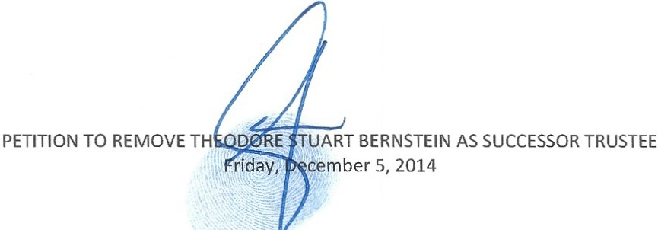

L·A W 0 F F J C E S

TESCHE R & SPALLINA , P.A.

ATTORNEYS
DONALD R. TESCHER ROBERT l.SPALLINA LAUREN A. GALVANI
BOCA VILLAGE CORPORATE CENTER l 4855 TECHNOLOGY WAY, Sum:i 720 BOCA RATON, FLORIDA 33431

TEL: 561-997-7008
FAX: 561-997-7308
TOLL FREE: 888-997-7008.
WWW. TESCHERSPALLINA.COM

January 14, 2014

SUPPORT 511\PF DIANE DUSTIN KIMBERLY MORAN SuANN TESCHER

VIA U.S.MAIL AND EMAIL
Ted S. Bernstein 880 Berkeley Street
Boca Raton, FL 33487

Eliot Bernstein
2753 NW 34111 Street
Boca Raton, FL 33434

Lisa S. Friedstein 2142 Churchill Lane
Highland Park, IL 60035

Pamela B. Sjmon
950 North Michigan Ave. Suite 2603
Chicago, IL 60606
Jill lantoni
2101 Magnolia Lane Highland Park, IL 60035

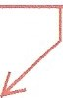Re: Estates and Trusts of Shirley Bernstein and Simon Be1·nstein
Post Mortem change to Trust to alter beneficiaries of Estate now admitted by Spallina to Sheriff .

Dear Ladies and Gentlemen:

Tt has been brought to my attention that a document was prepared in our office that altered the disposition ofthe Shirley Bernstein Trust subsequent to Simon Bernstein'sdeath. Information provided to me appears to indicate that there were two versions of the First Amendment to the Shirley
Bernstein Trust Agreement, both executed on November 18, 2008. Under one version the children r-- ----. of Pam Simon and Ted Bernstein would not be permissible appointees of Simon Bernstein's exercise So whole time of the power of appointment while under the second version that restriction was removed. As you that they
all know, Simon Bernstein's dispositive plan, expressed to all ofyou during bis lifetime on a conference worked to
call, was to distribute the Estate to all ten of h. grandchildren. That was the basis upon which the distribute
1s
administration was moving forward. Shirley Trust
Assets to ten
grandchildren

Under the Shirley Bernstein Trust, there is a definition of children and lineal descendants. That
definition excluded Pam Simon, Ted Bernstein and thei r respective children from inheriting. The document also contained a special Power of Appointment for Simon wherein he could appoint the assets of the Trust for Shirley's lineal descendants. Based upon the definition of children and lineal descendants, the Power of Appointment could not be exercised in favor of Pam Simon, Ted Bernstein or their respective children, although we believe it was Simon Bernstein's wish to provide equaJly for all of his grandchildren .

they knew it could not be done legally.

On November 18, 2008, it does appear from the information that I have reviewed that Shirley Bernstein executed a First Amendment to her trust agreement. The document as executed appears to make only one relatively minor modification to her trust disposition by eliminating a specific gift to Ted

Bernstein Family
Spallina later admits to Palm Beach County Sheriff that he altered the document but only after we bust them in Court with the fact that it cannot be the ten grandchildren they daimed in Court and to many other parties to make distributions knowingly to improper parties. Spallina and Tescher acted over and over to make the improper distributions to the ten grandchildren and when necessary to show their claim it was the grandchildren, they went and created a new post mortem document to accomadate their fraudulent scheme.
January 14, 2014
Page 2

Bernstein's stepson. In January of 2013 a First Amendment to the Shirley Bernstein Trust Agreement was provided to Christine Yates,Esq. who, atthat time, was representing Eliot Bernstein .The document provided contained a paragrapnnumper 2 which modified the definitional language in Shirley's document so as to permit, by deleting the words "and their respective lineal descendants" from the definition, an exercise of the power of appointment by Simon Bernstein over the Shirley Bernstein Trust to pass equally to all ten grandchildren rather than only six of the grandchildren.
By virtue of The Florida Bar Rules of Professional Conduct, I am duty bound to provide this information lo you. Obviously, as a result of the issues and ramifications raised by the allegations, my firm must resign from further representation in all matters relating to the Estates and Trusts of Simon Bernstein and Shirley Bernstein. Furthermore, it is my intent, and Iassume also tbe intent of Robett Spallina, to tender our resignations as personal representatives of the Simon Bernstein Estate and as trustees of the Simon Bernstein Trust. Ifthe majority of the Bernstein family is in agreement, Iwould propose to exercise the power to designate a successor trustee by appointing Ted Bernstein in that
capacity. With regat'd to the Simon Bernstein Estate, the aooointment of the successor would require a court proceeding. ,Don knows the alleged 2012 Simon Trust successor cannot be Ted due to language that prohibits this apponint

Yet, continues to act and even prepares an accounting after resigning and
withdrawing
in court.

and Don should know. he did the document but yet needs to continue fraud and cover up ,...._
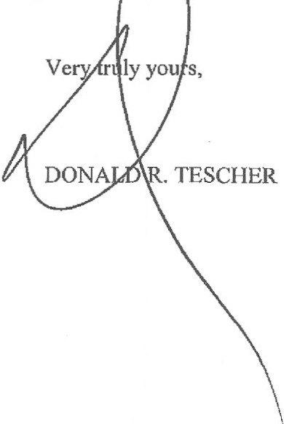I am obviously upset and distraught over this chain ofevents and will do aJJ that I reasonably can to correct and minim ize any damages to the Bernstein fa 11 .As Ibelieve you know, to date there has only been a modest funding of some, but not all, ofthe c tinui g trusts for the grandchildren emanating from Shirley's Trust assets.

ORT/km
cc: Alan Rose, Esq.

L A W O F F I C E S
TESCHER & SPALLINA, P.A .

.. . . ...

IN THE CIRCUIT COURT FOR PALM BEACH COUNTY, FL

IN RE: ESTATE OF SIMON L.BERNSTEIN, PROBATE DIVISION

Deceased, CASE NO. 502012CP004391XXXXSB

DIVISION: IY (COJ.,IN)

.l! LIOT IVAN BERNSTEIN, PRO SE

Petitioner

vs.

TESCHER & SPALLINA, P.A., (and all parties, associates and of counsel); ROBERT L. SPALLINA (both personally and professionally); DONALD R. TESCHER (both personally and professionally); THEODORE STUART BERNSTEIN (as alleged
personal representative, trustee, successor trustee) (both personally and professionally); ct. al.

Respondents.

PETITION FOR RESIGNATION AND DISCHARGE

Petitioners, Donald R. Tescher and Robert L. Spallina, as co-Personal Representatives ofthe Estate of Simon L. Bernstein, hereby file their Petition for Resignation and Discharge and state:
- Donald R. Tescherand Robert L. Spallina are the named co-Personal Representatives

under the Last Will and Testament of Simon L. Bernstein admitted to probate on October 2) 2012, with Letters of Administration issued on that same day.
- As a result ofirreconcilable differences with the children and grandchildren of Simon

L. Bernstein, it is necessary for the Petitioners to resign, and the Petitioners hereby seek leave to resign pursuant to § 733.502 of the Florida Statutes. The family members have indicated that they are amenable to this voluntary resignation of the co-Personal Representatives.
- The interests of the estate will not be jeopardized by the resignation of the co - Personal Representatives.
-1-

. ..

- The Petitioners will co-operate with the duly appointed successor Personal Representative or comt-appointed curator pending appointment of a successor Personal Representative pmsuant to § 733.5061 of the Florida Statutes and will immediately make available all relevant documents and materials, subject to retaining such access as necessruy to pe1mit the Petitioners to fulfill their accounting obligations under § 733.5061 and § 733.508 of the Florida Statutes.
- Upon rendering a fmal accounting and fulfilling their obligations and responsibilities outlined in § 733.502, § 733.5035, § 733.5036, § 733.508, and § 733.509 of the Florida statutes, as we11 as related Probate Rules, the Petitioners request that this Court discharge the Petitioners as co- Personal Representatives.
WHEREFORE, Petitions request this court issue an Order accepting their resignation as co- Personal Representatives and revoking their Letters of Administration pursuant to § 733.502 of the Florida Statutes, reserving any and all issues as to discharge pending the rendering of their final accounting and the fulfillment of such other responsibilities outlined herein pursuant to the Florida Statutes.
DATED thisl--veiay of Januruy, 2014.
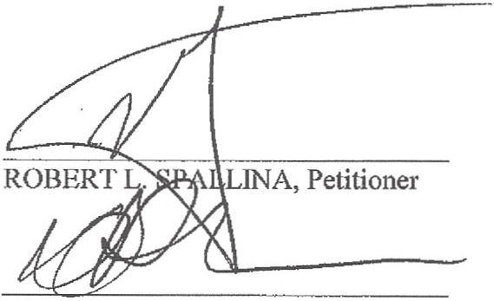Respectfully Submitte 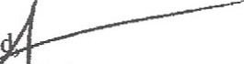
TESCHER & A, P.A.

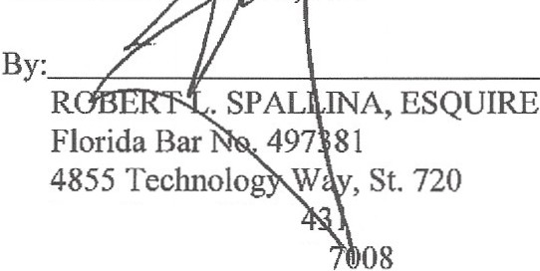Boca Raton, FL 33 Telephone: 561-997- rspallina@tescherspallina.eom kmoran@tescherspallina.com

DONALD R.TESCHER, Petitioner

-2-

CERTIFICATE OF SERVICE

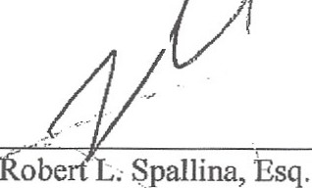I HEREBY CERTIFY that a true and correct copy of the foregoi g has been furnished
.
.I
l
·

by e-mail to the de | ? | d address(es) and U.S. Mail, as noted, to all p rties on the following
Service List, this |  | day of January, 2014. .

SERVICE LIST

Theodore Stuart Bernstein (e-mail) Life fnsurance Concepts
950 Peninsula Corporate Circle, Suite 3010 Boca Raton, Florida 33487
Alan B. Rose, Esq. (E-mail)
Page Mrachek Fitzgerald Rose Konopka &
Dow PA
505 S Flagler Dr Ste 600
West Palm Beach, Florida 33401

Eliot Bernstein (U.S. Mail) 2753 NW 34t1• Street
Boca Raton, Florida 33434

Lisa Sue Friedstein (U.S. Mail)
2142 Churchill Lane
Highland Park, Illinois 60035

Pamela Beth Simon (U.S. Mail)
950 North Michigan Avenue, Suite 2603
Chicago, Illinois 60611

Jill Iantoni (U.S. Mail) 2101 Magnolia Lane
Highland Park, Illinois 60035

Donald R. Tescher (E-mail)
4855 Technology Way, Suite 720 Boca Raton, Florida 33431
Mark R. Manceri, Esq. (E-mail) Mark. R. Manceri, P.A.
2929 East Commercial Boulevard, Ste. 702
Fo1t Lauderdale, Florida 33308

-3-

IN THE CIRCillT COURT FOR PALM BEACH COUNTY, FL

IN RE: ESTATE OF PROBATE DNISION

SHIRLEY BERNSTEIN, File No.502011CP000653XXXXSB

Deceased.

MOTION TO WITHDRAW AS COUNSEL

COME NOW, Robert L. Spallina, Esq., and Tescher & Spallina, P.A., pursuant to Rule
2.505 of the Florida Rules of Judicial Administration, hereby file this Motion to Withdraw as Counsel and, in support thereof, state as follows:

- TESCHER & SPALLINA, P.A. was retained by Ted S. Bernstein as successor Personal Representative (hereinafter, the "Client") to represent him in these proceedings.
2. ROBERT L. SPALLINA, ESQ. of TESCHER & SPALLINA, P.A. was the attorney responsible for rendering services to the Client.
- In-econcilable differenceshave arisen which prevent the continued representation of the Client.
- The mailing address, e-mail address and telephone number of the Client are as follows:
Mailing Address: 950 Peninsula Corporate Circle, Suite 3010
Boca Raton, Florida 33487

E-Mail Address:
tbernstein@lifeinsuranceconcepts.com

Telephone Number: (561) 988-8994

WHEREFORE, TESCHER & SPALLINA, P.A. and ROBERT L. SPALLINA, ESQ.,

hereby respectfully request that this Honorable Cou1t enter an Order consistent with the relief requested herein allowing TESCHER & SPALLINA, P.A. and ROBERT L. SPALLINA, ESQ.
-1-

to withdraw and any other relief this Honorable Court deems just, equitable and proper.
r;-·

Signed on
f}-{} J tY ' 2014.

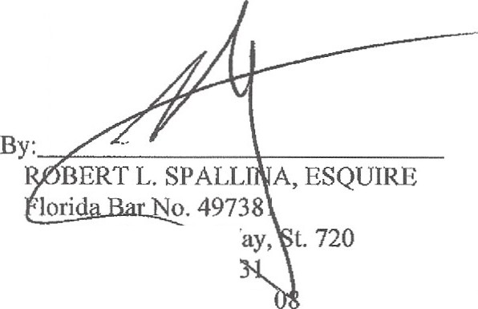TESCHER & SPALLINA, P.A.

4855 Technolog Way, Boca Raton, FL 334 Telephone: 561-997-70
rspalJina@tescherspallina. com kmoran@tescherspallina. com

-2-

·"

CERTIFICATE OF SERVICE

I HEREBY CERTIFY that a true and correct copy of the foregoing has been furnished by e-mail to the designated address(es) and U.S.Mail, as noted, to all parties on the following
Service List, this J) :1-- day of January, 2014. 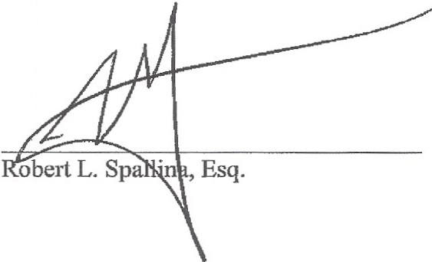

SERVICE LIST

Theodore Stua11Bernstein (e-mail) Life Insurance Concepts
950 Peninsula Corporate Circle, Suite 3010 Boca Raton, Florida 33487

Eliot Bernstein (U.S.Mail)
2753 NW 34th Street
Boca Raton, Florida 33434

Lisa Sue Friedstein (U.S. Mail)
2142 Churchill Lane Highland Park, Illinois 60035
Pamela Beth Simon (U.S. Mail)
950 North Michigan Avenue, Suite 2603
Chicago, Illinois 60611

Jill Iantoni (U.S. Mail)
2101 Magnolia Lane Highland Park, Illinois 60035

Alan B. Rose, Esq. (E-mail)
Page Mrachek Fitzgerald Rose Konopka &
Dow PA
505 S Flagler Dr Ste 600
West Palm Beach, Florida 33401

Mark R. Manceri, Esq. (E-mail) Mark. R. Manceri, P.A.
2929 East Commercial Boulevard, Ste. 702 Foit Lauderdale, Florida 33308

-3-

,,. '•

IN THE CIRCUIT COURT FOR PALM BEACH COUNTY, FL

JN RE: ESTATE OF SIMON L. BERNSTEIN, PROBATE DIVISION

Deceased. CASE NO. 502012CP004391XXXXSB

DIVISION: IY (COLIN)

ELIOT IVAN BERNSTEIN, PRO SE

Petitioner

vs.

TESCHER & SPALLINA, P.A., (and all parties, associates and of counsel); ROBERT L.SPALLINA (both pe1·sonally and professionally); DONALD R. TESCHER (both 1>ersonaJly and pl'Ofessionally); THEODORE STUART BERNSTEIN (as alleged
personal representative, trustee, successor trustee)
(both personally and professionally); et. al.

Respondents.

CONSENT AND JOINDER
TO MOTION TO WITHDRAW AS COUNSEL OF RECORD

I, ROBERT L. SPALLINA, ESQ., as co-personal representative of the above-referenced estate, as counsel for the co-personal representative, Donald R. Tescher, and as a respondent, both personally and professionally, hereby consent to and join in the Motion to Withdraw as Counsel of Record filed by Mark R. Manceri, Esq. and Mark. R. Manceri, P.A., on January 10, 2014, which motion has been set for hearing on January 23, 2014, at 8:45 a.m.

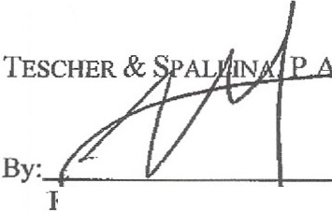DATED this cJO-day of January, 2014.

- Fr.;i-J?- SPAL INA, ESQUIRE Florida Bar No. 7 81
4855 Technology , St. 720
Boca Raton, FL 3343 Telephone: 561-997-70 8 rspaJlina@tescherspall ina.com kmoran@tescherspallina.com

. .

CERTIFICATE OF SERVICE

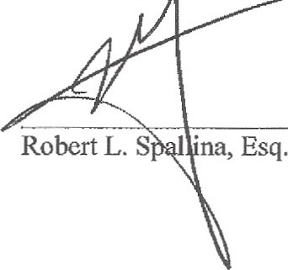I HEREBY CERTIFY that a true and correct copy of the foregoing has been furnished by e-mail to the dar-d address(es) and U.S. Mail, as noted, t all parties .-the following Service List, this day of January, 2014.

SERVICE LIST

Theodore Stuart Bernstein (e-mail) Life Insurance Concepts
950 Peninsula Corporate Circle, Suite 3010 Boca Raton, Florida 33487

Eliot Bernstein (U.S. Mail) 2753 NW 34th Street
Boca Raton, Florida 33434
Lisa Sue Friedstein (U.S. Mail) 2142 Churchill Lane
Highland Park, Illinois 60035
Pamela Beth Simon (U.S. Mail)
950 North Michigan Avenue, Suite 2603
Chicago, Illinois 60611
Jill Iantoni (U .S. Mail) 2101 Magnolia Lane
Highland Park, Illinois 60035

Donald R. Tescher (E-mail)
4855 Technology Way, Suite 720 Boca Raton, Florida 33431
Mark R. Manceri, Esq. (E-mail) Mark. R. Manceri, P.A.
2929 East Commercial Boulevard, Ste. 702 Fort Lauderdale, Florida 33308
Alan B. Rose, Esq. (E-mail)
Page Mrachek Fitzgerald Rose Konopka &
Dow PA
505 S Flagler Dr Ste 600
West Palm Beach, Florida 33401

,f ' '" ...

IN THE CffiCUIT COURT FOR PALM BEACH COUNTY, FL IN RE: ESTATE OF SHIRLEY BERNSTEIN, PROBATE DIVISION
Deceased. CASE NO. 502011CP000653XXXXSB

DIVISION: IY (COLIN)

ELIOT IVAN BERNSTEIN,PRO SE

Petitioner

vs.

TESCHER & SPALLINA, P.A., (and all parties, associates and of counsel); ROBERT L. SPALLINA (both personally and professionally); DONALD R. TESCHER (both personally and professionally); THEODORE STUART BERNSTEIN (as alleged
personal representative, trustee, successor trustee) (both personally and professionally); et. al.

Respondents.

CONSENT AND JOINDER
TO MOTION TO WITHDRAW AS COUNSEL OF RECORD

I, ROBERT L.SPALLINA, ESQ., as counsel for the successor personal representative, Ted
S. Bernstein, and as a respondent, both personally and professionally, hereby consent to and join in the Motion to Withdraw as Cow1sel of Record filed by Mark R. Manceri, Esq. and Mark. R. Manceri, P.A., on January 10, 2014, which motion has been set for hearing on January 23, 2014, at 8:45 a.m.

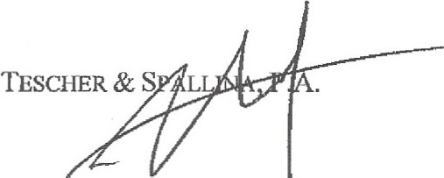DATED this8fr day of January, 2014.

By :----F..,....-=-...::-- -+- --­
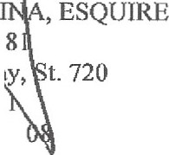ROBERT L. SALL
Florida Bar No. ·4 738
4855 Technology Y> Boca Raton, FL 3343 Telephone:561-997-70
rspallina@tescherspallina.com kmornn@teschetspa llina.com

,,

CERTIFICATE OF SERVICE

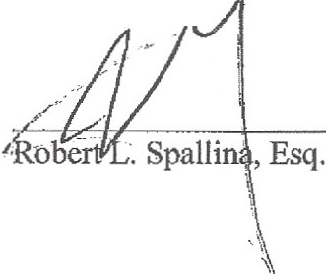I HEREBY CERTIFY that a true and correct copy of the foregoing has been furnished by e-mail to the ded address(es) and U.S. Mail, as noted, to all artis-on the following Service List, this day of Januaiy, 2014. ,,.- ·- ·-

SERVICE LIST

Theodore Stuait Bernstein (e-mail) Life Insurance Concepts
950 Peninsula C01porate Circle, Suite 3010 Boca Raton, Florida 33487

Eliot Bernstein (U.S. Mail) 2753 NW 34th Street
Boca Raton, Florida 33434
Lisa Sue Friedstein (U.S.Mail) 2142 Churchill Lane
Highland Park, Illinois 60035
Pamela Beth Simon (U.S. Mail)
950 North Michigan Avenue, Suite 2603
Chicago, Illinois 60611

Jill Iantoni (U.S. Mail) 2101 Magnolia Lane
Highland Park, Illinois 60035

Donald R. Tescher (E-mail)
4855 Technology Way, Suite 720 Boca Raton, Florida 33431
Mark R. Manceri, Esq. (E-mail) Mark. R. Manceri, P.A.
2929 East Commercial Boulevard, Ste. 702 Fort Lauderdale, Florida 33308
Alan B. Rose, Esq. (E-mail)
Page Mrachek Fitzgerald Rose Konopka & Dow PA
505 S Flagler Dr Ste 600
West Palm Beach, Florida 33401

Filing # 9051696 Electronically Filed 01/10/2014 05:12:14 PM

IN THE CIRCUIT COURT FOR PALM BEACH COUNTY, FLORIDA WILLIAM E. STANSBURY, CIVIL DMSION
Plaintiff, CASE NO: 502012CA013933 MB AA

vs.

TED S. BERNSTEIN; DONALD TESCHER
and ROBERT SPALLINA, as Co-Personal Representatives of the ESTATE OF SIMON
L. BERNSTEIN and as Co-Trustees of the SHIRLEY BERNSTEIN TRUST AGREEMENT dated May 20, 2008; LIC HOLDINGS, INC.; ARBITRAGE INTERNATIONAL MANAGEMENT, LLC, f/k/a ARBITRAGE INTERNATIONAL HOLDINGS, LLC; BERNSTEIN FAMILY REALTY, LLC,

Defendants.
DMSION: BLANC

MOTION TO WITHDRAW AS COUNSEL OF RECORD

COME NOW . Mark R. Manceri. Esq.• and Mark R. Manceri, P.A. , pursuant to Rule

2.505 of the Florida Rules of Judicial Administration and hereby file this their Motion to Withdraw as Counsel of Record and in support thereof state, as follows:
- MARK R. MANCERI, P.A. was retained by Donald R. Tescher and Robert L. Spallina, as Co-Personal Representatives of the Estate of Simon Bernstein; and Bernstein Family Realty LLC (hereinafter the "Clients") to represent them in these proceedings .
- MARK R. MANCERI, ESQ.of MARK R. MANCERI, P.A. was the attorney

responsible for rendering the legal services co the Clients.

- Professional consideration(s) has arisen which prevent(s) the continued

- 1-

MARK R. MANCERI, P.A.•2929 East Commercial Blvd.•Suite 702 •Fort Lauderdale, FL 33308 • (954) 491-7099

FITJE N0.:502012CA013933 MB AA

representation of the Clients.

- The mailing and e-mail addresses and the telephone numbers of the Clients are as follows:
Donald R. Tescher, Co-Personal Representarive, 4855 Technology Way, Suite
720, Boca Raron, Florida 33431 , e-mail: dtescher@tescherspallina.com; telephone number (561) 997-7008.

Robert L. Spallina, Co-Personal Representative, 4855 Technology Way, Suite 720, Boca Raton, Florida 33431, e-mail: rspallina@tescherspallina.com: telephone number (561) 997-7008.

Bernstein Family Really, LLC, c/o Janet Craig, CTFA. Senior Vice Presidem & Compliance Office, Oppenheimer Trust Company , 18 Columbia Turnpike , Florham Park, NJ 07932, e-mail: Janec.Craig@op co .com :telephone number (973) 245-4635 ..

WHEREFORE, MARK R. MANCERI, P.A. and MARK R. MANCERI. ESQ., hereby

request that this Honorable Court enter an Order consistem with rhe relief requested herein allowing MARK R. MANCERJ, P.A. and MARK R. MANCERI. ESQ. ro withdraw aml any other relief this Honorable Court deems just, equirable and proper.
MARK R. MANCERI. P.A.
Attorney for Donald R. Tescher and Robert L. Spallina. as Co-Personal Representatives and Bernstein Family Real ty , LLC
2929 East Commercia l Blvd., Suire 702
Ft. Lauderdale, FL 33308
Telephone: (954) 491-7099
Enl]ii: n rm. law@comcast. net
I mnlawl@gmail.com
B . \ ;tt'V'- c iL-r .
Mark R. Manceri, Esq.
Florida Bar No. 444560

- 2 .

.VIARK R. l\lANCERl, P.A.• 2929 East Commcrdal Blvd.• Suite 702 • Fort Lauderdale. FL 33308 • (954) 491-7099

502012CA013933 MB AA

CERTIFICATE OF SERVICE

I HEREBY CERTIFY that a true and correct copy of the foregoing has been furnished by e-mail to the designated address(es) to all parties on the following Service List, this 10th day of January, 2014.

Mark R. Manceri, Esq.

SERVICE LIST

Peter M. Feaman, Esq. Peter M. Fearnan, P.A.
3615 West Boynton Beach Blvd. Boynton Beach, Florida 33436

Alan B. Rose, Esq.
Page, Mrachek, Fitzgerald, et.al. 505 South Flagler Drive, Suite 600 West Palm Beach, Florida 33401

Donald R. Tescher, Co-Personal Representative
4855 Technology Way, Suite 720
Boca Raton, Florida 33431

Robert L. Spallina, Co-Personal Representative
4855 Technology Way, Suite 720
Boca Raton, Florida 33431

Bernstein Family Realty, LLC c/o Janet Craig, CTFA
Senior Vice President & Compliance Office Oppenheimer Trust Company
18 Columbia Turnpike Florham Park, NJ 07932

- 3 -

MARK R. MANCERI, P.A.•2929 East Commercial Blvd.• Suite 702 •Fort Lauderdale, FL 33308 •(954) 491-7099

IN THE CIRCUIT COURT FOR PALM BEACH COUNTY, FLORIDA

PROBATE DMSION
FILE NO.:502012CP004391XXXXSB IY DIVISION: COLIN

IN RE: ESTATE OF

SIMON BERNSTEIN

Deceased.

MOTION TO WITHDRAW AS COUNSEL OF RECORD

COME NOW , Mark R. Manceri, Esq., and Mark R. Manceri, P.A., pursuant to Rule

2.505 of the Florida Rules of Judicial Administration and hereby file this their Motion to Withdraw as Counsel of Record and in support thereof state, as follows:
- MARK R. MANCERl, P.A. was retained by Donald R. Tescher and Robert L. Spallina, as Co-Personal Representatives of the Estate of Simon Bernstein (hereinafter the "Clients") to represent them in these proceedings.
- MARK R. MANCERI , ESQ. of MARK R. MANCERI, P.A. was the attorney responsible for rendering the legal services to the Clients.
- Professional consideration(s) has arisen which prevent(s) the continued representation of the Clients.
- The mailing and e-mail addresses and the telephone numbers of the Clients are as follows:

- 1-

MARK R. MANCERI, P.A.•2929 East Commercial Blvd.•Suite 702 •Fort Lauderdale, FL 33308 •(954) 491-7099

FILE NO.: S02012CP00439IXXXSB IY

Donald R. Tescher, Co-Personal Representative, 4855 Technology Way, Suite 720, Boca Raton, Florida 33431, e-mail: dtescher@tescherspalli na.com; telephone number (561) 997-7008.

Robert L. Spallina, Co-Personal Representative, 4855 Technology Way, Suite 720, Boca Raton, Florida 33431, e-mail: rspallina@tescherspalli na.com; telephone number (561) 997-7008.

WHEREFORE, MARK R. MANCERI, P.A. and MARK R. MANCERI, ESQ., hereby

request that this Honorable Court enter an Order consistent with the relief requested herein allowing MARK R. MANCERI, P.A. and MARK R. MANCERI. ESQ. to withdraw and any other relief this Honorable Courc deems jusr, equitable and proper.
MARK R. MANCERI, P.A.
Attorney for Donald R. Tescher and Roben L.
Spallina, as Co-Pt!rsonal Represencatives 2929 East Commercial Blvd .. Suite 702 Ft. Lauderdale, FL 33308
Telephone: (954) 491-7099
E-ma•I\: mr')Jfaw@comcast .net
J mqh1awl@grnail.com
By : I 9. (11...y_ ;, .,il-._ •
Mark R. Manceri, Esq . Florida Bar No. 444560

- 2 -

MARK R. MANCERI, P.A.• 2929 East Commercial Blvd.• Suite 702 • Fort Lauderdale. f L 33308 •(954) 491-7099

FILE NO.: 502012CP004391XXXXSB IY

CERTIFICATE OF SERVICE
I HEREBY CERTIFY that a true and correct copy of the foregoing has been furnished by e-mail to the designated address(es) and U.S. mail, as noted, to all parties on the following Service List, this l01 day of January , 2014. \ r
1i I
I
I ) :t._(;;f·,

Mark R. Manceri . Esq.

SERVICE LIST

Peter M. Feaman, Esq. (e-mail) Perer M. Feaman, P.A.
3615 West Boynton Beach Blvd. Boynton Beach, Florida 33436

Eliot Bernstein (U.S. mail) 2753 NW 34111 Street

Boca Raron, Florida 33434

Theodore Sruart Bernstein (e-mail) Life Insurance Concepts
950 Peninsula Corporate Circle, Suite 3010
Boca Raton, Florida 33487

Lisa Sue Friedstein (U.S. mail) 2142 Churchill Lane
Highland Park, IL 60035

Pamela Beth Simon (U.S. mail)
950 North Michigan Avenue, Suite 2603
Chicago, IL 60611

Jill Iantoni (U.S. mail) 2101 Magnolia Lane Highland Park, IL 60035

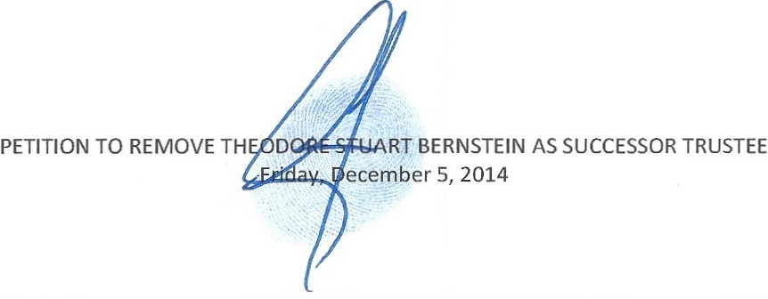
EXHIBIT E

February 19th, 2014 Court Order -Denying Ted Bernstein Petition to become Curator

rN THE CIRCUIT COURT OF THE FIFTEENTH JUDICIAL CIRCUIT OF FLORIDA, IN AND FOR PALM BEACH COUNTY, FLORIDA

IN RE: Case No.: 50 2012 CP 004391 SB
.JUDGE MARTIN COLIN

ESTATE OF SIMON BERNSTEIN,
Deceased. Division: IY
I

ORDER ON MOTION FOR APPOINTME T OF CURATOR OR ADMINISTRATOR AD LITEM

THIS MATTER came before this Court on Tuesday, February 18, 2014, upon the Motion for Appointment of Curator or Administrator Ad Litern, filed by Ted S. Bernstein, and the Court. having heard argument of counsel, and considered the evidence, it is
r
ORDERED AND ADJUDGED that:
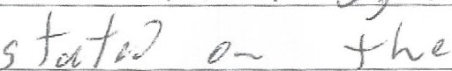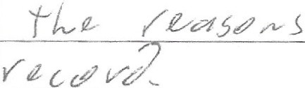l) ;L/ I £ I fur l"

DONE and ORDERED in Delray Beach, Palm Beach County, Florida. this / 7day of February, 2014.

ccu

Copies to:

Alan Rose, Esq., PAGE, MRACHEK 505 So. Flagler Drive, Suite 600, We:.t Palm Beach, FL 3340 I ;
John J. Pankauki, Esq., PANKAUSKl LAW FIRM. 120 South Olive Avenue. Suite 70 L West Palm Beach, FL 33401;
Peter M. Feaman, Esq., PETER M. FEAMAN, P.A., 3615 Boynton Beach Blvd., Boynton Beach, Florida 33436.

