IN THE CIRCU1T COURT OF THE 15TH JUDICIAL CIRCU1T, IN AND FOR PALM BEACH COUNTY, FLORIDA

Case No. 502014CP003698XXXXSB

Eliot Ivan Bernstein, Individually ; Eliot Bernstein in his capacity as Natural Guardian of his
minor children, Joshua, Jacob and Daniel; and as beneficiary of the alleged Shirley Bernstein Trust dated May 20, 2008, as
amended and Eliot Bernstein as Trustee of the Eliot Bernstein Family Trust dated May 20, 2008,

Honorable Martin Colin

Jury Trial Requested

Counter Plaintiff,

v.

Tescher & Spallina, P.A., and all Partners Associates and of Counsel ; Robert L. Spallina, Esq., Personally ;
Robert L. Spallina, Esq., Professionally ; Donald R. Tescher, Esq., Personally ; Donald R. Tescher, Esq., Professionally ;
Gutter Chaves Josepher Rubin Forman Fleisher Miller, P.A.; Theodore Stuart Bernstein, Individually ;
Theodore Stuart Bernstein, as alleged Trustee of the Shirley Trust; Theodore Bernstein as Personal Representative of the Shirley Estate; Lisa Sue Friedstein, Individually ;
Jill Marla Iantoni, Individually ; Pamela Beth Simon, Individually; Mark Manceri, Esq., Personally; Mark Manceri, Esq., Professionally;
Mark R. Manceri, P.A., and all Partners, Associates and of Counsel;
Page, Mrachek, Fitzgerald & Rose, P.A., and all Partners Associates and of Counsel; Alan B. Rose, Esq. -Personally;
Alan B. Rose, Esq. - Professionally;
Pankauski Law Firm PLLC, and all Partners, Associates and of Counsel; John J. Pankauski, Esq. -Personally ;
John J. Pankauski, Esq. - Professionally ; Kimberly Francis Moran -Personally; Kimberly Francis Moran -Professionally;
Lindsay Baxley aka Lindsay Giles - Personally ; Lindsay Baxley aka Lindsay Giles -Profes ionally;

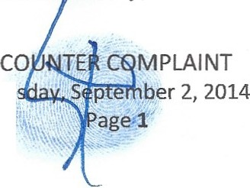
Tue

"Simon L. Bernstein Amended and Restated Trust Agreement" Dated July 25, 2012; Simon Bernstein Trust Agreement Dated May 20th 2008;
Shirley Bernstein Trust Agreement Dated May 20th 2008; The Estate of Simon Bernstein;
The Estate of Shirley Bernstein;
SIMON L. BERNSTEIN IRREVOCABLE TRUST AGREEMENT (2008); SIMON BERNSTEIN IRREVOCABLE TRUST U/A 9/7/06;
SHIRLEY BERNSTEIN IRREVOCABLE TRUST U/A 9/7/06;
SHIRLEY BERNSTEIN IRREVOCABLE TRUST AGREEMENT (2008);
SIMON BERNSTEIN IRREVOCABLE INSURANCE TRUST DATED 6/21/1995; SIMON BERNSTEIN 2000 INSURANCE TRUST (dated August 15, 2000);
SHIRLEY BERNSTEIN 2000 INSURANCE TRUST (DATED AUGUST 15, 2000);
Trust f/b/o Joshua Bernstein under the Simon L. Bernstein Trust <ltd 9/ 13/2012; Trust f/b/o Daniel Bernstein under the Simon L. Bernstein Trust <ltd 9/ 13/2012; Trust f/b/o Jake Bernstein under the Simon L. Bernstein Trust <ltd 9/ 13/2012; ELIOT BERNSTEIN FAMlLY TRUST DATED MAY 20, 2008;
DANIEL BERNSTEIN IRREVOCABLE TRUST DATED SEPTEMBER 7, 2006; JAKE BERNSTEIN IRREVOCABLE TRUST DATED SEPTEMBER 7, 2006; JOSHUA Z. BERNSTEIN IRREVOCABLE TRUST DATED SEPTEMBER 7, 2006; DANIEL BERNSTEIN IRREVOCABLE TRUST 07-JUL-10 049738;
JAKE BERNSTEIN IRREVOCABLE TRUST 07-JUL-10 0497381; JOSHUA Z BERNSTEIN IRREVOCABLE TRUST 07-JUL-10 0497381 ;
John and Jane Doe's (1-5000), Counter Defendants,

Judge Martin Colin, Personally ; Judge Martin Colin, Professionally ; Judge David French, personally ; Judge David French, professionally;

Material and Fact Witnesses who may become Defendants in any amended complaint.

COUNTER COMPLAINT

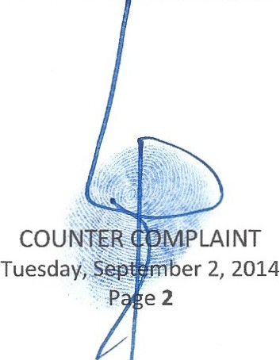

COMES NOW, PRO SE1 Eliot Ivan Bernstein ("Eliot") as Beneficiary and Interested Party both for himself personally and as Guardians for his three minor children of the alleged "Shirley Bernstein Trust dated May 20, 2008, as amended" ("Shirley Trust") and as Trustee of the "Eliot Bernstein Family Trust dated 5/20/2008" and hereby files this "ANSWER AND COUNTER COMPLAINT" and in support thereof states, on information and belief, as follows:
,
Parties, Jurisdiction and Venue

1. This is an action for money damages in excess of $15,000.00 and for equitable, compensatory, punitive and other reliefs that may be as high as billions of dollars explained further herein.
- Counter Plaintiff, Eliot Ivan Bernstein ("Eliot") or ("Counter Plaintiff ') is the parent and natural guardians of minors, Joshua Ennio Zander Bernstein ("Joshua") or ("Josh"), Jacob Noah Archie Bernstein ("Jacob") or ("Jake") and Daniel Elijsha Abe Ottomo Bernstein ("Daniel") or ("Danny"), and resides with them in Palm Beach County, Florida.
- Counter Plaintiff Eliot Ivan Bernstein is the alleged Trustee of the Eliot Bernstein Family Trust.

- Counter Defendant, Tescher & Spallina, P.A. and all Partners Associates and of Counsel ("TSPA"), is domiciled in Florida and was counsel to Simon and Shirley Bernstein for Estate planning and more.
- Counter Defendant, Robert L. Spallina, Esq. ("Spallina"), personally is a resident of Florida.

- Counter Defendant, Robert Spallina, Esq., professionally , is a resident of Florida and a central defendant in all allegations contained herein.
1Pleadings in this case are being filed by Plaintiff In Propria Persona, PRO SE, wherein pleadings are to be considered without regard to technicalities. Propria, pleadings are not to be held to the same high standards of perfection as practicing lawyers. See Haines v. Kerner 92 Set 594,also See Power 914 F2d 1459 (11th Cir1990), also See Hulsey v. Ownes 63 F3d 354 (5th Cir 1995). also See In Re: HALL v. BELLMON 935 F.2d 1106 (10th Cir. 1991)."
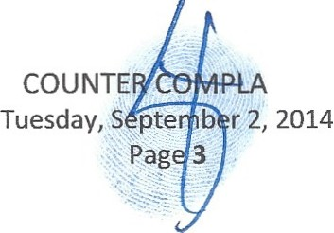In Puckett v. Cox, it was held that a pro-se pleading requires less stringent reading than one drafted by a lawyer (456 F2d 233 (1972 Sixth Circuit USCA). Justice Black in Conley v. Gibson, 355 U.S. 41at 48 (1957)"The Federal Rules rejects the approach that pleading is a game of skill in which one misstep by counsel may be decisive to the outcome and accept the principle that the purpose of pleading is to facilitate a proper decision on the merits." Accordi ng to Rule 8{f) FRCP and the State Court rule which olds that all pleadings shall be construed to do substantial justice.
INT

- Counter Defendant, Robert L. Spallina, Esq., as the former, Co-Personal Representative, Counsel and Fiduciary of the ESTATE and WILL OF SIMON BERNSTEIN (2012); Co-Trustee, Counsel and Fiduciary of the alleged SIMON L. BERNSTEIN AMENDED AND RESTATED TRUST AGREEMENT (2012); Counsel to the Co-Personal Representatives and Co-Trustees of the alleged WILL OF SIMON BERNSTEIN (2012); Counsel to the Co-Personal Representatives and Co­ Trustees of the alleged SIMON L. BERNSTEIN AMENDED AND RESTATED TRUST AGREEMENT (2012); Trustee, Counsel and Fiduciary of the SIMON L. BERNSTEIN IRREVOCABLE TRUST AGREEMENT (2008); Trustee and Fiduciary of the MARITAL TRUST and FAMILY TRUST created by SHIRLEY BERNSTEIN TRUST (2008); Trustee, Counsel and Fiduciary of the SIMON BERNSTEIN IRREVOCABLE INSURANCE TRUST DATED 6/21/1995; Trustee, Counsel and Fiduciary of the SIMON L. BERNSTEIN TRUST AGREEMENT (2008); Personal Representative, Fiduciary and Counsel to the ESTATE and WILL OF SIMON
BERNSTEIN (2008); Trustee, Fiduciary and Counsel to the SIMON BERNSTEIN IRREVOCABLE TRUST U/A 917/06; Trustee, Fiduciary and Counsel to the SHIRLEY BERNSTEIN IRREVOCABLE TRUST U/A 917106; Trustee, Fiduciary and Counsel to the WILMINGTON TRUST 088949-000 SIMON L BERNSTEIN IRREVOCABLE TRUST; Counsel to the Personal
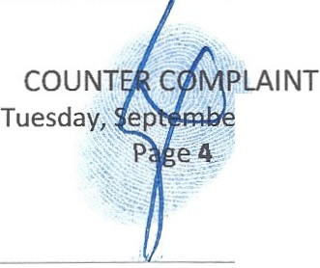Representative and Fiduciary Simon Bernstein and Successor Personal Representative Theodore Bernstein for the ESTATE AND WILL OF SHIRLEY BERNSTEIN (2008); Counsel to the Trustee and Fiduciary Simon Bernstein and Successor Trustee Theodore Bernstein for the SHIRLEY BERNSTEIN TRUST AGREEMENT (2008); Counsel to the alleged Successor Trustee and Fiduciary Theodore Bernstein of the MARITAL TRUST and FAMILY TRUST created by SHIRLEY BERNSTEIN TRUST (2008); Trustee, Fiduciary and Counsel to the ELIOT BERNSTEIN FAMILY TRUST DATED MAY 20, 2008; Trustee, Fiduciary and Counsel to the SHIRLEY BERNSTEIN IRREVOCABLE TRUS U/A 917/06; Trustee, Fiduciary and Counsel to
r 2, 2014

the SlMON BERNSTEIN IRREVOCABLE TRUST VIA 917/06; Trustee, Fiduciary and Counsel to the DANIEL BERNSTEIN IRREVOCABLE TRUST DATED SEPTEMBER 7, 2006; Trustee,
Fiduciary and Counsel to the JAKE BERNSTEIN IRREVOCABLE TRUST DATED SEPTEMBER 7, 2006; Trustee, Fiduciary and Counsel to the JOSffiJA Z. BERNSTEIN IRREVOCABLE TRUST DATED SEPTEMBER 7, 2006; Counsel to the DANIEL BERNSTEIN IRREVOCABLE TRUST 07-JUL-10 049738; Counsel to the Defendant, JAKE BERNSTEIN IRREVOCABLE TRUST 07- JUL-10 0497381; Counsel to the Defendant, JOSHUA Z BERNSTEIN IRREVOCABLE TRUST
07-JUL-10 0497381 ; Counsel and Registered Agent to the Defendant, BERNSTEIN FAMILY REALTY, LLC; Counsel, Registered Agent and Manager of Bernstein Holdings LLC; Counsel and Registered Agents for Bernstein Family Investments LLLP; Counsel and Trustee to Defendants, Trust f/b/o Joshua Bernstein under the Simon L. Bernstein Trust dtd 9/13/2012; Trust f/b/o Daniel Bernstein under the Simon L. Bernstein Trust dtd 9/13/2012; Trust f/b/o Jake Bernstein under the Simon L. Bernstein Trust dtd 9/13/2012.
- Counter Defendant, Donald R. Tescher, Esq. ("Tescher"), personally is a resident of Florida.

- Counter Defendant, Donald R. Tescher, Esq., professionally, is a resident of Florida and a central defendant in all allegations contained herein.
- 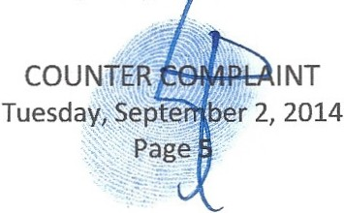Counter Defendant, Donald Tescher, Esq. as the former; Co-Personal Representative, Counsel and Fiduciary of the ESTATE and WILL OF SlMON BERNSTEIN (2012); Co-Trustee, Counsel and Fiduciary of the alleged SlMON L. BERNSTEIN AMENDED AND RESTATED TRUST AGREEMENT (2012); Counsel to the Co-Personal Representatives and Co-Trustees of the alleged WILL OF SlMON BERNSTEIN (2012); Counsel to the Co-Personal Representatives and Co­ Trustees of the alleged SlMON L. BERNSTEIN AMENDED AND RESTATED TRUST AGREEMENT (2012); Trustee, Counsel and Fiduciary of the SlMON L. BERNSTEIN IRREVOCABLE TRUST AGREEMENT (2008); T ustee and Fiduciary of the MARITAL TRUST

and FAMILY TRUST created by SHIRLEY BERNSTEIN TRUST (2008); Trustee, Counsel and Fiduciary of the SIMON BERNSTEIN IRREVOCABLE INSURANCE TRUST DATED 6/21/1995;
Trustee, Counsel and Fiduciary of the SIMON L BERNSTEIN TRUST AGREEMENT (2008); Personal Representative, Fiduciary and Counsel to the ESTATE and WILL OF SIMON BERNSTEIN (2008); Trustee, Counsel and Fiduciary of the SIMON BERNSTEIN IRREVOCABLE TRUST U/A 9/7/06; Trustee, Fiduciary and Counsel to the SHIRLEY BERNSTEIN IRREVOCABLE TRUST U/A 9/7/06; Trustee, Fiduciary and Counsel to the WILMINGTON TRUST 088949-000 SIMON L BERNSTEIN IRREVOCABLE TRUST; Counsel to the Personal
Representative and Fiduciary Simon Bernstein and Successor Personal Representative Theodore Bernstein for the ESTATE AND WILL OF SHIRLEY BERNSTEIN (2008); Counsel to the Trustee and Fiduciary Simon Bernstein and Successor Trustee Theodore Bernstein for the SHIRLEY BERNSTEIN TRUST AGREEMENT (2008); Counsel to the alleged Successor Trustee and Fiduciary Theodore Bernstein of the MARITAL TRUST and FAMILY TRUST created by SHIRLEY BERNSTEIN TRUST (2008); Trustee, Fiduciary and Counsel to the ELIOT BERNSTEIN FAMILY TRUST DATED MAY 20, 2008; Trustee, Fiduciary and Counsel to the SHIRLEY BERNSTEIN IRREVOCABLE TRUST U/A 9/7/06; Trustee, Fiduciary and Counsel to the SIMON BERNSTEIN IRREVOCABLE TRUST U/A 9/7/06; Trustee, Fiduciary and Counsel to the DANIEL BERNSTEIN IRREVOCABLE TRUST DATED SEPTEMBER 7, 2006; Trustee,
Fiduciary and Counsel to the JAKE BERNSTEIN IRREVOCABLE TRUST DATED SEPTEMBER 7, 2006; Trustee, Fiduciary and Counsel to the JOSHUA Z. BERNSTEIN IRREVOCABLE TRUST DATED SEPTEMBER 7, 2006; Counsel to the DANlEL BERNSTEIN IRREVOCABLE TRUST
07-JUL-10 049738; Counsel to the Defendant, JAKE BERNSTEIN IRREVOCABLE TRUST 07- JUL-l O 0497381; Counsel to the Defendant, JOSHUA Z BERNSTEIN IRREVOCABLE TRUST
07-JUL- l 0 0497381; Counsel and Registered A ent to the Defendant, BERNSTEIN FAMILY

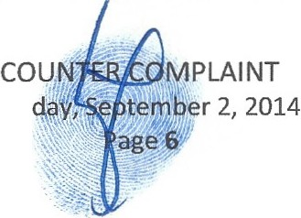
Tues

REALTY, LLC; Counsel, Registered Agent and Manager of Bernstein Holdings LLC; Counsel and Registered Agent for Bernstein Family Investments LLLP; Counsel and Trustee to Defendants, Trust f/b/o Joshua Bernstein under the Simon L. Bernstein Trust dtd 9/13/2012; Trust f/b/o Daniel Bernstein under the Simon L. Bernstein Trust dtd 9/13/2012; Trust f/b/o Jake Bernstein under the Simon L. Bernstein Trust dtd 9/13/2012.
- Counter Defendant, Gutter Chaves Josepher Rubin Forman Fleisher Miller, P.A. and all Partners Associates and of Counsel fka Tescher Gutter Chaves Josepher Rubin Ruffin & Forman , P.A. C'GC") is domiciled in Florida and was Counsel to Simon and Shirley Bernstein for Estate planning work and more prior to Donald Tescher's removal from that firm and forming Tescher & Spallina,
P.A. and where Simon's account was then transferred by Tescher, the account manager, to his new firm TSPA.
- Counter Defendant, Theodore Stuart Bernstein ("Theodore") or ("Ted"), individually, is a resident of Florida and a central defendant in all allegations contained herein.
- Counter Defendant Theodore Stuart Bernstein, as alleged Trustee of the Shirley Trust;

- Counter Defendant Theodore Bernstein as, Personal Representative of the Shirley Estate; Personal Representative and Fiduciary of the ESTATE AND WILL OF SHIRLEY BERNSTEIN (2008); alleged Successor Trustee and Fiduciary of the SIDRLEY BERNSTEIN TRUST AGREEMENT (2008); alleged Successor Trustee and Fiduciary of the SIMON L. BERNSTEIN AMENDED AND RESTATED TRUST AGREEMENT (2012); as the alleged Trustee and Fiduciary of the SIMON L. BERNSTEIN TRUST AGREEMENT (2008); as alleged Successor Trustee and Fiduciary of the MARITAL TRUST and FAMILY TRUST created by SHIRLEY BERNSTEIN TRUST (2008); as the alleged Trustee and Fiduciary of the SIMON BERNSTEIN IRREVOCABLE INSURANCE TRUST DATED 6/21/1995; as an alleged Trustee and Fiduciary of the SIMON L. BERNSTEIN IRREVOCABLE TRUST AGREEMENT (2008); as leged Manager of Bernstein Family Realty

LLC; as alleged Trustee and Fiduciary to the WILMINGTON TRUST 088949-000 SIMON L BERNSTEIN IRREVOCABLE TRUST.
- Counter Defendant, Lisa Sue Friedstein ("Lisa"), Individually, is an Illinois resident with interests in the Florida probate and trusts of Simon and Shirley.
- Counter Defendant, Jill Marla Iantoni ("Jill"), Individually. is an Illinois resident with interests in the Florida probate and trusts of Simon and Shirley.
- Counter Defendant, Pamela Beth Simon ("Pamela") or ("Pam"), individually, is a resident of Illinois and acting on behalf her daughter and herself in the Florida Probate matters of Simon and Shirley.
- Counter Defendant, Mark Manceri, Esq. ("Manceri "), personally, is a resident of Florida.

- Counter Defendant, Mark Manceri, Esq., professionally is a resident of Florida and was Counsel to, BERNSTEIN FAM1LY REALTY, LLC; Counsel to Defendants Tescher and Spallina; Counsel to Defendant Theodore Bernstein as an Individual; Counsel to Theodore Bernstein as alleged Successor Trustee of Shirley Bernstein Trust Agreement 2008; Counsel to Theodore Bernstein as Personal Representative of the Estate and Will of Shirley Bernstein; Counsel to the Estate and Will of Simon Bernstein 2012.
- Counter Defendant, Mark R. Manceri, P.A. and all Partners, Associates and of Counsel, is domiciled in Florida and acted as counsel in these matters to various parties.
- Counter Defendant, Page, Mrachek, Fitzgerald & Rose, P.A. and all Partners Associates and of Counsel ("PMFR"), is domiciled in Florida and acted as counsel in these matters to various parties.
- Counter Defendant, Alan B. Rose, Esq. ("Alan") or ("Rose"), personally , is a resident of Florida who acted as counsel to various parties in these matters.
- 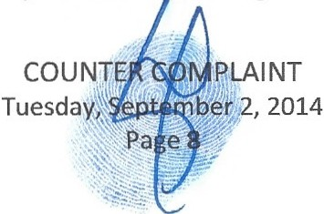Counter Defendant, Alan B. Rose, Esq., professionally, is a resident of Florida and acted as Counsel to Defendant Theodore Bernstein as an Individual ; Counsel to Theodore Bernstein as alleged Successor Trustee of the alleged Shirley Bernstein rust Agreement 2008; Counsel to Theodore

Bernstein as Personal Representative of the Estate and Will of Shirley Bernstein; Counsel to the alleged Successor Trustee Theodore Bernstein of the alleged Simon Bernstein Amended and Restated Trust (2012); Counsel to Theodore Bernstein in the Stansbury Creditor Lawsuit in various capacities of various entities named thereunder.
- Counter Defendant, Pankauski Law Firm PLLC and all Partners, Associates and of Counsel (PLW'), is domiciled in Florida and represented various parties in these matters.
- Counter Defendant, John J. Pankauski, Esq. ("Pankauski"), personally, is a resident of Florida that acted as counsel to various parties in these matters;
- Counter Defendant, John J. Pankauski, Esq., professionally, is a resident of Florida and as Counsel to Defendant Theodore Bernstein as an Individual; Counsel to Theodore Bernstein as alleged Successor Trustee of the alleged Shirley Bernstein Trust Agreement 2008; Counsel to Theodore Bernstein as Personal Representative of the Estate and Will of Shirley Bernstein; Counsel to the alleged Successor Trustee Theodore Bernstein of the alleged Simon Bernstein Amended and Restated Trust (2012).
- Counter Defendant, Kimberly Francis Moran ("Moran"), personally, is a resident of Florida who was arrested in the matters for fraudulently notarizing documents and admitted to forging documents in these matters.
- 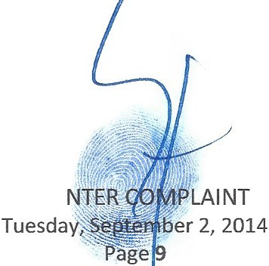Counter Defendant, Kimberly Francis Moran, professionally, is a resident of Florida and was Notary Public/Legal Assistant for Spallina & Tescher P.A. and was convicted of Felony Fraudulent Notarization in the Estate of Shirley Bernstein and admitted Forgeries, including Post Mortem Forgery of Simon's name while working and under direction of Defendants Tescher, Spallina and Tescher & Spallina, P.A. Moran has also had her N tary Public license revoked by Governor of Florida Rick Scott's Notary Public Division.

cou

- Counter Defendant, Lindsay Baxley aka Lindsay Giles ("Baxley") or ("Giles"), personally , is a resident of Florida who improperly notarized documents and was charged with such by the Florida Governor Rick Scott's Notary Public Division while working for Theodore Bernstein.
- Counter Defendant, Lindsay Baxley aka Lindsay Giles, professionally, is a resident of Florida who improperly notarized documents and was charged with such by the Florida Governor Rick Scott's Notary Public Division while working for Theodore Bernstein.
- Counter Defendant, Simon L. Bernstein Trust Agreement dated May 20, 2008 and as alleged Amended and Restated Trust Simon L, Bernstein Trust Agreement dated July 25, 2012 ("Simon Trust") is a trust established in Florida.
- Counter Defendant, Shirley Bernstein Trust Agreement dated May 20th 2008 ("Shirley Trust"), is a trust established in Florida.
- Counter Defendant, Estate of Simon Bernstein, is an estate in the State of Florida.

- Counter Defendant, Estate of Shirley Bernstein, is an estate in the State of Florida.

- Counter Defendant, SIMON L. BERNSTEIN IRREVOCABLE TRUST AGREEMENT (2008), is a Trust established in Florida by Simon and where the Beneficiaries, include but are not limited to, Eliot and/or his children or both.
- Counter Defendant, SIMON BERNSTEIN IRREVOCABLE TRUST U/A 9/7/06, is a Trust established in Florida by Simon and where the Beneficiaries, include but are not limited to, Eliot and/or his children or both.
- 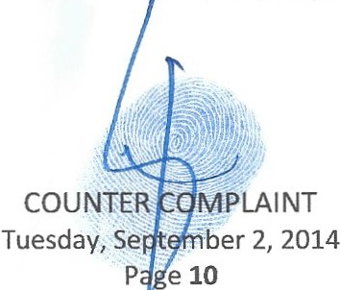Counter Defendant, SHIRLEY BERNSTEIN IRREVOCABLE TRUST U/A 9/7/06, is a Trust established in Florida by Shirley. Information is currently unavailable regarding the Trustees, etc. as it is alleged missing or destroyed and where the eneficiaries, include but are not limited to, Eliot and/or his children or both.

- Counter Defendant, SHIRLEY BERNSTEIN IRREVOCABLE TRUST AGREEMENT (2008), is a Trust established in Florida by Shirley and where the Beneficiaries are presumed to include but are not limited to, Eliot and/or his children or both. Information is currently unavailable regarding the Trustees, etc. as it is alleged missing or destroyed.
- Counter Defendant, SIMON BERNSTEIN IRREVOCABLE INSURANCE TRUST DATED 6/21/1995, is a suppressed and denied trust that is alleged missing and lost and yet a Plaintiff in a US Federal Court case and where the Beneficiaries, include but are not limited to, Eliot and/or his children or both and the Estate of Simon.
- Counter Defendant, SIMON BERNSTEIN 2000 INSURANCE TRUST (dated August 15, 2000), is a Trust established in Florida by Simon and where the Beneficiaries, include but are not limited to, Eliot and/or his children or both.
- Counter Defendant, SHIRLEY BERNSTEIN 2000 INSURANCE TRUST (DATED AUGUST 15, 2000), is a Trust established in Florida by Shirley and where the Beneficiaries, include but are not limited to, Eliot and/or his children or both.
- Counter Defendant, Trust f/b/o Joshua Bernstein under the Simon L. Bernstein Trust <ltd 9/13/2012, is a trust set up in Florida by an unknown. Information is currently unavailable regarding the Trustees, etc. as it is alleged missing or destroyed.
- Counter Defendant, Trust f/b/o Daniel Bernstein under the Simon L. Bernstein Trust dtd 9/13/2012, is a trust set up in Florida by an unknown. Information is currently unavailable regarding the Trustees, etc. as it is alleged missing or destroyed.
- 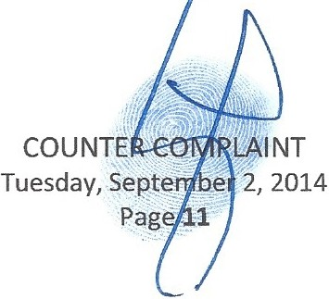Counter Defendant, Trust f/b/o Jake Bernstein under the Simon L. Bernstein Trust dtd 9/13/2012, is a trust set up in Florida by an unknown. Information is urrently unavailable regarding the Trustees, etc. as it is alleged missing or destroyed.

- Counter Defendant, ELIOT BERNSTEIN FAMJLY TRUST DATED MAY 20, 2008, is a Trust established in Florida by Shirley and Simon.
- Counter Defendant, DANIEL BERNSTEIN IRREVOCABLE TRUST DATED SEPTEMBER 7, 2006, is a Trust established in Florida by Shirley and Simon.
- Counter Defendant, JAKE BERNSTEIN IRREVOCABLE TRUST DATED SEPTEMBER 7, 2006, is a Trust established in Florida by Shirley and Simon.
- Counter Defendant, JOSHUA Z. BERNSTEIN IRREVOCABLE TRUST DATED SEPTEMBER 7, 2006, is a Trust established in Florida by Shirley and Simon.
- Counter Defendant, DANIEL BERNSTEIN IRREVOCABLE TRUST 07-JUL-10 049738, is a Trust established in Florida by Shirley and Simon.
- Counter Defendant, JAKE BERNSTEIN IRREVOCABLE TRUST 07-JUL-10 0497381, is a Trust established in Florida by Shirley and Simon.
- . Counter Defendant, JOSHUA Z BERNSTEIN IRREVOCABLE TRUST 07-JUL-10 0497381, is a

Trust established in Florida by Shirley and Simon.

- Counter Defendants, JOHN AND JANE DOE 1-5000, are John and Jane Doe.

- Material and Fact Witness - Judge Martin Colin, personally and professionally , where certain Felony crimes occurred in and upon the Court of Judge Colin and were committed by Officers and Fiduciaries of his Court.
- Material and Fact Witness -Judge David French, personally and professionally, where certain Felony crimes occurred in and upon the Court of Judge French and were committed by Officers and Fiduciaries of his Court.
- Jurisdiction and venue are proper in Palm Beach County, Florida because the beneficiaries of the trusts reside here or have interests in the trusts in Florida, the trusts were allegedly created in Florida, the corporate entities are domiciled here and/or o business in the State of Florida.
COUN MPLAINT
'J.1)
Tuesda ;Se tber 2, 2014
:· e
12

BACKGROUND SPECIFIC TO THIS CASE

- That Eliot states that the Trustees complaint uses language from documents that are already challenged in the Court and need to be forensically analyzed for further evidence of fraud. All language cited from any alleged trusts is now speculative. Where it is alleged that Simon did not amend and restate his 2008 Will and Simon Trust in 2012 and that these documents were done Post Mortem and are all fraudulent, forged, improperly notarized and improperly constructed to commit fraud.
- That all documents executed allegedly by Simon in 2012 to change anything with Shirley's 2008 Will and Shirley Trust are further fraudulent and forged documents and legally invalid.
- That until this Court can determine the dispositive documents to use forward due to the fraud and forgeries and more, any language cited from any of the wills or trusts of both Simon and Shirley cannot be relied on without disclaimer that identifies the fact that these documents all must be analyzed and reviewed forensically for further evidence of fraud, before any language can be accepted as legally valid.
- That as of this date, Eliot has been refused to see or inspect the original dispositive documents in the estates and trusts of Simon and Shirley, in violation of Probate and Trust Rules and Statutes.
- That Eliot hereby incorporates all statements made in his Answer to this complaint, all pleading made in the Oppenheimer v. Candice and Eliot Bernstein lawsuit before Hon. Judge Colin and all prior pleadings in the Probate cases of Simon and Shirley before Hon. Judge Colin and Hon. Judge David French pending hearings, all are hereby incorporated by reference herein.
- That this Court is in part the SCENE OF THE CRIME, as the fraudulent and forged documents were posited with this Court, by Officers of this Court, Tescher and Spallina by their law firm TSPA, which enabled the illegal seizure of Dominion and ontrol of the Estates and Trusts of both Simon
and Shirley.

,LAINT
0
".:_.- er 2, 2014
13

- That a highly sophisticated legal process abuse scheme was committed by the fiduciaries and counsel to the fiduciaries (including certain of the fiduciaries acting as their own counsel) committing felony acts while acting as Fiduciaries and Officers of this Court to illegally seize Dominion and Control of the Estates and Trust of Simon and Shirley.
- That Simon and Shirley Bernstein had a net worth between 40-100 million dollars.

- That these crimes, include but are far from limited to, proven Frauds on the Court, alleged Fraud on a Federal Court, proven Frauds on the Beneficiaries, proven Fraudulent Notarizations, Admitted Forgery of six persons including Simon POST MORTEM, admitted fraudulent alteration of a Shirley Trust document POST MORTEM, Creditor Fraud, Bank Fraud, Insurance Fraud, Theft of Assets, Identity Theft of a dead person and more.
- That all the crimes listed above were committed primarily by Fiduciaries and Attorneys as Law, all acting as Officers of this Court, all who proceeded to then use the fraudulent and forged documents to commit Fraud on the Court and Fraud on the beneficiaries . These crimes included using Simon as an acting PR/Executor while he was dead for several months to close his wife Shirley's Estate illegally.
- That Simon was used while DEAD to submit false instruments to this Court filed by TSPA, as they needed to make it look like Simon closed his deceased wife Shirley's Estate and made changes to he and Shirley's Estates and Trusts while alive.
- That Simon died on September 13, 2012 and at that time was the PR/Executor of Shirley's Estate and Trustee of the Shirley Trust.
- 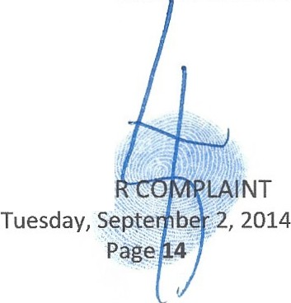That Simon submitted documents to the Court as if alive from the date he died until January 2013 when Shirley's Estate was illegally closed by a dead R/Executor.
COUNTE ·

- That after Simon died no Successor PR/Executor was appointed for Shirley's Estate as it appeared Simon had closed the Shirley Estate while alive and died after so doing, which is untrue, Simon died before closing Shirley's Estate.
- That after Simon died no Successor Trustee was appointed for the Shirley Trust, as it appeared Simon had closed the Shirley Estate while alive and died after so doing, which is untrue, Simon died before closing Shirley's Estate.
- That documents were fraudulently notarized for Simon POST MORTEM.

- That documents were fraudulently notarized for five of Simon's children.

- That documents were forged for Simon Post Mortem.

- That documents were forged for five of Simon's children.

- That documents were admitted fraudulently altered in the Shirley Bernstein Trust.

- That when Shirley Bernstein passed her Shirley Trust became irrevocable.

- That when Shirley Bernstein passed the beneficiaries of the Shirley Trust were Eliot, Jill and Lisa and their lineal descendants through Family Trusts created for them thereunder.
- That Theodore and Pamela and their lineal descendant are disinherited entirely and considered predeceased for all purposes of Simon and Shirley's Trusts and distributions made thereunder.
- That Theodore and Pamela and their lineal descendants are disinherited entirely and considered predeceased for all purposes of the 2008 Simon Trust and distributions made thereunder.
- That Theodore and Pamela and their lineal descendants are disinherited entirely and considered predeceased for all purposes of the alleged 2012 Amended and Restated Simon Trust and distributions made thereunder.
- 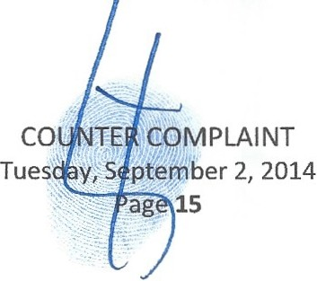That Theodore and Pamela and their lineal descendants are disinherited entirely and considered predeceased for all purposes of the alleged 200 Shirley Trust and distributions made thereunder.

- The Simon L. Bernstein Amended and Restated Trust is alleged to have been amended from the Simon L. Bernstein Trust dated May 20, 2012 and was amended improperly and improperly notarized approximately 48 days prior to Simon's unexpected and sudden death.
- That the alleged Shirley Trust states,

ARTICLE III. GENERAL

  - Definitions. In this Agreement,
    - Children, Lineal Descendants. The terms "child," "children" and "lineal descendant" mean only persons whose relationship to the ancestor designated is created entirely by or through (a) legitimate births occurring during the marriage of the joint biological parents to each other, (b) children and their lineal descendants arising from surrogate births and/or third party donors when (i) the child is raised from or near the time of birth by a married couple (other than a same sex married couple) through the pendency of such marriage, (ii) one of such couple is the designated ancestor, and (iii) to the best knowledge of the Trustee both members of such couple participated in the decision to have such child, and (c) lawful adoptions of minors under the age of twelve years. No such child or lineal descendant loses his or her status as such through adoption by another person.
Notwithstanding the foregoing, a s have adequately provided for them during my lifetime, for purposes of the dispositions made under this Trust, my children, TED S. BERNSTEIN ("TED") and PAMELA B. SIMON ("PAM"),and their respective lineal descendants shall be deemed to have predeceased the survivor of my spouse and me, provided, [emphasis added] however, if my children, ELIOT BERNSTEIN, JlLL !ANTONI and LISA S.
FRIEDSTEIN, and their lineal descendants all predecease the survivor of my spouse and me, then TED and PAM, and their
respective lineal descendants shall not be deemed to have predeceased me and shall be eligible beneficiaries for purposes of the dispositions made hereunder.

- That the alleged Simon Trust states,

ALLEGED ORIGINAL 2008 SIMON L. BERNSTEIN TRUST AGREEMENT

ARTICLE I. DURING MY LIFE AND UPON MY DEATH
A. Rights Reserved. I reserve the right (a) to add property to this trust during my life or on my death, by my Will or otherwise; (b) to withdraw property held hereunder; and (c) by separate written instrument delivered to the rustee, to revoke this Agreement in

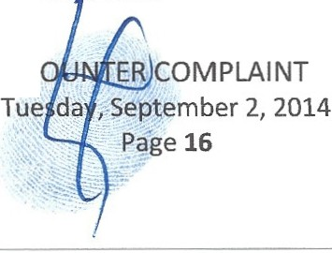
c

whole or in part and otherwise modify or amend this Agreement. However, after my spouse's death I may not exercise any of said rights with respect to property added by my spouse upon my spouse's death by my spouse's Will or otherwise. [emphasis added).

- That the alleged 2012 Amended and Restated Simon L. Bernstein Trust Agreement states,

ALLEGED 2012 AMENDED AND RESTATED SIMON L. BERNSTEIN TRUST AGREEMENT

ARTICLE I. DURING MY LIFE AND UPON MY DEATH
A Rights Reserved. I reserve the right (a) to add property to this trust during my life or on my death, by my Will or otherwise; (b) to withdraw property held hereunder ; and (c) by separate written instrument delivered to the Trustee, to revoke this Agreement in whole or in part and otherwise modify or amend this Agreement.

[NOTE LANGUAGE FROM 2008 SJMON TRUST REMOVED]

- That Simon could not by the 2008 Simon Trust to revoke this 2008 Simon Trust Agreement in whole or in part and otherwise modify or amend the Simon Trust Agreement after Shirley's death with respect to property added by Shirley upon Shirley's death by Shirley's Will or otherwise and could not amend or change the Shirley Trust.
- That through the 2012 Amended and Restated Simon Trust Agreement, attempts are made to modify and amend the 2008 Simon Trust with respect to property added by Shirley upon Shirley's death.
- That Eliot through trusts already established in his family's name is a beneficiary of l/3rd of the 2008 Shirley Trust.
- That Eliot is a l/3rd beneficiary through a Family Trust in his name of the 2008 Simon Trust.

- 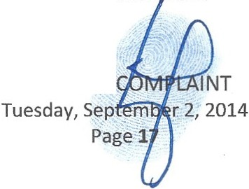That if the alleged 2012 documents do not survive and the 2008 Simon Trust prevails, which there is already evidence of fraud, improper construction, proven improper notarizations and more and there is new evidence now indicating they were procured to knowingly commit fraud by the fiduciaries and officers of this Court and this would legally invalidate hem.

- That if the 2012 alleged Simon Trust and Will fail are legally invalidated, Eliot is a I/3rd beneficiary of the Simon Trust and the Shirley Trust both dated May 20, 2008.
- That in a May 2012 meeting Eliot was asked by Simon if he would be willing to give up his 113rd interests in Simon and Shirley's Estate and Trusts and transfer Eliot's interests to Simon's 10 grandchildren.
- That there were disputes and issues that Theodore and Pamela had with Simon and Shirley having disinherited them and their lineal descendants that were discussed in the May 2012 meeting and if Simon, Eliot, Jill and Lisa choose to later execute upon the contemplated changes these disputes were agreed to come to an end.
- That after the May 20, 2012 meeting Eliot requested documents from Tescher and Spallina and stated he would in no way do anything with transferring his interests until seeing what interests he was giving up and what the terms, tax and other consequences would be for he and his family and if the arrangement agreed to in principle was legally possible.
- That Eliot to date, despite repeated requests of the former and current alleged fiduciaries for accountings of his interests, has never received the accounting of his interests asked for in the May 2012 meeting and in multiple written requests since that time in violation of Probate and Trust Rules and Statutes.
- That Eliot to date, despite repeated requests to the former and current alleged fiduciaries has not received complete dispositive documents in the Estates and Trusts of Shirley and Simon with all Schedules, Addendums and any other attachments affixed and has been further refused inspection of the original documents.
- 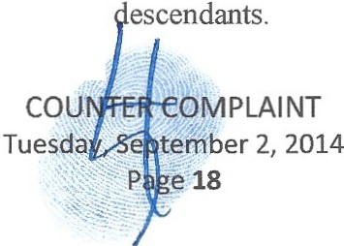That Simon did not have the right to change the beneficiary class of the Shirley Trust as the Trust became irrevocable with Eliot, Jill and Lisa beneficiaries only through Family Trusts created exclusively and only for them and their lineal

- Shirley and Simon's wishes and intents were drafted together and stated in their 2008 Wills and Trust documents for them with clear desires to wholly disinherit Theodore, Pamela and their lineal descendants and considered them predeceased for all purposes of their trusts and distributions made thereunder for compensation they already received while Simon and Shirley were alive.
- That in the 2008 Shirley Trust and 2008 Simon Trust, Theodore, Pamela and their lineal descendants are referred to as having been adequately provided for during their lifetimes.
--
lOO. ,That Theodore and Pamela in the May 2012 meeting with Simon agreed that if Simon were

' t .'fo an:e his estate plans legally they would cease their disputes, harassment and extortion of Simon to force him to make changes and allow him to see his grandchildren again.
- That this relief from abuse was all Theodore and Pamela were asked to give up in the May 20, 2012 meeting, as they had nothing to give up in either the Simon Trust or Shirley Trust as they were wholly disinherited and had no beneficial or other interest in the 2008 Simon and Shirley Trusts.
- That the disputes between Theodore and Pamela with Simon did not cease until the day Simon died. In fact, the disputes and hostilities grew worse after the May 20, 2012 meeting, as Simon never expressed any desire to make any changes again or did anything to make changes to he and Shirley's estate plans.
- That Simon never asked Eliot again to consider giving up his interests in he and Shirley's Estates and Trusts to benefit Theodore and Pamela's family in order to cease the elder abuse against him.
- The elder abuse of having his grandchildren held hostage to either make changes and concede to demands by four of his five children continued until the day he died. These disputes and issues grew over the refusal of Simon to make estate plan changes to reinsert Theodore and Pamela's lineal descendants only back into the estate plans, as discussed in the May 20, 2012 meeting.
- 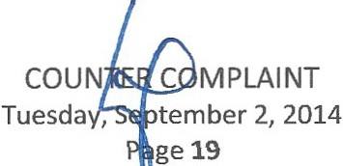That Simon also refused to stop seeing his girlfriend to the day he died, Maritza Puccio Rivera, and, Theodore, Pamela, Jill and Lisa continued to us their children as pawns withholding them from him

to persuade Simon to give in to their demands to stop seeing her or never see four of his five children and seven of his ten grandchildren again.
- That the May 2012 meeting was called for by Simon to end disputes with his four other children, other than Eliot whom he had no disputes with and who was not extorting him to do anything and never withheld his children from him for any reason whatsoever.
- That Spallina and Tescher drafted the alleged 2012 Will and Amended and Restated Trust of Simon, Spallina witnessed the document and Spallina and Tescher named themselves as Co-Personal Representatives and Co-Trustees.
- That Spallina represented as counsel he and Tescher as Co-Personal Representatives and Co-Trustees of the alleged 2012 Will and Amended and Restated Trust of Simon.
- That Spallina represented Theodore as counsel in his role as alleged Successor PR and alleged Successor Trustee of the Shirley Bernstein Estate and Shirley Trust.
- The alleged 2012 dispositive documents of Simon gave Spallina and Tescher fiducial and legal powers in the Estate and Trusts of Simon and therefore direct interests and financial gains via their alleged roles as Co-PR/Executors, Co-Trustees and Counsel to themselves as fiduciaries.
- That Tescher and Spallina through their law firm TSPA billed the Estate and Trusts for time worked to forge, fraudulently notarize and fraudulently alter trust documents in the Estates and Trusts of Simon and Shirley.
- That the alleged 2012 dispositive documents of Simon were witnessed by Kimberly Moran and Robert Spallina who have both now admitted to fraudulently altering documents in these matters.
- That Kimberly Moran worked as a Legal Assistant and Notary Public while employed by Tescher &

Spallina, P.A.

- 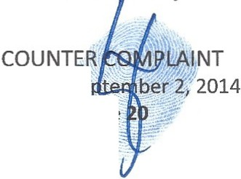That fraudulently notarized documents and forged documents crafted by Moran were posited by Tescher & Spallina, P.A. with the Probate Court in hirley's Estate on behalf of Simon who was
-:-·.:.:·
Tuesday,Se
Ha
-_

g |  | -
.... |  | ... -

acting as the PR/Executor (Spallina his counsel as PR/Executor) at the time while Simon was dead at the time the documents were posited with the Court.
- That Theodore, Spallina and Manceri were told by Judge Martin Colin in a September 13, 2013 hearing, one year after Simon died, that when he discovered that Simon was dead at the time he was alleged to be serving closing documents with Court that he had enough to read them their Miranda Rights. Judge Colin reiterated this later in the hearing to Theodore and Spallina.
- The alleged 2012 alleged Simon Will and alleged Amend and Restated Simon Trust documents were improperly notarized by Lindsay Baxley who works as Theodore's assistant, as determined by Governor Rick Scott's Notary Public Division for failing to state if Simon was present when the documents were notarized in his name.
117. That Moran was arrested and convicted for fraudulently notarizing a document and admitted to fraudulently notarizing six documents for six separate parties, including one for Simon Post Mortem and these false instruments were posited with this Court by Tescher & Spallina, P.A. on behalf of their client Simon as PR/Executor after Simon had died.
- That for three to four months after died Simon was used by Spallina and Tescher as if he were alive to submit closing documents for Shirley's Estate and then closed the Estate of Shirley with a dead PR/Executor in violation of law.
- That Moran admitted to Palm Beach County Sheriff Investigators that she forged six documents for six separate parties, including a Post Mortem forgery for Simon and these false instruments were posited with this Court by Tescher & Spallina, P.A.
- That Alan Rose is a Respondent in the probate Estate cases of both Simon and Shirley.

- That Alan Rose is a Counter Defendant in the Oppenheimer v. Candice and Eliot lawsuit before this Court.
- That Theodore Bernstein is a Respondent in the rebate Estate cases of both Simon and Shirley.

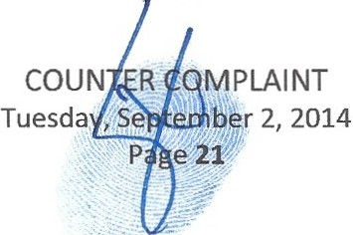

- That Theodore Bernstein is a Counter Defendant in the Oppenheimer v. Candice and Eliot lawsuit before this Court.
- That Robert Spallina, Esq. is a Respondent in the probate Estate cases of both Simon and Shirley.

- That Robert Spallina, Esq. is a Counter Defendant in the Oppenheimer v. Candice and Eliot lawsuit before this Court.
- That Donald Tescher, Esq. is a Respondent in the probate Estate cases of both Simon and Shirley.

- That Donald Tescher, Esq. is a Counter Defendant in the Oppenheimer v. Candice and Eliot lawsuit before this Court.
- That on or about January 2013, Lisa and Jill were notified that there were forged and fraudulent documents in the Estate of Shirley in their name and their deceased father's name.
- That on or about May 2013, Theodore, Pamela, Spallina, Tescher, Lisa and Jill were all notified that there were forged and fraudulent documents in the Estate of Shirley in Theodore, Pamela, Lisa, Jill, Eliot and their deceased father's name through a pleading filed by Eliot in the Probate cases of both Simon and Shirley.
- That these fraudulent acts attempt to change beneficiaries in the Shirley Trust and the Simon Trust illegally through committing multiple, separate and distinct Frauds on this Court and the beneficiaries, achieved by advancing fraudulent and forged instruments to various parties to commit various frauds and these acts were perpetrated primarily by Counter Defendants, Tescher, Spallina, Tescher & Spallina, P.A., Moran, Baxley, Rose, Pankauski, Manceri, Theodore, Pamela and others acting either separately or in various combinations in conspiracy to commit fraud and more.
- 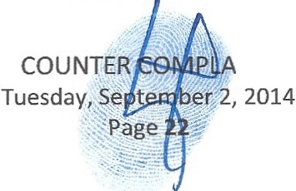That Robert Spallina has admitted to Palm Beach County Sheriff Investigators that he fraudulently altered a trust document of the Shirley Trust after consulting with Donald Tescher about what to do to attempt to make changes to the IRREVOCABLE Shirley Trust beneficiary class. This alteration was necessary as the Shirley Trust was irrevocable d Simon was also prohibited from making
INT

changes to the Shirley Trust beneficiary class and so Spallina alleges to PBSO investigators that he took it upon himself to alter a trust document to achieve what he and Tescher knew was legally impossible and fraudulent.
- That distributions were made in the Shirley Trust to improper parties as the only beneficiaries of Shirley's Trust are Eliot, Lisa and Jill through Family Trusts created under the Shirley Trust for the benefit of them and their lineal descendants only, despite any efforts Simon may or may not have made to change the beneficiary class, he was prohibited from any such changes and thus would have been committing a fraud by changing them after Shirley's death.
- That Spallina and Tescher have resigned and withdrawn due to their fraudulent activities that have now caused intentional delays with Eliot's inheritance and interfered and delayed distributions for now almost two years by their attempt to feloniously change beneficiaries to benefit Theodore and Pamela who without the fraudulent acts would receive nothing in the Simon Trust and Shirley Trust.
- That Theodore introduced Tescher and Spallina to Simon and the Bernstein family as Theodore was doing business with them and was a close personal friend with Tescher primarily and Spallina.
- That Tescher was the main partner on the Bernstein family matters and worked closely with his partner Spallina on virtually all documents and issues relating to the Bernstein family matters.
- That Theodore Bernstein was asked by Eliot Bernstein to contact the FBI in relation to his having been the last party to take possession of Eliot's car and having it towed to where it was blown up and blew up three cars next to it in what is alleged to have been an attempted murder of Eliot and his family, see www.1viewit.tv for graphic images.
- 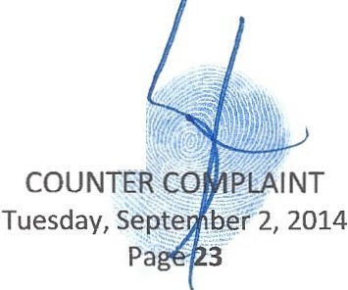That Theodore is adverse to Eliot as Eliot has alleged that Theodore worked with defendants in a RICO and ANTITRUST lawsuit Eliot filed, against 'nterests in companies and intellectual properties owned by Simon and Eliot.
·'

- That Theodore works closely with several of the defendants in the RICO that Eliot alleges have stolen intellectual properties owned by Eliot and Simon, including the law firms of Greenberg Traurig, Proskauer Rose LLP, Albert Gortz, Esq. and Gerald Lewin, CPA., four of the primary suspects in orchestrating the original IP thefts.
- This case is related to ALL of the following ongoing actions2 worldwide involving Eliot Bernstein

where there are claims of civil and criminal conspiracy, including RICO, where the main predicate acts are committed by Attorneys at Law in each separate action.
- That Eliot's RICO and ANTITRUST lawsuit is legally related to a New York Supreme Court Disciplinary Department Attorney at Law Whistleblower Lawsuit of Christine C. Anderson, Esq.
- That shockingly there are many links in each of the lawsuits to the same Attorneys at Law as in the initial RICO, acting in various combinations in each case, including the instant action, in efforts to harm Eliot and his family, including a massive amount of legal process abuse and crimes committed in and upon the Courts involved in these cases. That the lawsuits, include but are not limited to:
t. UNITED STATES DISTRICT COURT SOUTHERN DISTRICT OF NEW YORK, ELIOT I. BERNSTEIN, et al., Plaintiffs, - against - APPELLATE DIVISION FIRST DEPARTMENT DISCIPLINARY C01\1MITTEE, et al., Defendants. Case No. 07 Civ. 11196 (SAS), Honorable Judge SHIRA A. SCHEINDLIN, US.DJ. (HEREBY FULLY INCORPORATED BY REFERENCE IN ENTIRETY HEREIN, ALL PLEADINGS, ORDERS, ETC.) (TO BE PETITIONED TO REOPEN BASED UPON FRAUD ON THE COURT AND OBSTRUCTION RECENTLY DISCOVERED).
11. SIMON BERNSTEIN ESTATE PROBATE CASE IN THE CIRCUIT COURT FOR PALM BEACH COUNTY, FL ESTATE OF SIMON LEON BERNSTEIN CASE NO. 502012CP004391 IZ XXXX SB (HEREBY FULLY INCORPORATED BY REFERENCE IN ENTIRETY HEREIN, ALL PLEADINGS, ORDERS, ETC.).
m. SHIRLEY BERNSTEIN ESTATE PROBATE CASE IN THE CIRCUIT COURT FOR PALM BEACH COUNTY, FL ESTATE OF SHIRLEY BERNSTEIN CASE NO.
502011CP00653:XXXXSB (HEREBY FULLY INCORPORATED BY REFERENCE IN ENTIRETY HEREIN, ALL PLEADINGS, ORDERS, ETC.).
- IN THE UNITED STATES DISTRICT CODRT FOR THE NORTHERN DISTRICT OF ILLINOIS EASTERN DIVISION, Case No. 13cv3643, before the Hon. Judge Amy St.

2 The estate and trust cases all should be related legally related by the Court but appear not yet related and Eliot is asking this Court to do so in the administration of justic and to save costs.


PLAINT
""" o,-·

Eve (HEREBY FULLY INCORPORATED BY REFERENCE IN ENTIRETY HEREIN,
ALL PLEADINGS, ORDERS, ETC.)3
- OPPENHEIMER V CANDICE AND ELIOT BERNSTEIN CASE NO. 502014CP002815XXXXSB
- IN THE CIRCUIT COURT OF THE FIFTEENTH JUDICIAL CIRCUIT IN AND FOR PALM BEACH COUNTY, FLORIDA, CASE NO. CA 01-04671 AB, PROSKAUER ROSE LLP, A NEW YORK LIMITED LIABILITY PARTNERSHIP, PLAINTIFF, VS. IVIEWIT.COM, INC., A DELAWARE CORPORATION, IVIEWIT HOLDINGS, INC., A DELAWARE CORPORATION, AND IVIEWIT TECHNOLOGIES, INC., A DELAWARE CORPORATION, DEFENDANT . (To be petitioned to reopen based upon fraud on the court and obstruction recently discovered.)
vn. OBSIDIAN FINANCE GROUP, LLC ET AL. V. COX CASE NO. 3:11-CV-00057-HZ. (HEREBY FULLY INCORPORATED BY REFERENCE IN ENTIRETY HEREIN, ALL
PLEADINGS, ORDERS, ETC.). (Note Bernstein is not a Defendant but was tried to be added as a Defendant after the case was heard).
vm. RANDAZZA ET AL V. COX, BERNSTEIN ET AL., CASE NO. 2:12-CV-02040 -GMN­ pAL. (HEREBY FULLY INCORPORATED BY REFERENCE IN ENTIRETY HEREIN, ALL PLEADINGS, ORDERS, ETC.)
ix. COX VS. RANDAZZA, ET AL. - NEVADA RICO CASE NO. 2: 13-CV-00297-JCM­ VCF CHANGED TO 2:13-CV-00297 JCM (NJK) CHANGED TO 2:13-CV-00297 MMD-VCF. (HEREBY FULLY INCORPORATED BY REFERENCE IN ENTIRETY HEREIN, ALL PLEADINGS, ORDERS, ETC.)
x. MARC J. RANDAZZA ET AL. V GODADDY, LLC ET AL. ISSUED BY THE Miarni­ DADE COUNTY, FLORIDA 11TH JUDICIAL CIRCUIT COURT, CIVIL ACTION NO.
2014-5636-CA. (HEREBY FULLY INCORPORATED BY REFERENCE IN ENTIRETY HEREIN, ALL PLEADINGS, ORDERS, ETC.)

- That Tescher, Spallina, Moran, Theodore, Manceri, Pamela, Baxley and others are all under INVESTIGATION with Palm Beach County Sheriff Office ("PBSO") detectives.
- That Moran and Baxley were investigated and found guilty of various Notary violations in these matters by Florida's Governor Rick Scott's Notary Public Division. Allegations investigated were for Fraud, Fraudulent Notarizations, Forgery and other crimes, instigated by Eliot and Candice in relation to criminal acts4 talcing place in the Estates and Trusts of Simon and Shirley with both state and federal civil and criminal authorities.

3 Where the Estate of Simon was recently allowed to intervene in the II.case as it directly relates to the Estate of Simon. The Estate was not previously represented in the case by the former PR's of the Estate Tescher and Spallina, who actually represented Theodore in direct opposition to the Estate beneficiaries and aided and abetted him in committing Insurance Fraud and Fraud on a US Federal ourt.
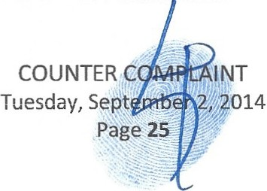4

- That Spallina filed an insurance death benefit claim form with Heritage Union Life acting as the Trustee of a what he and others claim is a lost "SIM:ON BERNSTEIN IRREVOCABLE INSURANCE TRUST DATED 6/21/1995" that no executed copies have been produced for and that he claimed never to have seen or possessed.
- That Spallina's fraudulent death benefit claim was denied for good and just cause by the insurance carrier for failure to produce a qualified legal beneficiary and more.
- That Theodore Bernstein filed a Breach of Contract lawsuit in an Illinois Circuit Court that was moved to an Illinois Federal Court for Heritage's Union's failure to pay the fraudulent death claim filed by Spallina, acting as the Plaintiff in that lawsuit with direct conflicting interests with the Estate of Simon and Simon Trust beneficiaries, including his own children, as Theodore is trying to extract the proceeds of policy to himself directly versus the Estate of Simon beneficiari es.
- The Theodore is the alleged "Trustee" for the missing "SIM:ON BERNSTEIN IRREVOCABLE INSURANCE TRUST DATED 6/21/1995" a document he claims not to possess or to have ever seen
  - Palm Beach County Sheriff Report - Case No. 12121312 -Alleged Murder of Simon Bernstein filed by Theodore Bernstein
- Palm Beach County Sheriff Report - Case No. 13097087 - Forgery and Fraudulent Notarizations
- Palm Beach County Sheriff Report - Case No. 13159967 - Theft of Assets of Estates
- Palm Beach County Sheriff Report - Case No. 14029489 - Continuation of Fraud,Extortion and more.
  - PBSO REPORTS @ http://www.i viewit.tv/Sheriff Reports.pdf
- State Attorney FL -- Case No. 13CF010745 - Forgery and Fraudulent Notarizations
- Jacksonville, IL. Police Department - Case No.#2014000865 - Insurance Fraud - Directed to Federal Authorities.
- Case No. 13-cv-03643 United States District Court - Northern District II.
- Florida Probate Simon - Case No. 502012CP004391XXXXSB
- Florida Probate Shirley - Case No. 502011CP000653XXXXSB
- Heritage Union Fraud Investigation - Case No.TBD
- Florida Medical Examiner - Autopsy Case No. 12-0913 - Filed by Theodore Bernstein
- Governor Rick Scott Notary Public Division - Moran - Case No. Eliot and Simon Bernstein v. Moran
  - http: jwww.iviewit.tv/Simon and Shirley
Estate/20131014%200ffice%20of<>Ai20the%20Governor%20Moran %20Suspension%20of<>Ai20Notary.p df
- Governor Rick Scott Notary Public Division - Baxley - Case No. Eliot and Simon Bernstein v. Baxley
  - 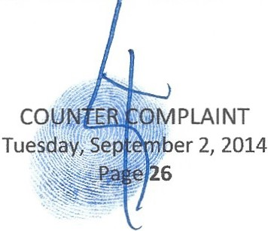htt : www.iviewit.tv Simon and Shirle Estate 20140421 Office Of Governor Lindsa Baxie Comp l aint Misconduct.pdf

an executed copy, along with his counsel Tescher and Spallina who also claim never to have possessed or seen the nonexistent trust.
- That Spallina had in his possession an alleged 2000 insurance trust, titled "SIMON BERNSTEIN 2000 INSURANCE TRUST (dated August 15, 2000) allegedly done by Simon with Proskauer Rose LLP that would have made legally void any 1995 prior insurance trust claimed to be the beneficiary by Spallina as the 2000 insurance trust specified the Heritage Union Life missing policy.
- That the alleged SIMON BERNSTEIN 2000 INSURANCE TRUST (dated August 15, 2000) was secreted from the insurance company, this Court, the Federal Court involved in the Breach of Contract litigation and the beneficiaries by Spallina, Tescher, Theodore and Pamela.
- That the SIMON BERNSTEIN 2000 INSURANCE TRUST (dated August 15, 2000) until it was discovered in the production documents Spallina and Tescher were forced to turn over by this Court's Order to the Curator Benjamin Brown, Esq. upon their removal and withdrawal.
- That the discovery in 2014, almost two years after Spallina filed his fraudulent claim on behalf of the 1995 lost trust and Theodore filed his lawsuit on behalf of the 1995 lost trust, also came with evidence that conspiratorial efforts were made in writing by Tescher, Spallina, Theodore and Pamela
to hide the document, while advancing a claim that would get Pamela money, as the 2000 insurance trust had her already disinherited therein.
- That Theodore Bernstein filed the Breach of Contract lawsuit claiming he was the alleged "Trustee" of the lost 1995 trust after Spallina's filed a claim only months earlier stating that he was the
''Trustee" of the 1995 insurance trust.

- 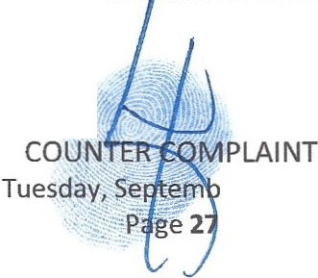That Theodore was advised by his Counsel Spallina allegedly that he had no basis to file the Breach of Contract Lawsuit as the alleged "Trustee" of a nonexistent trust and yet Theodore ignored the advice of counsel and went ahead with filing the aseless Breach of Contract lawsuit.
er 2, 2014

- That Theodore's brother-in-law David Simon and his brother Adam Simon through their law firm housed in Pamela's company then replaced Spallina as Theodore's counsel in the Illinois Breach of Contract Lawsuit.
- That Tescher and Spallina were sent multiple correspondences from Heritage Union Life addressed to them as the Trustee of the LaSalle National Trust, N.A. in regard to the Heritage Union Life policy.
- That NO executed copies of this alleged "SIMON BERNSTEIN IRREVOCABLE INSURANCE TRUST DATED 6/21/1995"and Theodore like Spallina claims to have never seen or possessed this lost trust.
- That after the insurance death benefit claim was denied, Theodore upon filing his Breach of Contract lawsuit and replaced his former counsel Spallina as the alleged Trustee of this lost and missing "SIMON BERNSTEIN IRREVOCABLE INSURANCE TRUST DATED 6/21/1995" that neither he nor his Attorneys at Law, Spallina and Tescher claim to have ever seen or have any proof that it factually exists or any idea of what the executed document states.
- That while representing Theodore initially in the Breach of Contract matters, Spallina and Tescher, were also simultaneously representing the Estate and Trust of Simon at the time as Co-PR's, Co­ Trustees and Counsel to the Co-PR's and Co-Trustees and had fiducial duties to the Estate.
- That if no beneficiary can be found at the time of death, Florida statutes state the death benefit will go to the Estate.
- 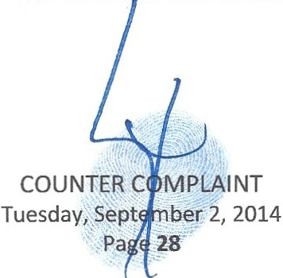That once the Breach of Contract lawsuit was filed by Theodore, acting as Trustee of the lost "SIMON BERNSTEIN IRREVOCABLE INSURANCE TRUST DATED 6/21/1995", Spallina and Tescher, while knowing of the lawsuit, failed to i ervene on behalf of the Estate of Simon's interests in the policy.

- That instead of representing the Estate in the Breach of Contract lawsuit, Spallina and Tescher aided and abetted Theodore and three of his four siblings (Pamela, Lisa and Jill) in their attempt to fraudulently move the insurance policy out of the Estate that was allegedly OWNED by Simon and thereby have the proceeds paid to themselves directly in equal shares, to the detriment of the Estate and Estate beneficiaries, who they claim are their own children.
- That acting as Trustees and Guardians for their children in the Estate of Simon matters, when filing their Breach of Contract Lawsuit to get the benefits transferred to themselves, Theodore, Pamela, Jill and Lisa failed to get counsel for their children, necessary to protect their alleged interests in the policy and this set up a classic conflict interest. Even after knowing that if the lost trust does not legally exist and could not secure the insurance proceeds, the Estate and hence their children would allegedly get the proceeds or Eliot, Lisa and Jill would get them if the 2012 alleged Amended and Restated Simon Trust documents are found legally invalid.
- That if the Breach of Contract Lawsuit is successful Theodore and Pamela would receive 2/5th of the insurance policy proceeds and the amount of the death benefit currently is an unknown, as the policy is also missing and lost as claimed by Spallina, Tescher, Theodore, Pamela and even claimed lost by the insurance carrier.
- That if the Breach of Contract Lawsuit is unsuccessful, and the policy proceeds instead are paid to the Estate, which owns the policy allegedly, Theodore and Pamela would receive NOTHING as they have been disinherited and their children may receive nothing or 4/10th of it.
- That Theodore sold a condominium and signed tax forms as the Personal Representative in the process, prior to this Court having issued him Letters.
- 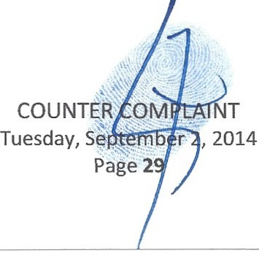That Theodore failed to properly notify beneficiaries that he was allegedly the Successor Trustee of the Shirley Trust timely and also failed to follow Trust ules and Statutes by failing to send complete

Shirley Trust documents with all Schedules and Addendums and other attachments requested with his acceptance.
- That upon his alleged acceptance Theodore failed to file accountings and NO final accounting was ever submitted by Simon to the Court prior to Theodore claiming to be Successor Trustee to Simon and Theodore failed to file any Accounting in the two years since he has alleged himself to be the Successor Trustee in violation of Trust Rules and Statutes.
- That Simon never transferred the role of PR to Theodore as the Estate was closed by Simon while dead.
- That had Tescher and Spallina notified the Court that Simon was dead prior to Simon closing

Shirley's Estate while he was dead, a Successor would have been appointed to have closed the Estate legally.
- That the Estate of Shirley was closed illegally, which led to it being reopened and remains reopened as of the date of this Counter Complaint filing with the Court.
- That Robert Spallina and Donald Tescher informed Eliot and others the day Simon died that Theodore was going to be the Successor Trustee and PR/Executor of the Estate and Trusts of Shirley because he was the oldest living child and that was the law in Florida.
- That later on the day Simon died after learning of this, Eliot challenged the anointment of Theodore as Successor Trustee and PR/Executor of Shirley's Estate and Trusts.
- That Spallina and Tescher then stated they just discovered documents, the 2008 Will and Shirley Trust that actually named Theodore as the Successor Trustee and Successor PR/Executor, contradicting their prior claims that Theodore was only a uccessor because he was the oldest living

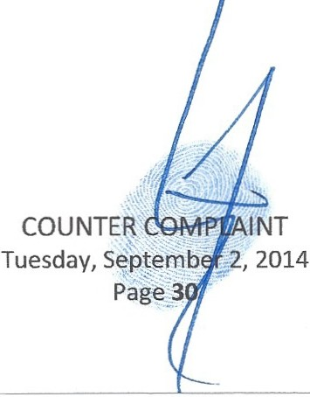
child.

- That Eliot asked for copies of all dispositive documents to inspect for both Simon and Shirley and was told by Spallina they were not giving dispositive out at the time and that he did not have to give them to Eliot, as he claimed Eliot had no interests.
- That Eliot was not given full and complete copies of these documents to inspect and still has not been given them and was forced to retain Tripp Scott law firm to attempt to recover them for Eliot and his three minor children.
- Eliot is a beneficiary through his Family Trust set up under the Shirley Trust, which he is Trustee for.

Eliot also acts as a Trustee and Guardian for his children who may or may not be decided by this Court to be beneficiaries and either way he was owed the documents under Florida Probate and Trust Rules and Statutes as a beneficiary or Guardian of beneficiaries.
- That defying logic and raising the brow, in a case already fraught with felonious document tampering in both Simon and Shirley's Estates and Trusts by several parties, is that Shirley allegedly had Tescher and Spallina draft the Shirley Trust that completely disinherited and considered Theodore deceased for all purposes and for distributions made thereunder and then contradict that language and name Theodore as alleged Successor Trustee able to then make distribution thereunder. In essence, Shirley would have created a direct conflict of interest knowing that any disinherited child would be bitter and that she had made him legally dead so that he could not make distributions. Eliot has challenged this document as fraudulent in part for these reasons.
- That Theodore has been accused by the Creditor Stansbury of having architected a scheme to defraud him of over two million dollars in the Creditors action against the Estates of Simon and Shirley .
- 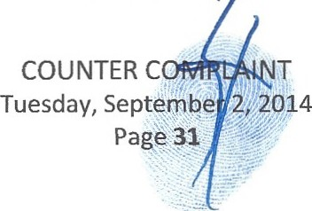That Theodore is involved in insurance litigation centering around his having been involved in insuring parties for much higher insurance amounts than they had insurable interest for through possible felonious underwriting. That parties are alleged to have died and insurance companies learned of the unjustified amounts of death benefits and ,r alled other policies whereby the same

uninsurable interests were found, causing a payback to be sought for commissions made by those who advanced the scheme.
- That Theodore with his counsel Rose have negotiated an alleged settlement with Stansbury for himself personally and simultaneously settled with the Estate of Shirley acting as the PR/Executor.
- That this settlement presents a classic conflict of interest where Theodore negotiated for his personal interests while negotiating simultaneously as a PR/Executor for Shirley's Estate where he has no interests and waiving others interests that he has fiduciary responsibilities to, to benefit himself at their expense. Theodore should have resigned himself with Rose from one side of the negotiations and not negotiated both sides while conflicted.
- That beneficiaries were not made aware of the settlement discussions and were not given any documents to review the transactions, which occurred in a black box for the Estate beneficiaries, where the terms are still unknown and no documents or what amounts of what was settled have been provided.
- That the beneficiary designations of IRA accounts for Simon and Shirley are now claimed missing by Spallina, Tescher and JP Morgan.
- That Theodore Bernstein was transferred the position of Manager of a company, Bernstein Family Realty LLC that is part of the estate plan of Simon and Shirley, owned by Eliot's minor children.
- That Theodore was allegedly transferred the Manager position by Janet Craig, who simultaneously upon Theodore's acceptance sent over personal and confidential information she maintained regarding this company to Theodore and other private and confidential trust information regarding Eliot and his three minor children.
- That Theodore later claimed he knew nothing about this transfer of the Manager role by Craig while simultaneously paying bills of Bernstein Family Realty LC over a several month period using
Shirley Trust funds to make the payments.

COUNTER,C
. 'X·
Tuesday, Septe
Pag L- -.-........

- That Theodore received letters written to him by Craig that stated she was transferring information to him as Manager of BFR.
- That after Simon died by several months, Spallina ILLEGALLY transferred the role of the Manager position of Bernstein Family Realty LLC to Craig at Oppenheimer and in so doing violated the operating agreement of BFR.
- That the operating agreement of BFR that Spallina created and kept record for, called for a vote to elect a Successor Manager after Simon died by the Members, who are Eliot and Candice Bernstein as Guardians of their children who own the company equally.
- That Spallina made the decision without consulting with Eliot and Candice on who to elect and told Eliot and Candice that the new Manager was Craig.
- That Craig accepted the transfer from Spallina in violation of the operating agreements of BFR, which would have had to have her voted in by the Members.
- That Craig transferred the documents and role of Manager of BFR to Theodore in violation of the operating agreements of BFR as no vote was again taken by the Members of BFR, Eliot and Candice on behalf of their children.
- That Legacy Bank accounts that Simon was the only signatory party on the accounts that pertained to BFR were used for several months after Simon was deceased by several parties who were unauthorized .
- That Simon's American Express was used for several months after he was deceased by other parties.

- That Simon Post Mortem received a red light ticket and his license was suspended for failure to respond.
- That Legacy Bank froze accounts of Simon's that were being sed after his death by several months.

COUNTER COM..P.:-
Tuesday, September;. 21
Page 33:

- That Pamela, Jill and Lisa after Shirley's death came to the home of Simon in Florida and shipped personal properties of Simon's that were left to him by Shirley back to their homes in Chicago, including but not limited to, Jewelry, Art, Clothing and more.
- That these items taken from Simon's residence are estimated to be worth several million dollars and they were taken by his daughters who claimed they were protecting them from being stolen by
Rachel Walker, Simon's assistant and then from his girlfriend, Maritza Puccio. These items have not been accounted for in Shirley's Estate or on her inventory or Simon's Estate inventory and accounting, as if they vanished. Eliot has repeatedly requested their return and has been completely denied even a response regarding these missing assets of the Simon Estate.
- That Robert Spallina alleges to have transferred monies frozen at Legacy Bank of Simon's for BFR to new Oppenheimer BFR accounts months after Simon's death.
- That furniture and other personal properties of Shirley and Simon's, estimated to be worth millions of dollars was not properly inventoried on Shirley or Simon's inventory when they passed .
- That furniture and other personal properties of Simon's estimated to be worth millions of dollars that was transferred to Simon as his personal property when Shirley died and was inventoried (but challenged already by Eliot and Creditor Stansbury as to the value) now appears to be missing.
- That this Court was told by Alan Rose and Theodore Bernstein that furniture of Simon's that was his personal property was moved when the Condominium was fraudulently sold and was taken to Simon's other residence in Saint Andrews Country Club. To confirm this removal of the properties and transfer to the other residence, this Court ordered a re-inventorying of the furniture and other properties of the Condominium on a motion filed by the Curator Benjamin Brown, Esq.
- That Donald Tescher and Alan Rose, in a deposition of Tescher's conducted by his friend and colleague who Tescher and Theodore retained in these matters, Alan Rose, then claimed that the furniture had been sold with Condominium an that they would "true it up" later with the

MPLAINT
;t
"'-- mber 2, 2014
·34
··

beneficiaries. That this statement directly contradicts the statements to this Court about where the furniture went.
- That the parties Theodore committed fraud with in the sale of the Condominium, include but are not limited to, Nestler Polleto Realty I Sotheby's International Realty, Attorney at Law Gregory S. Gefen, PA of Florida, All Regency Title dba US Title of Florida, Old Republic National Title Insurance Company and George Wesley Thomas Voorheis a Canadian resident.
- That Theodore Bernstein gave Eliot a gold ten commandment necklace Simon had told Eliot he was bequeathing him (specific bequeathed items are missing from the Estates and Trust documents despite reference to them in the ALLEGED dispositive documents). Theodore told Eliot he was taking the personal property jewels of Simon he removed from his residence and accounting for this Jewelry with Tescher and Spallina. Theodore stated the necklace would be deducted from any distributions later made to Eliot. That nowhere on the inventory of Simon or Shirley is this jewelry listed or accounted for.
- That an appraisal of Shirley's Jewelry done for an insurance policy done are materially different in character and substance of the quality and type of the alleged same pieces Theodore then had appraised. It appears that there are either similar looking pieces inventoried and appraised and there then should be two separate pieces of jewelry that look the same and appear to be named similarly but that have wholly different characteristics and MASSIVE discrepancy in worth over several hundred thousand dollars on one jewel alone. Alternatively, the Jewels were changed from the time the insurance company appraised them to when Theodore took possession of them and had them appraised.
- 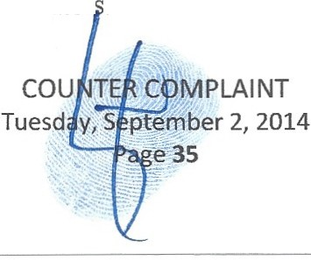Theodore took possession for months of Jewelry that was an asset of Simon's Estate, despite the fact that Spallina and Tescher upon Simon's death were the alleged PR's responsible for these jewels.
This has been reported to Sheriff Investigator .

- That Theodore, Pamela, Lisa and Jill, acting as alleged trustees for their children, all knew documents were forged and fraudulently notarized in their names that could change the beneficiaries
of the Estates and Trusts of Simon and Shirley and took no actions for months to notify authorities or this Court and instead during that time rushed to liquidate assets and convert and comingle monies to knowingly questionable parties.
- That Theodore, Pamela, Lisa and Jill, instead of reporting the forged and fraudulent documents in their names now proven and admitted by them as such, then tried to waive the forgery and fraud through perjured new waivers filed with this Court in attempts to replace the illegally done ones. That further they attempted to forgive the felony crimes done in their names, their father Post Mortem and Eliot's names without reporting such crimes. That this behavior imparts aiding and abetting in the crimes. misprision of a felony and breach of fiduciary duties.
- That Theodore Bernstein opened a criminal investigation on the day Simon died into what he alleged was a possible murder of Simon with Palm Beach Sheriff Investigators claiming that Simon's girlfriend Maritza Puccio had poisoned Simon.
- That Theodore Bernstein ordered on the day Simon died an autopsy of Simon for what he alleged was a possible murder of Simon with the Palm Beach Medical Examiner 's office claiming that Simon's girlfriend Maritza Puccio had poisoned Simon.
- That Simon Bernstein owned 30% of initial shares of stock in several companies5 he formed together

with Eliot and some that were formed fraudulently without their knowledge by Proskauer Rose and

5

lviewit Holdings,Inc. - DL
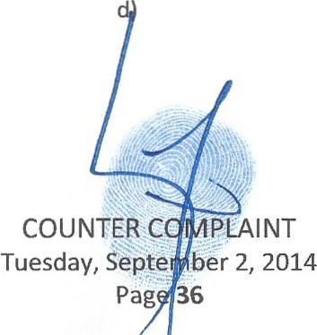lviewit Holdings, Inc. - DL (yes, two identically named) lviewit Holdings, Inc.- FL (yes, three identically name lviewit Technologies,Inc. - DL
Uviewit Holdings,Inc. - DL Uview.com, Inc. - DL lviewit.com, Inc.- FL lviewit.com, Inc.- DL

Gerald R. Lewin that used identically named to their companies, as listed in footnote one, herein together all these companies are referred to as "Iviewit Stock"
- That Proskauer Rose and Foley & Lardner filed patents on behalf of Eliot Bernstein for technologies Eliot invented that Simon had a 30% ownership interest in them.
- That Proskauer Rose LLP and Gerald Lewin formed these companies and have held the Iviewit Stock that was supposed to be in Simon's Estate and Trusts and that Theodore and Spallina made contact with Proskauer and Lewin to find where they were.
- That Tescher and Spallina after contacting Proskauer and Lewin were unable to find the missing Iviewit Stock and Proskauer and Lewin who maintained the Iviewit Stock and patent interests did not turn them over.
- That the Iviewit Stock may be worth hundreds of BILLIONS of dollars as certain of the Iviewit Stock companies held rights to Intellectual Properties of Eliot's where the technologies have been estimated to have values including "billions" and "priceless" by others who reviewed the Intellectual Properties, invested in them and licensed them, including but not limited to, Wayne Huizenga and Wayne Huizenga Jr., Crossbow Ventures, Wachovia Bank and others who evaluated them such as Real 3D, Inc. (owned by Intel 20%, Lockheed Martin 70% and Silicon Graphics Inc. 10%) and now owned wholly by Intel, Warner Bros., Sony, AOL, Time Warner, Proskauer Rose, Foley & Lardner, Goldman Sachs and others.
- 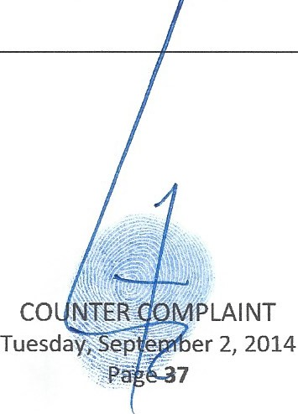This instant lawsuit is yet another Fraud on the Court, beneficiaries and others, in efforts to make prior illegal and fraudulent distribution committed no legal through attempting to modify an

l.C., Inc. - FL
lviewit.com LLC - DL lviewit LLC - DL
lviewit Corporation - FL lviewit, Inc. - FL
lviewit, Inc. - DL lviewit Corporation

irrevocable trust beneficiary class. This attempt to reconstruct the language of the irrevocable Shirley Trust and change the Class of Beneficiaries defined at her death on December 08, 2010 through documents that are challenged and alleged to be fraudulent and evidence of fraud already proven and admitted in regard to documents in the Estate and Trusts of Simon and Shirley.
- That after attempting to alter the Class of Beneficiaries of the Shirley Trust fraudulently, Theodore, Pamela, Jill and Lisa took distributions allegedly for their children based upon knowingly fraudulent documents and knowing the distributions were improper.

COUNT 1 - CIVIL CONSPIRACY

- This is an action for Civil Conspiracy under Florida Statutes.

- Counter Plaintiff hereby reiterates and incorporates herein by reference, as if fully restated herein, preceding paragraphs 1 through 219, inclusive.
- That as with any conspiracy, all of the facts regarding the actions of each of the defendants is largely unknown at this time and with ongoing investigations and new production documents that reveal even more alleged criminal acts and civil torts, more is being learned every day but one thing is for certain in this illegal legal conspiracy, the primary participants known at this time are licensed Attorneys at Law who have acted together to deprive Eliot and his family of legal rights through further abuse of process and complex illegal legal frauds constructed to obstruct justice and deny Eliot of due process and procedure and his and his children's inheritances.
- 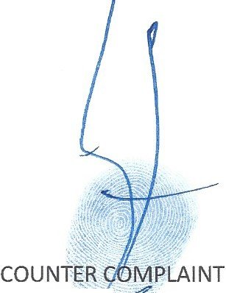That Theodore, on the day Simon died on September 13, 2012 alleged that Simon was murdered and filed a Palm Beach County Sheriff report already e ·denced herein, claiming that Simon's girlfriend poisoned Simon.

Tuesday, Sep - .. er 2, 2014 Page 38

- That Theodore, on the day Simon died on September 13, 2012 alleged that Simon was murdered and ordered an Autopsy6 be done, alleging that Simon's girlfriend poisoned Simon.
- That Simon may have been murdered but now a growing body of evidence uncovered involves proven and further alleged FELONY criminal misconduct by the Counter Defendants in combination.
- That Simon may have been murdered not by his girlfriend but by those involved in the criminal conspiracy that has taken place to illegally seize Dominion and Control of the Estates and Trusts of Shirley and Simon and loot their assets to the tune of between $20-100 Million dollars (not including the lviewit Stock and interests in Eliot's Intellectual Properties which would raise the values into the BILLIONS) and deprive Eliot and his family of their inheritances.
- That Simon may have been murdered not by his girlfriend but by those involved in the criminal conspiracy to steal intellectual properties worth billions upon billions of dollars, a conspiracy that has already been filed in a RICO and ANTITRUST lawsuit, already embodied herein, whereby there are allegations that ATTORNEYS AT LAW and others put a bomb in the Minivan of Eliot to murder he and his family, have made repeated and reported death threats to Eliot, OBSTRUCTED nJSTICE (allegedly in this Court as well in a prior lawsuit already mentioned herein), ABUSED PROCESS, ILLEGALLY WIRETAPPED AND MISUSED JOINT TERRORISM TASK FUNDS AND RESOURCES TO VIOLATE ELIOT and others PRIVACY RIGHTS and more.
- That Eliot is the midst of attempting to bring about a change in the legal system in efforts to root out systemic corruption at the highest levels by a rogue group of criminals disguised as Attorneys at Law, Judges, Politicians and more.
- That in Eliot's Federal RICO and ANTITRUST Lawsuit, recent news shows a massive fraud on the courts occurred and Obstructions of Justice directly committed by heads of the New York Attorney at

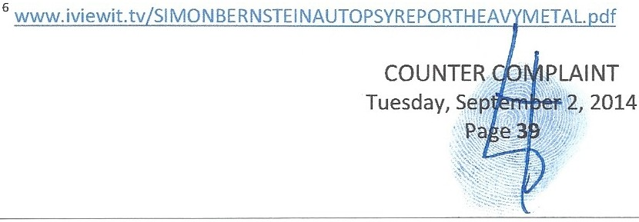

Law Disciplinary Committees and more, see all of the following articles. These articles relate to Eliot Bernstein's Federal RICO and ANTITRUST lawsuit that was legally related by Hon. Judge Shira Scheindlin to the Whistleblower Lawsuit of Attorney at Law and Disciplinary Expert former New York Supreme Court Attorney, Christine C. Anderson, Esq. Eliot's RICO is one of the cases mentioned in the articles related to her case that due process and procedure was obstructed with intentionally. All of these matters will be cause for the lawsuits, including Eliot's that are legally related to Anderson to be reopened due to fraud on the court and obstruction newly learned of, as evidenced in the following articles. That the articles in reference to Senator John Sampson being threatened and taking bribes to stifle corruption he was aware of are also related to Eliot's testimony before the New York Senate Judiciary Committee on Public Corruption in the New York Supreme Court Disciplinary Departments of New York (akin to the Florida Bar) that Sampson chaired while head of the Democratic Party of New York.
SELECTED ARTICLES RELATING TO THE ELIOT BERNSTEIN RICO AND NEW INFORMATION ABOUT OBSTRUCTION OF JUSTICE AND MORE:

BREAKING NEWS!!!

INDICTMENTS COMING! US SENATOR JOHN SAMPSON FORMER HEAD OF THE NEW YORK DEMOCRATIC PARTY AND CHAIRMAN OF THE NEW YORK SENATE JUDICIARY COMMITTEE WAS THREATENED & BRIBED TO COVER UP NY & FEDERAL CORRUPTION! !

UPDATE - INDICTMENTS COtvllNG :Iviewit Breaking News: NY Supreme Court Ethics Oversight Bosses Alleged MISUSE of Joint Terrorism Task Force Resources & Funds & Violations of Patriot Acts Against Civilian Targets for Personal Gain... US Senator John Sampson Threatened & Bribed to Cover Up NY & Federal Corruption!!

http: jwww.free-press-rel ease.com/news-iviewit-breaking-indictments-coming-us-senator-john ­ sampson-threatened-bribed-to-cover-up-ny-federa1-corruption-1369140092.htmI

---------------------------------------------------------------------- ------

Wednesday, May 15, 2013 Expose orrupt Courts
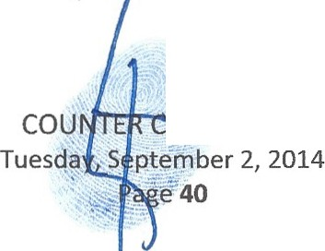
OMPLAINT

INSIDER SAYS NY STATE OFFICIALS BRIEFED ON JUDICIAL CORRUPTION INDICTMENTS

BREAKING NEWS: A New York State Court administrative insider says that top state officials have been briefed by the feds on pending federal corruption indictments that will include New York state court employees....

And late this morning, a Washington, D.C. source confirmed the information, adding that the target of one federal corruption indictment will include at least one sitting New York State judge and other individuals- all with ties to major banks.......

hup://cxposccom1ptcourts.blogspot .com/20 13/05/ insider-savs-nv-statc-official s-briefcd. html

UPDATE:SENATOR JOHN SAMPSON, FORMER NEW YORK SENATE JUDICIARY CHAIR THREATENED AND BRIBED TO COVER UP OFFICIAL CORRUPTION

FRIDAY, MAY 17, 2013

Washington, D.C. Insider Says Senator John Sampson Covered-Up Court Corruption

BREAKING NEWS: Washington, D.C. insider says NYS Senator John Sampson covered-up evidence of widespread corruption in New York Surrogate's Courts.

Source says Sampson was first threatened,but then successfully bribed, to bury evidence involving countless state and federal crimes involving billions of dollars.

Syracuse, Rochester, Albany, White Plains, Brooklyn and Manhattan Surrogate's Courts are said to top the list of areas involved.

It was revealed on Wednesday that a New York State Court administrative insider said that top state officials had been briefed by the feds on pending federal corruption indictments that would include employees of New York's Office of Court Administration (a/ka/ "OCA"). Most court employees, including judges , are employed by OCA.

It was further con.finned by the Washington, D.C. source that judges , with ties to banks, would be among those charged.

ht lp: //cthicsga te.b logspot.com/2013/0 5/washington-dc-insider-says-scnator-john .html

IVIEWIT BREAKING NEWS: NY SUPREME COURT ETHICS OVERSIGHT BOSSES ALLEGED MISUSE OF JOINT TERRORISM TASK FORCE RESOURCES & FUNDS & VIOLATIONS OF PATRIOT ACTS AGAINST CIVILIAN TARGETS FOR PERSONAL GAIN. .

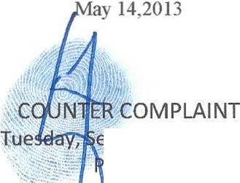

tfa.!IT7" .eptember 2,2014 age 41

See Full Story at:

http ://v.· ww.free-press-release .com/ncws-iviewi t -breaking-ne·ws-ny-supreme-court -eth.ics­ ovcrsight-bosses-alleged-misuse-of-joint-terrorism-task-forcc-rcsources-funds-violations -of­ patriot-136853373 l.html

and

http://cthicsgate.blogspot .com/2013 /0.+/formal-complaint-filed-against-nys .html

FORMAL COMPLAINT FILED AGAINST NYS EMPLOYEES FOR ILLEGAL WIRETAPPING ...THE WIDESPREAD ILLEGAL WIRETAPPING INCLUDED TARGETED NEW YORK STATE JUDGES AND ATTORNEYS .....

http://ethicsgate.blogspot.com/20 13/04/formal -complaint-filed -against-nys. ht ml SELECT QUOTES FROM THAT NEWS STORY
April 3, 2013

Robert Moossy, Jr., Section Chief Criminal Section, Civil Rights Division US Department of Justice
950 Pennsylvania Avenue, NW Washington, D.C. 20530

RE: FORMAL COMPLAINT AGAINST NEW YORK STATE EMPLOYEES INVOLYING CONSTITUTIONAL VIOLATIONS, INCLUDING WIDESPREAD ILLEGAL WIRETAPPING

Dear Mr. Moossy,

At some point in time shortly after 9/11, and by methods not addressed here, these individuals improperly utilized access to, and devices of, the lawful operations of the Joint Terrorism Task Force (the JTIF). These individuals completely violated the provisions of FISA, ECPA and the Patriot Act for their own personal and political agendas. Specifically, these NY state employees essentially commenced black bag operations, including illegal wiretapping, against whomever they chose- and without legitimate or lawful purpose .

This complaint concerns the illegal use and abuse of such lawful operations for personal and political gain, and all such activity while acting under the color of law. This un-checked access to highly-skilled operatives found undeserving protection for some connected wrong-doers, and the complete destruction of others- on a whim, including the pre-prosecution priming of falsehoods (set-ups). The aftern1ath of such abuse for such an extended period of time is staggering.

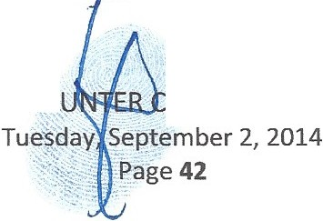It is believed that most of the 1.5 million-plus items in evidence now under seal in Federal District Court for the Eastern District of New York, case #09cr405 (EDNY) supports the fact, over a ten­ year-plus period of time, of the illegal wiretapping of New York State judges, attorneys, and related targets, as directed by state employ s.

co. OMPLAINT

One sworn affidavit, by an attorney, confirms the various illegal activity of Manhattan's attorney ethics committee, the Departmental Disciplinary Committee (the DDC), which includes allowing cover law firm operations to engage in the practice of law without a law license. Specifically, evidence (attorney affidavits, etc.) supports the claim that Naomi Goldstein, and other DDC employees supervised the protection of the unlicensed practice of law. The evidence also shows that Ms. Goldstein knowingly permitted the unlicensed practice of law, over a five-year-plus period of time, for the purpose of gaining access to, and information from, hundreds of litigants.

Evidence also supports the widespread illegal use of black bag operations by the NYS employees for a wide-range of objectives: to target or protect a certain judge or attorney, to set-up anyone who had been deemed to be a target, or to simply achieve a certain goal. The illegal activity is believed to not only have involved attorneys and judges throughout all of the New York State, including all 4 court-designated ethics departments, but also in matters beyond the borders of New York.

The set-up of numerous individuals for an alleged plot to bomb a Riverdale, NY Synagogue. These individuals are currently incarcerated. The trial judge,U.S. District Court Judge Colleen McMahon, who publicly expressed concerns over the case, saying, I have never heard anything
like the facts of this case. I don't think any otherjudge has ever heard anything like the facts of this case. (2nd Circuit llcr2763).

The concerted effort to fix numerous cases where confirmed associates of organized crime had made physical threats upon litigants and/or witnesses, and/or had financial interests in the outcome of certain court cases.

The judicial and attorney protection/operations , to gain control, of the $250 million-plus Thomas Carvel estate matters, and the pre-prosecution priming of the $150 million-plus Brooke Astor estate.

The wire-tapping and ISP capture, etc., of DDC attorney, Christine C. Anderson, who had filed a lawsuit after being assaulted by a supervisor, Sherry Cohen, and after complaining that certain evidence in ethics case files had been improperly destroyed. (See SDNY case #Q7cv9599 - Hon. Shira A. Scheindlin, U.S.D.J.)

The eToys litigation and bankruptcy , and associates of Marc Dreir, involving over $500 million and the protection by the DDC of certain attorneys, one who was found to have lied to a federal judge over 15 times.

The set-up and chilling of effective legal counsel of a disabled woman by a powerful CEO and his law finns, resulting in her having no contact with her children for over 6 years.

The wrongful detention for 4 years, prompted by influential NY law firms, of an early whistleblower of the massive Wall Street financial irregularities involving Bear Sterns and where protected attorney-client conversations were recorded and distributed.

The blocking of attorney accountability in the $1.25 billion Swiss Bank Holocaust Survivor settlement where one involved NY admitted attorney was ultimately disbarred- in New Jersey. Only then, and after 10 years, did the DDC ollow with disbarment. Gizella Weisshaus v. Fagan.

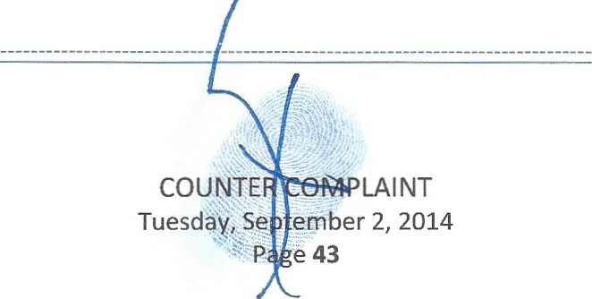

NY SUPREME COURT BOSSES ILLEGALLY WIRETAPPING JUDGES CHAMBERS & HOMES.CHRISTINE ANDERSON WHISTLEBLOWER ILLEGALLY TARGETED FOR 24/7/365 SURVEILLANCE IN RELATED CASE TO IVIEWIT ELIOT BERNSTEIN
RICO...

FOR lMMEDIATE RELEASE

(Free-Press-Release.com) May 14, 2013 -- According to news reports,yes, the heads of the NY Supreme Court Ethics Department have been accused of derailing Justice by targeting victims and misusing Government Resources against private citizens with no other motive then Obstruction of Justice in court and regulatory actions against them or their cronies.

World Renowned Inventor Eliot Bernstein files NEW RICO RELATED CRIMINAL ALLEGATIONS against Law Firms Proskauer Rose, Foley & Lardner, Greenberg Traurig and more. Allegations that Bernstein was a target of these criminals cloaked as ATTORNEY AT LAW ETIIICS BOSSES at the NY Supreme Court were presented to Federal Judge Shira A. Scheindlin. That evidence was presented that Bernstein's father may have been a target and murdered for his efforts to notify the authorities and more!!!

READ ALL ABOUT IT @

http://www .iviewit.tv/CompanyDocs/United%20States%20Di strict%20Court%20Southern%20Di s trict°.1620NY/20130512%20 FINA L%20M otio n%20to%20Rehea r%20a nd%20Reope n%200bstru ctio n%20of%20J ustice 1 65555%20WITH%20EXH IBITS. pdf

PREVIOUS PRESS RELEASES RELATING TO JUDGES ILLEGALLY WIRETAPPED

That on Tuesday, February 19, 2013, ECC released the story,

ETHICSGATE UPDATE FAXED TO EVERY U. S. SENATOR THE ULTIMATE VIOLATION OF TRUST IS THE CORRUPTION OF ETIDCS OVERSIGHT EXCLUSIVE UPDATE:

http://cxposecorruptcourts.blogspot.com/2013 /02/cthicsgatc-updatc-faxcd -to-ever.-us. html

IVIEWIT LETTER TO US DOJ OFFICE OF INSPECTOR GENERAL MICHAEL E. HOROWITZ

http://www.iviewit.tv/CompanyDocs/Unitcd% 20Statcs%20District%20Court%20Southcm%20Di strict%20NY/20130520%20FINAL%20Michacl%20Horowitz%20Inspector' /o20Gcncral%20Dcpa rtmcnt%20of%20Justice%20SlGNED%20PRlNTED%20EMAIL.pdf

IVIEWIT RICO MOTION FOR CLARIFICATION:

http://\V\\ ' \\ .ivic\\"it. l:\·/CompanvDocs/U ni tcd%20States%20District%20Court %20Southern%20Di strict%20NY/201305 l 3%20FINAL%20Motio %20for/'o20Clarification%20of%200rder l 7-l60-l
%20WITH%20N0%20EXHIBITS.pdf 
COIJ fy'lPLAINT
Tuesday, Se ember 2, 2014
1 P e 44

Investigative Blogger Crystal Cox Sues Forbes and the New York Times for Defamation. March 6, 2013

http://www.free-press-release. coni/nc'YS-i nvcstiga t ive-blogger -crystal -cox -sues-forbes-and-the­ new-york-times-for-defamation-13625+ 70 IO.html

COURT CASES OF INTEREST

COX VS. RANDAZZA, ET AL." NEVADA RICO CASE NO. 2:13-CV-00297-JCM -VCF CHANGED TO 2:13-CV-00297 JCM (NJK) CHANGED TO 2 :13-CV-00297 MMD-VCF

OBSIDIAN FINANCE GROUP, LLC ET AL. V. COX CASE NO. 3:11-CV-00057-HZ (Fan1ed
First Amendment Rights Attorney at Law and Professor, Eugene Volokh, Esq., Professor at UCLA School of Law is representing Cox on Appeal)

THE BEGINNING OF THE END NEW YORK SENATE J U DICIARY COM MITTEE HEARINGS

September 24, 2009 - Second Hearing

Public Hearing: Standing Committee On The Judiciary New York Senate Judiciary Committee John L. Sampson Chairman

SENATE STANDING COMMITTEE ON THE JUDICIARY NOTICE OF PUBLIC HEARING

SUBJECT: The Appellate Division First Department Departmental Disciplinary Committee, the grievance committees of the various Judicial Districts and the New York State Commission on Judicial Conduct

PURPOSE: This hearing will review the mission, procedures and level of public satisfaction
-with the Appellate Division First Department Departmental Disciplinary Committee, the grievance committees of the various Judicial Districts as well as the New York State Commission on Judicial Conduct

ORAL TESTIMONY BY:

Witness List for Judiciary Hearing 9/24/09 The Judicial & Attorney Disciplinary Process in the State of New York

  - Richard Kuse of New City, NY
- Victor Kovner of the Fund for Modem Courts
- Douglas Higbee of Mamaroneck, NY
- Judith Herskowitz of Miami Beach, FL
- Peter Gonzalez of Troy, NY
- Andrea Wilkinson of Rensselaer, NY
- Maria Gkanios of Mallopac, NY
- Dominic Lieto of Mahopac, NY
- 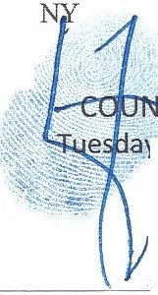Regina Felton Esq of Brooklyn, NY 10. Kathryn Malarkey of Purchase,

TER COMPLAINT
. .Y, September 2, 2014
' Page 45

- Nora Renzuli, Esq. of Staten Island, NY
- Stephanie Klein of Long Beach, NY
- Ike Aruti of Rosedale, NY
- Terrence Finnan of Keene, NY
- Gizella Weisshaus, NY
16. Eliot L Bernstein of Boca Raton, FL
17. Suzanne McCormick & Patrick Handley of NY
The Appellate Division of the Supreme Court is the entity that is legally responsible for enforcing the Rules of Professional Conduct governing the conduct of attorneys in New York State. The Appellate Division Departments have created grievance committees that are charged with the investigation of complaints against attorneys. Within the First Judicial Department the Departmental Disciplinary Committee of the Appellate Division investigates complaints against attorneys. The New York State Commission on Judicial Conduct was created by the State Constitution and is charged with investigating complaints against Judges and Justices of the Unified Court System.

According to the 2009 Report of the Commission on Judicial Conduct, there were 1,923 complaints filed in 2008. Yet of these complaints only 262 were investigated and of those, 173 were dismissed. This hearing will examine the processes and procedures that are followed by the various agencies charged with the responsibility of enforcing the rules and regulations that must be followed by the Judiciary and the Bar in the State of New York. Itwill also evaluate public satisfaction with the disciplinary process.

- That Eliot has been targeted through a complete violation of his personal property rights, privacy rights and more.as he is a related case to Anderson Whistleblower lawsuit that was obstructed and in effort to silence his efforts to take a large bite out of crime in New York and Florida.
- That this lawsuit and all the other related Probate cases and other legal cases Eliot is in are a coordinated and conspiratorial efforts to harm Eliot and his family through legal process abuse and RICO type activities that use the legal system to deprive victims of their due process rights against those that hold seats of power and honor who were fixing the cases against them and their friends and misusing government resources to do so.
- That this legal conspiracy may relate to other legal actions Eliot is currently involved in as described

in Eliot's first Petition in the Estate cases7
,
which are again involving conspiracy charges against

primarily Attorneys at Law.

That on May 6,2013 Petitioner filed an "EMERGENCY PETITION TO: FREEZE ESTATE ASSETS, APPOINT NEW
7
PERSONAL REPRESENTATIVES, INVESTIGATE FORGED AND FRAUDULENT DOCUMENTS SUBMITIED TO THIS COURT AND OTHER INTERESTED PARTIES, RESCIND SIGNATURE F ELIOT BERNSTEIN IN ESTATE OF SIMON/SHIRLEY
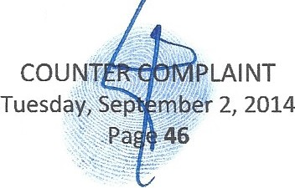BERNSTEIN AND MORE." Filed in both estates.

- That many defendants in the RICO and ANTilRUST who stand as the primary accused are similar to parties alleged to be involved in the criminal misconduct in the probate and trust cases before this Court, including but not limited to, Gerald Lewin, CPA and Proskauer Rose LLP (Albert Gortz, Esq.).
- That Eliot will be seeking the US District Court's approval to have the RICO reopened based on Fraud on that Court, new evidence of RICO related crimes in the Probate and Trust actions defined herein with common threads to the RICO defendants and new evidence of intentional Obstruction of Justice in the RICO and related cases currently unfolding.
- That Simon may have been murdered but not by his girlfriend as alleged, as he may have been talking with State and/or Federal Authorities regarding his knowledge in Proskauer Rose's alleged involvement in the Sir Robert Allen Stanford Ponzi scheme8 and more and to gain control or destroy Simon's interests in Eliot's Intellectual Properties and the lviewit Stock companies.
- That Eliot is pursuing Proskauer Rose LLP, Gerald Lewin, CPA and Albert Gortz, Esq. as the main initial parties involved in the theft of Simon and Eliot's Intellectual Properties and companies that were set up to hold those assets, worth estimated billions of dollars.

15th Judicial Florida Probate Court www.iviewit.tv/20130506Petiti onFreezeEstates. pdf and
Most Honorable Shira A. Scheindlin. Pages 156-582 reference estate matters in Simon and Shirley as it relates to
RICO allegations.
www .iviewit.tv/20130512MotionRehearReopenObstruction.pdf US District Court Southern District of New York

8 "U.S. justices say Allen Stanford victims can sue lawyers, brokers" REUTERS, By Lawrence Hurley, WASHINGTON Wed Feb 26,2014 4:09pm EST http://www.reuters.com/article/2014/02/26/us-usa-court -stanford­
idUSBR EA1P17220140226
and
"Proskauer, Chadbourne Could Face Billions In Damages" Law 360,By Stephanie Russell-Kraft, New York (February 26, 2014,10:16 PM ET)
http://www.law360.com/articles/513782/proskauer-chadbourne -could-face-billions-in-damages and
"How Allen Stanford kept the SEC at bay" Reuters, By Murray Waas, January 27, 2012 11:06 AM ET htt : business.financial ost.com 2012 01 27 how-all -stanford-ke t-the-sec-at-ba

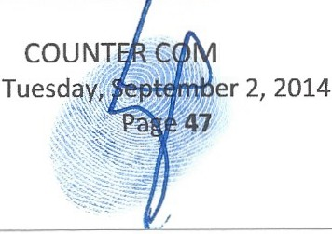
PLAINT

- That the RICO CONSPIRACY has reached into the estates and trusts, again through corruption involving complex legal frauds committed through misuse of the legal system now by new Attorneys at Law acting as Officers of this Court, acting in concert with those accused in Eliot's RICO and criminal complaints, now committed in efforts to deprive Eliot and his family of their inheritances to interfere and hinder their efforts to bring about justice in several of the other now legal battles Eliot and they are involved in.
- That the Simon and Shirley probate and trust matters before this Court now have several elements of RICO in Florida, including but not limited to, proven fraudulent notarizations, admitted forgery, alleged Extortion, alleged Murder (by Theodore and Pamela primarily and Theodore's past employee Rachel Walker), Conversion, Multiple Counts of Interstate Mail and Wire Fraud, Insurance Fraud, Institutional Trust Company Fraud, Theft, Fraud on this Court, Fraud on a Federal Court and more.
- That two or more parties have conspired in each of the frauds described herein and others, some acting as fiduciaries in the Estates and Trusts of Simon and Shirley while simultaneously serving as Officers of this Court and under this Court's Jurisdiction.
- That to effectuate the looting of the Estate, the document fraud on this Court and the beneficiaries allowed the fraudsters to illegally seize Dominion and Control of the Estates and Trusts and by misusing their fiducial trust and powers and violating most of the Probate and Trust Rules and Statutes they were enabled to loot the assets of Simon and Shirley through various state and federal criminal acts.
- That new evidence reveals that Eliot and his family have been targeted by high ranking members of the legal community (disciplinary department members, judges and attorneys at law) who illegally misused Joint Terrorism Task Force funds and resources to specifically Obstruct Justice in Eliot's prior lawsuits cited herein by targeting them an surveilling them directly to interfere with their rights to due process and procedure.
:- -
COl)N1ER
'\.. -:. . .
Tuesd,a, ::._mber 2, 2014
..,,. · 48

- That Simon and Shirley left vast wealth to their beneficiaries under their years of elaborate estate plans, costing thousands upon thousands of dollars to set up these trusts, business entities and other vehicles. Simon and Shirley went to Proskauer for Estate planning in 2000 primarily to protect their interests in Eliot's technologies but Simon fired them upon learning of their involvement in the criminal acts involved in the stolen Intellectual Properties against his son.
- That Simon and Shirley's interests in the technologies and companies that held them is missing from the Estates and Trusts of Simon and Shirley at this time, as are ALL Schedules, Addendurns and other attachments that were required to be attached to them and given to beneficiaries.
- That Spallina contacted Lewin and Proskauer to find out where the Iviewit Stocks were that they held for the companies they formed to hold the Intellectual Properties and did not receive any information back regarding where the Iviewit Stock companies stocks were.
- That Oppenheimer and JP Morgan were both initially involved in Eliot's technologies and signed various agreements with the companies that held the Intellectual Properties, see
http ://iviewit.tv/CompanyDocs/Appendix%20A/ .

- That all of these complex estate plans, including multiple layers of trusts, business entities and other estate planning vehicles have been seized illegally and interfered with by various of the Counter Defendants, acting alone and/or in concert with other Counter Defendants.
- That assets have been converted to improper parties through a combination of frauds and thefts to defeat Eliot of his inheritance, including but not limited to, the shares of the Iviewit Stock companies that held the Intellectual Properties.
- That many of these crimes have occurred in and on this Court as the scene of the crimes, which were committed by Officers of this Court and the fiduciaries .
- That in order to achieve this looting of the Estate, Trusts and Corporate Entities, financial and accounting information due the Beneficiaries has een suppressed and denied and now it is learned in
COUN MPLAINT
Tuesday temer 2, 2014
e 49'jl

some instances even destroyed, in violation of probate statutes, trust statutes, state law, federal law, attorney conduct codes and through breach upon breach of fiduciary duties.
- That all parties sued hereunder have acted alone and in combination with others to violate the trusts, business entities and other vehicles to fraudulently remove assets from the corpuses of the trusts and estates and business entities, invarious artifices to defraud the true and proper beneficiaries.
- That if this Court would like a more definite type conspiracy statement at this time, detailing all

known participants and each act they have committed in the conspiracy, including those already pled in the Estate cases before the Court, Petitioner will be happy to provide a statement similar to a RICO Statement to tie the conspirators together in any Amended Complaint that further elaboration is requested.
- That more on the conspiracy aspect of this lawsuit and how it interrelates to the Probate cases now before the Court can be found in Eliot's first Petition in the Estate cases of both Simon and Shirley, under the section titled "The Elephant in the Room."9 While this was done over a year ago, many of the main allegations of criminal misconduct and civil torts that were alleged at that time have now been either proven or admitted and many more recently uncovered new crimes have been found.
- All conditions precedent to this action have been performed or occurred and continue. WHEREFORE, Counter Plaintiff prays for judgment against Counter Defendants for Civil
Conspiracy, jointly and severally, personally and professionally, for remedies as may be awarded Counter Plaintiff under other Counts herein, together with such other and further relief as the Court may deem just and appropriate.
9 That on May 6, 2013 Petitioner filed an "EMERGENCY PETITION TO: FREEZE ESTATE ASSETS,APPOINT NEW PERSONAL REPRESENTATIVES ,INVESTIGATE FORGED AND FRAUDULENT DOCUMENTS SUBMITIED TO THIS COURT AND OTHER INTERESTED PARTIES, RESCIND SIGNATURE OF ELIOT BERNSTEIN IN ESTATE OF SIMON/SHIRLEY
BERNSTEIN AND MORE." Filed in both estates.
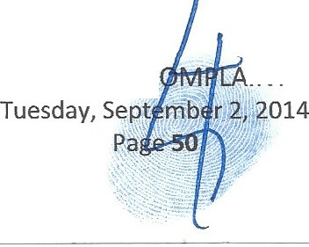www.iviewit.tv/20130506PetitionFreezeEstates.pdf 15th Judicial Florida Probate Court and www.iviewit.tv/20130512MotionRehearReopenObstructi on.pdf US District Court Southern District of New York, Most Honorable Shira A. Scheindlin. Pages 156-582 reference state matters in Simon and Shirley as it relates to RICO allegations.

COUNTER C . INT

COUNT 2 - CIVIL EXTORTION

- This is an action for Civil Extortion under Florida Statutes.

- Counter Plaintiff hereby reiterates and incorporates herein by reference, as if fully restated herein, preceding paragraphs lthrough 253, inclusive.
- That many of the claims of Extortion have already been pied before this Court in filings 10 yet unheard at this time but that are fully incorporated here by reference.

10 That on September 04, 2013,ELIOT filed Docket #TBD, in the estate of Simon, a "NOTICE OF EMERGENCY MOTION TO FREEZE ESTATES OF SIMON BERNSTEIN DUE TO ADMITIED AND ACKNOWLEDGED NOTARY PUBLIC FORGERY, FRAUD AND MORE BY THE LAW FIRM OF TESCHER & SPALLINA, P.A., ROBERT SPALLINA AND DONALD TESCHER ACTING AS ALLEGED PERSONAL REPRESENTATIVES AND THEIR LEGAL ASSISTANT AND NOTARY PUBLIC, KIMBERLY MORAN: MOTION FOR INTERIM DISTRIBUTION DUE TO EXTORTION BY ALLEGED PERSONAL REPRESENTATIVES AND OTHERS; MOTION TO STRIKE THE MOTION OF SPALLINA TO REOPEN THE ESTATE OF
SHIRLEY; CONTINUED MOTION FOR REMOVAL OF ALLEGED PERSONAL REPRESENTATIVES AND ALLEGED SUCCESSOR TRUSTEE."
http://www.iviewit.tv/20130904Moti onFreezeEstatesShi rleyDueToAdmittedNotaryFraud.pdf and
That on October 10,2013 Petitioner filed in Shirley's estate case Motions titled,
  - MOTION TO ORDER ALL DOCUMENTS BOTH CERTIFIED AND VERIFIED REGARDING ESTATES OF SHIRLEY AND SIMON (SIMON'S DOCUMENT ARE REQUESTED AS IT RELATES TO SHIRLEY'S ALLEGED CHANGES IN BENEFICIARIES) BE SENT TO ELIOT AND HIS CHILDREN IMMEDIATELY IN PREPARATION FOR THE EVIDENTIARY HEARING ORDERED BY THIS COURT
  - MOTION TO FOLLOW UP ON SEPTEMBER 13,2013 HEARING AND CLARIFY AND SET STRAIGHT THE RECORD
(Ill) MOTION TO COMPEL FOR IMMEDIATE, EMERGENCY RELIEF!!!, INTERIM DISTRIBUTIONS AND FAMILY ALLOWANCE FOR ELIOT, CANDICE & THEIR THREE MINOR CHILDREN DUE TO ADMITTED AND ACKNOWLEDGED FRAUD BY FIDUCIARIES OF THE ESTATE OF SHIRLEY AND ALLEGED CONTINUED EXTORTION
- MOTION TO CORRECT AND DETERMINE THE BENEFICIARIES OF THE ESTATE BASED ON PRIOR CLOSING OF THE ESTATE THROUGH FRAUD ON THE COURT BY USING FRAUDULENT DOCUMENTS SIGNED BY SIMON WHILE HE WAS DEAD AND POSITED BY SIMON IN THIS COURT WHEN HE WAS DEAD AS PART OF A LARGER FRAUD ON THE ESTATE BENEFICIARIES
- MOTION TO ASSIGN NEW PERSONAL REPRESENTATIVES AND ESTATE COUNSEL TO THE ESTATE OF
SHIRLEY FOR BREACHES OF FIDUCIARY DUTIES AND TRUST, VIOLATIONS OF PROFESSIONAL ETHICS, VIOLATIONS OF LAW,INCLUDI NG BUT NOT LIMITED TO ADMITIED AND ACKNOWLEDGED FRAUD,ADMITIED AND
ACKNOWLEDGED FRAUD ON THE COURT, ALLEGED FORGERY, INSURANCE FRAUD,REAL PROPERTY FRAUD AND MORE
- MOTION FOR GUARDIAN AD LITUM FOR THE CHILDREN OF TED, P. SIMON, !ANTONI AND FRIEDSTEIN AND ASSIGN A TRUSTEE AD LITUM FOR TED FOR CONFLICTS OF INTEREST, CONVERSION AND MORE
- MOTION TO RECONSIDER AND RESCIND ORDER ISSUED BY THIS COURT "ORDER ON NOTICE OF EMERGENCY MOTION TO FREEZE ASSETS" ON SEPTEMBER 24TH FOR ERRORS AND MORE AND
- 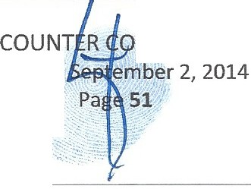MOTION TO RECONSIDER AND RESCIND ORDER ISSUED BY THIS COURT "AGREED ORDER TO REOPEN THE ESTATE AND APPOINT SUCCESSOR PERSONAL REPRESENTATIVES" ON SEPTEMBER 24TH FOR ERRORS AND MORE www. i viewit.tv 20131010MotionCom elFreezeYouHavetheRi httoRemainSilent. df

Tuesday

M PLAI NT

- That the Counter Defendants worked together and with others to interfere and deprive in combinations and separately to illegally seize Dominion and Control of BFR and the children's trust funds, which were the primary sources of funding for Eliot's family, along with intentional interference with Eliot and his children's inheritances.
- That Counter Defendants worked together in concert and with others to interfere and deprive in combinations and separately, a Pattern and Practice of frauds to destroy BFR and the children's trusts, in efforts to deplete Eliot of resources and then extort Eliot to either accept improper distributions as others had done to his children by participating in their fraud or else deprive Eliot of his and his children's inheritances.
- That the Counter Defendants worked together in concert and with others to interfere and deprive in combinations and separately to illegally seize Dominion and Control of the Estates and Trusts and delay and interfere with expectancies and inheritances of Eliot and his children.
- That the Counter Defendants worked together in concert and with others to interfere and deprive in combinations and separately to illegally seize Dominion and Control of Telenet Systems and delay and interfere with Eliot and Candice's income and interests in that company.
- That once Counter Defendants had seized Dominion and Control of the Estates, Trusts and Corporate Entities and diminished available funds to Eliot's family, they began an extortive attempt to have Eliot either participate in the fraudulent activity they were caught in or to face intentional financial calamity they now controlled.
- That when Eliot refused and instead continued to pursue investigations with civil and criminal authorities, Counter Defendants worked together in concert and with others to interfere and deprive in combinations and separately to interfere and deprive Eliot and his family of inheritances due them and deplete trust funds in his three minor hildren' s trusts and leave them with no income.
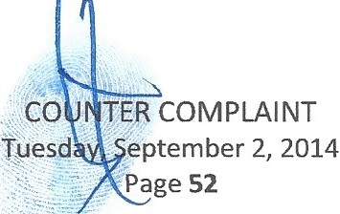

- That income for Eliot and his family had been set up to continue for years to come by Simon and Shirley in their estate plans and through their inheritances and these funds were shut off illegally and virtually overnight cutting them off of essential monies owed them and thrusting Eliot and his family to financial ruin with intent and scienter.
- That Eliot and his children had been set up financially through entities created by both Simon and Shirley while living. These finances were intended to continue after their deaths through their ELABORATE estate plans especially in regard to Eliot and some of these entities were created exclusively for Eliot and his family's PROTECTION and so designed to provide monthly income, fully prefunded school funds and a fully paid for home owned by his children for many years into the future. That these plans were intentionally interfered with and Eliot's needs were held on accepting a carrot fraught with fraud and the hope that Eliot would sign releases, waivers and through participation in a knowing fraud a consent of sorts.
- That ELIOT is a one third beneficiary of the Estates and Trusts of both Simon and Shirley Bernstein until Counter Defendants through a series of forged and fraudulent documents created by the former PR's and Trustees of Simon and Shirley's Estates and Trusts then attempted to claim that Simon had changed Shirley's beneficiaries and his own from their three children, Eliot, Jill and Lisa, to their ten grandchildren.
- That Fraud on the Court was committed by Officers of this Court, including using a dead PR, Simon, to close the Estate of Shirley his deceased wife, morbid indeed and Fraud on the Court, as the PR's failed to notify the Court that Simon was dead and failed then to elect a successor PR or Trustee once they were through using the dead Simon to achieve their Fraud on the true and proper beneficiaries.
- 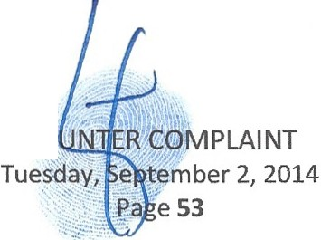That Eliot's siblings Theodore and his sister Pamela had been wholly disinherited and considered predeceased for Shirley and Simon's Estate d Trusts in 2008. When Shirley died in 2010 her
CQ

Trusts that held millions of dollars in assets then became irrevocable with Eliot, Lisa and Jill and their lineal descendants as the only ultimate beneficiaries.
- That both Simon and Shirley completed mirrored Wills and Trusts in 2008, according to deposition statements made by Donald Tescher on July 09, 2014, and these plans wholly left their Estates and Trusts and all properties to Eliot, Lisa and Jill and their lineal descendants only.
- That documents recently provided by Court Order in the Estate of Simon have revealed that the 2008 Wills and Trusts of Shirley and Simon's appear materially different and not mirrored bringing into question their legal validity.
- That Shirley died with her 2008 Will and Trusts as her dispositive documents, with Simon as a Trustee while alive and only Eliot, Lisa and Jill and their lineal descendants as the beneficiary class when it became irrevocable through Family Trust created for them and their lineal descendants only.
- That Simon could neither add nor subtract beneficiaries to the Shirley Trust once she died as the Shirley Trusts became irrevocable.
- Despite efforts by the former PR/Executors!frustees, Tescher, Spallina, Theodore, Rose, Manceri, Pankauski, Moran, Baxley and others to illegally achieve changes to the beneficiaries through a series of fraudulent and admitted forged and fraudulently altered documents, Simon did not factually do the changes.
- That no documents exist that are not fraudulently altered or improperly prepared, witnessed, notarized and executed showing that Simon ever made any changes to he and Shirley's alleged 2008 Wills and Trusts.
- 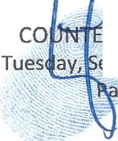That subsequent to the Fraud on the Court and positing of fraudulent documents that led to seizure of Dominion and Control, illegal distributions were made and converted and comingled, as if these fraudulent beneficiary changes were legal. This fraud was to the advantage of Theodore and Pamela primarily and to the disadvantage of other eneficiaries including primarily Eliot and his family.
R 1 0MPLAI NT
e....p,,t..ember 2, 2014
ge 54

- That Simon in no way could execute a Power of Appointment to make any changes to the class of beneficiaries in Shirley's Will and Trusts (Eliot, Lisa and Jill and their lineal descendants) once she passed away due to language in the Simon Trust that prohibited him from amending or revoking anything with Shirley's Trust property once it transferred to him. Despite knowing these facts about the frauds, the PR's and Fiduciaries rushed to sell assets and then take knowingly improper distributions made to knowingly improper.
- That in 2012 Shirley's Estate was reopened by Hon. Judge Martin Colin due to Fraud committed by Tescher, Spallina, TSPA, Theodore, Manceri and Moran et al. and remains open today, pending ongoing litigation.
- That in 2012 it is ALLEGED that Simon annulled his 2008 Will (instead of amending it) and allegedly replaced it with an alleged 2012 Will and further allegedly Amended his 2008 Simon Trust and allegedly replaced it with a 2012 Amended and Restated Simon Trust, only 48 days before he passed suddenly and unexpectedly and by alleged MURDER according to Theodore and Pamela primarily.
- That in 2013 it is proven in this Court in the Estate and Trust cases that POST MORTEM, Simon closed the Estate of Shirley, while dead for four months acting as Personal Representative, yes dead and done with Fraudulently Notarized, Fraudulent and Forged documents that has already led to one an arrest for felony acts and admissions of fraudulently altering trust documents and more.
- That in 2013 it was learned from the Governor Rick Scott's Office Notary Public Division that the notarizations on the ALLEGED 2012 Will and Amended and Restated Trust were improperly notarized .
- That Simon cannot now said to have been present on the date the documents were allegedly signed, due to such improper notarization and therefore e legally void for this and other defects.

COUN

- The documents have been challenged before this Court for the alleged 2012 Will and Trusts of Simon.
- That Eliot has assisted the Palm Beach County Sheriff Office Financial Crimes Division in making the arrests and forcing the admissions of fraud, while also pursuing other alleged criminal acts to loot the Estates and Trusts of Simon and Shirley that are under ongoing investigations and civil actions.
- Many of the crimes committed were done by the Officers and Fiduciaries of this Court and due to this fact Counter Defendants in this lawsuit and Counter Defendants in the Oppenheimer Lawsuit have further conspired to deny Eliot and his family, including three minor children, of their inheritances and made further extortive efforts to have Eliot participate in knowingly fraudulent distributions.
- That knowing that they were intentionally harming Eliot and his family financially, they proceeded to repeatedly attempt to force Eliot to either partake in illegal activities to get his inheritance monies by participating in the fraud they had done, sign waivers to release them and give them implied consent or starve and watch his family suffer from his failure to partake in fraud and give them waivers and releases of liabilities to partially set them free and make their illegal acts not prosecutable by Eliot.
- Eliot is also now threatened with foreclosure through more fraudulent acts, already pied in the

Estates and Trust cases before the Court and threatened to be evicted from the home his children own that is now claimed via an alleged Mortgage and Promissory Note allegedly held by Simon's Estate, that was added to an amended inventory of Simon's after the fiduciaries were contacted by criminal authorities.
- 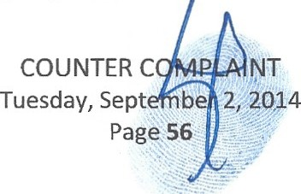These tactics represent classic extortion, with a either play or pay, even using the kids in certain of the alleged attempted extortions to force Eliot to take illegal distributions or watch his THREE MINOR CHIT.,DREN suffer from their abuses, including, taking a KIA Soul that Simon had given Eliot's 1S year old son for his birthday days before he ied and using it as a bargaining chip to try

and gain waivers, claiming it as an asset of the Estate. The extortive attempt was based on if Eliot would cooperate and take the car the way they wanted, they would release it as a gift. IfEliot did not comply they would take it and claim it as personal property of Simon's, which they did. This battle went on for over a year until they finally when brought to this Court abandoned their effort to extort Eliot using his son's car and dropped their legal action and gave it back as exempt property before facing Your Honor. However, before so returning the exempt property they filed pleadings with this Court claiming it as Personal Property of Simon's, yet this does not appear on the final accounting of Simon or his inventories.
- That the fiduciaries cut off all inheritance funds for Eliot and his family and claimed Eliot could have the monies to pay his bills, keep his children in school, etc. but only on the condition that he took illegal distributions to improper parties as others did, which of course he would not break the law, as fully illustrated in the September 13, 2013 hearing before this Court.
- Where since that September 13, 2013 hearing, Eliot and his family have suffered economic doom that has intentionally been levied upon him by the PR's and Fiduciaries of the Estates and Trusts (excluding Benjamin Brown, Esq. Curator to replace removed PR to Simon's Estate and Brian O'Connell, Esq. Successor PR in Simon's Estate) that continues to this day. Repeated efforts have been made while Eliot was forced to beg the very criminals caught in their crimes for funds or watch each time his family suffer, which he did.
- That the soon to be DOO.rvIBD efforts to force foreclose on the home Eliot's children home they own and further starve out Eliot and his family completely, wholly defeats the wishes of both Simon and Shirley Bernstein.
- That the elaborate estate planning mechanisms Simon and Shirley put in place to protect Eliot and his family's assets, in some instances these plans were solely for Eliot and his family, knowing that Eliot and his family 's lives are in danger, where set u to provide steady monthly income to Eliot to work
COU NJl"ll-MM...1. MPLAINT
Tuesda .,

...:. ....
\-:..._ .
....;:.

on protecting his and Simon's patent interests and to work on protecting himself from another TERRORIST STYLED CAR BOMBING ASSASSINATION ATTEMPT.
- That if Eliot had his inheritance in the Shirley Trust as provided for under the terms of the irrevocable trust at this time, Eliot would suffer no financial duress for either he or his children, just on the few assets they are now aware are part of the Shirley Trust corpus or trust res. Again, if the Schedules, Addendurns and other referenced attachments were disclosed Eliot would know the true extent of his inheritance and what exactly property was in both the Shirley Trust and Simon Trust.
- All conditions precedent to this action have been performed or occurred and continue. WHEREFORE, Counter Plaintiff prays for judgment against Counter Defendants for Civil
Extortion, jointly and severally, personally and professionally, for remedies as may be awarded Counter Plaintiff under other Counts herein, together with such other and further relief as the Court may deem just and appropriate.
COUNT 3 - THEFT

- This is an action for Civil Theft under the Florida Statutes.

- Counter Plaintiff hereby reiterates and incorporates herein by reference, as if fully restated herein, preceding paragraphs 1through 292 inclusive.
- That theft of property has occurred with illegal Post Mortem use of bank accounts, including POST MORTEM use in accounts held in the Estates and Trusts.
- That IRA beneficiaries are missing and IRA monies are alleged missing and no accountings exist for these items that were part of Shirley and Simon's Estates and Trusts.
- That a series of property frauds have left assets missing and unaccounted for at this time, including but not limited to, Jewelry, Artwork and Furnishings, worth tens of millions of dollars, which has been reported to authorities and remains under ongoing investigation.
- That insurance fraud has occurred and is under ongoin civil actions and criminal investigations.

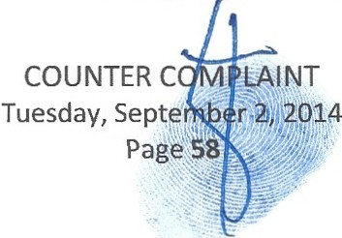

- All conditions precedent to this action have been performed or occurred and continue. WHEREFORE, Counter Plaintiff prays for judgment against Counter Defendants for Theft,
jointly and severally, personally and professionally, for remedies as may be awarded Counter

Plaintiff under other Counts herein, together with such other and further relief as the Court may deem just and appropriate.

COUNT 4 - FRAUDULENT CONVERSION

- This is an action for Fraudulent Conversion under Florida Statutes.

- Counter Plaintiff hereby reiterates and incorporates herein by reference, as if fully restated herein, preceding paragraphs l through 299, inclusive.
- That Spallina, Tescher, Theodore, Craig, Worth, Manceri, Rose, Pankauski and others have interfered with Eliot and his children's inheritances by falsifying documents and other criminal acts and civil torts to convert assets to improper parties and seize Dominion and Control of various trusts
and estates assets with intent and destroy, suppress and deny Eliot and his family of their inheritances and fraudulently convert and corningle monies to improper parties illegally.
- All conditions precedent to this action have been performed or occurred and continue. WHEREFORE, Counter Plaintiff prays for judgment against Counter Defendants for
Conversion, jointly and severally, personally and professionally, for remedies as may be awarded Counter Plaintiff under other Counts herein, together with such other and further relief as the Court may deem just and appropriate.

COUNT 5 - INTENTIONAL INTERFERENCE WITH AN INHERITANCE/EXPECTANCY

- This is an action for Torturous Interference with an Inheritance under Florida Statutes.

- 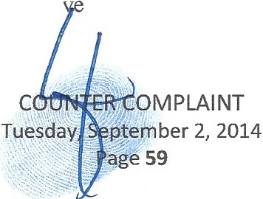Counter Plaintiff hereby reiterates and incorporates herein by reference, as if fully restated herein, preceding paragraphs 1 through 302, inclusi .

- That Eliot and/or his children had expectancy from the Trusts, Estates and Corporate Entities of Simon and Shirley left to them by Simon and Shirley in their Estates and Trusts and there has been intentional interference with the expectancy through tortuous felonious misconduct by the fiduciaries and their counsel that caused and continues to cause damages.
- That Spallina, Tescher, Theodore, Craig, Worth, Manceri, Rose, Pankauski and others have interfered with Eliot and his children's inheritances through a number of schemes and artifices to defraud and by falsifying dispositive documents to convert assets to improper parties and seize Dominion and Control of various trusts and estates assets with intent and destroy, suppress and deny Eliot and his family of their inheritances.
- That Eliot and his family have been denied access to Estate and Trust documents and accountings for now four years in Shirley's Estates and Trusts and two years in Simon's Estates and Trusts in efforts to deny them their inheritances and convert properties to improper parties.
- That despite the fact that Simon and Shirley's Estate and Trusts were to be distributed to Eliot and his children immediately upon their deaths to provide income for their health, maintenance,
schooling and more, through intentional egregious acts of bad faith and criminal activity Eliot and his family have not received any inheritance in almost two years since Simon and four years since Shirley passed, which was intentionally delayed to cause harm to he and his minor children.
- All conditions precedent to this action have been performed or occurred and continue. WHEREFORE, Counter Plaintiff prays for judgment against Counter Defendants for
Intentional Interference with an Inheritance/Expectancy ,jointly and severally, personally and professionally and for remedies as may be awarded Counter Plaintiff under other Counts herein, together with such other and further relief as the Court may deem just and appropriate.

COUNT 6 -CML FRAUD

- This is an action for Civil Fraud under Florida atutes.
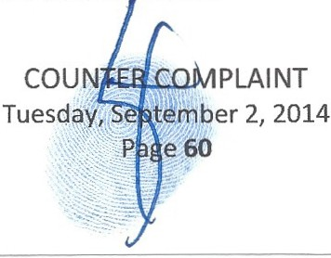

- Counter Plaintiff hereby reiterates and incorporates herein by reference, as if fully restated herein, preceding paragraphs 1through 310, inclusive.
- That a complex set of frauds have taken place in the Estates and Trusts of Simon and Shirley and some are already proven such as improper notarizations of Wills and Trusts of Simon, proven fraudulently notarized Waivers in Shirley's Estate, proven Fraud on this Court through use of a deceased person, Simon, to act as Personal Representative to close an Estate through documents filed by the law offices of Tescher and Spallina on behalf of a dead PR and with no notice to the Court for months that the PR that was filing the documents had passed and this was done with scienter with
this Court POST MORTEM through various fraudulent acts.

- That when Simon died the Estate of Shirley had not been closed and in order to attempt to change her beneficiaries of her Estate and Irrevocable Trusts, the scheme needed Simon to be alive and close the Estate and transfer her Shirley Trust property to him while alive so that it could be stated that he then changed her Shirley Trust irrevocable class of beneficiaries while living. Ifthe estate was not closed nothing could transfer officially and so since Simon did not close her Estate while living and acting as the PR and Trustee to her Shirley Trust, it was done for him Post Mortem to make it appear it happened while he was living.
- 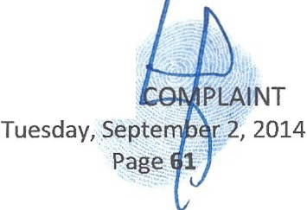That knowing that Simon's ALLEGED Power of Appointment was Limited and he could not make changes to the Shirley Trust class of beneficiaries after her death legally Simon never exercised his power of appointment while living and therefore Simon was used POST MORTEM for several months while he was dead to close Shirley's Estate. Then allegedly Simon attempted to amend his Simon Trust to try and make changes to Shirley's beneficiary class and his own. It is alleged that this was all done for Simon POST MORTEM, through already proven fraudulent documents and admitted forgeries, admitted altered trust documents d more that is alleged and currently under investigation.
COUNTER

- That virtually every act of the Fiduciaries and their Counsel has been fraudulent since the altering and changing of dispositive documents to illegally seize Dominion and Control of the Estates, Trusts and Corporate Entities in efforts to loot the Estates, Trusts and Corporate Entities of Simon and Shirley through various subsequently enacted fraudulent acts that remain ongoing and under investigation both civilly and criminally at this time.
- All conditions precedent to this action have been performed or occurred and continue. WHEREFORE, Counter Plaintiff prays for judgment against Counter Defendants for Frauds,
jointly and severally, personally and professionally, for remedies as may be awarded Counter

Plaintiff under other Counts herein, together with such other and further relief as the Court may deem just and appropriate.

COUNT 7 - BREACH OF FIDUCIARY DUTIES

- This is an action for Breach of Fiduciary Duties under Florida Statutes.

- Counter Plaintiff hereby reiterates and incorporates herein by reference, as if fully restated herein, preceding paragraphs I through 317, inclusive.
- That the fiduciaries of the Estates, Trusts and Corporate Entities sued hereunder are alleged to have gained their fiduciary positions through a series of fraudulent documents and other egregious acts of bad faith done with unclean hands through felony misconduct and more. Almost EVERY action the fiduciaries of the Estates and Trusts have taken since using fraudulent and forged documents and fraudulently altering others is a breach of fiduciary duties through combinations of self-dealing transactions, excessive compensations, excessive and unjustified legal fees (including billing for time to respond to investigators and more), improper and illegal investment decisions and a mass of pilfering and stealing of assets.
- 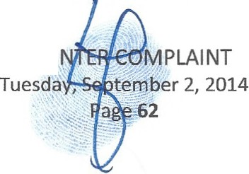That despite being aware of their involvement in criminal acts, the fact that they are under ongoing investigations, the fact that the dispositive docu ents have been challenged and found fraught with
cou

fraud and more, the fiduciaries, primarily now Theodore, since the counsel he brought to the Bernstein family, Tescher, Spallina, Manceri and now Pankauski are all removed and withdrawn from these matters citing irreconcilable differences with Theodore.
- Tescher and Spallina withdrew and cited such irreconcilable differences with Theodore and the Bernstein family entirely after admitting to fraudulently altering trust documents and more.
- That despite Prima Facie evidence in the dispositive documents Theodore acts under, that states that Theodore specifically cannot be a fiduciary, he continues to act in defiance as a fiduciary for purposes of making distributions he is explicitly prohibited from doing in the documents. The fact that Theodore and his Counsel Rose know that the alleged 2012 Simon Trust and the alleged 2008 Shirley Trust both have language that considers Theodore deceased and further language that considers him predeceased for distributions made under the Shirley Trust and Simon Trust, Theodore continues to act as a non-qualified fiduciary in violation of Probate and Trust Rules and Regulations.
- That Theodore has multiple and irrefutable conflicts of interest that preclude him from acting as a fiduciary, including conflicts with his own children, conflicts now with other beneficiaries caused by the fraud of his former counsel Tescher and Spallina where his family may lose all interests, conflicts with the Stansbury matter as he is the primary accused party of the bad acts against Stansbury and a defendant in that lawsuit. The Simon Estate, Simon Trust and Shirley Trust are tied up in that litigation as defendants and may have damages awarded against them and so the Estate and Trusts if damaged may end up suing Theodore if they are forced to settle or lose in the litigation. Therefore, Theodore cannot negotiate on the one hand for himself personally and as an officer of companies he owns and then negotiate as Trustee for the interests of the Estate and Trusts as a fiduciary, especially where he has no interests in the Estate and Trusts and would benefit for shifting the liabilities from settlement or suit to the Estate and Trusts instead of him elf personally and professionally where he

Tuesday, Septembe
Page 63

has everything to lose. These conflicts act as separate and distinct breaches of his fiduciary duties and require his withdrawal under Florida Probate and Trust Rules and Statutes.
- That Theodore has adverse interests against beneficiaries, in fact he has stated he wants to use "forceful and aggressive" tactics against Eliot in sworn statements in a hearing before this Court that further preclude his involvement forward as fiduciary in the Estates and Trusts of Simon and Shirley and require his withdrawal under Florida Probate and Trust Rules and Statutes.
- That despite Theodore knowing and being informed repeatedly of the reasons he cannot now serve in any fiduciary capacities in the Estates and Trusts of Simon and Shirley he continues with his counsel to act willfully, wantonly and grossly negligent in disregard of his fiduciary duties.
- That Theodore is alleged by his counsel to have took distributions against the advice of counsel as claimed by Spallina to Palm Beach County Sheriff Investigators, in transactions that Spallina claimed were legally impossible to them, all in efforts to loot further the Estates and Trusts before he is fully removed in every capacity in the Estates and Trusts of Simon and Shirley by this Court.
- That all fiduciaries to the Estates, Trusts and Corporate Entities sued hereunder have committed multiple Egregious Acts of Bad Faith with Unclean Hands in violation of thei r fiduciary duties and in violation of state and federal laws causing a mass of civil torts against Counter Plaintiffs through multiple, separate and distinct breaches of fiduciary duties.
- All conditions precedent to this action have been performed or occurred and continue.

WHEREFORE, Counter Plaintiff prays for judgment against all Counter Defendants in any fiduciary role for any of the trusts sued hereunder for Breach of Fiduciary Duties under 736.1001 Remedies for breach of trust and other applicable statutes both jointly and severally, personally and professionally , and for remedies as may be awarded Counter Plaintiff under other Counts herein, together with such other and further relief as the Court may deem just and appropriate.

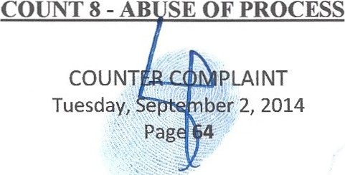

- This is an action for Abuse of Process under Florida Statutes.

- Counter Plaintiff hereby reiterates and incorporates herein by reference, as if fully restated herein, preceding paragraphs l through 329, inclusive.
- That improper use of the Court's process through Toxic, Vexatious, Fraudulent and Costly litigations, fraudulent and forged documents submitted to the Court, fraudulently altered trust documents and Toxic, Vexatious, Fraudulent and Costly pleadings and other illegal legal debauchery already defined herein that has taken place repeatedly, including the filing of this instant action with ulterior and improper motives of the Counter Defendants to now make their crimes already committed legal by attempting yet another fraud on this Court and passing further false instruments to this Court.
- That all of the document frauds have been implemented using Court processes to achieve Dominion and Control of the Estates and Trusts through a series of fraudulent dispositive documents crafted to commit fraud both on the Court and the Beneficiaries, Interested Parties and Creditors.
- That several instances of Fraud on this Court by Officers and Fiduciaries of this Court are already proven in these matters and this represents irrefutable PRIMA FACIE evidence of Abuse of Process, similar to the abuse of process in this action, whereby the Courts are being used to attempt to diffuse and cover up the crimes that have taken place already.
- That there are multiple abuses of process that are expensive and abusive to the beneficiaries, including legal harassment in efforts to further harm beneficiaries by causing expensive delays and disputes in estate and trust administration and billing up outrageous attorney fees and costs through frivolous and fraudulent pleadings and litigations such as this.
- All conditions precedent to this action have been performed or occurred and continue.

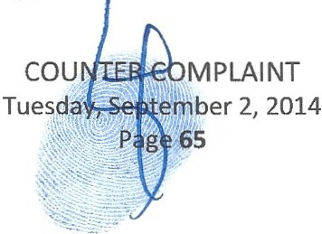WHEREFORE, Counter Plaintiff prays for judgment against Counter Defendants, jointly and severally, personally and professionally, for use of Process and for remedies as may be awarded

Counter Plaintiff under other Counts herein, together with such other and further relief as the Court may deem just and appropriate, together with such other and further relief as the Court may deem just and appropriate.

COUNT 9 - LEGAL MALPRACTICE

- This is an action for Legal Malpractice under Florida Statutes.

- Counter Plaintiff hereby reiterates and incorporates herein by reference, as if fully restated herein, preceding paragraphs 1through 336, inclusive.
- That Attorneys at Law, Spallina, Tescher, Manceri, Rose, Pankauski, Gortz and others have worked together in concert and with others to interfere and deprive in combinations and separately to commit frauds, frauds on the courts through intentional legal malpractice and more in direct efforts to commit a series of criminal wrongdoings and civil torts against parties to the Estates and Trusts of Simon and Shirley, which have enriched them greatly through legal fees and more.
- That all Attorneys at Law named as Counter Defendants hereunder have committed legal malpractice by subverting their clients' interests and participating in a variety of criminal acts resulting in a mass of civil torts to the true and proper Beneficiaries of the Estates and Trusts of Simon and Shirley and others.
- That through a web of conflicting interests and adverse interests the Attorneys at Law involved in this action and those involved in the probate of the Estates of Simon and Shirley have worked together in concert and with others, to interfere and deprive in combinations and separately, violating virtually the entire Attorney Conduct Codes, Probate and Trust Rules and Statutes and State and Federal Laws to injure Counter Plaintiff and others through legal malpractice and more.
- 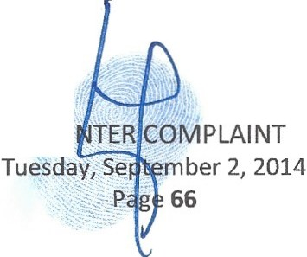That the Attorneys at Law have enriched themselves through these fraudulent activities they participated in and advanced to the disadvanta e of Eliot and his family and others involved through
cou

intentional acts where they directly violated their attorney ethics and law and so abused process to enact fraud after fraud.
- That the Attorneys at Law named hereunder as Counter Defendant, in some instances even admittedly, altered Estate and Trusts documents to enrich themselves and others, including their friend and client Theodore, while intentionally causing problems with the Beneficiaries to gin up disputes that resulted in excessive legal fees for themselves and the fiduciaries, in some cases the Attorneys also acting as the Fiduciaries and then counsel to themselves as the fiduciaries, as the case is with Tescher and Spallina.
- That Tescher and Spallina conspired together to change and alter Trust documents in Shirley's Estate in efforts to benefit their CLIENT, FRIEND and BUSINESS ASSOCIATE, Theodore.
- That all Attorneys at Law to the Estates, Trusts and Corporate Entities sued hereunder have committed multiple Egregious Acts of Bad Faith with Unclean Hands in violation of their Attorney Conduct Codes and Law causing a mass of civil torts against Counter Plaintiffs.
- All conditions precedent to this action have been performed or occurred and continue. WHEREFORE , Counter Plaintiff prays for judgment against Counter Defendants for Legal
Malpractice, jointly and severally, professionally and personally and for remedies as may be awarded Counter Plaintiff under other Counts herein, together with such other and further relief as the Court may deem just and appropriate.

COUNT 10 - EQUITABLE LIEN

- Counter Plaintiff hereby reiterates and incorporates herein by reference, as if fully restated herein, preceding paragraphs 1 through 345, inclusive.
- This is an action to impose an Equitable Lien on the Estates and Trusts Assets in both the Simon and Shirley Estates that were seized illegally from ecember 08, 2010 when Shirley deceased and then



ber 2,2014

further from September 13, 2012 when Simon deceased through a series of fraudulent activities that transferred Dominion and Control of the assets to improper parties and have since led to numerous other fraudulent activities under ongoing State and Federal investigations both civil and criminal.
- That this is an action for an Equitable Lien on the children's Trusts, all Trusts sued hereunder and all Estates, Trusts and Corporate Entities sued hereunder that Simon and Shirley had interests in, due to the fraudulent activity taking place in a wide array of Estate and Trust documents and to preserve and protect the assets from further ongoing loss and theft.
- That the Counter Defendants have become enriched unjustly due to the criminal acts and civil torts defined herein.
- All conditions precedent to this action have been performed or occurred and continue.

WHEREFORE, Counter Plaintiffs prays forjudgment for an Equitable Lien and for remedies as may be awarded Counter Plaintiff under other Counts herein, together with such other and further relief as the Court may deem just and appropriate.

COUNT 11 - ACCOUNTING

- Counter Plaintiff hereby reiterates and incorporates herein by reference, as if fully restated herein, preceding paragraphs l through 350, inclusive.
- This is an action against Theodore, Spallina and Tescher who have failed to provide statutorily required accountings for the Estates and Trusts they allege to be Trustees for to the Beneficiaries and Interested Parties and further for full formal accountings of all Trusts, Estates and Entities involved in the estate plans of Simon and Shirley and sued hereunder.
- 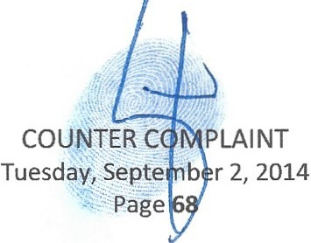That Theodore has failed to provide accounting in any of his alleged roles as a fiduciary in the Estates and Trusts of Shirley and Simon as require by law since he allegedly began acting as a fiduciary .

- That Theodore states he was appointed by Tescher and Spallina as Successor Trustee in the Simon Trust and has failed to file a transitional accounting since January 2014 in violation of Probate and Trust Rules and Statutes.
- That Spallina and Tescher and all other current and former trustees (excluding Benjamin Brown, Esq. the Curator of Simon's Estate and the new Successor PR of the Estate of Simon, Brian O'Connell, Esq.) failed to provide accountings or tender documents to Beneficiaries and Interested Parties according to well established probate rules and statutes in their roles as fiduciaries and counsel to the Estates and Trusts of Simon and Shirley as required by law.
- That Theodore after allegedly becoming Successor Trustee to the Trusts of Simon has failed to provide an accounting or any other evidence that he was elected legally as the Successor Trustee.
- That Theodore after acting for almost a year in Shirley's Estates and Trusts with no legal authority or notice or accountings to beneficiaries, was then appointed PR of the Estate of Shirley by Judge Colin and since October 2013 when he supposedly received Letters he has failed to provide an accounting, failed to provide his Letters and copies of the Shirley Will and all Schedules and Addendum to the beneficiaries, in violation of Probate Rules and Statutes.
- All Trustees in ALL of the Trusts created by Simon and Shirley Bernstein and so sued hereunder have failed to perform accounting under;
736.0813 Duty to inform and account-The trustee shall keep the qualified beneficiaries of the trust reasonably informed of the trust and its administration.
  - The trustee's duty to inform and account includes, but is not limited to, the following:
    - Within 60 days after acceptance of the trust, the trustee shall give notice to the qualified beneficiaries of the acceptance of the trust, the full name and address of the trustee, and that the fiduciary lawyer-client privilege in s. 90.5021 applies with respect to the trustee and any attorney employed by the trustee.
    - Within 60 days after the date the trustee acquires knowledge of the creation of an irrevocable trust, or the date the trustee acquires knowledge that a formerly revocable trust has become irrevocable, whether by the death of the settlor or otherwise, the trustee shall give notice to the qualified beneficiaries of the trust's existence, the identity of the settlor or settlors, the right to request a copy of the trust instrument, the right to accoun ·ngsunder this section, and that the

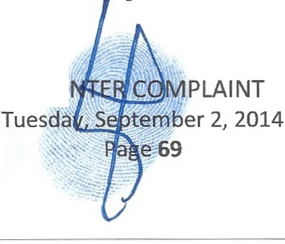
cou

fiduciary lawyer-client privilege in s. 90.5021 applies with respect to the trustee and any attorney employed by the trustee.
    - Upon reasonable request, the trustee shall provide a qualified beneficiary with a complete copy of the trust instrument.
    - A trustee of an irrevocable trust shall provide a trust accounting, as set forth in s. 736.08135, from the date of the last accounting or, ifnone, from the date on which the trustee became accountable, to each qualified beneficiary at least annually and on termination of the trust or on change of the trustee.
    - Upon reasonable request, the trustee shall provide a qualified beneficiary with relevant information about the assets and liabilities of the trust and the particulars relating to administration.

- That all Fiduciaries and Attorneys at Law to the Estates, Trusts and Corporate Entities sued hereunder have committed multiple Egregious Acts of Bad Faith with Unclean Hands in violation of their fiduciary duties by failing to provide legally timely accountings and have intentionally and with scienter have failed to provide accountings causing a mass of civil torts against Counter Plaintiff.
- That all fiduciaries sued hereunder have failed to provide complete copies and present for inspection upon requests by beneficiaries the complete trusts and wills of Simon and Shirley, in violation of Florida Probate Rules and Statutes.
- All conditions precedent to this action have been performed or occurred and continue. WHEREFORE, Counter Plaintiff demands judgment for accountings for ALL Estate and
Trusts of both Shirley and Simon sued hereunder that have been denied in violation of statutes and for remedies as may be awarded Counter Plaintiff under other Counts herein, together with such other and further relief as the Court may deem just and appropriate.

COUNT 12 - REMOVE COUNTER DEFENDANTS IMMEDIATELY FROM ALL FIDUCIARY AND LEGAL POSITIONS IN THE ESTATES, TRUSTS AND OTHER CORPORA TE ENTITIES SUED HEREUNDER
- This is an action to remove the current ALLEGED Trustee of the Estate and Shirley Trust and the Trustee of the Simon Trust, Theodore.
- 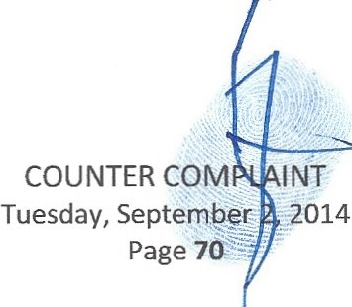Counter Plaintiff hereby reiterate and incorporate herein y reference, as if fully restated herein, preceding paragraphs 1 through 362, inclusive.

736.0706 Removal of trustee

- That on July 11th 2014 Theodore's Motion to be Appointed Personal Representative of the Estate of Simon to replace the Curator, Benjamin Brown, Esq. who was appointed after Tescher and Spallina were removed in all capacities from the Estates and Trusts of Simon and Shirley Bernstein amidst the criminal acts and civil torts proven, admitted and alleged in the Estates and Trusts thus far that they were a part of was withdrawn by Theodore and his counsel at the strong urging of this Court to withdraw the pleading.
- That Theodore made a bid to become the Successor PR of Simon's Estate, against a tidal wave of opposition and legally sound reasons that do not make him qualified now or ever to act in any fiduciary capacities in either the Estates and Trusts of Simon and Shirley. Theodore withdrew his request after wasting this Court and everyone's time, including a mass of legal fees encumbered by all parties in responding and coming to Court and allowed an independent Third Party Personal Representative to be elected, Brian O'Connell, Esq.
- That Theodore is not now qualified to be Personal Representative or Trustee or Manager of any of Simon and Shirley's Wills and Trusts and other entities created by them for the beneficiaries, as he has a plethora of Conflicts of Interests, he has absolute Adverse Interests in both Simon and Shirley's Estates and Trusts, he is under ongoing criminal investigations and civil actions that further make
him conflicted and unable to legally serve and he must instantly be removed by this Court to preserve and protect the assets of Simon and Shirley from further Fraud and more that Theodore is the central alleged perpetrator of.
- That Theodore has directly benefited the most from the riminal acts already proven, admitted and

alleged.

COUNTER
Tuesday, Septembe 2
Page 71

- That Theodore has been considered in all Wills and Trusts of Simon and Shirley as PREDECEASED and for purposes of distributions made thereunder and thus cannot be Successor Trustee as he is dead and prohibited by explicit language in the Simon Trust and Shirley Trust.
- That Theodore has no real beneficial interest in these matters due to his disinheritance and in light of the allegations against him it is strange that he wants to continue to act as a Fiduciary. In fact, he is being sued for Breaches of Duties and due to the fact that all of the ongoing frauds were allowed under his tutelage and were aided and abetted by his Attorneys at Laws that represented him and that are his friends and business associates, all who came in to the Simon and Shirley Estate and Trust matters through their relation to Theodore.
- Theodore must be removed as he and his sister Pamela are the direct benefactors of all these problems and criminal acts committed thus far, to the disadvantage of other beneficiaries , interested parties and creditors and thus are adverse to other beneficiaries where their families may be wholly disinherited and their children receive nothing if they do not act in their own best interests and not the beneficiaries.
- All conditions precedent to this action have been performed or occurred and continue. WHEREFORE, Counter Plaintiff prays for judgment to REMOVE COUNTER
DEFENDANTS IMMEDIATELY FROM ALL FIDUCIARY AND LEGAL POSITIONS IN THE ESTATES AND TRUSTS AND OTHER ENTITIES OF SIMON AND SHIRLEY BERNSTEIN, to
SEIZE ALL RECORDS and Estate and Trust Assets from all Counter Defendants regarding the Estates, Trusts and Corporate Entities Sued hereunder and for remedies as may be awarded Counter Plaintiff under other Counts herein, together with such other and further relief as the Court may deem just and appropriate.

COUNT 13 - PRELIMINARY INJUNCTION


cou

- This is an action under Florida Statute 526.312 and any other applicable statutes to prohibit instantly the current ALLEGED Trustee of the Shirley Trust and Simon Trusts, Theodore from taking any further actions in any fiducial capacities without Court approval until these matters of fraud and more can be fully resolved both criminally and civilly before this Court and state and federal civil authorities.
- Counter Plaintiff hereby reiterates and incorporates herein by reference, as if fully restated herein, preceding paragraphs 1 through 372, inclusive.
- That this injunction should freeze all assets held in ALL Trusts, Estates and Entities named hereunder to preserve them from further fraud being committed by fiduciaries and counsel to the fiduciaries, who are all alleged to be directly involved in the prior criminal acts, ongoing alleged criminal acts and admitted criminal acts and that no further acts regarding the assets should be made without direct Court approval, including ALL Attorney at Law fees, costs or any other transactions
other than those already arranged by the Court with Brian O'Connell and Benjamin Brown. That this is to include all properties held in all Trusts. Estates and Corporate Entities sued hereunder that Simon and Shirley owned or had interests in.
- All conditions precedent to this action have been performed or occurred and continue.

- All conditions precedent to this action have been performed or occurred and continue.

WHEREFORE, Eliot prays for judgment a Preliminary Injunction and for remedies as may

be awarded Counter Plaintiff under other Counts herein, together with such other and further relief as the Court may deem just and appropriate.
WHEREFORE, Eliot further prays further for judgment for the following,

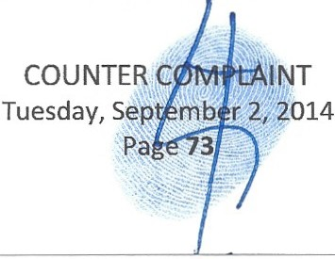1. to have 120 days to Amend this Counter Complaint and notices this Court that this complaint was done while Eliot is undergoing dental work that has had him medicated on narcotic analgesics and the muscle relaxer flexeril and herefore request an extension.

IL A verified statement by Judge Martin Colin and David French stating that they have no conflicts of interest with these matters where the crimes have occurred in and upon their Courts and further stating that their involvement directly in the case and fact that they will both be material and fact witnesses to the crimes that occurred in their Courts by Officers of the Court that they approved and had Jurisdiction over who committed felonious acts in and upon their Courts. This request is to help overcome any appearance of impropriety that is created by their handling a lawsuit where they and the Officers of their Courts are centrally involved in the criminal misconduct and civil torts. Inother words so the general public would not think that any judge could be covering up crimes committed in and upon their court for themselves and officers of their court involved directly and indirectly in the crime. This statement should affirm to the beneficiaries, interested parties and creditors that any involvement in the cases forward would violate no known, attorney conduct codes, jud icial canons, state and federal law and in no way can be viewed to prejudice the rights of any parties subject to the lawsuit.
m. That Eliot prays this Court demand the alleged Fiduciaries to release funds to Eliot to hire counsel for his family, his children, and for the Trust separate from the Alleged Trustee counsel to protect the innocent beneficiaries from further damage in these matters that they have deemed essential to the administration of the Estate and Trusts of Simon and Shirley and since these legal actions are the direct result of fraud caused by the fiduciaries and their counsel in part and have forced Eliot and his children to need separate and distinct counsel to defend their interests. The PR's and Trustees have refused repeated requests for legal fees even for the minor children and so this Court must Order them to pay.
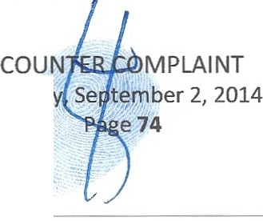iv. That as this case is similar and related to the probate estate and trust cases before this Court already and the Counter Defendants are imilar to the Respondents in those matters that
Tuesda

Service of this Counter Complaint be waived by the Court, other than through email service and ECF service to save Eliot monies as he is indigent due to intentional delays in his inheritance caused by Officers of this Court and others to directly harm Eliot and prevent him from having legal representation . Any fees to file this Counter Complaint should also be paid for by the Estates and Trusts until it can be recovered from the responsible parties who
caused these costs to be necessary as a result of their frauds and more. That already in the Oppenheimer Counter Complaint many parties that are inthe related cases including many attorneys at law are refusing to waive service and force Eliot to send a Marshal instead and waste more monies. Attorneys hiding from service of process, unheard of in matters they
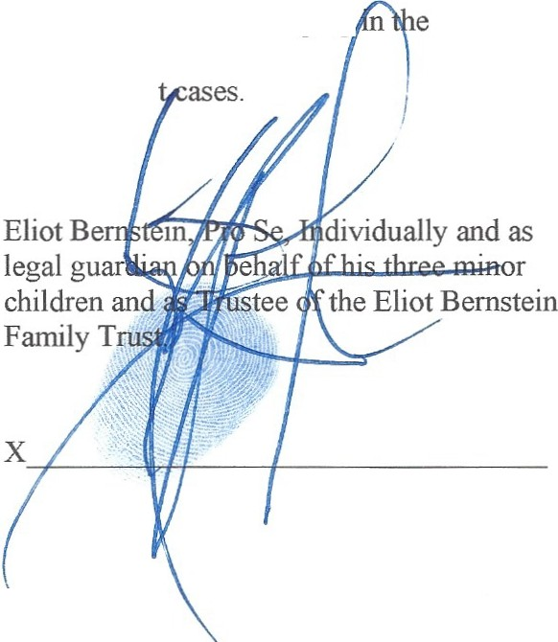created from their criminal acts in many of the instances of service dodging Oppenheimer matter by Respondents inthe Estate and Trus
Filed on Tuesday, September 2, 2014.

CERTIFICATE OF SERVICE

I, ELIOT IVAN BERNSTEIN , HEREBY CERTIFY that a true and c rrect copy of the

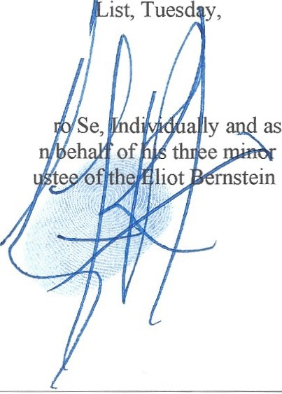
foregoing has been furnished by email to all parties on the following Service

September 2, 2014,

Eliot Bernstein, P legal guardian o children and Tr Family Trust.

COUNT PLAINT
Tuesday:<::.'....t'll'PN:..
-"

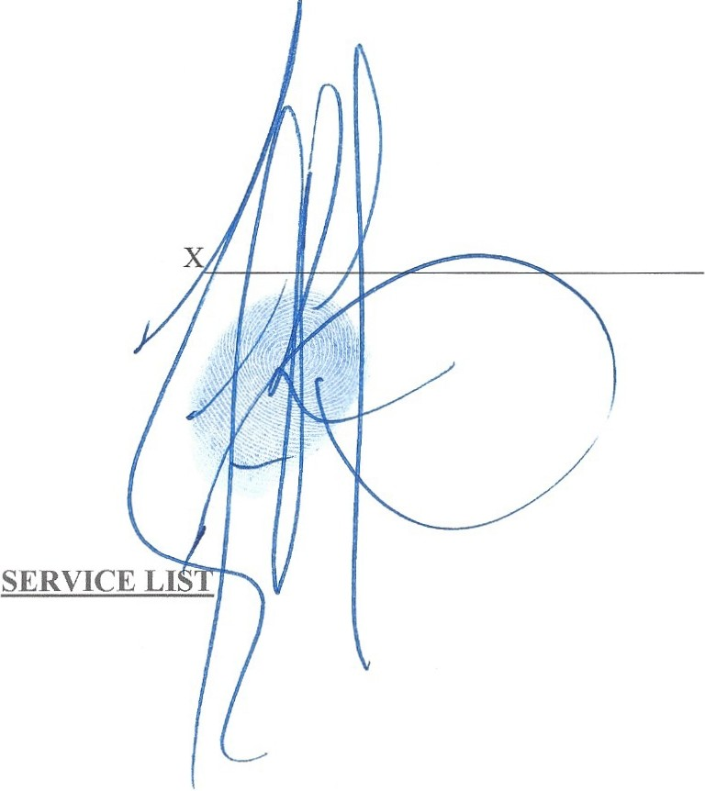

Robert L. Spallina, Esq., Tescher & Spallina, P.A. Wells Fargo Plaza
925 South Federal Hwy Suite 500 Boca Raton, Florida 33432 rspallina@tescherspallina.com kmoran@tescherspal lina.com ddustin@tescherspallina.com

Ted Bernstein 880 Berkeley
Boca Raton, FL 33487
tbernstein@lifeinsuranceconcepts.co m
John J. Pankauski,Esq. Pankauski Law Firm PLLC 120 South Olive Avenue 7th Floor
West Palm Beach,FL 33401

Pankauski Law Firm PLLC 120 South Olive Avenue 7th Floor
West Palm Beach,FL 33401 courtfilings@pankauski lawfirm.com john@pankauski lawfirm.com

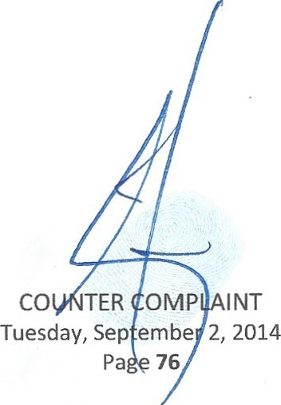

Donald Tescher, Esq., Tescher & Spallina, P.A. Wells Fargo Plaza
92S South Federal Hwy Suite SOD Boca Raton, Florida 33432 dtescher@tescherspalli na.com ddustin@tescherspallina.com kmoran@tescherspal lina.com

TESCHER & SPALLINA, P.A .
Wells Fargo Plaza
92S South Federal Hwy Suite SOD Boca Raton, Florida 33432 dtescher@tescherspalli na.com ddustin@tescherspal lina.com kmoran@tescherspallina. com

Ted Bernstein
Life Insurance Concepts et al. 9SO Peninsula Corporate Circle Suite 3010
Boca Raton,FL 33487
tbernstein@Iifeinsuranceconcepts.co

m

Alan B. Rose, Esq.
PAGE, MRACHEK, FITZGERALD, ROSE, KONOPKA, THOMAS & WEISS,P.A.
SOS South Flagler Drive, Suite 600 West Palm Beach,Florida 33401 arose@pm-law.com
and
arose@mrachek-law.com

Pamela Beth Simon
9SO N. Michigan Avenue Apartment 2603
Chicago,IL 60611
psimon@stpcorp.com

Pamela Simon President
STP Enterprises, Inc. 303 East Wacker Drive Suite 210
Chicago IL 60601-S210
psimon@stpcorp .com

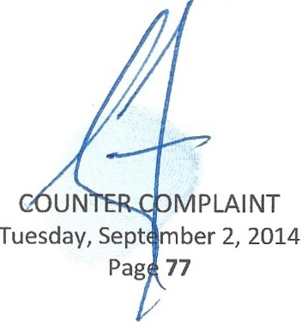

Mark R. Manceri,Esq.,and Mark R.Manceri,P.A.,
2929 East Commercial Boulevard Suite 702
Fort Lauderdale, FL 33308 mrmlaw@comcast. net mrmlawl@gmail.com

L. Louis Mrachek, Esq.
PAGE, MRACHEK, FITZGERALD, ROSE, KONOPKA, THOMAS & WEISS, P.A.
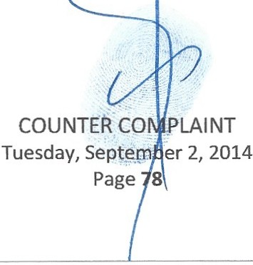505 South Flagler Drive, Suite 600 West Palm Beach, Florida 33401 lmrachek@mra ek-law.com

Charles D. Rubin Managing Partner
Gutter Chaves Josepher Rubin Forman Fleisher Miller PA
Boca Corporate Center
2101 NW Corporate Blvd.,Suite 107 Boca Raton, FL 33431-7343 crubin@floridatax.com

Kimberly Moran Tescher & Spallina, P.A. Wells Fargo Plaza
925 South Federal Hwy Suite 500
Boca Raton,Florida 33432 kmoran@tescherspal lina.com

Jill lantoni
2101 Magnolia Lane Highland Park, IL 60035 jilliantoni@gmail.com

Lindsay Baxley aka Lindsay Giles Life Insurance Concepts
950 Peninsula Corporate Circle Suite 3010
Boca Raton, FL 33487
lindsay@lifeinsuranceconcepts.com

Lisa Friedstein
2142 Churchill Lane Highland Park, IL 60035 Lisa@friedsteins.com
lisa.friedstein@gmail.com lisa@friedstei s.com

Estate of Simon Bernstein Personal Representative Brian M. O'Connell, Partner
Ciklin Lubitz Martens & O'Connell 515 N Flagler Drive
20th Floor
West Palm Beach,FL 33401 boconnell@ciklinlubitz.com jfogl ietta@cikli nlubitz.com

