UNITED STATES DISTRICT COURT
SOUTHERN DISTRICT OF NEW YORK
X

ELIOT I. BERNSTEIN, et al. DOCKET NO: 07Civ11196 (SAS)
[rel. 07 Civ 09599]
Plaintiffs,

-against-

APPELLATE DIVISION FIRST

DEPARTMENT DEPARTMENTAL

DISCIPLINARY COMMITTEE, et al.

MOTION FOR RECONSIDERATION AND REVERSAL OF ORDER

Defendants

X

MOTION FOR RECONSIDERATION AND REVERSAL OF ORDER

PLAINTIFFS, ELIOT I. BERNSTEIN, Pro se, individually and P. STEPHEN LAMONT, Pro se and Plaintiff BERNSTEIN on behalf of shareholders of Iviewit Holdings, Inc., Iviewit Technologies, Inc., Uview.com, Inc., Iviewit Holdings, Inc., Iviewit Holdings, Inc., Iviewit.com, Inc., Iviewit.com, Inc., I.C., Inc., Iviewit.com LLC, Iviewit LLC, Iviewit Corporation, Iviewit, Inc., Iviewit, Inc., and other John Doe companies (collectively, “Iviewit Companies”), and patent interest holders, move this honorable Court to reconsider and reverse the Order dated May 9, 2008 in this case and in support state as follows:
REQUEST FOR RECONSIDERATION AND REVERSAL
- Plaintiffs are in receipt of your Order dated May 9, 2008 (“Order”). Plaintiffs oppose the Order as it appears that from that Order that motions to dismiss will be decided on based on the Complaint and not the properly and timely Amended Complaint according to the Court order granting Plaintiffs Motion to File an Amended Complaint dated April 17, 2008. Whereby staying the service of the Amended Complaint after your order of April 17, 2008 granting the Plaintiffs motion to file an Amended Complaint seriously prejudices Plaintiffs, as where in the Motion to Dismiss filed by The Florida Bar counsel it was claimed that there was a failure to state a claim and other objections and whereby the Amended Complaint cures such objections.
- That Plaintiffs have consistently advised the Court that the Complaint was filed Pro Se, to aid the heroic efforts of the inside whistleblower Anderson that this case is related too and as such was rushed to file in time for her initial hearing with the intent of submitting an Amended Complaint to cure any defects caused by such rush.
- That the only Defendant at this time to file a Motion to Dismiss, The Florida Bar, submitted a letter stating that they considered their own Motion to Dismiss moot pending the Amended Complaint (Exhibit 1) and as such would need to respond to the Amended Complaint versus the Complaint.
- That Proskauer has also submitted a letter, that Plaintiffs previously submitted to this Court in the Plaintiffs Motion In Opposition to the Order dated May 15, 2008, where Proskauer requests Plaintiffs clarification of the Order, wherein it appears, although not certain, that Proskauer plans on responding to the Amended Complaint.
- That Plaintiffs’ request that all Defendants need to respond to the properly and timely filed Amended Complaint according to your order of April 17, 2008 when filing their answers or motions to dismiss.
- That Plaintiffs state that per the Court rules, in so far as Plaintiffs are entitled to file one Amended Complaint without Court approval prior to any Answers, and where no Answers have yet been filed it appears that this Amended Complaint should be filed and served accordingly and responded to by all Defendants, replacing the Complaint.
- That Plaintiffs’ filed with the Court a motion for filing an Amended Complaint and whereby it was granted by this Court and as such should be accepted and served without stay for all old and new Defendants to respond to accordingly.
- That the letter by Proskauer to stay the Amended Complaint may have been tendered by conflicted counsel in these matters, Proskauer, and whereby the merits of the conflict issues should be resolved prior to Proskauer having an effect on the case from such conflicted actions, prejudicing Plaintiffs’ chances of success while possibly acting in conflict. Whereas this same conflict issue must also be addressed by the Court with Greenberg Traurig, PA, and whereby Plaintiffs and Greenberg Traurig, PA differ on issues of conflict in their former representation on behalf of Plaintiff Bernstein and their current representation of their client, The Florida Bar. Before any decisions by the Court in response to any declarations by such possibly conflicted counsel, including anticipated motions to dismiss, prejudice the case, should not the conflict issues be resolved first to avoid prejudice? The Court’s earlier Order claimed, “Any further consideration of the substantive issues raised by plaintiffs, including plaintiffs’ requests regarding conflicts of interest, must await the resolution of anticipated motions to dismiss” and Plaintiffs ask this Court to reverse that process and decide the conflict issues with all parties first, including, Proskauer, Foley and Greenberg, as already raised and supported with facts to this Court, and then consider motions to dismiss submitted by non conflicted third party counsel. That in light of the Amended Complaint’s inclusion of the Office of Attorney General and Eliot Spitzer and cause of action for such is stated in the Amended Complaint and whereby Proskauer was counsel for former Attorney General Spitzer, the New York Attorney General’s representation further in the matter may be conflicted. Where this may cause certain Defendants represented by the New York Attorney General to need third party non-conflicted counsel.
- That Plaintiffs’ state that the Proskauer request to this Court to stay service of the Amended Complaint was premature and when viewed in light of the filed Amended Complaint, the reasons stated in that request for stay become moot as their concerns are addressed in the Amended Complaint.
WHEREFORE, based on the above, Plaintiffs request this Court reconsider and reverse the Order and lift any temporary stay on new and old Defendants, reversing the prior Order to remove any chance of prejudicing Plaintiffs. That Plaintiffs further seek this Court to resolve all conflict of interest issues with attorneys Proskauer, Foley, Greenberg and the New York Attorney General prior to allowing further representations, or further rulings on earlier filings whereby they may have been tendered in conflict of interest, thus prejudicing Plaintiffs and where such pleadings in conflict would presumably be stricken from the record other than as evidence of the conflicts.
Exhibit 1 – Greenberg Traurig Letter
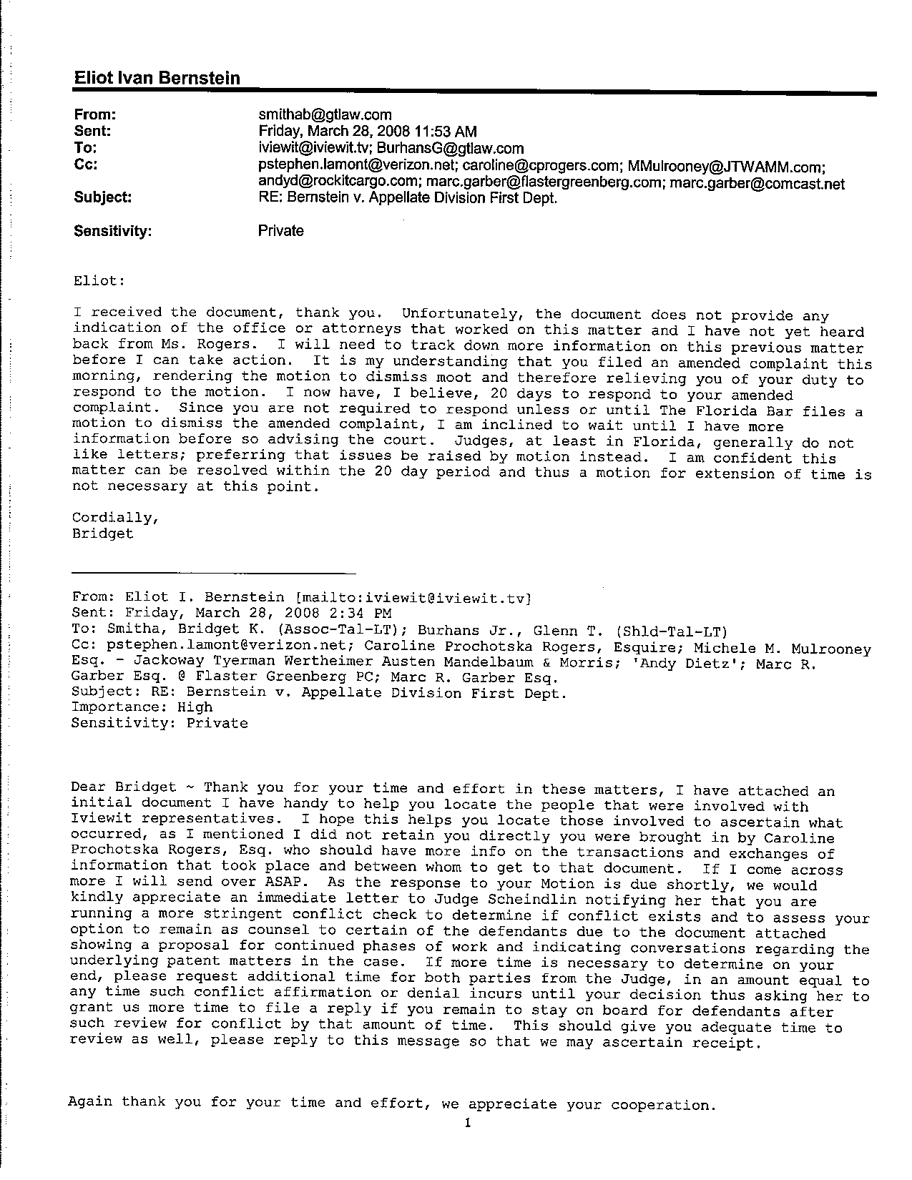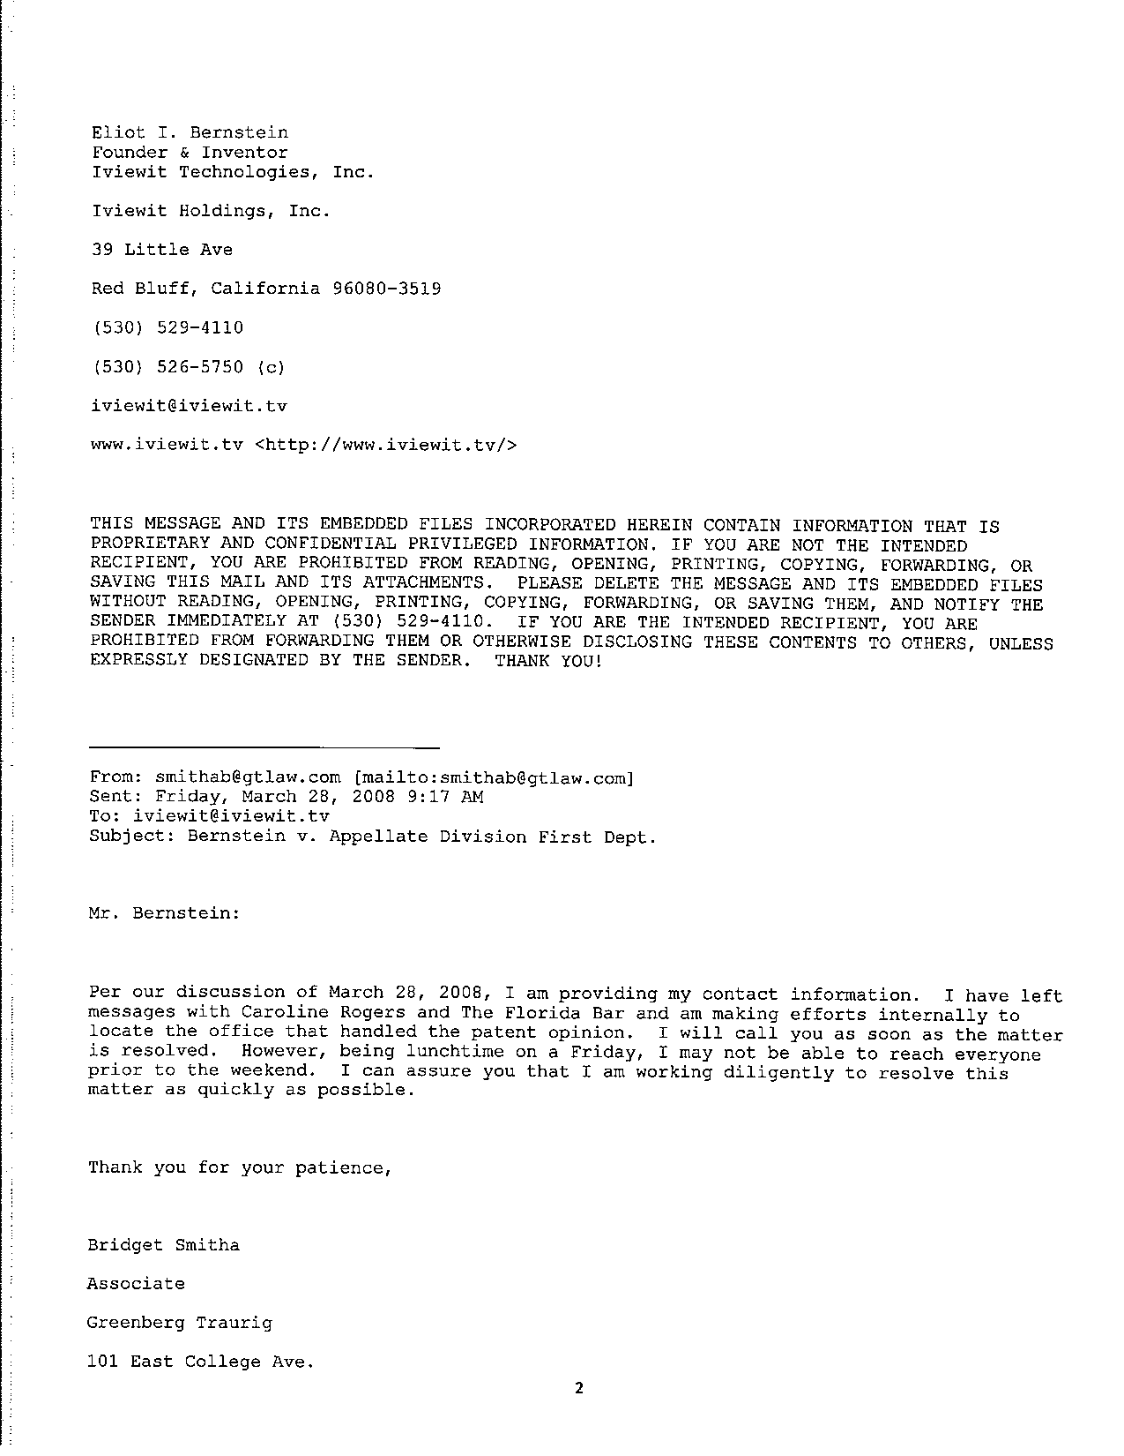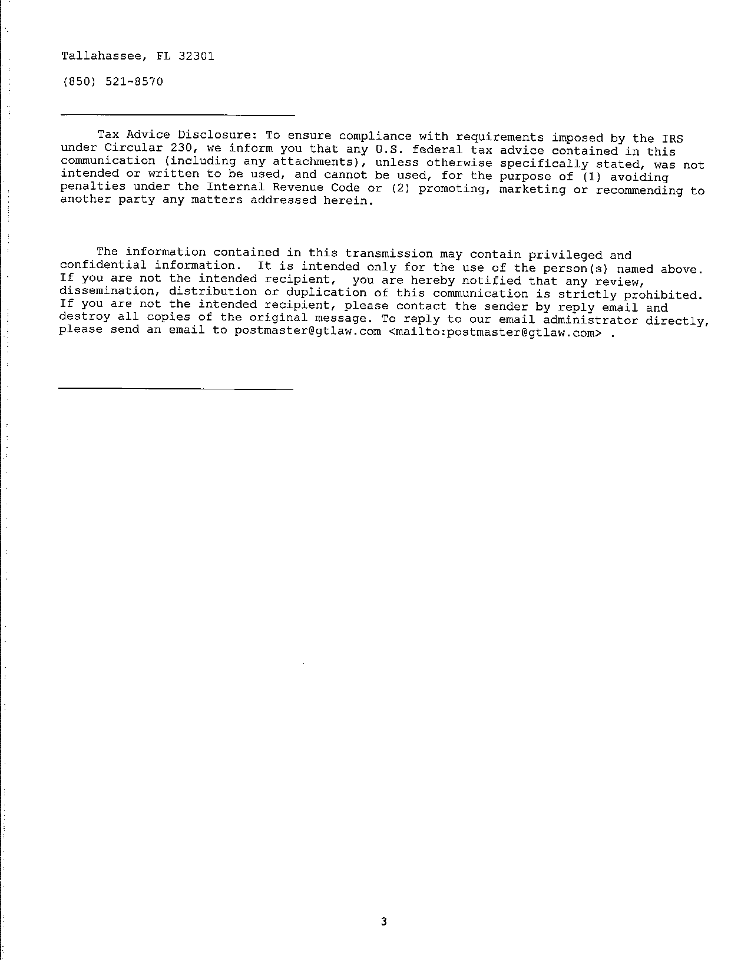

Attorney for Petitioners
Eliot I. Bernstein, Pro se
39 Little Avenue
Red Bluff, Cal. 96080
Tel.: (530) 529-4410

By:
Eliot I. Bernstein

AFFIDAVIT OF SERVICE

I hereby certify that a true and correct copy of the foregoing will be furnished by facsimile or email and/or U.S. Mail, per the requests of Defendants, on the 16th day of April 2008 on the Defendants.

Eliot I. Bernstein, Pro se

