UNITED STATES DISTRICT COURT
SOUTHERN DISTRICT OF NEW YORK
X

ELIOT I. BERNSTEIN, et al. DOCKET NO: 07Civ11196 (SAS)
[rel. 07 Civ 09599]
Plaintiffs,

-against-

APPELLATE DIVISION FIRST

DEPARTMENT DEPARTMENTAL

DISCIPLINARY COMMITTEE, et al.

MOTION IN OPPOSITION TO ORDER

Defendants

X

MOTION IN OPPOSITION TO STAY ORDER DATED MAY 09 2008 ~ REQUEST FOR CLARIFICATION OF ORDER

PLAINTIFFS, ELIOT I. BERNSTEIN, Pro se, individually and P. STEPHEN LAMONT, Pro se and Plaintiff BERNSTEIN on behalf of shareholders of Iviewit Holdings, Inc., Iviewit Technologies, Inc., Uview.com, Inc., Iviewit Holdings, Inc., Iviewit Holdings, Inc., Iviewit.com, Inc., Iviewit.com, Inc., I.C., Inc., Iviewit.com LLC, Iviewit LLC, Iviewit Corporation, Iviewit, Inc., Iviewit, Inc., and other John Doe companies (collectively, “Iviewit Companies”), and patent interest holders, move this honorable Court to clarify the Order dated May 9, 2008 in this case and in support state as follows:
REQUEST FOR CLARIFICATION OF ORDER
- Plaintiffs are in receipt of your Order dated May, 9, 2008. Plaintiffs want to confirm our understanding of your Honor's Order, and reserve the right to oppose the Order if necessary. The Order states that the additional Defendants will be served after Your Honor rules on the pending motions to dismiss. That will start the time period for responsive pleadings. Plaintiffs assume this was ordered to allow the Court to maintain proper order and scheduling in this case, so that pending and anticipated motions can be determined, resulting in the additional Defendants being served thereafter. Plaintiffs also assume that since the Court is not "Served", but instead the Amended Complaint was properly filed, that it is a Pleading, although not yet docketed and is part of the record as of this time. Plaintiffs filed the Amended Complaint which does not appear on the docket but other documents filed with it are and Plaintiffs want to clarify that the Amended Complaint constitutes a Pleading that will be formally docketed. As such, Plaintiffs can use it in responding to Defendant's motions and for other similar purposes.
- Plaintiffs also assume that the additional Defendants will be served regardless of the outcome of the Motions practice, as many new Defendants have that status irrespective of the initially named defendants based on their alleged actions and inactions as set forth in the Amended Complaint. Please respond to this Motion in Opposition to Order and confirm our understandings, whereby if correct they may save the Court having to review a more formal motion in opposition to the stay Order.
- Where it appears from the attached letters dated May 13, 2008 from Proskauer to Plaintiffs (Exhibit 1), Kent Anker letter dated May 14, 2008 to Plaintiffs (Exhibit 2) and an email accepting the Amended Complaint from Greenberg Traurig, PA, on May 14, 2008 (Exhibit 3) that Proskauer, Greenberg and Anker also appear confused by the May 09, 2008 Order and appear to seek confirmation of their opinions of Your Honor’s Order from Pro Se guys versus Your Honor, and, whereby Plaintiffs await an answer to this request for clarification before presuming to know any answers or taking any actions predicated on assumption.
- Plaintiffs also request to know if the Court will have the Marshal’s Office serve the Amended Complaint on all old defendants, due to the problems with the original service of the Complaint, due to mail problems, due to actions from other than Plaintiffs. That in the MOTION FOR PRO SE OFFICE TO COPY AND TRANSMIT AMENDED COMPLAINT TO U.S. MARSHAL’S OFFICE which in part was denied for the time being by Your Honor, that question remains unanswered but to clarify confusions, Plaintiffs again ask this Court to have the Marshal’s service serve the old defendants the Amended Complaint, as well as, later the new defendants servicing of the Amended Complaint at the Court’s discretion. If the Court would like Plaintiffs to serve the old defendants the Amended Complaint please issue clarification as it was unclear in the prior Order of May 09, 2008 of whether Plaintiffs should and whereby to facilitate in the spirit of adversarial etiquette a copy of the Amended Complaint was sent to Proskauer, as per their request and a copy to all those they carbon copied their letter too. Where in no way was this sending a copy intended to be servicing of the copy but it appears that some felt that it was and some did not?
WHEREFORE, based on the above, Plaintiffs request this Court provide clarification to the Order dated May 9, 2008 and if such interpretations offered by Plaintiffs are incorrect, allow Plaintiffs time to oppose the Order formally after clarification. Plaintiffs believe that the stay requested by Proskauer was premature and that after this Court reviews the filed Amended Complaint, the Court will order all defendants to be served timely with the Court’s schedule and direction, lifting any temporary stay at such time, as Proskauer’s arguments to stay the service of the Amended Complaint were based on a draft amended complaint and all those arguments to stay are moot when viewed against the filed Amended Complaint.
Exhibit 1 – Proskauer Letter Dated May 13, 2008
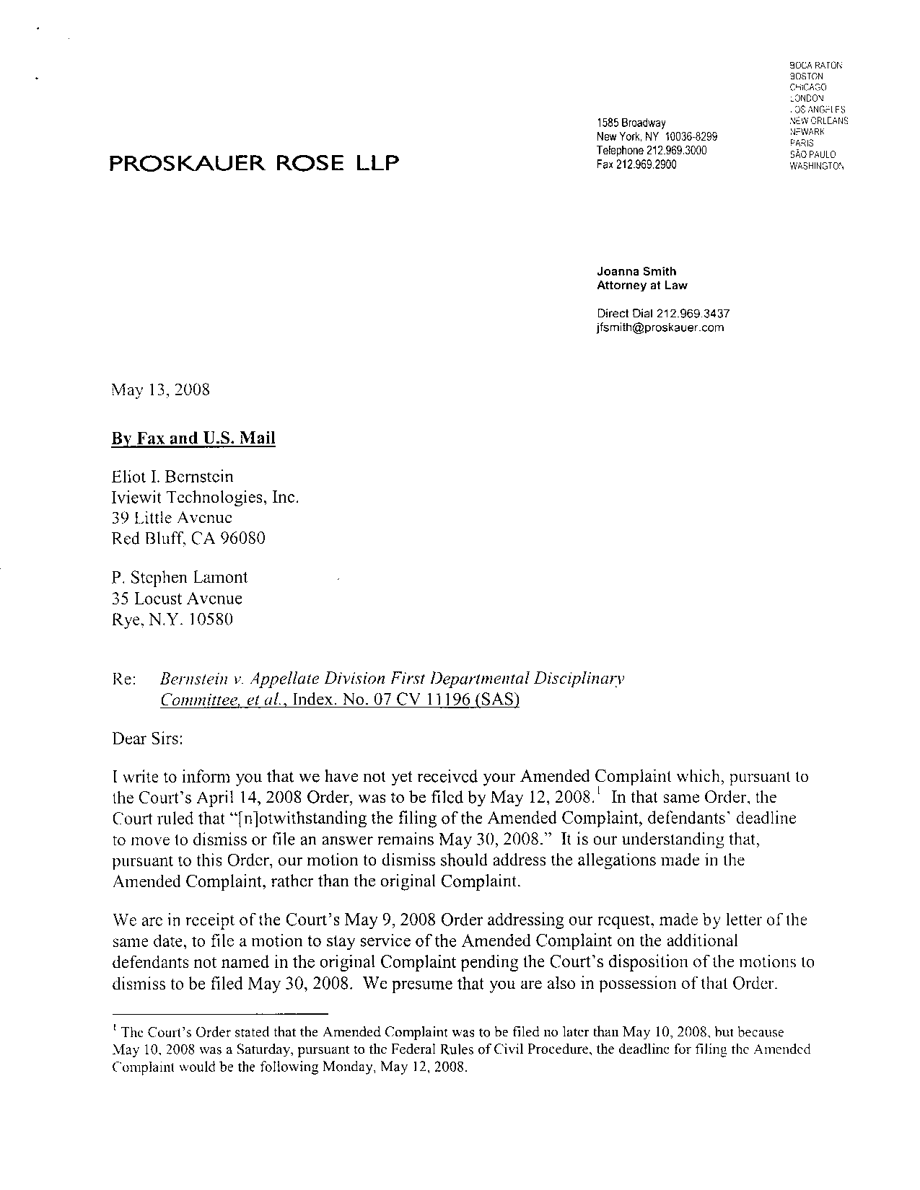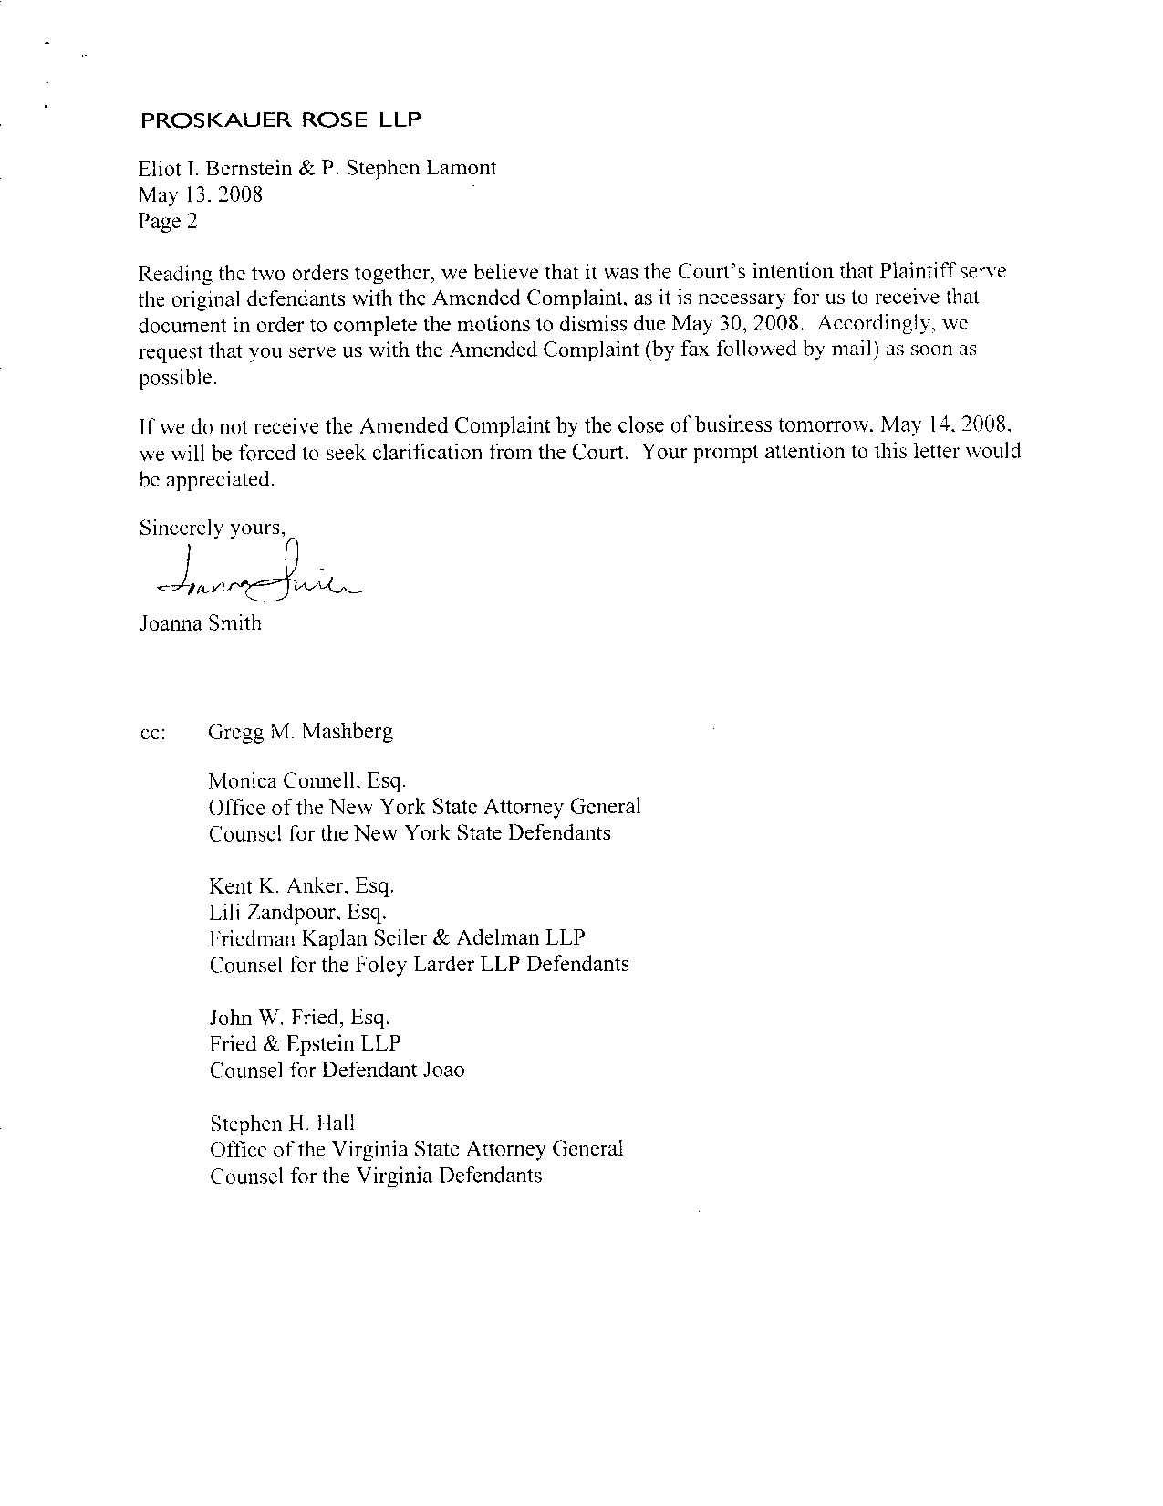
Exhibit 2 – Kent Anker Letter Dated May 14, 2008
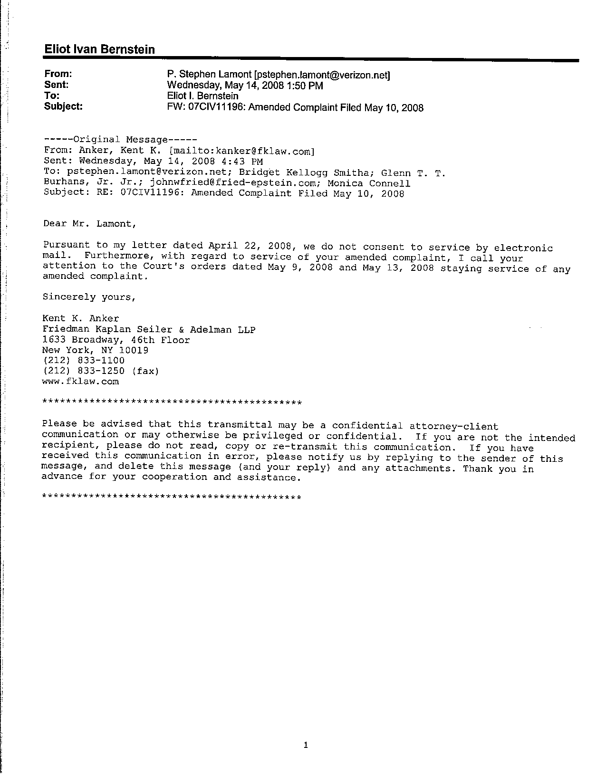
Exhibit 3 – Greenberg Traurig Letter May 14, 2008
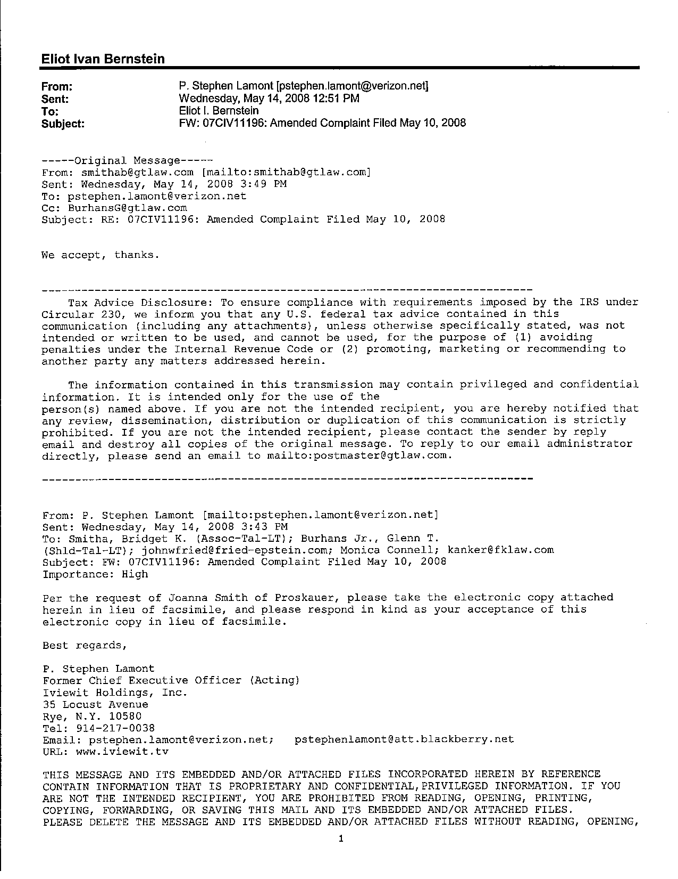

Attorney for Petitioners
Eliot I. Bernstein, Pro se
39 Little Avenue
Red Bluff, Cal. 96080
Tel.: (530) 529-4410

By:
Eliot I. Bernstein

By:
P. Stephen Lamont
AFFIDAVIT OF SERVICE

I hereby certify that a true and correct copy of the foregoing will be furnished by facsimile or email and/or U.S. Mail on the 15th day of April 2008 on the defendants.

Eliot I. Bernstein, Pro se

P. Stephen Lamont, Pro se

