

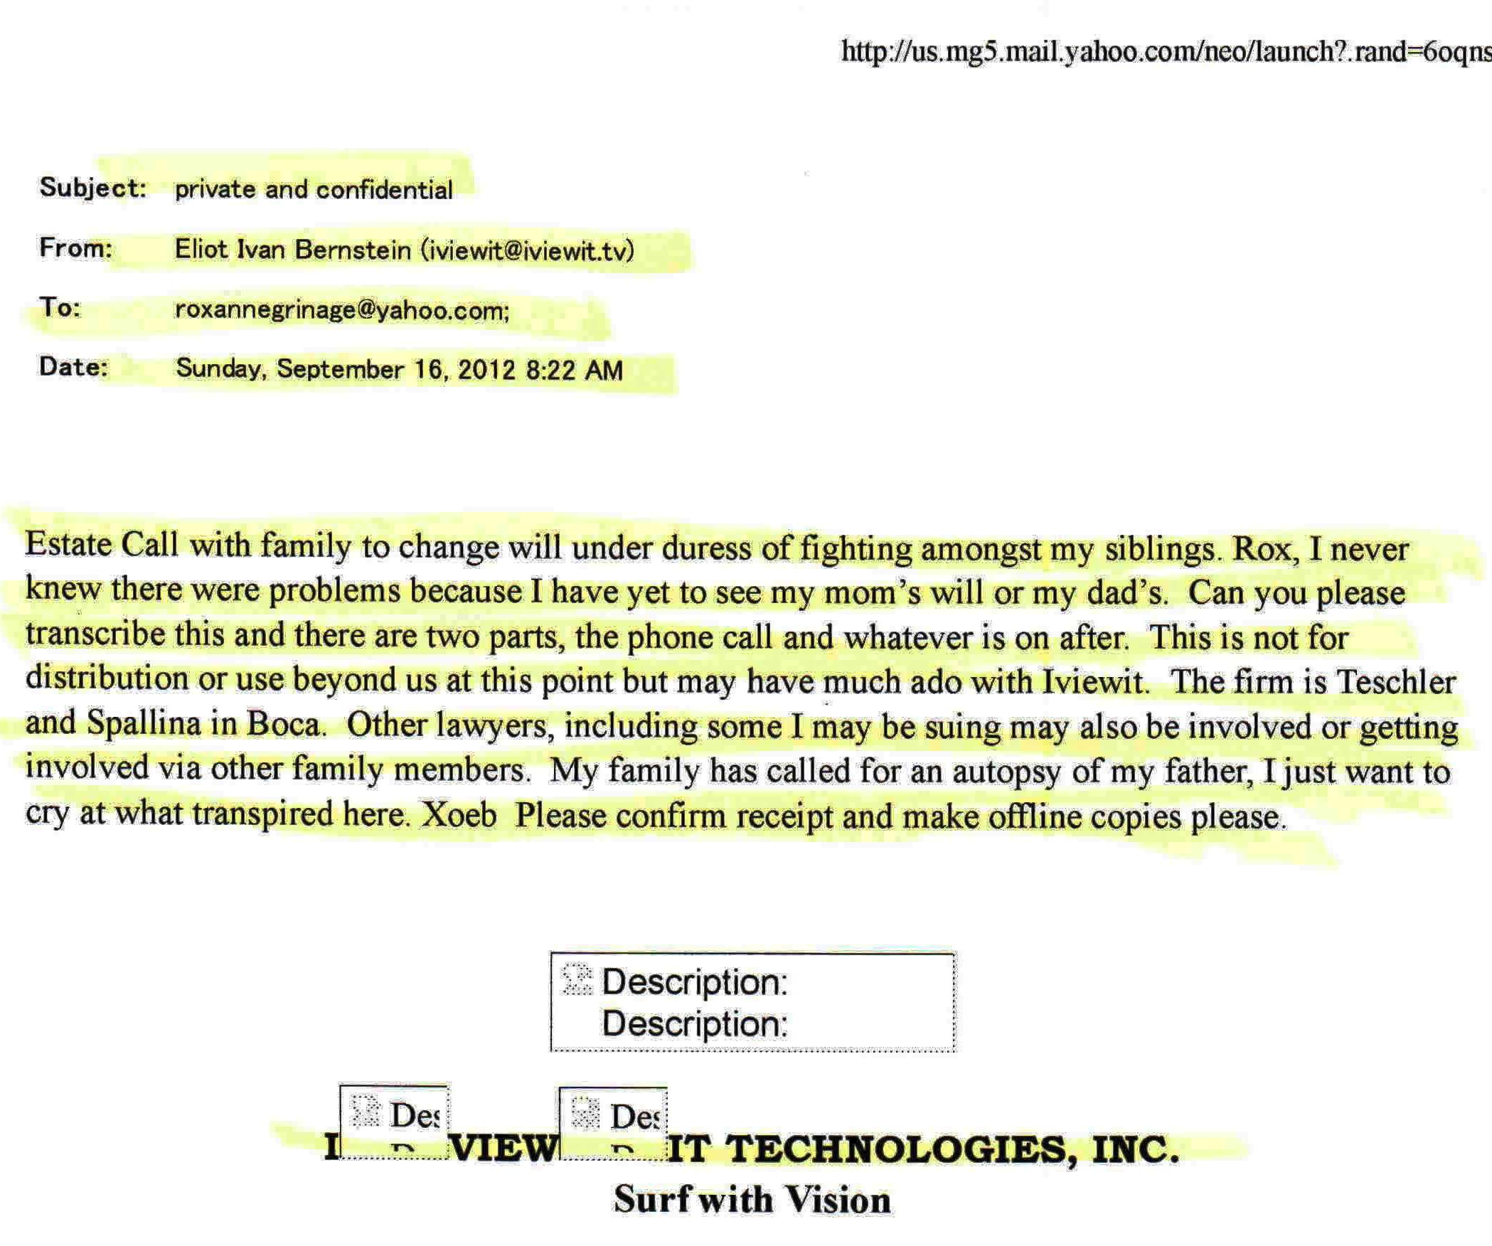

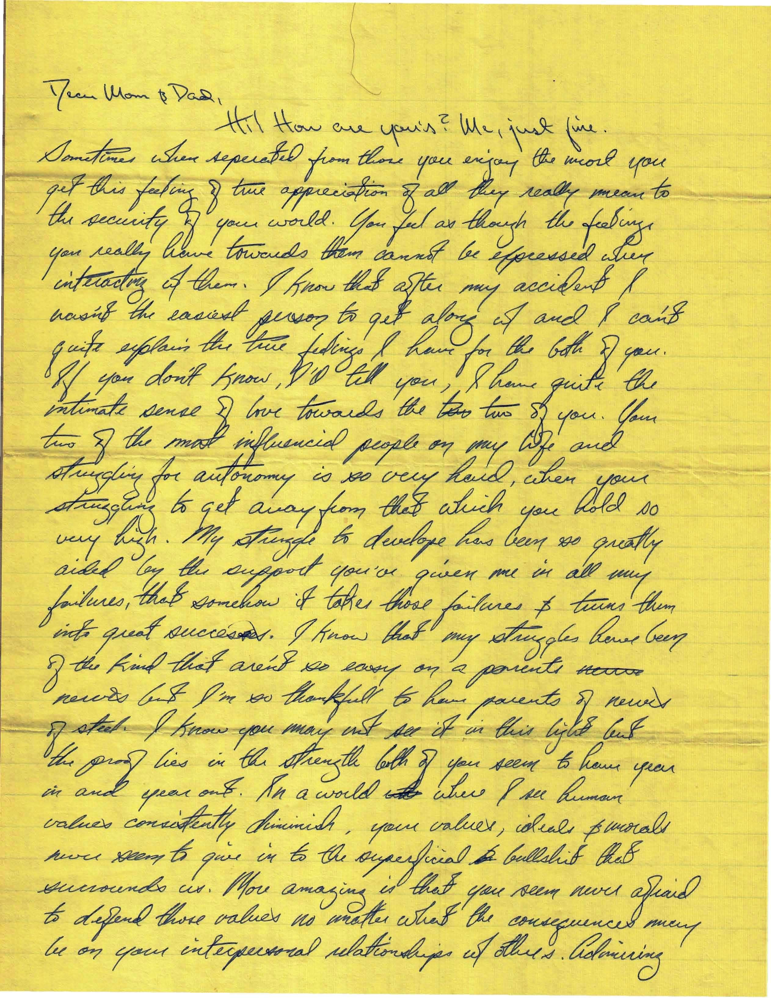

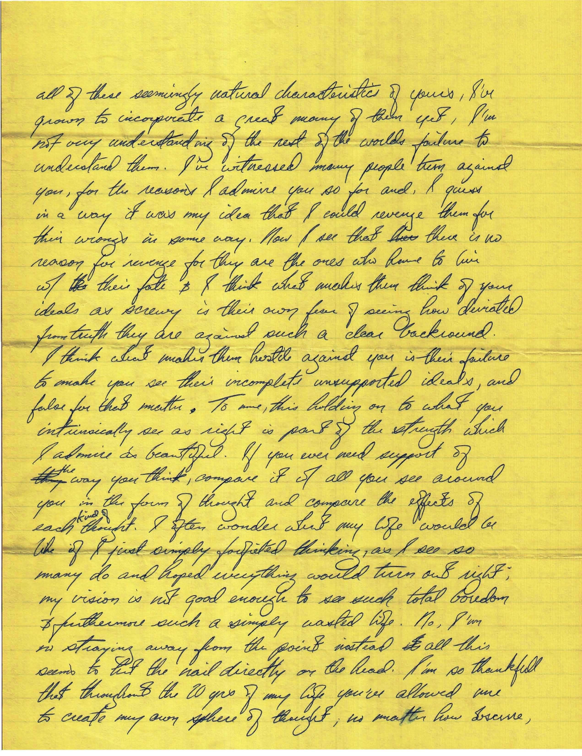

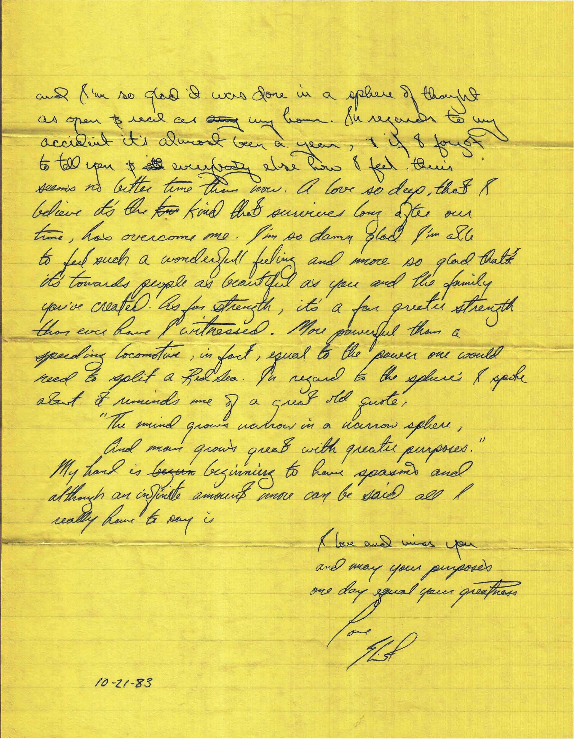

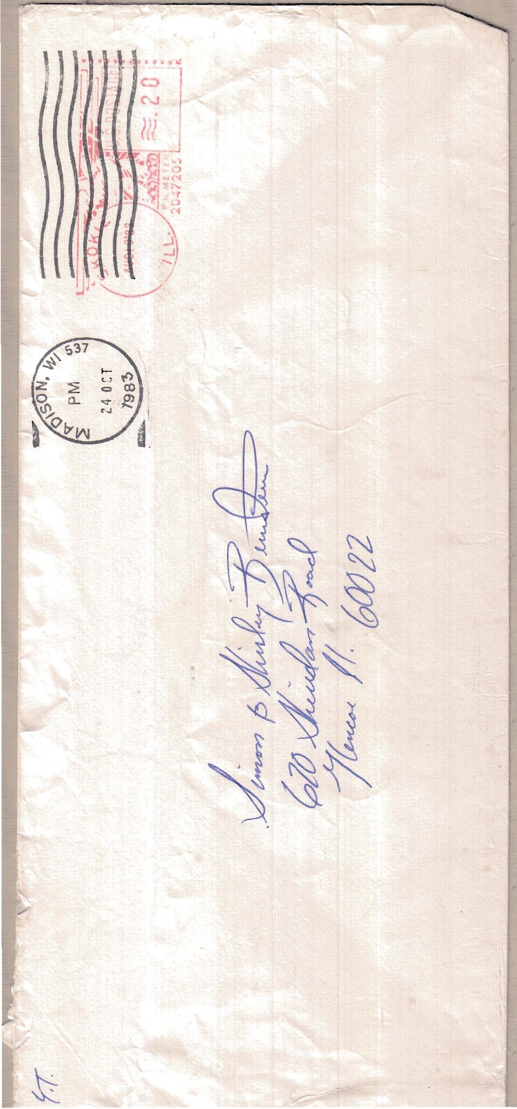

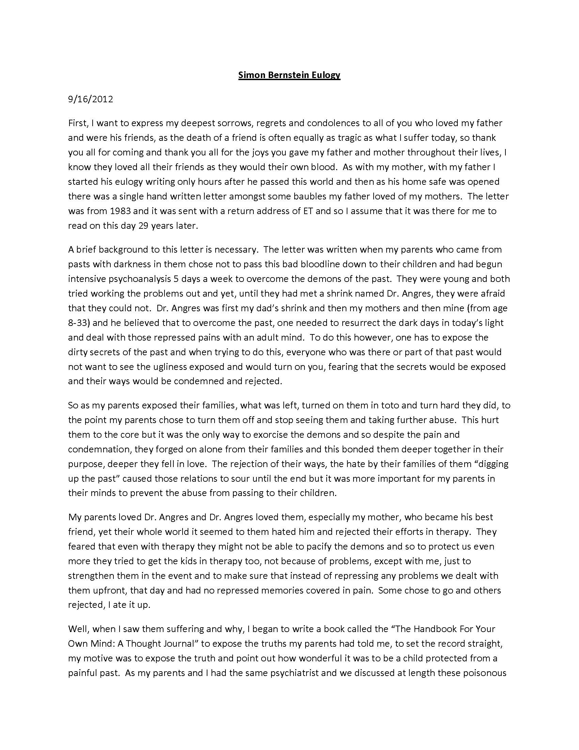

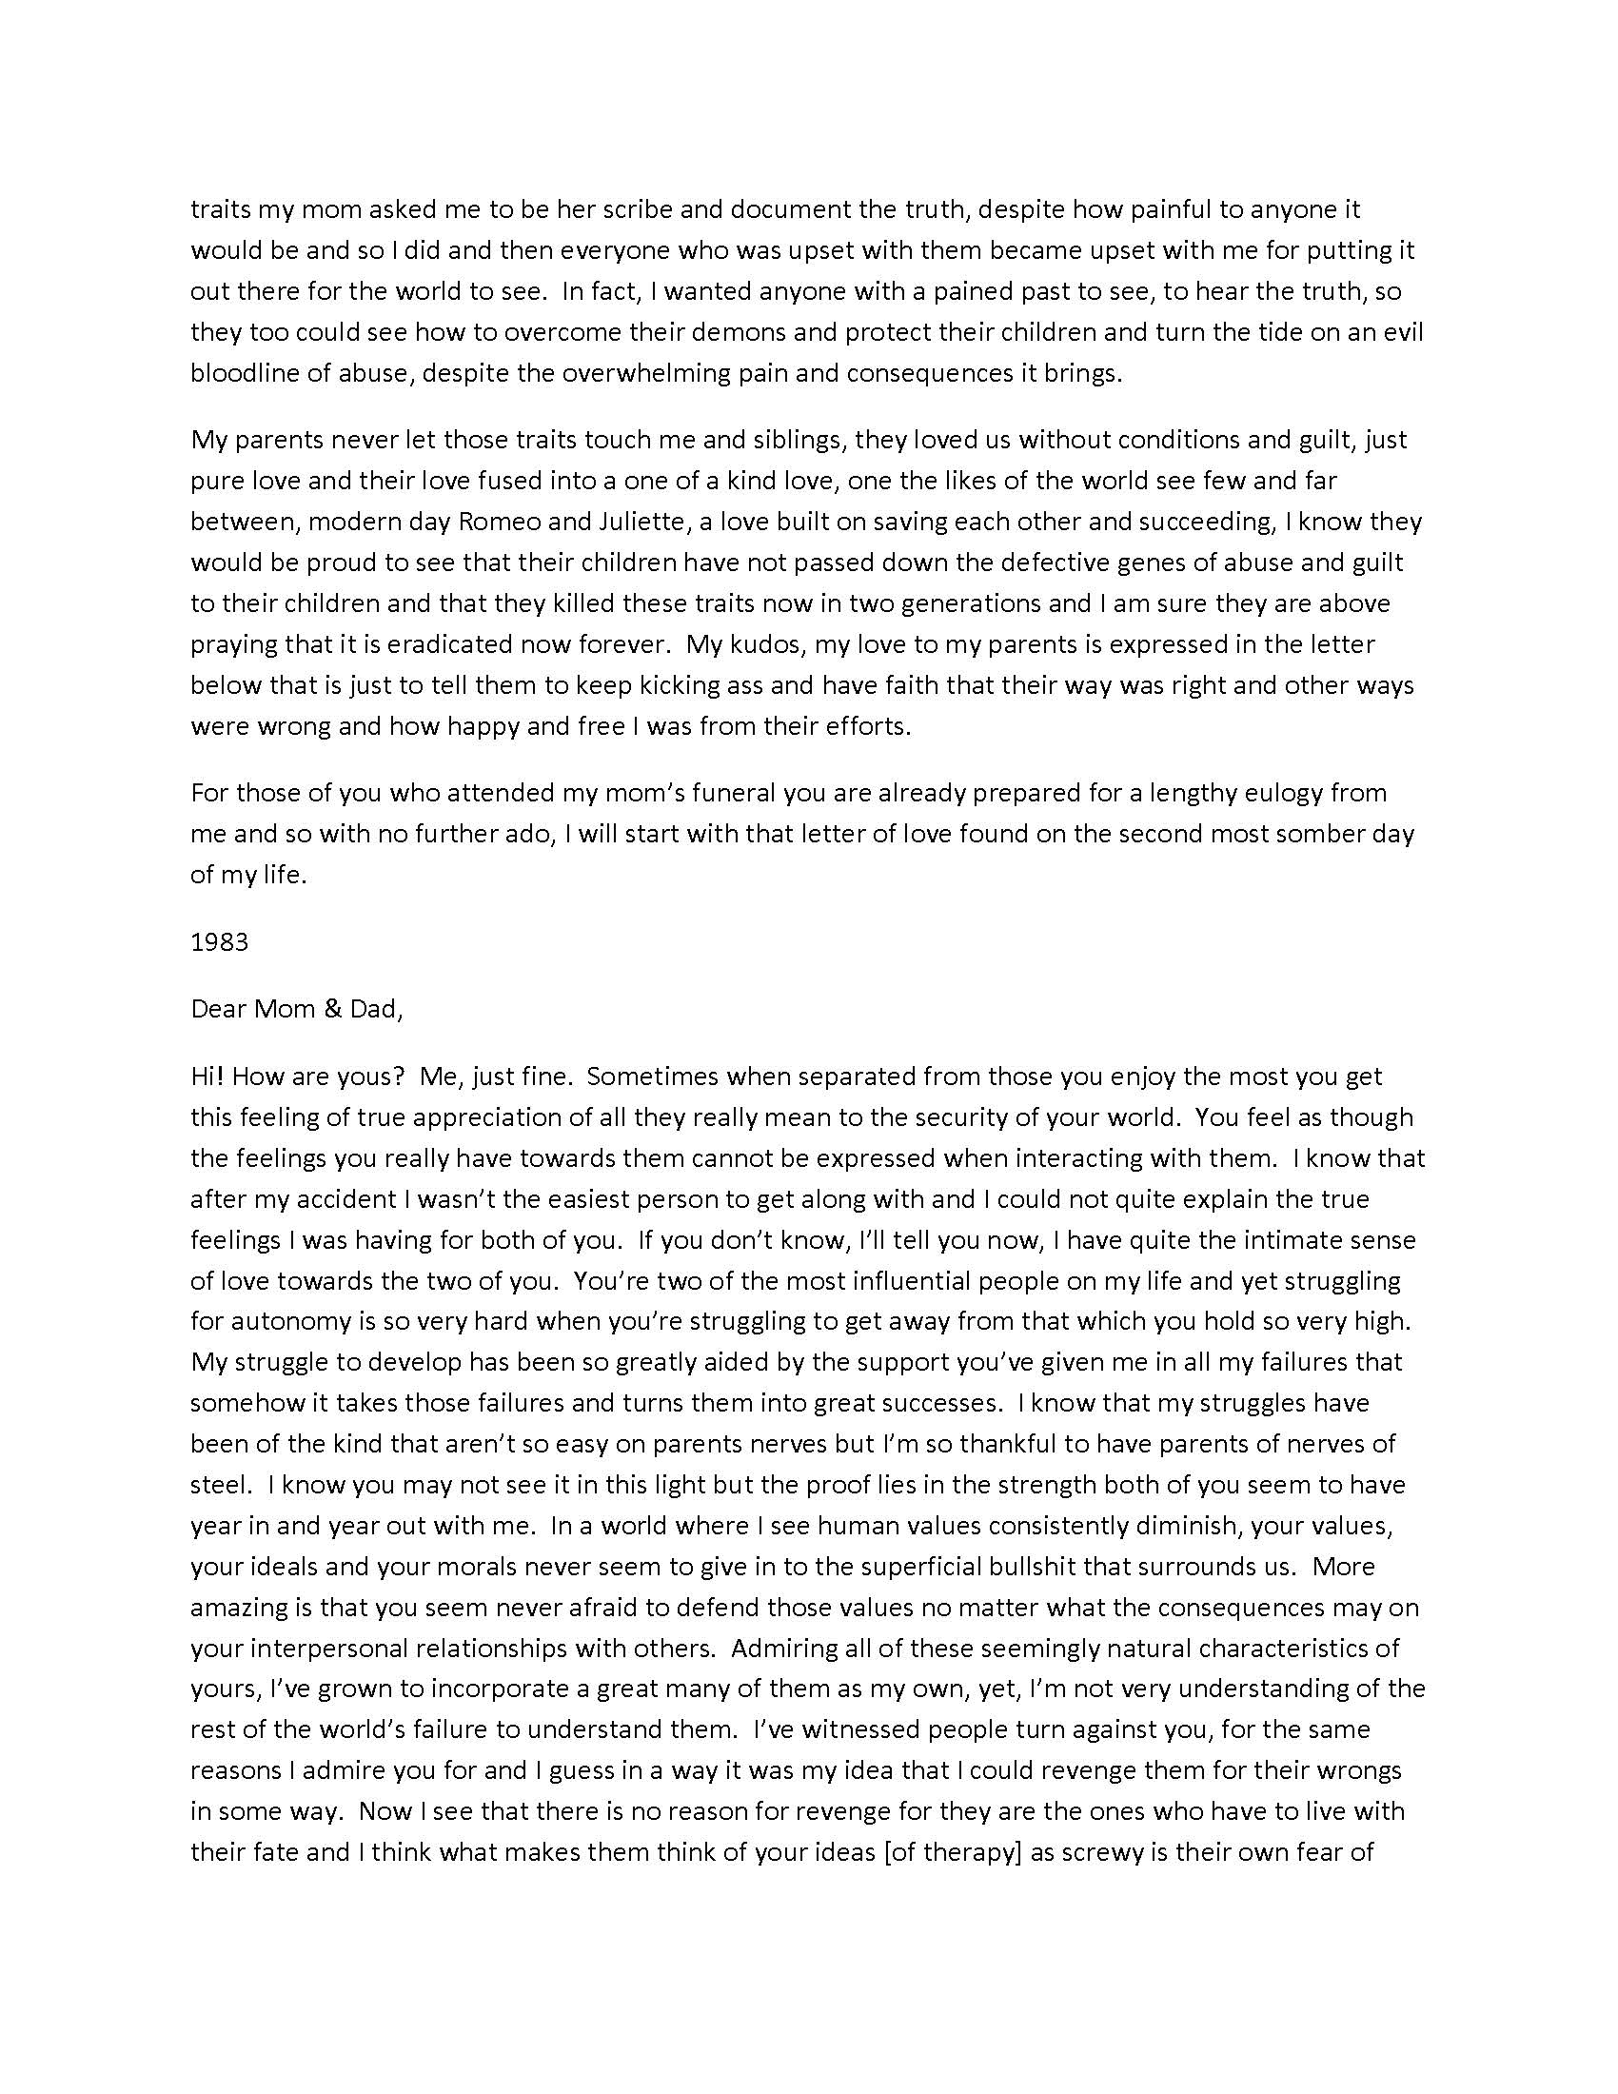

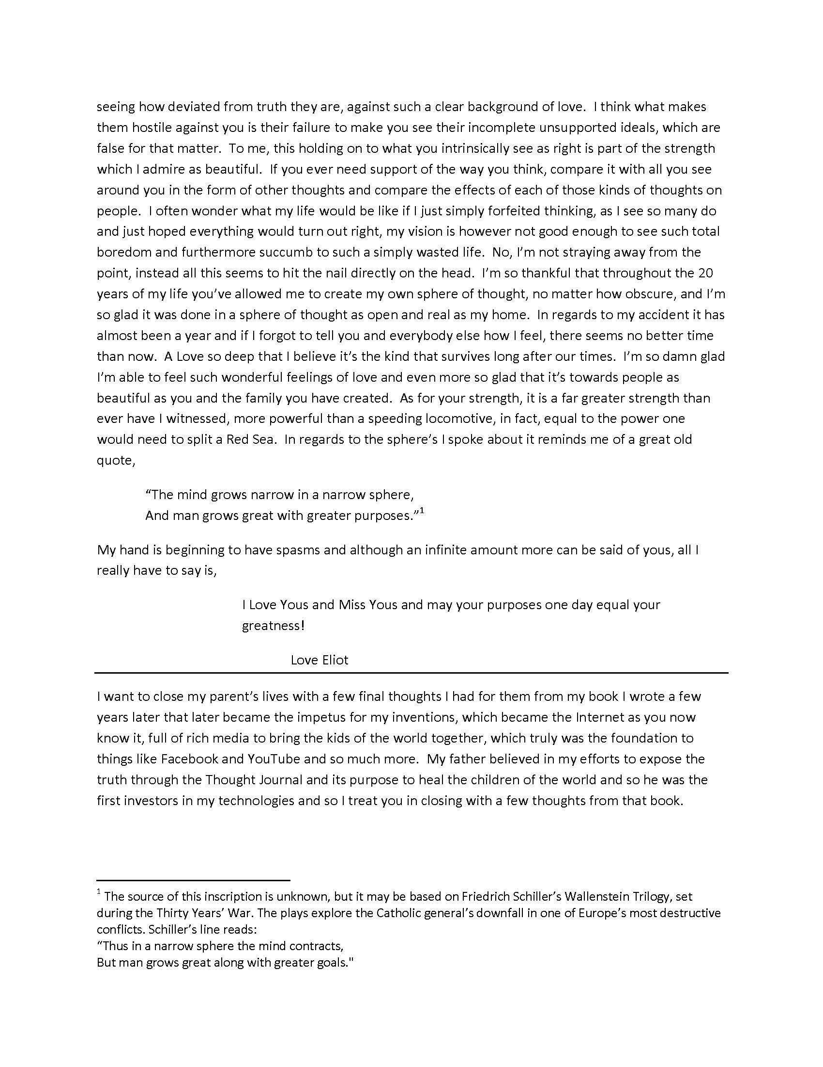

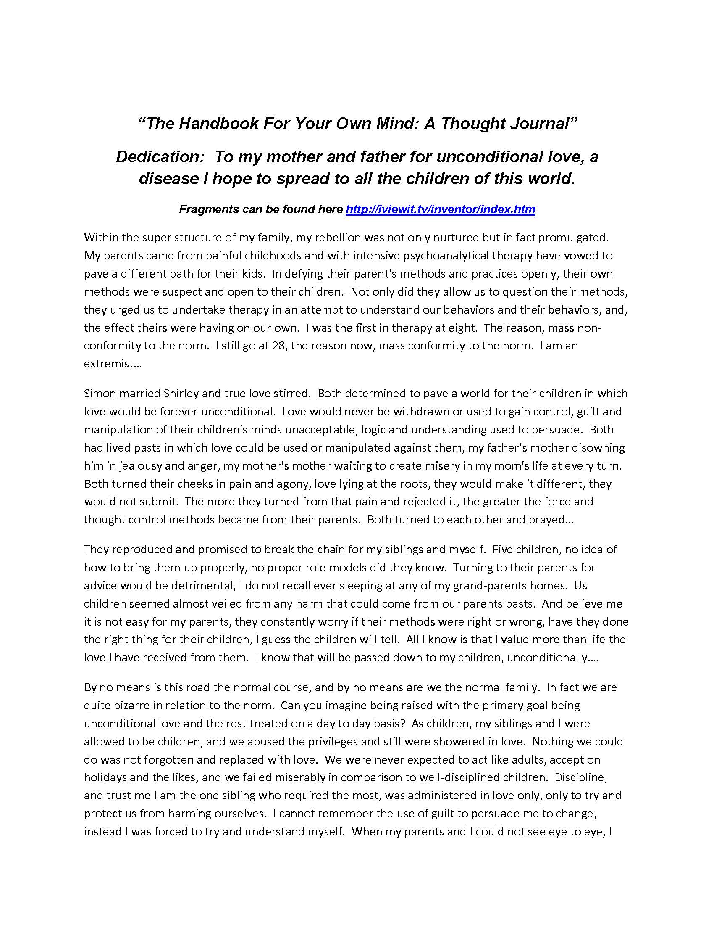

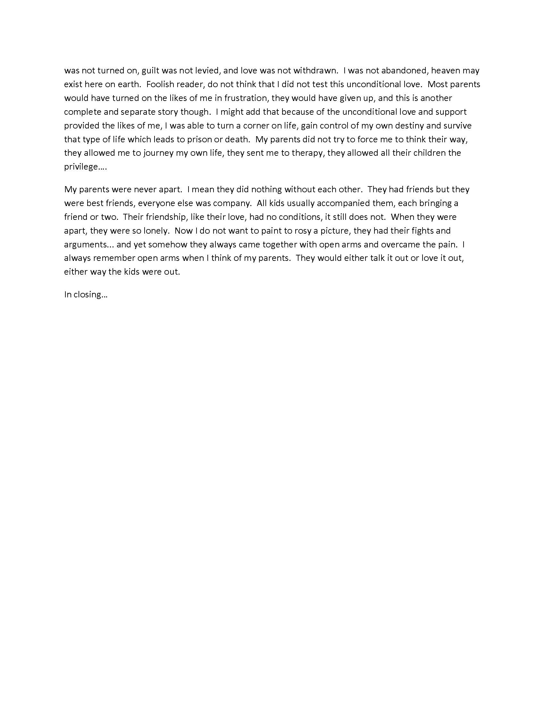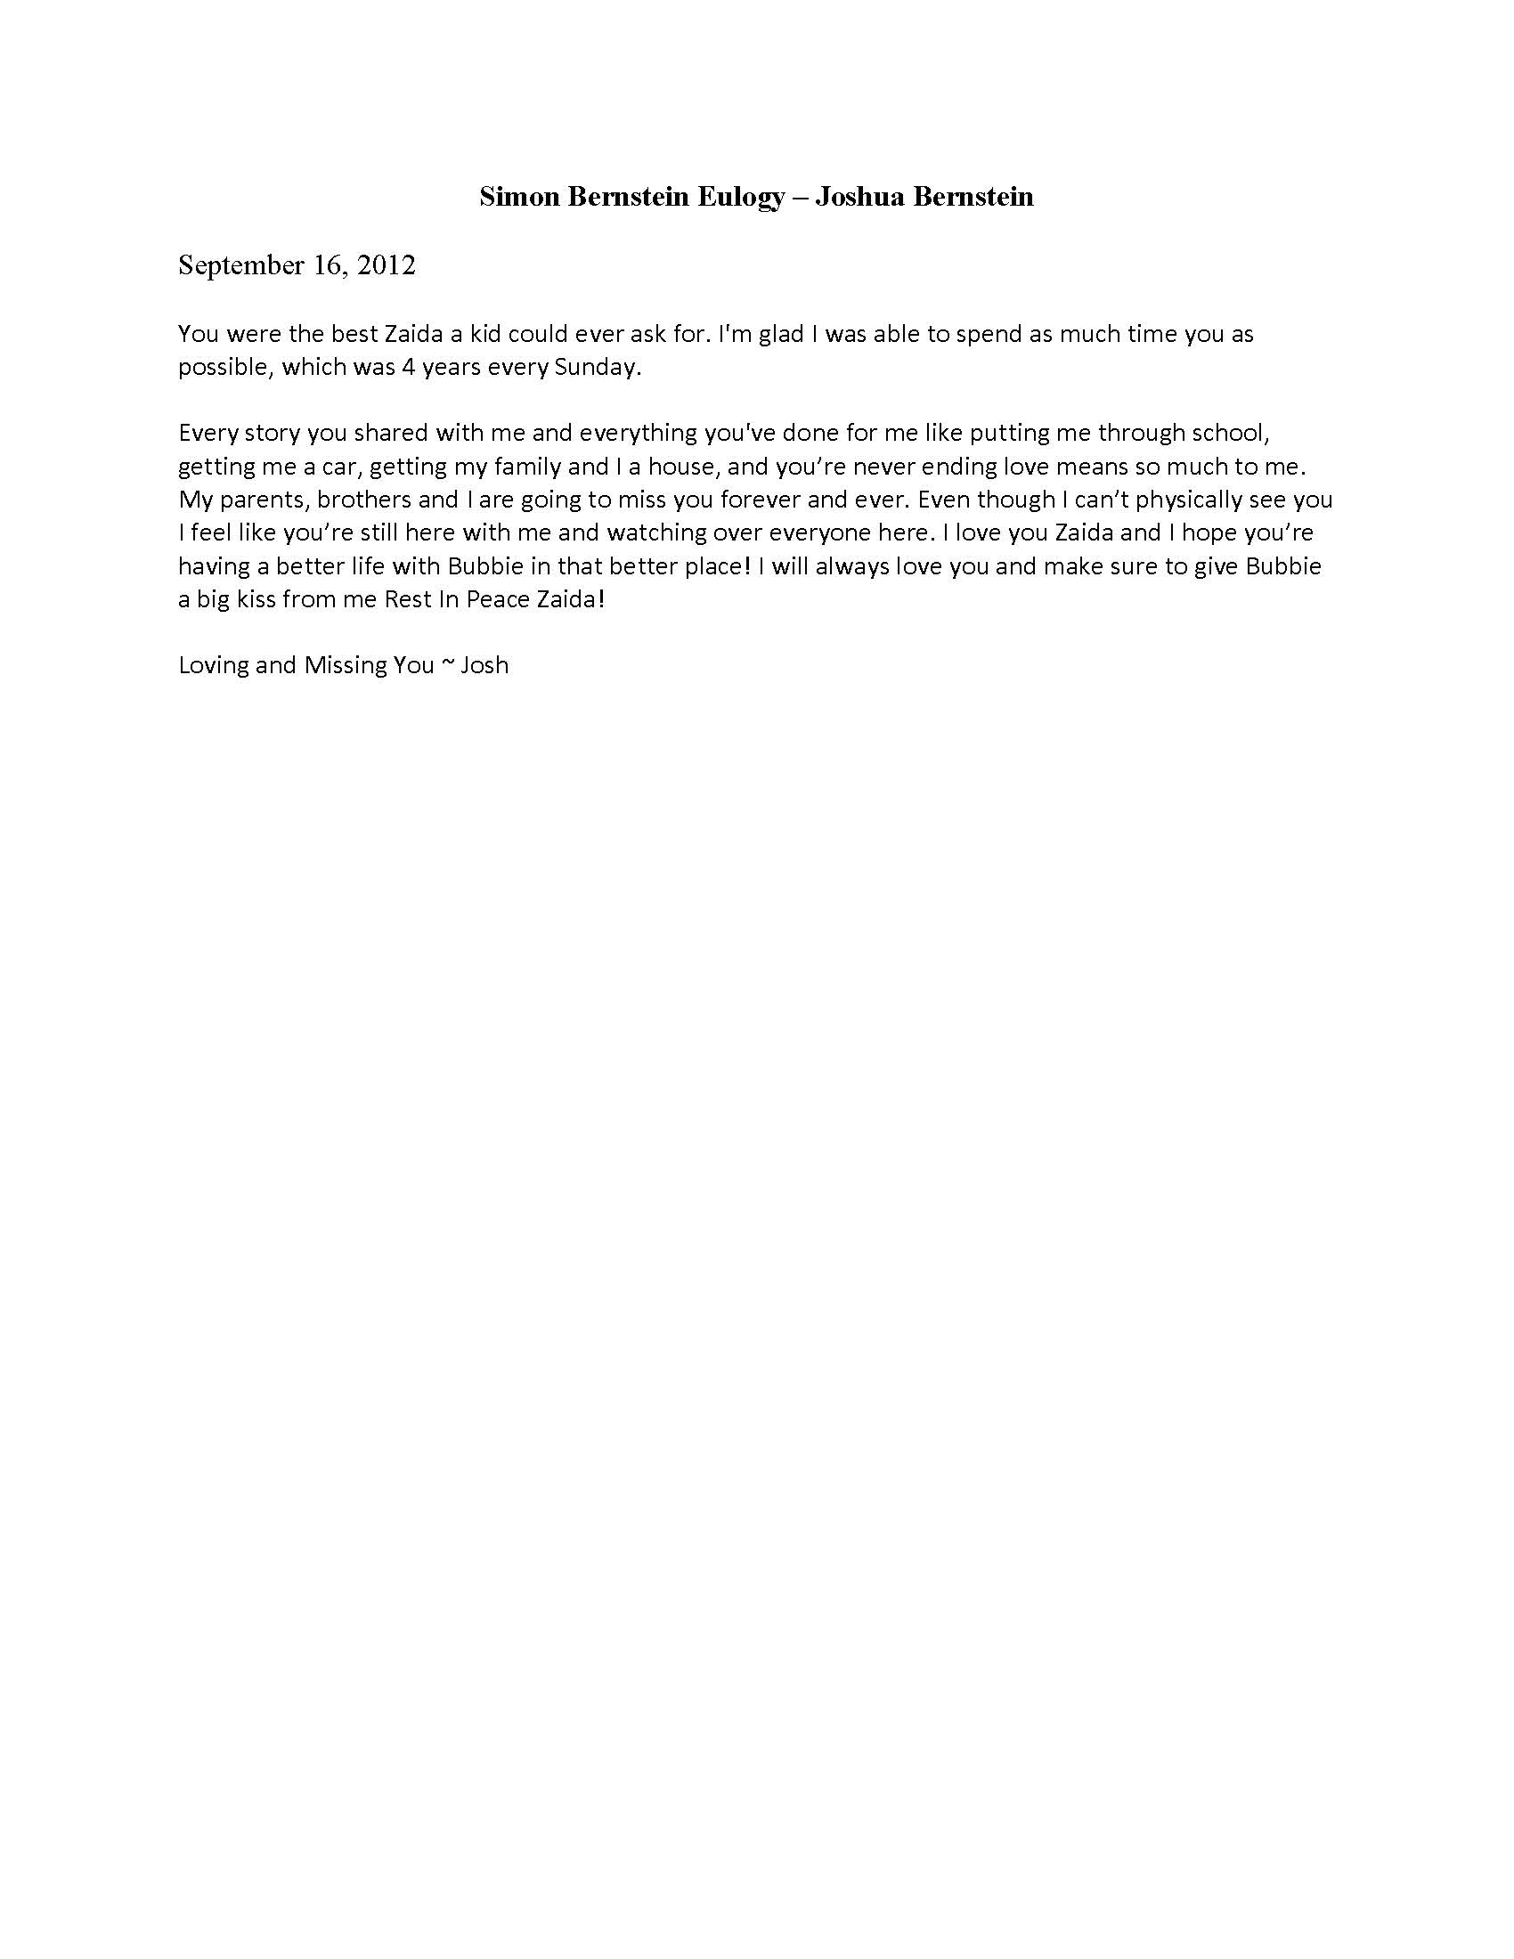

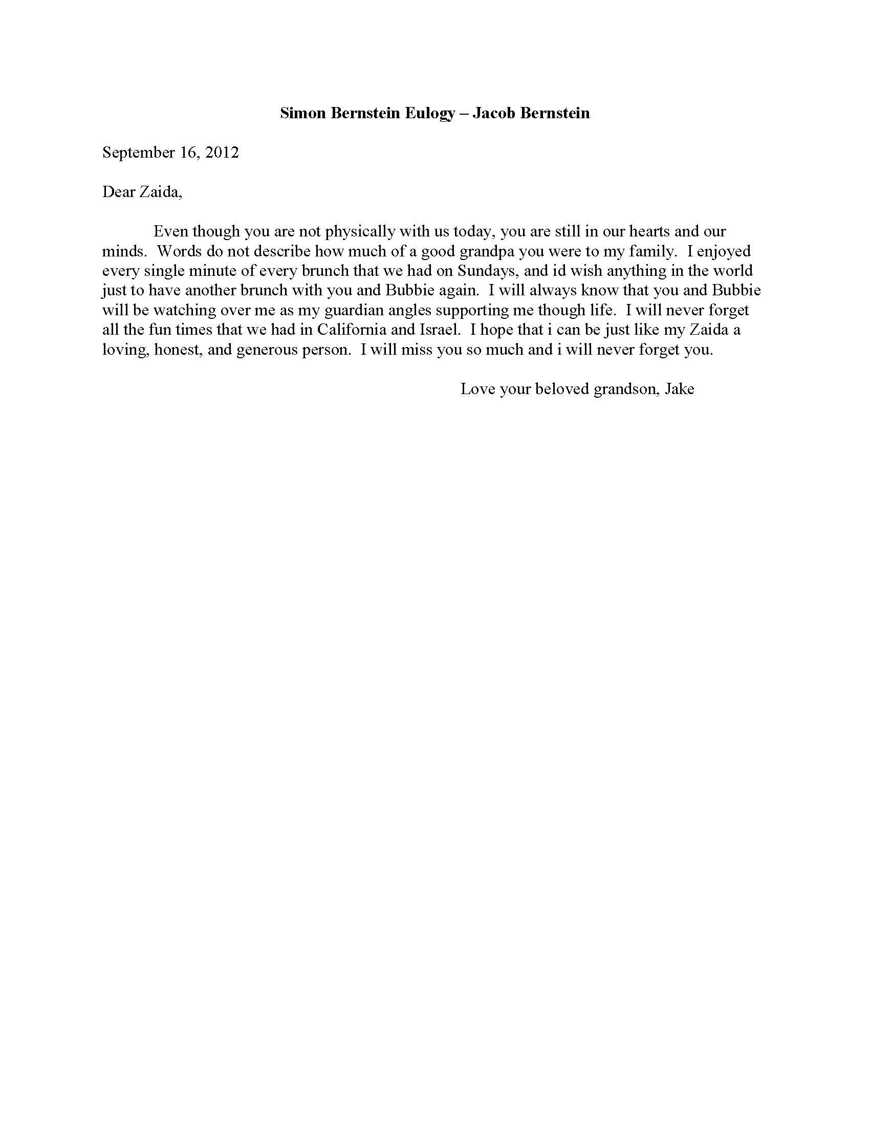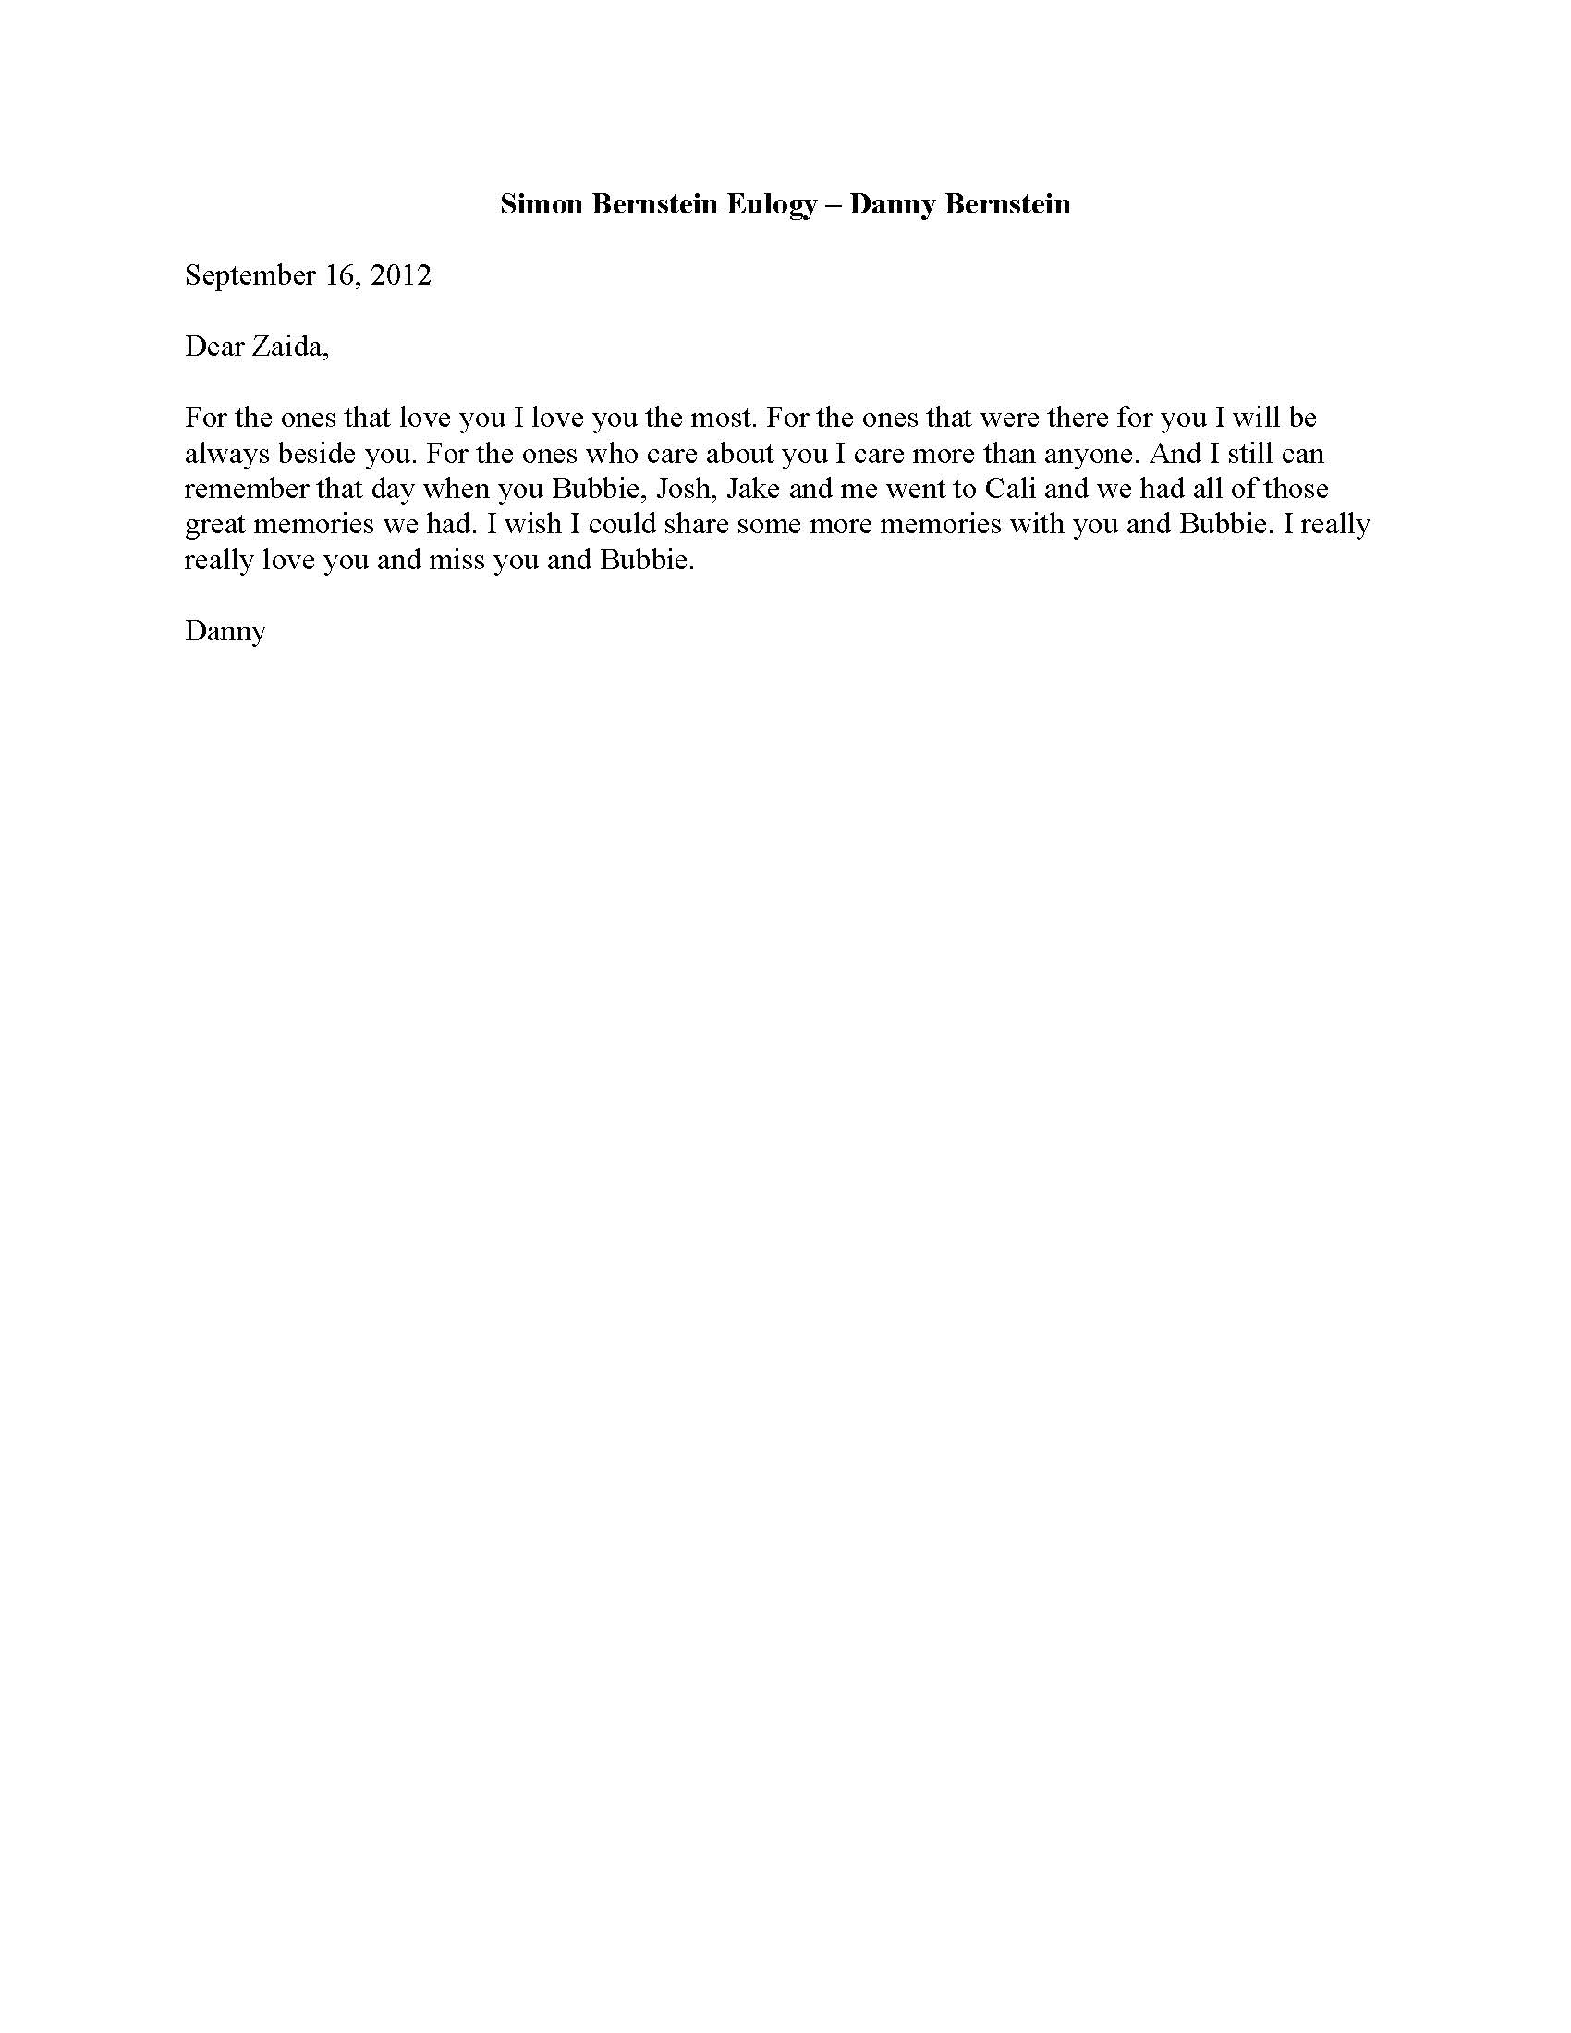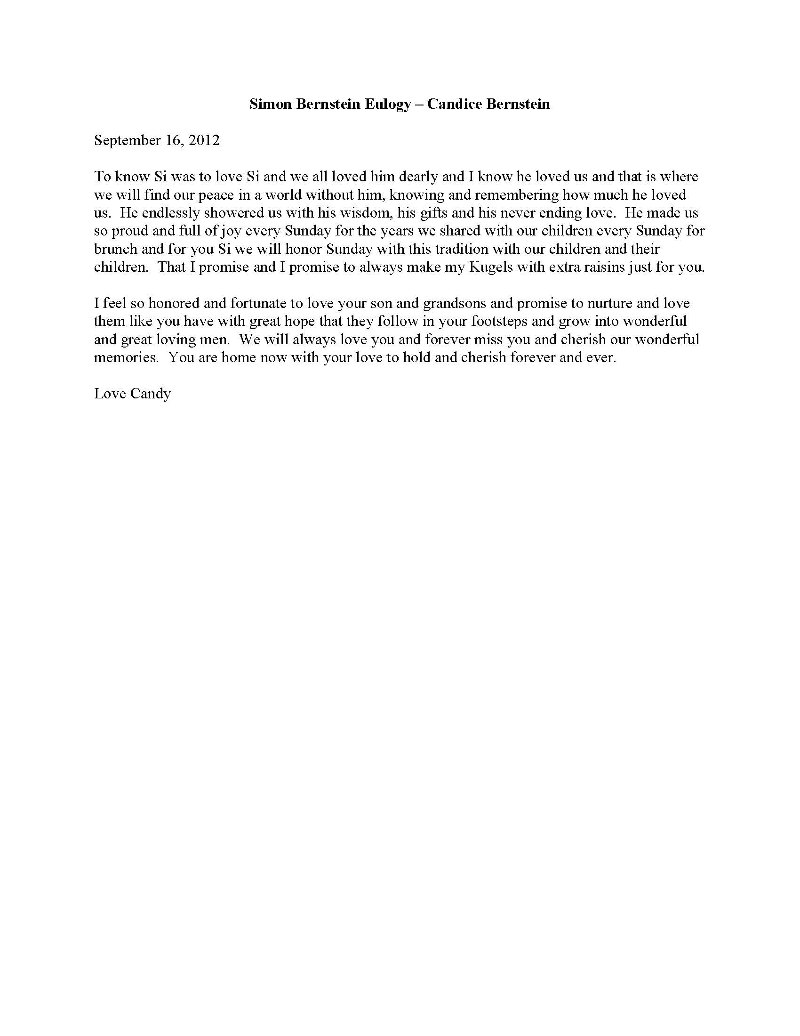

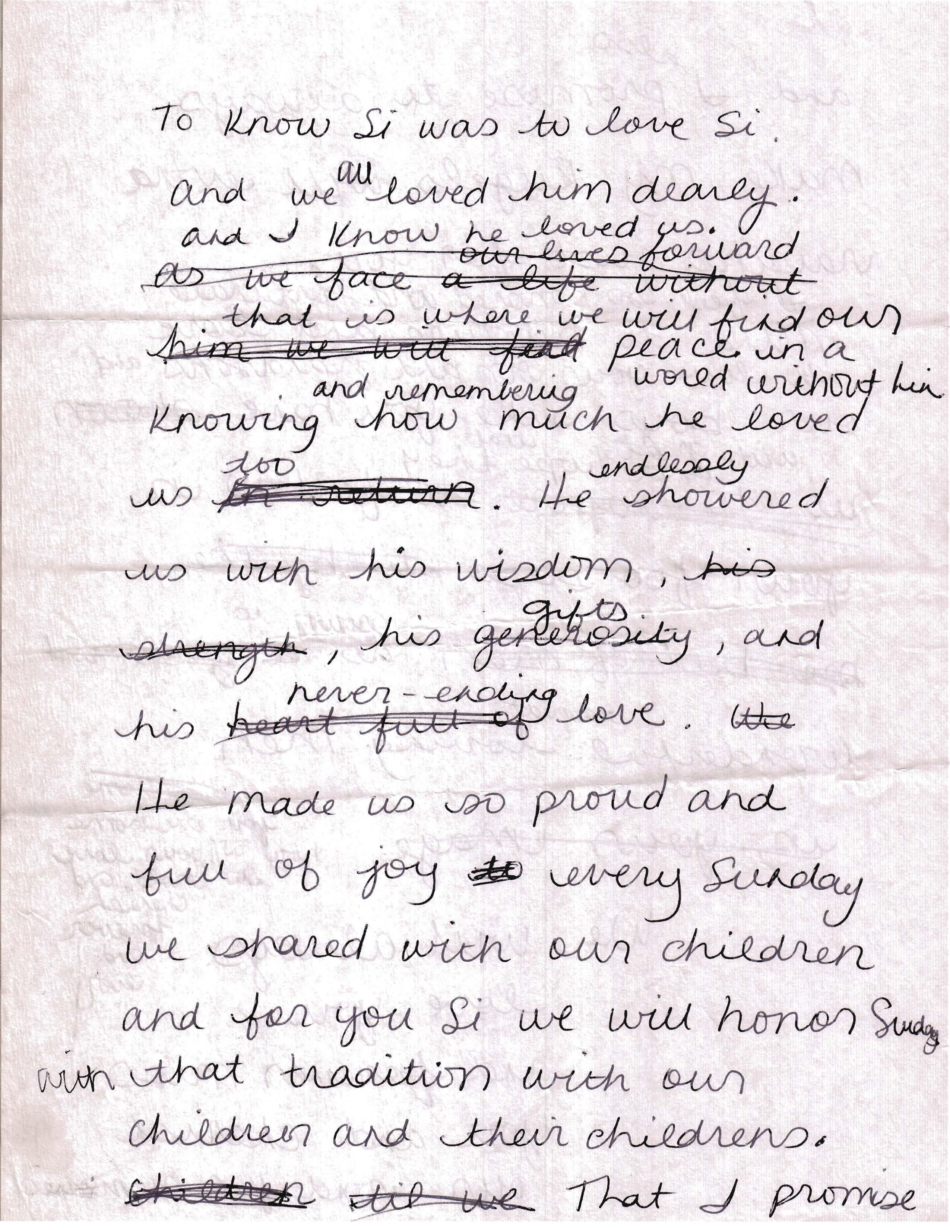

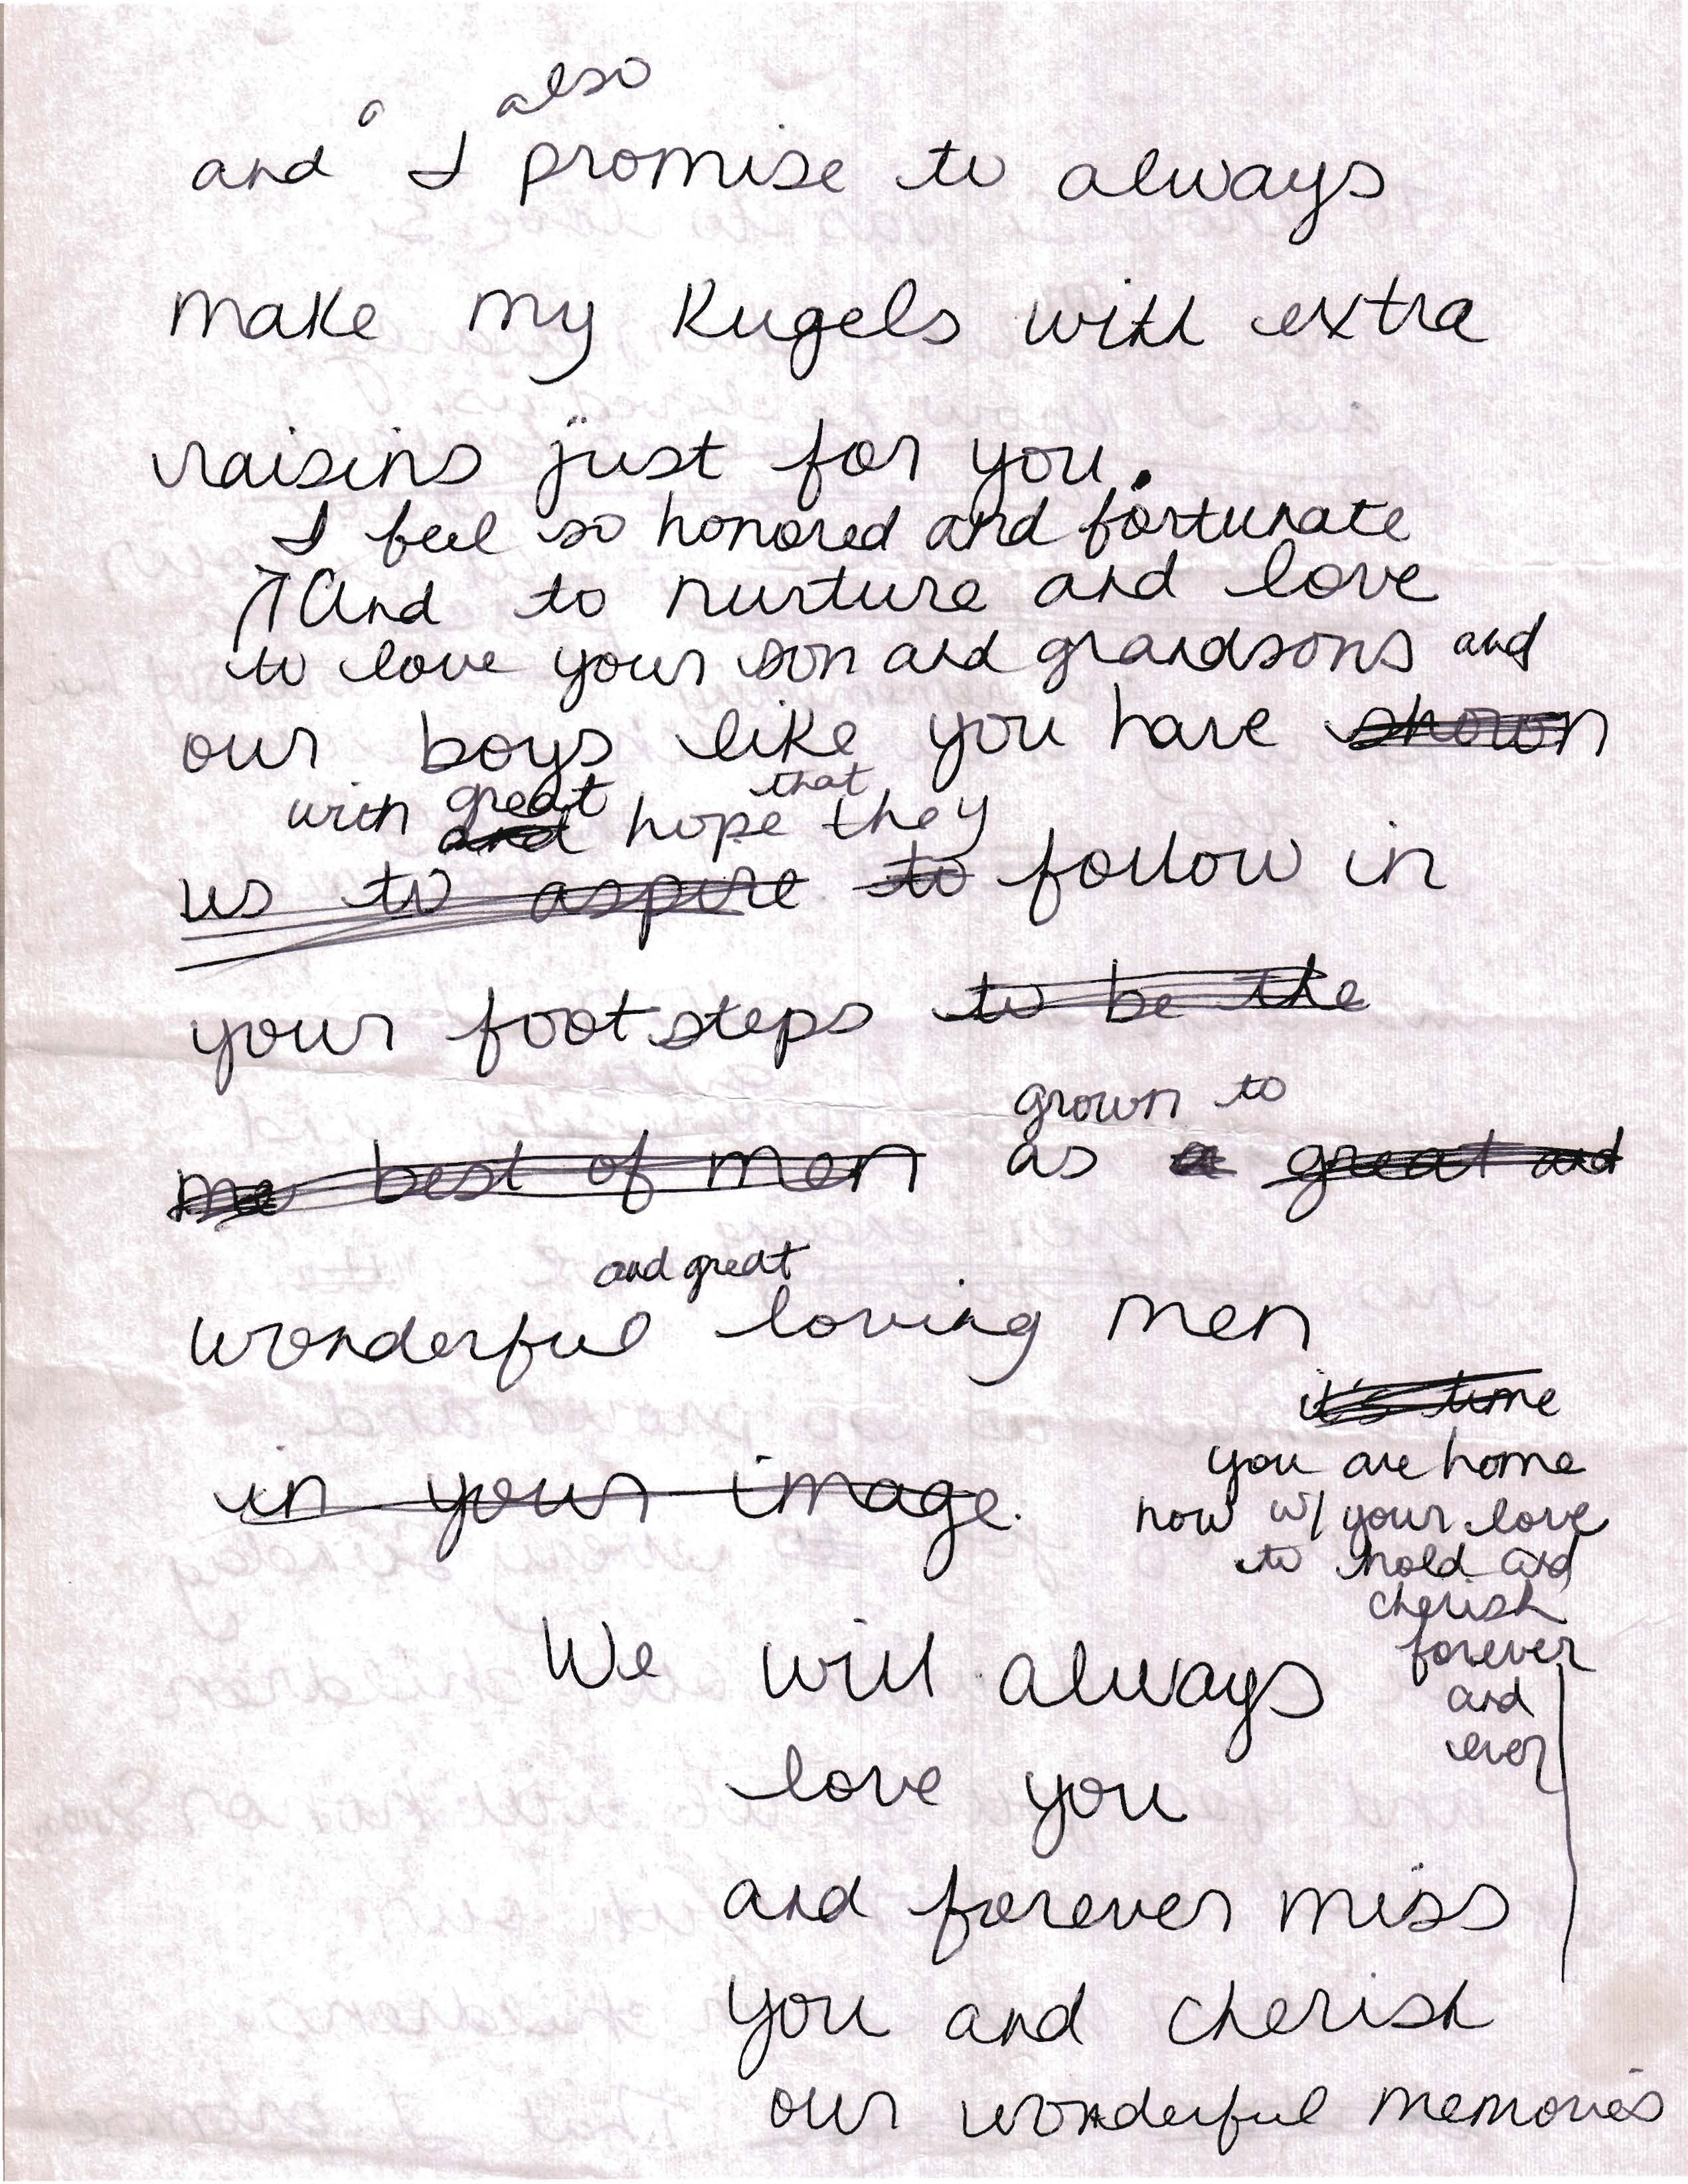

091612 email of EIB to Rox for Transcribe fam 24.43 meeting Teschler and Spallina Simon Bernstein.wma

**Date Meeting occurred is not discernible from recording: Date: ______________________**

**Transcribed September 17, 2012 7:30 a.m. by rox with Secretaries Comments Tasks Notes.**

**"All List" means there is a person place or thing which has to be recorded into Project Manager Database.**

**When name of speaker is unknown, rox indicates gender and we can do global to fix later.**

**TO DO TASK: ELIOT AUTHORIZE CONTACT AND IDENTITY INFO LIST OF SIBLINGS OR PARTIES. ASSESS VULNERABILITY / IDENTIFY IF BERNSTEIN FAMILY MEMBER WAS TARGETED BY A LAWYER BENEFICIARY DURING A DECEPTIVE SCHOOL WORK OR COMMUNITY/WORSHIP OR MARRIAGE RELATIONSHIP.**

**TO DO TASK: RESEARCH HOW TO REMOVE/PARTICULAR ATTORNEYS FROM MNAGEMENT OF ESTATE VS. CONTEST WILLS IN FLORIDA AND WEIGH RISK OF STATE STEALING EVERYTHING VERSUS TYING UP ESTATE IN PROBATE WHILE WILL DISPUTE SETTLES.**

**TO DO TASK:** **Rox return resource to Eliot Bernstein 102310 Training Notes Understanding the Executor Office and Use of the Executor Letter.docx** **AND ALSO APPENDED AT END IN CASE HYPERLINK DOESN'T WORK.**

**ROX THINKS AN EXECUTOR ESTATE LETTER COULD DEMAND DISCLOSURE OF ATTORNEY'S FEES AND COSTS OF BANK FEES SUCH THAT ECONOMISTS REPORTS AND PROJECTION WILL VERIFY COST OF ADMINISTRATING ESTATE THROUGH THESE LAWYERS IS GREATER THAN THE EQUAL SHARES DIVIDED ACTUALLY RECEIVED "PER CAPITA" BY GRANDKIDS - LIKE NOTHING LEFT EVEN IF PARENT TRUSTEE ACT RESPONSIBILITY. THE BANK STATEMENTS AND THE LAWYERS FEES EXTENDED A GENERATION WILL ABSORB AND "FEW DOLLARS" OR "BURDEN OF WEALTH" IN THE TRUST ACCOUNTS.**

**TRANSCRIPT**

**(Eliot identified law firm present is Teschler and Spallina "Robert Spallina is present)**

|  |  |  |
| --- | --- | --- |
| **Speaker** | **Verbatim** | **Eliot and Rox flags** |
| Simon Bernstein | Who's not there? |  |
| Female Voice | I think we're all here dad |  |
| Simon Bernstein | Whoever's not here we will not hear from |  |
| Male Voice | Right. |  |
| Female Voice | Eliot's here [sounds like] [Tim] [Ted] [Jewel] [Lisa] and [myself] so all the kids are here. |  |
| Simon Bernstein | Okay. Robert you want to start or do you want me to start? |  |
| Robert Spallina | I think you should start. |  |
| Simon Bernstein | I asked for this meeting so that we can move on and get behind us what all of you seem so concerned with and that is the few dollars I have left. And uh, I met with Robert Spallina, I don't know whether he has notified you or not but we have been having meetings and I think we've come to what we agree is an adequate solution to a problem that was never meant to be created but I guess we created it your mother and I and so now I hope to rectify it. It's really quite simple, am I right Bob? |  |
| Robert Spallina | Yeah, I mean....Listen well obviously this is a sensitive issue (um) and it wasn't an easy decision at the time when the documents were being created but there were certainly reasons for doing what we've done and now that your mother has passed away you know her document becomes irrevocable and (um) under that document the way it was structured (uh you know) the the [he says it twice] assets of her estate upon your father's death would go down to three of the children and there's definitely been some issues and discussions about that and ya know I think the easiest thing would just to be [sounds like] [provide for] under my document and then you know directing at my death under mom's document that all of the assets, the collective assets of both estates go to all of the grand children in equal shares. |  |
| [transcriptionist not sure if Robert Spallina is still speaking or Simon Bernstein says this - eliot can identify speaker...] | So, um, as I understand it, um, the ten grandchild will divide whatever is left among them equally and that will be it. | Eliot needs to identify if this is his dad because the person who who said this is uncomfortable in saying it. |
| Robert Spallina | Those assets will be held in trust for them...they will be protected assets from their own creditors...they'll be protected assets from ya know...bad marriages if there are any bad marriages down the road...and will survive estate taxation in each of their estates. You know there's just a lot there when you divide things up ten ways but it is still important to protect those assets and make sure we have the proper trustees of which the logical choice would seem to be uhhhhh you know each of you is trustee[s] of you own children's trusts uhhh but we have it worked out the mechanics of all the trustees so...uh but that....[Simon Bernstein interrupts] | What does "we have it worked out the mechanics of all the trustees..." mean? |
| Simon Bernstein | I think they should have the right to choose their own trustee and [Robert Spallina interrupts] |  |
| Robert Spallina | Yea. [pause] yeah and then again well, the [Robert Spallina says a phrase which is not clear but pretty sure it's either "the parents" or the "the lawyers"] have the ability to appoint trustees and if you feel that your children have not reached a level of maturity and responsibility you could always make them co-trustees with you or you could definitely make them the sole trustees of their trust you know but this planning it becomes a burden at times I know Simon kind of has it hanging over him and so we want to close out your mother's estate umm and there are some documents that we have to sign and we just kind of wanted everybody to be on board with this plan.  If anybody has any comments or questions to kind of get those on the table today. | [Robert Spallina says a phrase which is not clear but pretty sure it's either "the parents" or the "the lawyers"]  3.33min into sound file.  This is going to be real import discernment for intent if Spallina said "the lawyers" - he's talking to the "the parents" so rox thinks he said "the lawyers but Eliot has to confirm. |
| Simon Bernstein | Yes this is the time to do it so if there are any questions go ahead and ask. |  |
| Eliot Bernstein | I don't even know what we're talking about. |  |
| Robert Spallina | What's that? |  |
| Eliot Bernstein | I don't even know what we're talking about. |  |
| Simon Bernstein | We're talking about what money I have left when I die Eliot. |  |
| Eliot Bernstein | And so the issue? |  |
| Simon Bernstein | What? |  |
| Eliot Bernstein | You started out saying there was an issue or something - we were concerned or something?.... |  |
| Simon Bernstein | There's issues with different siblings and uh... |  |
| Eliot Bernstein | Okay, I have seen anything that's all I'm saying then... |  |
| Robert Spallina | He's asking the question....the way your mother's document is structured and the way your dad's existing document is structured, the assets at your dad's death, the collective estates would go down, in the absence of us changing anything to only Lisa and [Jewel/Jule] and Eliot.  [Sy and Shirley] had said that they had helped out [________________] and Pam had structured their joint estates that way...uhhh. There were certainly issues that were aired about that when mom passed on and that was discovered and he's been sitting here struggling on what to do given the fact that he may have upset one or more of you and today he wants to rectify that by kind of just making it easiest among the grand children and kind of making amends for the planning they sat down and did in 2000 and [is interrupted by next speaker] |  |
| Unknown male | Aah Aah I don't want to say that they're making amends. |  |
| Another male voice | I think that's a bad word too. |  |
| Eliot Bernstein | Okay, I...[starts to speak defers to Robert Spallina who begins speaking at the same time.] |  |
| Robert Spallina | Because at the time there were varied reasons for doing that and the world was a different place and the insurance businesses were different businesses at that time....  You know there was certainly a feeling that Pam and Ted you know having worked in the business and been part of the insurance business all their lives had had to wake up in that regard and decided they want to see Eliot and Jill and Lisa ya know get a share in the estate.  So, today it is much different. The insurance business is not what it was and the size of the estate is not nearly what we thought it was going to be and so the few dollars that are left here he felt would better be [______] going down to the grand kids than going to the children. |  |
| Eliot Bernstein | Okay but I haven't seen anything but whatever my dad thinks is good I'm good with. I mean I haven't seen any documents to this point so you know if what my dad thinks what's right is right, I'm good with it. |  |
| Robert Spallina | We're talking about the planning. The documents of your dad redoing his estate planning documents provide that at his demise the assets go down to the grand children.  The document I was talking about withn regard to your mother's estate is just a closing document and any person that is concerned an interested person signs off on that. Aaaah, I could make an argument that because of the way Pam and Ted and their living descendants have been written out of the document are not "interested people" but we wanted to have this conference call so that at the time Sy is not here you know we don't have a big fight about what's going on with the estate.  And that's not directed at anybody. |  |
| Eliot Bernstein | Okay I'm good with that. |  |
| Robert Spallina | How does everybody else feel? |  |
| Female Voice (Lisa) | Thank you for doing that. |  |
| Robert Spallina | Who is that? |  |
| Pam | That's Lisa. |  |
| Ted | I have a problem. |  |
| Robert Spallina | What's that Ted. |  |
| Ted | I have a big problem with it. |  |
| Robert Spallina | Okay.... |  |
| Ted | My father knows I think this will make all of any issues dissolve and it is extremely equitable and I think it will probably get him a lot of ease over this and can't see how this presents a problem in any way either now going forward or at his death. |  |
| Robert Spallina | That's what we're try to....that's what we're trying to get out of this meeting here. | ?Sure you're not extending time for lawyer trustee access be deferring distribution of the state a generation?" |
| Different Male Voice An Attorney referring to "I see a lot of clients" | The last thing I want is to see families fight over money. But unfortunately wealth can create a burden and I see a lot of clients struggle you know they create a lot of wealth aaahhhh they struggle with how to dispose of that wealth at their death and you know very often in wealth and when you think about this at the children's level even in your own family you all have different numbers of children and the way the more [sounds like] dispositive plan works is that instead of counting them on a [an accounting term sounds like per cerpita basis] we're counting them on a per capita basis and they are each going to share equally.  Well it really is the equitable thing to do and really nobody should have any issue with that. | Smooth....So let me get this right, because Bernstein Estate generated wealth their only option for disposing of it equitably is the give attorneys access "to the mechanics" of trustee assignment instead of distributing to the parents of the grandchildren who will give to their children without attorneys exacting a generational toll.  The dollar value of the Bernstein estate has been described as "a few dollars left" to it's not what was expected to "it's only a few dollars" to "a burden of wealth" by each attorney speaker - which is it? Is it wealth or is it a few dollars that Teschler and Spallina should get a medal and a parade for going through the trouble of drawing up the "planning documents." Wow. |
| Simon Bernstein | I haven't heard from Jill. |  |
| Jill | That sounds wonderful. |  |
| Simon Bernstein | I said I agree and that sounds wonderful. |  |
| Simon Bernstein | We have agreement on all parties. |  |
| Female Sibling | Thank you dad. |  |
| Eliot Bernstein | Thanks dad. |  |
| Another Female Sibling | Thank you dad. |  |
| Robert Spallina | Thank you very much. It's been a lot easier than last time and I'm glad it was easy. Okay? |  |
| Two females at same time | Chuckle laugh and Bye....Bye. |  |
| Robert Spallina | Those closing documents for your mom's estate, please send those back so we can get it closed okay? |  |
| Two or three people | Allright/okay/I will. |  |
| Robert Spallina | Everybody's going to get a document to sign. |  |
| People on phone Siblings say all at once | Okay, good, yeah. |  |
| Robert Spallina | Some on behalf of the minor children and others for the adult grand children they are going to have to sign it. | Do the adult grandchildren receive distribution of their trust accounts now? |
| Ted | So, it's nothing we have right now? |  |
| Robert Spallina | No you haven't received it yet. Okay? |  |
| Ted | Okay. |  |
| Female siblings in unison | Okaaaay. Thanks |  |
| Simon Bernstein | Good-bye everybody. |  |
| Eliot Bernstein | Great. Thanks. |  |
|  | **END OF CALL** |  |
| **ELIOT BERSTEIN** | **START NEW CALL** |  |
| Eliot Bernstein | At 12:09 minutes into wav audio until/through 17.56 minutes  Typing Keyboard sounds.  Touch tone dialing. phone ringing, sounds of doors opening and closing children's voice.  Phone rings at Eliot Bernstein's location and stops [did not ring long may have been answered by someone else in another room]  More foot steps movement sound of door swinging closed / latches.  Now, we are outside with whomever is recording, hear an airplane and traffic sounds along with footsteps and movement and door opens and swings closed/latches again. More footsteps.  Touch tone dialing again.  Ringing 4 times phone answered on 4.5 rings. |  |
| Male voice | [sounds like he says] Yeah Tony. |  |
| Eliot Bernstein | Hi. [sounds like Melissa but can't be right - a male answers the call and says yes second time Eliot says sounds like Melissa. Do global replace Melissa with correct name. |  |
| Male voice | Hold on. I'll connect you. |  |
| 2nd Male voice global replace Melissa when identified | Hello. |  |
| Eliot Bernstein | Hi Melissa? |  |
| Melissa global replace | Yes. |  |
| Eliot Bernstein | So just in hearing that for the first time ever any of that I only have one question - that to me sounded like I got an inheritance that is now going to the kids in trust and my only concern would be if he died tomorrow how would I take care of my family at all other than that trust and what would happen to that money? |  |
| Male Melissa global replace | [a few indiscernible words] that trust would go to you as trustee to take care of your family.  But as the kids get older it goes to [undiscernible]. |  |
| Eliot Bernstein | Yes but so they don't become wards of the state or whatever because I can't afford to have whatever happens to me happens to them....because I'll be penniless at that point. |  |
| Male Melissa Global Replace | Well. |  |
| Eliot Bernstein. | Well. I'm okay with that but to me it sounded like it was coming to me. And that's okay [if] you've got something worked out in here - if there is something there to keep us afloat to the minimal degree - whatever I need to keep my family going you know then I am more than happy and I figured all that out. |  |
| Different male voice speaking in the background on Melissa's end | I think you used up all the [____________] | Could be second male voice or first (lawyer) melissa global replace - the tape could have slowed to make the voice sound deeper. |
| Eliot Bernstein | I've been through $7,700 |  |
| 2nd Male voice | Was it $7,000 or 700 dollars? |  |
| Melissa global replace | I really don't know that. |  |
| Eliot Bernstein | But I just didn't know if you thought about that aspect. |  |
| Melissa global replace | The money will come through a trust. You will be a trustee and you will take care of your family. |  |
| Eliot Bernstein | So there will some access to it but it's protected for the kids, but we have enough money to pull out $10,000 a month or whatever we're paying right now so the lights don't go off.  That's what I'm worried about. |  |
| Melissa global replace | [undiscernible] the possibly to pull out $10,000 [undiscernible] because that's approximately 80 percent. |  |
| Eliot Bernstein | Oh no. Will we be able to take out and pay electricity bills and all that stuff and stay in the house and what not.  That's all here I don't care about any of the other nonsense. |  |
| Melissa global replace | I'm working on it. It is a work in process. |  |
| Eliot Bernstein | I know and you know I am in a weird situation. So... |  |
| Melissa global replace | I understand Right. |  |
| Eliot Bernstein | Right so I figured you considered all that. And as far as that other nonsense about all the other kids, I'm happy to see all of the grandkids get their fair share of whatever is left of your $72,700 Million. | Is Eliot talking to his father Simon Bernstein? |
| Melissa global replace | Yeah Right. It won't be anywhere near that. |  |
| Eliot Bernstein | Well other than the work. And I never asked and |  |
| Melissa global replace | [undiscernible.] |  |
| Eliot Bernstein | That's 7 Bucks!!! laugh. And I've never asked and I don't care. I will live with whatever is there and we are happy for everything you've done for us our whole life you know. So, I don't look at any of that and I don't care about any of the in-fighting and I don't care about any of that nonsense. | Could Eliot be talking to his father? |
| Melissa global replace | [undiscernible] I can't really go into to [___________] is setting it up. |  |
| Eliot Bernstein. | For sure. |  |
| Melissa global replace | Yes. | Think by now Eliot could be talking to his dad and not a lawyer |
| Eliot Bernstein. | You're setting it up like today? |  |
| Melissa global replace | I know you're not going to like Eliot so I can't tell you. | Is Eliot talking to Simon Bernstein? |
| Eliot Bernstein. | I mean is it any worse than what we have? |  |
| Melissa global replace | No. Nah. |  |
| Eliot Bernstein. | So [sounds like] is it that [sounds like no fee] fellow? |  |
| Melissa global replace | Well [undiscernible]. |  |
| Eliot Bernstein. | So does it pass to the children? |  |
| Melissa global replace | Yeah. |  |
| Eliot Bernstein. | So isn't that like a few hours searching for someone? |  |
| Melissa global replace | Naw it doesn't [explains a process that is undiscernible on the recording] |  |
| Eliot Bernstein. | Is it hard to serve at all? |  |
| Melissa global replace | No. Okay I have to [________________] |  |
| Eliot Bernstein. | Okay |  |
|  | **CALL ENDS** |  |
|  | **ELLIOT DIALS ANOTHER CALL** |  |
| Eliot Bernstein | Touch tone dialing. ringing  Jake? |  |
| Jake (a female) | Yeah. |  |
| Eliot Bernstein | What was all that? |  |
| Jake | What did you say? |  |
| Eliot Bernstein | Was was all that? |  |
| Jake | Oh, I'd love to talk to you but I'm literally walking out the door, I'm picking my neighbor up who is standing at my front door. |  |
|  | **RECORDING ENDS** |  |
|  |  |  |

**ROXANNE GRINAGECUSTOM DESIGNS DONE TO BEGIN BUILDING BRAND RECOGNITION EIB/CSB ESTATE AND HEIRS CAREER PATHS GROWING**

**MARKETING CAREERS LABEL STORES**

**HERITAGE BERNSTEIN**

|  |  |
| --- | --- |
| **091512 Blue Green Star of David** | **091512 Star of David light blue purple** |
| **091512 Bernstein Heritage Plain** | **091512 Bernstein Heritage** |
| **Slide2** | **Slide1** |
| **EliotBernsteinWhyWeCelebrateLivesSimonShirleyCustoDesignTributeRoxanneGrinage091612** | **SlideAributeEliotIvanBernsteinHeritageGrinageCustomDesign** |
| **EliotandCandiceHonorSimonShirleyBernstein** | **EliotBernsteinDedicationToParentsExcerpt** |

**Understanding the Executor Office and Use of the Executor Letter**

**Based on notes from Dave Clarence training calls through October 23, 2010**

**Reference** <http://www.talkshoe.com/tc/39904> David Clarence with Angela

**Definitions**

**Adjourn(ed).** To put off; defer; postpone. *[Black’s Law Dictionary, 4th Ed.]*

**Sine Die.** Without day; without assigning a day for a further meeting or hearing. Hence, a final adjournment; final dismissal of a cause. *[Black’s Law Dictionary, 4th Ed.]*

**-Adjourned Sine Die-**

**Arrogated**. Claimed by undue pretenses. *[Webster’s Dictionary 1828]*

“**Decedent**. A deceased person.” *[Black’s Law Dictionary, 4th Ed.]*

**Estate:** The word “estate” is a word of the greatest extension, and comprehends every species of property, real and personal. It describes both the *corpus* and the extent of interest. …it signifies everything of which riches or fortune may consist. *[Black’s Law Dictionary, 4th Ed.]*

**EXECUTOR:**

“**General Executor**. A general executor is one who is appointed to administer the whole estate, without any limit of time or place, or of the subject-matter." *[Bouvier's Law Dictionary, 1856 edition]*

"**General Executor**. One whose power is not limited either territorially or as to the duration or subject of his trust." *[Black’s Law Dictionary, 1st Ed.]*

“**Executor.** He to whom another commits by will the execution of his last will and testament.” *[William C. Anderson, A Dictionary of Law (1893)]*

“**General Executor**. An executor whose power is unlimited as to time, place, or subject matter.” *[William C. Anderson, A Dictionary of Law (1893)]*

**Executor De Son Tort**: Executor of his own wrong. A person who assumes to act as executor of an estate without any lawful warrant or authority, but who, by his intermeddling, makes himself liable as an executor to a certain extent.

If a stranger takes upon him to act as executor without any just authority. (as by intermeddling with the goods of the deceased, and many other transactions,) he is called in law an "executor of his own wrong," de son tort. 2 B1. Comm. 507. [Blacks 1st]

**Executor**:

25. An **executor de son tort**, or of his own wrong, is one, who, without lawful authority, undertakes to act. as executor of a person deceased. To make fin executor de son tort, the act of the party must be, 1. Unlawful. 2. By asserting ownership, as taking goods or cancelling a bond, and not committing a mere, trespass. Dyer, 105, 166; Cro. Eliz. 114. 3.

He is, in general, held responsible for all his acts, when he does anything which might prejudice the estate, and receives no, advantage whatever in consequence of his assuming the office. He cannot sue a debtor of the estate, but may be sued generally as executor.

26.-2. The usurpation of an office or character cannot confer the rights and privileges of it, although it may charge the usurper with the duties and obligations annexed to it. On this principle an executor de son tort is an executor only for the purpose of being sued, not for the purpose, of suing. In point of form, he is sued as if he were a rightful executor. He is not denominated in the declaration executor (de son tort) of his own wrong*. [Bouvier's 1856]*

**Ordinary**, civil and eccles. law. An officer who has original jurisdiction in his own right and not by deputation.

2. In England the ordinary is an officer who has immediate jurisdiction in ecclesiastical causes. Co. Litt. 344.

3. In the United States, the ordinary possesses, in those states where such officer exists, powers vested in him by the constitution and acts of the legislature, In South Carolina, the ordinary is a judicial officer. *1 Rep. Const. Ct. 26; 2 Rep. Const. Ct. 384. [Bouvier’s Law Dictionary, 1856]*

**Register or Registrar**. An officer authorized by law to keep a record called a register or registry; as the register for the probate of wills. *[Bouvier's 1856]*

**Register For The Probate Of Wills**. An officer in Pennsylvania, who has generally the same powers that judges of probates and surrogates have in other states, and the ordinary has in England, in admitting the wills of deceased persons to probate. *[Bouvier's 1856]*

**Probate:** The actor process of proving a will.The proof before an ordinary, surrogate, register, or other duly authorized person that a document produced before him for official recognition and registration, and alleged to be the last will and testament of a certain deceased person, is such in reality.*[Black’s Law Dictionary, 4th Ed.]* **Common and solemn form of probate.** In English law, there are two kinds of probate, namely, probate inn common form, and probate in solemn form. Probate in common form is granted in the registry, without any formal procedure in court, upon an *ex parte* application made by the executor. Probate in solemn form is in the nature of a final decree pronounced in open court, all parties interested having been duly cited. The difference between the effect of probate in common form and probate in solemn form is that probate in common form is revocable, whereas probate in solemn form is irrevocable, as against all persons who have been cited to see the proceedings, or who can be proved to have been privy to those proceedings, except in the case where a will of subsequent date is discovered, in which case probate of an earlier will, though granted in solemn form, would be revoked. *[Black’s Law Dictionary, 4th Ed.]*

**Probate Of A Will**.

2. The officer. who takes such probate is variously denominated; in some states he is called judge of probate. in others register, and surrogate in others. Vide 11 Vin. Ab. 5 8 12 Vin. Ab. 126 2 Supp. to Ves. jr. 227 1 Salk. 302; 1 Phil. Ev. 298; 1 Stark. Ev. 231, note, and the cases cited in the note, and also, 12 John. R. 192; 14 John. R. 407 1 Edw. R. 266; 5 Rawle, R. 80 1 N. & McC. 326; 1 Leigh, R. 287; Penn. R. 42; 1 Pick. R. 114; 1 Gallis. R. 662, as to the effect of a probate on real and personal property, *[Bouvier's 1856]*

**Surrogate**. In some of the states, as in New Jersey, this is the name of an officer who has jurisdiction in granting letters testamentary and letters of administration.

2. In some states, as in Pennsylvania, this officer is called register of wills and for granting letters, of administration in others, as in Massachusetts, he is called judge of probates.

**Warrant.** v.t.   
1. To authorize; to give authority or power to do or forbear any thing, by which the person authorized is secured or saved harmless from any loss or damage by the act. A commission warrants an officer to seize an enemy. We are not warranted to resist legitimate government. Except in extreme cases.  
2. To maintain; to support by authority or proof.  
4. To secure; to exempt; to privilege..  
6. In law, to secure to a grantee an estate granted; to assure. *[Webster’s Dictionary, 1828]*

**Will or Testament.** The legal declaration of a man's intentions of what he wills to be performed after his death. Co. Litt. 111; Swinb. Pt. 1, s. II. 1; Shep. Touch. 398; Bac. Abr. Wills, A.

2. The terms will and testament are synonymous, and they are used indifferently by common lawyers, or one for the other. Swinb. p. 1, s. 1. 5; Bac. Ab. Wills. A. Civilians use the term testament only. See Testament.

13. It is a rule that the last will revokes all former wills. It follows then that a man cannot by any testamentary act impose upon himself the inability of making another inconsistent with and revoking the first will. Bac. Ab. Wills, E; Swinb. pt. 7, s. 14.

14. A will voluntarily and intentionally made by a competent testator, according to the form required by law, may be avoided, 1st. By revocation, see Revocation; Bac. Abr. Wills, G 1; Vin. Abr. Devise, P; 1 Rolle, Ab. 615; Com. Dig. Estates by Dev. F; and, 2d. By fraud.

---------------------------------------------------------------------------------------------------------------------

**Estate Name**

“The” ALL CAPS NAME Estate. The word “The” does not appear on the Birth Certificate in front of the ALL CAPS NAME, and is not part of the name of the estate, so don’t put it in front of the estate name. So: ALL CAPS NAME, Estate –or in other places use- The ALL CAPS NAME Estate. (Note the comma or lack of a comma in these examples

However your name as presented on your Birth Certificate is how you should present it in all of your documentation. Whether the name is in upper and lower case letters or ALL CAPS letters, be sure to use it that way for the name of the estate. If you have used a “Jr., Sr., etc. all your life, but it is not written as such on the Birth Certificate, don’t use it as part of the Estate Name. Conform exactly to how your name is written on the Birth Certificate.



**General Information about The Estate**

When you were born, a certificate of birth was created with your ALL CAPS NAME, which was the creation of an “estate” by that all caps name. The word “estate” is deliberately left off of the all caps name on the birth certificate to hide it. The ALL CAPS NAME is an unincorporated association - an estate. The ALL CAPS NAME is a decedent. The estate was created for your benefit and use, with you as the grantor (by placing your landmarks [footprints] on the certificate of birth).

Your first (lawful) act was putting your foot prints on your BC and after that you were in the world (legal, not lawful). The corporate state did not create the estate – the grantor did so with his footprints on the document. The Grantor continues to live and when he dies, there will be a Certificate of Death issued. The estate died and your father and finally you become the Executor in the Executor Office. **You are an earthly estate walking around.**

The Certificate of Birth or Live Birth Certificate is the Public Record of the Estate and that it is Probated. It is recognition by the World of the Grantor's [foot prints] Will.

Since the seal and signature is on the cert of birth, that is not prima facie proof. It’s certified proof, finished, Adjourned, done, a judgment, that the estate has been probated. It must be an estate, because a trust cannot come before an estate. A trust can only exist if there is already an Estate in existence.

You do not own the estate. It’s the grantor’s estate. It’s not your office. The Grantor has liability. You do not want to own it, because ownership creates liability. You can however control the estate and its assets.

The estate is in the nature of a trust, but is not a trust. The estate is non-corporate. The estate is subject to trust law and is affected by probate law. Probate law is the highest form of law. Scripture is trust and estate law, and trumps all other law ie. - Treaty, Civil, Criminal, Law of Nations, Domestic, Probate, Equity – just made-up rules for the world game, for lawyers to control everything. True law has to be simple and work equally for everyone = Equality. UCC is not contract law because there’s not full disclosure.

The Estate is a realm of action that is a combining of the physical and spiritual aspects of each individual.

The estate is older than any form of law or legal issue that is in or around the world today and has been passed down through generations, having come from God. As such, no form of law, other than scripture, can access or penetrate the truth of the estate.

The Executor Office is or appears to be as high or higher than the term of Sovereign, i.e. ruler, Pope, King, or any other illusion of Man’s superiority, as some understand it.

With this level of power, the Office is in a position to operate, in Private or Public, on equal or higher rank than any other as long as it is done in honor and without causing or creating harm or problems for others. All are warned to Not Attempt to Utilize the Estate for Impure Intent - Evil or Selfish Intent Will Come Right Back into your Face FULL FORCE.

As such, one cannot operate as the holder of the Office and then attempt to operate in a different capacity as well, i.e. as a trustee or beneficiary in a trust or even in a different capacity, for example as a damaged party or citizen in order to be able to bring a legal action into something that would be termed as a lower court with less power than the Executor Office. To do this would be indicative of having a double mind. A house divided cannot stand. That is precisely what the BAR-Flies have done to us - lured us into functioning in a trustee capacity under the Social Security Trust so we are then held liable for the charges.

When the Executor Office is occupied, all lower offices, or false offices are naturally bound to perform the highest level of service possible so the Executor is protected and the Office is defended.

Once the executor steps up and occupies the Executor Office then there are no trustee positions any longer. When functioning in the Executor Office it cancels out all trustee functions. It overrides them all.

Thus, the Executor Office would or should have no reason or need to ever consider a legal action from a lower system as the Office has the authority to submit either an order or request to lower office enforcement holders to perform corrective actions. The Executor Office is the “Court”, as the Sovereign is in equality. Definition of Court in Black's states that the Sovereign with their Real Retinue Wherever They May Be - is the Executor Office.

Operating in the Office entails that all acts or actions of the executor are done to expand or increase the estate and Better Our Fellow Man and Womb-man, as Commanded by the First Executor of the First Estate - yahshua,

Then, this would allow the executor to operate in commerce under normal life, with honor and truth, in positions of employment or self exchange or in no position if that is the choice, as long as no harm is caused, noting that Commerce is the Law Merchant and opposite The Golden Rule,

Thus, one is able to operate without needing as much and working with others, as an Association or Assembly, and can operate much more simply and equally with other executors in exchange.

Remember, a trust is a contract and pursuant to uSA Constitution, Article 1, Sec. 10, Cl 1, no state shall pass any law impairing the obligation of contracts. In essence, an estate or trust (contract) is private law between the parties thereto. No one, not even the courts, have the authority to look into the business of the estate. The executor never turns over any estate records.

The executor is the highest office in trust law. The estates are the authorities. Executor office is the highest authority. All other courts are courts of inferior jurisdiction.

The Executor has immunity and only has liability if he/she commits a fraud in the administration of the estate. Showing your footprints is a liability…. Shows you are the actual grantor! They will never ask for your footprints!

It is understood that we have the authority to administer the whole estate, so there is no need to use the title “General Executor” in deference to “Executor” (see definitions above).

The registrar is the probate court (not the judge in the probate court). In Great Britain, just as in the United States, the registrar is the court. The probate court is the paperwork at the registrar’s office. The birth certificate with the registrar’s seal shows that the estate is either in probate or has already been probated. David Clarence thinks it has already been probated. The birth certificate is the certification of a death and the creation of an estate. Since the seal and signature is on the certificate of birth, that is certified proof that the estate has been probated. It must be an estate, because a trust cannot precede an estate.

The probate court just approves what the executor has already done. The executor office is higher than the probate court.

The courts do not have jurisdiction (in personam or subject matter) over the estate. The only probate court possible to bring a claim into is the one described on the birth certificate. They won’t do that.

All officials and government servants have taken an oath. Even if they have not taken an oath on record, they have cashed a pay check and accepted the responsibility. The fiduciary duty of all officials is to serve and protect the Estates and the occupant of the Executor Office. A fiduciary responsibility is the highest responsibility in law.

Until you come of age, your father has the authority to occupy the Executor Office of the Estate (provided he is aware). Upon attaining the age of majority (21), you may step into and assume your proper capacity in the Executor Office of the ALL CAPS NAME, Estate.

As the grantor of the estate, you are the only one who can appoint the executor or assign its duties to someone else. The executor can appoint trustees but cannot authorize fictional entities to administrate the estate. You cannot function in the executor office of someone else. If you give someone the authority to carry out your executor duties, they could get you into trouble or jail.

In the absence of someone (either your father or yourself) occupying the Executor Office of the Estate, the court will step in and administrate the estate (act like trustee), as if it was abandoned. See definition of **executor de son tort,** above.

Until you step up and occupy the Executor Office of the Estate, you are considered to be an incompetent. Acts of an incompetent have no legal effect. So, whatever you did as an incompetent before assuming the Executor Office, did not happen, because you had no authority to take any action on the part of the estate. For example, only the Executor can copyright the ALL CAPS Estate name, so if you attempted to do so before you occupied the Executor Office of the Estate, you were not successful! Until you step up as executor, judges will treat you as a trustee in violation of your fiduciary duties and as liable for debts.

A man is the executor of his estate. An unmarried woman is the executrix of her estate. “Maiden Name” means: in a capacity without a husband; unmarried.

The estate of a woman married through a civil marriage comes under the estate of the husband, and only the husband may sign as executor for the wife’s estate which estate is the property of the husband’s estate. However, if the husband is malfeasant and misfeasent, the wife may act as the executrix. The wife may sign for her estate as executrix, if she is in a common law marriage or widowed. Also, woman can be executrix if divorced and has no father, no brothers of the father (uncles).

Children are the property of the father’s estate until they reach the age of majority (21) and even after a divorce. If the father dies, the father’s father becomes the executor and next in line is the oldest brother of the father. The oldest son is the executor of the parents’ estates after their death.

A marriage is a trust. When a birth occurs, the mother is coerced into signing the Birth Certificate as a trustee, so now the entities of the world can go after the trustee. The Birth Certificate refers to her as the “Informant”.

***Note: Y*ou *should never refer to the estate as “your estate”, but for convenience here, I’m doing it anyway!***

By using the words “executor” or “estate” you become the creditor. Creditors have immunity from the debtor.

When you function in the Executor Office of the estate, you deny everyone else from exercising a presumption of authority to administrate the estate.

The ALL CAPS NAME is foreign to the US ***and the States***. It is immune under the Foreign Immunities Act, because it is a creditor. In 28 USC 1300, et al (FSIA), “foreign State” means “foreign estate”.

The address of the estate is the file number on the birth certificate. The estate resides at the file number. The estate is restricted to the file number; it cannot move anywhere else.

The Social Security account is connected to everything you do in the world and all paperwork is directed to the SSN trust assuming that you are the trustee and therefore have the liability.

When being served for collection of a Credit Card, etc., the trust of the Social Security account is being sought. The only paperwork that has ever been served on the estate or the executor is the Birth Certificate. They cannot come after the estate or the executor office. The government created the Social Security system so they had a trust where we can be regarded as trustees. Trustees have liability, whereas executors do not.

Don’t move anything (property, accounts) over to the estate.

Why are we authorized to be the Executor? When you were born, you were sent the Executor Office (the Birth Certificate), and then only 3 people could get a copy of your Birth Certificate – you, mom and dad. Once you reached the age of maturity (21), you became the only one authorized.

A copy of the Birth Certificate is proof of the estate. Other proofs of the existence of the Estate are bills, mortgage papers, credit reports, the drivers license, etc. that have the ALL CAPS NAME. Never use a Social Security Card as identification. The SS trust is what they are using against you.

Mail the executor letter to yourself, as proof of your position of executor.

According to David, the goal desired by becoming the Executor of the Estate is to come out of the world system and be separated therefrom.

Making public notice of taking occupancy of the executor position is not necessary (and perhaps not desirable). The king does not need to notice the subjects of his function.

Do not make an Executor Office Seal. An Executor Office “seal” would take you back into the world. Your signature is your seal. You can use your right thumb print in red, if you wish.

Any trusts created in the world system are property of the estate. Executor Office cannot operate trusts. The best you can do is take control of the property. If your name is not on a deed, you have no standing to operate as the Executor. The Estate can claim property as property of the estate, and there will likely be no objections.



**General Post Office Location**

David Clarence has developed the following postal location, designed to make you non-domestic:

1. NAME, Estate.
2. Executor Office.
3. Nation Your State.
4. General–Post Office.
5. Main Street - 100.
6. Anytown.
7. United States Minor, Outlying Islands.
8. Near. [00000-9998]

**NOTE:** Numbers at beginning of each line of the postal location have been so placed solely for reference purposes in the line by line explanation of the postal location below. Remove the number before using for the postal location.

**NOTE:** You can use either your (own) street address or the street address of the Post Office.

While this looks like an address, it is actually a “**location**”, not an address. It is a postal location.

**Explanation of the Postal Location**

1. **NAME, Estate. ALL CAPS NAME, Estate.** See “Estate Name” section above for instructions on constructing your proper Estate Name.
2. **Executor Office.** Always type Executor Office as shown. It never changes.
3. **Nation Your State.** Ex.: **Nation Colorado.** Enter the state name in which you presently live. Do not put the word “of” between the word “Nation” and the “name of your state,” thus creating a legal fiction.
4. **General-Post Office**. Always type General-Post Office as shown. It never changes.

When mail is delivered to General–Post (Mailing Location), it is now outside the jurisdiction of the Postal Service. It is now in the hands of the General–Post Office. You have moved it out of that domestic realm, outside their jurisdiction, into the private, where you have always been.

1. **Main Street – 100.** Type your address or the address of the Post Office in the format shown. Street number last, puts it on the land and takes it out of the UNITED STATES and corporate STATE jurisdiction. Describes the mailing location for General–Post.
2. **Anytown.** Ex. **Peoria.**
3. **United States Minor, Outlying Islands.** Type as shown. Explanation of United States Minor, Outlying Islands:

The United States Minor Outlying Islands are country locations, but they are nation states. United States is Minor to the Outlying Island Nation States surrounding them.

The United States Minor, Outlying Islands do not include Guam, American Samoa, etc. They are described as territories. The CIA Fact Book states that the United States Minor, Outlying Islands is not a description exclusive to those Pacific islands. We are each considered to be an “outlying island”.

All of the islands are in the Pacific, except for Navassa Island, which is in the Caribbean.

Here is a list of the islands: [Baker Island](http://usmoi.com/../baker/) - [Howland Island](http://usmoi.com/../howland/) - [Jarvis Island](http://usmoi.com/../jarvis/) - [Johnston Atoll](http://usmoi.com/../johnston/) - [Kingman Reef](http://usmoi.com/../kingman/) - [Midway Atoll](http://usmoi.com/../midway/) - [Navassa Island](http://usmoi.com/../navassa/) - [Palmyra Atoll](http://usmoi.com/../palmyra/) - [Wake Island](http://usmoi.com/../wake/).

1. **Near. [00000-9998]** – Ex.: **Near. [80611-9998]** Use the word Near. before the zip code. Put all zip codes in brackets. All zip codes have entanglements with the Postal System and the world. Brackets remove it from the page.

The ZIP CODES -0000 thru -9997 are on the public side. The Post Master has 2 functions – public side and private side.

9999 is the Postmaster’s private zip code extension for the Postmaster of the Postal Service or for General Delivery on the public side.

9998 is the private Postmaster designation of the Postmaster at General–Post Office, on the private side, because the General-Post Office is the Estate’s Post Office. Using 9998, the Postmaster is the Occupant of the Executor office. If you use that address with the 9998, you have changed your home or office into the Post Office.

**Note:** At the end of the text presented on each of lines 1 thru 7 of the postal location, there must be a period “.”, as well as after the word “Near” on line 8, so the attorney can’t slip any additional information in.

The Postal Location on the letter puts you in the Nation and out of the state.

Being located at the General-Post Office makes you non-domestic to the United States.

Change the General-Post to the street and number of the home making the home the Post Office. Good luck foreclosing on the “Post Office”.

Even if you are going to continue having mail addressed to your home, you can still put in a change of address changing your delivery to the General-Post Office.

You can get some of your mail at your home or a POB, and other mail at General-Post.

It is best to completely stop getting mail delivered to your home or office. Take the numbers off your house, remove the mail box, and take away the welcome mat, so the authorities no longer have any authority. The mail box, address and door mat are an open invitation for the authorities to exercise their deluded authority.

If you do send a change of address form to the Postal Service signifying General-Post with your home address, you have just changed your home into the post office. You can hang a Civil Flag of the US on your property. Hang it down, not from a pole.

If you leave that "residence" address, mail-box or receptacle and house number in place, it is an Open Invitation to zoning enforcement, process servers, tax and other revenue collectors...

Everyone must follow his or her own path - David has been located at General-Post since 1994 and says he has never found an advantage to do otherwise and in Fact he Can Only Find Legal Disadvantages To Having Mail Delivery at his home.

If you are receiving your mail at a US POB, describe your PO Box as “General-Post Box 1234”.

You cannot get out from under the Postal Service by using a private mailbox, i.e. UPS Store.

The street name and number used in the mailing location to General-Post Office is not necessary. The mail will go to wherever the Zip Code is. However, some entities will not accept an address to General-Post Office and require a street name and number. In that case you can either use your own street name and number, or use the street name and number of the Post Office building. Must be a main Post Office, not a branch.

The Contract that you have with the UPS Store, etc., is linked directly to the address that you provided when you entered into that contract. If you want to sever those entanglements, you must have your mailing location at General-Post Office.

Put the “Mailing Location” on everything you can.

Because you are in the highest office, why would you go get some inferior government officer to certify your Executor Letter? You do it yourself by getting the Post Office to do it. That correspondence has been certified by the United States Postal Service for your General-Post Office and the postmaster position of the Executor.

**Example of why you need to be located at General-Post Office**

Review these code sections to understand how the proper Mailing Location benefits your tax status:

[TITLE 26](http://www.law.cornell.edu/uscode/26/usc_sup_01_26.html) > [Subtitle B](http://www.law.cornell.edu/uscode/26/usc_sup_01_26_10_B.html) > [CHAPTER 11](http://www.law.cornell.edu/uscode/26/usc_sup_01_26_10_B_20_11.html) > [Subchapter A](http://www.law.cornell.edu/uscode/26/usc_sup_01_26_10_B_20_11_30_A.html) > [PART I](http://www.law.cornell.edu/uscode/26/usc_sup_01_26_10_B_20_11_30_A_40_I.html) > § 2001

§ 2001. Imposition and rate of tax

**(a)** **Imposition**

A **tax is hereby imposed on the transfer of the** **taxable estate of every decedent who is a** citizen or **resident of the United States**.

§ 2002. Liability for payment

**The tax imposed by this chapter shall be paid by the executor**.

TITLE 26 > Subtitle B > CHAPTER 11 > Subchapter C > § 2203

§ 2203. Definition of executor

The term **“executor” wherever it is used in this title in connection with the estate tax imposed by this chapter means the executor or administrator of the decedent**, or, **if there is no executor or administrator appointed, qualified, and acting within the United States, then any person in actual or constructive possession of any property of the decedent.**

see <http://www.law.cornell.edu/uscode/26/usc_sec_26_00002002----000-.html>

Thus, if you are the Executor of the Estate of the decedent, whose your Mailing Location is outside of the United States making it not a resident thereof, you as the Executor owe no tax.

**One Person’s Experience:**

One man included the Executor Letter (without the reference to abandoned paperwork) with his change of address form, informing the Post Master at 9999 that he was changing the mailing location of the Estate to General-Post. He went to the Post Office and asked for his mail and was told that they did not have it, because it would have to be received at another Post Office and they were working on it. He got a phone call from the Post Office that afternoon. They informed him that they had received it and were working on making the change. The next day he received two phone calls. On the first phone call he was told they had located where the post office was and they were working on making the change. On the second call he was told the change was complete. He was given a phone number to call to check for incoming mail. When he calls or goes to pick up the mail, their demeanor changes when he tells them his name.

**Some Examples of Successes Using the Executor Letter**

**Example 1: Child Custody Case**

A husband and wife going through a nasty divorce were involved in a child custody case. Wife had brought baseless, but damaging allegations against husband. Wife hired a lawyer. Lawyer turned out to be the son of the judge hearing the case. Child Services got involved and decided that the husband could only see the children, under supervised visitation for 20 minutes once a month. It was clear that the wife was going to be awarded full custody of the children at the court hearing.

Father filed documentation that he was the Executor of the Estate.

When the parties went to court, the father was recognized as Executor of the children’s estates and the children as property of the father’s estate. Father was awarded custody of the children. The next day the judge’s case load was stripped from him. He seems to be removed from the bench. Lawyer has disappeared. Governor of the state has dispatched 2 special agents (who have contacted the father) to the county – apparently to put the court system back together again.

**Example 2: Man on Trial Set Free and Case Dismissed**

A man in jail awaiting trial the next day calls wife, who had received a sample of the Executor Letter. Wife reads Executor Letter to husband, who writes down every word. Man writes out Executor Letter in long hand and signs in front of notary. Man goes to court next day, and presents Executor Letter to judge. Judge reads letter and immediately instructs bailiff to release this man and get him out of his court. Man goes free and case is dropped.

**Example 3: Man Accused of Practicing Law w/o License gets out of Jail**

A man who was charged with practicing law without a license was sent to jail. He presented the Executor Letter and got out of jail.

**Example 4: Foreclosures Stopped**

At least two cases have been reported where foreclosures were stopped using the Executor Letter. And another foreclosure stopped in Maryland just before we went to press!

**Example 5: Stopped Garnishment and Taking of Payroll Taxes**

Bob had been garnished by the IRS 3 times. He sent Executor Letter to the CFO of his company. The day after the company got the letter, everyone suddenly started acting cold towards Bob. Bob got an EIN for his estate with him as Executor. His immediate boss came back from vacation and was not as friendly as usual.

Bob gave her the EIN for the Estate. She took it and was shaking. She reads that Bob is dead and yet he is the Executor of the estate. She sent the EIN to corporate. Bob gave her another copy of the Executor Letter and told her to inform payroll they had no authority to deduct anything from Estate property (his check) other than medical insurance premium payments. The next business day, everyone at the company is once again talking to him and calling him “sir”, even though Bob is not management.

Then Bob took a W8 BEN for the estate to remove the Social Security number from the payroll account. He had been garnished the previous week. The big boss calls Bob in the next day. Boss asks if there is anything they can do for Bob. Ends up putting him in the job position he wanted and he now is required to work fewer hours.

Bob went back to see his immediate boss to see if the records had been properly changed. She said, I really don’t understand all of this, but it is a foreign entity, and corporate is taking care of it. She then told Bob that the CFO was fired yesterday.

The CFO was fired because he lost his bonding. (He had allowed the garnishment after receiving the Executor Letter!) The Executor Letter is a lien. It’s a judgment by the court, from the Post Office of the Estate from the Postmaster in the executor’s office – certified, recorded and registered. Only the board of directors can fire the CFO.

The estate may try to bond the CFO so he gets his job back.

**Example 6: No Jury Duty**

Same Bob as in Example 5 used Executor Letter to get out of jury duty.

**Example 7: No County Refuse Fees**

Same Bob lives on a farm got rid of refuse fees from the county.

**Example 8: Plentitude**

One person knows 20 people who have had the Executor Letter work every time.

**Example 9: Release from Jail**

A man in New York was released from jail on criminal charges after presenting the Executor Letter.

**Example 10: Credit Card Case Dropped**

A guy back east went to court with his Executor Letter in hand. Turned it into the court, then gave a copy to the plaintiff’s attorney. The attorney read the letter, then started visibly shaking. Attorney immediately called the judge on the case, and the judge entered a default judgment in favor of the defendant.

**A Non-Success Example**

A man was charged with filing UCC liens. The Executor Letter was filed and the case settled. After 3 weeks the guy couldn’t take the suspense any more and filed some commercial paperwork. The day the court got it, they issued a warrant for his arrest. Now he is in jail for 6 years.

**How to Respond to Inquiries About the Estate**

If anyone asks questions about the estate – say: “I cannot answer that. It is a private estate and I am duty bound to non-disclosure concerning the business of the estate.”

**How to Execute Documents**

When signing the Executor Letter, sign your name as follows:

“**By: executor Your Upper Lower Case Name Signature**” (Use all given names and family name.) (Note: you may also sign in all lower case letters)

When signing any other document (including checks, driver license, traffic tickets, etc.), sign your name as follows (do not insert the word “executor”):

“**By: Your Upper Lower Case Name Signature**”

(Note: you may also sign in all lower case letters)

Signing your name this way removes all liability and has the same effect as UCC 1-308 (All rights reserved).

**Abandoned Paperwork**

When a party sends paperwork addressed to the ALL CAPS NAME, they are addressing the Estate and assume the Estate is abandoned – hence the term “abandoned paperwork”. When you return their paperwork to them, you are returning the evidence of their attempt to defraud the “abandoned estate”. They assume the estate is abandoned until you step up into the Executor Office and notify them with the Executor Letter.

They deliberately leave the words, executor, estate, trust and trustee off of all the paperwork they abandon and direct to your attention.

Everything is unauthorized, unless the executor office has delegated in writing such authority.

Anything they send you is “abandoned paperwork”.

All the paperwork we receive is directed towards the trust. The trustee has liability. So, when you respond (as trustee) you have already lost. Since the documents do not say “NAME Trustee”, you have the discretion to assume its the “NAME, Estate”… therefore they are attacking the Estate and have all the liability.

So if you regard the name on the paper work as the estate, they have no authority. They cannot come after the executor.

**What to do if you have not been sent paperwork:** If someone files a document in the county recorder’s office that trespasses on the estate (but did not send you a copy – like a lien or lis pendens), get a certified copy and return it with the Executor Letter.

The abandoned paperwork is to be paper clipped (not stapled to) the Executor Letter.

**Executor Letter**

When you receive written correspondence addressed to the ALL CAPS NAME, it is addressing the Estate. Anytime anyone is addressing the Estate and attempting to take anything from the Estate, the issue is “**trespass**”.

The only response to written correspondence (abandoned paperwork) addressed to the Estate is to reply with the Executor Letter to which you attach (do not staple) every document that has been abandoned on the issue. Ex. – If you receive a collection letter, foreclosure notice, complaint, summons, information, etc., attach (DO NOT STAPLE) it to the Executor Letter and mail it as described below. If you are in a court case and are just now finding out about this process, make a copy of every presentment the other side has sent to the Estate and attach (DO NOT STAPLE) them all to the Executor Letter.

Executor Letter puts them on notice that you are aware of the Estate and now Occupy the Executor Office. We want “them” to repent and forsake their evil ways, conflict generation, etc.

Always direct the letter to an office occupied by a living being. Not the “Office of the Bureau of Taxes”, but to the director of the “Office of the Bureau of Taxes”.

NOTE: When replying, make no demands, except for their authority to administrate the Estate.

In the Executor Letter, we do not threaten or go to war with them (re. paragraph 2 of the letter). They’ve got nothing but liability. This letter is about making peace. Do not use the Estate letter for commerce.

It is to be understood that every time a new issue comes up where the Estate is being attacked, you must send a new Executor Letter to those threatening the Estate.

Generally speaking, the Executor Letter should go to top management level for best results.

It is likely that the lawyers (on and off the bench) are the ones who best understand the seriousness of the Estate fraud issues that can arise if the assault of the Estate continues after notification by Executor Letter.

Always mail the original of the Executor Letter by Certified Mail - US Postal Service CERTIFIED MAIL (PS Form 3800), with a Green Card (PS Form 3811). The original goes to the Office to which it is addressed.

Normally a court case never closes. Executor Letter seems to close the case on the public side. Commercial trading, of the securities that are issued re the case, on the private side probably continue, especially if you’ve signed any documents. Your signature is gold and they won’t throw away the notes with your signature. They won’t give the note back to you either when they are paid off. If a note is produced in court as proof of debt, the Judge must sequester the note (take it out of circulation) before he issues a judgment against you to pay the debt that was just proven with that note production.

If you are sending the Executor letter to an entity that is withholding benefits from the Estate, while they acknowledge the validity of the claim, or are allowing partial benefits to the Estate (such as “partial” disability payments, etc), you should include the paperwork showing they acknowledge the valid claim, but don’t call it abandoned, arrogated, alleged, erroneous, etc. Remove that language reference the paperwork that is working for the benefit of the Estate. (Don’t nullify that “good” paperwork). Say that “*You are hereby warranted and this claim is hereby approved. The claim is hereby Adjourned.*” Leave in all the reference to their Bonds, showing you are aware of all that stuff. It is threatening their Bonds without threatening them.

**Example:** If one was to have been issued a search warrant, an indictment, an arrest warrant, and finally a criminal case filed, a separate Executor Letter would be issued for each proceeding.

**Explanation of the Executor Letter – Line by Line!**

**General**

The Executor Letter must be on legal size (8.5 X 14) paper and best if printed on a color laser printer. There is no such thing as a legal document on 8.5 x 11 papers. Congressional bills are presented on legal size paper. We are not going into the courts, so we do not want to use the 8.5 x 11 paper they use. The courts use 8.5 x 11 because they are no longer lawful or legal.

We use blue ink, because it is royal law. Black ink is used in commerce and is dead and without life.

Type the Executor Letter using 12 point font.

Put all zip codes on the Executor Letter (even the zip code of the person to whom the letter is addressed) in brackets. All zip codes have entanglements with the Postal System and the world. Brackets remove it from the page.

**Executor’s Return Address (i.e., Postal Location)**

See Section above “General-Post Office Location” for instructions regarding the Postal Location. The Postal Location at the top of the letter and again below the Executor’s signature are always the same and both are required.

If you don’t put the Mailing Location below your signature, the bar-flies will assume you are located in the notary public office (back in the world).

**Date of Executor Letter**

The date of the Executor Letter is done in the manner shown: i.e., “night – of twenty-two October two-zero one-zero, because, in Genesis, Chapter One, the universe began at night, and day one began at night.

**Certified Mail Number Strip**

The certified mail number strip, should be peeled from the certified mail receipt and placed on the letter between the dashed lines. The space between the dashed lines is a right-of-way. Make sure the dashed lines are outside the strip, so they can be seen once the strip is put into place. Since it could be construed that the outside edge of the certified mail number strip makes it not appear on the page, we put the passing lanes outside the certified mail number strip to defeat that possible assertion.

The certified mail number strip certifies the document. After the notary public notarizes it and records it in the notary register, it is a registered certified document. You now have 3 records – 2 witnesses (Notary and US Postal Service record). You only need two.

**Addressee – General**

Always direct the letter to the office occupied by a living being.

Executor Office always deals with the administrative office, because the Executor’s office is a court. It is an administrative office, but it is a judicial office also.

Always address the lawyer at the top of the food chain, if it is not a court issue.

For court issues, do not file a copy of the Executor Letter with the court. The court clerk’s office is to serve the lawyer industry, not you or the Estate. Never give them anything. Never send the Estate letter to a Judge, always to the State Court Administrator or highest lawyer in the food chain, etc.

The Governor and Attorney General of the Birth State are probably trustees over the Estate.

**See Table at the end of this document for list of where to send the original and copies of the Executor Letter in most common circumstances.**

**Address of Addressee –Explained Line by Line**

1. **Office of e.g. Court Administrator or Chief Counsel or Chief Financial Officer**

This is always the office, not the department, agency, corporation, etc. The Executor Letter is a communication from the Executor Office of the Estate to their office (Office to Office). The Executor Office is superior to their office. This is not a personal communication. It is office to office to office.

1. **Attention: [name of occupant of office]** e.g. **John Public Servant**

This is always the name of the person occupying the Office stated on line 1.

1. **Corporate Location [state/federal court or financial headquarters],** e.g. **United States District Court For The District of Colorado.**

This is the name of the court or corporation.

1. **10 Public Square** – e.g. **101 Commerce Street**
2. **Anytown, State** – Ex.: **Denver, CO**
3. **U.S.A. [XXXXX]** e.g. **U.S.A. [80212]**

Even if you send the letter to Washington D.C., put “U.S.A.” before the zip code and put their zip code in brackets, because you want to separate this communication from the United States. You want to remain non-domestic to the US foreign corporate entity. You do not want to drag the Estate or the executor office into the world system.

**Note**: The line numbers above are for reference purposes only. Remove line numbers for application to letter.

**To:**

Enter the same information as was entered in line 1 of the address of the addressee of the letter.

Ex. from above: **Office of Court Administrator.**

**From:**

Ex.: **Executor Office – ALL CAPS NAME, Estate.**

**Regarding:**

The first line of the “To:” section is the same for both the Executor and Executrix signing for the Estate that bears their ALL CAPS NAME, as follows:

* Ex.: **Unauthorized administration of ALL CAPS NAME, Estate;**

The second line, 1) for both the Executor and Executrix signing for the Estate that bears their ALL CAPS NAME, and 2) the third line for the Executor signing for the Estate of his wife or children, are both prepared the same. It must identify the [Court Name & Docket, Financial Account or Tax Number, etc] that identifies the issue:

* Ex.: [**Douglas County Courts, Case Number 10-cv-00404] Note:** Leave the brackets

The third line (which only applies to the Executor signing for the Estate of his wife or children must provide the ALL CAPS NAME, Estate of the wife or child Estate, the File Number found on the Birth Certificate and the name of the Birth State:

* Ex.: **Being the** [**My Honey Bunny, Colorado Birth Certificate File Number 34893], Estate Note: [**Leave the brackets]

**Note:** the information inserted in the To and From fields, ends with **“.”**.

**First Paragraph of Executor Letter**

The purposes of this paragraph are to identify the person who signed the abandoned paperwork, to issue an order, and to adjourn the false claim.

The name of the person who signed the abandoned paperwork goes in this paragraph, along with his/her title (and STATE BAR card number, naming the State that issued the BAR Number, if a member of the BAR**). Ex.: Gonna Stab Em, Attorey At Law, Colorado, BAR Number 30293**

See Section entitled “Abandoned Paperwork” above for discussion of that topic.

“Adjourned” means “closed”. This is a court ruling by the executor office. It is the court ruling. You are the judge of the court. The actions and abandoned paperwork have been overruled by the court.

In this paragraph you may also issue other orders such as: *You are hereby warranted by the Executor Office to cease and desist this fraud or seizure (the sale) of the (Estate) property. This matter is hereby adjourned.*

Go here to find the BAR card number for STATE OF COLORADO Attorneys:

<http://coloradosupremecourt.com/Search/AttSearch.asp>

**Second Paragraph of Executor Letter**

The purposes of this paragraph are to demand the written delegated authority to administrate the Estate and to demand copies of bonds, sureties, indemnification, insurance and CRIS CUSIP numbers, etc. In so doing, a lien has been placed on those sureties.

The name and title of the person occupying the Office to which this Executor Letter is addressed is named in this paragraph.

**Certified Document**

At the bottom left of the document, where it says “Certified Document:”, do not enter the certified mail number (it is already attached above on the letter). If you do write in the number, you have put a facsimile of the certified number on the letter and have nullified the passing lanes.

When you send copies of the Executor Letter, each one can be mailed certified by putting another certified mail sticker below the original one on the copy of the original Executor Letter.

**Copy to: Office of Governor/ Office of Attorney General**

* On the first line of each “copy to:….” Leave the text exactly as presented, e.g.

**“copy to: Office of Governor”** and **“copy to: Office of Attorney General”**, respectively.

* On the second line of each “copy to:…”, where it says “**STATE OF [CORPORATE BIRTH STATE]**”, replace the words “CORPORATE BIRTH STATE”, and remove the brackets, e.g. **STATE OF COLORADO**
* On the third line of each “copy to:…”, where it says **[Governor’s Name], Governor** or **[Attorney General’s Name], Attorney General**, respectively, replace with the name of the persons who occupy the Office of Governor and Attorney General, e.g. **John Wilkes Booth, Governor** and **Patty Cakes Booth, Attorney General**. Remove the brackets.

Note: If you were born in Washington, D.C., your birth state is Maryland.

If copies of this letter are to be sent to other parties, they can be listed in like manner in this area.

**Signature of executor**

Sign your name exactly as it appears on your Birth Certificate.

**Notary Jurat**

Place a Jurat at the bottom of the page in **Black Ink**. Make STATE and COUNTY names in ALL CAPS.

**“ADDRESSING” the Executor Letter in Response to mail addressed to the Estate, regarding a Court Case in the State**

For all State court issues, address the letter to the Office of the State Court Administrator, not to the clerk of court. Never file anything into the court case. Stay on the financial side of the court.

Court Administrators are all lawyers. The Court Administrator of the state notifies all of the state Supreme Court justices immediately.

In Colorado, **ADDRESS** the Executor Letter to:

Office of State Court Administrator

Attention: Gerald A. Marroney

101 W Colfax Ave, Ste 500

Denver, CO

U.S.A. [80202]

The State Court Administrator administers attorney licensing in the state, so by notifying the State Court Administrator in the state where the court action takes place, you bring to bear someone who has control over the attorney.

Below is the link to find State Court Administrators:

State Court Administrators

<http://cosca.ncsc.dni.us/COSCApublicroster.pdf>

**“ADDRESSING” the Executor Letter in Response to mail addressed to the Estate, regarding a Federal Court Case**

For all Federal court issues, address the letter to the Administrative Office Of The United States Courts. Court Administrators are all lawyers. The court administrator for the federal court system notifies the Supreme Court justices and the appellate court judges.

See Organization @: Read all about it?

<http://www.uscourts.gov/FederalCourts/UnderstandingtheFederalCourts/AdministrativeOffice/DirectorAnnualReport/Viewer.aspx?doc=/uscourts/FederalCourts/AnnualReport/2009/directors-message.shtml>

Office of Director, Administrative Office of the United States Courts

Attention: James C. Duff, Director

Administrative Office of the United States Courts

One Columbus Circle, NE

Washington, DC

U.S.A. [20544]

**“ADDRESSING” the Executor Letter in Response to a Collection Letter From an Attorney for a Credit Card Account, Foreclosure (Pre-Court), or Other Administrative Issues Outside of a Court Action**

If you receive a collection letter or any letter addressed to the ALL CAPS NAME (the Estate), for the collection of a credit card debt, mortgage, or any other attempted trespass on The Estate, the Executor Letter should be **ADDRESSED** to the attorney who sent you the letter, e.g. the Chief Counsel of the company, or the CFO.



**“ADDRESSING” the Executor Letter in Response to a letter from the IRS [and presumably any other PRIVATE COMPANY/BUSNESS]**

Address the Executor Letter to: <http://www.irs.gov/newsroom/article/0,,id=161546,00.html>

OFFICE OF CHIEF COUNSEL

William J. Wilkins, Chief Counsel

Internal Revenue Service Headquarters

1111 Constitution Ave., NW

Washington, DC

U.S.A. [20224]

As in all other cases, the higher up the chain of command you send the Executor Letter, the more likely you are to get the results you desire.

If the issue also involves an employer, you may want to send a copy of the Executor Letter to the employer as well.

**Traffic tickets**

Sign a citation with **By: signature** and prepare an Executor letter and return the citation to the state court administrator with the letter.

**Bill Collectors**

Collection agency documents – send to the Secretary of State for the state; never to the collection agency.

**Where to Send Copies of the Executor Letter**

*When the Executor Letter is completed, signed, and notarized, make* ~~scan and print~~ *COLOR copies to send to the following parties by regular US Mail*:

For all issues, both state and federal, send a copy of the Executor Letter to the Governor and Attorney General in your Birth State. You may want to also send a copy of the Executor Letter to the Governor and Attorney General in the state in which the action is taking place (where you live). Again the idea is that the more officials to whom you provide the Executor Letter, the greater the chance that someone will perform. Additionally, you want to send a copy of the letter to the Secretary of State in your state, so that, if the entity who sent you the abandoned paperwork is not registered to do business in your state that fact may come to the attention of the Attorney General.

***The Governor gets a copy because he is over the insurance commissioner***. The State Attorney General gets a copy because he is ultimately over all of the corporations, trusts and estates of the state. The State Attorney General is the Chief Counsel for the State and State Agencies

For List of State Governors see <http://www.usa.gov/Contact/Governors.shtml>

For List of State Attorney Generals see <http://www.naag.org/current-attorneys-general.php>

The abandoned documents, need only be sent with the original of the Executor Letter.

Your Social Security number is attached to the court case, so they know the identity of the Estate and the Executor. The Birth State manages the fiscal health of the Estate through the State Treasurer. The Birth State already has the CRIS CUSIP accounting of every case the day after it’s filed on the Treasurer’s system. The States have a reciprocation agreement regarding information concerning the Estate and Executor Office.

### If the IRS seizes or sells property, look for a letter from the manager of ACS (Automated Collection Service) or District Director to send a copy of the letter to.

In a foreclosure, in a non judicial state, address the Executor Letter to the State Court Administrator. Copy the letter to the Attorney who sent the foreclosure letter, the CFO of the foreclosing Bank, and the Governor and Attorney General of the birth state and state where the property is located.

**Verbally Presenting and Enforcing Your position as Executor while in Court**

Once you send the Executor Letter: **The issue is not how the Executor enforces his position –The issue is that THEY now cannot enforce their position.**

**If possible, you should mail your Executor Letter before your court appearance.** If you are unable to do so, then present the letter to the prosecutor in court (you should have a copy for the judge in case he requests one) and mail it to the other parties ASAP after court.

Never tell your attorney that you are presenting the Executor Letter. Drop the bomb in court and they will back off.

When in court make your statements such as those below and ask questions. Try not to engage in any other conversation or arguments. When in court (whether or not you have already presented the Executor Letter), as soon as the case is called, announce the following to the court by addressing the opposing counsel:

“*I am here in my proper capacity as the Occupant of the Executor Office of the ALL CAPS NAME, Estate*”

Turn to the opposing counsel, and say:

“*I demand your written authority to administrate the ALL CAPS NAME, Estate.*”

If the attorney gives you any lip, or says he doesn’t have the written authority, tell him:

*“I understand that the quickest way for you to get disbarred is to screw with the ALL CAPS NAME, ~~JOHN PAUL JONES~~ Estate. Do you plan on screwing with the ALL CAPS NAME,?”*

If the attorney is smart, he will pack his briefcase and immediately exit - stage right!

If the attorney tries to give you any guff, tell him or her:

*“Sir, as the person occupying the Executor Office of the ALL CAPS NAME, Estate, I must warn you that if you refuse to stand down, I will, in furtherance of my fiduciary duties, forthwith file a complaint with the bar association for tampering with the ALL CAPS NAME, Estate.”*

You may also write out a bill for your time and hand it to the attorney.

And, for good measure, you may want to appoint the attorney as a Trustee of the Estate. **(Lots of liability)**

If the judge ignores your position as Executor, ask:

*“Excuse me, you honor, I am a bit confused about something here. Is this a probate court?”*

You can then state:

*“The Executor Office of the ALL CAPS NAME, Estate being the highest office represented here today, I demand that this case be immediately dismissed with prejudice, and that all damages owing to the ALL CAPS NAME, Estate be paid forthwith.”*

If the judge still refuses to give in, appoint him as a Trustee of the Estate: **(Lots of liability)**

*“As the Occupant of the Executor Office of the ALL CAPS NAME, Estate, I am appointing you as a Trustee of the Estate and directing you to dismiss this case and award damages to the ALL CAPS NAME, Estate as appropriate.”*

If the damages have already been stated in the paperwork, then you can refer to them and demand that an order to that effect be issued by the court. If the damages have not been stated, and you know the amount, you can state them in court at this time, and demand an order. If you do not know the amount of the damages, then you can advise the court that you will prepare a statement of the charges and file them with the court within X days (you decide how long you need to prepare the charges).

If the judge, or anyone else objects to your statement that the Executor is the highest office present in the court, or continues to move forward acting as if they have the authority to administrate the Estate (after being advised that you are the Executor) ask for the written authority to administrate the *ALL CAPS NAME,* Estate of all such persons.

**Another approach when going into court:** From outside the bar, address the prosecutor (adversary) (not the judge): I am appearing here occupying the Executor Office of the Estate. Where is your written delegation of authority from this Executor Office to administrate the estate or the bond for your fraud? “***Present your authority now***.”

Remember: The attorneys have only 2 cards to play, both Jokers. The “intimidation” card and the “deceit” card. They use these card to attempt to get you to cave in – a bluff.

**Appointing a Judge as Trustee of the Estate**

In some cases you may want to appoint the judge as a trustee of the Estate, so that he has a fiduciary duty to protect the Estate, according to the directions given by the Executor. Here is what the Colorado Court Rules have to say about that topic.

**Colorado Court Rules Rule 3.8: Appointments to Fiduciary Positions**

(A) A judge shall not accept appointment to serve in a fiduciary* position, such as executor, administrator, trustee, guardian, attorney in fact, or other personal representative, except for the estate, trust, or person of a member of the judge's family,* and then only if such service will not interfere with the proper performance of judicial duties.

(B) A judge shall not serve in a fiduciary position if the judge as fiduciary will likely be engaged in proceedings that would ordinarily come before the judge, or if the estate, trust, or ward becomes involved in adversary proceedings in the court on which the judge serves, or one under its appellate jurisdiction.

(C) A judge acting in a fiduciary capacity shall be subject to the same restrictions on engaging in financial activities that apply to a judge personally.

(D) If a person who is serving in a fiduciary position becomes a judge, he or she must comply with this Rule as soon as reasonably practicable, but in no event later than one year after becoming a judge.

**When you consider this Colorado Court Rule, the judge is in a real jam when appointed as trustee. He is holding a hot potato he has to get rid of real quick like!**

**Enforcement of the Executor Letter in a Court Case**

When you send the Executor Letter to the State Court Administrator, the Administrator’s job is to take care of the problem and to bring it to the attention of the judge on the case. The judge will consider it a “hot potato” with **loads of liability** attached. He will pass it off to the prosecuting attorney, admonishing the attorney for bringing this problem into his court, and will require the attorney to clean up the mess he caused. The judge will dismiss the case on the request of the attorney, who is charged with righting any wrongs that have been caused to the Estate.

If the judge does not take care of the problem quickly i.e., dismiss the case in short order, you should have already sent a letter to the State Attorney General and Governor (also to the US Attorney General in Federal cases) advising of the fraudulent activities of the court and demanding that the situation be corrected.

You may also write a letter to the judge to reinforce the wishes of the Estate; if you have not already appointed the judge as a Trustee of the Estate, do so, and instruct the judge to dismiss the case and award damages to the Estate.

When (if) the court administrator returns your documents that means they want it to go away. They hope you will not do anything further.

When the Executor Letter is not obeyed by the court, go after the lawyers bonds, court administrator’s bonds, judge’s bonds, clerk’s bonds. If the state court administrator has been served, go after his bonds and the Supreme Court justice’s bonds.

David is working on arresting bonds, CUSIP numbers., and other remedies.

**Bankruptcy Court Issues**

If in a Bankruptcy case, you can stop it with the Executor Letter. If there is an IRS issue clear that up first.

In Bankruptcy submit the Executor letter on all underlying financial issues, then present the letter on the Bankruptcy to the court administrator for the BK court and it will be dismissed immediately. The BK trustee will get word of it when the first executor letter goes out and may dismiss the Bankruptcy right away.

**Miscellaneous Uses for the Executor letter**

**Mortgages - Foreclosures**

Your bank does not like you changing your mail to General–Post, because they can’t come after you with a foreclosure or for late payments.

You can tell the mortgagee (bank) in a foreclosure situation: *You are hereby warranted by the Executor office to cease and desist the sale of the property. This matter is hereby adjourned.*

**Disability**

If you are denied social security disability, send the Executor letter to Chief Counsel of Social Security. Order them to issue the disability. Reference the claim number. “*You are hereby warranted and directed to approve and issue the disability claim in full. This matter is hereby adjourned*.”

**Internal Revenue Service**

When asked by the IRS to bring your records, bring a box of phonograph records, taped up, and marked outside – “Private Estate Records,” on all 6 sides of the box. They will not open that box!

**Property Title**

Land patent is from the corporate government. The Estate has first and best title. David thinks he has it worked out. Transfer the deed to the estate.

**Children**

The Executor can order the return of a child to the estate.

**Release of Prisoners**

The Executor Letter cannot be used to secure the release of prisoners, where there has been an injury to another person or property.

**Effect of Executor Status on Receiving Social Security Checks**

US Treasury, who has acknowledged that the NAME is deceased, sends his NAME’s Social Security checks to David’s General-Post every month.

Even though there is a decedent on that Treasury document. The all caps name is a decedent. It is not a corporation. It is a company, if it is anything.

The Estate is under the Birth Granting - the benefits are under the Social Security Trust - two different status's,,, one does not effect the other,,,

**Do Not Mix Remedies**

David Clarence says that once you issue an Executor Letter in a particular situation, you are estopped from thereafter pursuing other forms of remedies, such as commercial remedies, filing a lawsuit, etc. He says you cannot bring a lawsuit from the Estate into court, because the Estate is the court. If the Estate goes into court, the Estate is abandoned.

If you use this process to try to collect liens you are going to prison. You can’t mix these two law forms.

You cannot collect private judgments with the Executor letter. That would be mixing the estate with commercial activities.

It is not hard to understand that since the Estate is a higher court, you would not want to go to a lower court to ask for a remedy. However, if you do that, you are simply utilizing their court to bring the trespasser into their jurisdiction to seek the replevin. Maybe it would be better form to **issue the lower court a writ of mandate instead of filing a complaint.**

David has cited a case (see above) where a man used a commercial process after presenting the Executor Letter and then went to jail.

