Divider[Print](http://www.phonedetective.com/member/PDAjax.aspx?_act=initialtracerreportdisplay&_oit=7099406567&phone=5612014853)[Close](javascript:window.close())



Tip: Links on this report open in separate windows and do not navigate away from this page.

Report created on 5/10/2011 1:34 PM

**Phone Results For (561) 201-4853**

http://maps.gstatic.com/intl/en_us/mapfiles/transparent.pnghttp://maps.gstatic.com/intl/en_us/mapfiles/transparent.pnghttp://maps.gstatic.com/intl/en_us/mapfiles/transparent.pnghttp://maps.gstatic.com/intl/en_us/mapfiles/transparent.pnghttp://maps.gstatic.com/intl/en_us/mapfiles/transparent.pnghttp://maps.gstatic.com/intl/en_us/mapfiles/transparent.pnghttp://maps.gstatic.com/intl/en_us/mapfiles/transparent.pnghttp://maps.gstatic.com/intl/en_us/mapfiles/transparent.pnghttp://maps.gstatic.com/intl/en_us/mapfiles/transparent.pnghttp://maps.gstatic.com/intl/en_us/mapfiles/transparent.pnghttp://maps.gstatic.com/intl/en_us/mapfiles/transparent.pnghttp://maps.gstatic.com/intl/en_us/mapfiles/transparent.png

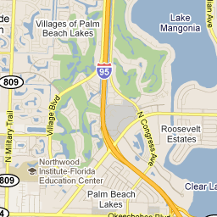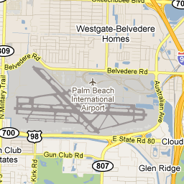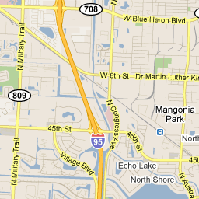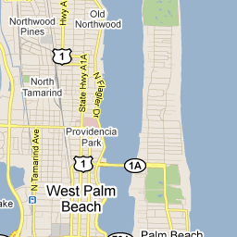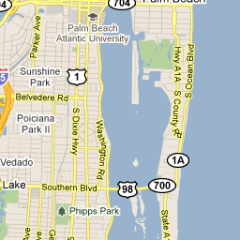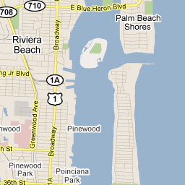

http://maps.gstatic.com/intl/en_us/mapfiles/shadow50.pnghttp://maps.gstatic.com/intl/en_us/mapfiles/dithshadow.gif

http://maps.gstatic.com/intl/en_us/mapfiles/marker.pnghttp://maps.gstatic.com/intl/en_us/mapfiles/markerie.gif

http://maps.gstatic.com/intl/en_us/mapfiles/iws3.png

http://maps.gstatic.com/intl/en_us/mapfiles/iws3.png

http://maps.gstatic.com/intl/en_us/mapfiles/iws3.png

http://maps.gstatic.com/intl/en_us/mapfiles/iws3.png

http://maps.gstatic.com/intl/en_us/mapfiles/iws3.png

http://maps.gstatic.com/intl/en_us/mapfiles/iws3.png

http://maps.gstatic.com/intl/en_us/mapfiles/iws3.png

http://maps.gstatic.com/intl/en_us/mapfiles/iws3.png

http://maps.gstatic.com/intl/en_us/mapfiles/iws3.png

http://maps.gstatic.com/intl/en_us/mapfiles/iws3.png

http://maps.gstatic.com/intl/en_us/mapfiles/iws3.png

http://maps.gstatic.com/intl/en_us/mapfiles/markerTransparent.png

http://maps.gstatic.com/intl/en_us/mapfiles/iw_close.gifhttp://maps.gstatic.com/intl/en_us/mapfiles/iw_plus.gif[[http://maps.gstatic.com/intl/en_us/mapfiles/iw_fullscreen.gif](javascript:void(0))Full-screen](javascript:void(0))http://maps.gstatic.com/intl/en_us/mapfiles/iw_minus.gif

Young Trappa  
[Run Background Search](javascript:void(0))

http://maps.gstatic.com/intl/en_us/mapfiles/iw3.png

http://maps.gstatic.com/intl/en_us/mapfiles/iw3.png

http://maps.gstatic.com/intl/en_us/mapfiles/iw3.png

http://maps.gstatic.com/intl/en_us/mapfiles/iw3.png

http://maps.gstatic.com/intl/en_us/mapfiles/iw3.png

Map data ©2011 Google - [Terms of Use](http://www.google.com/intl/en_us/help/terms_maps.html)

[http://maps.gstatic.com/intl/en_us/mapfiles/poweredby.png](http://maps.google.com/maps?ll=26.725067,-80.053425&spn=0.040631,0.06609&z=13&client=gme-peoplesearch&sensor=false&mapclient=jsapi&oi=map_misc&ct=api_logo)

|  |  |
| --- | --- |
| **Owner Name**: | Young Trappa  [Run Background Search](javascript:void(0)) |
| **Address**: | West Palm Beach, FL |
| **Phone Type**: | What Is This?Mobile |
| **Phone Issuing Location**: | What Is This?Phone issuing location is based on NPA-NXX exchange information provided by phone companies. This does not refer to where the owner of the phone lives, only where the actual number was derived and allocated.  Metro Pcs, Inc. Palm Beach, FL 33480 |
| **Run Another Phone Search**  Top of Form    Bottom of Form  Ex: 555-555-5555 | |

**Email Addresses - Owned**

Email addresses and social network results that match known residences for Young Trappa

**No email addresses found associated with Young Trappa**

© 2011 PhoneDetective.com - All rights reserved.  
You agree to use this information only for appropriate, legal purposes, and in compliance with all applicable federal, state and local laws and regulations, as outlined in the End User Agreement.

Processing...