

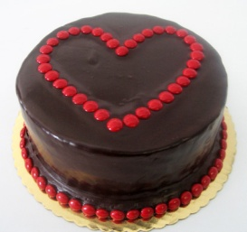**Candy Mamalade**

Candy is sweet like a chocolate treat,

Candy so kind, a mother divine.

Candy the world to me and mother to three,

Candy we love without with we cannot see.

Candy we say when we wake each day,

Candy we cry when the world seems wry,

Candy, oh mommy, the love in our eyes,

Candy’s kisses cure pains of all shapes and sizes.

Candy! Candy! Candy! Chime her angels in chorus,

Candy replies to each request with her motherly breast.

Candy to bring a smile whenever we request,

Candy a mother so kind it blows your mind.

Candy, on Mother’s Day, we cannot thank you enough,

Candy, we want you to know we love you so.

So much so, we want to eat you up and swallow you whole,

So love may forever and forever and forever fill our souls!

Jake

---

I love you with all my heart

Just like a sweet candy tart

We are our own wolfpack clan

When dad is howling, “Can, Can, Can.”

Each day your smile

Makes us go the extra mile,

You are like the stars

But you’re sweeter than any Candy bar.

Josh

--

Who loves us more than any other

Than Candy the world’s greatest mother?

She is like a Reese’s peanut butter treat

Making people happy from head to feet.

Her love is like the oceans waters so large and protective,

Without it we cannot live like fish without a stream.

Danny

--

Mommy I love you so much,

You are my honey candy,

Always making me feel dandy,

Your love fills my heart and we will never be apart.

WE LOVE OUR MOMMY!!!! HAPPY MOM’S DAY

Your 4 Boys