Kaye appointed Chair of Judicial Nomination Commission
May 21, 2009 at 2:33 pm by Irene Jay Liu
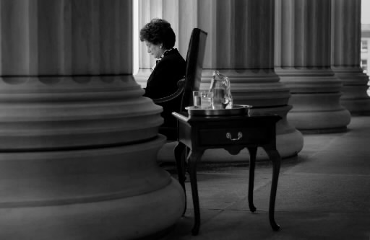
Times Union/ Paul Buckowski
Retired Chief Judge Judith Kaye has been selected by the Commission on Judicial Nomination to serve as chairperson.
The chairperson presides over Commission meetings and acts as the Commission’s sole spokesperson.
Kaye was recently appointed to the Commission by Governor David Paterson to serve a term that expires March 31, 2013. Paterson appointed Frederick K. Brewington last year, with a term that was supposed to end March 31, 2012, however Brewington resigned the day before Kaye was appointed.
According to the New York Law Journal:
During a Law Day speech Friday at the Court of Appeals, Mr. Paterson said Ms. Kaye, now counsel at Skadden, Arps, Slate, Meagher & Flom, has agreed to sit on the Commission on Judicial Nomination, which he criticized earlier this year for sending him a chief judge list of seven men as not diverse enough. The governor said Friday Ms. Kaye “will bring added integrity” to the nomination process. “She’s one who I think knows the process well,” the governor said. “With greater outreach and opportunity we just want to make sure we are getting the right people,” Mr. Paterson told reporters after his speech.
The term of the commission’s former chair, Pataki appointee John O’Mara, ended on March 31, 2009.
Of the twelve members of the Commission, four are chosen by the Governor, four by the Chief Judge, and one each by the Speaker of the Assembly, Temporary President of the Senate, Minority Leader of the Senate and Minority Leader of the Assembly.
Full release after the jump.
FOR IMMEDIATE RELEASE
The Commissioners of the New York State Commission on Judicial Nomination
have elected former Chief Judge of the New York Court of Appeals Judith S. Kaye to be the
Commission’s new chairperson. The chairperson presides over Commission meetings and acts as
the Commission’s sole spokesperson. Judge Kaye was recently appointed to the Commission by
Governor David A. Paterson to serve a term that expires March 31, 2013.
“I am honored that Governor Paterson appointed me to the Commission and am
now doubly honored to be chosen to serve as Chair,” Judge Kaye remarked. “I look forward to
working with my fellow Commissioners to make sure that the Court of Appeals continues to be
among the nation’s most respected courts, and that the Judges of the Court continue to reflect the
best of New York’s talented and diverse legal community.”
The Commission on Judicial Nomination was created by Article 6, § 2 of the New
York State Constitution. The Commission nominates seven persons for a vacancy in the office
of Chief Judge, from whom the Governor must select his appointment for the vacancy. The Governor’s appointment is subject to confirmation by the New York Senate. Of the twelve
members of the Commission, four are chosen by the Governor, four by the Chief Judge, and one
each by the Speaker of the Assembly, Temporary President of the Senate, Minority Leader of the
Senate and Minority Leader of the Assembly.
Posted in General |

