UNITED STATES DISTRICT COURT
NORTHERN DISTRICT OF TEXAS,
DALLAS DIVISION
X

In the Matter of the Application and
Petition-Complaint of Eliot Bernstein
to Intervene and/or Join as a Plaintiff
in the within Action both
Individually and as A Trustee on
behalf of Joshua Ennio Zander
Bernstein Irrevocable Trust, Jacob
Noah Archie Bernstein Irrevocable
Trust & Daniel Elijsha Abe Ottomo
Bernstein Irrevocable Trust;

Petitioner,
DOCKET NO:
3:09-cv-00298-N
3:09-cv-00298-L
1:09-mc-00002-JAD
SECURITIES AND EXCHANGE COMMISSION
PETITION TO WITHDRAW AND DISCONTINUE SPECIFIED CLAIMS
Plaintiff,

-v-

STANFORD INTERNATIONAL BANK, LTD,

STANFORD GROUP COMPANY, STANFORD

CAPITAL MANAGEMENT, LLC, R. ALLEN

STANFORD, JAMES M. DAVIS, AND

LAURA PENDERGEST-HOLT,

Defendants

X

PETITION TO WITHDRAW AND DISCONTINUE SPECIFIED CLAIMS

Petitioner-Co-Plaintiff Eliot Bernstein ALLEGES AS FOLLOWS:

Petitioner Eliot Bernstein respectfully shows this Court and prays for relief as follows:

1. My name is Eliot Bernstein and I reside at 2753 N.W. 34th Street Boca Raton Florida 33436.

2. On or about February 25th 2009, I Petitioned this Court on behalf of myself Individually and also on behalf of my sons, Joshua, Jacob and Daniel, as Trustee of Trust Funds for such children held in Stanford Trust Company, such Petition seeking to formally Intervene and Join as a party in interest in an action filed by the Securities Exchange Commission ( SEC ) as set forth above against R. Allen Stanford of Stanford Trust Company.

3. Whereas, however, I now respectfully Petition this Court and seek to Withdraw and Discontinue only those Claims specified on behalf of my sons as their Trustee since I am not the Trustee on Trust Accounts named herein although I am Trustee on other non-related accounts to this action.

4. Such Petition and prayer for relief shall be strictly limited to those specified claims and for such claims I hereby formally move to withdraw such specified claims and discontinue the action for those specified claims.

5. This petition and prayer for relief is not intended to withdraw and/or discontinue any claims I, Eliot Bernstein, have filed individually in this matter.

Wherefore, it is respectfully prayed for an Order withdrawing and discontinuing all such claims as specified herein relating to the following Trust Accounts for my sons as Exhibited herein for:
Daniel Bernstein Irrevocable Trust – STBR10045
Jacob “Jake” Bernstein Irrevocable Trust – STBR10050
Joshua EZ Bernstein Irrevocable Trust – STBR10049
and for any other and further relief as to this Court may seem just and proper.

EXHIBIT 1
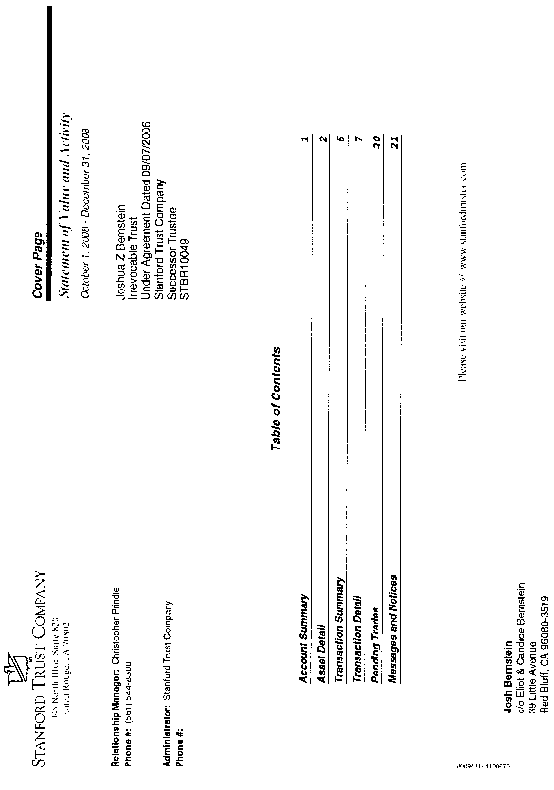
EXHIBIT 1
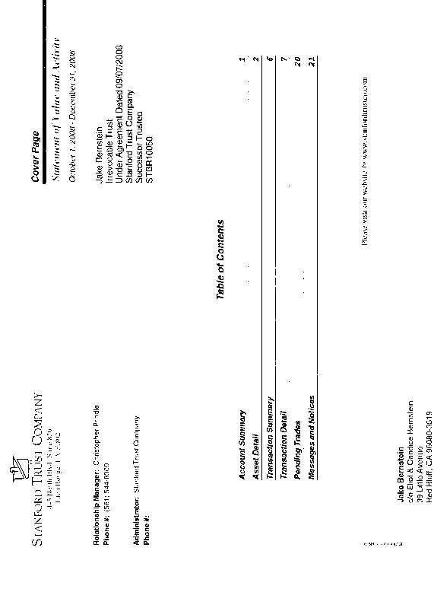
EXHIBIT 1
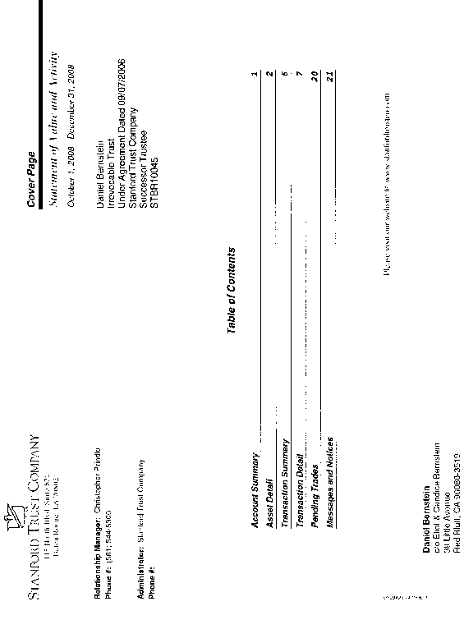
Attorney for Petitioner
Eliot I. Bernstein, Pro se
2753 N.W. 34th Street
Boca Raton, FL 33434
(561) 245-8588
(561) 886-7628
iviewit@iviewit.tv

By:
Eliot I. Bernstein

AFFIDAVIT OF SERVICE

I, Eliot Ivan Bernstein hereby certify under the penalty of perjury that on the 16th day of March, 2009 served by United States Mail, Facsimile or hand delivery the (PETITION TO WITHDRAW AND DISCONTINUE SPECIFIED CLAIMS) on this Court, requesting this Court serve all named Plaintiffs, Defendants and other necessary parties via the United States Marshal Service or other method this Court deems acceptable, or otherwise so reply to as the correct parties for these cases with all applicable addressing information.

Eliot I. Bernstein, Pro se
2753 N.W. 34th Street
Boca Raton, FL 33434
(561) 245-8588
(561) 886-7628
iviewit@iviewit.tv

