08-4873-CV

United States Court of Appeal for the Second Circuit

ELIOT I. BERNSTEIN, INDIVIDUALLY and P. STEPHEN LAMONT AND ELIOT I. BERNSTEIN ON BEHALF OF SHAREHOLDERS OF IVIEWIT HOLDINGS, INC., IVIEWIT TECHNOLOGIES, INC., UVIEW.COM, INC., IVIEWIT HOLDINGS, INC., IVIEWIT HOLDINGS, INC., IVIEWIT.COM, INC., IVIEWIT.COM, INC., I.C., INC., IVIEWIT.COM LLC, IVIEWIT LLC, IVIEWIT CORPORATION, IVIEWIT, INC., IVIEWIT, INC., and PATENT INTEREST HOLDERS as defined in the Amended Complaint.

Plaintiffs – Appellants

--v--

STATE OF NEW YORK, THE OFFICE OF COURT ADMINISTRATION OF THE UNIFIED COURT SYSTEM, PROSKAUER ROSE LLP, and, all of its Partners, Associates and Of Counsel, in their professional and individual capacities, STEVEN C. KRANE in his official and individual Capacities for the New York State Bar Association and the Appellate Division First Department Departmental Disciplinary Committee, and, his professional and individual capacities as a Proskauer partner, KENNETH RUBENSTEIN, in his professional and individual capacities, ESTATE OF STEPHEN KAYE, in his professional and individual capacities, ALAN S. JAFFE, in his professional and individual capacities, ROBERT J. KAFIN, in his professional and individual capacities, CHRISTOPHER C. WHEELER, in his professional and individual capacities, MATTHEW M. TRIGGS in his official and individual capacity for The Florida Bar and his professional and individual capacities as a partner of Proskauer, ALBERT T. GORTZ, in his professional and individual capacities, CHRISTOPHER PRUZASKI, in his professional and individual capacities, MARA LERNER ROBBINS, in her professional and individual capacities, DONALD “ROCKY” THOMPSON, in his professional and individual capacities, GAYLE COLEMAN, in her professional and individual capacities, DAVID GEORGE, in his professional and individual capacities, GEORGE A. PINCUS, in his professional and individual capacities, GREGG REED, in his professional and individual capacities, LEON GOLD, in his professional and individual capacities, MARCY HAHN-SAPERSTEIN, in her professional and individual capacities, KEVIN J. HEALY, in his professional and individual capacities, STUART KAPP, in his professional and individual capacities, RONALD F. STORETTE, in his professional and individual capacities, CHRIS WOLF, in his professional and individual capacities, JILL ZAMMAS, in her professional and individual capacities, JON A. BAUMGARTEN, in his professional and individual capacities, SCOTT P. COOPER, in his professional and individual capacities, BRENDAN J. O'ROURKE, in his professional and individual capacities, LAWRENCE I. WEINSTEIN, in his professional and individual capacities, WILLIAM M. HART, in his professional and individual capacities, DARYN A. GROSSMAN, in his professional and individual capacities, JOSEPH A. CAPRARO JR., in his professional and individual capacities, JAMES H. SHALEK, in his professional and individual capacities, GREGORY MASHBERG, in his professional and individual capacities, JOANNA SMITH, in her professional and individual capacities, MELTZER LIPPE GOLDSTEIN WOLF & SCHLISSEL, P.C. and its predecessors and successors, and, all of its Partners, Associates and Of Counsel, in their professional and individual capacities, LEWIS S. MELTZER, in his professional and individual capacities, RAYMOND A. JOAO, in his professional and individual capacities, FRANK MARTINEZ, in his professional and individual capacities, FOLEY & LARDNER LLP, and, all of its Partners, Associates and Of Counsel, in their professional and individual capacities, MICHAEL C. GREBE, in his professional and individual capacities, WILLIAM J. DICK, in his professional and individual capacities, TODD C. NORBITZ, in his professional and individual capacities, ANNE SEKEL, in his professional and individual capacities, RALF BOER, in his professional and individual capacities, BARRY GROSSMAN, in his professional and individual capacities, JIM CLARK, in his professional and individual capacities, DOUGLAS A. BOEHM, in his professional and individual capacities, STEVEN C. BECKER, in his professional and individual capacities, BRIAN G. UTLEY, MICHAEL REALE, RAYMOND HERSCH, WILLIAM KASSER, ROSS MILLER, ESQ. in his professional and individual capacities, STATE OF FLORIDA, OFFICE OF THE STATE COURTS ADMINISTRATOR, FLORIDA, HON. JORGE LABARGA in his official and individual capacities, THE FLORIDA BAR, JOHN ANTHONY BOGGS in his official and individual capacities, KELLY OVERSTREET JOHNSON in her official and individual capacities, LORRAINE CHRISTINE HOFFMAN in her official and individual capacities, ERIC TURNER in his official and individual capacities, KENNETH MARVIN in his official and individual capacities, JOY A. BARTMON in her official and individual capacities, JERALD BEER in his official and individual capacities, BROAD & CASSEL, and, all of its Partners, Associates and Of Counsel, in their professional and individual capacities, JAMES J. WHEELER, in his professional and individual capacities, FLORIDA SUPREME COURT, HON. CHARLES T. WELLS, in his official and individual capacities, HON. HARRY LEE ANSTEAD, in his official and individual capacities HON. R. FRED LEWIS, in his official and individual capacities, HON. PEGGY A. QUINCE, in his official and individual capacities, HON. KENNETH B. BELL, in his official and individual capacities, THOMAS HALL, in his official and individual capacities, DEBORAH YARBOROUGH in her official and individual capacities, DEPARTMENT OF BUSINESS AND PROFESSIONAL REGULATION – FLORIDA, CITY OF BOCA RATON, FLA., ROBERT FLECHAUS in his official and individual capacities, ANDREW SCOTT in his official and individual capacities, SUPREME COURT OF NEW YORKAPPELLATE DIVISION FIRST DEPARTMENT DEPARTMENTAL DISCIPLINARY COMMITTEE, THOMAS J. CAHILL in his official and individual capacities, PAUL CURRAN in his official and individual capacities, MARTIN R. GOLD in his official and individual capacities, SUPREME COURT OF NEW YORK APPELLATE DIVISION FIRST DEPARTMENT, CATHERINE O’HAGEN WOLFE in her official and individual capacities, HON. ANGELA M. MAZZARELLI in her official and individual capacities, HON. RICHARD T. ANDRIAS in his official and individual capacities, HON. DAVID B. SAXE in his official and individual capacities, HON. DAVID FRIEDMAN in his official and individual capacities, HON. LUIZ A. GONZALES in his official and individual capacities, SUPREME COURT OF NEW YORK APPELLATE DIVISION SECOND JUDICIAL DEPARTMENT, SUPREME COURT OF NEW YORK APPELLATE DIVISION SECOND DEPARTMENT DEPARTMENTAL DISCIPLINARY COMMITTEE, LAWRENCE DIGIOVANNA in his official and individual capacities, DIANA MAXFIELD KEARSE in her official and individual capacities, JAMES E. PELTZER in his official and individual capacities, HON. A. GAIL PRUDENTI in her official and individual capacities, HON. JUDITH S. KAYE in her official and individual capacities, STATE OF NEW YORK COMMISSION OF INVESTIGATION, ANTHONY CARTUSCIELLO in his official and individual capacities, LAWYERS FUND FOR CLIENT PROTECTION OF THE STATE OF NEW YORK, OFFICE OF THE ATTORNEY GENERAL OF THE STATE OF NEW YORK, ELIOT SPITZER in his official and individual capacities, as both former Attorney General for the State of New York, and, as former Governor of the State of New York, COMMONWEALTH OF VIRGINIA, VIRGINIA STATE BAR, ANDREW H. GOODMAN in his official and individual capacities, NOEL SENGEL in her official and individual capacities, MARY W. MARTELINO in her official and individual capacities, LIZBETH L. MILLER, in her official and individual capacities, MPEGLA, LLC, LAWRENCE HORN, in his professional and individual capacities, REAL 3D, INC. and successor companies, GERALD STANLEY, in his professional and individual capacities, DAVID BOLTON, in his professional and individual capacities, TIM CONNOLLY, in his professional and individual capacities, ROSALIE BIBONA, in her professional and individual capacities, RYJO, INC., RYAN HUISMAN, in his professional and individual capacities, INTEL CORP., LARRY PALLEY, in his professional and individual capacities, SILICON GRAPHICS, INC., LOCKHEED MARTIN, BLAKELY SOKOLOFF TAYLOR & ZAFMAN, LLP, and, all of its Partners, Associates and Of Counsel, in their professional and individual capacities, NORMAN ZAFMAN, in his professional and individual capacities, THOMAS COESTER, in his professional and individual capacities, FARZAD AHMINI, in his professional and individual capacities, GEORGE HOOVER, in his professional and individual capacities, WILDMAN, HARROLD, ALLEN & DIXON LLP, and, all of its Partners, Associates and Of Counsel, in their professional and individual capacities, MARTYN W. MOLYNEAUX, in his professional and individual capacities, MICHAEL DOCKTERMAN, in his professional and individual capacities, HARRISON GOODARD FOOTE, and, all of its Partners, Associates and Of Counsel, in their professional and individual capacities, EUROPEAN PATENT OFFICE, ALAIN POMPIDOU in his official and individual capacities, WIM VAN DER EIJK in his official and individual capacities, LISE DYBDAHL in her official and personal capacities, YAMAKAWA INTERNATIONAL PATENT OFFICE, and, all of its Partners, Associates and Of Counsel, in their professional and individual capacities, MASAKI YAMAKAWA, in his professional and individual capacities, CROSSBOW VENTURES, INC., ALPINE VENTURE CAPITAL PARTNERS LP, STEPHEN J. WARNER, in his professional and individual capacities, RENE P. EICHENBERGER, in his professional and individual capacities, H. HICKMAN “HANK” POWELL, in his professional and individual capacities, MAURICE BUCHSBAUM, in his professional and individual capacities, ERIC CHEN, in his professional and individual capacities, AVI HERSH, in his professional and individual capacities, MATTHEW SHAW, in his professional and individual capacities, BRUCE W. SHEWMAKER, in his professional and individual capacities, RAVI M. UGALE, in his professional and individual capacities, DIGITAL INTERACTIVE STREAMS, INC., ROYAL O’BRIEN, in his professional and individual capacities, HUIZENGA HOLDINGS INCORPORATED, WAYNE HUIZENGA, in his professional and individual capacities, WAYNE HUIZENGA, JR., in his professional and individual capacities, TIEDEMANN INVESTMENT GROUP, BRUCE T. PROLOW, in his professional and individual capacities, CARL TIEDEMANN, in his professional and individual capacities, ANDREW PHILIP CHESLER, in his professional and individual capacities, CRAIG L. SMITH, in his professional and individual capacities, HOUSTON & SHAHADY, P.A., and any successors, and, all of its Partners, Associates and Of Counsel, in their professional and individual capacities, BART A. HOUSTON, ESQ. in his professional and individual capacities, FURR & COHEN, P.A., and, all of its Partners, Associates and Of Counsel, in their professional and individual capacities, BRADLEY S. SCHRAIBERG, ESQ. in his professional and individual capacities, MOSKOWITZ, MANDELL, SALIM & SIMOWITZ, P.A., and, all of its Partners, Associates and Of Counsel, in their professional and individual capacities, WILLIAM G. SALIM, ESQ. in his professional and individual capacities, SACHS SAX & KLEIN, P.A., and, all of its Partners, Associates and Of Counsel, in their professional and individual capacities, BEN ZUCKERMAN, ESQ. in his professional and individual capacities, SPENCER M. SAX, in his professional and individual capacities, SCHIFFRIN & BARROWAY LLP, and any successors, and, all of its Partners, Associates and Of Counsel, in their professional and individual capacities, RICHARD SCHIFFRIN, in his professional and individual capacities, ANDREW BARROWAY, in his professional and individual capacities, KRISHNA NARINE, in his professional and individual capacities, CHRISTOPHER & WEISBERG, P.A., and, all of its Partners, Associates and Of Counsel, in their professional and individual capacities, ALAN M. WEISBERG, in his professional and individual capacities, ALBERTO GONZALES in his official and individual capacities, JOHNNIE E. FRAZIER in his official and individual capacities, IVIEWIT, INC., a Florida corporation, IVIEWIT, INC., a Delaware corporation, IVIEWIT HOLDINGS, INC., a Delaware corporation (f.k.a. Uview.com, Inc.), UVIEW.COM, INC., a Delaware corporation, IVIEWIT TECHNOLOGIES, INC., a Delaware corporation (f.k.a. Iviewit Holdings, Inc.), IVIEWIT HOLDINGS, INC., a Florida corporation, IVIEWIT.COM, INC., a Florida corporation, I.C., INC., a Florida corporation, IVIEWIT.COM, INC., a Delaware corporation, IVIEWIT.COM LLC, a Delaware limited liability company, IVIEWIT LLC, a Delaware limited liability company, IVIEWIT CORPORATION, a Florida corporation, IBM CORPORATION, JOHN AND JANE DOES.

Defendants – Appellees

ON APPEAL FROM THE UNITED STATES DISTRICT COURT
FOR THE SOUTHERN DISTRICT OF NEW YORK
CASE 07 Civ. 11196 (SAS) Eliot I. Bernstein, et al. v. Appellate Division First Department, Department Disciplinary Committee et al.

Related Case
07 Civ. 9599 (SAS-AJP) Christine C. Anderson v. the State of New York, et al.

Cases seeking or related to anderson
(07cv11612) Esposito v The State of New York, et al.,
(08cv00526) Capogrosso v New York State Commission on Judicial Conduct, et al.,
(08cv02391) McKeown v The State of New York, et al.,
(08cv02852) Galison v The State of New York, et al.,
(08cv03305) Carvel v The State of New York, et al.,
(08cv4053) Gizella Weisshaus v The State of New York, et al.,
(08cv4438) Suzanne McCormick v The State of New York, et al.

PLAINTIFF BERNSTEIN APPELLANT BRIEF

ELIOT IVAN BERNSTEIN
2753 N.W. 34TH STREET
BOCA RATON, FLORIDA 33434-3459
(561) 245.8588 (o) / (561) 886.7628 (c) / (561) 245-8644 (f)
iviewit@iviewit.tv / www.iviewit.tv

TABLE OF CONTENTS

I. PRELIMINARY STATEMENT 8
II. STATEMENT OF SUBJECT MATTER AND APPELLATE JURISDICTION 9
a. District Court’s Subject Matter Jurisdiction 9
b. Court of Appeals for the Second Circuit’s Subject Matter Jurisdiction 9
III. ISSUES PRESENTED FOR REVIEW 10
IV. STATEMENT OF THE CASE 10
V. DISMISSAL AT THIS STAGE OF LITIGATION WAS INAPPROPRIATE AND CASE SHOULD BE REMANDED 16
VI. 2008 SIXTH CIRCUIT US COURT OF APPEALS: DISCOVERY BEFORE DISMISSAL ON SUBJECT MATTER JURISDICTION: 18
a. FEDERAL JURISDICTION 20
b. Intellectual Properties under Article I of the US Constitution - HARRY I. MOATZ, DIRECTOR, OFFICE OF ENROLLMENT AND DISCIPLINE – UNITED STATES PATENT & TRADEMARK OFFICE 21
VII. FBI SPECIAL AGENT LUCCHESI, WEST PALM BEACH “Attempted Murder” and “MURDER” according to Judge Scheindlin 23
VIII. PREMATURE TO DISMISS AT THIS STAGE OF LITIGATION: STATUTE OF LIMITATIONS “Attempted Murder” and “Murder” and More 25
IX. ANOTHER SPECIFIC AREA OF DISCOVERY RENDERING DISMISSAL BY THE DISTRICT COURT AS IMPROPER AT THIS STAGE OF LITIGATION: "NY ETHICS SCANDAL TIED TO INTERNATIONAL ESPIONAGE SCHEME" FROM WWW.EXPOSECORRUPTCOURTS.BLOGSPOT.COM 27
X. EQUITABLE TOLLING 29
XI. SEGWAY with “RELATED CASES”: DISMISSAL WITHOUT DISCOVERY PREMATURE WITHOUT “RELATED CASES” DISCOVERY 30
XII. DISMISSAL ON IMMUNITY GROUNDS ALSO PREMATURE AND ERROR AT THIS STAGE OF LITIGATION 33
XIII. ADDITIONAL FEDERAL JURISDICTION AND THE ERRONEOUS RELIANCE ON "ROOKER-FELDMAN FOR DISMISSAL 36
XIV. CONCEALMENT / CONTINUING TORT- CONSPIRACY / RICO / EQUITABLE TOLLING 38
XV. FIRST AMENDMENT FUNDAMENTAL RIGHT OF GRIEVANCES AND DUE PROCESS 39
XVI. CONCLUSION 41
XVII. APPENDICES 42
A. –I Amended Complaint 43
A. – II Motions to Dismiss 44
A. – II Motions to Dismiss Continued 45
A. – III Oppositions 46
A. – IV Order 47
Cases
(07cv11612) Esposito v The State of New York, et al., 5
(08cv00526) Capogrosso v New York State Commission on Judicial Conduct, et al., 5
(08cv02391) McKeown v The State of New York, et al., 5
(08cv02852) Galison v The State of New York, et al., 5
(08cv03305) Carvel v The State of New York, et al., 5
(08cv4053) Gizella Weisshaus v The State of New York, et al. 5
(08cv4438) Suzanne McCormick v The State of New York, et al. 5
07 Civ. 9599 (SAS-AJP) Christine C. Anderson v. the State of New York, et al. 5
Bender v. Williamsport Area Sch. Dist., 475 U.S. 534, 543 n. 6, 106 S.Ct. 1326, 1332 n. 6, 89 L.Ed.2d 501 (1986) 31
Bracy v Gramley, US 96-6133, June 9, 1997 40
Conley v. Gibson, 355 U.S. 41, 45 -46 (1957) (footnote omitted). [416 U.S. 232, 237] 18
Dunton v. County of Suffolk, 729 F.2d 903, 907 (2d Cir.) 31, 32
Edelman v. Jordan, 415 U.S. 651 (1974) 35
Ex parte Young, 209 U.S. 123 (1908) 34
Gardner v. Toilet Goods Assn., 387 U.S. 167, 172 (1967). 18
Gilligan v. Morgan, 413 U.S. 1 (1973) 18
In re Ahead by a Length, Inc, 100 BR 157 ( SDNY Bankr. 1989 ) 39
Kentucky v. Graham, 473 U.S. 159, 165, 105 S.Ct. 3099, 3105, 87 L.Ed.2d 114 (1985) 31
Scheuer v Rhodes, et al., US Supreme Court 16
Scheuer v. Rhodes, 416 US 232 35
Scheuer v. Rhodes, US Supreme Court, 416 US 232 ( 1974 ) 17
US Constitution 40
Withrow v. Larkin, 421 U.S. 35, 46 (1975) 40
Zahrey v. Coffey, 221 F.3d 342, 348 (2d Cir. 2000) 33

, US Supreme Court 16
Scheuer v. Rhodes, 416 US 232 35
Scheuer v. Rhodes, US Supreme Court, 416 US 232 ( 1974 ) 17
US Constitution 40
Withrow v. Larkin, 421 U.S. 35, 46 (1975) 40
Zahrey v. Coffey, 221 F.3d 342, 348 (2d Cir. 2000) 33

- PRELIMINARY STATEMENT
Plaintiff-Appellant, Eliot Ivan Bernstein, individually, files this Brief to appeal the decision of Hon. Shira A. Scheindlin, a United States District Judge for the Southern District of New York in Opinion and Order (07-cv-11196, S.D.N.Y., Filed August 8, 2008) (“Order”) which dismissed without answer or discovery Plaintiff's case in its entirety while simultaneously making referrals of the "related" cases to seek intervention of an appropriate United States Attorney and/or NYS Attorney General herein. Plaintiff-Appellant Eliot Bernstein appeals from each and every part of such Order of Dismissal by the District Court of August 2008.
Plaintiff-Appellant Bernstein notes at this time that a motion by Plaintiff-Appellant Bernstein is pending with this Court, the US Second Circuit Court of Appeals, which seeks various forms of relief including but not limited to Dismissing the Appeal of Plaintiff-Appellant P. Stephen Lamont for lack of standing and capacity to sue as the Original Complaint and the Amended Complaint were brought not in Lamont’s individual capacity but instead only "on behalf of others" wherein P. Stephen Lamont not only lacks such standing to sue in such capacity, but has not brought forward any consent to sue by any others he claims to sue on behalf of even if such action is proper, which it is not.&. Plaintiff-Appellant Bernstein after learning that there was no basis to sue on behalf of others and without consent of others and that such representation may be viewed as practicing law without a license, has since asked this Court and the lower court to remove his representation on behalf of others and allow his individual interest to prevail.
- STATEMENT OF SUBJECT MATTER AND APPELLATE JURISDICTION
  - District Court’s Subject Matter Jurisdiction
The District Court has subject matter jurisdiction over this dispute pursuant to 28 U.S.C. §§ 1331 and 1338 (federal question jurisdiction). Jurisdiction is premised upon Defendants-Appellees’ breach of, among other federal statutes, 15 U.S.C.A. §§ 1 and 2,
Racketeer Influenced and Corrupt Organizations Act, and Article 1, Section 8 of The Constitution of the United States.
  - Court of Appeals for the Second Circuit’s Subject Matter Jurisdiction
The Courts of Appeals for the Second Circuit has jurisdiction of appeals from the final decisions of the District Court pursuant to 28 U.S.C. § 1291, in that this is an appeal from a final judgment of the District Court disposing of all claims by all parties. The final judgment was entered on August 8, 2008 and the notice of appeal was filed on or about August 28th 2008, although it was then lost at the US District Court and not filed by that Pro Se office with this Court until October 23, 2008. This appeal is thus timely, F.R.A.P. 4(a)(1)(A).
This Brief is file in accordance with the Court’s Pro Se Appeal Scheduling Order #1 of November 24, 2008. This Brief by Eliot Bernstein, individually as Plaintiff-Appellant is further filed in accordance with an updated schedule communicated to Bernstein via US Second Circuit indicating the Court had extended my Brief filing date until February 27, 2009.
It is noted that the US Second Circuit Court of Appeals denied my request for a longer extension which request by Bernstein was premised on two major topics: 1) Medical Necessity as amply demonstrated by the Treatment Plan filed by with the US Second Circuit; 2) Extension request premised upon petitioning the US Second Circuit Court of Appeals to seek the intervention of the "United States" in this appeal via the United States Attorney General's Office of Eric Holder and the US Solicitor General to fundamentally protect the United States and Article I of the United States Constitution.
Plaintiff-Appellant Bernstein notes that this Brief does not address an Appeal of that denial and again notes that other portions of that motion are pending with the US Second Circuit as noted in Footnotes 1 and 2. This Brief is thus timely.
- ISSUES PRESENTED FOR REVIEW
    - Was the district courts dismissal at this stage of litigation and without discovery premature and clearly erroneous? Yes.
- STATEMENT OF THE CASE
    - This Appeal comes before the Court from a Dismissal Order issued by US SDNY Judge Shira Scheindlin in August of 2008 which was issued prior to any Answer by any of the multiple Defendants in this case and issued prior to any formal Discovery permitted in the case despite the fact that Hon. Judge Scheindlin had previously marked the Bernstein case herein as "Related" to a currently pending case before Judge Scheindlin's Court involving a Whistleblower named Christine Anderson ( hereinafter "Anderson" ) where some of the specific allegations in Anderson involve claims of corruption and cover-up specifically relating to the Bernstein and Iviewit matters herein at the NYS First Department Disciplinary Committee. Christine Anderson previously was a Staff attorney at the NYS First Department Disciplinary Committee for several years according to her federal complaint and thus was in a position to have direct and personal knowledge of the operations of the NYS First Department Discipline Committee.
    - Remarkably, District Court Judge Scheindlin had also marked several other cases as being "related" to the Anderson case and yet in a sudden, unexpected sua sponte act Dismissed all of those other "related" cases by Order of the same date, August, 2008. Even more remarkable is that the Dismissal Order of District Court Judge Scheindlin of the "related" cases contains an inherently contradictory referral of "related" cases to an appropriate US Attorney's Office and/or the NYS Attorney General's Office. It is noted that the Bernstein/Iviewit case as mentioned above is one of the cases marked as "related" by District Court Scheindlin to the ongoing Anderson case and yet the Dismissal precluded Plaintiff Bernstein and the other "related" cases from accessing Discovery in the Anderson case which is fundamentally illogical and inherently contradictory and must be considered error and/or an abuse of discretion at least as it relates to Bernstein and Iviewit matters as her knowledge of the Iviewit complaints against key members of the Department is alleged to have had impact on her termination and the harassment she received both physically and mentally, as cited in her original filed complaint.
    - Thus, moving to the Bernstein case itself, presented to this Court are detailed allegations in the Amended Complaint demonstrating a massive multi-party, multi-year pattern of fraud and conspiracy in violation of federal RICO laws and civil rights under 42 USC Sec. 1983 all surrounding a common scheme for the fraud and theft of technologies and US Intellectual Property Rights ( IP ), including Patents, Trademarks, Copyrights, Trade Secrets and rights valued at nearly a trillion dollars over the life of the IP. As noted in the Amended Complaint, the underlying allegations herein implicate massive scandals such as Enron and Enron Broadband as the backbone Intellectual Property "technologies" alleged as stolen from original inventor and Owner Eliot Bernstein herein not only transformed the Internet as it is now known but is used to enable digital video and imaging, creation and distribution, across the entire digital spectrum, hardware and software, and is now the de facto standard for thousands of applications
    - Such technologies developed and invented by Original Inventors, including Plaintiff Eliot Bernstein were hailed in 1998-1999 as the "Holy Grail" by some of the most powerful and dominant forces in both the Defense industry and multi-national corporations including but not limited to Strategic Alliance Partner Real 3D, Inc. (an Intellectual Property consortium formerly 70% Lockheed Martin, 20% Silicon Graphics, Inc. and 10% Intel Corp., since acquired wholly by Intel Corp), AOLTW, WB, Sony and more.
    - The allegations in the Amended Complaint amply demonstrate that the case spans across multiple states within the United States such as New York, Florida, California, Delaware, offices in Washington, DC and more as well as internationally across the globe involving the European Patent Office, Japanese Patent Office, Korean Patent Office and through US Trade Treatises, including the Patent Cooperation Treaty.
    - It is noted at this time and stage of litigation that Plaintiff-Appellant Eliot Bernstein who is the only party to sue as a Plaintiff in an individual capacity as the original and true owner and inventor of the backbone technologies herein that Bernstein does not endorse in its entirety the original complaint filed by Plaintiff P. Stephen Lamont and in fact has filed a motion which is pending with this Court in relation to P. Stephen Lamont's capacity to sue and that such motion suggests that P. Stephen Lamont may have been involved in the improprieties associated with the filing and service of the original complaint and it is noted that a US Postal Inspector General's investigation is pending in this matter.
    - It is further critical to note that there has been significant and substantial involvement in the underlying actions and allegations as raised by the Amended Complaint herein by various Offices of the federal government of the United States including but not limited to US Dept. of Justice Office of Inspector General Glenn A. Fine, Harry Moatz of the US Patent Office OED, H. Marshall Jarrett of the US FBI OPR, and most remarkably actions by a Special Agent of the FBI, one Special Agent Stephen Lucchesi who has allegedly "retired" from the FBI but is now missing and unavailable with his records and files and investigation materials.
    - Of paramount importance is that US District Court Judge Shira Scheindlin states that the Bernstein and Iviewit case involves "murder" which carries no statute of limitations while Plaintiff-Appellant Bernstein himself specifically alleges the crime of Attempted Murder similarly with no statute of limitations as demonstrated pictorially and graphically at the website www.iviewit.tv showing the Bernstein family MiniVan that was car bombed Iraqi style. Rick Lee, Plans Reviewer/Fire Protection Engineer investigator of the Boynton Beach Fire & Rescue stated that accelerants were the cause of the blast and advised Plaintiff-Appellant Bernstein to contact the FBI agent in charge of my other matters and that he was contacting the Florida Marshal to engage their investigators as well.
    - Yet, FBI Special Agent Stephen Lucchesi who has since become a "missing witness" and investigator was supposedly investigating the Iraqi style car bombing Attempted Murder upon Plaintiff-Appellant Bernstein as the information was transmitted to his offices and the Iviewit matters including the ongoing thefts and fraud of Intellectual property rights against Plaintiff-Appellant Bernstein and the United States Patent & Trademark Office at the time Special Agent Lucchesi went missing and who remains missing at this time with all the files.
    - Of paramount importance is that US District Court Judge Shira Scheindlin states that the Bernstein and Iviewit case involves "murder" which carries no statute of limitations while Plaintiff-Appellant Bernstein himself specifically alleges the crime of Attempted Murder similarly with no statute of limitations as demonstrated pictorially and graphically at the website and supported by the statements of the Rick Lee.
    - Yet, FBI Special Agent Stephen Lucchesi who has since become a "missing witness" and investigator was specifically investigating the Iraqi style car bombing Attempted Murder upon Plaintiff-Appellant Bernstein and the Iviewit matters ongoing thefts and fraud of Intellectual property rights at the time Special Agent Lucchesi went missing who remains missing at this time.
    - It is specifically noted as being of paramount importance for purposes of this Brief at this stage of litigation that certain federal investigations are ongoing and continue such as the work of the Office of the Inspector General of the Dept. of Justice Glenn A. Fine which office has not closed "Iviewit" related investigations and further that Harry I. Moatz, Director of the Office of Enrollment & Discipline at the United States Patent & Trademark Office has begun formal investigations of the IP attorneys complained of to his offices, directed Plaintiff-Appellant Bernstein to work with a team of USPTO agents to move the IP into suspension and directed Bernstein to file a complaint with the Commissioner of Patents, claiming not only possible fraud on Plaintiff-Appellant Bernstein but fraud on the USPTO. These actions directed by Moatz have led to certain IP suspended by the Commissioner of Patents pending investigation. Referenced herein is a list of ongoing and unsolved federal and state investigations which underlie the entire Amended Complaint and Bernstein and Iviewit matters.
    - Central to the entire Amended Complaint are the actions of the Proskauer Rose firm and actions of attorneys who either claimed to be working for Proskauer, were working for Proskauer, or were working in conjunction with the Proskauer Rose international firm as the Proskauer firm became intimately involved with Plaintiff-Appellant Bernstein during the earliest years of the development of the "technologies". It is noted at this time that the Proskauer Rose firm is implicated in additional massive financial fraud scandals which have broken since the time of the Dismissal by the District Court in August of 2008 involving the Bernard Madoff and now Allen Stanford financial scandals. It is alleged to this Court that Discovery from these similar and related financial fraud schemes is proper for the instant action herein and that Plaintiff -Appellant Eliot Bernstein has formally moved in the District Court of the Nothern District of Texas to be permitted to intervene in the SEC filed case in that action.
    - Also central to the Amended Complaint are ongoing and continuing massive actions of fraud, deceit, and violation of public and private ethics and attorney Disciplinary Rules by the multiple attorneys and firms herein designed to block due process and justice at each and every stage of litigation thus far. This is precisely why Dismissal by Judge Scheindlin in August of 2008 without permitting Discovery from the ongoing and pending federal Whistleblower Anderson case alleging fraud and corruption at the NYS First Dept DDC specifically relating to Eliot Bernstein and Iviewit matters must be deemed error and / or an abuse of discretion requiring a reversal and remand of the action to the appropriate District or Federal Court at this time.
    - For all of the reasons set forth in the Brief herein, the Dismissal Order of the Hon. Judge Shira Scheindlin dated August 2008 must now be reversed, vacated, and the action remanded to the appropriate federal court for further proceedings and such other and further relief as may be just and proper.
- DISMISSAL AT THIS STAGE OF LITIGATION WAS INAPPROPRIATE AND CASE SHOULD BE REMANDED
See; Scheuer v Rhodes, et al., US Supreme Court

For all of the reasons herein, Dismissal of my federal complaint and action by US SDNY Hon. Judge Shira Scheindlin on August 08, 2008 prior to any Answer being filed by any defendant, prior to resolving the multiple conflicts within conflicts, including those unknown conflicts deemed “substantive” by Judge Scheindlin in an Order in that Court, amongst named defendant parties and the lawyers representing named defendant parties who in some instances are simultaneously acting as their own lawyers while Defendants against their former client Plaintiff-Appellant Bernstein, prior to any formal Discovery and perhaps most importantly prior to Discovery from the “related” federal Whistleblower action of former State First Department Discipline Committee staffer Christine Anderson ( hereinafter “Anderson” ) and all the other related Anderson cases was error under law and established US Supreme Court precedent and this Court must now vacate such Dismissal and remand to an appropriate District Court Judge for further proceedings.
In Scheuer v. Rhodes, US Supreme Court, 416 US 232 ( 1974 ) which I assert is good law with 30 more years of US Supreme Court precedent, being a federal civil rights case under 42 USC Sec. 1983 arising out of the actions on the campus of Kent State in Ohio during the turbulent times facing the nation as a result of the Vietnam and related conflicts, the US Supreme Court centered on the primary fundamental question of whether “dismissal at this stage of litigation” was appropriate and answered that dismissal at that stage of litigation was not appropriate without evidence and the opportunity for contested proceedings and remanded the case back to the District Court for further proceedings which is precisely the action that should now be taken by this Court, the US Second Circuit Court of Appeals.
I cite for this Court the important language, inquiries and law of the US Supreme Court in
Scheuer v Rhodes and the US Supreme Court progeny thereafter as these precise principles apply to my case and all of the grounds used by the US District Court in the Dismissal Order of August 2008 which was “clearly erroneous” and an abuse of discretion and must now be reversed:
"These cases arise out of the same period of alleged civil disorder on the campus of Kent State University in Ohio during May 1970 which was before us, in another context, in Gilligan v. Morgan, 413 U.S. 1 (1973). " . . . . . . .

"When a federal court reviews the sufficiency of a complaint, before the reception of any evidence either by affidavit or admissions, its task is necessarily a limited one. The issue is not whether a plaintiff will ultimately prevail but whether the claimant is entitled to offer evidence to support the claims. Indeed it may appear on the face of the pleadings that a recovery is very remote and unlikely but that is not the test. Moreover, it is well established that, in passing on a motion to dismiss, whether on the ground of lack of jurisdiction over the subject matter or for failure to state a cause of action, the allegations of the complaint should be construed favorably to the pleader.
"In appraising the sufficiency of the complaint we follow, of course, the accepted rule that a complaint should not be dismissed for failure to state a claim unless it appears beyond doubt that the plaintiff can prove no set of facts in support of his claim which would entitle him to relief." Conley v. Gibson, 355 U.S. 41, 45 -46 (1957) (footnote omitted). [416 U.S. 232, 237]
See also Gardner v. Toilet Goods Assn., 387 U.S. 167, 172 (1967). "
"The District Court dismissed the complaints for lack of jurisdiction over the subject matter on the theory that these actions, although in form against the named individuals, were, in substance and effect, against the State of Ohio and thus barred by the Eleventh Amendment. The Court of Appeals affirmed the action of the District Court, agreeing that the suit was in legal effect one against the State of Ohio and, alternatively, that the common-law doctrine of executive immunity barred action [416 U.S. 232, 235] against the state officials who are respondents here. 471 F.2d 430 (1972). We are confronted with the narrow threshold question whether the District Court properly dismissed the complaints. We hold that dismissal was inappropriate at this stage of the litigation and accordingly reverse the judgments and remand for further proceedings. We intimate no view on the merits of the allegations since there is no evidence before us at this stage. ". . . . . . . . .

“The District Court acted before answers were filed and without any evidence other than the copies of the proclamations issued by respondent Rhodes and brief affidavits of the Adjutant General and his assistant. In dismissing the complaints, the District Court and the Court of Appeals erroneously accepted as a fact the good faith of the Governor, and took judicial notice that "mob rule existed at Kent State University." There was no opportunity afforded petitioners to contest [416 U.S. 232, 250] the facts assumed in that conclusion. There was no evidence before the courts from which such a finding of good faith could be properly made and, in the circumstances of these cases, such a dispositive conclusion could not be judicially noticed. " See, Scheuer v Rhodes, 416 US 232 (1974 )

- 2008 SIXTH CIRCUIT US COURT OF APPEALS: DISCOVERY BEFORE DISMISSAL ON SUBJECT MATTER JURISDICTION:

I respectfully provide to this Court another principle of federal law which I assert applies in my case and is similar to the principles outlined in Scheuer v Rhodes above but I do note that due to time constraints from my health conditions I only quote the language of this 2008 case from an Article Link:
"In their reply to the joint motions to dismiss from the Republicans, the Democrats reminded that 6th Circuit precedent grants discovery before a suit like this can be dismissed on the jurisdictional grounds the Republicans had cited in their motions.
Under controlling Sixth Circuit precedent, when jurisdictional challenges raise questions of fact that are intertwined with merits questions, the proper course is denial of the motion to dismiss, conduct of discovery in the ordinary course, and consideration of the issues at the appropriate time on summary judgment. And because none of the Defendants has answered an interrogatory or produced a document in response to the Court-ordered discovery on jurisdictional issues, controlling precedent bars the Court from granting their motions. The rule is simple: When a defendant introduces evidence of its own related to the merits, it cannot block the plaintiff from conducting full discovery and still prevail."

Article Link:

http://emptywheel.firedoglake.com/2008/10/20/mi-republicans-admit-to-illegal-foreclosure-scheme-surrender-to-democrats/

In this case before the Court the record amply demonstrates multiple questions of fact intertwined with questions of law including but not limited to issues involving subject matter jurisdiction which should have permitted discovery before dismissal and therefore the dismissal Order at this stage of litigation was error. Of particular importance involves the Admission against interest made by NYS Assistant AG Monica Connell in response to conflicts of interest involving the representation by the NYS AG of over 30 State defendants wherein NYS Assistant AG Monica Connell declares that these conflict issues were matters for the federal court to resolve. Thus, it was plain and reversible error to have not permitted discovery on those areas of conflict alone particularly as it relates to subject matter jurisdiction and more particularly that at that stage of litigation the Office of the NYS AG not only was representing more than 30 state officials but also simultaneously having private communications and strategy sessions with the primary private law firms who are not only alleged to be central to the original patent theft scheme which is ongoing but are the very firms that state officials were supposed to be regulating under the attorney disciplinary rules. Likewise, as set out herein, under Scheuer and all law thereafter and under the principles of federal law above from this 2008 Michigan Voting Rights case, Dismissal of my complaints and claims at this stage of litigation by the US District Court was improper as Discovery on the Subject Matter jurisdiction and related issues should have been permitted and the Dismissal Order must now be Vacated and the case remanded to an appropriate federal court for further proceedings.
  - FEDERAL JURISDICTION

It is respectfully submitted that the District Court’s Dismissal Order of August 2008 is ripe with conflicts within conflicts, just as the entire case and action before this Court is ripe with conflicts within conflicts, which I, Eliot Bernstein, have requested to be corrected, and addressed both prior to Dismissal and subsequent to Dismissal by the District Court.
The Amended Complaint (and Original Complaint filed by P. Stephen Lamont which I do not endorse in total and complete submission ) makes it abundantly clear that Federal Jurisdiction is proper and appropriate in this case and any dismissal predicated on lack of federal jurisdiction is error.
  - Intellectual Properties under Article I of the US Constitution - HARRY I. MOATZ, DIRECTOR, OFFICE OF ENROLLMENT AND DISCIPLINE – UNITED STATES PATENT & TRADEMARK OFFICE
Article I makes it ever so clear that the issuance of Intellectual Property (patents, trademarks, copyrights and trade secrets) are a matter for the jurisdiction of the United States federal courts under Article I of the US Constitution and thus federal subject matter jurisdiction is appropriate since some of the most critical facts and allegations underlying my Amended Complaint and P. Stephen Lamont’s Original Complaint involve and allege not only an ongoing conspiracy to deny me as the primary Owner and Inventor of the “Technologies” the rightful use and rights in the Intellectual Properties of these Technologies, but further alleges fundamental fraud at the United States Patent Office. The fraud at the USPTO is thus necessarily intertwined with the allegations in my federal Amended Complaint. This further supports the exercise of federal subject matter jurisdiction herein.
In fact, a federal official, Harry I. Moatz of the USPTO directed me to file with the Commissioner of Patents allegations of fraud on the USPTO by licensed USPTO attorneys under his oversight and then assembled a team of USPTO experts to aid me in filing responses to get the Intellectual Properties into suspension with the USPTO. Based on these allegations filed on the direction of Moatz, the Intellectual Property in certain instances has been suspended by the Commissioner of Patents pending investigation into Fraud on the USPTO and thus such allegations are sufficient to allege an ongoing fraud and conspiracy at play sufficient for the exercise of subject matter jurisdiction, particularly at this stage of litigation prior to formal discovery or answer by the Defendants and the multiple conflicts within conflicts of defendants. ( See Amended Complaint ).
It is black letter law in the federal courts that any and all such allegations or claims made by myself or any of the 'related' Plaintiffs-Appellants “at this stage of litigation” must be accepted as true for purposes of the Motion to Dismiss erroneously granted by District Court Judge Shira Scheindlin. Thus, since it is alleged in my Federal Amended Complaint that Harry I. Moatz himself of the USPTO as Director of the Office of Enrollment and Discipline has claimed that fundamental fraud on the US Patent Office is one of the underlying parts of the conspiracies I allege, that he and the USPTO now are presumably investigating which led to suspensions of the Intellectual Properties based on investigation of such allegations by the USPTO and FBI jointly, certainly and clearly without question this raises matters which are and must be under law appropriate for Federal Jurisdiction.
In considering and contemplating the various conflicts within conflicts raised not only within the Amended Complaint itself but also within the contradictory and conflicting and erroneous Order of Dismissal of August 2008 by the District Court, it is shocking to the conscience that the District Court could attempt to dismiss for lack of federal jurisdiction and this Order must now be vacated and the action remanded to the appropriate District Court and or other Federal Court for appropriate action therein.
" This is particularly true where US District Court Judge Scheindlin herself referred my case and all of the "related" cases to the appropriate US Attorney's Office for relief. At most, the District Court could or should have stayed the "related" civil actions pending official involvement and intervention by the United States via the US Attorney's Office, a request which I have officially made to this Court. Thus, the Dismissal must now be vacated and reversed and the case remanded to the appropriate federal court for further proceedings."
- FBI SPECIAL AGENT LUCCHESI, WEST PALM BEACH “Attempted Murder” and “MURDER” according to Judge Scheindlin
Even more shocking or as equally shocking to the conscience in the Dismissal by the US District Court is that the allegations in the Amended Complaint specifically allege the direct involvement of an additional Federal Agent of the United States being one FBI Special Agent Lucchesi of the West Palm Beach FBI office who has been both actively involved in the Investigation of an Attempted Murder on my life and that of my Family as evidenced by an Iraqi style car bombing of my Mini Van in Boynton Beach as well as Investigation of the underlying Intellectual Properties Theft Conspiracies involving “Iviewit” and the Intellectual Properties of my “Technologies” both against me and against the United States and several US and Foreign government agencies, including the USPTO, the EPO and Small Business Administration. Again, it should be patently stark, clear and obvious that such matters are “Federal” matters of the United States and Federal Jurisdiction is appropriately invoked herein and that any dismissal predicated on lack of federal jurisdiction is Clearly Erroneous and must now be vacated and remanded to an appropriate federal court.
Of further specific relevance and importance to Point I herein and the principles set out by the US Supreme Court in Scheuer v Rhodes is that FBI Agent Luchessi has gone “Missing” per the FBI although he had stated at our last conversation that he was going to the USPTO to work on the crimes against the government and Iviewit on the advice of the US Attorney in Florida and I confirmed such with Moatz that they were joined in an ongoing investigation, as Moatz has begun formal investigation of approximately 12 licensed attorneys with the Patent Bar he oversees. Further, the files and records of Special Agent Lucchesi and investigative files have also disappeared and thus I as Plaintiff have not been able and was not able through no fault in pleading of my own to secure any affidavit or further evidence from this Special Agent of the FBI at the time of the filing of my Amended Complaint. Yet, under the Black Letter federal law standards for considering a Motion to Dismiss “At this Stage of Litigation” I am not required to plead with specificity each and every link in the chain of the Conspiracy and my pleadings must be accepted as True at this stage of litigation and every rationale, fair minded, intelligent conclusion and connotation and inference that can and should be drawn can only result in my favor that Dismissal at this Stage was inappropriate and must now be vacated and the case remanded for further proceedings including the Discovery of information and evidence from both Harry I. Moatz, Special Agent Lucchesi and more. It is noted that the allegations of my Amended Complaint specifically involve the actions of politically connected private attorneys such as Michael Grebe formerly of Foley & Lardner, who was Republican National Committee ( RNC ) Chief Counsel nationwide during the relevant years with such actions being intertwined with Official federal government actions and 'state actors' herein.
- PREMATURE TO DISMISS AT THIS STAGE OF LITIGATION: STATUTE OF LIMITATIONS “Attempted Murder” and “Murder” and More

In addition to an ongoing Intellectual Properties theft of multiple inventions conspiracy it is alleged that the crime of “Attempted Murder” is also but one additional claim asserted in both the Amended Complaint and P. Stephen Lamont’s “Original Complaint” which I, Eliot Bernstein as the true Owner and Inventor of the Technologies herein only endorse in “limited” manner.
Hon. District Court Judge Scheindlin, however, in but one of many examples of the “conflicted” and perhaps “confused” Dismissal Order states that this case of Eliot Bernstein and “Iviewit” involves “Murder” in addition to my claims involving “Attempted Murder.” See, Scheindlin Dismissal Order of August 2008.
Whether it is just “Attempted Murder” as pictorially and graphically demonstrated by the Iraqi style car bombing of my Mini Van at www.iviewit.tv or “Murder” that Scheindlin knows of only, both alleged crimes have no Statute of Limitations which could be appropriately relied upon to Dismiss the Complaint or Amended Complaint at this stage of litigation since only Discovery of the evidence of missing “witness” FBI Special Agent Lucchesi, Harry Moatz of the USPTO, the discovery of the information in the related cases and Discovery and depositions amongst the multiple named Defendants and those “un-served” Defendants would yield the type of factual specifics and links in the chains of evidence which could properly determine whether any defendant should be dismissed on the basis of a statute of limitations claim which again is all premature to determine at “this stage of litigation” rendering the only appropriate action for this Court to be vacating the Dismissal Order and Remanding to the appropriate federal Court for further proceedings.
This is squarely and precisely the type of inquiry made 34 plus years ago by the US Supreme Court in Scheuer v Rhodes which again focused the central and primary question on the “Stage of Litigation” and found Dismissal to be improper which is also improper at this stage of Litigation herein in the Eliot Bernstein and Iviewit matters and thus vacating the Dismissal and remanding to the proper federal court is the only proper remedy under federal law.
I respectfully ask this Court to take Judicial Notice of the ongoing Criminal conspiracy proceedings presently being litigated in the US SDNY District Court in White Plains involving former NYC Mayor Rudy Giuliani Police Commissioner Bernard Kerik who among other charges is alleged to have used his Public Office to further a criminal conspiracy which is similar and applicable theory to the claims asserted by my Amended Complaint to the host of Federal and State office holders and “state actors” under 42 USC Sec. 1983. Assistant US Attorney Jacobsen for the US Attorney’s Office of the SDNY was quoted by the Westchester Guardian as recently arguing before US Judge Robinson as follows:
Jacobson went on to cite Minuti and Eppolito, the former stating, “A conspiracy continues until the conspirators receive their anticipated economic benefits,” the latter for the proposition “a briber and a bribe share a common purpose.”
And further,

Jacobson then spoke of the briber and the bribee. Jacobson said, “Where there is no overt act required, the effect of that he does continues after he leaves office. It would certainly continue as the co-conspirators continue to reap benefits.”

Prosecutor Jacobson went on to explain, “there is a presumption in a no-overt acts conspiracy that the defendant must prove disconnection from the conspiracy. There were a whole host of acts that were predicated on the conspiracy.”

Likewise, in the Eliot Bernstein and Iviewit matters, the massive economic benefits to the wrongful parties and actors herein continues thus rendering any dismissal on statute of limitations grounds at this stage of litigation reversible error particularly without discovery and thus the dismissal Order should be vacated and reversed at this time.

- ANOTHER SPECIFIC AREA OF DISCOVERY RENDERING DISMISSAL BY THE DISTRICT COURT AS IMPROPER AT THIS STAGE OF LITIGATION: "NY ETHICS SCANDAL TIED TO INTERNATIONAL ESPIONAGE SCHEME" FROM WWW.EXPOSECORRUPTCOURTS.BLOGSPOT.COM
An additional specific area of Discovery which renders Dismissal at this Stage of Litigation improper, which directly relates to the conspiracy at play, directly relates to the "whitewashing" of Attorney Complaints at the First Dept. DDC, and derives from sources which further support the exercise of federal subject matter jurisdiction comes from an article called "NY Ethics Scandal Tied to International Espionage" at www.exposecorruptcourts.blogspot.com posted on April 1, 2008 prior to the Dismissal by the District Court. The full link to this article can be found as follows: http://exposecorruptcourts.blogspot.com/2008/04/ny-ethics-scandal-tied-to-international.html .
According to the article:
"Reports surfaced in New York and around Washington, D.C. last week detailing a massive communications satellite espionage scheme involving major multi-national corporations and the interception of top-secret satellite signals.
The evidence in the corporate eavesdropping cover-up “is frightening,” according to an informed source who has reviewed the volumes of documentation. The espionage scheme, he says, is directly tied to the growing state bar ethics scandal at the Appellate Division First Department, Departmental Disciplinary Committee (DDC) in Manhattan.
Rumors had been Circulating Linking the NY Bar Scandal to International Corporate Espionage Ops Using Satellites.
The highflying spy operation involves private and public companies, mainly in the U.S. and Europe, that operate apart- but not too far- from national intelligence services. Confidential sources have learned that the original source of much of the secret information comes from satellite intercepts sold by telecom companies under contract to government spy agencies". See Link above.
While it is suspected that the source of this article comes from Federal sources, at the stage of litigation where my case was improperly dismissed the only inquiry that matters is that specified discovery which is directly relevant to the allegations of my Amended Complaint existed which I was prevented from Discovering in violation of due process and the principles announced in the Scheuer US Supreme Court case. The essence of my Federal complaint are allegations involving major multi-national corporations within the US and abroad including private and public attorneys within the United States depriving the rightful and proper Intellectual Properties interest holders of the rights and royalties to the novel Intellectual Properties which is alleged to be a continuing and ongoing scheme.
I further direct this Court's attention to that portion of my Amended Complaint, which specifies the multiple ongoing federal and state investigations that have yet to be completed which are additional sources of Discovery which have been wrongfully denied to myself as part of this improper Dismissal at this stage of litigation. See Amended Complaint. Information at this website, www.exposecorruptcourts.blogspot.com , specifically suggests that such high flying corporate espionage directly relates to the Eliot Bernstein and Iviewit matters and since upon information and belief such website gathers information from Federal agents and officials these are specific areas of discovery which should have been permitted to Plaintiff Bernstein prior to any Dismissal by the District Court herein and thus this dismissal must now be vacated and reversed.
This Court should now Vacate the Order of Dismissal and remand to an appropriate federal court for further proceedings including Discovery.
- EQUITABLE TOLLING
Since Dismissal was improperly premature and cut off Discovery and the opportunity to contest, gather and present evidence in violation of due process, it was impossible for the District Court to determine properly any alleged violation of the statute of limitations requiring the Dismissal to be vacated and the case remanded to an appropriate federal court. The Doctrine of Equitable Tolling however should be invoked on my behalf as the original Inventor and Owner of the Technologies particularly to the facts alleged in my Amended Complaint, which amount to a continuing cycle of due process violations blocking due process within conflicts in conflicts amongst public and private lawyers and more. Thus, any dismissal on statute of limitations grounds was premature and such Dismissal Order must now be reversed and vacated.
- SEGWAY with “RELATED CASES”: DISMISSAL WITHOUT DISCOVERY PREMATURE WITHOUT “RELATED CASES” DISCOVERY
It is alleged by the Amended Complaint herein that the financial objects of the underlying conspiracy continues as the proper royalties, license fees, monetization of the Intellectual Properties have not been corrected and thus without proper Discovery to determine the types of factual specifics alluded to in the Kerik case above, it was fundamentally premature for the US District Court to Dismiss on Statute of Limitations grounds at this “stage of litigation” the claims of Eliot Bernstein and again the Dismissal Order must be vacated.
It is respectfully asserted to this Court, the US Second Circuit Court of Appeals, that yet one more of the examples of the “conflicts” with the District Court Order of Dismissal is that Hon. Judge Scheindlin specifically refers the “Related Cases” to the appropriate US Attorney Office to seek relief and yet Dismissed without Staying the District Court actions until such time as a non-conflicted US Attorney entered officially into the case. Such actions by the District Court are inherently contradictory as in one breathe the District Court is recognizing the ongoing federal crimes sufficient to refer the Related cases to the US Attorney’s Office and then in the same document dismisses the cases.
My case was one of the cases specifically marked “related” to the federal “Anderson” whistleblower case and Anderson specifically involved in part anyhow claims that conflicts and corruption within the First Department Discipline Committee and whitewashing specifically involved matters pertaining to myself, Eliot Bernstein, and that involving the “Iviewit” Technologies. Without Discovery it is impossible to determine at this stage of litigation whether immunity and good faith doctrines apply to any of the state officials and if so to whom not only making Dismissal improper but further making the failure to address the conflicts of interests more egregious." See, Dunton v. County of Suffolk, 729 F.2d 903, 907 (2d Cir.) (explaining potential conflicts between defenses of municipality and its employees in § 1983 action).
“When a governmental official is sued in his official and individual capacities for acts performed in each capacity, those acts are "treated as the transactions of two different legal personages." Bender v. Williamsport Area Sch. Dist., 475 U.S. 534, 543 n. 6, 106 S.Ct. 1326, 1332 n. 6, 89 L.Ed.2d 501 (1986) (internal quotation marks omitted). Thus, a person sued in his official capacity has no stake, as an individual, in the outcome of the litigation. Id. at 543-44, 106 S.Ct. at 1332-33. Personal or individual capacity suits "seek to impose personal liability upon a government official for actions he takes under color of state law," while an official capacity suit is "only another way of pleading an action against an entity of which an officer is an agent." Kentucky v. Graham, 473 U.S. 159, 165, 105 S.Ct. 3099, 3105, 87 L.Ed.2d 114 (1985) (internal quotation marks omitted). "As long as the government entity receives notice and an opportunity to respond, an official-capacity suit is, in all respects other than name, to be treated as a suit against the entity," and not as a suit against the official personally, "for the real party in interest is the entity." Id. at 166, 105 S.Ct. at 3105.
The distinctions between suits against an official in his individual and official capacities give rise to differing and potentially conflicting defenses. Most notably, the government entity could defend itself by asserting that the official whose conduct is in question acted in a manner contrary to the policy or custom of the entity. See id. at 166, 105 S.Ct. at 3105. Also, an individual capacity defendant could assert the defense of qualified immunity. See Dunton v. County of Suffolk, 729 F.2d 903, 907 (2d Cir.) (explaining potential conflicts between defenses of municipality and its employees in § 1983 action)."
In the instant case before the Court presented are conflicts within conflicts which currently remain unresolved and undetermined involving both the state officials charged with administering New York’s system of ethics and discipline intertwined with the actions of the private lawyers that are at the heart of the original and ongoing conspiracy. This Court is respectfully reminded of the admission against interest against the State of New York made by NYS Assistant AG Monica Connell who stated that resolution of these conflicts was a matter for the federal district court at time when the NYS AG office was representing over 30 state officials and engaging in private communications and strategy sessions with the primary private defendants including but not limited to Proskauer Rose and Foley & Lardner.
Not only were these conflicts never resolved prior to the erroneous dismissal, but also related case Plaintiff-Appellant Kevin McKeown specifically alleges to possess sworn affidavits from New York State Judges who have wished to testify and present evidence of systematic corruption and wrongdoing relevant to these cases. Plaintiff-Appellant Bernstein and the other related Plaintiffs/Appellants were shut out of accessing the necessary and specific discovery prior to dismissal.
Thus, it was clearly erroneous and an abuse of discretion for the District Court to dismiss my case “at this stage of litigation” on statute of limitations grounds or any other grounds without proper Discovery from Anderson and the “Related” cases to Anderson and again this Dismissal Order must now be vacated and the case remanded to an appropriate federal court for further proceedings.
- DISMISSAL ON IMMUNITY GROUNDS ALSO PREMATURE AND ERROR AT THIS STAGE OF LITIGATION
In Zahrey v. Coffey, 221 F.3d 342, 348 (2d Cir. 2000), the Court stated that "We hold that dismissal is inappropriate at this stage of litigation and accordingly reverse the judgments and remand for further proceedings." The court in Zahrey goes on to state “The complaining parties are entitled to be heard more fully than is possible on a motion to dismiss a complaint, "precisely the set of facts of the Order in the instant case.
Lastly, the court in Zahrey stated “If the immunity is qualified, [416 U.S. 232, 243] not absolute, the scope of that immunity will necessarily be related to facts as yet not established either by affidavits, admissions, or a trial record. Final resolution of this question must take into account the functions and responsibilities of these particular defendants in their capacities as officers of the State government, as well as the purposes of 42 U.S.C. 1983.”
Thus, without Discovery and an opportunity to contest evidence and present evidence, it was entirely premature for the District Court to Dismiss on Any claim of Immunity at this stage of litigation and the Dismissal Order must now be vacated and the case remanded to the appropriate District Court for further proceedings.
Like Dismissal on federal and subject matter jurisdiction and statute of limitation grounds, any Dismissal predicated upon immunity grounds, whether Eleventh Amendment immunity, judicial immunity, or other, is improper at this Stage of litigation prior to Answers being filed, prior to Conflicts being resolved, prior to Discovery proceedings and more.
As Scheuer v Rhodes reminded the lower courts,
"However, since Ex parte Young, 209 U.S. 123 (1908), it has been settled that the Eleventh Amendment provides no shield for a state official confronted by a claim that he had deprived another of a federal right under the color of state law. Ex parte Young teaches that when a state officer acts under a state law in a manner violative of the Federal Constitution, he
"comes into conflict with the superior authority of that Constitution, and he is in that case stripped of his official or representative character and is subjected in his person to the consequences of his individual conduct. The State has no power to impart to him any immunity from responsibility to the supreme authority of the United States." Id., at 159-160. (Emphasis supplied.) "
"There is no such avenue of escape from the paramount authority of the Federal Constitution. When there is a substantial showing that the exertion of state power has overridden private rights secured by that Constitution, the subject is necessarily one for judicial inquiry in an appropriate proceeding directed against the individuals charged with the transgression." Id., at 397-398. "
“ The District Court acted before answers were filed and without any evidence other than the copies of the proclamations issued by respondent Rhodes and brief affidavits of the Adjutant General and his assistant. In dismissing the complaints, the District Court and the Court of Appeals erroneously accepted as a fact the good faith of the Governor, and took judicial notice that "mob rule existed at Kent State University." There was no opportunity afforded petitioners to contest [416 U.S. 232, 250] the facts assumed in that conclusion. There was no evidence before the courts from which such a finding of good faith could be properly made and, in the circumstances of these cases, such a dispositive conclusion could not be judicially noticed. " See, Scheuer v. Rhodes, 416 US 232, above.
All of these principles are ever so more important as it relates to claims against the State level officials from either New York or Florida and in particular for New York defendants since the Discovery from Anderson and the “Related” cases has been denied thus far and I Eliot Bernstein have been denied Due Process by being denied an opportunity to contest proceedings, present evidence, obtain evidence through Discovery and more.
This all renders the dismissal by the District Court at this stage of litigation to be improper and mandating vacating the Order of Dismissal and remanding to the appropriate federal courts.
The Eleventh Amendment does not preclude suit against State officers for the kind of injunctive and declaratory relief at issue here. If a State official acts in contravention of the Constitution, pursuant to an unconstitutional statute, or in a manner that violates an individual's constitutionally protected rights, suit to enjoin the offending behavior is proper and does not run afoul of a State's sovereign immunity. (See Ex Parte Young, 209 U.S. 123, 160 (1908)).
In Ex Parte Young, the Supreme Court provided an important exception to the Eleventh Amendment sovereign immunity States enjoy: the “Stripping Doctrine.” See also Edelman v. Jordan, 415 U.S. 651 (1974). With the advent of the Stripping Doctrine, which allows citizens to sue State officials, it argues that when a State officer takes an unconstitutional action, as the State Defendants have done herein, such officer acts beyond the scope of authority, and that when acting outside such authority the officer is "stripped" of official power and cannot invoke the State's immunity, although the officer remains subject to the consequences of the official conduct.
Additionally, Ex Parte Young and Edelman v. Jordan provide that the District Court can grant retroactive monetary relief against an officer sued in his individual capacity, as bringing an action against an officer in his individual capacity does not implicate State sovereignty.
Explicit §5 Override: §5 of the Fourteenth Amendment grants Congress the power to enforce, by appropriate legislation, the provisions of that Amendment; courts have recognized that this new Amendment, again a consensus of the people, abrogates the immunity provided by the Eleventh Amendment.
When Congress enacts legislation under the auspices of §5 of the Fourteenth Amendment they can specifically abrogate Eleventh Amendment immunity, and plaintiffs can prosecute States, under such federal statutes, in Federal courts. Thus, it was clearly erroneous to dismiss at this stage of litigation and the Order of Dismissal must now be vacated and the case and action remanded to the appropriate federal court for further proceedings.
- ADDITIONAL FEDERAL JURISDICTION AND THE ERRONEOUS RELIANCE ON "ROOKER-FELDMAN FOR DISMISSAL

In addition to Article I of the United States Constitution being jeopardized and implicated by my claims and complaint herein and it clearly invoke Federal subject matter jurisdiction, I also attach by reference Regulations under the Patent Cooperation Treaty which is an International Treaty again appropriate to invoke Federal subject matter jurisdiction as the underlying Intellectual Properties theft claims and conspiracy are both national and international as alleged and both directly against multiple Foreign and United States Agencies, myself and the Iviewit companies.
See, http://www.wipo.int/pct/en/texts/rules.
Rooker-Feldman was erroneously relied upon by the District Court to support the Dismissal Order. However, the "Rooker" doctrine raises the question of whether there is original federal court subject matter jurisdiction and it has been amply demonstrated that there is proper original federal court subject matter jurisdiction by the allegations relating to Intellectual Properties under Article I of the US Constitution, allegations under the RICO statutes, the involved International Treaties implicated herein, the involvement of Harry I. Moatz of the US Patent Office OED, the "missing witness" and missing evidence caused by the disappearance of FBI Special Agent Lucchesi along with his files, and the allegations on conspiracy among public and private "state actors" under 42 USC Sec. 1983.
When properly applied, the Rooker doctrine says there is no original federal court jurisdiction for a federal court to hear what amounts to an "Appeal" of a State Court decision. However, clearly this is not the case of my Amended Complaint seeking to "appeal" state court decisions as what is alleged is a federal and state Rico conspiracy and 42 USC Sec. 1983 et seq and related conspiracy crossing state lines both nationally and internationally and the underlying actions by any "state" level officials from New York have not been even remotely determined "at this stage of litigation" without formal Answers, without Discovery, depositions, interrogatories, without the Anderson and "related" case evidence, and in fact without any proper due process opportunity to present or contest evidence herein. In fact, the admission against interests of the State of New York proclaimed by NYS Assistant Attorney General Monica Connell that matters of "conflicts" are to be determined by the US District Court before US District Judge Scheindlin clearly shows that the State of New York by and through counsel of record NYS Assistant AG Monica Connell believed that no "state court" process, procedure or determination could be relied upon for dismissal under Rooker Feldman and the State defendants should be estopped from asserting such defense, at least at this stage without discovery. This statement by NYS AG Monica Connell renders Rooker Feldman inapplicable and at minimum creates issues of fact intertwined with law relating to subject matter jurisdiction and other issues such that Dismissal was plain error at this stage of litigation without formal discovery. Moreover, there has been no "final" State Decision or Order which could be appealed from and the Amended Complaint is not seeking to "appeal" such a final state court decision.
Further, under Rooker-Feldman, all "independent" and "separate" claims being separate from any final state court decision if there was such a “final" decision which there is not anyhow would still not be barred by Rooker in any event making Dismissal at this stage of litigation inappropriate and thus the Dismissal Order must be vacated and the case remanded to the appropriate federal court for further proceedings.
- CONCEALMENT / CONTINUING TORT- CONSPIRACY / RICO / EQUITABLE TOLLING
Most all federal courts have permitted equitable tolling of the statute of limitations in civil RICO cases and when doing so have based their decision on three grounds: fraudulent concealment; continuing tort or conspiracy; or pendency of another court action. See, 156 ALR 361.
Under the record herein, Plaintiff-Appellant Eliot Bernstein individually has clearly met both the Second Circuit and US Supreme Court test of objective "due diligence" in seeking investigations and inquiries reasonably believed to develop the truth. See, In re Ahead by a Length, Inc, 100 BR 157 ( SDNY Bankr. 1989 ) where defendants were alleged to be sending phony invoices and Klerh, 512 US at 194.
In this instant case, there is a decade long record of Plaintiff-Appellant Bernstein's due diligence as referenced by the multiple ongoing and active investigations and reports. See http://iviewit.tv/CompanyDocs/INVESTIGATIONS%20MASTER.htm. There are also ongoing federal criminal cases against Defendants from this action such as the Dreier law firm and potentially related Madoff and Stanford financial scandals, not to mention reports of FBI investigations into alleged death threats among witnesses in this NY ethics scandal. See, www.exposecorruptcourts.blogspot.com.
Moreover, the scheme clearly is ongoing and continues and Plaintiff-Appellant has recently gone as far as seeking the involvement of the Office of the President and US Attorney General and an Act of Congress in relation to the frauds concealed at the US Patent Office as directed to do by Harry Moatz of the US Patent Office.
Since Plaintiff-Appellant Bernstein has been denied access to specifically relevant discovery and formal discovery entirely by the premature Dismissal, it was error to dismiss on Statute of Limitations grounds at this stage of litigation and the dismissal must now be reversed and remanded to the appropriate federal court.
- FIRST AMENDMENT FUNDAMENTAL RIGHT OF GRIEVANCES AND DUE PROCESS
The First Amendment to the US Constitution provides as a fundamental right to all citizens of the United States the right to seek redress for grievances. See, US Constitution. Yet, as the admission against interest against the State of New York by NYS Assistant AG Monica Connell makes clear the resolution of the multiple conflicts within conflicts in this instant action was to be resolved by the US District Court exercising federal jurisdiction. The District Court's failure to do so has fundamentally impaired this First Amendment right of the Plaintiff-Appellant Bernstein and likely that of all the "related" cases to Anderson by prematurely and improperly dismissing at this stage of litigation without resolution of the conflicts and without discovery.
Further, fundamental rights of due process have been denied in such premature dismissal and the actions of the District Court are so inherently conflicted and contradictory as to raise reasonable questions of improper bias or influence upon the District Court itself especially where the District Court refers Plaintiff - Appellant Bernstein and the "related" cases to the US Attorney's office instead of staying the actions until appearance by the United States.
The US Supreme Court has permitted Discovery on specifically alleged bias and influence issues as set out in the US Supreme Court case of Bracy v Gramley, US 96-6133, June 9, 1997, a case relating to widespread bribery in the Chicago justice system which also cites the established principle that:
"But the floor established by the Due Process Clause clearly requires a "fair trial in a fair tribunal," Withrow v. Larkin, 421 U.S. 35, 46 (1975), before a judge with no actual bias against the defendant or interest in the outcome of his particular case. See, e.g., Aetna, supra, at 821-822; Tumey, supra, at 523." See, Bracy v Gramley, US 96-6133, June 9, 1997.
Thus, dismissal at this stage was error in violating the First Amendment rights and due process rights of Plaintiff - Appellant Bernstein and this dismissal must now be reversed and the case remanded to the appropriate federal court for further proceedings.
- CONCLUSION

For all the forgoing reasons, Plaintiff-Appellant Eliot Ivan Bernstein appeals the Order of the District Court and respectfully requests this Court to vacate and reverse the Order of Dismissal and the remand the proceedings back to the appropriate District Court or other Federal Court and for such other and further relief as may be just and proper.

Attorney for Plaintiff Bernstein
Eliot Ivan Bernstein, Pro Se
2753 NW 34th St.
Boca Raton, FL 33434
Tel.: (561) 245-8588

By: _________________________
Eliot Ivan Bernstein

- APPENDICES

A. –I Amended Complaint
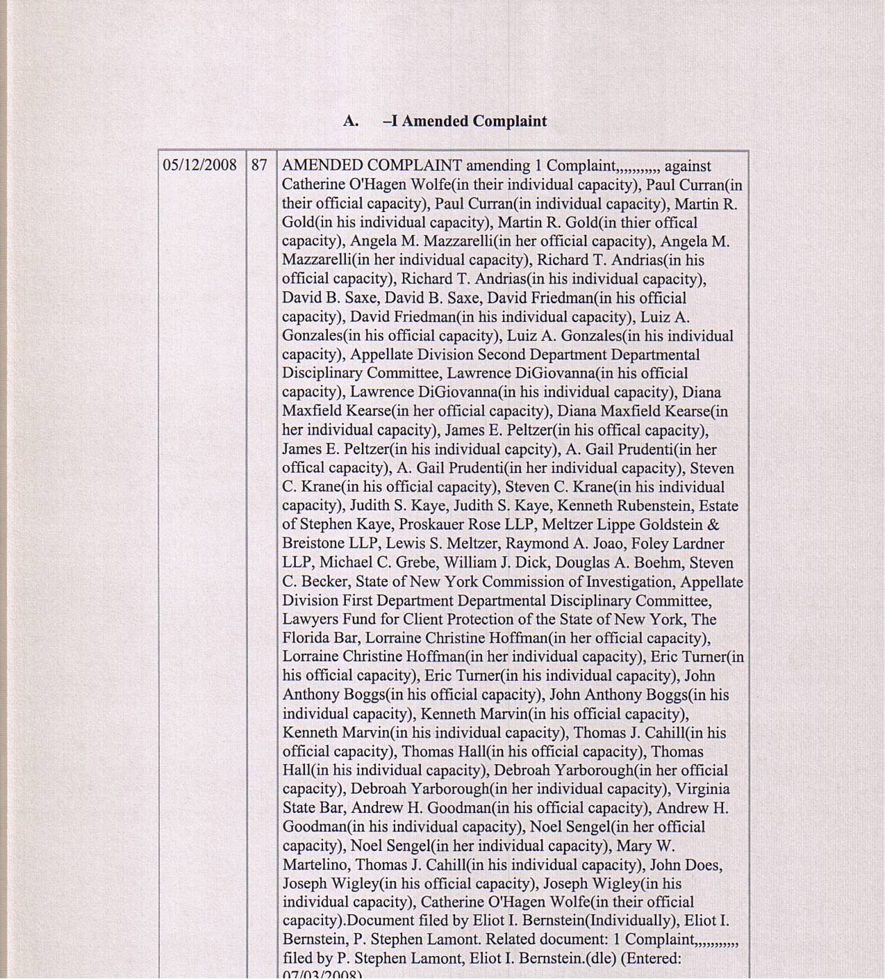

A. – II Motions to Dismiss
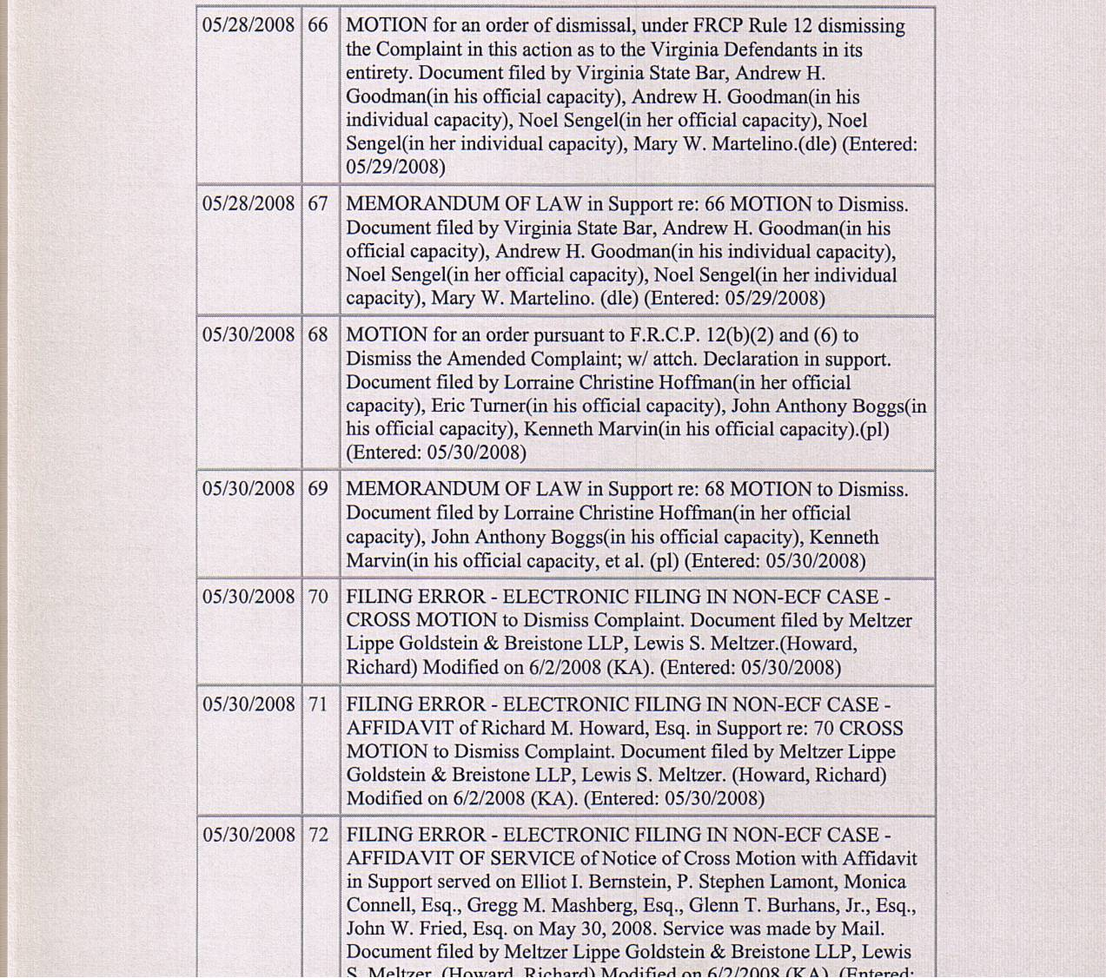

A. – II Motions to Dismiss Continued
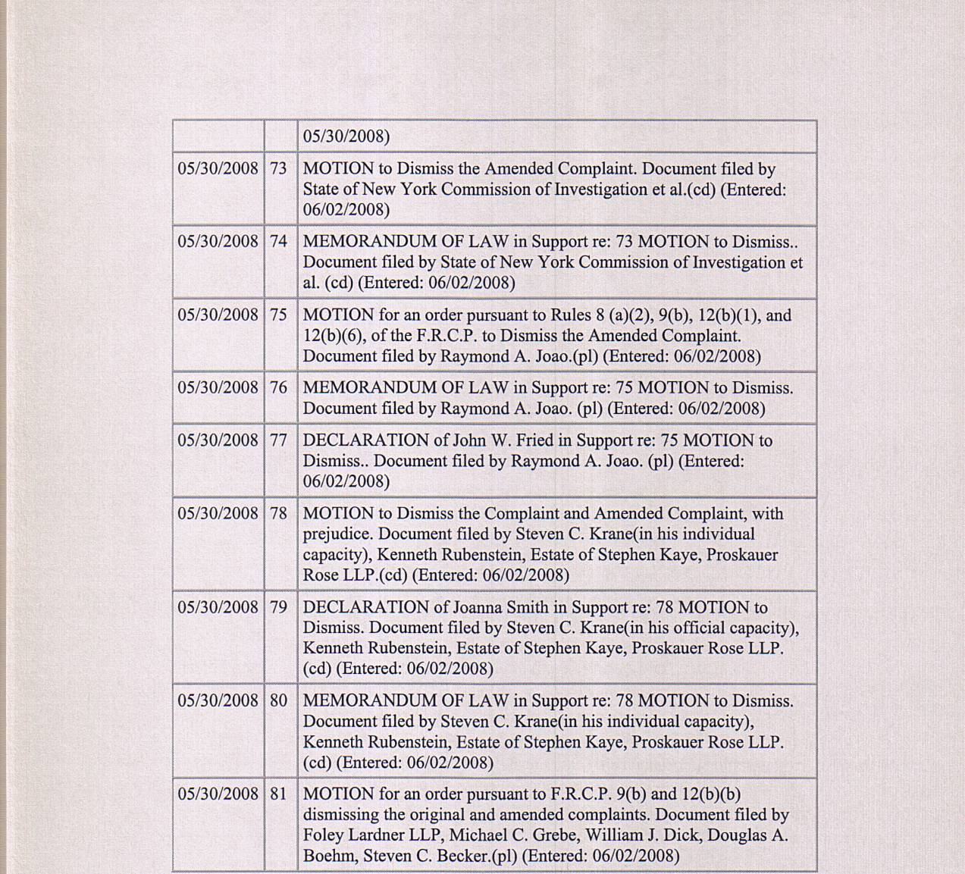

A. – III Oppositions
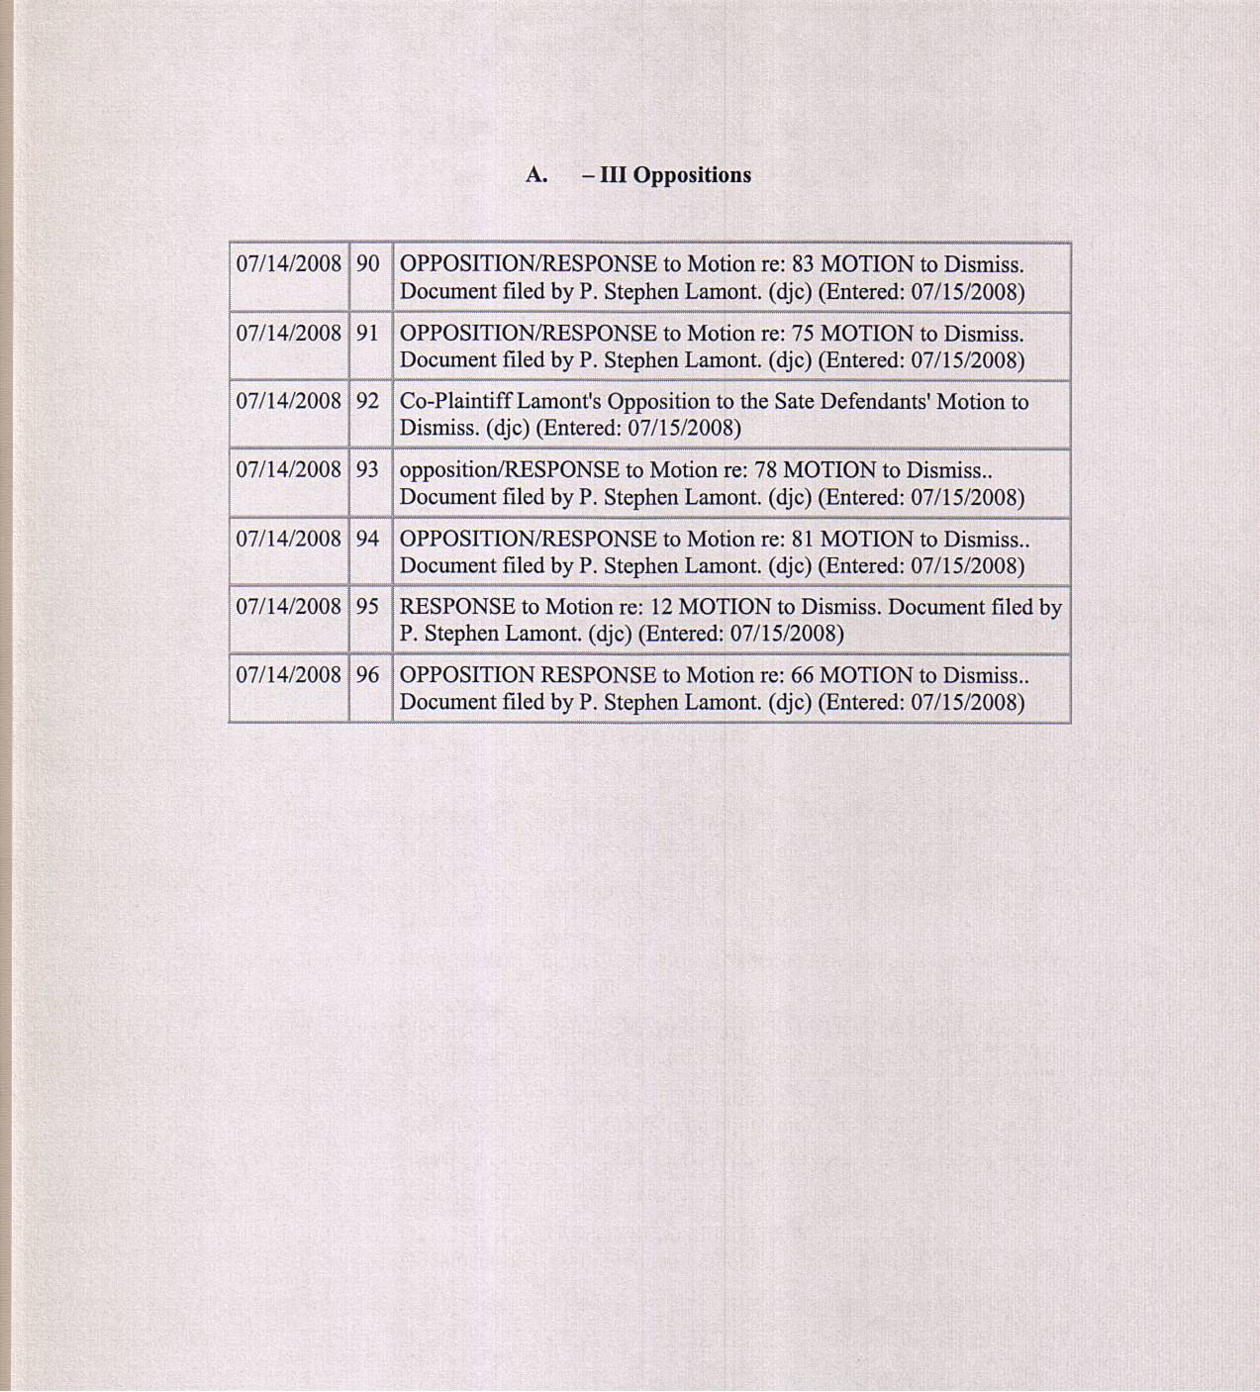

A. – IV Order
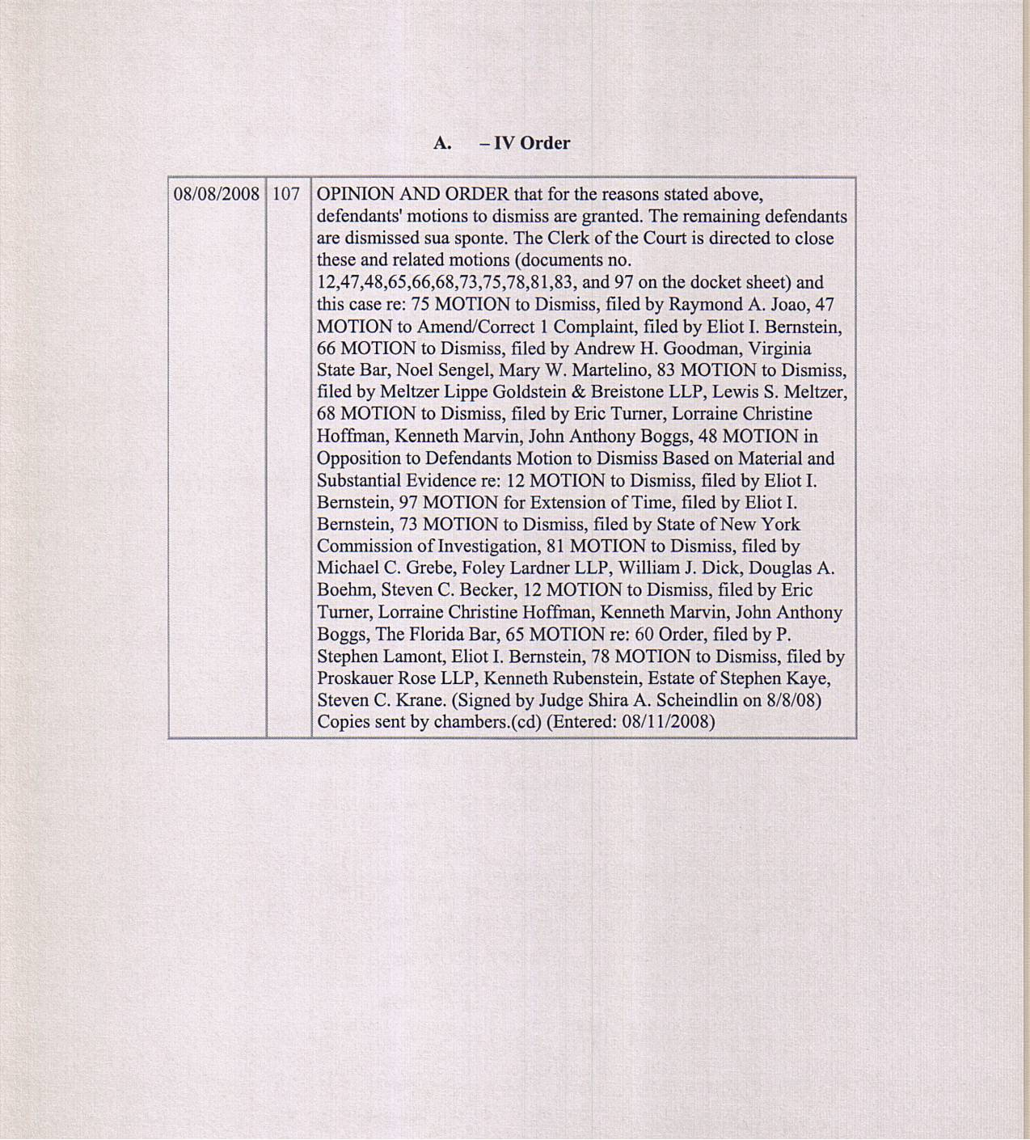

UNITED STATES COURT OF APPEALS
FOR THE SECOND CIRCUIT

U.S.C.A. Docket No. CERTIFICATE
08-4873-cv OF SERVICE

Bernstein

V.

Appellate Division First Department
Disciplinary Committee

I, Eliot Ivan Bernstein hereby certify under the penalty of perjury that on the 27th day of February, 2009 served by United States Mail or hand delivery the ( PLAINTIFF BERNSTEIN APPELLANT BRIEF ) on the Court, requesting this Court serve all named Defendants below via the United States Marshal Service as requested herein or service by the Court as in prior filings, as the Court has been serving certain documents already to the defendants, although it is unclear if this Court has served all documents to all the Amended Complaint defendants or just select few and if defendants counsel have similarly been selectively servicing their filings in these matters, inapposite of law. The Amended Complaint list of defendants necessary to service is as follows:

STATE OF NEW YORK, THE OFFICE OF COURT ADMINISTRATION OF THE UNIFIED COURT SYSTEM, PROSKAUER ROSE LLP, and, all of its Partners, Associates and Of Counsel, in their professional and individual capacities, STEVEN C. KRANE in his official and individual Capacities for the New York State Bar Association and the Appellate Division First Department Departmental Disciplinary Committee, and, his professional and individual capacities as a Proskauer partner, KENNETH RUBENSTEIN, in his professional and individual capacities, ESTATE OF STEPHEN KAYE, in his professional and individual capacities, ALAN S. JAFFE, in his professional and individual capacities, ROBERT J. KAFIN, in his professional and individual capacities, CHRISTOPHER C. WHEELER, in his professional and individual capacities, MATTHEW M. TRIGGS in his official and individual capacity for The Florida Bar and his professional and individual capacities as a partner of Proskauer, ALBERT T. GORTZ, in his professional and individual capacities, CHRISTOPHER PRUZASKI, in his professional and individual capacities, MARA LERNER ROBBINS, in her professional and individual capacities, DONALD “ROCKY” THOMPSON, in his professional and individual capacities, GAYLE COLEMAN, in her professional and individual capacities, DAVID GEORGE, in his professional and individual capacities, GEORGE A. PINCUS, in his professional and individual capacities, GREGG REED, in his professional and individual capacities, LEON GOLD, in his professional and individual capacities, MARCY HAHN-SAPERSTEIN, in her professional and individual capacities, KEVIN J. HEALY, in his professional and individual capacities, STUART KAPP, in his professional and individual capacities, RONALD F. STORETTE, in his professional and individual capacities, CHRIS WOLF, in his professional and individual capacities, JILL ZAMMAS, in her professional and individual capacities, JON A. BAUMGARTEN, in his professional and individual capacities, SCOTT P. COOPER, in his professional and individual capacities, BRENDAN J. O'ROURKE, in his professional and individual capacities, LAWRENCE I. WEINSTEIN, in his professional and individual capacities, WILLIAM M. HART, in his professional and individual capacities, DARYN A. GROSSMAN, in his professional and individual capacities, JOSEPH A. CAPRARO JR., in his professional and individual capacities, JAMES H. SHALEK, in his professional and individual capacities, GREGORY MASHBERG, in his professional and individual capacities, JOANNA SMITH, in her professional and individual capacities, MELTZER LIPPE GOLDSTEIN WOLF & SCHLISSEL, P.C. and its predecessors and successors, and, all of its Partners, Associates and Of Counsel, in their professional and individual capacities, LEWIS S. MELTZER, in his professional and individual capacities, RAYMOND A. JOAO, in his professional and individual capacities, FRANK MARTINEZ, in his professional and individual capacities, FOLEY & LARDNER LLP, and, all of its Partners, Associates and Of Counsel, in their professional and individual capacities, MICHAEL C. GREBE, in his professional and individual capacities, WILLIAM J. DICK, in his professional and individual capacities, TODD C. NORBITZ, in his professional and individual capacities, ANNE SEKEL, in his professional and individual capacities, RALF BOER, in his professional and individual capacities, BARRY GROSSMAN, in his professional and individual capacities, JIM CLARK, in his professional and individual capacities, DOUGLAS A. BOEHM, in his professional and individual capacities, STEVEN C. BECKER, in his professional and individual capacities, BRIAN G. UTLEY, MICHAEL REALE, RAYMOND HERSCH, WILLIAM KASSER, ROSS MILLER, ESQ. in his professional and individual capacities, STATE OF FLORIDA, OFFICE OF THE STATE COURTS ADMINISTRATOR, FLORIDA, HON. JORGE LABARGA in his official and individual capacities, THE FLORIDA BAR, JOHN ANTHONY BOGGS in his official and individual capacities, KELLY OVERSTREET JOHNSON in her official and individual capacities, LORRAINE CHRISTINE HOFFMAN in her official and individual capacities, ERIC TURNER in his official and individual capacities, KENNETH MARVIN in his official and individual capacities, JOY A. BARTMON in her official and individual capacities, JERALD BEER in his official and individual capacities, BROAD & CASSEL, and, all of its Partners, Associates and Of Counsel, in their professional and individual capacities, JAMES J. WHEELER, in his professional and individual capacities, FLORIDA SUPREME COURT, HON. CHARLES T. WELLS, in his official and individual capacities, HON. HARRY LEE ANSTEAD, in his official and individual capacities HON. R. FRED LEWIS, in his official and individual capacities, HON. PEGGY A. QUINCE, in his official and individual capacities, HON. KENNETH B. BELL, in his official and individual capacities, THOMAS HALL, in his official and individual capacities, DEBORAH YARBOROUGH in her official and individual capacities, DEPARTMENT OF BUSINESS AND PROFESSIONAL REGULATION – FLORIDA, CITY OF BOCA RATON, FLA., ROBERT FLECHAUS in his official and individual capacities, ANDREW SCOTT in his official and individual capacities, SUPREME COURT OF NEW YORKAPPELLATE DIVISION FIRST DEPARTMENT DEPARTMENTAL DISCIPLINARY COMMITTEE, THOMAS J. CAHILL in his official and individual capacities, PAUL CURRAN in his official and individual capacities, MARTIN R. GOLD in his official and individual capacities, SUPREME COURT OF NEW YORK APPELLATE DIVISION FIRST DEPARTMENT, CATHERINE O’HAGEN WOLFE in her official and individual capacities, HON. ANGELA M. MAZZARELLI in her official and individual capacities, HON. RICHARD T. ANDRIAS in his official and individual capacities, HON. DAVID B. SAXE in his official and individual capacities, HON. DAVID FRIEDMAN in his official and individual capacities, HON. LUIZ A. GONZALES in his official and individual capacities, SUPREME COURT OF NEW YORK APPELLATE DIVISION SECOND JUDICIAL DEPARTMENT, SUPREME COURT OF NEW YORK APPELLATE DIVISION SECOND DEPARTMENT DEPARTMENTAL DISCIPLINARY COMMITTEE, LAWRENCE DIGIOVANNA in his official and individual capacities, DIANA MAXFIELD KEARSE in her official and individual capacities, JAMES E. PELTZER in his official and individual capacities, HON. A. GAIL PRUDENTI in her official and individual capacities, HON. JUDITH S. KAYE in her official and individual capacities, STATE OF NEW YORK COMMISSION OF INVESTIGATION, ANTHONY CARTUSCIELLO in his official and individual capacities, LAWYERS FUND FOR CLIENT PROTECTION OF THE STATE OF NEW YORK, OFFICE OF THE ATTORNEY GENERAL OF THE STATE OF NEW YORK, ELIOT SPITZER in his official and individual capacities, as both former Attorney General for the State of New York, and, as former Governor of the State of New York, COMMONWEALTH OF VIRGINIA, VIRGINIA STATE BAR, ANDREW H. GOODMAN in his official and individual capacities, NOEL SENGEL in her official and individual capacities, MARY W. MARTELINO in her official and individual capacities, LIZBETH L. MILLER, in her official and individual capacities, MPEGLA, LLC, LAWRENCE HORN, in his professional and individual capacities, REAL 3D, INC. and successor companies, GERALD STANLEY, in his professional and individual capacities, DAVID BOLTON, in his professional and individual capacities, TIM CONNOLLY, in his professional and individual capacities, ROSALIE BIBONA, in her professional and individual capacities, RYJO, INC., RYAN HUISMAN, in his professional and individual capacities, INTEL CORP., LARRY PALLEY, in his professional and individual capacities, SILICON GRAPHICS, INC., LOCKHEED MARTIN, BLAKELY SOKOLOFF TAYLOR & ZAFMAN, LLP, and, all of its Partners, Associates and Of Counsel, in their professional and individual capacities, NORMAN ZAFMAN, in his professional and individual capacities, THOMAS COESTER, in his professional and individual capacities, FARZAD AHMINI, in his professional and individual capacities, GEORGE HOOVER, in his professional and individual capacities, WILDMAN, HARROLD, ALLEN & DIXON LLP, and, all of its Partners, Associates and Of Counsel, in their professional and individual capacities, MARTYN W. MOLYNEAUX, in his professional and individual capacities, MICHAEL DOCKTERMAN, in his professional and individual capacities, HARRISON GOODARD FOOTE, and, all of its Partners, Associates and Of Counsel, in their professional and individual capacities, EUROPEAN PATENT OFFICE, ALAIN POMPIDOU in his official and individual capacities, WIM VAN DER EIJK in his official and individual capacities, LISE DYBDAHL in her official and personal capacities, YAMAKAWA INTERNATIONAL PATENT OFFICE, and, all of its Partners, Associates and Of Counsel, in their professional and individual capacities, MASAKI YAMAKAWA, in his professional and individual capacities, CROSSBOW VENTURES, INC., ALPINE VENTURE CAPITAL PARTNERS LP, STEPHEN J. WARNER, in his professional and individual capacities, RENE P. EICHENBERGER, in his professional and individual capacities, H. HICKMAN “HANK” POWELL, in his professional and individual capacities, MAURICE BUCHSBAUM, in his professional and individual capacities, ERIC CHEN, in his professional and individual capacities, AVI HERSH, in his professional and individual capacities, MATTHEW SHAW, in his professional and individual capacities, BRUCE W. SHEWMAKER, in his professional and individual capacities, RAVI M. UGALE, in his professional and individual capacities, DIGITAL INTERACTIVE STREAMS, INC., ROYAL O’BRIEN, in his professional and individual capacities, HUIZENGA HOLDINGS INCORPORATED, WAYNE HUIZENGA, in his professional and individual capacities, WAYNE HUIZENGA, JR., in his professional and individual capacities, TIEDEMANN INVESTMENT GROUP, BRUCE T. PROLOW, in his professional and individual capacities, CARL TIEDEMANN, in his professional and individual capacities, ANDREW PHILIP CHESLER, in his professional and individual capacities, CRAIG L. SMITH, in his professional and individual capacities, HOUSTON & SHAHADY, P.A., and any successors, and, all of its Partners, Associates and Of Counsel, in their professional and individual capacities, BART A. HOUSTON, ESQ. in his professional and individual capacities, FURR & COHEN, P.A., and, all of its Partners, Associates and Of Counsel, in their professional and individual capacities, BRADLEY S. SCHRAIBERG, ESQ. in his professional and individual capacities, MOSKOWITZ, MANDELL, SALIM & SIMOWITZ, P.A., and, all of its Partners, Associates and Of Counsel, in their professional and individual capacities, WILLIAM G. SALIM, ESQ. in his professional and individual capacities, SACHS SAX & KLEIN, P.A., and, all of its Partners, Associates and Of Counsel, in their professional and individual capacities, BEN ZUCKERMAN, ESQ. in his professional and individual capacities, SPENCER M. SAX, in his professional and individual capacities, SCHIFFRIN & BARROWAY LLP, and any successors, and, all of its Partners, Associates and Of Counsel, in their professional and individual capacities, RICHARD SCHIFFRIN, in his professional and individual capacities, ANDREW BARROWAY, in his professional and individual capacities, KRISHNA NARINE, in his professional and individual capacities, CHRISTOPHER & WEISBERG, P.A., and, all of its Partners, Associates and Of Counsel, in their professional and individual capacities, ALAN M. WEISBERG, in his professional and individual capacities, ALBERTO GONZALES in his official and individual capacities, JOHNNIE E. FRAZIER in his official and individual capacities, IVIEWIT, INC., a Florida corporation, IVIEWIT, INC., a Delaware corporation, IVIEWIT HOLDINGS, INC., a Delaware corporation (f.k.a. Uview.com, Inc.), UVIEW.COM, INC., a Delaware corporation, IVIEWIT TECHNOLOGIES, INC., a Delaware corporation (f.k.a. Iviewit Holdings, Inc.), IVIEWIT HOLDINGS, INC., a Florida corporation, IVIEWIT.COM, INC., a Florida corporation, I.C., INC., a Florida corporation, IVIEWIT.COM, INC., a Delaware corporation, IVIEWIT.COM LLC, a Delaware limited liability company, IVIEWIT LLC, a Delaware limited liability company, IVIEWIT CORPORATION, a Florida corporation, IBM CORPORATION.

Eliot Ivan Bernstein

_______________________
Pro Se Appellant and Plaintiff
2753 N.W. 34th Street
Boca Raton, Florida 33434
(561) 245-8588

Pending Motion to Second Circuit @ http://iviewit.tv/CompanyDocs/United%20States%20District%20Court%20Southern%20District%20NY/20090129%20Final%20Extension%20of%20Time%202%20SIGNED%20low.pdf
Court Ruling On Pending Motion @ http://www.iviewit.tv/CompanyDocs/United%20States%20District%20Court%20Southern%20District%20NY/20090218%20Motion%20other%20than%20ext%20sent%20to%20panel%20to%20hear%20appeal%20ORDER.pdf
Exhibit @ http://iviewit.tv/CompanyDocs/United%20States%20District%20Court%20Southern%20District%20NY/20080808%20Scheindlin%20Dismissal%20of%20Complaint.pdf
Exhibit http://iviewit.tv/CompanyDocs/INVESTIGATIONS%20MASTER.htm
Exhibit http://iviewit.tv/CompanyDocs/United%20States%20District%20Court%20Southern%20District%20NY/20090225%20USDC%20Northern%20TX%20Filing%20RE%20SEC%20STANFORD%20ll.pdf
Exhibit http://iviewit.tv/CompanyDocs/United%20States%20District%20Court%20Southern%20District%20NY/20080321%20Order%20Scheindlin.pdf
413 U.S. 1 http://caselaw.lp.findlaw.com/cgi-bin/getcase.pl?navby=case&court=us&vol=413&invol=1
Reply http://static1.firedoglake.com/28/files/2008/10/response-to-motion-to-dismiss3.pdf
Conflict Letters & Orders http://iviewit.tv/CompanyDocs/United%20States%20District%20Court%20Southern%20District%20NY/20080229%20NYAG%20State%20Actors%20Letter%20to%20Hon%20Schiendlin.pdf and, http://iviewit.tv/CompanyDocs/United%20States%20District%20Court%20Southern%20District%20NY/20080305%20Final%20Plaintiff%20Oposition%20to%20AG%20Cuomo%20letter%20email%20copy.pdf and, http://iviewit.tv/CompanyDocs/United%20States%20District%20Court%20Southern%20District%20NY/20080305%20Final%20Plaintiff%20Opposition%20to%20Proskauer%20letter%20as%20counsel.pdf , and, http://iviewit.tv/CompanyDocs/United%20States%20District%20Court%20Southern%20District%20NY/20080313%20FINAL%20Plaintiff%20Response%20to%20Schiendlin%20March%2007%202008%20Order.pdf and, http://iviewit.tv/CompanyDocs/United%20States%20District%20Court%20Southern%20District%20NY/20080314%20FINAL%20Letter%20to%20NY%20AG%20to%20reistigate%20investigation%20on%20new%20evidence.pdf and, and, http://iviewit.tv/CompanyDocs/United%20States%20District%20Court%20Southern%20District%20NY/Scheindlin%20Order%2003%2007%202008%20(2).pdf and, http://iviewit.tv/CompanyDocs/United%20States%20District%20Court%20Southern%20District%20NY/20080321%20Order%20Scheindlin.pdf and, http://iviewit.tv/CompanyDocs/United%20States%20District%20Court%20Southern%20District%20NY/20080310%20First%20Department%20Complaint%20Proskauer%20and%20Foley.doc
Exhibit – Amended Complaint @ http://iviewit.tv/CompanyDocs/United%20States%20District%20Court%20Southern%20District%20NY/20080509%20FINAL%20AMENDED%20COMPLAINT%20AND%20RICO%20SIGNED%20COPY%20MED.pdf
Exhibit – Original Complaint @ http://iviewit.tv/20071215usdcsnycomplaint.pdf
http://caselaw.lp.findlaw.com/scripts/getcase.pl?navby=search&court=US&case=/us/000/96%2D6133.html

