UNITED STATES DISTRICT COURT
NORTHERN DISTRICT OF TEXAS,
DALLAS DIVISION
X

In the Matter of the Application and
Petition-Complaint of Eliot Bernstein
to Intervene and/or Join as a Plaintiff
in the within Action both
Individually and as A Trustee on
behalf of Joshua Ennio Zander
Bernstein Irrevocable Trust, Jacob
Noah Archie Bernstein Irrevocable
Trust & Daniel Elijsha Abe Ottomo
Bernstein Irrevocable Trust;

Petitioner,
DOCKET NO:
3:09-cv-00298-N
3:09-cv-00298-L
1:09-mc-00002-JAD
SECURITIES AND EXCHANGE COMMISSION
PETITION-COMPLAINT
Plaintiff,

-v-

STANFORD INTERNATIONAL BANK, LTD,

STANFORD GROUP COMPANY, STANFORD

CAPITAL MANAGEMENT, LLC, R. ALLEN

STANFORD, JAMES M. DAVIS, AND

LAURA PENDERGEST-HOLT,

Defendants

X

In the Matter of the Application and Petition-Complaint of Eliot Bernstein to Intervene and/or Join as a Plaintiff in the within Action both Individually and as Trustee on behalf of Joshua Ennio Zander Bernstein Irrevocable Trust, Jacob Noah Archie Bernstein Irrevocable Trust & Daniel Elijsha Abe Ottomo Bernstein Irrevocable Trust

Petitioner-Co-Plaintiff Eliot Bernstein ALLEGES AS FOLLOWS:

- I am Eliot Bernstein and reside at 2753 N.W. 34th Street, Boca Raton, FL 33434.
- I respectfully Petition and Move this Court to be Joined as a Co-Plaintiff in the within action against the "Stanford" related Defendants names above and / or as an Intervenor under Federal Rules of Civil Procedure No. 24 and 20 and Join in the SEC's request for emergency relief and injunctive relief as set out in the SEC Complaint under the above Docket Nos. signed by Stephen J. Korotash of the Oklahoma Bar and J. Kevin Edmundson of the Texas Bar and the other signatory attorneys on behalf of the Securities Exchange Commission via the Fort Worth, Texas Office.
- I act Pro Se and thus seek to intervene and/or join in this Action under Docket No. 3:09-cv-00298-N, 3:09-cv-00298-L and 1:09-mc-00002-JAD under any and all appropriate laws, statutes, rules and in the fundamental interests of fairness and justice.
- Because I have not had the benefit of any formal Discovery or Disclosures at this time and primarily rely upon the current state of the news media in the dissemination of relevant information herein, I assert in the broadest and most liberal manners any and all rights to relief both individually, jointly, severally, and others and assert common questions of law and facts will arise in this action and /or also arise out of the same or similar set of transactions, occurrences and series of transactions.
- I assert direct claims and assert and respectfully petition that I share individually and on behalf of others financial interests relating to the properties and transactions which are the subject of the within action and that disposition of this action may as a practical matter impair and/or impede my ability to protect interests and therefore it is respectfully asserted that joinder and/or intervention is appropriate.
- I respectfully Petition this Court for relief as Both a Trustee of Trusts and Assets with Stanford Trust Companywhich are directly impacted by the disposition of this action being a Trustee of the following Trusts:
  - Joshua Ennio Zander Bernstein Irrevocable Trust,
  - Jacob Noah Archie Bernstein Irrevocable Trust, and,
  - Daniel Elijsha Abe Ottomo Bernstein Irrevocable Trust;
and I further Petition as the Primary Owner and Inventor of "Technologies" and Intellectual Properties (Patents, Trademarks, Trade-Secrets & Copyrights) which are the subject of related actions of ongoing and continuing fraud both privately and against the "United States" and "United States Patent Office" and more which actions are currently pending in the US Second Circuit Court of Appeals under Docket No. 08-4873-cv.
- This US Second Circuit action is presently on appeal from the US Southern District of New York before Hon. Judge Shira A. Scheindlin under Docket No. 07civ11196 and which was marked "Related" in the SDNY by Judge Scheindlin to a New York Ethics Whistleblower suit presently in federal court in the SDNY brought by one Christine Anderson who formerly was a Staff attorney at the First Dept. Disciplinary Committee for attorneys. See Anderson US SDNY Docket No. 07 Civ. 9599 (SAS-AJP) Christine C. Anderson v. the State of New York, et al. and where other cases either related or seeking related status to Anderson are:
  - (07cv11612) Esposito v The State of New York, et al.,
  - (08cv00526) Capogrosso v New York State Commission on Judicial Conduct, et al.,
  - (08cv02391) McKeown v The State of New York, et al.,
  - (08cv02852) Galison v The State of New York, et al.,
  - (08cv03305) Carvel v The State of New York, et al.,
  - (08cv4053) Gizella Weisshaus v The State of New York, et al., and,
  - (08cv4438) Suzanne McCormick v The State of New York, et al.
- It is specifically alleged in the "related" whistleblower suit of Christine Anderson that part of her claims of corruption at the NYS First Dept. DDC directly involve actions to cover up conflicts of interest and misconduct involving my inventions and patents and the Iviewit story specifically involving, including but not limited to, the law firms of:
  - Proskauer Rose, LLP
  - Dreier & Baritz LLP
  - Meltzer, Lippe, Goldstein, Wolf & Schlissel, P.C.
  - Foley & Lardner
  - Schiffrin & Barroway, LLP
  - Blakely Sokoloff Taylor & Zafman LLP
  - Wildman, Harrold, Allen & Dixon LLP
  - Christopher & Weisberg, P.A.
  - Yamakawa International Patent Office
There are ongoing investigations of many of the Intellectual Property Attorneys involved being conducted by Harry I. Moatz, Director, Office of Enrollment & Discipline, United States Patent & Trademark Office, as well as other ongoing investigations as further set forth herein.
- Common questions of facts and law in this action in the District Court of Texas involving the attorneys of the Proskauer Rose firm are sufficiently related and common to the actions of Proskauer Rose in my action pending at the US Second Circuit Court of Appeals such that joinder and intervenor status being granted to myself is appropriate at this time.
- I have attached as Exhibit to my Petition the URL which is a recent letter to President Barack Obama, White House Counsel Craig, US Attorney General Eric Holder, US House Judiciary Chair Conyers and US Senate Judiciary Chair Leahy and related other individuals and Offices which further fleshes out the continuing nature of the fraud against my patent rights and interests and specifically involving the Proskauer Law firm as a primary bad actor herein and as this Court will note, I specifically seek the "United States" and related appropriate federal executive agencies to join in the ongoing actions involving my claims and related matters at the US Second Circuit Court of Appeals in Manhattan.
- Just yesterday, Monday February 23, 2009 I made telephone calls and inquiries to SEC Branch Chief Michael King and FBI Special Agent in Charge of the Dallas Field Office Robert E. Casey Jr. in furtherance of this investigation in this action in the US District Court of Texas and in furtherance of my rights herein and to protect the assets of the Trusts for which I am Trustee. I am presently awaiting return calls from both of these offices in this matter.
- It is respectfully alleged that it was only in the last weeks that I first discovered that Thomas V. Sjoblom, Esq. an attorney from the Proskauer Rose Firm was intimately and centrally involved as acting counsel in the breaking Stanford financial scandals and the role of the Proskauer firm in the Stanford matters itself presents common questions of facts and law which should permit my joinder as a party and/or intervenor at this time.
- It is noted for this Court that US SDNY Judge Shira A. Scheindlin specifically referred all of the "related" cases including my "related" case to the Anderson Whistleblower Ethics case over to the US Attorney's Office for relief and my Letter to President Obama and US Attorney General Holder attached herein specifically seeks the formal intervention of the "United States" by and through the US Attorney's Offices and appropriate federal and executive agencies in the related matters of my cases pending in the US Second Circuit Court of Appeals.
- One of the underlying central themes of my Amended federal complaint pending at the US Second Circuit Court of Appeals involves the maze and labyrinth of Shell/Fraud companies, Shell/Fraud Intellectual Properties/false companies/stolen companies/converted and misappropriated royalties, monies and more that are alleged to be in the hundreds of billions already relating to the thefts of my Patents and Patent rights by the Proskauer and related law firms which further involve a maze of conflicts within conflicts both individually and professionally again presenting common questions of facts and law before this Court making joinder and/or intervenor status appropriate at this time because a central theme in Stanford is a similar maze and labyrinth of lawyers, shell companies and more for the purpose of the continuing fraud which specifically involves the Proskauer firm which is central to my actions in the Second Circuit.
- It is respectfully alleged to this Court as demonstrated by my recent letter to President Obama, the White House Counsel's Office, the US Attorney General's Office and others as set out in my federal Amended Complaint that ongoing federal investigations involving the Office of US DOJ Inspector General Glenn A. Fine, US PTO OED Harry Moatz relating to Fraud on the US Patent Office, investigations by H. Marshall Jarrett of the FBI OPR, and other federal and state investigations continue making joinder and intervenor status appropriate at this time based on the commonality of the Proskauer involvement in the Stanford issues and more.
- I respectfully ask this Court to take Judicial Notice of the SEC declarations filed in a civil suit in Manhattan pertaining to attorney Marc S. Dreier of Dreier, LLP and also note that attorney Marc S. Dreier upon information and belief remains a defendant in a criminal action under strict federal house arrest reporting conditions similar to Bernard Madoff.
- As one of the factual allegations underlying my federal Amended Complaint pending at the US Second Circuit Court of Appeals it is alleged in essence that attorney Raymond A. Joao claimed to be a Proskauer Rose attorney in the early years of my invention, was introduced to me by Proskauer Rose as such but that such attorney Raymond Joao was in fact with Meltzer Lippe Goldstein & Schlissel and then left to join with attorney Marc S. Dreier of the Dreier Baritz LLP firm where 90 or so Patents were falsely placed in his name and now the Dreier firm is presently connected with a similar financial fraud scheme involving use of false names and false companies and the misappropriation and alleged theft of millions in currency and assets. Moatz is investigating attorney Joao and the USPTO has suspended my Intellectual Properties pending investigations of fraud on the USPTO, myself and many other shareholders including the SBA, Ellen DeGeneres, Alanis Morissette and more.
- Upon information and belief, the Proskauer firm is not only involved in the Stanford scandal in this action but further involved in the Bernard Madoff investigation with layers of conflicts presented there as the firm represents clients facing a "financial 9/11" according to one Proskauer source and yet the Proskauer firm and name is also involved as defendant with Raymond Joao and Drier & Baritz LLP from the Eliot Bernstein and Iviewit complaints as well creating sufficient common questions of facts and law at this stage to make Joinder and intervenor status appropriate.
I respectfully remind this court that one of the precise motions pending before the US Second Circuit Court of Appeals involves the addressing of the layers of conflicts within conflicts individually and professionally involving the Proskauer and related law firms and actors therein where discovery and intervenor status in this case is likely at this preliminary stage to impact the disposition of common assets and property rights.
There thus appears to be ongoing common schemes in Madoff, Dreier and now Stanford all involving multiple layers of fraud, conflicts, and funneling and laundering and diverting of massive amounts of financial assets which is a common theme and allegation to the entire Eliot Bernstein and Iviewit story involving massive theft, fraud, conflicts of interests, dummy and false companies, money laundering, etc. relating to the thefts of my Intellectual Properties and Patents valued in excess of a trillion dollars in liability.
- I further provide to this Court the Docket Nos. of all my civil cases and ongoing state, federal and international investigations since without Discovery it is impossible to determine further commonality of facts and law issues however it is generally noted that the general estimate of Damages from the ongoing patent and royalties theft from my technologies is in the nature of a Trillion dollars over the 20+ year life of the IP and thus it is reasonably alleged and presumed that only through a maze and labyrinth of shell companies present in the Stanford, Dreier and Madoff cases could such monies be funneled and laundered out of the country from the rightful and proper owners of such assets, royalties and properties.
WHEREFORE, it is respectfully prayed for an Order granting Joinder and/or Intervenor status to Eliot Bernstein both individually and as Trustee of Joshua Ennio Zander Bernstein Irrevocable Trust, Jacob Noah Archie Bernstein Irrevocable Trust & Daniel Elijsha Abe Ottomo Bernstein Irrevocable Trust; granting Discovery as necessary, proper and appropriate, marshalling assets and properties and enjoining transfer of same, enjoining Stanford defendants and their attorneys from destroying evidence and files and records herein, determining a priority lien position for Bernstein et al. as the facts and law determines as just and proper, and further relief as previously requested by the SEC in the action herein and any other and further relief as justice, law and fairness may require.

EXHIBIT 1
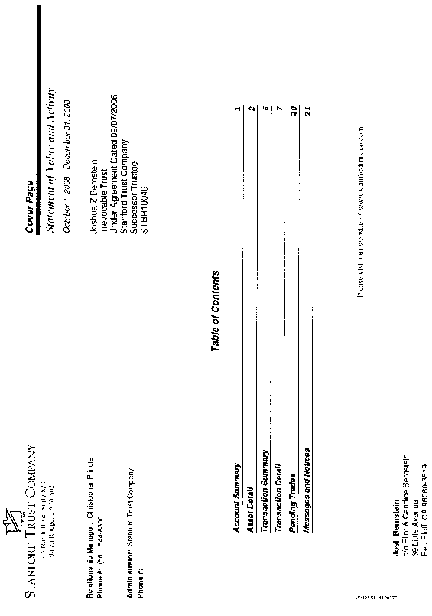
EXHIBIT 1
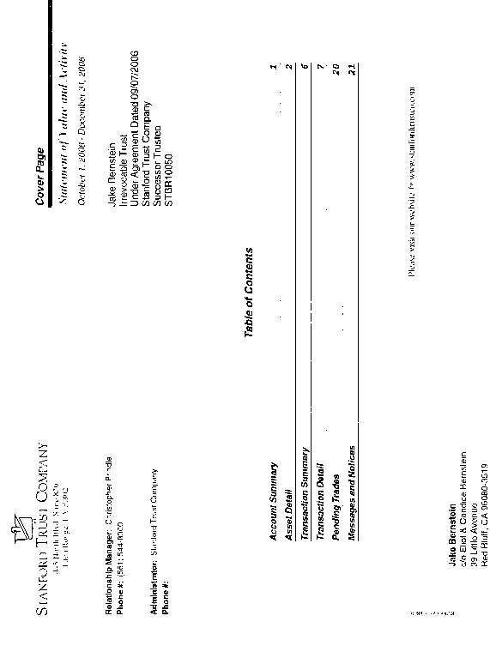
EXHIBIT 1
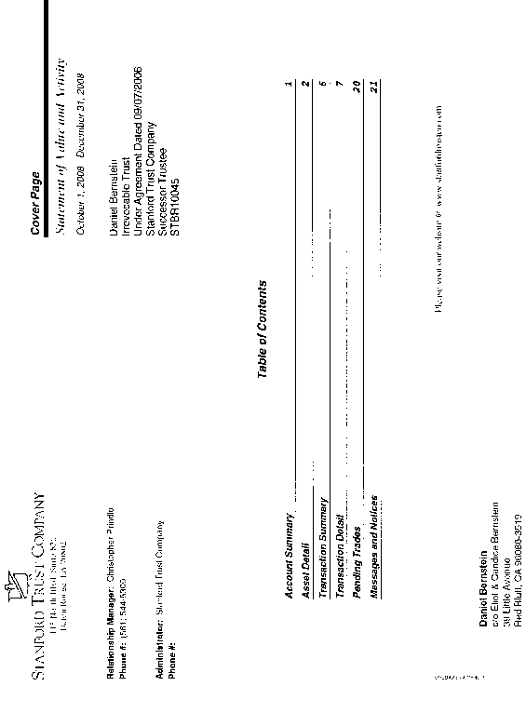
Attorney for Petitioners
Eliot I. Bernstein, Pro se AND AS A TRUSTEE FOR JOSHUA ENNIO ZANDER BERNSTEIN IRREVOCABLE TRUST, JACOB NOAH ARCHIE BERNSTEIN IRREVOCABLE TRUST & DANIEL ELIJSHA ABE OTTOMO BERNSTEIN IRREVOCABLE TRUST
2753 N.W. 34th Street
Boca Raton, FL 33434
(561) 245-8588
(561) 886-7628
iviewit@iviewit.tv

By:
Eliot I. Bernstein

AFFIDAVIT OF SERVICE

I, Eliot Ivan Bernstein hereby certify under the penalty of perjury that on the ___ day of February, 2009 served by United States Mail, Facsimile or hand delivery the (Petitioners PETITION-COMPLAINT IN THE MATTER OF THE APPLICATION AND PETITION-COMPLAINT OF ELIOT BERNSTEIN TO INTERVENE AND/OR JOIN AS A PLAINTIFF IN THE WITHIN ACTION BOTH INDIVIDUALLY AND AS TRUSTEE ON BEHALF OF JOSHUA ENNIO ZANDER BERNSTEIN IRREVOCABLE TRUST, JACOB NOAH ARCHIE BERNSTEIN IRREVOCABLE TRUST & DANIEL ELIJSHA ABE OTTOMO BERNSTEIN IRREVOCABLE TRUST) on this Court, requesting this Court serve all named Plaintiffs, Defendants and other necessary parties via the United States Marshal Service or other method this Court deems acceptable, or otherwise so reply to as the correct parties for these cases with all applicable addressing information.

Eliot I. Bernstein, Pro se AND AS A TRUSTEE FOR JOSHUA ENNIO ZANDER BERNSTEIN IRREVOCABLE TRUST, JACOB NOAH ARCHIE BERNSTEIN IRREVOCABLE TRUST & DANIEL ELIJSHA ABE OTTOMO BERNSTEIN IRREVOCABLE TRUST
2753 N.W. 34th Street
Boca Raton, FL 33434
(561) 245-8588
(561) 886-7628
iviewit@iviewit.tv

Attached Exhibit 1 – Trust Cover Sheets
http://iviewit.tv/CompanyDocs/United%20States%20District%20Court%20Southern%20District%20NY/20090213%20FINAL%20SIGNED%20LETTER%20OBAMA%20TO%20ENJOIN%20US%20ATTORNEY%20FINGERED%20ORIGINAL%20MAIL%20l.pdf
In Judge Scheindlin’s Opinion & Order dated August 08, 2008 whereby she claims the case is a “murder” case and involved possibly with the Enron Case http://iviewit.tv/CompanyDocs/United%20States%20District%20Court%20Southern%20District%20NY/20080808%20Scheindlin%20Dismissal%20of%20Complaint.pdf
http://iviewit.tv/CompanyDocs/United%20States%20District%20Court%20Southern%20District%20NY/20080509%20FINAL%20AMENDED%20COMPLAINT%20AND%20RICO%20SIGNED%20COPY%20MED.pdf
http://iviewit.tv/CompanyDocs/INVESTIGATIONS%20MASTER.htm

