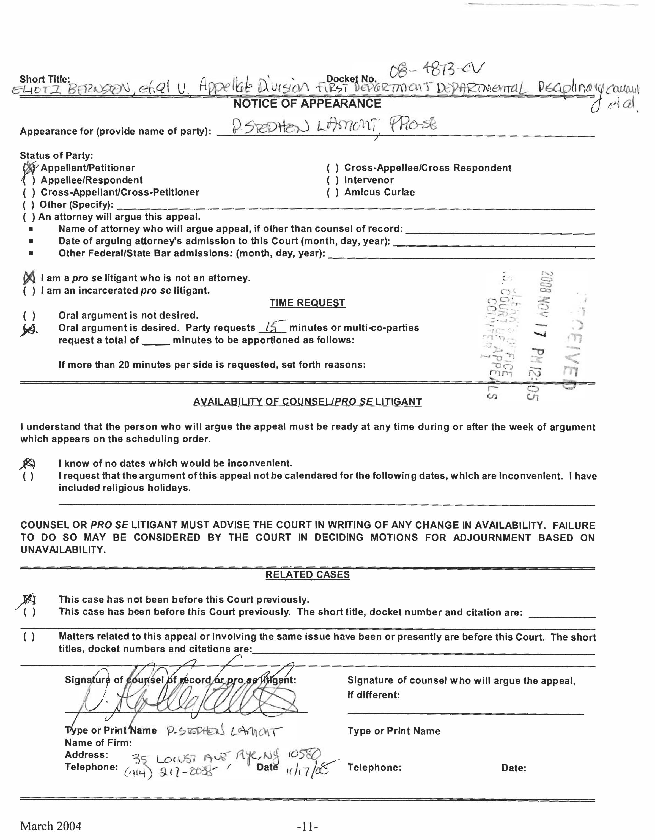

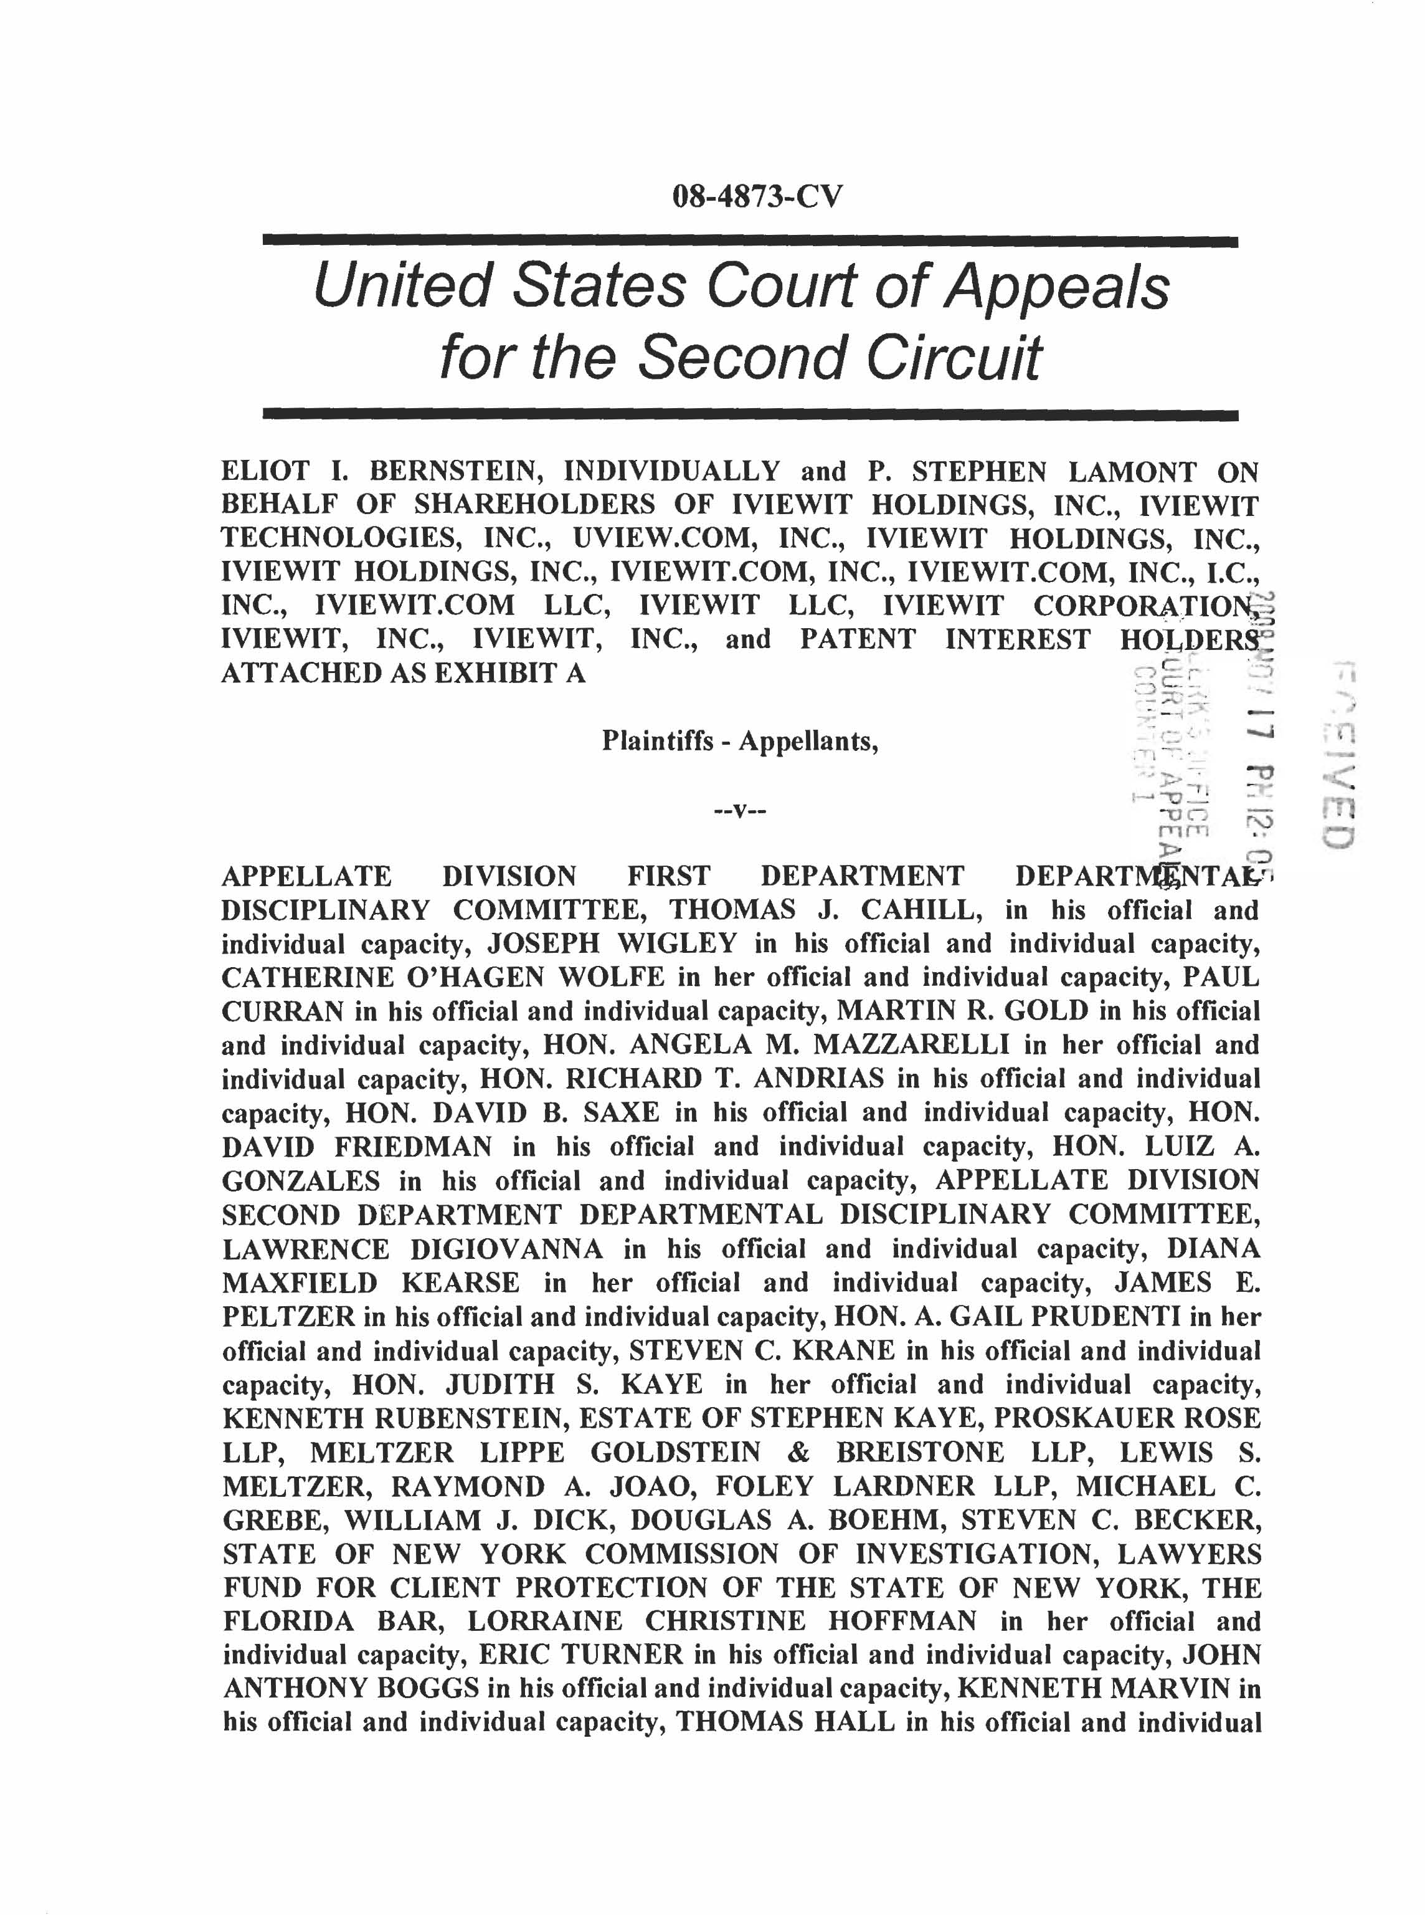

capacity, DEBORAH YARBOROUGH in her official and individual capacity, VIRGINIA STATE BAR, ANDREW H. GOODMAN in his official and individual capacity, NOEL SENGEL in her official and individual capacity, MARY W. MARTELINO in her official and individual capacity, and John Does.

Defendants-Appellees
ON APPEAL FROM THE UNITED STATES DISTRICT COURT FOR THE SOUTHERN DISTRICT OF NEW YORK
PLAINTIFFS-APPELLANTS’ BRIEF
P. STEPHEN LAMONT, PRO SE 35 LOCUST AVENUE RYE, NEW YORK 10580

(914) 217-0038

TABLE OF CONTENTS
I. PRELIMINARY STATEMENT ............................................................................. 6
II. STATEMENT OF SUBJECT MATTER AND APPELLATE JURISDICTION ............................................................................................................... 6
A. DISTRICT COURT’S SUBJECT MATTER JURISDICTION............................................... 6
B. COURT OF APPEALS FOR THE SECOND CIRCUIT’S SUBJECT MATTER JURISDICTION.6
III. ISSUES PRESENTED FOR REVIEW............................................................... 7
IV. STATEMENT OF THE CASE............................................................................ 7
A. DEVELOPMENT AND SABOTAGE OF THE VIDEO AND IMAGING TECHNOLOGY .......... 7
B. DISCOVERY OF THE THEFT....................................................................................... 9
C. FURTHER COVER-UP .............................................................................................. 12
V. SUMMARY OF THE ARGUMENTS .................................................................. 13
VI. ARGUMENT....................................................................................................... 14
A. POINT I – NEW EVIDENCE...................................................................................... 14 NEW EVIDENCE BECOMES AVAILABLE; EVIDENCE NOT HEARD ................................... 15
Christine C. Anderson v. The State of New York, et al., 07Civ9599 (S.D.N.Y. filed October 26, 2008) ..................................................................................................... 15 Kevin McKeown v. The State of New York, et al., 08Civ2391 (S.D.N.Y. filed March 2, 2008) ..................................................................................................................... 16 Luisa C. Esposito v. The State of New York, et al., 07Civ11612 (S.D.N.Y. filed December 28, 2007).................................................................................................. 16
B. POINT II - ERROR ................................................................................................... 17
Reliance on Rooker-Feldman Doctrine is Error ...................................................... 17 No Right of Review is Error...................................................................................... 18 Immunity Analysis Within the Order is Error........................................................... 18 No Private Right of Action in the Patent Clause of the Constitution of the United States is Error ........................................................................................................... 21
C. POINT III – MANIFEST INJUSTICE........................................................................... 21
Introduction............................................................................................................... 21 Dismissal is Premature at this Stage of the Litigation ............................................. 22 Equitable Tolling ...................................................................................................... 23
VII. CONCLUSION ................................................................................................... 24
VIII. APPENDICES................................................................................................. 26
A. –I AMENDED COMPLAINT ...................................................................................... 27
A. – II MOTIONS TO DISMISS...................................................................................... 28
A. – III OPPOSITIONS.................................................................................................. 30
A. – IV ORDER ........................................................................................................... 31

TABLE OF AUTHORITIE
S

CASES Page(s)
Alexander v. Janie Cockrell, et al.,

(U.S.C.A. 5th Circuit, No. 01-20736, June 11, 2002)…………………….23
Atascadero State Hospital v. Scanlon,
473 U.S. 234, 105 S.Ct. 3142, 87 L.Ed.2d 171 (1985)…………………….20
Carter v. Collins, 918 F.2d 1198,
1202 n.4 (5th Cir. 1990)……………………………………………………24
Childress v. Johnson,
103 F.3d 1221, 1226 n.7 (5th Cir. 1997)………………………………….24
Christine C. Anderson v. The State of New York, et al.,
07Civ9599 (S.D.N.Y. filed October 26, 2008)………….….13, 15, 16, 22, 24
Ciralsky v. Cent. Intelligence Agency,
355 F.3d 661, 671 (D.C. Cir. 2004)……………………………………14, 16
Demosthenes v. Baal,
495 U.S. 731, 735 (1990)…………………………………………………..23
District of Columbia Court of Appeals v. Feldman,
460 U.S. 462, 483 n. 16 (1983)………………………………….7, 13, 17, 18
Dyer v. Johnson,
108 F.3d 607, 609 (5th Cir. 1997) ………………………………………..23
Edelman v. Jordan,
415 U.S. 651 (1974)………………………………………………………..19
Ex Parte Young,
209 U.S. 123, 160 (1908)…………………………………………………..19
Exxon Mobil Corn, v. Saudi Basic Industries Corp.,
544 U.S. 280 (2005)………………………………………………………..17
Felder v. Johnson,
204 F.3d 168, 170-71 (5th Cir. 2000), cert. denied, 531 U.S. 1035 (2000)………………………………………..23

Page(s)

Fisher v. Johnson,
174 F.3d 710, 714 (5th Cir. 1999), cert. denied, 531 U.S. 1164 (2001)……………………………………. 23
Reyes v. State,
753 S.W.2d 382, 383-84 (Tex. Crim. App. 1988)……………………..23
Kevin McKeown v. The State of New York, et al.,
08Civ2391 (S.D.N.Y. filed March 2, 2008)………………………..13, 16
Kostok v. Thomas,
105 F.3d 65, 69 (2d Cir. 1997)…………………………………………21
Luisa C. Esposito v. The State of New York, et al.,
07Civ11612 (S.D.N.Y. filed December 28, 2007)……………..13, 16, 17
Mitchum v. Foster,
407 U.S. 225, 238-39 (1972)………………………………………….21
Phillips v. Donnelly,
216 F.3d 508, 511 (5th Cir. 2000)…………………………………...23
United States v. Patterson,
211 F.3d 927, 931 (5th Cir. 2000).…………………………………...23
Zahrey v. Coffey,
221 F.3d 342, 348 (2d Cir. 2000)…………………………………….22 STATUTES 28 U.S.C. §1331………………………………………………………..6 28 U.S.C. §1338………………………………………………………..6 28 U.S.C. §1291………………………………………………………..6
F.R.A.P. 4(a)(1)(A)…………………………………………………….6 FRCP Rule 8(a) and Rule 12(b)……………………………………....14 Eleventh Amendment………………………………………....18, 19, 20 Fourteenth Amendment…………………………………………...20, 21 42 U.S.C. § 1983……………………………………………...20, 21, 23

I.
PRELIMINARY STATEMEN
T

Plaintiffs-Appellants, individually, and on behalf of shareholders of the Iviewit Companies and patent interest holders, file this Brief to appeal the decision of Hon. Shira
A. Scheindlin, a United States District Judge for the Southern District of New York in Opinion and Order (07-cv-11196, S.D.N.Y., Filed August 8, 2008) (“Order”).
II. STATEMENT OF SUBJECT MATTER AND APPELLATE JURISDICTION
A. District Court’s Subject Matter Jurisdiction
The District Court has subject matter jurisdiction over this dispute pursuant to 28 U.S.C. §§ 1331 and 1338 (federal question jurisdiction). Jurisdiction is premised upon Defendants-Appellees’ breach of, among other federal statutes, 15 U.S.C.A. §§ 1 and 2, Racketeer Influenced and Corrupt Organizations Act, and section 8 of The Constitution of the United States.
B. Court of Appeals for the Second Circuit’s Subject Matter Jurisdiction
The Courts of Appeals for the Second Circuit has jurisdiction of appeals from the final decisions of the District Court pursuant to 28 U.S.C. § 1291, in that this is an appeal from a final judgment of the District Court disposing of all claims by all parties. The final judgment was entered on August 8, 2008 and the notice of appeal was filed on September 4, 2008. This appeal is thus timely, F.R.A.P. 4(a)(1)(A). This Brief is file in accordance with the Court’s Pro Se Appeal Scheduling Order #1 of October 15, 2008 (filing due by November 17, 2008). This Brief is thus timely.

III. ISSUES PRESENTED FOR REVIEW

1. Are their instances of new evidence that has become available prior, during, and after the District Court’s Order?

2. Is the District Court’s reliance on Rooker-Feldman doctrine error?

3. Is the District Court’s opinion that Appellants’ claims have no right of review in the Federal forum error?

4. Is the District Court’s immunity analysis within the Order error?

5. Is the District Court’s opinion that there is no private right of action in the Patent Clause of the Constitution of the United States error?

6. Is the District Court’s dismissal premature at the then stage of the litigation?

7. Is the District Court’s opinion that the claims are not subject to equitable tolling error?

IV. STATEMENT OF THE CASE
A. Development and Sabotage of the Video and Imaging Technology
Beginning in 1997, Plaintiff-Appellant Eliot I. Bernstein and others invented video and imaging technologies (the "Inventions"). The Inventions permit transmission of video signals using significantly less bandwidth than other technologies. They also provide a way to "zoom almost infinitely on a low resolution file with clarity," something that is generally believed to be impossible. The Inventions were quickly incorporated into almost every digital camera and present screen display device and they played a pivotal part in changing the Internet from a text based medium to a medium filled with magnificent images and video, thought prior to be

impossible on the limited bandwidth of the Internet. They are also used by DVDs,

televisions, cable and satellite and terrestrial television broadcasting, certain websites, and applications specific integrated circuits (“chips”). In 1998, Bernstein’s accountant, Gerald R. Lewin, suggested that Bernstein contact Albert T. Gortz, an attorney at Proskauer Rose LLP, regarding the Inventions. Gortz, an estate planner, put Bernstein in contact with Proskauer partner Christopher C. Wheeler, a real estate attorney, who told Bernstein that he would determine whether Proskauer’s New York office had partners with appropriate experience in patent law. Several weeks later, they represented that partners Kenneth Rubenstein and Raymond A. Joao would secure patents for the Inventions and would perform other trademark, trade secret, and copyright work. Apparently impressed by the Inventions, Proskauer agreed to accept 2.5% of the equity of Iviewit, Inc., the company that owned the Inventions, in return for its services. Unbeknownst to Bernstein, Rubenstein and Joao did not at the time work for Proskauer. Rubenstein subsequently joined Proskauer, but Joao remained at the firm Meltzer Lippe Goldstein Wolf & Schlissel, P.C. ("MLG”). Rubenstein was also counsel to MPEG LA LLC, one of the largest users of the Inventions. When he was hired by Proskauer, MPEG LA became Proskauer's client. MPEG LA bundled the Inventions in with other technologies that they license, but did not pay Iviewit any royalties. In fact, Plaintiffs-Appellants allege that Rubenstein was part of a scheme to steal the Inventions. Apparently as part of this scheme, Joao filed for more than ninety related patents in his own name.

Then, to mask the sabotage, Proskauer created numerous illegitimate companies with

names similar to that of Iviewit in various jurisdictions (the "Similar Companies"). Proskauer filed defective patent applications for Iviewit and valid applications for the Similar Companies. Proskauer then brought in representatives from Real (a consortium that at the time comprised Intel, Silicon Graphics, Inc., and Lockheed Martin, and that was later acquired by Intel). Real made use of the Inventions without first arranging for a license from Iviewit. Proskauer required Real and other interested parties to sign nondisclosure agreements, but did not enforce these agreements. Proskauer also distributed the Inventions to Enron Broadband. Enron booked enormous revenue through Enron Broadband without a single movie to distribute, but because they lost use of the Inventions, the deal collapsed over night causing massive losses to Enron investors - indeed, Plaintiffs-Appellants allege that this may be one of the major reasons for Enron's bankruptcy. Meanwhile, Proskauer pursued investors for the Similar Companies. Using fraudulent documents, they secured millions of dollars from the Small Business Administration, Goldman Sachs, Gruntal & Co., Wachovia Securities, and various others, including Defendant-Appellee Huizenga Holdings, Inc. Plaintiffs-Appellants also allege that in March of 2001, the Tiedemann Investment Group ("TIG) invested several hundred thousand dollars in the Similar Companies. Plaintiffs-Appellants suggest that some of this money may have been stolen.
B. Discovery of the Theft.
Almost immediately after Joao began work on the patents, Bernstein discovered that Joao had made changes to the patent applications after they were signed. Bernstein forced Joao

to fix the applications, mailed them, and then dismissed Joao. Joao was replaced by

William J. Dick, Douglas A. Boehm, and Steven C. Becker of Foley & Lardner LLP ("Foley"). But they too filed false papers, not only with the U.S. Patent and Trademark Office ("USPTO"), but also with various foreign patent offices. Bernstein began to discover the full extent of the scheme. To ensure Bernstein's silence, Brian G. Utley, President of one of the Similar Companies, flew to Iviewit's California office and told Bernstein that if he did not shut up about what was discovered . . . that he and law firms would destroy him, his family and his companies. Utley explained that if he were not made CEO, Bernstein and his family would be in danger from Proskauer and from Foley. In response, Bernstein told his wife and children to flee their home. Bernstein also attempted to have all corporate records from Iviewit's Florida office shipped to California, though Defendants-Appellees were able to destroy many of those documents before they could be shipped. Utley and Michael Reale, Vice President of Operations for one of the Similar Companies, told Iviewit's Florida employees that they were fired and should join the Similar Companies. Utley and Reale also stole equipment that belonged to Iviewit, leading to the filing of charges with the Boca Raton Police Department. Not satisfied with threats, Defendants-Appellees blew up Bernstein's car. Fortunately for Bernstein, he was not in the vehicle at the time. Plaintiffs-Appellants contacted the New York Attorney General's Office and requested that the Attorney General and the New York State Disciplinary Committee open an investigation into the actions of these attorneys. For his failure to respond to the earlier complaints, former New York Attorney General Eliot Spitzer and the New York Attorney

General have also been included herein as Defendants-Appellees in the Amended

Complaint (“AC”). Meanwhile, in the year 2000, Arthur Andersen LLP began an audit of the Similar Companies. Arthur Andersen discovered some of these irregularities and requested clarifying information from certain parties, including Proskauer, which provided false information to prevent Arthur Andersen from discovering the full extent of the fraud. Bernstein also discovered a federal bankruptcy action filed in the Southern District of Florida. In this case, Defendant-Appellee in the AC, RYJO Inc., a subcontractor for Intel and Real, was attempting to steal some of the inventions. Defendant-Appellee in the AC, Houston & Shady, P.A., were counsel to the bankruptcy plaintiffs in that action, which was filed in 2001. This case was dropped after it was discovered by Iviewit. Bernstein also learned of Proskauer Rose LLP v. Iviewit.com, Inc., an action in Florida state court presided over by Defendant-Appellee of the AC, the Hon. Jorge Labarga, Justice of the Circuit Court of the 15th Judicial Circuit in and for Palm Beach County, Florida. Bernstein and lviewit fired the attorneys who claimed to be representing Iviewit, Sachs Saxs & Klein, P.A., and retained new counsel, Steven Selz and Schiffrin Barroway Topaz & Kessler, LLP ("SBTK), to represent the Iviewit companies in this action. Unfortunately for Iviewit, SBTK joined in the conspiracy with Proskauer. The AC also alleges that Justice Labarga was part of the conspiracy and finds substantial fault with his handling of the case. In fact, Plaintiffs-Appellants suggest that the Iviewit case may have distracted Justice Labarga from his work on Bush v. Gore, leading possibly to its result. Labarga granted a default judgment against Iviewit.

In 2003, Plaintiffs-Appellants filed a complaint with The Florida Bar that alleges

Wheeler and Proskauer violated various ethical rules. However, The Florida Bar failed to give the complaints due consideration. Plaintiffs-Appellants therefore appealed to Florida Supreme but that court closed the case without explanation or basis in law. The events involving Florida lasted from Spring 2003 to Spring 2004.
C. Further Cover-up
As mentioned earlier, Plaintiffs-Appellants had filed complaints with the New York Appellate Division, First Department Disciplinary Committee ("1st DDC") against Rubenstein, Joao, and Proskauer itself. But Proskauer arranged for Defendant-Appellee Steven C. Krane, a partner at Proskauer and member of the 1st DDC, to have the complaints delayed and then dismissed. Plaintiffs-Appellants discovered Krane's involvement on May 20, 2004. They filed a complaint against Krane with the 1st DDC. Believing Krane to be conflicted in his representation of Proskauer, Plaintiffs-Appellants contacted Catherine O'Hagan Wolfe (a Defendant-Appellee in this case), then the Clerk of the First Department, but the First Department took no action, allegedly because of the involvement of the judges of the First Department in the conspiracy. In July of 2004, Plaintiffs filed a formal complaint with the First Department. The First Department voted to begin investigating Rubenstein, Proskauer, Krane, MLG, and Joao and transferred the investigation to the Second Department Disciplinary Committee ("2d DDC"), which refused to pursue it. Plaintiffs-Appellants also contacted Defendant-Appellee the Hon. Judith Kaye, Chief Judge of the New York Court of Appeals, but she failed to intervene. Plaintiffs-Appellants also requested an investigation by the New York Lawyers' Fund for Client

Protection. It declined because it too was controlled by the conspiracy. Plaintiffs-

Appellants had a similar experience with the State of New York Commission of Investigation. They then contacted Eliot Spitzer, then Attorney General of the State of New York, but he too conspired with defendants and refused to investigate. Similar inquiries with the Virginia State Bar were unsuccessful. Thereafter, after being apprised of par. 97 (see below) in the original complaint of Christine C. Anderson v. The State of New York, et al., 07Civ9599 (S.D.N.Y. filed October 26, 2008), alleging the “white washing” of Plaintiffs-Appellants complaints at the 1st DDC and 2nd DDC, Plaintiffs-Appellants filed their action in the District Court, where Motions to Dismiss were filed on May 30, 2008 (A-II), Oppositions were filed on July 14, 2008 (A-III), and the subsequent Order was filed on August 8, 2008 (A-IV), the subject of this appeal.
V. SUMMARY OF THE ARGUMENTS First, there are instances of new evidence that has become available in the related cases of Anderson, Kevin McKeown v. The State of New York, et al., 08Civ2391 (S.D.N.Y. filed March 2, 2008), and Luisa C. Esposito v. The State of New York, et al., 07Civ11612
(S.D.N.Y. filed December 28, 2007). Second, in light of the cases cited below, the District Court erred in the following matters:

• Reliance on Rooker-Feldman doctrine;
• Opinion that Plaintiffs-Appellants’ claims have no right of review in the Federal forum;
• The immunity analysis within the Order; and

•

Opinion that there is no private right of action in the Patent Clause of the

Constitution of the United States. Third, as described in the cases cited below, the District Court did not prevent manifest injustice by:
- Prematurely dismissing the action at the August 8, 2008 stage of the litigation; and
- Not applying the doctrine of equitable tolling in the claims of Plaintiffs-Appellants.

VI. ARGUMENT
A. Point I – New Evidence
According to Ciralsky v. Cent. Intelligence Agency, 355 F.3d 661, 671 (D.C. Cir. 2004), a “motion to alter the judgment of the [District Court] need not be granted unless there is an intervening change of controlling law, new evidence becomes available, there is a need to correct a clear error, or prevent manifest injustice.” The District Court concluded that Appellants’ pleadings were facially defective under FRCP Rule 8(a) and Rule 12(b), however Plaintiffs-Appellants contend that enough facts were plainly and simply pled to identify the who, what, where, when, and how of the allegations that sufficiently state claims, and will become more fully evident through discovery. As this is the case, the “Facts” section of the District Court’s August 8, 2008 Order was able to succinctly state the instant case herein only because of the plain and simple statement of facts that state claims in Plaintiffs-Appellants’ AC. Further, this Court must reverse or reverse and remand the District Court’s Order so as to allow this discovery to take place as the discovery phase of the litigation will enable

Appellants to ascertain all of the facts heretofore unknown to Appellants that are

attributable to the sabotage of Appellants’ backbone, enabling video and imaging
technology, the whitewashing of Appellants’ attorney complaints (stemming from the
patent sabotage) in New York and elsewhere as well as the multiple conspiracies which
prevented courts and other Federal and State agencies from hearing any of the facts
clearly set forth in the AC.

New Evidence Becomes Available; Evidence Not Heard
Plaintiffs-Appellants maintain that there are instances of evidence never heard or tested
by the District Court, and that, at this juncture, the Defendants-Appellees, in light of the
District Court’s Order, have not had to refute such allegations:
Christine C. Anderson v. The State of New York, et al., 07Civ9599 (S.D.N.Y. filed October 26, 2008)
In the deposition of Anderson, Plaintiffs-Appellants maintain that the Order, prior to
Plaintiffs-Appellants viewing of the July 31, 2008 deposition of Anderson, effectively,
denies Plaintiffs-Appellants the information of, where in paragraph 97 of Anderson’s
complaint, Anderson stated that:
Upon information and belief, defendants also state that the timing of the Plaintiff’s abrupt firing was connected to the newly circulated revelations concerning Cahill's status as an individually named defendant in a lawsuit entitled In the Matter of Complaints Against Attorneys and CounselorsAt-Law; Kenneth Rubenstein-Docket 2003.0531; Raymond Joao-Docket 2003.0532: Steven C. Krane - Docket Pending Review By Paul J. Curran, Esq. -Thomas J. Cahill J. Cahill - Docket Pending By Special Counsel Martin R. Gold on Advisement of Paul J. Curran (Separate Motion Attached); and the Law Firm of Proskauer Rose, LLP; Eliot I. Bernstein, Pro Se and P. Stephen Lamont Both Individually and On Behalf of Shareholders of: Iviewit Corporation, et al, Petitioner. That lawsuit was filed in the Supreme Court of the State of New York, Appellate Division: First Department.

Thus, the Order of the District Court prior to giving Plaintiffs-Appellants the opportunity to review the
Anderson
deposition, tears the heart out of the Pro Se arguments of the instant case, and all related cases.

Kevin McKeown v. The State of New York, et al., 08Civ2391 (S.D.N.Y. filed March 2, 2008)
In the case of McKeown, that plaintiff is in possession of affidavits of one elected, sitting New York State Supreme Court Justice and one retired Judge of New York State stating “[they have] first hand knowledge of the systemic corruption…within the New York State grievance committees and, further, within the New York State Commission on Judicial Conduct,” or words to these effects, the Order at this point in time has the same effect on Pro Se Plaintiffs-Appellants as described in Anderson, and is directly analogous to Ciralsky v. Cent. Intelligence Agency.
Luisa C. Esposito v. The State of New York, et al., 07Civ11612 (S.D.N.Y. filed December 28, 2007)
In Esposito, it is clear from the Court’s decision in her Opinion and Order that none of Esposito’s proof of fabrication by the Appellate Division First Department Departmental Disciplinary Committee’s (“DDC”) was considered. These proofs were attached as exhibits to this plaintiff’s opposition to the motion to dismiss by the State Defendants. Submitted as Exhibit "A" to her opposition, was the DDC’s fabricated version of the transcript. This was a 1 hour and 49 minute DVD recording containing clear admissions from Defendant Allen H. Isaac (“Isaac”), which should have been considered by the District Court when determining the outcome on defendant’s motion to dismiss.

Defendant Isaac is unequivocally and clearly heard in this DVD admitting to sexually assaulting plaintiff Esposito. He further admits to receiving favors from judges on cases. Isaac is unmistakably heard on the DVD recording, stating
“
he was in the New York State Supreme Court Appellate Division First Department on October 6, 2005, and that some of the judges on that panel were very close friends of his.
”
He is heard on the DVD stating
“
he wanted them to know that he was interested in that case.
”
Isaac then goes on to state " It
’
s all back room politics."

B. Point II - Error
Plaintiff(s) maintain that there are many instances of clear error in the Order as follows:

Reliance on Rooker-Feldman Doctrine is Error
The Basic Elements of Rooker-Feldman Are Not Met. The District Court invokes the Rooker-Feldman doctrine as a means to support its Order in granting Defedants-Appellees’ Motions to Dismiss. Yet this reliance is misplaced, as it erroneously conflates the doctrine with claim preclusion (res judicata). The recent Supreme Court case of Exxon Mobil Corp. v. Saudi Basic Industries Corp., 544 U.S. 280 (2005), makes clear that claim preclusion is a separate doctrine entirely. Exxon stipulates the requisite elements that must be met for the Rooker-Feldman doctrine to apply: (i) the case must be brought by a party that has already lost in State court; (ii) the injury claimed must be as a result of the judgment itself; (iii) a final judgment on the State court proceeding must have already been rendered before the Federal action is brought; (iv) the Federal case must invite review and rejection of the State law claim; if the claims are not identical, the Federal claim must be inextricably intertwined with the State law claim, so as to implicate common facts pertaining to the same transaction or occurrence. (See

District of Columbia Court of Appeals v. Feldman
, 460 US. 462,483 n. 16 (1983)). As

none of these factors is present in the instant case, accordingly, this Court must reverse or reverse and remand as the Rooker-Feldman doctrine does not apply and the District Court should not have relied upon it in granting Defendants-Appellees’ Motions to Dismiss.

No Right of Review is Error
Finally, a fundamental underpinning of Rooker-Feldman doctrine is the principle that the proper forum to appeal State court decisions is in State court. In the instant case, it is clear that Appellants had no possible avenue by which to have the decisions reviewed in State court, because State law makes no provision to hear Appellants’ constitutional claims. Therefore, the only possible venue for Plaintiffs-Appellants to be heard is in the Federal forum. Since Plaintiffs-Appellants had no opportunity to take recourse to the State court system in order to resolve their case, the District Court cannot preclude Plaintiffs-Appellants from bringing the claim in Federal court.

Immunity Analysis Within the Order is Error
Regarding Immunity, Plaintiffs-Appellants’ Complaint, the AC, and Opposition Memorandums pray for injunctive relief; this was clearly stated. Eleventh Amendment Does Not Bar Suits for Declaratory or Injunctive Relief Given this standard, the District Court’s bald assertion that in the instant case the AC lacks any foundation upon which the District Court can grant legal relief is clearly erroneous. The Eleventh Amendment does not preclude suit against State officers for the kind of injunctive and declaratory relief at issue here. If a State official acts in

contravention of the Constitution, pursuant to an unconstitutional statute, or in a manner

that violates an individual's constitutionally protected rights, suit to enjoin the offending behavior is proper and does not run afoul of a State's sovereign immunity. (See Ex Parte Young, 209 U.S. 123, 160 (1908)). In Ex Parte Young, the Supreme Court provided an important exception to the Eleventh Amendment sovereign immunity States enjoy: the “Stripping Doctrine” (See also Edelman v. Jordan, 415 U.S. 651 (1974)). Under the Stripping Doctrine, citizens may sue State officials, where it argues that when a State officer takes an unconstitutional action, as the AC plainly states, the acts committed by State Defendants-Appellees herein, or acts beyond the scope of their authority, and that when taking such an unconstitutional action or acting outside such authority the officer is "stripped" of official power and cannot invoke the State's immunity. Thus, the officer remains subject to the consequences of his or her conduct. Moreover, it would defy logic to conclude that their actions were taken as official conduct where the AC plainly states that, in the instance of the Defendant-Appellee Appellate Division Second Department Departmental Disciplinary Committee, they refused to follow the court order of the New York State Supreme Court Appellate Division First Department, but simply dismissed it out of hand to aid and abet the attorneys involved in the patent sabotage, further allowing the sued attorneys to conceal their actions. Additionally, Ex Parte Young and Edelman v. Jordan provide that the District Court can grant retroactive monetary relief against an officer sued in his individual capacity, as bringing an action against an officer in his individual capacity does not implicate State sovereignty.

Explicit
§5 Override
:
§5 of the Fourteenth Amendment grants Congress the power to

enforce, by appropriate legislation, the provisions of that Amendment; courts have recognized that this new Amendment, again a consensus of the people, abrogates the immunity provided by the Eleventh Amendment. When Congress enacts legislation under the auspices of §5 of the Fourteenth Amendment they can specifically abrogate Eleventh Amendment immunity, and plaintiffs can prosecute States, under such Federal statutes, in Federal courts. In Atascadero State Hospital v. Scanlon, 473 U.S. 234, 105 S.Ct. 3142, 87 L.Ed.2d 171 (1985), the Supreme Court said that Congress can use its Fourteenth Amendment power to override a State's Eleventh Amendment protection. The District Court’s Order Cannot Claim Judicial and Qualified Immunity. Furthermore, the District Court cannot allow the Appellees to use the guise of State authority as a license for violating Plaintiffs-Appellants’ constitutional rights. Indeed, the entire purpose behind the enactment of Section 1983 was to secure the protection of individuals' constitutional rights against infringement by State governments and State actors who purportedly act under the authority of State law. Where a person is deprived of such rights, such as is the case of Plaintiffs-Appellants in the instant case, Section 1983 creates a private cause of action for damages (as well as injunctive relief) against those "persons" responsible for the deprivation. As the Supreme Court has stated:
As a result of the new structure of law that emerged in the post-Civil War era, and especially of the Fourteenth Amendment, which was its centerpiece, the role of the Federal government as a guarantor of basic federal rights against state power was clearly established. Section 1983 opened the federal courts to private citizens, offering a uniquely federal remedy against incursions under the claimed authority of state law upon rights secured by the Constitution and the laws of the Nation...The very purpose of Sec. 1983 was to interpose the Federal courts between the

States and the people, as guardians of the people's Federal rights - to

protect the people from unconstitutional action under color of state law,
whether this action be executive, legislative, or judicial.
Mitchum v. Foster, 407 U.S. 225,238-39 (1972). The court has further stated that Section 1983 was intended not only to restrain the States from violating the Fourteenth Amendment, as well as certain Federal statutes, but also to compensate injured plaintiffs for the State-sponsored intrusion of their federal rights. In Kostok v. Thomas, 105 F.3d 65, 69 (2d Cir. 1997), this Court determined that declaratory and prospective injunctive relief are available, and that the plaintiffs' claims brought under 42 U.S.C. § 1983 need not be dismissed.

No Private Right of Action in the Patent Clause of the Constitution of the United States is Error
The United States Patent and Trademark Office (“USPTO”) is the regulating authority for intellectual property in the United States. However, the USPTO does not adjudicate disputes and other wrongs surrounding intellectual property, but leaves such adjudication of disputes and other wrongs to the Federal District Courts, the United States Court of Federal Claims, the Courts of Appeals, and the United States Supreme Court.

C. Point III – Manifest Injustice Introduction
Appellants are entitled to have all of their facts heard by a tribunal: patent sabotage, the whitewashing of attorney complaints, failures to follow a court order, as well as the suspicious dismissal of the Motion to Amend Answer and Assert a Counterclaim for Damages in the Florida Circuit Court (see A-I, AC par. 376-419), all of which

demonstrates the great lengths to which Appellees took to conceal the actions asserted in

the AC. Allowing the District Court’s decision to stand allows Appellees to “hide the proverbial ball” as they know the allegations set forth in the AC are indisputable and the actions were directed by high powered attorneys who must rely on procedural rules; they know that once an tribunal is faced with the facts, they would be forced to explain their actions.

Dismissal is Premature at this Stage of the Litigation
Proceeding from Section IV.A. deposition of Anderson, ensuing depositions have involved the testimony of, among others, Thomas J. Cahill and Sherry Cohen, where Cahill is a Defendant-Appellee in the instant case and Cohen is not, both depositions are expected to shed light on the inner workings and the “white washing” of attorney complaints. It is of a peculiarly special note that the District Court, in issuing its Order "at this stage" of litigation, had full knowledge of the going forward of the Anderson discovery, since completed. In Zahrey v. Coffey, 221 F.3d 342, 348 (2d Cir. 2000), this Court stated "We hold that dismissal is inappropriate at this stage of litigation and accordingly reverse the judgments and remand for further proceedings." This Court in Zahrey goes on to state “The complaining parties are entitled to be heard more fully than is possible on a motion to dismiss a complaint," precisely the set of facts disregarded by the District Court’s Order in the instant case. Lastly, the court in Zahrey stated “If the immunity is qualified, [416 U.S. 232, 243] not absolute, the scope of that immunity will necessarily be related to facts as yet not established either by affidavits, admissions, or a trial record. Final resolution of this question must take into account the functions and responsibilities of these particular

defendants in their capacities as officers of the State government, as well as the purposes of 42 U.S.C. 1983.
”
This is especially true where Defendants-Appellees have committed multiple instances of conspiracies to cloak the facts, even when involved in attorney disciplinary complaints.

Equitable Tolling
Moreover, the Court’s Order allows the Defendants-Appellees to have it both ways, commonly referred to as the “Whipsaw Effect:” first, Plaintiffs-Appellants tried to go to many different forums, but their complaints were never heard due to denials of due process, where now Defendants-Appellees now argue that the statute of limitations preclude Plaintiffs-Appellants’ claims. The statute should be tolled as the AC clearly and plainly demonstrates that Plaintiffs-Appellants complaints were not heard in any judicial, quasi-judicial, and other contexts, but where a conspiracy (all of whom are identified in Appellants’ AC) repeatedly blocked due process. In Alexander v. Janie Cockrell, et al. (U.S.C.A. 5th Circuit, No. 01-20736, June 11, 2002), the Fifth Circuit stated “"The doctrine of equitable tolling preserves a plaintiff's claims when strict application of the statute of limitations would be inequitable…The petitioner bears the burden of proof concerning equitable tolling, and must demonstrate "rare and exceptional circumstances" warranting application of the doctrine. (See also United States v. Patterson, 211 F.3d 927, 931 (5th Cir. 2000), Dyer v. Johnson, 108 F.3d 607, 609 (5th Cir. 1997), Phillips v. Donnelly, 216 F.3d 508, 511 (5th Cir. 2000), Felder
v. Johnson, 204 F.3d 168, 170-71 (5th Cir. 2000), cert. denied, 531 U.S. 1035 (2000), Fisher v. Johnson, 174 F.3d 710, 714 (5th Cir. 1999), cert. denied, 531 U.S. 1164 (2001), Reyes v. State, 753 S.W.2d 382, 383-84 (Tex. Crim. App. 1988), Demosthenes v. Baal,
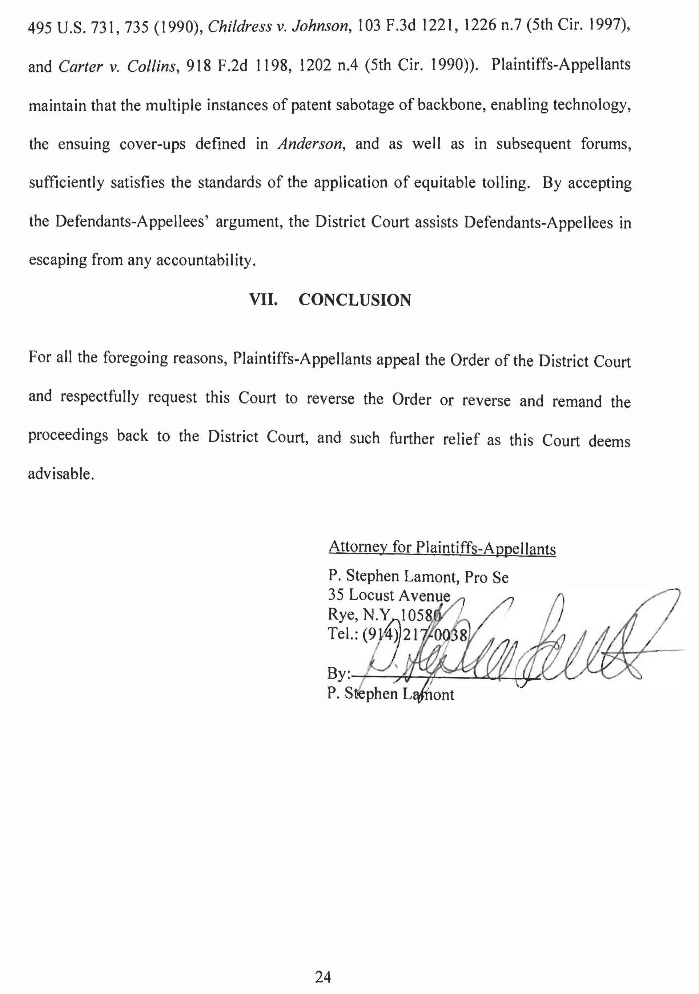
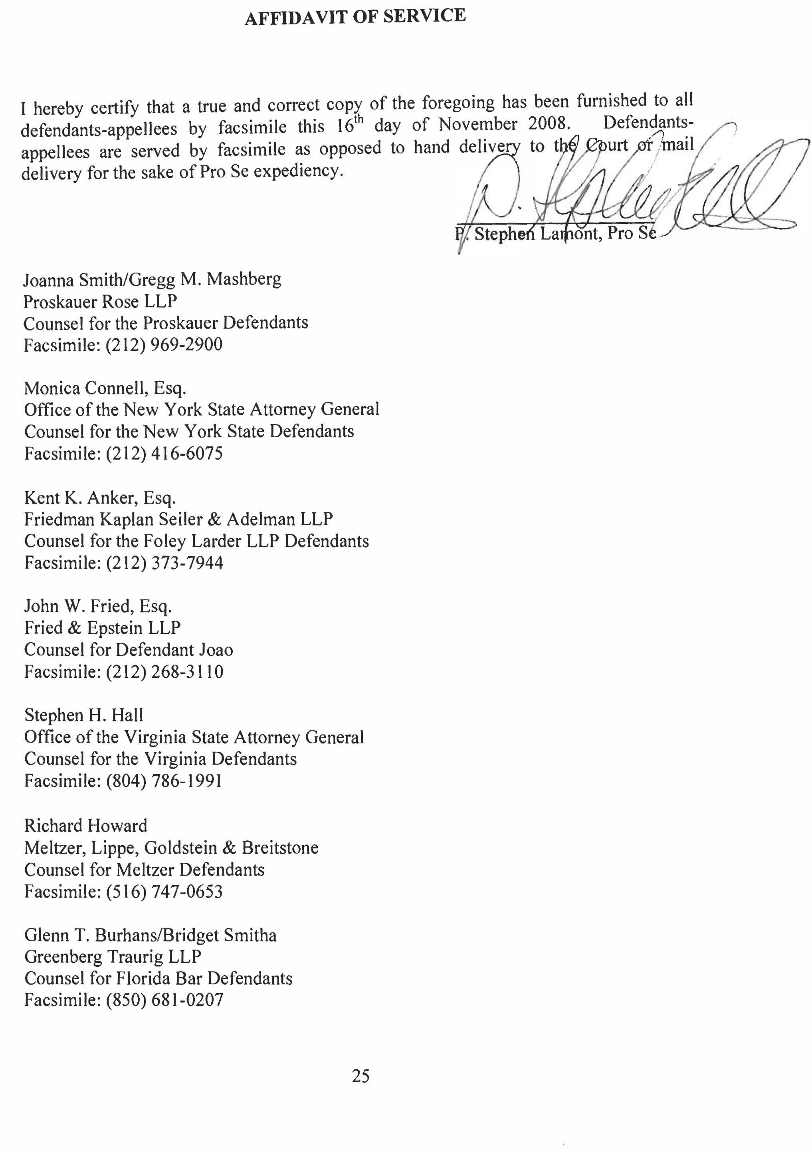

VIII. Appendices

A.
–
I Amended Complaint

05/12/2008
87
AMENDED COMPLAINT amending 1 Complaint,,,,,,,,,,, against Catherine O'Hagen Wolfe(in their individual capacity), Paul Curran(in their official capacity), Paul Curran(in individual capacity), Martin R. Gold(in his individual capacity), Martin R. Gold(in thier offical capacity), Angela M. Mazzarelli(in her official capacity), Angela M. Mazzarelli(in her individual capacity), Richard T. Andrias(in his official capacity), Richard T. Andrias(in his individual capacity), David B. Saxe, David B. Saxe, David Friedman(in his official capacity), David Friedman(in his individual capacity), Luiz A. Gonzales(in his official capacity), Luiz A. Gonzales(in his individual capacity), Appellate Division Second Department Departmental Disciplinary Committee, Lawrence DiGiovanna(in his official capacity), Lawrence DiGiovanna(in his individual capacity), Diana Maxfield Kearse(in her official capacity), Diana Maxfield Kearse(in her individual capacity), James E. Peltzer(in his offical capacity), James E. Peltzer(in his individual capcity), A. Gail Prudenti(in her offical capacity), A. Gail Prudenti(in her individual capacity), Steven
C. Krane(in his official capacity), Steven C. Krane(in his individual capacity), Judith S. Kaye, Judith S. Kaye, Kenneth Rubenstein, Estate of Stephen Kaye, Proskauer Rose LLP, Meltzer Lippe Goldstein & Breistone LLP, Lewis S. Meltzer, Raymond A. Joao, Foley Lardner LLP, Michael C. Grebe, William J. Dick, Douglas A. Boehm, Steven
C. Becker, State of New York Commission of Investigation, Appellate Division First Department Departmental Disciplinary Committee, Lawyers Fund for Client Protection of the State of New York, The Florida Bar, Lorraine Christine Hoffman(in her official capacity), Lorraine Christine Hoffman(in her individual capacity), Eric Turner(in his official capacity), Eric Turner(in his individual capacity), John Anthony Boggs(in his official capacity), John Anthony Boggs(in his individual capacity), Kenneth Marvin(in his official capacity), Kenneth Marvin(in his individual capacity), Thomas J. Cahill(in his official capacity), Thomas Hall(in his official capacity), Thomas Hall(in his individual capacity), Debroah Yarborough(in her official capacity), Debroah Yarborough(in her individual capacity), Virginia State Bar, Andrew H. Goodman(in his official capacity), Andrew H. Goodman(in his individual capacity), Noel Sengel(in her official capacity), Noel Sengel(in her individual capacity), Mary W. Martelino, Thomas J. Cahill(in his individual capacity), John Does, Joseph Wigley(in his official capacity), Joseph Wigley(in his individual capacity), Catherine O'Hagen Wolfe(in their official capacity).Document filed by Eliot I. Bernstein(Individually), Eliot I. Bernstein, P. Stephen Lamont. Related document: 1 Complaint,,,,,,,,,,, filed by P. Stephen Lamont, Eliot I. Bernstein.(dle) (Entered: 07/03/2008)

A.
–
II Motions to Dismiss

05/28/2008 | 66 | MOTION for an order of dismissal, under FRCP Rule 12 dismissing the Complaint in this action as to the Virginia Defendants in its entirety. Document filed by Virginia State Bar, Andrew H. Goodman(in his official capacity), Andrew H. Goodman(in his individual capacity), Noel Sengel(in her official capacity), Noel Sengel(in her individual capacity), Mary W. Martelino.(dle) (Entered: 05/29/2008)
05/28/2008 | 67 | MEMORANDUM OF LAW in Support re: 66 MOTION to Dismiss. Document filed by Virginia State Bar, Andrew H. Goodman(in his official capacity), Andrew H. Goodman(in his individual capacity), Noel Sengel(in her official capacity), Noel Sengel(in her individual capacity), Mary W. Martelino. (dle) (Entered: 05/29/2008)
05/30/2008 | 68 | MOTION for an order pursuant to F.R.C.P. 12(b)(2) and (6) to Dismiss the Amended Complaint; w/ attch. Declaration in support. Document filed by Lorraine Christine Hoffman(in her official capacity), Eric Turner(in his official capacity), John Anthony Boggs(in his official capacity), Kenneth Marvin(in his official capacity).(pl) (Entered: 05/30/2008)
05/30/2008 | 69 | MEMORANDUM OF LAW in Support re: 68 MOTION to Dismiss. Document filed by Lorraine Christine Hoffman(in her official capacity), John Anthony Boggs(in his official capacity), Kenneth Marvin(in his official capacity, et al. (pl) (Entered: 05/30/2008)
05/30/2008 | 70 | FILING ERROR - ELECTRONIC FILING IN NON-ECF CASE -CROSS MOTION to Dismiss Complaint. Document filed by Meltzer Lippe Goldstein & Breistone LLP, Lewis S. Meltzer.(Howard, Richard) Modified on 6/2/2008 (KA). (Entered: 05/30/2008)
05/30/2008 | 71 | FILING ERROR - ELECTRONIC FILING IN NON-ECF CASE -AFFIDAVIT of Richard M. Howard, Esq. in Support re: 70 CROSS MOTION to Dismiss Complaint. Document filed by Meltzer Lippe Goldstein & Breistone LLP, Lewis S. Meltzer. (Howard, Richard) Modified on 6/2/2008 (KA). (Entered: 05/30/2008)
05/30/2008 | 72 | FILING ERROR - ELECTRONIC FILING IN NON-ECF CASE -AFFIDAVIT OF SERVICE of Notice of Cross Motion with Affidavit in Support served on Elliot I. Bernstein, P. Stephen Lamont, Monica Connell, Esq., Gregg M. Mashberg, Esq., Glenn T. Burhans, Jr., Esq., John W. Fried, Esq. on May 30, 2008. Service was made by Mail. Document filed by Meltzer Lippe Goldstein & Breistone LLP, Lewis S. Meltzer. (Howard, Richard) Modified on 6/2/2008 (KA). (Entered:

 |  | 05/30/2008)
05/30/2008 | 73 | MOTION to Dismiss the Amended Complaint. Document filed by State of New York Commission of Investigation et al.(cd) (Entered: 06/02/2008)
05/30/2008 | 74 | MEMORANDUM OF LAW in Support re: 73 MOTION to Dismiss.. Document filed by State of New York Commission of Investigation et al. (cd) (Entered: 06/02/2008)
05/30/2008 | 75 | MOTION for an order pursuant to Rules 8 (a)(2), 9(b), 12(b)(1), and 12(b)(6), of the F.R.C.P. to Dismiss the Amended Complaint. Document filed by Raymond A. Joao.(pl) (Entered: 06/02/2008)
05/30/2008 | 76 | MEMORANDUM OF LAW in Support re: 75 MOTION to Dismiss. Document filed by Raymond A. Joao. (pl) (Entered: 06/02/2008)
05/30/2008 | 77 | DECLARATION of John W. Fried in Support re: 75 MOTION to Dismiss.. Document filed by Raymond A. Joao. (pl) (Entered: 06/02/2008)
05/30/2008 | 78 | MOTION to Dismiss the Complaint and Amended Complaint, with prejudice. Document filed by Steven C. Krane(in his individual capacity), Kenneth Rubenstein, Estate of Stephen Kaye, Proskauer Rose LLP.(cd) (Entered: 06/02/2008)
05/30/2008 | 79 | DECLARATION of Joanna Smith in Support re: 78 MOTION to Dismiss. Document filed by Steven C. Krane(in his official capacity), Kenneth Rubenstein, Estate of Stephen Kaye, Proskauer Rose LLP. (cd) (Entered: 06/02/2008)
05/30/2008 | 80 | MEMORANDUM OF LAW in Support re: 78 MOTION to Dismiss. Document filed by Steven C. Krane(in his individual capacity), Kenneth Rubenstein, Estate of Stephen Kaye, Proskauer Rose LLP. (cd) (Entered: 06/02/2008)
05/30/2008 | 81 | MOTION for an order pursuant to F.R.C.P. 9(b) and 12(b)(b) dismissing the original and amended complaints. Document filed by Foley Lardner LLP, Michael C. Grebe, William J. Dick, Douglas A. Boehm, Steven C. Becker.(pl) (Entered: 06/02/2008)

A.
–
III Oppositions

A.
–
IV Order

07/14/2008 | 90 | OPPOSITION/RESPONSE to Motion re: 83 MOTION to Dismiss. Document filed by P. Stephen Lamont. (djc) (Entered: 07/15/2008)
07/14/2008 | 91 | OPPOSITION/RESPONSE to Motion re: 75 MOTION to Dismiss. Document filed by P. Stephen Lamont. (djc) (Entered: 07/15/2008)
07/14/2008 | 92 | Co-Plaintiff Lamont's Opposition to the Sate Defendants' Motion to Dismiss. (djc) (Entered: 07/15/2008)
07/14/2008 | 93 | opposition/RESPONSE to Motion re: 78 MOTION to Dismiss.. Document filed by P. Stephen Lamont. (djc) (Entered: 07/15/2008)
07/14/2008 | 94 | OPPOSITION/RESPONSE to Motion re: 81 MOTION to Dismiss.. Document filed by P. Stephen Lamont. (djc) (Entered: 07/15/2008)
07/14/2008 | 95 | RESPONSE to Motion re: 12 MOTION to Dismiss. Document filed by P. Stephen Lamont. (djc) (Entered: 07/15/2008)
07/14/2008 | 96 | OPPOSITION RESPONSE to Motion re: 66 MOTION to Dismiss.. Document filed by P. Stephen Lamont. (djc) (Entered: 07/15/2008)

08/08/2008
107
OPINION AND ORDER that for the reasons stated above, defendants' motions to dismiss are granted. The remaining defendants are dismissed sua sponte. The Clerk of the Court is directed to close these and related motions (documents no. 12,47,48,65,66,68,73,75,78,81,83, and 97 on the docket sheet) and this case re: 75 MOTION to Dismiss, filed by Raymond A. Joao, 47 MOTION to Amend/Correct 1 Complaint, filed by Eliot I. Bernstein, 66 MOTION to Dismiss, filed by Andrew H. Goodman, Virginia State Bar, Noel Sengel, Mary W. Martelino, 83 MOTION to Dismiss, filed by Meltzer Lippe Goldstein & Breistone LLP, Lewis S. Meltzer, 68 MOTION to Dismiss, filed by Eric Turner, Lorraine Christine Hoffman, Kenneth Marvin, John Anthony Boggs, 48 MOTION in Opposition to Defendants Motion to Dismiss Based on Material and Substantial Evidence re: 12 MOTION to Dismiss, filed by Eliot I. Bernstein, 97 MOTION for Extension of Time, filed by Eliot I. Bernstein, 73 MOTION to Dismiss, filed by State of New York Commission of Investigation, 81 MOTION to Dismiss, filed by Michael C. Grebe, Foley Lardner LLP, William J. Dick, Douglas A. Boehm, Steven C. Becker, 12 MOTION to Dismiss, filed by Eric Turner, Lorraine Christine Hoffman, Kenneth Marvin, John Anthony Boggs, The Florida Bar, 65 MOTION re: 60 Order, filed by P. Stephen Lamont, Eliot I. Bernstein, 78 MOTION to Dismiss, filed by Proskauer Rose LLP, Kenneth Rubenstein, Estate of Stephen Kaye, Steven C. Krane. (Signed by Judge Shira A. Scheindlin on 8/8/08) Copies sent by chambers.(cd) (Entered: 08/11/2008)

