UNITED STATES DISTRICT COURT
SOUTHERN DISTRICT OF NEW YORK
X

ELIOT I. BERNSTEIN, et al. DOCKET NO: 07Civ11196 (SAS)

Plaintiffs,

-against-

APPELLATE DIVISION FIRST

DEPARTMENT DEPARTMENTAL DISCIPLINARY
COMMITTEE, et al. OPPOSITION TO
DEFENDANTS
MOTION TO DISMISS

Defendants

X

PLAINTIFFS, ELIOT I. BERNSTEIN, Pro se, individually and P. STEPHEN LAMONT, Pro se and Plaintiff BERNSTEIN on behalf of shareholders of Iviewit Holdings, Inc., Iviewit Technologies, Inc., Uview.com, Inc., Iviewit Holdings, Inc., Iviewit Holdings, Inc., Iviewit.com, Inc., Iviewit.com, Inc., I.C., Inc., Iviewit.com LLC, Iviewit LLC, Iviewit Corporation, Iviewit, Inc., Iviewit, Inc., and other John Doe companies (collectively, “Iviewit Companies”), and patent interest holders, oppose Defendants’: The Florida Bar, John Anthony Boggs, Kenneth Marvin, Lorraine Hoffman, and Eric Turner (collectively, “The Florida Bar Defendants”), Motion to Dismiss, initially, in light of the potential conflicts of interest inherent in the representation of The Florida Bar Defendants by Greenberg Traurig, P.A. (hereinafter “GT”). Where Plaintiffs, were advised that “[GT is] diligently conducting a thorough investigation of your claims of conflict of interest. We will respond to you as soon as the investigation is complete,” yet choose to continue to act while there may be conflict and whereby Plaintiffs do not wish to be precluded from filing an additional Opposition to Defendants Motion to Dismiss when the investigation of GT is complete but refuse to tender an answer to a Motion to Dismiss tendered in possible conflict that arises from GT’s handling of the Iviewit patent portfolio.
On or about the Spring of 2002, the Iviewit Companies through a friend of Plaintiff Bernstein, Caroline Prochotska Rogers, Esq. (hereinafter “Rogers”), contracted with Greenberg Traurig, P.A. to audit Iviewit proprietary and confidential intellectual property information (hereinafter “IP”), the work which culminated in a patent audit for the IP showing the various owners, assignees and other information some of which contradicted former counsel defendants information tendered to shareholders. After the initial audit GT proposed further a phased proposal to continue to correct the deficient patent work of former counsel (Exhibit 1 – Phased Proposal).
Therefore, and in light of the contracted patent audit work and proposal, Plaintiffs claim a possible conflict of interest on the part of GT in its representation of The Florida Bar Defendants by:
- Retained by Rogers to audit and correct proprietary and confidential IP of Plaintiffs;
- Retained by Rogers to audit and correct IP, the then proferring of a bona fide proposal to continue representation of Plaintiffs to fix the deficient patent work of former counsel found by GT, and based on GT’s audit of proprietary and confidential IP of Plaintiffs;
- based on the result of the contracted audit work and the then proferring of a bona fide proposal in phases to correct the deficincies they found in their audit, Plaintiffs are more than likely to call members of GT to act as witnesses for the Plaintiffs to attest to the alleged disrepair and fraud of the patent applications and confirm the patent sabotage and crimes committed by members and associates of, including but not limited to, Proskauer Rose LLP, Meltzer Lippe Goldstein & Breitstone LLP, and Foley & Lardner LLP and thus reinforcing the allegations of cover ups by, among others, Appellate Division First Department Departmental Disciplinary Committee, Appellate Division Second Department Departmental Disciplinary Committee; the Virginia Bar Association, and The Florida Bar Defendants;
- based on the GT’s audit work for Rogers and Iviewit and the proposal of moving forward to correct the deficiencies found through their audit of the IP, and the more than likely appearance of members and associates of GT as plaintiff witnesses, the Court would face the prospect of looking across the courtroom and viewing other members and associates of GT acting in defense of The Florida Bar Defendants; and
- based on the GT’s audit work for Rogers and Iviewit and the proposal of moving forward to correct the deficiencies found through their audit of the IP, and the more than likely appearance of members and associates of GT as witnesses, and the Court looking across the courtroom and viewing other members and associates of GT acting in defense of The Florida Bar Defendants, the Court would also face the prospect of hearing the possible cross examination of the members and associates of GT conducted by other members and associates of GT.
CONCLUSION
In viewing the response of GT to these claims, Plaintiffs are stunned at GT’s response, when presented by Plaintiffs with a document entitled “Greenberg Traurig Proposal,” the response being the “document you previously provided was not on Greenberg Traurig letterhead, was entitled a ‘proposal’ and was not otherwise conclusive of the alleged relationship” rather than a more reasonable response of stopping in their tracks to take the most conservative approach in ascertaining the substance GT’s work on behalf of Iviewit’s patent portfolio and their proposal which indicates that prior counsel had errors in need of correction, if possible, and, the obvious conflicts of interest inherent in the information given to them if true and correct. To bank ones law firm on the lack of letterhead and continue representation of their defendants is a grave mistake especially at an ethics hearing where the strictest adherence to ethics would seem a preamble of any firm entering Your Honor’s Court and filing any motions.
Moreover, since the very inception of Plaintiffs filing of its Complaint, Plaintiffs requested the Court to require the execution of conflict of interest disclosure forms for every proposed counsel who touched these matters on behalf of the several defendants, when, now, in its absence, and time after time, we have seen conflicts of interest (note the recent about face of Foley & Lardner LLP in retaining third party counsel after initially representing themselves for some weeks in conflict) that seek to STRONG ARM THE JUDICIARY AND TILT THE BALANCE IN THIS SYSTEM OF JURISPRUDENCE THROUGH RELENTLESS CONTINUED INTENTIONAL CONFLICTS OF INTEREST TO DENY PLAINTIFFS DUE PROCESS AND PROCEDURE. Accordingly, Plaintiffs again point the Court to, with all due respect, and in light of the subject matter of the Complaint in conjunction with Anderson’s claims, the Conflict of Interest Disclosure Form attached as Exhibit C of the Complaint and beg the Court to have all counsel to any defendant perform an exhaustive and affirmed Conflicts Check, sign an affirmed acknowledgement of such, so as to assure that there is absolutely no conflict with any of the thousands of lawyers composing the law firms named, the judges named or the legal associations, courts and legal organizations named as defendants in these matters.
Moreover, Plaintiffs are more than happy to formally oppose the Florida Bar Defendants Motion to Dismiss, when and if GT acknowledges their possible conflict of interest in submitting the Motion to Dismiss on behalf of The Florida Bar Defendants. Plaintiffs feel no need to address any Motion that may have been tendered in conflict until it is submitted by counsel that assures this Court there is no conflict and whereby forcing the Plaintiffs to do so when the firm is not sure they are not conflicted would set a precedence that conflicts are allowed and no that no ethics rule apply to these attorneys who think they are above the law in that they feel they own the law.
Plaintiffs, at this time, request an EMERGENCY RULING AND IMMEDIATE NOTIFICATION by telephone, or any other means of communication at the discretion of the Court to this initial Opposition to Defendant’s Motion to Dismiss; Plaintiffs have computed the time to fully answer The Florida Bar Defendants Motion to Dismiss up to and including April 7, relying on Rule 6.1 of the Local Rules of the United States District Courts for the Southern and Eastern Districts of New York and Rule 6 of the Federal Rules of Civil Procedure, and request a confirmation of this date from the Court and ask the Court to extend the timeline of response based on extending the time by the time it takes GT to affirm that they are not acting in a conflict in these matters. In other words, we ask Your Honor, in light of GT’s refusal to withdraw their Motion to Dismiss until they are certain the Motion to Dismiss was not submitted in conflict, to extend the time a response would be due by the amount of time that GT either assures this Court that such Motion was not tendered in conflict or GT withdraws as counsel for conflict thus forcing a withdrawal of their motion tendered in conflict and new conflict free counsel tenders a motion not tendered in conflict on behalf of the defendants. Plaintiffs should not be subjected to tender response to the Motion to Dismiss until their fears are 100% absolved, as the fears are based on very real concerns about GT’s former representation of the Iviewit patent portfolio.
In light of the contentions asserted by Anderson of public office corruptions in the related Anderson Complaint it is feasible that no legal member of The Florida Bar, the Virginia Bar Association, or the New York Bar Association should be able to represent any of the several defendants in those states, as members of the organizations being sued, absent the express written consent of the Court and the Plaintiffs. Let defendants hire counsel that is not part of the organization being sued that could be intimidated by such organization that they are members of and where their right to continue to be licensed by such association could be revoked if they too do not play along with the corruptions as Anderson asserts partially occurred in her situation. Let the defendants seek counsel licensed with other state bars whose right to practice cannot be revoked by the accused defendants or where possible incentives could be granted to represent in violation of ethics rules which could be promised to be ignored by the organizations charged with enforcing them, as a favor to ignore them and deny due process to the Plaintiffs, a scratch my back and I will scratch yours situation to evade due process and procedure and thrash ethics in the process.
Finally, the amended complaint Plaintiffs are diligently working on will also include the New York State Bar Association (“NYSBA”) as defendant Steven Krane of Proskauer will be shown to have violated his office of President of the NYSBA in his representation in the disciplinary complaints of his firm Proskauer’s clients, Proskauer partner Kenneth Rubenstein, the firm Proskauer and himself, in their disciplinary complaints while under a blackout period that precluded his involvement in any disciplinary actions for a period of one year after his public office service for the NYSBA. Not only did Krane violate that rule of the NYSBA in representing his partners and firm but he also represented himself at the First Department in the complaint filed against him personally after he was found to have acted in violation of First Department Disciplinary rules concerning his roles with that disciplinary organization. Krane also had disciplinary roles at the First Department and the First Department Disciplinary that additionally precluded him from representing anyone while a senior member of that organization, let alone his firm, his partners and himself.

Attorney for Petitioners
Eliot I. Bernstein, Pro se
39 Little Avenue
Red Bluff, Cal. 96080
Tel.: (530) 529-4410

By:
Eliot I. Bernstein

P. Stephen Lamont, Pro se
35 Locust Avenue
Rye, N.Y. 10580
Tel.: (914) 217-0038

Exhibit 1 – Greenberg Proposal
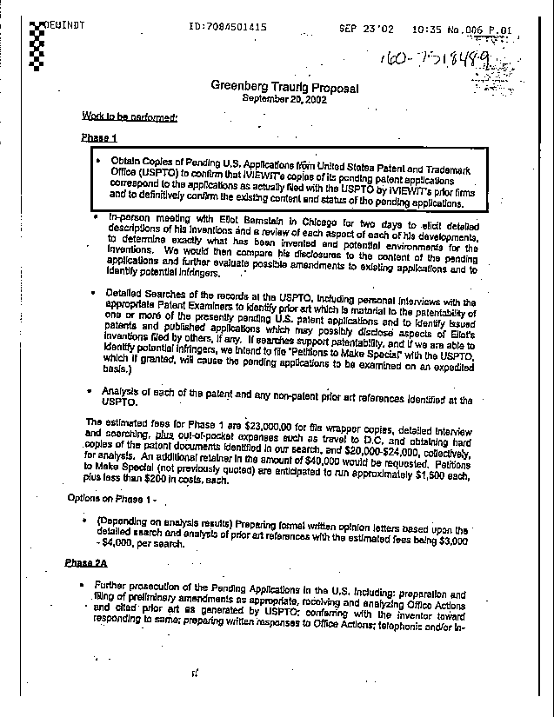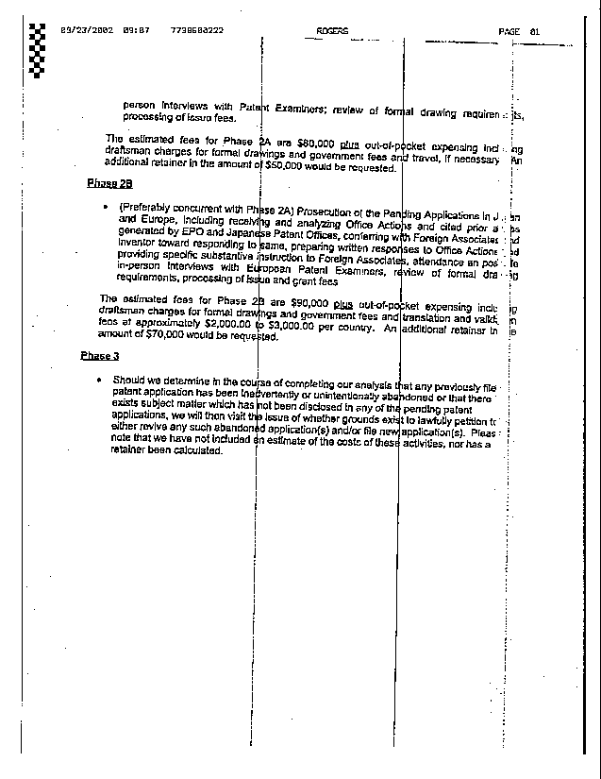

AFFIDAVIT OF SERVICE

I hereby certify that a true and correct copy of the foregoing has been furnished by facsimile and U.S. Mail this __ day of April 2008.

Eliot I. Bernstein, Pro se

Electronic mail message from Glenn T. Burhans, Jr. of March 31, 2008 at 3:03 P.M. EDT.
Electronic mail message from Bridget K. Smitha of March 31, 2008 at 12:21 P.M. EDT.

