UNITED STATES DISTRICT COURT
SOUTHERN DISTRICT OF NEW YORK
X

ELIOT I. BERNSTEIN, INDIVIDUALLY and P. STEPHEN
LAMONT AND ELIOT I. BERNSTEIN ON BEHALF
OF SHAREHOLDERS OF IVIEWIT HOLDINGS, INC.,
IVIEWIT TECHNOLOGIES, INC., UVIEW.COM, INC. ,
IVIEWIT HOLDINGS, INC., IVIEWIT HOLDINGS, INC., DOCKET NO: IVIEWIT.COM, INC., IVIEWIT.COM, INC., I.C., INC., 07 CV 11196
IVIEWIT.COM LLC, IVIEWIT LLC, IVIEWIT
CORPORATION, IVIEWIT, INC., IVIEWIT, INC., and
PATENT INTEREST HOLDERS ATTACHED AS EXHIBIT A
Plaintiffs,

-against-

APPELLATE DIVISION FIRST DEPARTMENT
DEPARTMENTAL DISCIPLINARY COMMITTEE,
THOMAS J. CAHILL, in his official and individual capacity,
JOSEPH WIGLEY in his official and individual capacity,
CATHERINE O’HAGEN WOLFE in her official and
individual capacity, PAUL CURRAN in his official and
individual capacity, MARTIN R. GOLD in his official
and individual capacity , HON. ANGELA M. MAZZARELLI
in her official and individual capacity, HON. RICHARD T.
ANDRIAS in his official and individual capacity, HON. DAVID
B. SAXE in his official and individual capacity, HON. DAVID
FRIEDMAN in his official and individual capacity, HON. LUIZ A.
GONZALES in his official and individual capacity, APPELLATE
DIVISION SECOND DEPARTMENT DEPARTMENTAL DISCIPLINARY COMMITTEE, LAWRENCE MOTION
DIGIOVANNA in his official and individual capacity, DIANA
MAXFIELD KEARSE in her official and individual
capacity, JAMES E. PELTZER in his official and individual
capacity, HON. A. GAIL PRUDENTI in her official and
individual capacity, STEVEN C. KRANE in his official and
individual capacity, HON. JUDITH S. KAYE in her official
and individual capacity, KENNETH RUBENSTEIN in his
official and individual capacity, ESTATE OF STEPHEN KAYE,
PROSKAUER ROSE LLP in their personal and professional
capacities, MELTZER LIPPE GOLDSTEIN & BREISTONE
LLP, LEWIS S. MELTZER, RAYMOND A.
JOAO, FOLEY LARDNER LLP, MICHAEL C. GREBE,
WILLIAM J. DICK, DOUGLAS A. BOEHM, STEVEN C.
BECKER, STATE OF NEW YORK COMMISSION OF
INVESTIGATION, LAWYERS FUND FOR CLIENT
PROTECTION OF THE STATE OF NEW YORK,
THE FLORIDA BAR, LORRAINE CHRISTINE HOFFMAN
in her official and individual capacity, ERIC TURNER in his
official and individual capacity, JOHN ANTHONY BOGGS
in his official and individual capacity, KENNETH MARVIN
in his official and individual capacity, THOMAS HALL in
his official and individual capacity, DEBORAH YARBOROUGH
in her official and individual capacity, VIRGINIA STATE
BAR, ANDREW H. GOODMAN in his official and individual
capacity, NOEL SENGEL in her official and individual
capacity, and MARY W. MARTELINO in her official and
individual capacity.

Defendants

X

MOTION FOR: APPOINTMENT OF PRO BONO COUNSEL; EXTENSION OF TIME TO FILE AMENDED COMPLAINT AFTER ORIGINAL COMPLAINT HAS BEEN FILED ON SOME OR ALL OF THE DEFENDANTS; ORDER FOR THE UNITED STATES MARSHAL SERVICE TO SERVE PAPERS ON REMAINING OR ALL OF THE DEFENDANTS; ACCEPT LIMITED POWER OF ATTORNEY OF PLANTIFF BERNSTEIN AND PLANTIFF LAMONT; ACCEPT REMOTE APPEARANCE OF PLAINTIFF BERNSTEIN FOR COURT PROCEEDINGS; AND PHYSICAL PROTECTION OF PLAINTIFFS FOR COURT APPEARANCES.

PLAINTIFFS, ELIOT I. BERNSTEIN, Pro se, individually and P. STEPHEN LAMONT, Pro se and Plaintiff BERNSTEIN on behalf of shareholders of Iviewit Holdings, Inc., Iviewit Technologies, Inc., Uview.com, Inc. , Iviewit Holdings, Inc., Iviewit Holdings, Inc., Iviewit.com, Inc., Iviewit.com, Inc., I.C., Inc., Iviewit.com LLC, Iviewit LLC, Iviewit Corporation, Iviewit, Inc., Iviewit, Inc., and other John Doe companies (collectively, “Iviewit Companies”), and patent interest holders attached as Exhibit A, move this Court to: (I) Order to appoint pro bono counsel; (II) Order to extend time to file an Amended Complaint by sixty (60) days after original complaint has been served on some or all of the Defendants; and (III) Order for the United States Marshal Service to serve papers on Defendants; (IV) Order to accept the Power of Attorney of Plaintiff BERNSTEIN and Power of Attorney of Plaintiff LAMONT for execution of papers; (V) Order to accept remote appearance of Plaintiff BERNSTEIN for Court proceedings; (VI) Order for physical protection of Plaintiffs for Court appearances; for all requested orders.
Plaintiffs references this Court to the facsimile of Friday, December14, 2007, attached herein as Exhibit A incorporated herein by reference as supplement and support to all counts following.
(I) APPOINTMENT OF PRO BONO COUNSEL
- That Plaintiffs are requesting this Court to appoint Pro Bono counsel for several reasons:
  - In that Plaintiffs claims are made against some of the most influential persons in the State of New York’s legal and judicial circles, that Plaintiffs request that this Court enter an Order for Pro Bono counsel, selected by this Court if within the Court’s powers, where such counsel is specialized in the niche areas that this case demands, (i.e. intellectual property, RICO, crimes against the government, and crimes perpetrated by government officials against Plaintiffs), and counsel of the caliber in which this Court has the utmost faith; and
  - Due to the denial of due process and violation of public offices to whitewash complaints that, in effect, aids and abets the volume of criminal activities that resulted from the volumes of criminal activities committed against Plaintiffs, as alleged in both this Complaint and 07 CV 9599, Christine C. Anderson v. The State of New York, et.al., Plaintiffs have suffered financial loss, including loss of jobs, money stolen from corporate accounts, therefore, in large part due to denial of due process and whitewashing of complaints that Plaintiffs request this Court to enter an Order for Pro Bono counsel; and
  - Simultaneously with the request to enter an Order for Pro Bono counsel, Plaintiffs request that this Court assign Pro Bono counsel with the resources and skills sets to represent this case, with time being of the essence, to provide for the drafting and filing of Plaintiffs’ Amended Complaint; and

  - Prior to this Complaint, Plaintiffs have searched for counsel and gone through the same exercise, where such retained counsel have entered into the same patterns of frauds, deceits and misrepresentations acting in collusion with the original conspirators Plaintiffs indirectly complain of in the Complaint, where the direct subject matter of the Complaint arises from the denial of due process of those attorney complaints.
(II) EXTENSION OF TIME TO FILE AMENDED COMPLAINT AFTER ORIGINAL COMPLAINT HAS BEEN SERVED ON SOME OR ALL OF THE DEFENDANTS

- In that Plaintiffs expect an inherent delay in securing such Pro Bono counsel whereby the complexity of the case and public office violation charges takes time to fully digest the matters and formulate a proper amended filing and, therefore, asking the Court for latitude for all the reasons stated to grant more time than the rule suggests, Rule 15(a) of the Federal Rules of Civil Procedure (“Rule”) that governs amended complaints.
- That Plaintiffs have begun to amend the original Complaint by the addition of new and or different Counts and Prayers for Relief to be contained in an Amended Complaint, including: through the civil RICO Count, adding perhaps hundreds of new Defendants; and, in the Prayers for Relief, injunctive relief that causes the shutdown of digital video and imaging as we know it, as a result of the unauthorized use of Plaintiffs technology, and in light of this Court’s review of Declaration in Support of Request to Proceed In Forma Pauperis attached herein as Exhibit B, Plaintiffs timely filing Pro Bono counsel’s Amended Complaint may take longer than the Rule suggests.
- That the intricacies of this complaint and the new and or different Counts and Prayers for Relief in the Amended Complaint are of such a complex nature that even the appointment of the most experienced Pro Bono counsel would necessitate the extension of time to file the Amended Complaint.
- For the above reasons, Plaintiffs request an extension to file an Amended Complaint by sixty (60) days after the mandated twenty (20) days post the service on some or all of the Defendants; Plaintiffs are considering serving Defendants within the week with a copy of the original filing.
(III) ORDER FOR THE UNITED STATES MARSHAL SERVICE TO SERVE PAPERS ON DEFENDANTS

- In that the filing fee for the Complaint was paid by an American Express Card ending in xxxxxxxxxx34006, the holder of which is Plaintiff LAMONT, Plaintiffs request this Court to return the filing fee to Plaintiff LAMONT in light of his Declaration in Support of Request to Proceed In Forma Pauperis attached herein as Exhibit B.
- That in returning the filing fee for the Complaint to Plaintiff LAMONT and accepting the request to proceed In Forma Pauperis, Plaintiffs move this Court to Order the United States Marshal Service to serve papers on some or all of the Defendants pursuant to Rule 4 of the Federal Rules of Civil Procedure.

(IV) ACCEPT THE POWERS OF ATTORNEY OF PLAINTIFF BERNSTEIN AND PLAINTIFF LAMONT

- In that the Plaintiffs are diverse within the meaning of 28 U.S.C. § 1367, there may be inherent delay in obtaining the original signature of Plaintiff BERNSTEIN, and, as a result, Plaintiffs request that this Court enter an Order to accept signature of Plaintiff BERNSTEIN according to his Limited Power of Attorney attached herein as Exhibit C.
- In that the Plaintiffs are diverse within the meaning of 28 U.S.C. § 1367, there may be inherent delay in obtaining the original signature of Plaintiff LAMONT, and, as a result, Plaintiffs request that this Court enter an Order to accept signature of Plaintiff LAMONT according to his Limited Power of Attorney attached herein as Exhibit D.
(V) ACCEPT REMOTE APPEARANCE OF PLAINTIFF BERNSTEIN FOR COURT PROCEEDINGS

- Although that Plaintiff BERNSTEIN was not a participant to the discussions pertaining to the Complaint during the 07 CV 9599 Christine C. Anderson v. The State of New York, et.al. hearing on December 12, 2007, Plaintiff BERNSTEIN requests to not make any similar appearances for Plaintiffs’ Complaint or 07 CV 9599 until the protections of (VI) below are in place, and, therefore, that this Court to hear Plaintiff BERNSTEIN by conference call in all matters in either case.
(VI) PHYSICAL PROTECTION OF PLAINTIFFS FOR COURT APPEARANCES

- As this Court may see by the car bombing of Plaintiff BERNSTEIN’S minivan at the URL http://www.iviewit.tv, involvement in these matters may go beyond the boundaries of physical well being, especially with the absence of federal and/or state protections and when combined with the associated risks caused by filing alongside 07 CV 9599, Christine C. Anderson v. The State of New York, a case in which this Court termed a "whistleblower" case, or words to that effect and whereby the elements of the Civil RICO tentacle to Criminal RICO and all those protections this Court may afford to any citizen coming forward to testify not only on behalf of Plaintiffs Complaint but also on behalf of any future criminal indictments tried by prosecutors in either matter.
- In that involvement on this case may go beyond the boundaries of physical well being, Plaintiffs request this Court to enter an Order that provides for the protective custody of Plaintiffs during proceedings within and outside of this Court and allow for teleconference appearances until such time that this Court may provide adequate protections for the safety and well being of Plaintiffs.
That with time being of the essence for (I) through (VI) above as a result of Plaintiffs’ quick filing to associate with 07 CV 9599 and the resulting imminent danger the matters attribute to Plaintiff BERNSTEIN, Plaintiffs request a time of the essence ruling in this Motion or an Emergency Hearing at the discretion of the Court.
WHEREFORE, Plaintiffs move this Court to: (I) Order to appoint Pro Bono counsel; (II) Order to extend time to file an Amended Complaint by sixty (60) days after original complaint has been filed on some or all of the Defendants; and (III) Order for the United States Marshal Service to serve papers on Defendants; (IV) Order to accept the Power of Attorney of Plaintiff BERNSTEIN and Plaintiff LAMONT for execution of papers; (V) Order to accept remote appearance of Plaintiff BERNSTEIN for Court proceedings; (VI) Order for physical protection of Plaintiffs for Court appearances, and such other relief as this Court deems just and equitable.

Attorney for Petitioners
Eliot I. Bernstein, Pro se
39 Little Avenue
Red Bluff, Cal. 96080
Tel.: (530) 529-4410

By:
Eliot I. Bernstein

P. Stephen Lamont, Pro se
35 Locust Avenue
Rye, N.Y. 10580
Tel.: (914) 217-0038

By:
P. Stephen Lamont

Affidavit of Service

I hereby certify that a true and correct copy of the foregoing will be furnished by facsimile or other methods approved by this Court, to the aforementioned Defendants with the original Complaint.

P. Stephen Lamont, Pro se

Eliot I. Bernstein, Pro se

CERTIFICATE OF AFFIRMATION

UNITED STATES DISTRICT COURT
SOUTHERN DISTRICT OF NEW YORK
X

ELIOT I. BERNSTEIN, INDIVIDUALLY and P. STEPHEN
LAMONT AND ELIOT I. BERNSTEIN ON BEHALF
OF SHAREHOLDERS OF IVIEWIT HOLDINGS, INC.,
IVIEWIT TECHNOLOGIES, INC., UVIEW.COM, INC. ,
IVIEWIT HOLDINGS, INC., IVIEWIT HOLDINGS, INC., DOCKET NO: IVIEWIT.COM, INC., IVIEWIT.COM, INC., I.C., INC., 07 CV 11196
IVIEWIT.COM LLC, IVIEWIT LLC, IVIEWIT
CORPORATION, IVIEWIT, INC., IVIEWIT, INC., and
PATENT INTEREST HOLDERS ATTACHED AS EXHIBIT A
Plaintiffs,

-against-

APPELLATE DIVISION FIRST DEPARTMENT
DEPARTMENTAL DISCIPLINARY COMMITTEE,
THOMAS J. CAHILL, in his official and individual capacity,
JOSEPH WIGLEY in his official and individual capacity,
CATHERINE O’HAGEN WOLFE in her official and
individual capacity, PAUL CURRAN in his official and
individual capacity, MARTIN R. GOLD in his official
and individual capacity , HON. ANGELA M. MAZZARELLI
in her official and individual capacity, HON. RICHARD T.
ANDRIAS in his official and individual capacity, HON. DAVID
B. SAXE in his official and individual capacity, HON. DAVID
FRIEDMAN in his official and individual capacity, HON. LUIZ A.
GONZALES in his official and individual capacity, APPELLATE
DIVISION SECOND DEPARTMENT DEPARTMENTAL DISCIPLINARY COMMITTEE, LAWRENCE
AFFIDAVIDTIN SUPPPORT OF MOTION
DIGIOVANNA in his official and individual capacity, DIANA
MAXFIELD KEARSE in her official and individual
capacity, JAMES E. PELTZER in his official and individual
capacity, HON. A. GAIL PRUDENTI in her official and
individual capacity, STEVEN C. KRANE in his official and
individual capacity, HON. JUDITH S. KAYE in her official
and individual capacity, KENNETH RUBENSTEIN in his
official and individual capacity, ESTATE OF STEPHEN KAYE,
PROSKAUER ROSE LLP in their personal and professional
capacities, MELTZER LIPPE GOLDSTEIN & BREISTONE
LLP, LEWIS S. MELTZER, RAYMOND A.
JOAO, FOLEY LARDNER LLP, MICHAEL C. GREBE,
WILLIAM J. DICK, DOUGLAS A. BOEHM, STEVEN C.
BECKER, STATE OF NEW YORK COMMISSION OF
INVESTIGATION, LAWYERS FUND FOR CLIENT
PROTECTION OF THE STATE OF NEW YORK,
THE FLORIDA BAR, LORRAINE CHRISTINE HOFFMAN
in her official and individual capacity, ERIC TURNER in his
official and individual capacity, JOHN ANTHONY BOGGS
in his official and individual capacity, KENNETH MARVIN
in his official and individual capacity, THOMAS HALL in
his official and individual capacity, DEBORAH YARBOROUGH
in her official and individual capacity, VIRGINIA STATE
BAR, ANDREW H. GOODMAN in his official and individual
capacity, NOEL SENGEL in her official and individual
capacity, and MARY W. MARTELINO in her official and
individual capacity.

Defendants

X

PLAINTIFF, P. (“Patrick”) Stephen Lamont, affirms under the penalty of perjury that all of the foregoing is true and accurate, and allege upon knowledge as to my own facts and upon information and belief as to all other matters.

DATED: RED BLUFF, CALIFORNIA
DECEMBER, 21, 2007
Respectfully submitted,

By:--------------------------
Eliot Ivan Bernstein as attorney-in-fact for P. (“Patrick”) Stephen Lamont
(Pro-se Plaintiff)
39 Little Ave.
Red Bluff, California 96080
(530) 529-4110 (o)
(530) 526-5751 (c)
iviewit@iviewit.tv
http://www.iviewit.tv

CERTIFICATE OF AFFIRMATION

UNITED STATES DISTRICT COURT
SOUTHERN DISTRICT OF NEW YORK
X

ELIOT I. BERNSTEIN, INDIVIDUALLY and P. STEPHEN
LAMONT AND ELIOT I. BERNSTEIN ON BEHALF
OF SHAREHOLDERS OF IVIEWIT HOLDINGS, INC.,
IVIEWIT TECHNOLOGIES, INC., UVIEW.COM, INC. ,
IVIEWIT HOLDINGS, INC., IVIEWIT HOLDINGS, INC., DOCKET NO: IVIEWIT.COM, INC., IVIEWIT.COM, INC., I.C., INC., 07 CV 11196
IVIEWIT.COM LLC, IVIEWIT LLC, IVIEWIT
CORPORATION, IVIEWIT, INC., IVIEWIT, INC., and
PATENT INTEREST HOLDERS ATTACHED AS EXHIBIT A
Plaintiffs,

-against-

APPELLATE DIVISION FIRST DEPARTMENT
DEPARTMENTAL DISCIPLINARY COMMITTEE,
THOMAS J. CAHILL, in his official and individual capacity,
JOSEPH WIGLEY in his official and individual capacity,
CATHERINE O’HAGEN WOLFE in her official and
individual capacity, PAUL CURRAN in his official and
individual capacity, MARTIN R. GOLD in his official
and individual capacity , HON. ANGELA M. MAZZARELLI
in her official and individual capacity, HON. RICHARD T.
ANDRIAS in his official and individual capacity, HON. DAVID
B. SAXE in his official and individual capacity, HON. DAVID
FRIEDMAN in his official and individual capacity, HON. LUIZ A.
GONZALES in his official and individual capacity, APPELLATE
DIVISION SECOND DEPARTMENT DEPARTMENTAL DISCIPLINARY COMMITTEE, LAWRENCE
AFFIDAVIDTIN SUPPPORT OF MOTION
DIGIOVANNA in his official and individual capacity, DIANA
MAXFIELD KEARSE in her official and individual
capacity, JAMES E. PELTZER in his official and individual
capacity, HON. A. GAIL PRUDENTI in her official and
individual capacity, STEVEN C. KRANE in his official and
individual capacity, HON. JUDITH S. KAYE in her official
and individual capacity, KENNETH RUBENSTEIN in his
official and individual capacity, ESTATE OF STEPHEN KAYE,
PROSKAUER ROSE LLP in their personal and professional
capacities, MELTZER LIPPE GOLDSTEIN & BREISTONE
LLP, LEWIS S. MELTZER, RAYMOND A.
JOAO, FOLEY LARDNER LLP, MICHAEL C. GREBE,
WILLIAM J. DICK, DOUGLAS A. BOEHM, STEVEN C.
BECKER, STATE OF NEW YORK COMMISSION OF
INVESTIGATION, LAWYERS FUND FOR CLIENT
PROTECTION OF THE STATE OF NEW YORK,
THE FLORIDA BAR, LORRAINE CHRISTINE HOFFMAN
in her official and individual capacity, ERIC TURNER in his
official and individual capacity, JOHN ANTHONY BOGGS
in his official and individual capacity, KENNETH MARVIN
in his official and individual capacity, THOMAS HALL in
his official and individual capacity, DEBORAH YARBOROUGH
in her official and individual capacity, VIRGINIA STATE
BAR, ANDREW H. GOODMAN in his official and individual
capacity, NOEL SENGEL in her official and individual
capacity, and MARY W. MARTELINO in her official and
individual capacity.

Defendants

X

PLAINTIFF, Eliot Ivan Bernstein, affirms under the penalty of perjury that all of the foregoing is true and accurate, and allege upon knowledge as to my own facts and upon information and belief as to all other matters.

DATED: RED BLUFF, CALIFORNIA
DECEMBER, 21, 2007
Respectfully submitted,

By:--------------------------
Eliot Ivan Bernstein
(Pro-se Plaintiff)
39 Little Ave.
Red Bluff, California 96080
(530) 529-4110 (o)
(530) 526-5751 (c)
iviewit@iviewit.tv
http://www.iviewit.tv

EXHIBIT A

[FAX OF FRIDAY, DECEMBER 14]

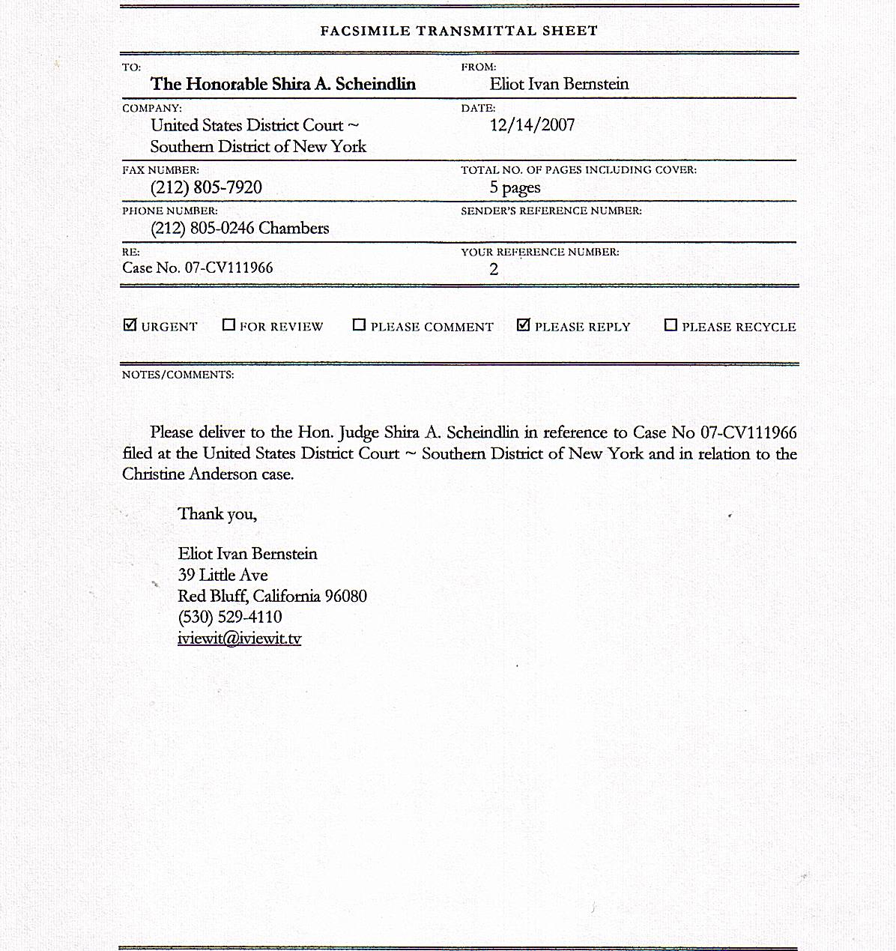

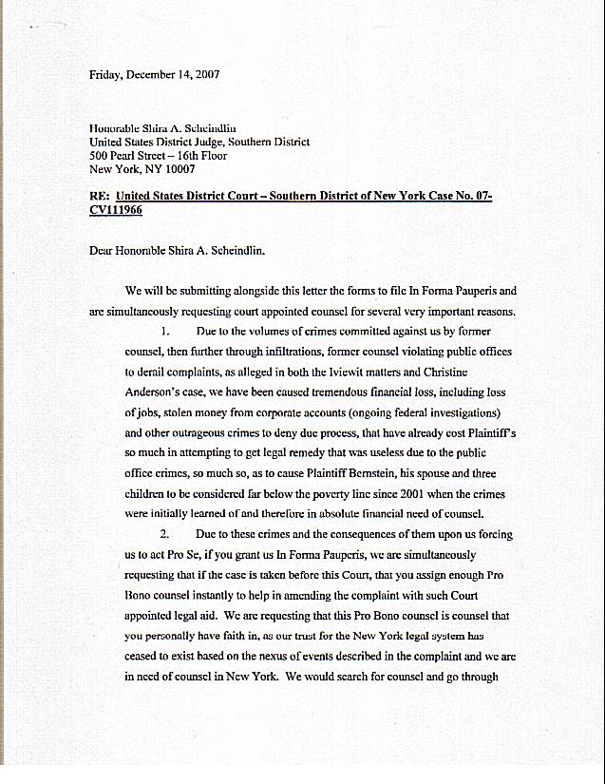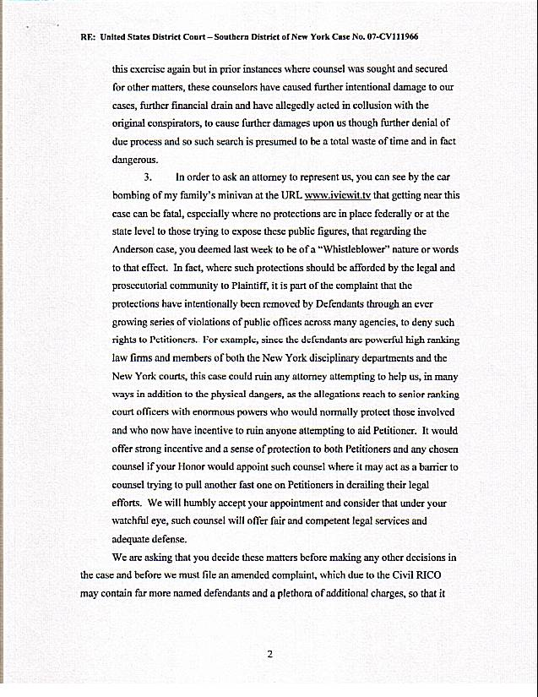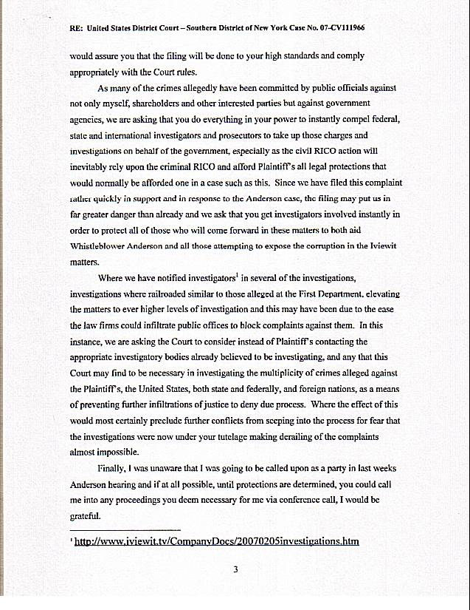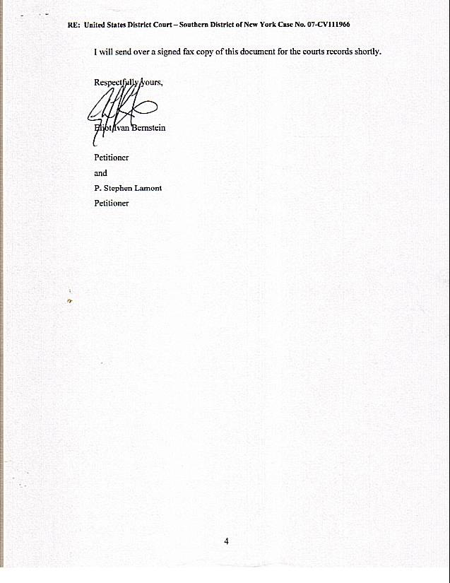

EXHIBIT B

[DECLARATION INFORMA PAUPERIS]

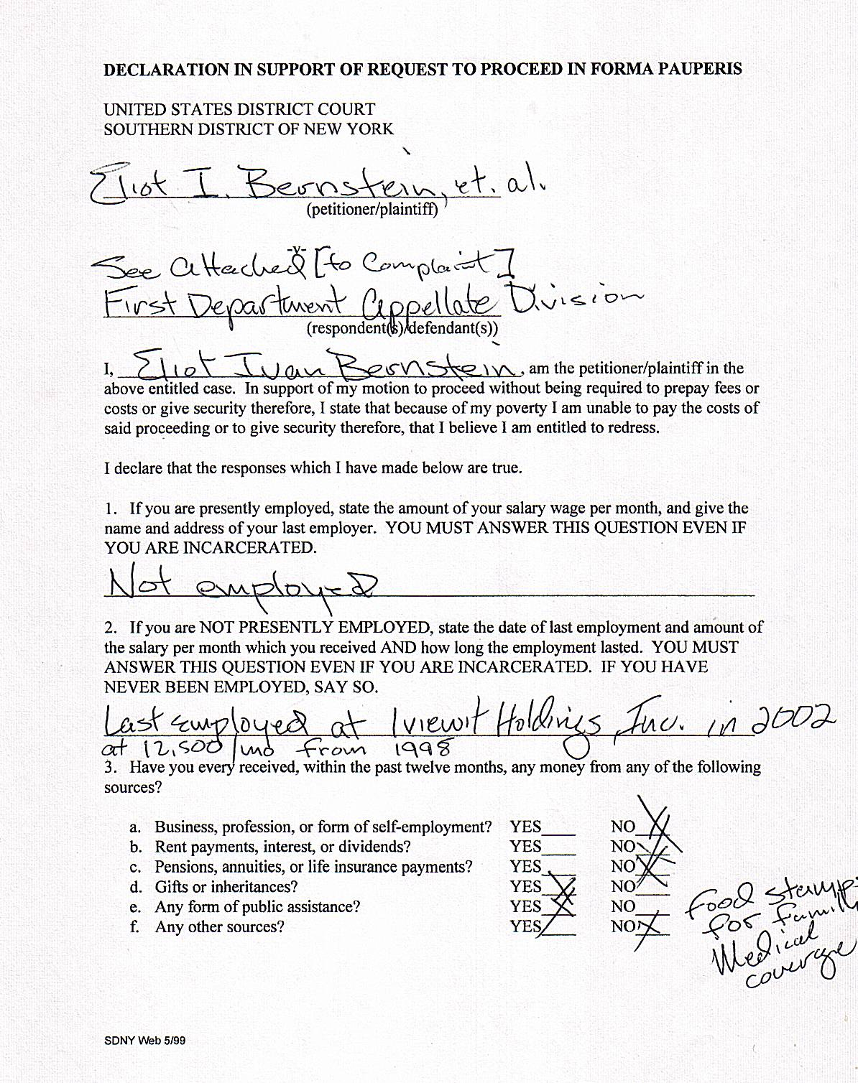
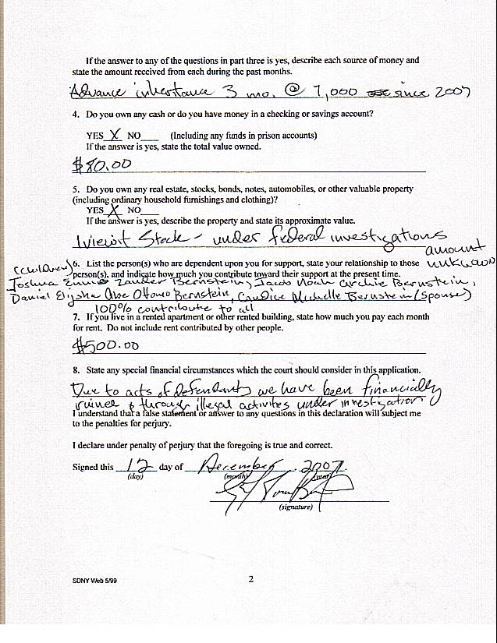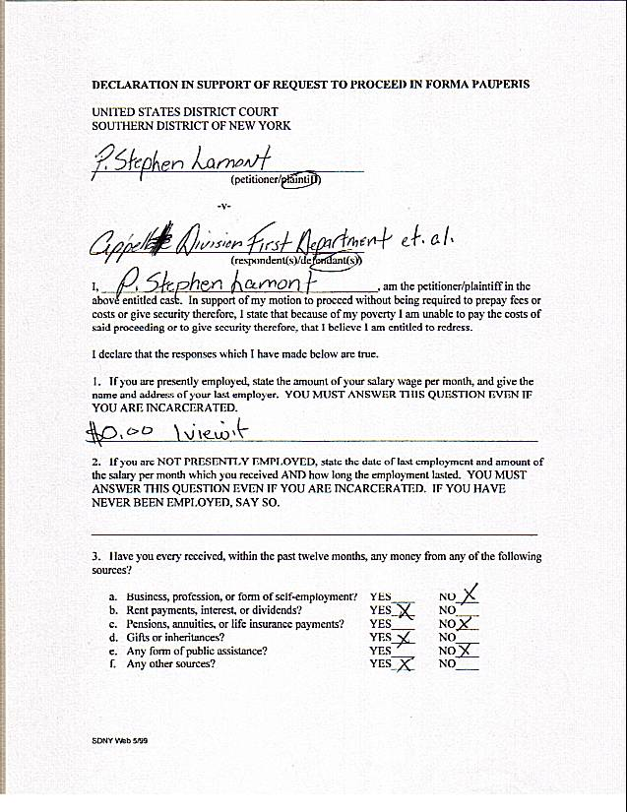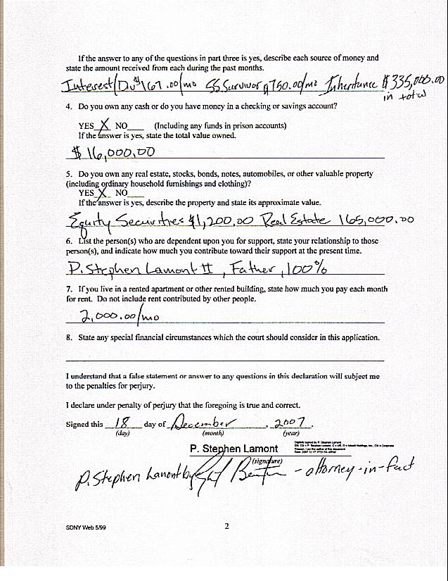

EXHIBIT C

[POA OF BERNSTEIN]
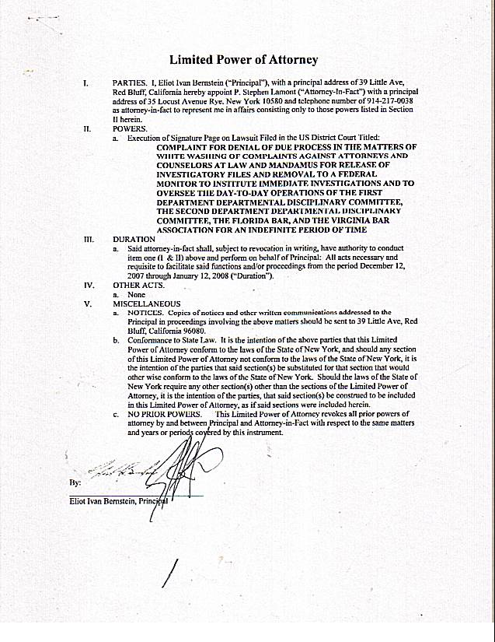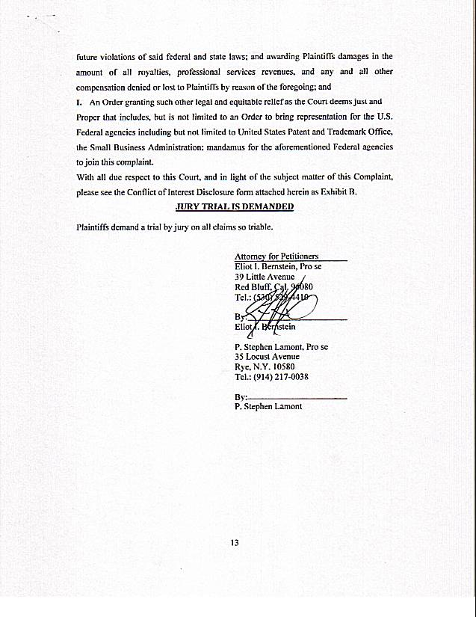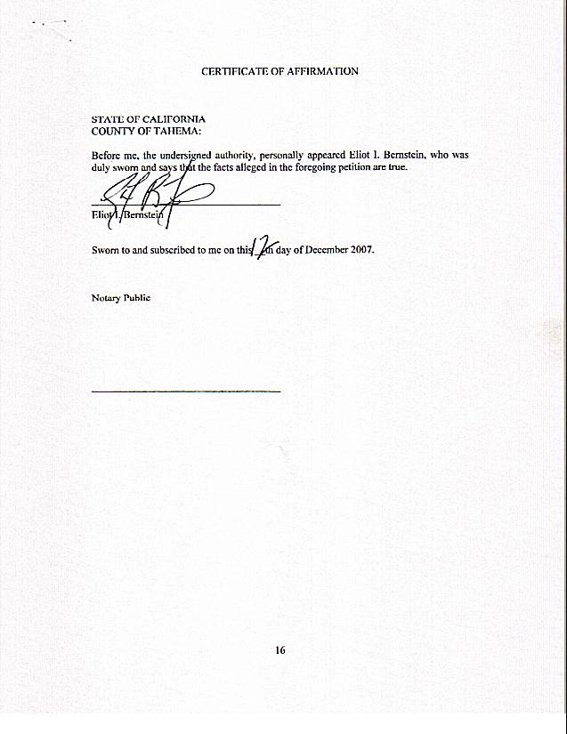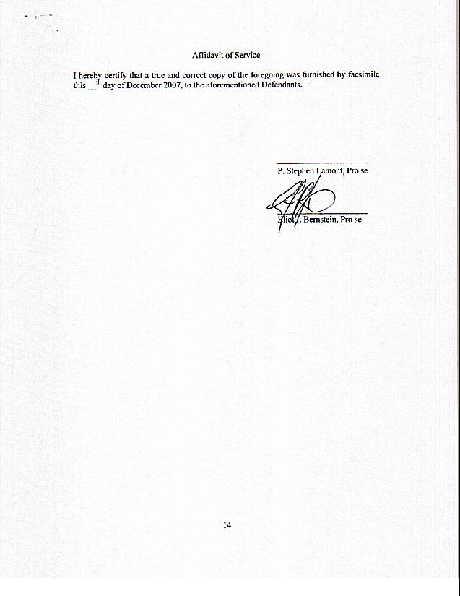

EXHIBIT D (POA LAMONT)
